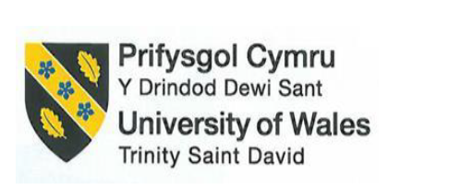

The Wales Celtic Legends Hospitality and Tourism

Student name : Marina Boeva
Student ID : 2246384
Module title: International Meetings Management BMIH6007
Module Lead: Kathryn Roberts

AI Declaration

I confirm that I have not used any kinds of AI tools to complete my assignment. I also have not presented any materials which are generated from AI. I have kept all drafts that I have used as notes and calculation and I could provide all those as evidence of own piece of writing.

Table of Contents
1 Introduction 3
1.1 Brief Description of the Expo 3
1.2 Rationale for Selecting this Event 3
1.3 Importance of Cultural Heritage and MICE Industry 3
2 The Event Cycle 3
2.1 Concept and Initiation 3
2.2 Feasibility and Planning 4
2.3 Implementation/Delivery 4
2.4 Post-Event Evaluation 4
3 Event Concept 4
4 Aim and Objectives 5
5 Event Management 6
5.1 Operational 6
5.2 Planning 7
5.3 Marketing 8
5.4 Sustainability Practices 8
6 Event Budget 9
7 Industry Trends, Issues & Impacts 10
8 Situational and Cultural Considerations 11
8.1 SWOT Analysis 11
8.2 PESTLE Analysis 12
9 Conclusion 14
10 References 15

Introduction

Brief Description of the Expo
The Wales Celtic Legends Hospitality and Tourism Expo will be a three-day global trade fair in ICC Wales, Newport, between 20 and 22 November 2025. It will highlight the Welsh culture, heritage, food and adventure tourism, along with B2B networking. Collaboration must be provided through networking sessions and keynote talks, whereas the storytelling experiences engage the participants in the unique identity of Wales (Crowther et al., 2021).

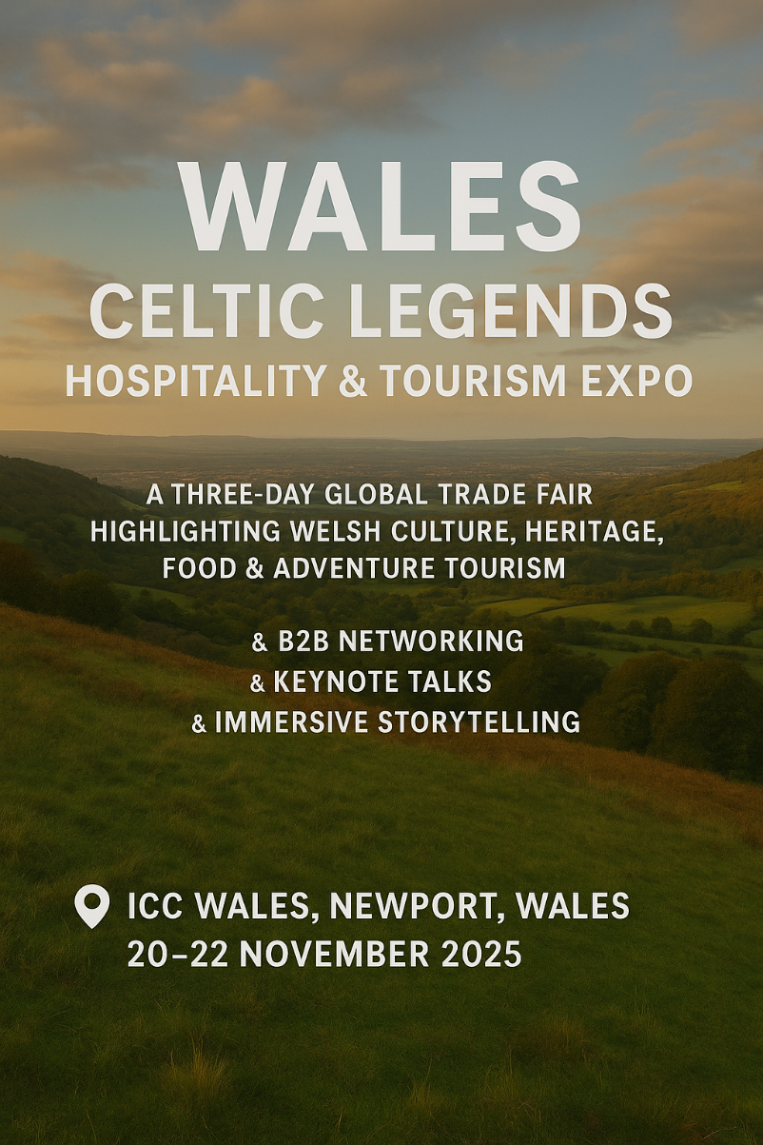
Figure 1:Wales Celtic Legends Hospitality and Tourism Expo
Source: (Author)

Rationale for Selecting this Event
The Wales Celtic Legends Expo is an offshoot of the Year of Legends campaign that showcases Welsh legends, language and the creativity of hospitality. It confirms the Welsh as a very different and competitive MICE destination. Compared to Ireland or Scotland, what was presented in Wales is unique in the sense that heritage, creativity and cultural experience can be used to increase the value of Wales as an international tourist destination. It is possible though that these assumptions about cultural differentiation as the guarantee of competitiveness are optimistic, because, without the constant investment in branding and infrastructure, the effects might be rather symbolic than radical.

Importance of Cultural Heritage and MICE Industry
Cultural heritage adds value to the MICE industry by ensuring a balance between authenticity and innovation. Recent places, a bilingual culture, folklore and the modern facilities of Wales make for memorable experiences. Tourism that pays attention to heritage creates a stronger sense of loyalty to the destination, it can enhance the value of sustainability, and encourage exchange of cultures, making tourism more meaningful and value-added for communities and for the international tourist.

The Event Cycle
The event cycle provides a framework for planning, execution and review of events which ensures a balance between creativity and control. For the Wales Celtic Legends Expo, this process is implementing cultural vision as measurable results through continuous learning and refinement.

Concept and Initiation
The idea came from the desire to combine Celtic heritage and modern innovation in hospitality inspired by the Year of Legends. It is a symbol of Wales' determination to boost MICE presence by striking the right balance between tradition and progress.

Feasibility and Planning
Feasibility (ICC Wales), location and sustainability concerns, cost, risk management and marketing of risks. Strategic differentiation and financial viability can be ensured with the assistance of competitor analysis and market analysis. However, strategic differentiation might be diluted as soon as neighbouring destinations like Scotland or Ireland quickly embrace similar format of hybrid and heritage events and demonstrate that Wales needs to constantly come up with new ways of narrating culture.

Implementation/Delivery
Demonstration will include exhibitions, oratory and cultural performances with bilingual employees, and total AR/VR engines, to ensure access and interest. Although such immersive technologies make the interactions more interesting, they potentially lead to the loss of real human interaction, which the organisers of the event will have to strike a balance to ensure the true cultural interaction.

Post-Event Evaluation
Performance will be gauged against SMART objectives using delegate feedback, financial performance and media reach. Observations will drive development in the future, providing strength to authenticity, operation and global competitiveness of the MICE sector.

Event Concept
The Wales Celtic Legends Hospitality and Tourism Expo is a three-day international business and cultural festival celebrating Welsh heritage by telling stories, folklore, and innovation. It will take place at ICC Wales, where it is a hybrid event that integrates trade show, networking, and immersive experiences (AR/VR virtual tours and hybrid involvement to be accessible worldwide). Every day, there is a theme, and it is business networking, cultural performances, and adventure tourism as the approaches that prove the bilinguality of Wales and sustainable hospitality methods. The Expo will also intend to make Wales a unique and competitive destination of MICE by integrating both tradition and the latest technological solutions that will provide the delegates with a traditional yet progressive cultural and business experience.
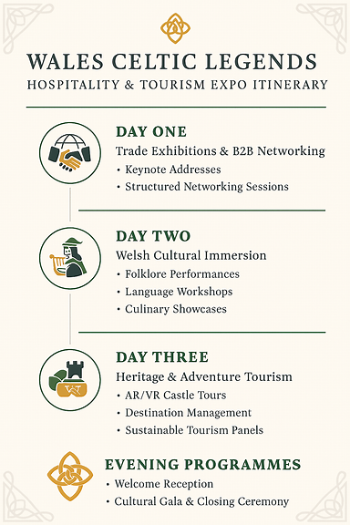
Figure 2: 3-day itinerary table
Source: (Author)

Aim and Objectives
The general objective of Wales Celtic Legends Hospitality and Tourism Expo is to promote Wales as a world leading MICE destination through the integration of the Celtic heritage and contemporary hospitality trends. As a cultural storytelling event, immersive technology, and a professional networking opportunity, the Expo aims to highlight the unique identity of Wales, as well as enhancing its international tourism image.
The SMART mentioned objctives are:
- Bring 1,000 or more foreigners through a worldwide marketing campaign with Visit Wales and collaborating tourist boards.
- Raise 500,000+ revenue via delegate fees, sponsorship, and government support and deliver financial sustainability.
- Expand the international brand awareness of Increase Wales by 20 percent via surveys, media, and online interactions.
The combination of these goals offers quantifiable deliverables that are in line with the strategic vision of the Expo and accountability in delivering the Expo.

Event Management

Operational
The International Convention Centre (ICC Wales) in Newport has been chosen because of its modern facilities, large capacity and good transport access. Its versatile exhibit rooms and breakout rooms make it convenient to trade show, network, and keynote events (Rogers and Wynn-Moylan, 2022). Logistics will be optimized by registration of the delegates, the regions of Welsh cuisine, and the zones of cultural themes (Koppel et al., 2023; Blok and Westerlaken, 2022). Immersive activities will be held in outdoor heritage locations (Iversen et al., 2022). Planning will be informed by the sustainability goal, resource management, and operations of low impact (Taheri Hosseinkhani, 2025). Both multidisciplinary teams (Allen et al., 2022; Dutta, 2025) and training in cross-cultural (Aririguzoh, 2022) will guarantee authentic, inclusive, and sustainable event delivery.
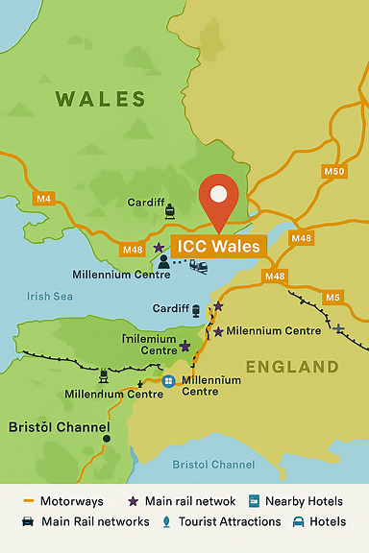
Figure 3: Map of Wales Event Location
Source: (Author)

Planning
A multidisciplinary team comprising of event planners, cultural experts, technical employees and hospitality professionals will be needed to plan the event effectively. The training will be focused on cross-cultural communication, bilingual service (Welsh and English) and awareness of sustainability. Collaboration with local suppliers such as catering providers, transport services, and entertainment agencies will ensure that the Welsh culture is reflected genuinely and the local businesses are promoted. Audio-visual systems, digital streaming, and hybrid platforms will be handled by the technical teams to ensure the smooth delivery of the same to both physical and virtual audiences.

Marketing
The marketing strategy will capitalize on the Year of Legends brand of Visit Wales using digital-first marketing strategies by using social media, interactive video, and global influencer partnerships. Liaisons with Visit Wales and the UK embassies and international tourism boards will help access the trade buyers and cultural institutions in other countries. The digital strategy will be supplemented by the traditional media coverage by travel magazines and press releases, and the early-bird registration discounts will facilitate the delegate sign-ups.
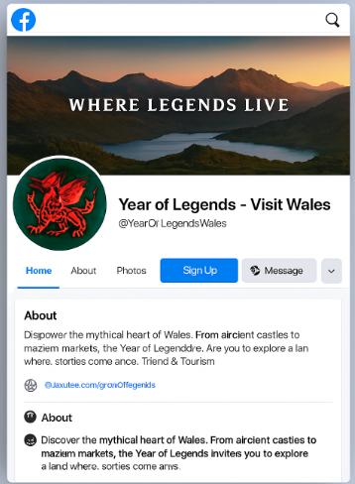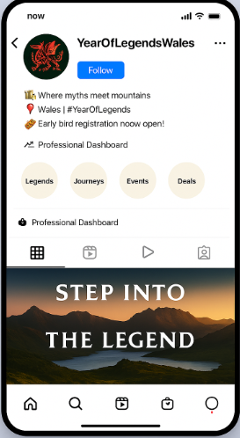
Figure 4: Digital Marketing Hub Strategy
Source: (Author)

Sustainability Practices
The sustainability will direct the operation and marketing of the Expo, where every activity will be environmentally friendly. Local food will be used in catering in a bid to cut carbon footprints and create Welsh food. Green transportation, recycling zones and recyclable exhibits will have minimal effect on the environment. These green initiatives will be at the core of the marketing, which will comply with international practices, as well as be attractive to the green-minded representatives. Nevertheless, sustainability efforts can add to the operational expenses and there should be a trade off between economic and environmental interests. Close cooperation between suppliers, performers, and personnel of the venue will facilitate logistics easily and honor the professional and thematic values of the Expo (Glenn et al., 2023).
All in all, all the elements of operational efficiency, strategic planning, oriented marketing and sustainability are incorporated so that the Expo will be not merely culture-authentic, but also strategically competitive in the world of MICE.

Event Budget
Category | Estimated Cost (£)
Venue & Logistics | 150,000
Catering (Welsh cuisine & F&B) | 100,000
Marketing & Promotion | 50,000
Staffing & Hospitality | 70,000
Technology (AV, AR/VR, Hybrid) | 40,000
Contingency Fund | 30,000
Total Costs | 440,000

Revenue Source | Projected Income (£)
Delegate Fees (400 x £800) | 320,000
Sponsorships & Partnerships | 100,000
Tourism/Heritage Grants (Visit Wales, Welsh Gov.) | 50,000
Merchandise & Cultural Stalls | 30,000
Total Revenue | 500,000

The Wales Celtic Legends Hospitality and Tourism Expo must be economically and culturally viable and it will require a financial planning. The total budget will be approximated by the price to rent the venue and cater it as the highest costs, which suggests the international visitors and the focus on the performance of Welsh cuisine. The largest cost category is venue and catering that can be attributed to the population of international delegates and the Wales culture centered on the Welsh food (Haven-Tang, et al., 2022). Revenue streams are diversified in order to reduce risks. The delegate fees will also yield the hotels, airlines, and cultural organisations sponsorship of the strategies of London100,000 and Visit Wales and Welsh Government grants of London50,000. The additional revenue of the merchandise and cultural stalls will earn approximately 30,000 pounds. The project estimates revenues of 500,000 provide a positive balance of and this indicates that it is viable and sustainable. However, the high dependency on the delegate fees will be a possible vulnerability since when the levels of international attendance or sponsorship decrease unexpectedly, the profitability will be disrupted, which indicates a possibility of a contingency or insurance-backed financial coverage. The strategy allows re-investing the profit on the following editions without losing cultural authenticity. The biggest source of funds will be the registration fees of the delegates as it will form a firm foundation of revenue (Becker et al., 2022). The other sponsorship will be carried out by corporate sponsors who would comprise the airlines, the hotels, the breweries and tourism enterprises (Chi et al., 2024). The minor revenue streams include the merchandise, the contributions of the cultural stalls and exhibitors (Aguado et al., 2024).

Industry Trends, Issues & Impacts
The worldwide Meetings, Incentives, Conferences and Exhibitions (MICE) sector is fast changing under the influence of the technological advancement and transformations in the expectations of participants. Hybrid events (physical and virtual participation) increase accessibility and globalization at the cost of local economic expenditure. The organiser should strike a balance between the two formats to achieve maximum value. Sustainability has become a necessity, and event delegates are now favouring low-impact events that are focused more on local sourcing, carbon emissions, and waste management (Leask and Barron, 2021). Immersive storytelling and experience of genuine cultural components is becoming more desirable in the post-pandemic world (Christou et al., 2025). The combination of business networking and cultural activities, which Wales has to offer, gives its increasing opportunities in the developing European MICE market (Litvinova-Kulikova et al., 2023).

Situational and Cultural Considerations
Nevertheless, this is well differentiated by the unique emphasis on legends and storytelling that was present in Wales (Fell, 2024). In contrast to competitors resorting to only business or culture, the Expo combines them both, as Wales has hitherto unexploited MICE potential. The unexploited potential of MICE in Wales is also a competitive edge, and the destination appeals to stakeholders to introduce new destinations.

SWOT Analysis
- Strengths
Welsh legends, culture and modern hospitality served in a special combination; government and Visit Wales sponsorship, close ties with tourism and cultural organisations (Hunter and Ironside, 2023).
- Weaknesses
Weak international branding relative to the neighbouring countries, such as Ireland and Scotland, and uncertain weather may impact the outdoor segments (George, 2021).
- Opportunities
Increased global awareness of cultural and experiential MICE events; there is a possibility of having long-term partnerships and more investment (An et al., 2021). Hybrid and digital growth is more available.
- Threats
The economy or geopolitical uncertainty may impact travel; there is already competition in the Celtic and European hospitality (Kazakova and Kim, 2021). Another weakness is that there is a risk that the Celtic branding will be confused in the UK and Ireland due to the overlapping. This further justifies the importance of accurate narrative positioning to avoid cultural homogenization.

PESTLE Analysis
- Political
The extent of government intervention is great, along with institutional support through Visit Wales initiatives and tourism policy, funding, and cooperation with other promotional partners (Price, 2021). Investor confidence also goes up due to political stability. However, unpredictability after Brexit and changing policy priorities can question any future financing or visa scheme of the EU representatives, which shows that the latent dangers of political dependence.
- Economic
The MICE market is a huge contributor to revenue in the tourism sector, and additional income by international representatives is applied to the benefit of local businesses (Wee et al., 2022). In 2024, the residents of Great Britain made 7.61 million overnight stays in Wales, spending 22.30 million nights and a total amount of 2.24 billion GBP in the course of these visits (Welsh Government, 2024).
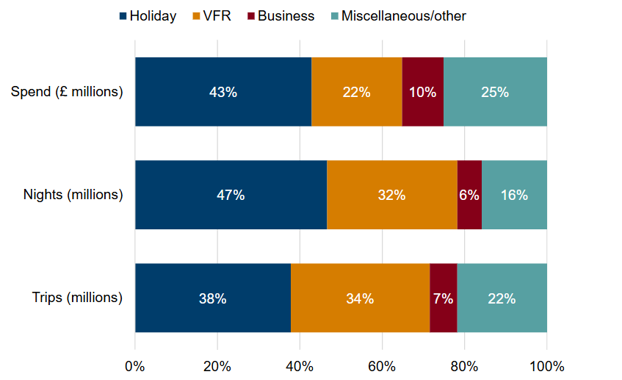
Figure 5: Proportion of trips, nights and spend in Wales by main purpose of trip, 2024
Source: (Great Britain Tourism Survey: overnight trips, 2024)
- Social
The development of interest in cultural tourism and the real experiences promotes the use of storytelling as the foundation of the Expo (Leong et al., 2024). The Welsh language, community and participation promote social value.
- Technological
AR/VR storytelling, hybrid event platforms, and digital networking tools will be incorporated to make the event more global and improve the process of interaction with the attendants (Semwal et al., 2024). This blend of strategic marketing, international organisation partnership, and brand-building culture programming will render the Expo as one of the most phenomenal events in the European hospitality industry.
- Legal
There is the ability to deliver smoothly through compliance with the health and safety regulations, licensing, and accessibility standards. Cultural performances should be taken into consideration in the intellectual property laws (Smits and Borghuis, 2022). Delivery can be made smooth by adherence to the health and safety regulations, licensing, and accessibility standards (Hall et al., 2022)
- Environmental
The experience of sustainability will be practised with local sourcing, the use of low-emission transport, and the reduction of waste (Getz and Page, 2019). In terms of natural landscape, weather, accessibility and infrastructure of Wales, culturally immersive experiences are bound to make the event a successful, sustainable and competitive event in the tourism industry.
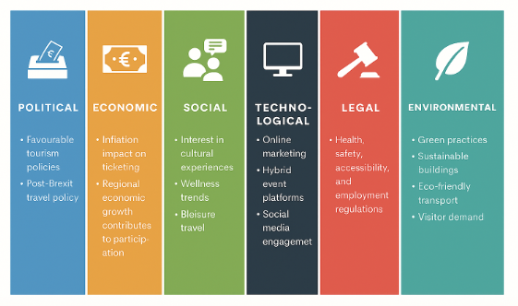

Conclusion
The structure and organisation of the Wales Celtic Legends Hospitality and Tourism Expo reveal that the organisation has given a great consideration to market trends, financial planning, logistics, and cultural factors. With the introduction of Welsh culture and use of hybrid event technologies and sustainable tourism, the Expo has an opportunity to draw a variety of local and international tourists. It can enhance the global image of Wales as an excellent business destination, leisure destination, and cultural destination. The Expo will encourage development of tourism, community, and cultural conservation, which will have long term economic and social impacts. Nevertheless, support of the stakeholders in the long term and the long-term financing are needed to ensure that its effect does not stall following the first success.

References
Aguado, L.F., Jesús Heredia-Carroza, Espinosa-Espinosa, A., Garizado-Román, P.A. and Duque-Sandoval, H. (2024). Anatomy of the economic value generated by a cultural event. Journal of Business Economics and Management, [online] 25(4), pp.828–848. Available at: https://repositorio.utb.edu.co/server/api/core/bitstreams/18ebda98-6fd5-4ec6-b982-dd3a1837187c/content [Accessed 21 Sep. 2025].
Allen, J., Harris, R. and Jago, L. (2022). Festival & Special Event Management, Essentials Edition. [online] Google Books. https://books.google.com.pk/books?hl=en&lr=&id=fbIxEAAAQBAJ&oi=fnd&pg=PR3&dq=Allen,+J.,+Harris,+R.+and+Jago,+L.+(2022).+Festival+%26+Special+Event+Management,+Essentials+Edition.+&ots=yUa05U8p1m&sig=13ihMGV4O-Av0EsdJ-7NS0jbWpY&redir_esc=y#v=onepage&q=Allen%2C%20J.%2C%20Harris%2C%20R.%20and%20Jago%2C%20L.%20(2022).%20Festival%20%26%20Special%20Event%20Management%2C%20Essentials%20Edition.&f=false [Accessed 20 Sep. 2025].
An, J., Kim, H. and Hur, D. (2021). Keeping the Competitive Edge of a Convention and Exhibition Center in MICE Environment: Identification of Event Attributes for Long-Run Success. Sustainability, [online] 13(9), pp.5030–5030. Available at: https://www.mdpi.com/2071-1050/13/9/5030 [Accessed 18 Sep. 2025].
Aririguzoh, S. (2022). Communication competencies, culture and SDGs: effective processes to cross-cultural communication. Humanities and Social Sciences Communications, 9(1), 1-11. Available at: https://www.nature.com/articles/s41599-022-01109-4 [Accessed 23 Sep. 2025].
Becker, D.M., Solberg, H.A. and Heyerdahl, G.S. (2022). The financial challenges of hosting sports events: a problem of insufficient separation between decision-making and decision-control. European Sport Management Quarterly, [online] 23(5), pp.1549–1566. Available at:https://www.tandfonline.com/doi/epdf/10.1080/16184742.2022.2044366?needAccess=true [Accessed 24 Sep. 2025].
Blok, M. and Westerlaken, R. (2022). How can event locations exceed the expectations of visually-impaired theatre guests for accessibility and service? Research in Hospitality Management. [online] doi:https://doi.org/10.1080//22243534.2023.2202479.
Chi, X., Zhou, H., Cai, G., and Han, H. (2024). Investigation into the festival brand co-creation mechanism: extended application of the customer-based brand equity model. Journal of Travel & Tourism Marketing, 41(3), 377-395. Available at: https://www.tandfonline.com/doi/full/10.1080/10548408.2024.2317738?scroll=top&needAccess=true [Accessed 19 Sep. 2025].
Christou, E., Giannopoulos, A. and Simeli, I., 2025. The Evolution of Digital Tourism Marketing: From Hashtags to AI-Immersive Journeys in the Metaverse Era. Sustainability, 17(13), p.6016. Available at: https://www.mdpi.com/2071-1050/17/13/6016 [Accessed 21 Sep. 2025].
Crowther, P., Westwood, C., and Langridge-Thomas, G. (2021). The Royal Welsh Show: the nation's true cauldron. Event Management: an international journal. Available at: https://shura.shu.ac.uk/26357/33/Crowther_RoyalWelshShow%28VoR%29.pdf [Accessed 20 Sep. 2025]
Dutta, S. (2025). Business Events: A Comprehensive Guide. Educohack Press. Available at: https://books.google.com.pk/books?hl=en&lr=&id=Q5pIEQAAQBAJ&oi=fnd&pg=PT18&dq=Dutta,+S.+(2025).+Business+Events:+A+Comprehensive+Guide.+Educohack+Press&ots=UOi1AIRfBh&sig=VzVzW-XMAvzSOfOTcZkGjLSPX6o&redir_esc=y#v=onepage&q=Dutta%2C%20S.%20(2025).%20Business%20Events%3A%20A%20Comprehensive%20Guide.%20Educohack%20Press&f=false [Accessed 18 Sep. 2025].
Fell, R. (2024). Traveller Storytelling in Scotland: Folklore, Ideology, Cultural Identity. Edinburgh University Press. Available at: https://books.google.com.pk/books?hl=en&lr=&id=6YEoEQAAQBAJ&oi=fnd&pg=PA2004&dq=Fell,+R.+(2024).+Traveller+Storytelling+in+Scotland:+Folklore,+Ideology,+Cultural+Identity.+Edinburgh+University+Press&ots=swPiF0CchI&sig=L8b3HbQC2Cxd7kaNFgWeOKoeCk8&redir_esc=y#v=onepage&q=Fell%2C%20R.%20(2024).%20Traveller%20Storytelling%20in%20Scotland%3A%20Folklore%2C%20Ideology%2C%20Cultural%20Identity.%20Edinburgh%20University%20Press&f=false [Accessed 23 Sep. 2025].
George, R. (2021). The Tourism and Hospitality Marketing Environment. Marketing Tourism and Hospitality, [online] pp.183–219. Available at: https://link.springer.com/chapter/10.1007/978-3-030-64111-5_6 [Accessed 20 Sep. 2025].
Getz, D. and Page, S.J. (2019). Event Studies. [online] Routledge eBooks. Informa. Available at: file:///C:/Users/M.A/Downloads/9780429023002_previewpdf.pdf [Accessed 19 Sep. 2025].
Glenn, McDonnell, I., Harris, R., O’Toole, W., Allen, J. and Jago, L. (2023). Events Management. Available at: file:///C:/Users/M.A/Downloads/9781003044963_previewpdf.pdf [Accessed 21 Sep. 2025].
Hall, S., McGee, J.M. and Cooper, W.E. (2022). Security and Risk Assessment for Facility and Event Managers. [online] Google Books. Available at: https://books.google.com.pk/books?hl=en&lr=&id=ZQV4EAAAQBAJ&oi=fnd&pg=PR1&dq=in+events+Delivery+can+be+made+smooth+by+adherence+to+the+health+and+safety+regulations,+licensing,+and+accessibility+standards.+&ots=6o0BzFq6dF&sig=rBx5wk6plNSxCUDYNWPrG82d6j8&redir_esc=y#v=onepage&q&f=false [Accessed 30 Oct. 2025].
Haven-Tang, C., Thomas, A. and Fisher, R. (2022). To What Extent Does the Food Tourism ‘Label’ Enhance Local Food Supply Chains? Experiences from Southeast Wales. Tourism and Hospitality, [online] 3(1), pp.153–160. Available at: https://www.mdpi.com/2673-5768/3/1/11 [Accessed 19 Sep. 2025].
Hunter, J., and Ironside, R. (Eds.). (2023). Folklore, people, and places: International perspectives on tourism and tradition in storied places. Taylor & Francis. Available at: https://books.google.com.pk/books?hl=en&lr=&id=QsKoEAAAQBAJ&oi=fnd&pg=PA2004&dq=Hunter,+J.,+and+Ironside,+R.+(Eds.).+(2023).+Folklore,+people,+and+places:+International+perspectives+on+tourism+and+tradition+in+storied+places.+Taylor+%26+Francis&ots=WQ5GG6kOa0&sig=Evpafy_QitIA9I2xL0rOodPPuLs&redir_esc=y#v=onepage&q=Hunter%2C%20J.%2C%20and%20Ironside%2C%20R.%20(Eds.).%20(2023).%20Folklore%2C%20people%2C%20and%20places%3A%20International%20perspectives%20on%20tourism%20and%20tradition%20in%20storied%20places.%20Taylor%20%26%20Francis&f=false [Accessed 24 Sep. 2025].
Iversen, N.M., Foley, C. and Hem, L.E. (2022). The Role of Immersive Festival Experiences, Identity, And Memory in Cultural Heritage Tourism. Event Management, [online] 27(1), pp.33–50. Available at: https://www.ingentaconnect.com/content/cog/em/2023/00000027/00000001/art00003 [Accessed 18 Sep. 2025].
Kazakova, A. and Kim, I. (2021). Geopolitical-Risk and Economic Policy—Uncertainty Impacts on Tourist Flows from Neighboring Countries: A Wavelet Analysis. Sustainability, [online] 13(24), p.13751. doi:https://doi.org/10.3390/su132413751.
Koppel, J., Dyke, T.V. and Kavanaugh, R.R. (2023). Hospitality With a Heart. [online] Google Books. Available at: https://books.google.com.pk/books?hl=en&lr=&id=DBLJEAAAQBAJ&oi=fnd&pg=PT5&dq=Koppel,+J.,+Dyke,+T.V.+and+Kavanaugh,+R.R.+(2023).+Hospitality+With+a+Heart.+%5Bonline%5D+Google+Books&ots=ApLb7_apW4&sig=LBMrn5bvGNechUZEccmV-8sHgbo&redir_esc=y#v=onepage&q&f=false [Accessed 23 Sep. 2025].
Leask, A. and Barron, P. (2021). Factors in the provision of engaging experiences for the traditionalist market at visitor attractions. Tourism Management Perspectives, [online] 38, pp.100810–100810. Available at: https://www.sciencedirect.com/science/article/abs/pii/S2211973621000234 [Accessed 20 Sep. 2025].
Leong, A. M. W., Yeh, S. S., Zhou, Y., Hung, C. W., and Huan, T. C. (2024). Exploring the influence of historical storytelling on cultural heritage tourists' value co-creation using tour guide interaction and authentic place as mediators. Tourism Management Perspectives, 50, 101198. Available at: https://www.sciencedirect.com/science/article/abs/pii/S2211973623001265 [Accessed 21 Sep. 2025].
Litvinova-Kulikova, L., Aliyeva, Z. and David, L.D. (2023). MICE Tourism: How the Pandemic Has Changed It. Journal of Tourism and Services, [online] 14(26), pp.197–218. Available at: https://www.jots.cz/index.php/JoTS/article/view/496/157 [Accessed 16 Sep. 2025].
Price, W.R. (2021). Mining for Tourists: An Analysis of Industrial Tourism and Government Policy in Wales. Tourism Planning & Development. Available at: https://www.tandfonline.com/doi/full/10.1080/21568316.2020.1829695?scroll=top&needAccess=true [Accessed 19 Sep. 2025].
Rogers, T., and Wynn-Moylan, P. (2022). Conferences and conventions: A global industry. Routledge. Available at: file:///C:/Users/M.A/Downloads/9781003298953_previewpdf.pdf [Accessed 16 Sep. 2025].
Semwal, R., Tyagi, P. K., Tripathi, N., and Pandey, U. K. (2024). Navigating the Data-Driven Future of Virtual and Hybrid Events. In New Technologies in Virtual and Hybrid Events (pp. 368-390). IGI Global. Available at: https://www.igi-global.com/chapter/navigating-the-data-driven-future-of-virtual-and-hybrid-events/353864 [Accessed 20 Sep. 2025].
Smits, J., and Borghuis, T. (2022). Generative AI and intellectual property rights. In Law and artificial intelligence: Regulating AI and applying AI in legal practice (pp. 323-344). The Hague: TMC Asser Press. Available at: https://link.springer.com/chapter/10.1007/978-94-6265-523-2_17 [Accessed 16 Sep. 2025].
Taheri Hosseinkhani, N. (2025). Sustainable and Resilient Supply Chain Strategies in the Post-COVID Era. Available at SSRN 5448394. Available at: https://dx.doi.org/10.2139/ssrn.5448394 [Accessed 16 Sep. 2025].
Wee, H., Dafiqah, N., Muhd, K. and Anas, S. (2022). MICE Industry Survival: A Systematic Literature Review. International Journal of Academic Research in Business and Social Sciences, [online] 12(11), pp.829–852. Available at: https://d1wqtxts1xzle7.cloudfront.net/100470247/mice-industry-survival-a-systematic-literature-review-libre.pdf?1680220912=&response-content-disposition=inline%3B+filename%3DMICE_Industry_Survival_A_Systematic_Lite.pdf&Expires=1759741398&Signature=JMTM9fip [Accessed 20 Sep. 2025].

