
Student Name : Dhavalkumar Manubhai Ahir
Student ID : 2523550

Module Name : Marketing Management
Module Code : LCMB7024

Lecturer’s Name : Dr Muhammad Tariq
Word Count : 2400
Submission Date: 01 May 2026
Term 1

Marketing Strategies Portfolio
(Brand Development Project: Meta Smart Work Glasses)

TABLE OF CONTENT
Element 1: Brand Extension Poster Summary 3
Element 2: Segmentation, Targeting, Differentiation and Positioning (STDP) Analysis 4
Segmentation 4
Targeting 4
Differentiation 5
Positioning 5
Element 3: Marketing Mix (7Ps) 7
Product 7
Price 7
Place 7
Promotion 8
People 8
Process 9
Physical Evidence 9
Element 4: Reflection 10
References 12
Appendices 14
Appendix 1: Element 1 Poster 14

Element 1: Brand Extension Poster Summary
Meta, a global leader in social and immersive technologies, is expanding its strategic focus beyond social media through the development of Meta Smart Work Glasses. This brand extension leverages augmented reality (AR) to enhance workplace productivity by enabling hands-free video conferencing, AI-powered note-taking, and real-time language translation, while integrating seamlessly with platforms such as Microsoft Teams and Zoom. The innovation reflects the increasing role of smart, connected products in creating more efficient and interactive customer experiences (Subramaniam, 2022). The product aligns with key market trends, particularly the rapid growth of the AR industry and the widespread adoption of hybrid working models. By allowing users to multitask and access real-time digital information, the glasses improve operational efficiency and support modern work practices. Additionally, the brand extension contributes to sustainability by reducing business travel and minimising reliance on physical resources. Overall, Meta Smart Work Glasses position the company as a forward-thinking innovator, delivering value through technological advancement, productivity enhancement, and environmentally conscious solutions. [Referred to Appendix 1]

Element 2: Segmentation, Targeting, Differentiation and Positioning (STDP) Analysis

Segmentation
Segmentation of customers should be done effectively to determine the most relevant customers to be targeted by Meta Smart Work Glasses. The wearable technology and augmented reality (AR) are thriving with the global AR market estimated to reach well above $97 billion by 2028 (Grand View Research, 2025). Segmentation is, therefore, done based on geographic, demographic, psychographic and behavioural variables. Geographically, the major markets encompass developed markets that are the United States, Western Europe, and Asia-Pacific with good digital infrastructure and adoption of enterprise technology driving demand. Demographically, the target market is professionals in their 25 to 50 years of age in managerial, technical, and knowledge-based jobs with medium to high income levels who can adopt innovative technologies. With psychographic factors, the product would target innovation-based, techno-savvy customers who require efficiency and a well-working digital connection as AR contributes greatly to the engagement and perceived value (Rauschnabel et al., 2024). At the behavioural level, there is an emphasis on remote workers, early adopters, and hybrid workers, where more than 70% of organisations have adopted hybrid work models (Statista, 2024) and requiring efficient, connected solutions.
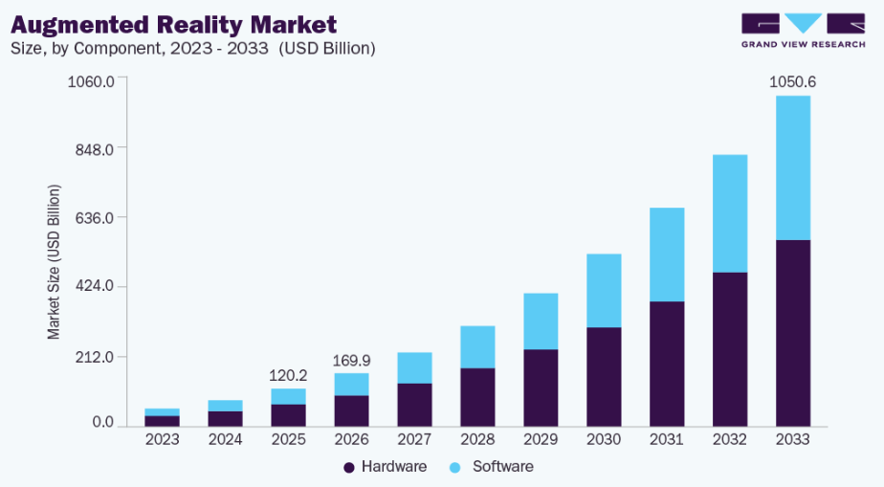
Figure 1: Augmented Reality Market
(Source: Grand View Research, 2025)

Targeting
By analysing the segmentation, Meta pursues a tight-fisted targeting approach, targeting mostly enterprise professionals and organisations that have hybrid and digital workplace settings. The primary target market is comprised of the corporate workers, managers and executives of companies who need sophisticated technological applications to make their work more productive, communicate and make decisions. This segment is strategically appealing because it has a high purchasing power, rising dependency on digital collaboration tools, and rising need of innovative workplace solutions. The necessity in the use of linked and smart items is still evolving as organisations seek to enhance operational effectiveness and productivity of their employees (Subramaniam, 2022). There are also other sectors like IT, consulting, and healthcare that are fast embracing the concept of augmented reality to improve productivity and even cut on the cost. The secondary target group comprises of freelancers, entrepreneurs, and remote employees who equally need effective digital tools. The increase in the gig economy and remote work culture is boosting this segment in a big way. With its focus on enterprise and individual users, Meta is able to optimise the market coverage, yet offers a focused and high value proposition in line with existing technological trends.

Differentiation
In differentiation, positioning of Meta Smart Work Glasses in a very competitive market dominated by Apple Vision Pro and Microsoft HoloLens is vital. As these competitors provide sophisticated solutions to AR, their products are oriented on the high value or much focused on specific industry solutions, which represent a chance of Meta to diversify its product. Meta Smart Work Glasses focuses on design, functionality and incorporation where the technology has been made more affordable, usable and integrated to a wider range of professional users. In contrast to Apple Vision Pro, which is a luxury product, Meta sets out to offer an inexpensive version. Equally, unlike Microsoft HoloLens, which covers only niche industries like manufacturing and engineering, Meta is aimed at a general workplace productivity, which will more generally attract users. One of the major distinguishing features is working in harmony with such popular tools as Microsoft Teams and Zoom, allowing working efficiently without having to use multiple devices. Research shows that AR technologies can improve task performance by up to 30–40% (Tan et al., 2022). Moreover, the powerful digital ecosystem of the Meta helps improve the user experience and interaction with customers, solidify brand relations (Plotkina et al., 2022).
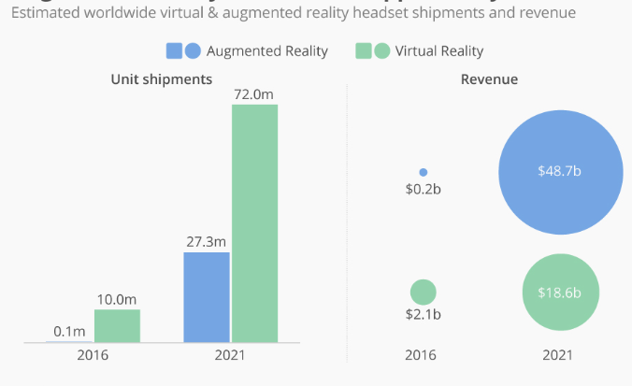
Figure 2: Augmented Reality Opportunity
(Source: Statista, 2026)

Positioning
Positioning determines the way in which the Meta Smart Work Glasses are seen in the minds of the target customers as against those of the opponents. The product is packaged as an access, pragmatic, and productivity-oriented AR solution tailored particularly to the present-day professionals that work in hybrid environments. The positioning strategy focuses on three fundamental aspects that include efficiency, innovation, and accessibility. Meta can distinctly separate its product from other providers that underline immersive experiences by concentrating on productivity instead of entertainment. The glasses provide the users with the ability to work off-hand, obtain real time information, and facilitate team work thus, increasing the overall efficiency of work.
A clear positioning statement for the product can be articulated as follows:
Meta Smart Work Glasses are an affordable, AI-powered augmented reality solution designed for professionals seeking seamless, hands-free productivity and enhanced collaboration in hybrid work environments.
This position is aligned with the market trends as organisations are prioritising more on digital transformation and staff efficiency. Also, AR technologies have been found to optimize customer experience and engagement through offering interactive and immersive functionalities (Du et al., 2022). A blend of technological innovation and practical workplace uses helps Meta to become a leader in the years to come of work.

Element 3: Marketing Mix (7Ps)

Product
Meta Smart Work Glasses is a high-end augmented reality (AR) software that will be used to scale up productivity in hybrid workplaces. The product incorporates the use of AI to offer real-time translation, voice-controlled note-taking, and hands-free video conferencing options so that users can execute various tasks at the same time. Research has shown that AR technologies are capable of enhancing task performance by 30-40% and that they have strong functional usefulness in the workplace environment (Tan et al., 2022). Most importantly, at the point when competitors are preoccupied with immersive entertainment, Meta is putting an accent on practical business use, which is in line with the enterprise productivity requirement. The product success, however, relies on user acceptance as localized usability barriers are possible with complex AR interfaces (Shyr et al., 2024). Meta should thus focus on easy design and integration to make it to be widely adopted.
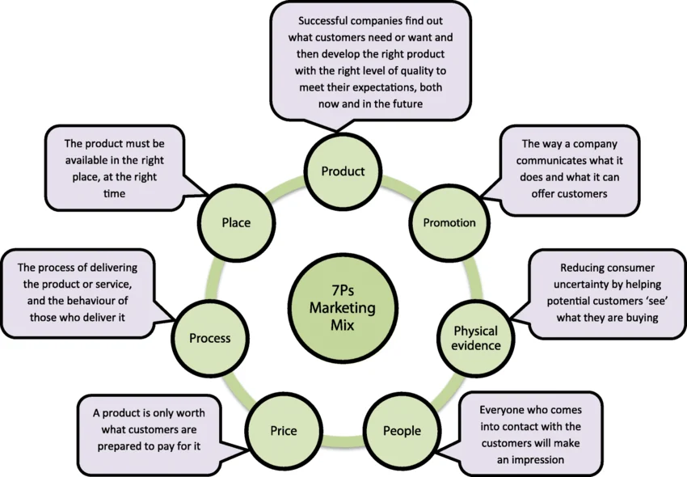
Figure 3: 7Ps Marketing Mix
(Source: Hindi et al., 2019)

Price
Meta is implementing a value based pricing model that will focus on affordable and yet technologically advanced pricing. Although Apple Vision Pro will be sold above $3,000, the price range of the product that Meta will offer will likely be significantly lower (e.g., $1,0001,500), as it will be more affordable to enterprise clients and professionals. Such pricing strategy sustains penetration of the market, as well as adoption rates, especially on the small and medium-sized enterprises (SMEs). Nevertheless, a cheaper price can pose a threat of detracting the perceived premium value and Meta will have to focus on functionality and return on investment (ROI). To further justify such pricing approach, organisations are becoming increasingly open to investing in productivity enabling devices which help minimise costs of their operations, e.g. travel and dependency on the device.

Place
Meta uses a multi-channel distribution approach which involves direct online retailing and B2B collaboration. The core channel consists of the internet platforms of Meta, allowing the world to reach it at low distribution expenses. Also, a partnership with corporate clients and technology providers allows sales that are enterprise-oriented, which increases market penetration. Omni-channel strategies have been demonstrated to enhance accessibility and engagement between customers through touchpoints (Thaichon et al., 2022). Most importantly, there might be the need to have dedicated distribution formats, such as bulk and corporate purchases on enterprise adoption. Though online mediums offer the ability to be scaled, this could inhibit the experiential aspect when only using digital channels; this is where the emphasis on showing how something works, can be demonstrated via pilot programmes or demonstrations centres, to facilitate adoption.

Promotion
The marketing plan is aimed at professional and targeted online marketing. Such places like LinkedIn play a crucial role, as they enable direct contact with decision-makers and corporate audiences. Data-driven marketing automation can help the marketing department in Metacoll centralize communication and optimize the engagement rates at Metacoll (Lehton, 2024). Also, measurable benefits published through webinars, virtual demonstrations and case studies can be emphasized, including productivity gains as high as 40%. Content marketing and social media also increase the brand visibility and engagement (Alhumud and Elshaer, 2024). Nevertheless, awareness should go on the promotion but then they should articulate business value, which is translational from an enterprise buyers perspective because they are ROI-driven rather than brand-driven. As such, credibility requires evidence-based marketing.

People
Human beings play a vital role in determining successful adoption of the product and customer satisfaction. Mastery Meta has to invest in qualified technical support service and onboarding specialists and enterprise account managers that help organisations adopt the product within current working processes. Loyalty to the service provider has been identified to increase customer loyalty and retention with efficient service delivery (Butt et al., 2023). Importantly augmented reality products (AR) usually need to be trained by users and poor support may sluggish or slow down adoption, especially in multifaceted organisational structures. Hence, Meta is to offer 24/7 customer care to enterprise clients, which has more intensive implementation processes. Moreover, organized training sessions and special help desk can minimize the opposition and enhance the experience. Human support coupled with technology innovation would enable Meta to bolster customer relationships, make the transition process more seamless, and capitalize on the long-term worth of the brand extension.

Process
The process element is aimed at providing a smooth, efficient and dependable user experience. To reduce the resistance of users to add Smart Work Glasses, Meta Smart Work Glasses need to be easily installed, allow quick integration of systems, and maintain the performance of the system across and through so as to maximise the usability. An automated and streamlined customer experience can enhance satisfaction and lessen resistance during the product usage (Poorrezaei et al., 2023). Moreover, other processes that must be in place to ensure the reliability of operations include the regular update of software, high level of data security and compatibility with the current enterprise systems. Most importantly, in work-related contexts where unavailability may affect productivity, the slightest inefficiencies may have a negative impact on user experience and adoption. Hence, Meta needs to adopt efficient and user effective procedures which focus on speed, security as well as stability. The company can enable a better integration into organisational processes, making it less challenging and causing users to be more confident in the technology, which will contribute to the long-term usage of the technology.

Physical Evidence
The perceived excellence of the product and brand positioning is supported with physical evidence. Innovation should be integrated in the Smart Work Glasses which should be styled in a smooth and sleek design making it out of high quality materials and professional outlook. The packaging, branding and digital interfaces can also play a role in customer perception. It is believed that a good brand presentation can contribute to customer interaction and confidence (Plotkina et al., 2022). Virtual demonstrations and practical use cases are also real-life not available to nature and are used as a tangible evidence of the value of the product. Nevertheless, since AR technology is rather intangible, Meta should make sure that physical and sensual details are helpful to convey the functionality and usability.

Element 4: Reflection
The Meta Smart Work Glasses brand extension development has proved to be a successful learning process, which not only contributed to the theoretical knowledge but also to the practical application of marketing principles. Making the poster and its translation into a systematic approach to marketing demanded critical interaction with the important models, including segmentation, targeting, positioning, and the marketing mix. The first issue was to match the innovative technological product to facts of the market reality, especially in the hybrid working conditions. This necessitated creating an analysis on the existing industry trends and considering how augmented reality (AR) would provide quantifiable fees to users. It has been found that AR technologies became a serious boost to engagement and efficiency, confirmed the topicality of the selected idea in terms of strategic value (Du et al., 2022). This process gained a better insight into customer-centric marketing. The need to target individual user requirements with value propositions depending on unique needs was underscored by the need to identify particular target segments, including enterprise professionals and remote workers. Moreover, the implementation of the marketing mix proved the connection between the strategic decisions concerning prices, promotion, and distribution which should influence each other and generate a coherent market offering. As an illustration, professional platforms combined with digital promotion like LinkedIn referred to the importance of one-to-one communication in shaping decision-makers. Moreover, the significance of customer experience was revealed, and smooth processes and efficient support systems are essential when it comes to facilitating adoption and satisfaction (Poorrezaei et al., 2023). The creation of this portfolio also assisted in the improvement of the essential transferable skills. Analytical and research skills were enhanced using academic literature and market data to help make strategic choices. Evaluation of competitive positioning and differentiation strategy was employed in the development of critical thinking skills in a very competitive AR market. Moreover, the poster preparation also enhanced communication and presentation skills in how to clearly and succinctly present a complicated idea through graphics. The skills are also critical to professional practice, particularly in employment where one is required to make strategic decisions and communicate well with stakeholders. Nonetheless, there were a couple of new areas that were identified to be improved. The use of secondary data was one of them because it might be incomprehensive in real-time dynamics in the market. Primary research (surveys, interviews) may be employed in the future works to get a more in-depth understanding of customer preferences. More thorough financial analysis, such as cost structures and ROI should also be incorporated to help reinforce the comprehensive strategy. It would also be possible to deepen into the integration of the emerging technologies, including artificial intelligence, which are shaping the digital transformation in industries more and more (Mohajer-Bastami et al., 2025). All in all, this project has developed not only academic but also practical skills in the development of marketing strategies. It has given a valuable perspective on how new tech can be successfully placed on the market, as well as the need to learn and keep adapting to such a fast-evolving business landscape.

References
- Alhumud, A.A. and Elshaer, I.A., 2024. Social commerce and customer-to-customer value co-creation impact on sustainable customer relationships. Sustainability, 16(10), p.4237.https://www.mdpi.com/2071-1050/16/10/4237
- Butt, A., Ahmad, H., Ali, F., Muzaffar, A. and Shafique, M.N., 2023. Engaging the customer with augmented reality and employee services to enhance equity and loyalty. International Journal of Retail & Distribution Management, 51(5), pp.629-652.https://www.emerald.com/ijrdm/article-pdf/51/5/629/1535261/ijrdm-04-2021-0165.pdf
- Du, Z., Liu, J. and Wang, T., 2022. Augmented reality marketing: A systematic literature review and an agenda for future inquiry. Frontiers in psychology, 13, p.925963.https://www.frontiersin.org/journals/psychology/articles/10.3389/fpsyg.2022.925963/pdf
- Grand View Research, (2025). Augmented reality market size, share & trends analysis report. https://www.grandviewresearch.com/industry-analysis/augmented-reality-market
- Hindi, A.M., Schafheutle, E.I. and Jacobs, S., 2019. Community pharmacy integration within the primary care pathway for people with long-term conditions: a focus group study of patients’, pharmacists’ and GPs’ experiences and expectations. BMC family practice, 20(1), p.26. https://link.springer.com/content/pdf/10.1186/s12875-019-0912-0.pdf
- Javeed, S., Rasool, G. and Pathania, A., 2024. Augmented reality in marketing: a close look at the current landscape and future possibilities. Marketing Intelligence & Planning, 42(4), pp.725-745.https://www.emerald.com/mip/article-pdf/42/4/725/9604114/mip-04-2023-0180.pdf
- Lehton, S., 2024. Exploring the role of marketing automation in fostering online engagement in business-to business settings.http://stax.strath.ac.uk/downloads/mk61rh45s
- Mohajer-Bastami, A., Moin, S., Ahmad, S., Ahmed, A.R., Pouwels, S., Hajibandeh, S., Yang, W., Parmar, C., Kermansaravi, M., Khalil, M. and Khalid, A.W., 2025. Artificial intelligence in healthcare: applications, challenges, and future directions. A narrative review informed by international, multidisciplinary expertise. Frontiers in Digital Health, 7, p.1644041.https://www.frontiersin.org/journals/digital-health/articles/10.3389/fdgth.2025.1644041/pdf
- Plotkina, D., Dinsmore, J. and Racat, M., 2022. Improving service brand personality with augmented reality marketing. Journal of Services Marketing, 36(6), pp.781-799.https://www.emerald.com/jsm/article-pdf/36/6/781/2846382/jsm-12-2020-0519.pdf
- Poorrezaei, M., Pich, C. and Resnick, S., 2023. A framework to improve retail customer experience: a qualitative study exploring the customer journey. Qualitative Market Research: An International Journal, 26(5), pp.663-686.https://www.emerald.com/qmr/article-pdf/26/5/663/2869324/qmr-07-2022-0120.pdf
- Rauschnabel, P.A., Hüttl‐Maack, V., Ahuvia, A.C. and Schein, K.E., 2024. Augmented reality marketing and consumer‒brand relationships: How closeness drives brand love. Psychology & Marketing, 41(4), pp.819-837.https://onlinelibrary.wiley.com/doi/pdf/10.1002/mar.21953
- Shyr, W.J., Wei, B.L. and Liang, Y.C., 2024. Evaluating students’ acceptance intention of augmented reality in automation systems using the technology acceptance model. Sustainability, 16(5), p.2015.https://www.mdpi.com/2071-1050/16/5/2015
- Statista. (2024). Wearables - statistics & facts. https://www.statista.com/topics/1556/wearable-technology/
- Statista. 2026. Augmented Reality a $50 Billion Opportunity? https://www.statista.com/chart/8633/virtual-and-augmented-reality-forecast/?srsltid=AfmBOooZP9lbH-1J3g0TfmsSiYjKlL0abUXM8712Lqm-cwwUCUObAoMC
- Subramaniam, M., 2022. How smart products create connected customers. MIT Sloan Management Review, 64(1), pp.33-37.http://professormohan.com/files/how-smart-products-create-connected-customers.pdf
- Tan, Y.C., Chandukala, S.R. and Reddy, S.K., 2022. Augmented reality in retail and its impact on sales. Journal of marketing, 86(1), pp.48-66.https://ink.library.smu.edu.sg/cgi/viewcontent.cgi?article=7695&context=lkcsb_research
- Thaichon, P., Phau, I. and Weaven, S., 2022. Moving from multi-channel to Omni-channel retailing: Special issue introduction. Journal of retailing and consumer services, 65, p.102311.https://research-repository.griffith.edu.au/bitstreams/80a46eea-2211-452e-8228-f9093d3134b8/download

Appendices

Appendix 1: Element 1 Poster


