ASSESSMENT 1
LCBB4004 MARKETING FUNDAMENTALS
STUDENT NAME: VASILICA-DANIELA STEFAN
STUDENT ID: 1714718
LECTURER: SYED JAFFERY
BLOGGING TO COMMUNICATE - APPLE CASE STUDY
Table of Contents
INTRODUCTION 1
STP ANALYSIS 1
MARKETING MIX STRATEGIES 8
CONCLUSION 11
REFERENCES 12

INTRODUCTION
Marketing can be explained as the set of elements that are used for promoting, distribution and sales of products and services with the help of accurate market research and various promotional tools (McLea, 2019). Blogging is a type of promotional tool that is used by businesses for improving their marketing activities in the era of digitalisation. With the help of marketing activities, demands of products and services among the customers is simulated locally, nationality and internationally. It consists of selecting the target audience, segmenting the market and positioning the products and services for attracting the maximum number of customers (Aeberhard and et. al., 2020). The following report will describe Apple Inc. that is an American multinational technology company, which was established in the year 1976-77 and is headquartered at California, U.S. The report will describe the key elements of marketing that must be considered while developing, planning and executing blogging communication activities of the organisation. Moreover, it will discuss the marketing mix of the organisation for improving its communication activities with the customers.

STP ANALYSIS
Marketing refers to the method of communicating, educating, notifying and attracting the customers towards the specific products and services that are offered by the company. With the help of blogging strategies and marketing activities the company tries to satisfy their customers for maximizing the profits. The marketing activities are concerned with the satisfaction of customers and full feeling they are demanded at the right place and at the right time.
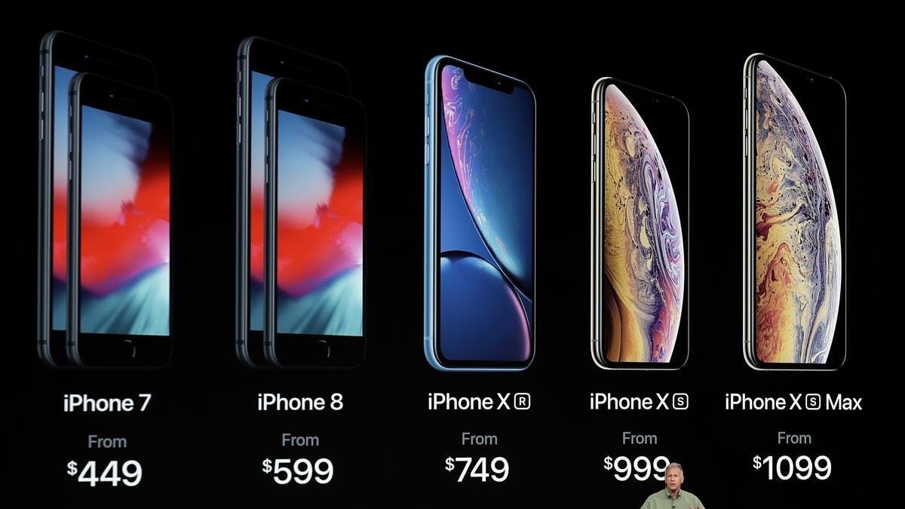
Figure 1 Apple Devices IPhones
Marketing activities of the Apple incorporation consist of market research, product planning and product development, promotion, distribution or selling and customer services (Gaikwad, 2020). One of the very important aspects of marketing is the promotion activity; in the era of digitalisation blogging is considered as a very cheap and cost effective method of advertising the products and services of the organisation. For this purpose the company needs to focus on improving its blogging activities through accurate segmenting, targeting and positioning of goods and services in the market.
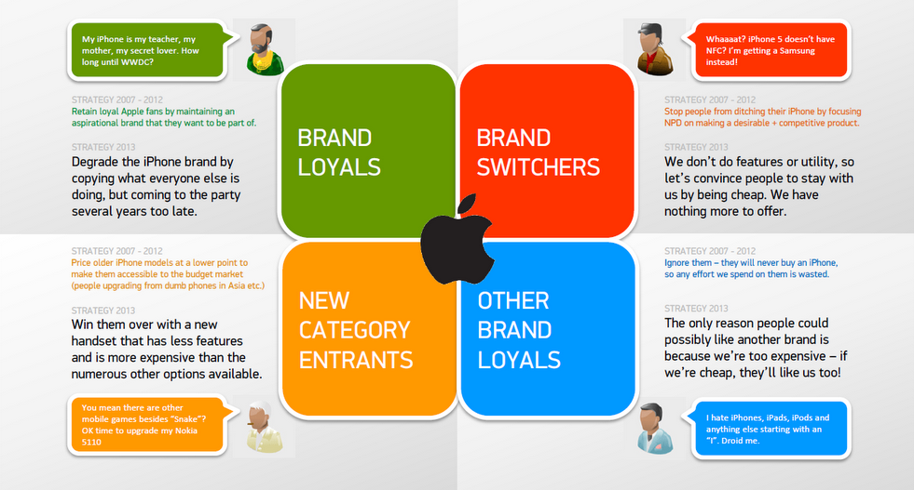
Figure 2 IPhone Segmentation Strategy
Target segment and target
The focus is towards the customers who desire high quality and high usage products that can be identified with the help of segmentation. (Unnithan, 2020). The segmentation of people is very important for developing accurate promotional activities for the products and services. Along with this the customers also desire high quality products that have an exclusive look and Apple develops its products that have unique looks and high quality for satisfying their customer wants. Apple is known for its unique quality products and unique interface and software systems that cannot be found in other devices. The company tries to differentiate their brand from those products that are sold by their competitors for enhancing their advertising and marketing activities for elevating the loyalty of customers towards the brand.

Segmentation of mobile phones
Segment or usage frequency | Quality of product | Technical aspects | Price for product
Low | Medium | High | Low
Medium | High | High | Medium
High | High | Very high | High

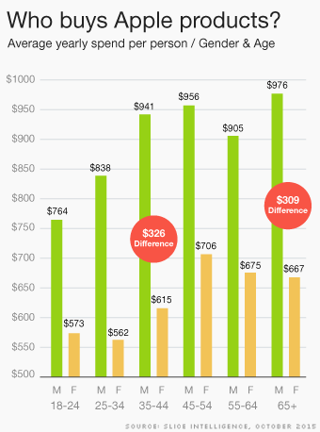
Figure 3 Customers of Apple Products
Attractiveness of the segments in the market
Segments | Size and growth | Structural attractiveness | Matches brand and sub brands resources and objectives
Low | The utilisation of digital technology has intensified in the epidermis developing world that has increased the compulsive buying. Strategy of Apple is very unique that provides positive results to the company. | Many users believe that smartphones with Android are better as compared to the Apple smartphone. There are many competitors in the market and new features and longer battery life are seen in their products. | There are many similar gadgets available in the market that also consists of top notch technology build up (Vargas Villanueva, 2021).
Medium | The use of smartphones has increased with time and is more likely to grow in upcoming duration. Due to the increasing income levels of people more and more people tend to have luxurious products. | Price compared to other smartphones is much higher than the products of Apple that shows its exclusiveness and high quality. | Interest in the products is associated with its exclusiveness and the quality that impresses people for the product.
High | The customers spend more time with their smartphones in their everyday life. Due to the conditions like work from home and work from office the communication activities needed to increase. | The products are mainly focused towards the people who are always involved in various activities with their smartphones. The expensiveness of the brand causes problem in the prices of network operations. | The use of Apple devices provides multiple features that help to save time by better connectivity and high level tech-support.

Brand positioning
The products of Apple are very exclusive and highly competitive in the smartphone industry and are sold at value prices. The company mainly relies on its customers when it sells its products and services at a higher price than their competitors (McLean, 2021). The competitors of the company mainly rely on their higher brand image that is developed by its constantly updated products with high grade quality, software and features. The Apple smart devices are comparatively more expensive than their competitors but it provides high quality design, features, software and exclusiveness in their devices. The company also provides after sale services, application store, technical support and intelligent assistant that enables the users to get better after sale services for the products of the company. The products of Apple are positioned to add the places where the customers have high quality lifestyles and prefer greater quality products. The company beats all its competitors in the quality of products that make it more valuable and demanding by the customers even at higher prices.
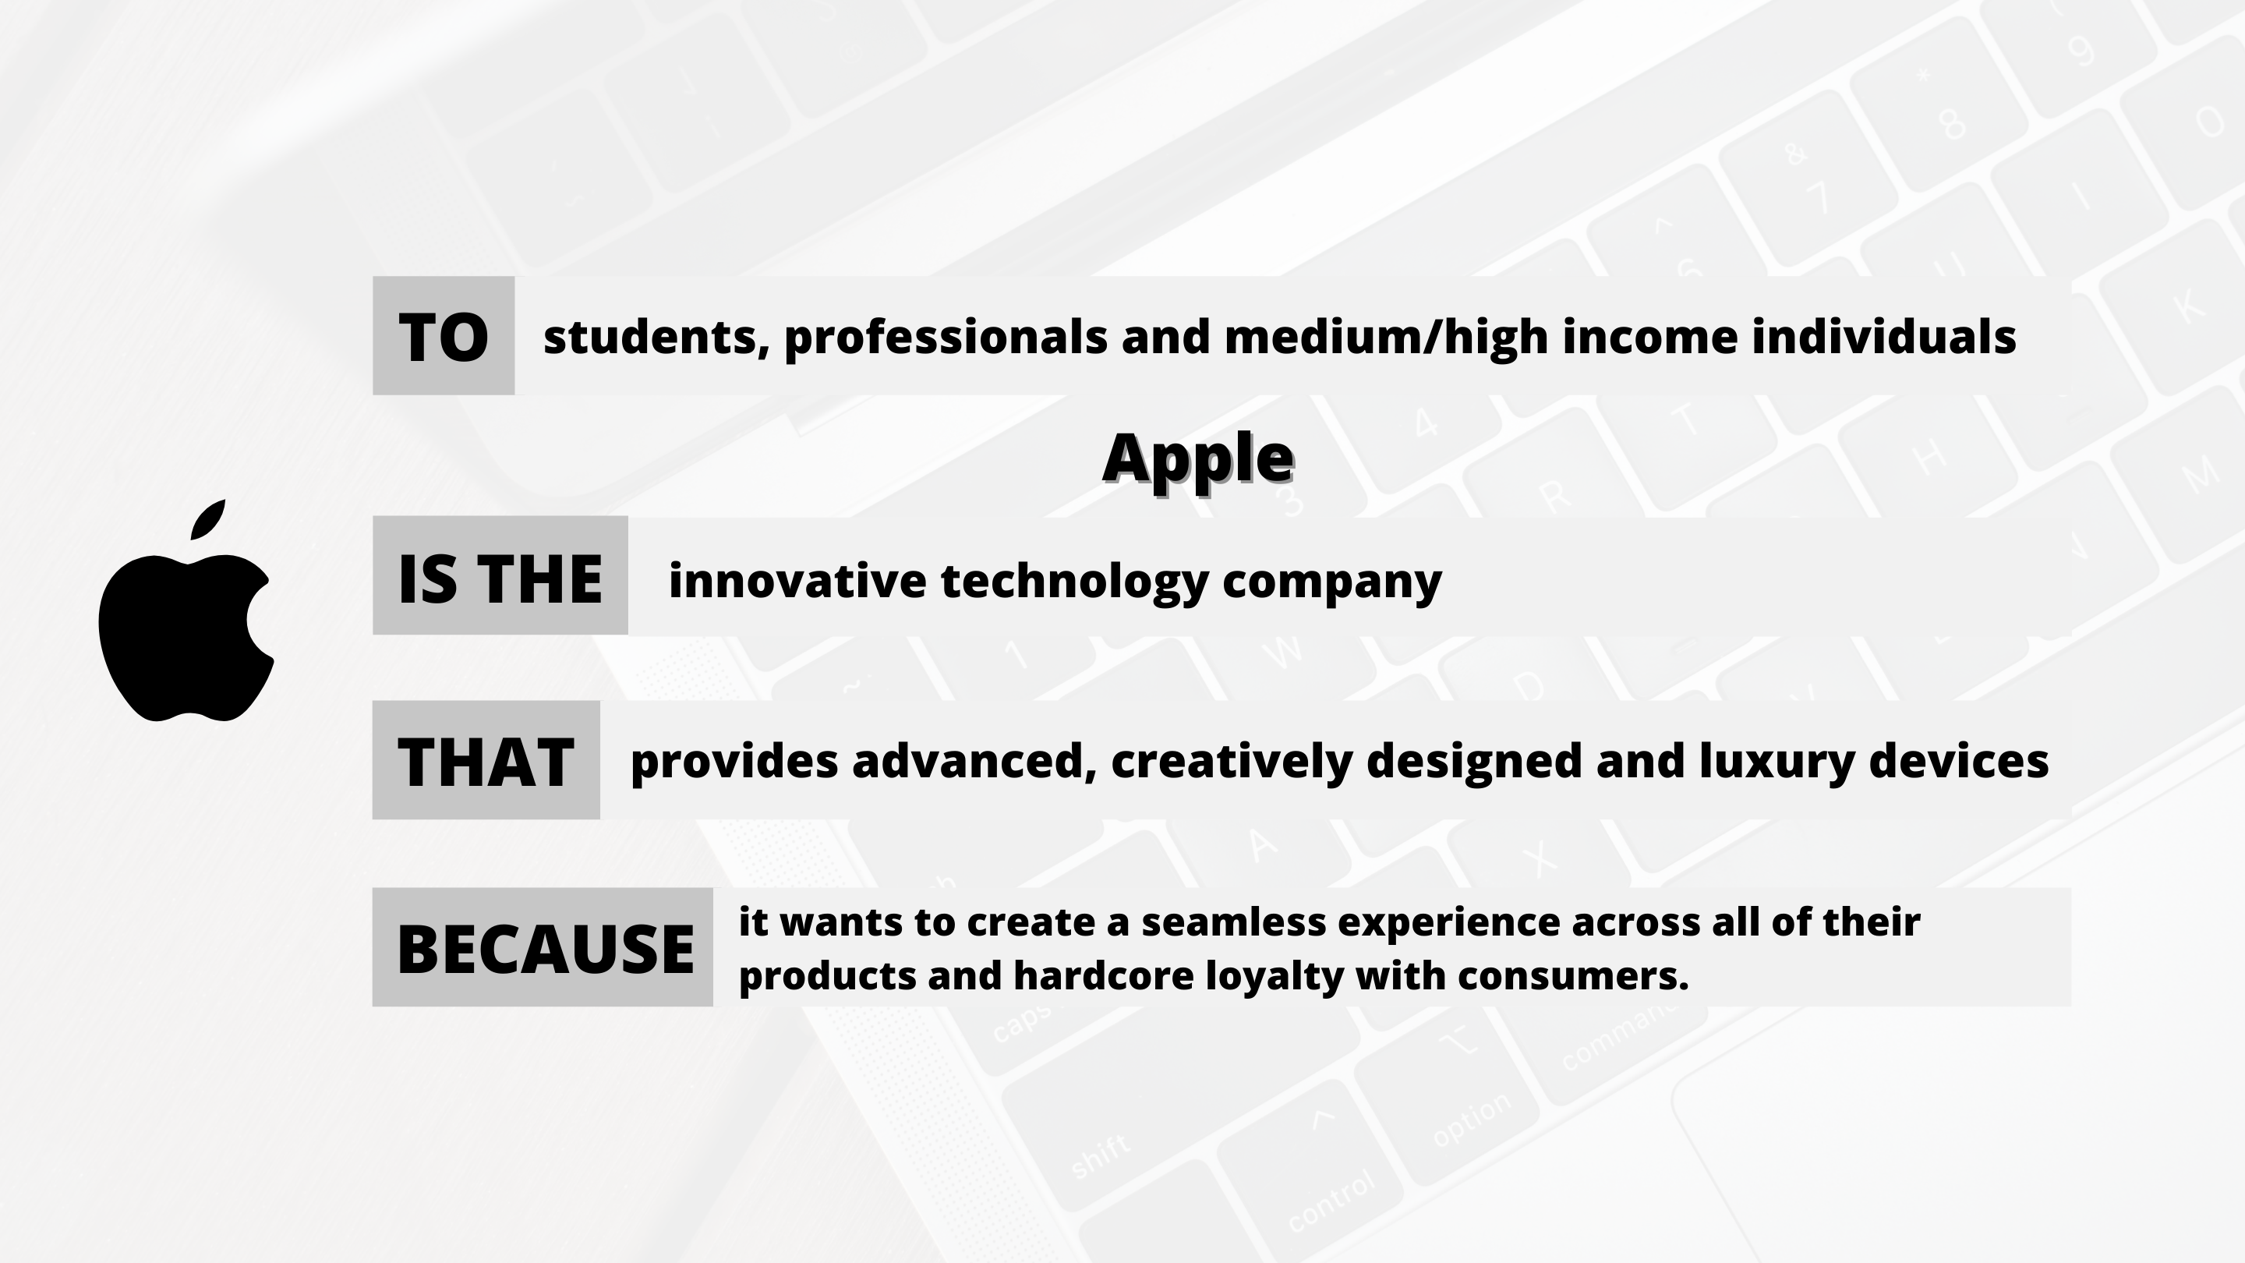
Figure 4 Targeting-Positioning of Apple Products
Positioning statement for the product
Important aspects | The technical support that is provided by the company is very unique and multiple Apple Care units at convenient locations have made the company ahead of its competitors.
Distinct aspects | Apple has its own software iOS that is much more different than Android software that is basically provided by the competitors.
Pre-emptive | Apple AppleCare Plus is the exceptional support system that is provided to the customers regarding technical and hardware issues of the device.
Unique features | Apple provides after sale services like every other smartphone provider but it has AppleCare Plus that provides hardware and technical support also.
Tech-superiority | The company provides warranty for their products that is highly important for the customers to derive a high level of satisfaction (Deepak and Jeyakumar, 2019).
Communication | The availability of quick information and websites on the devices supports customers with better quality of communication.
Promotions | The products of the company are supported by the technical support and warranty that decreases and lower down the actual cost invested in the products.
Cost and affordability | Add on prices results in high profits and almost all the customers do not experience issues with their devices after purchase.
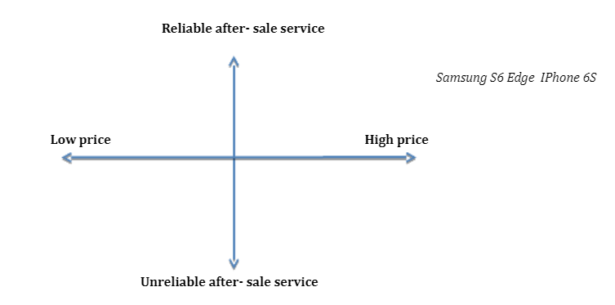
Figure 5 Positioning Map: Reliability of after-sale service vs Price
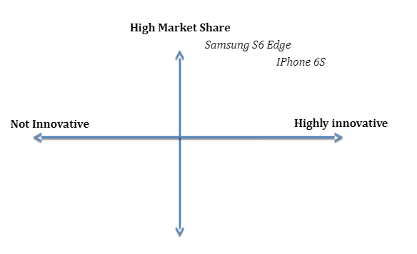
Figure 6Positioning map: Level of Market

MARKETING MIX STRATEGIES
A successful marketing strategy involves the marketing mix strategy for enhancing the overall market coverage by increasing the attractiveness of products and services (Baines, and et. al., 2021). With the help of an effective marketing mix, the use of 4Ps of Marketing can help to create an effective marketing plan and better promotion activities for a given product or service. The marketing mix strategy of Apple is given below.

Type of consumer product
The products of Apple mainly fall under the category of consumer goods that attracts premium customers for high quality products. The products of Apple are developed after a critical market research and it uses its brand name that supports its product development. The product is available at most of the high end electronic shops and smartphone outlets that are having a good coverage in the market (Terech, 2018). The products of the company are promoted through various methods and mainly support the views of customers regarding their products and services in the market.
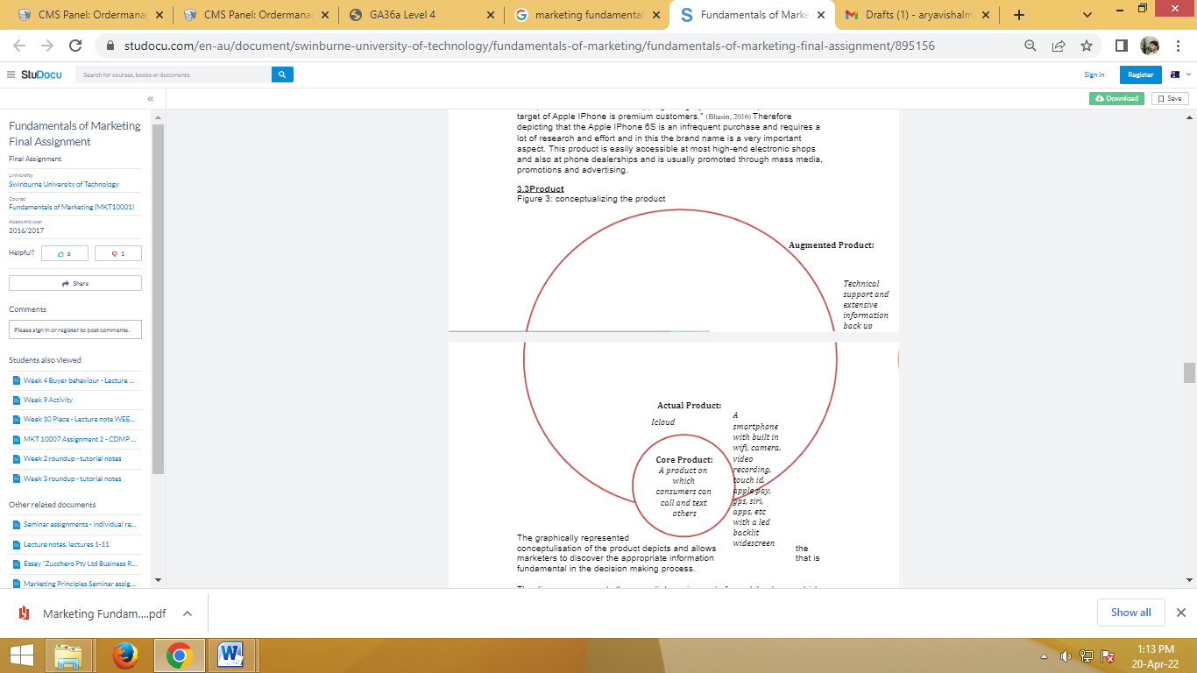
Figure 7: Concept of the Apple Products

Product
The above described graph shows the concept of a product that allows the market years to identify the most suitable information that can be helpful in the decision making process (Chernev, 2019). It explains the requirements of mobile phones for various purposes such as texting, calling and how these devices have developed, providing insight to Apple for their product development. With the help of the diagram it can be seen that the products are developed with high quality features, effective and efficient after sale services that are provided by Apple devices.

Place
Apple uses an all-round approach for distributing its products through various distribution channels. With the use of a good distribution strategy and effective supply chain the company reaches the market across the borders. Apple has its Apple stores and network operators that provide lather coverage in the market. The company has authorised retailers regarding their products and services to be sold by them in more efficient and effective ways (Jobber and Ellis-Chadwick, 2019). The products of the company are distributed by various online and physical distribution channels that provide maximum coverage to its products and services into the market.
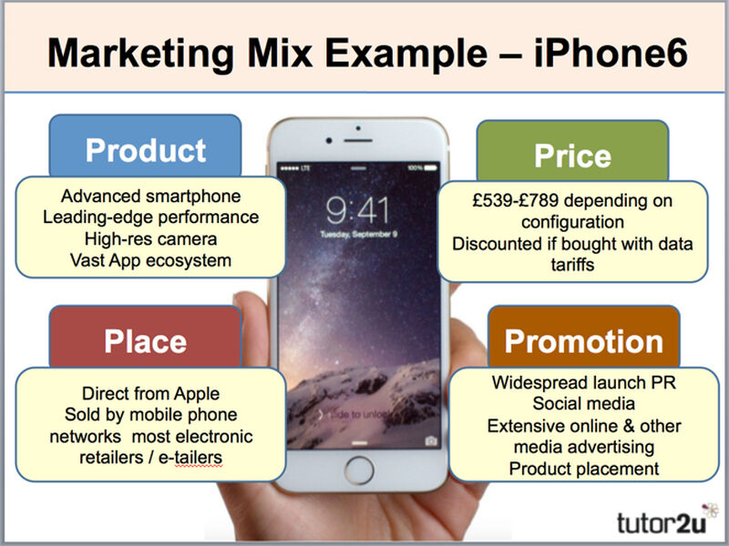
Figure 8 Marketing Mix of IPhone S
Promotion
The reason behind the extreme success of the organisation is its integrated marketing communication strategy and various promotional tools. The company constantly tries to improve their customer experience by upgrading new features, designs and software in the Apple gadgets. The uniqueness of the product is the main aspect in its promotion that demonstrates and depicts a high level of exclusiveness, quality and creativity in its products. The company is finished by the network operators for advertising their products so that their businesses can also remain competitive in the market (Dadwal, 2019). The company actually promotes its products and services through various methods and the main agenda is the promotion through press conferences for the new release of products of the company. The promoters of the company are mainly its customers, employees, company website and its stores that increase the overall sales of their product. Apple uses a disruptive promotion strategy for leaking its new products and press release publicity to create a high level of demand for their production services into the market (Eagle, 2019).
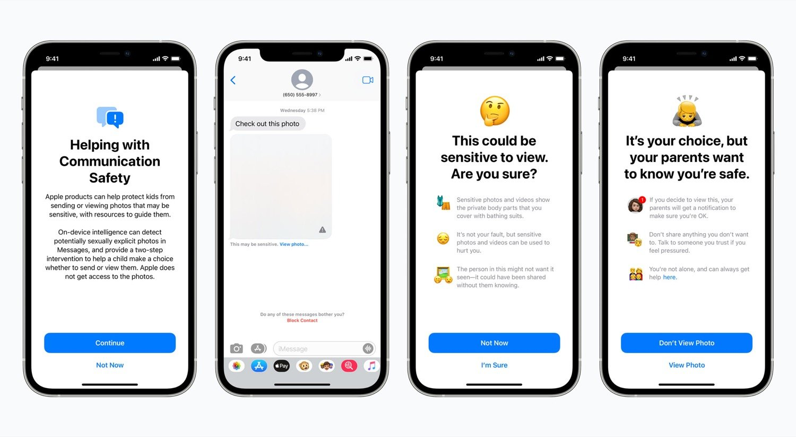
Price
The prices of the products are constantly changed and higher prices on the new products with high levels of technology are imposed (Lee, 2018). The company has built a very loyal customer group and it focuses on improving their experience by providing quality products at premium costs. The prices of the products are comparatively much higher than any other products in the market. The main reason behind the high prices of the product is the build quality, use of technology and high performance of the brand in the market that attracts the customers towards the product. The products of the company have complete market domination in regard to its prices and no other devices offer such an exclusive product at given prices.

CONCLUSION
It has been concluded from the above report that the marketing activities of an organisation are highly dependent on its strategies for effectively placing the products and services across the market. The report has been describing the use of segmentation, targeting and positioning for improving the promotion and blogging activities for the products of the company. It has been understood that the company can utilize effective marketing strategies such as 4Ps of marketing for creating better bogging and promotion for their products and services. It can be recommended to the organisation that it can enhance its blogging plan with the help of effective marketing strategies for promoting their products. The lowering down of prices can also result in a higher number of sales as compared to its strong competitors such as Samsung within the market. It has been obtained from the report that Apple needs to take more actions to improve their promotion and blogging activities with the help of segmenting, targeting and positioning their products. Finally, it has been discussed that the 4Ps of marketing are very effective for creating the best blogging and promotional aspects for the brand.

REFERENCES
Books and Journals

Aeberhard, M. and et. al., 2020. Marketing Management of Luxury Providers. In Luxury Tourism (pp. 109-155). Springer, Cham.
Baines, P., and et. al., 2021. Fundamentals of Marketing 2e. Oxford University Press, USA.
Chernev, A., 2019. Strategic marketing management: Theory and practice. Cerebellum Press.
Dadwal, S. S. ed., 2019. Handbook of Research on Innovations in Technology and Marketing for the Connected Consumer. IGI Global.
Deepak, R. K. A. and Jeyakumar, S., 2019. Marketing management. Educreation Publishing.
Eagle, W., 2019. YouTube blog marketing for dummies. John Wiley & Sons.
Gaikwad, D. D., 2020. Current Scenario of Different Type of Services Marketing and Delivery in Customer Relationship Management. International Journal of Engineering and Management Research, 10.
Jobber, D. and Ellis-Chadwick, F., 2019. EBOOK: Principles and Practice of Marketing, 9e. McGraw Hill.
Lee, I. ed., 2018. Diverse Methods in Customer Relationship Marketing and Management. IGI Global.
McLean, G., 2019. Digital Marketing Fundamentals.
McLean, G., 2021. Digital Marketing Fundamentals 4th Edition.
Terech, A., 2018. An introduction to marketing and branding. Generations, 42(1). pp.45-49.
Unnithan, A., 2020. Sustainable Consumption: Individual Consumer Concerns, Behaviour, and Practices (Literature Review).
Vargas Villanueva, A. G., 2021. Estrategias de Marketing mix y su incidencia en ventas de la empresa “Pro Shop MAG”, en el municipio de Cochabamba.

