Database Concepts
Ethan Hopkins (2201011)
24/04/2023
2023
Initial findings
The users who will need access to this database would be those who need to access the data to do their job. Such as the branch managers, patrons and the sales team so that they can input the orders data.

The different types of departments that the branches will require would be the branch manager, the audio and visual equipment professionals, sales team, cleaning team and an admin team who maintain the events as they are on.

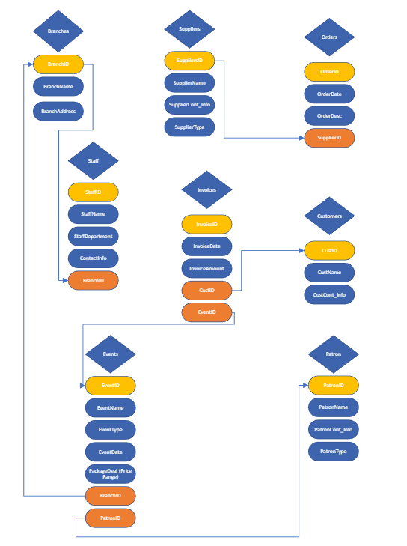
The staff table has a foreign key, and this foreign key allows the table to show the branchID of the staff. This then tells us what branch each member of staff is working at in the staff table.
The orders table has the suppliersID foreign key so that we can see what supplier has sold us the products.
The invoices table has 2 foreign keys in it. The CustID so that we can see what customers have placed an order, and the EventID so that we can see what event the order is for.
The events table also has 2 foreign keys, one being the BranchID so that we can see what branch is in charge of the planned event. And the other is the patronID so that we can see what patron the company will be working alongside with for that event.

Relationship diagram in access
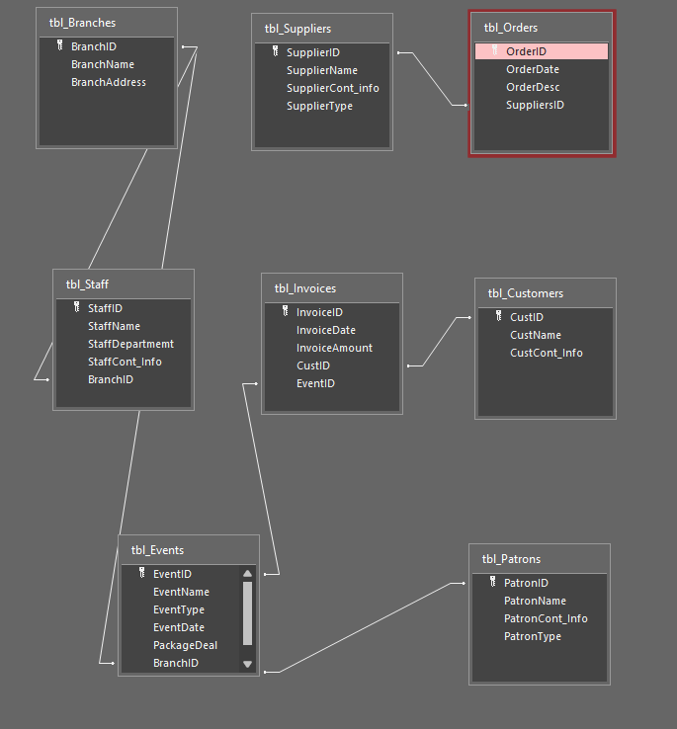

Documentation
Tables
Branches table
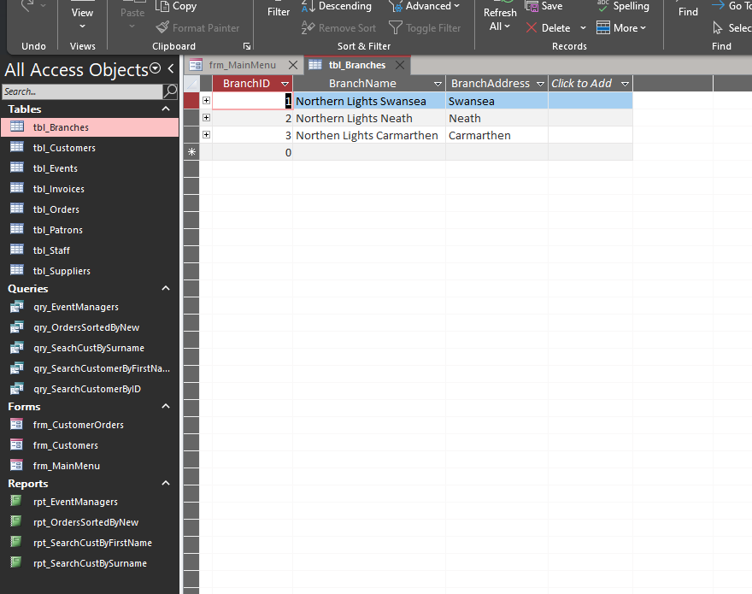
Table to show all northern lights branches, ID and their location.

Customers Table
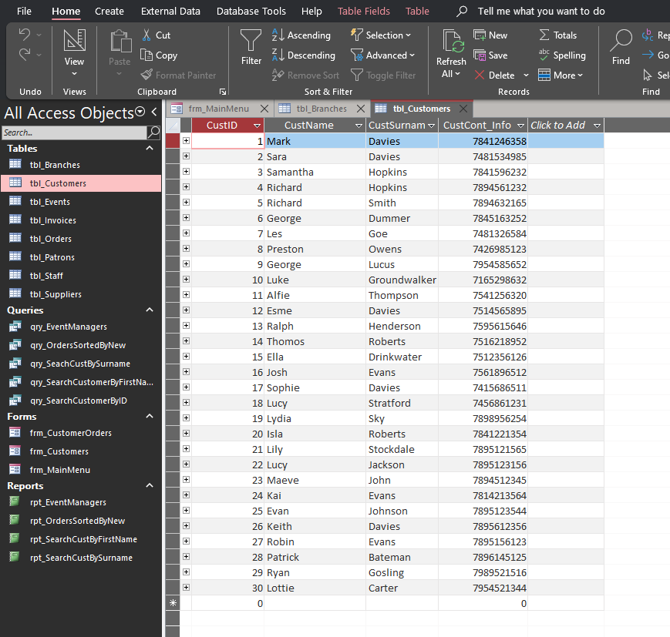
Table to show all customers on the database, including names, surnames and contact information.

Events Table
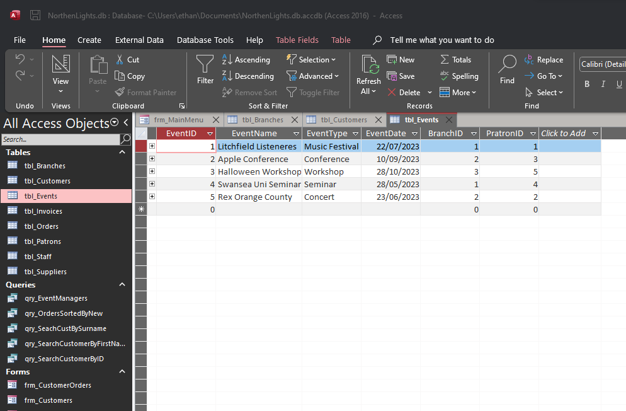
Table to show all events that are set to happen. Shows dates and event type.

Invoices Table
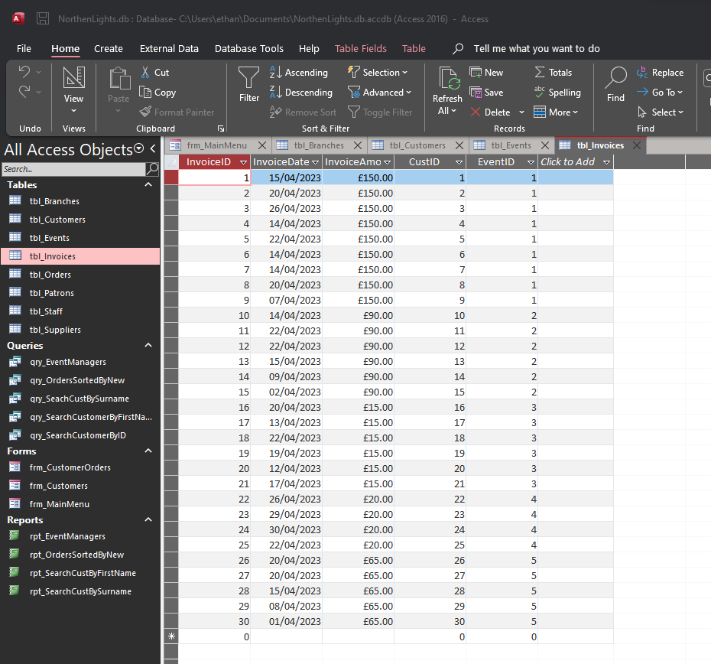
Table to show all customer purchases, including the price, date of purchase and the event they paid to attend.

Orders Table
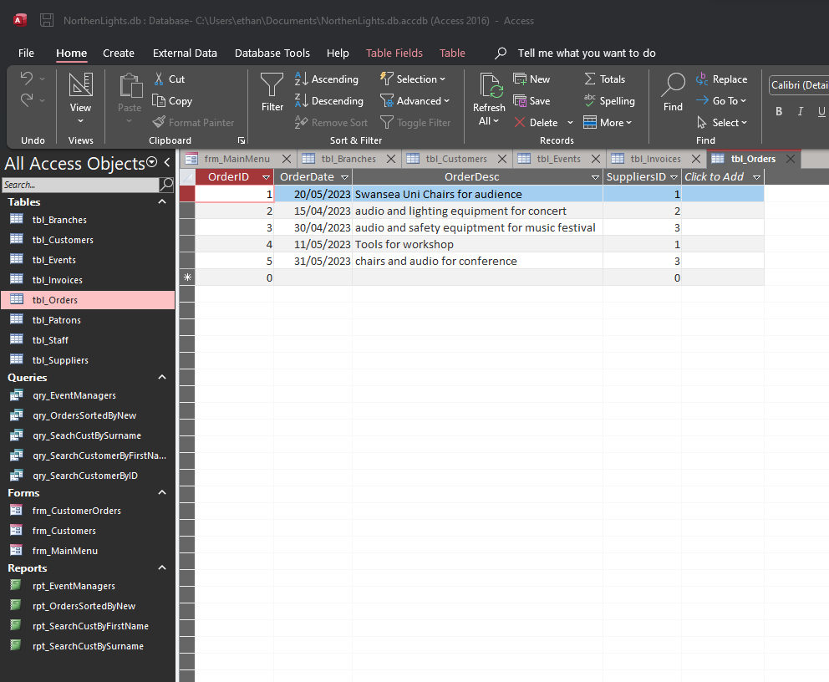
Table to show all orders made by the northern lights company so that that can manage the events.

Patrons Table
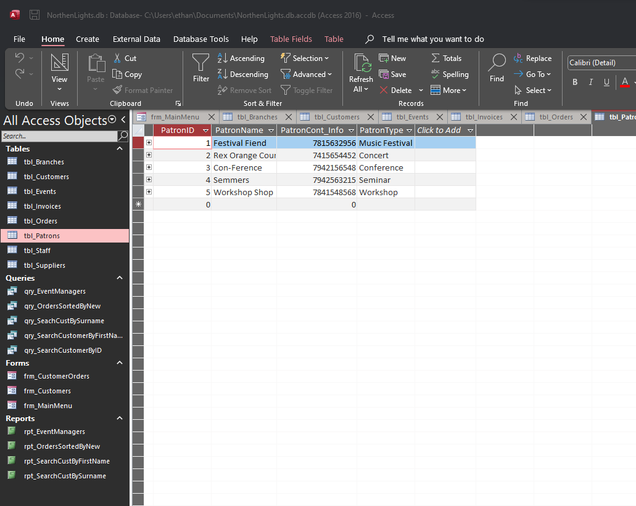
Table to show all the patrons that the company is associated with, and their phone numbers to contact them.

Staff Table
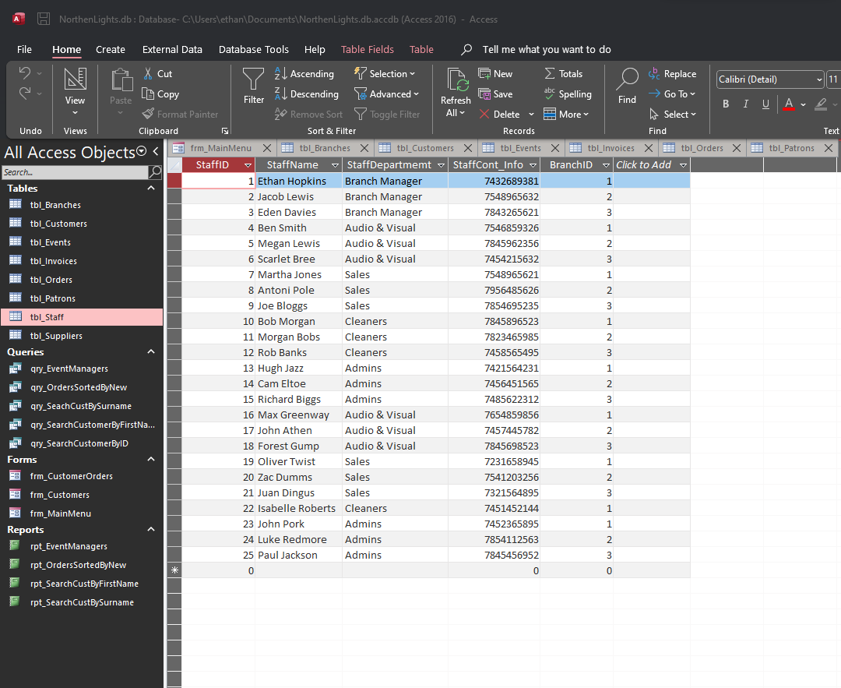
Table to show all the staff working for all the branches, including their role, name, and contact information.

Suppliers Table
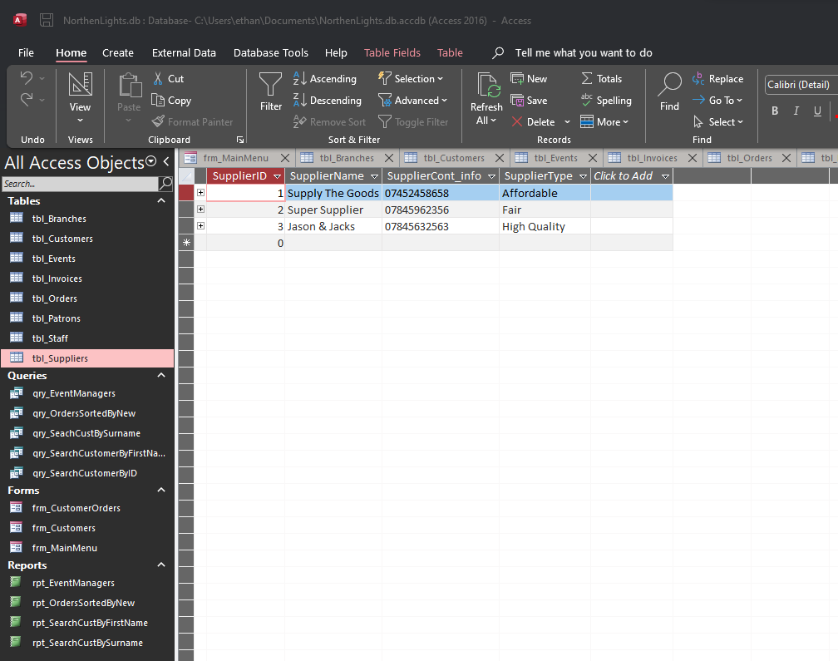
Suppliers table to show all the companies northern lights are associated with and use to get their equipment from.

Queries
Event managers query
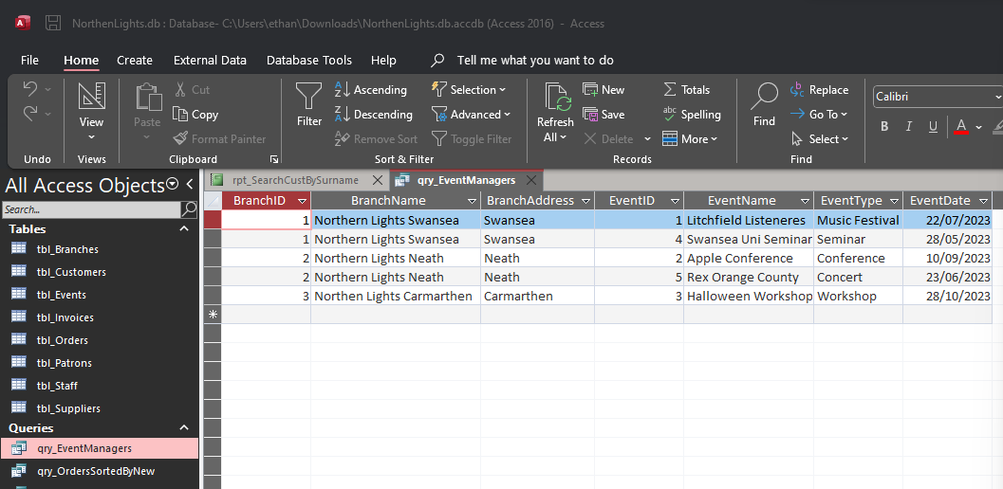
Query to show which branches oversee each of all the currently booked events.

Orders sorted by new query
Query to show all the customer orders sorted by new, so that we can see the latest orders. This will be used in a report later that we can have an almost live view of the orders.
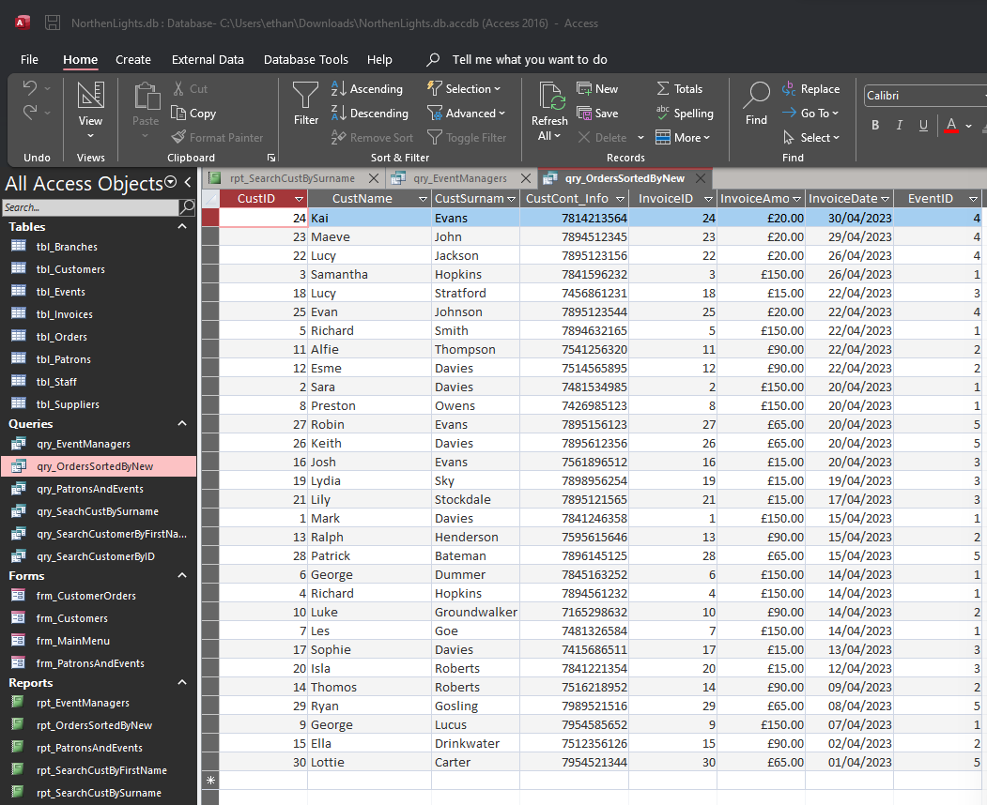

Patrons and events query
Query to show which patrons are aiding the company with each event.
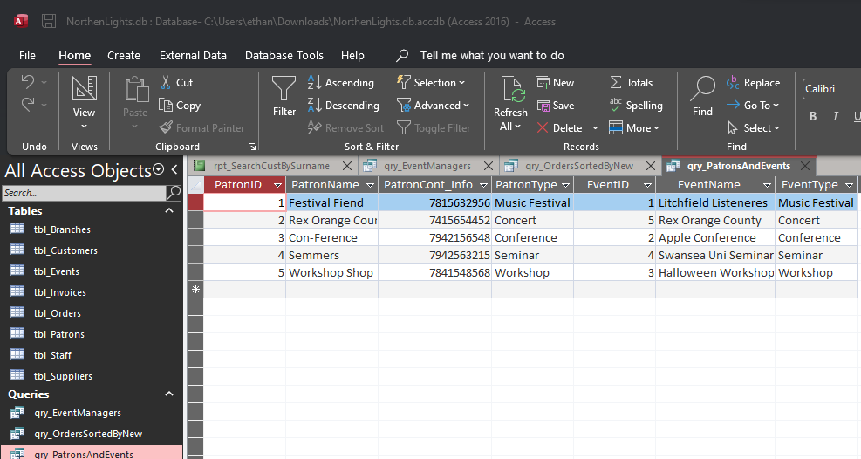

Search customer by surname query
This query allows the user to search for customers by their surname.
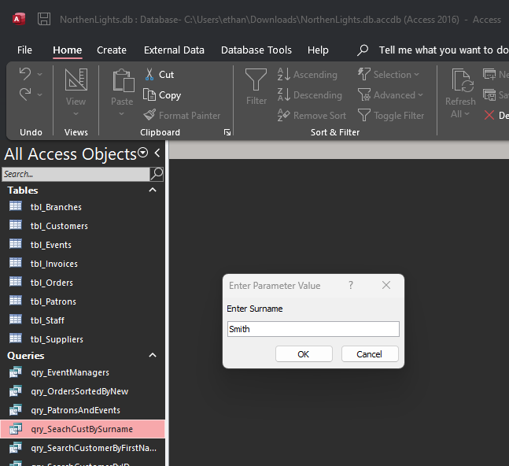
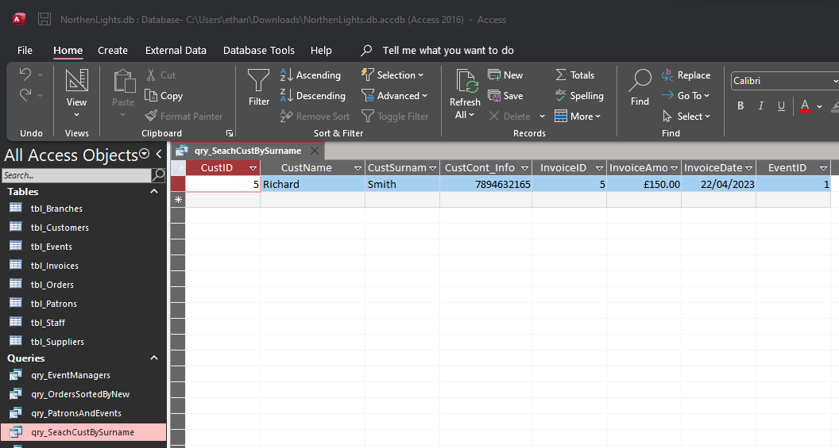

Search customer by first name
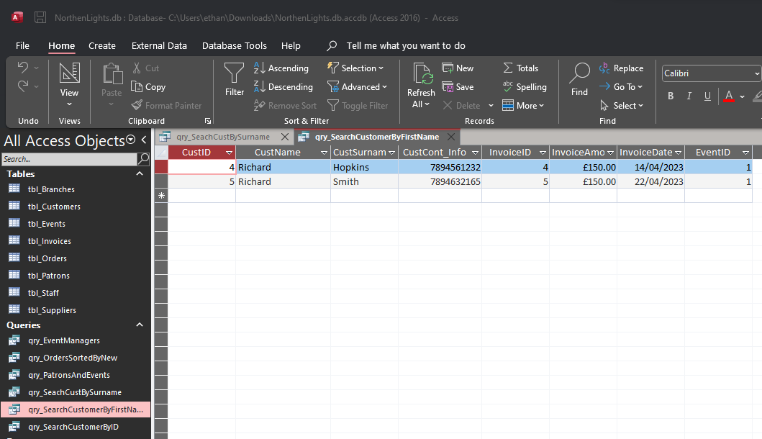
This query allows the user to search for customers by their First name.

Search customer by ID
This query allows the user to search for customers by their CustomerID.
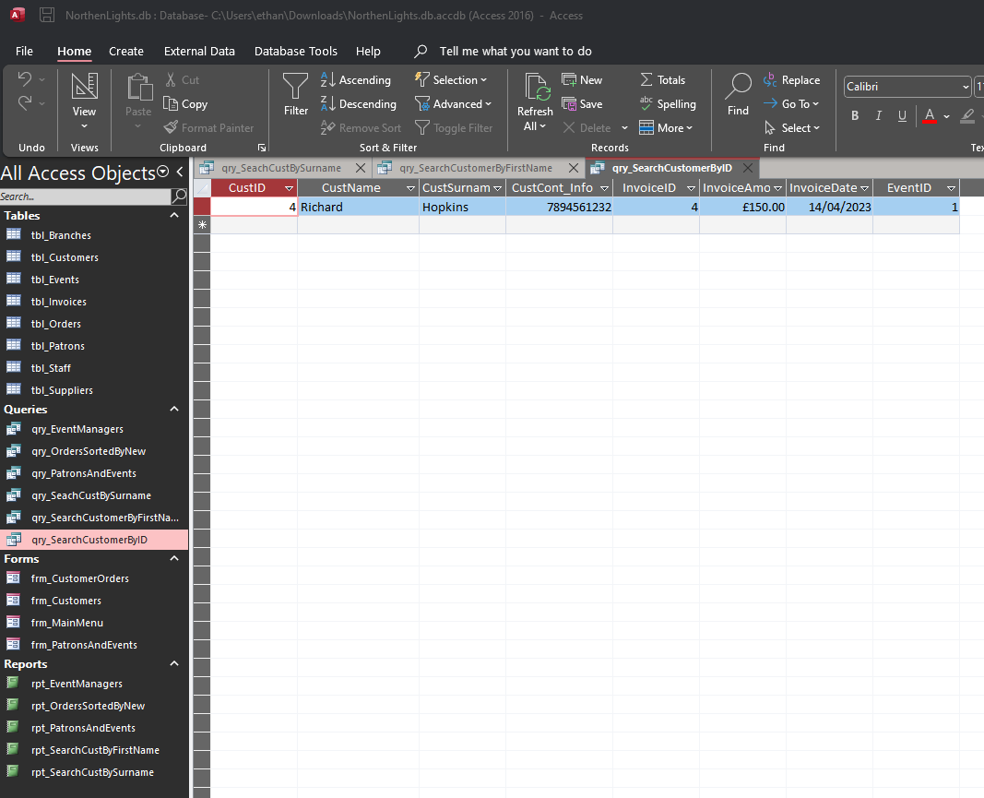

Forms
Main Menu
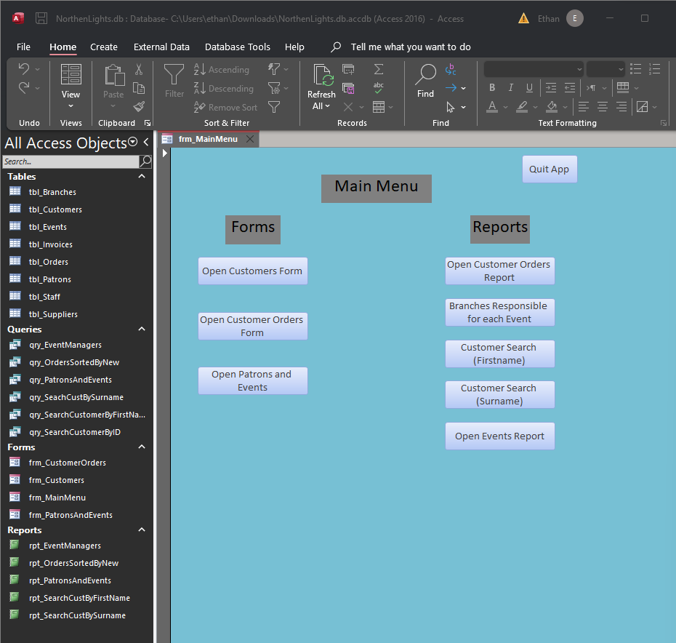
This is the main menu. It is opened automatically by the program so that this is the first thing the user is met with. It has functional buttons that take the user to different parts of the database, including forms so that data can be changed by the user which is then automatically updated into the database, and reports which can help the business with things like budgets and organising company data.

Customer Form
This form allows the user to view and edit information in the customer table. They can add, remove, and edit existing information which is then automatically updated elsewhere in the database.
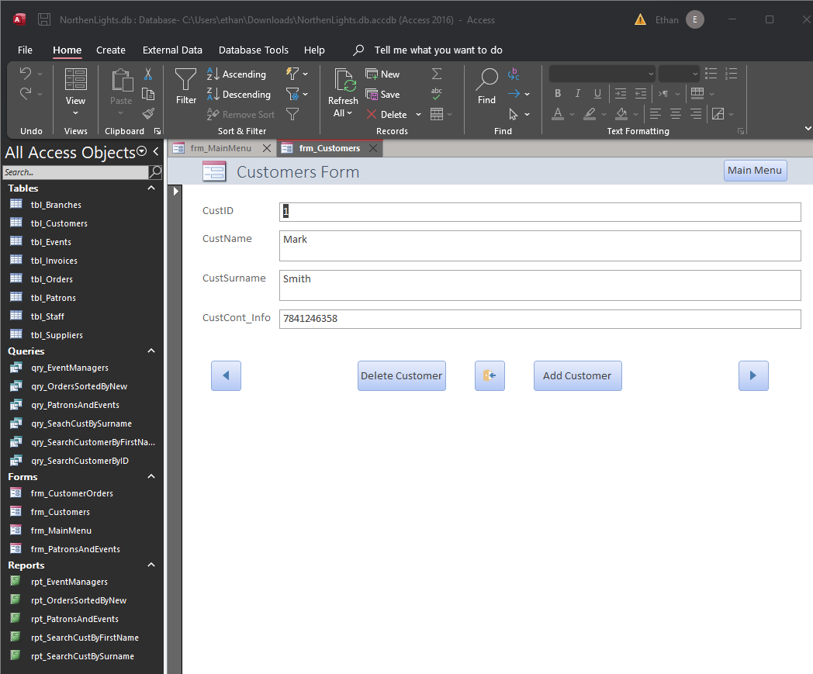

Customer Orders Form
This form allows the user to view and edit information from the invoices and customer tables. They can use this form to search for customers and then change information in the situation where the customer had made a mistake and bought the wrong ticket for example.
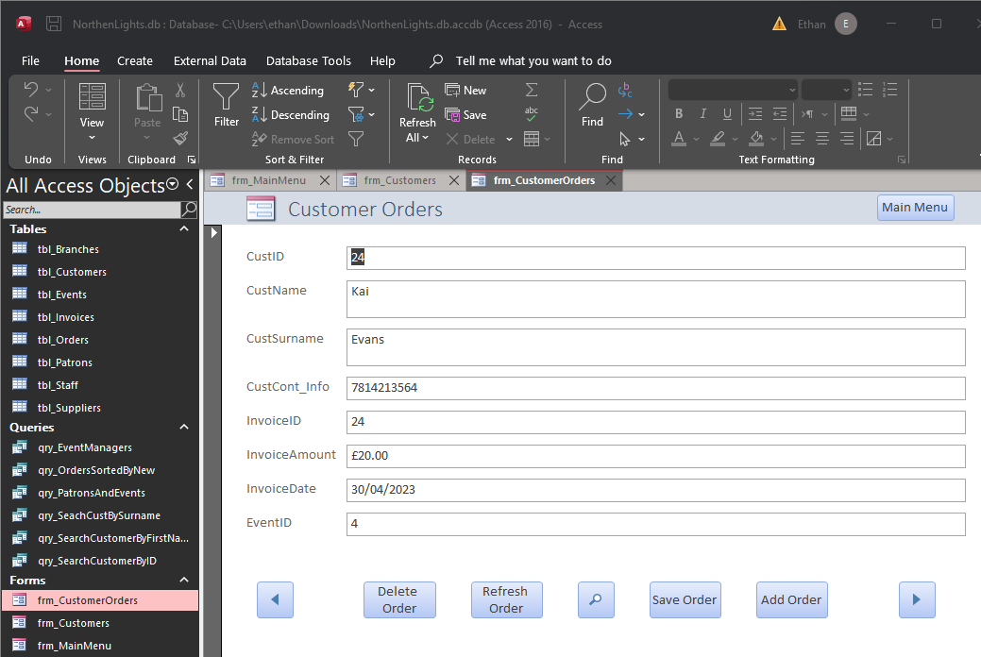

Patrons and Events Form
This form allows the user to access information on the events and which patrons are apart of that event. This is useful in the situation where a patron was assigned to an event by mistake and needs to be changed or removed.
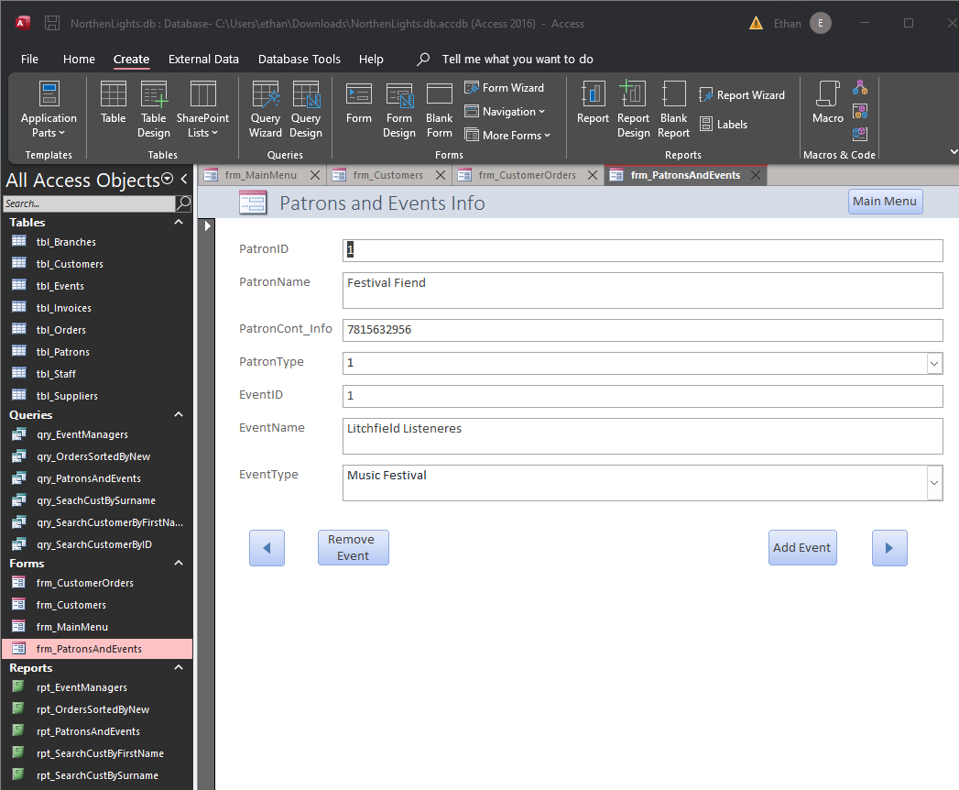

Reports
Events Managers
This report allows the company to have an organised and simple view of which branches will be taking on which events.
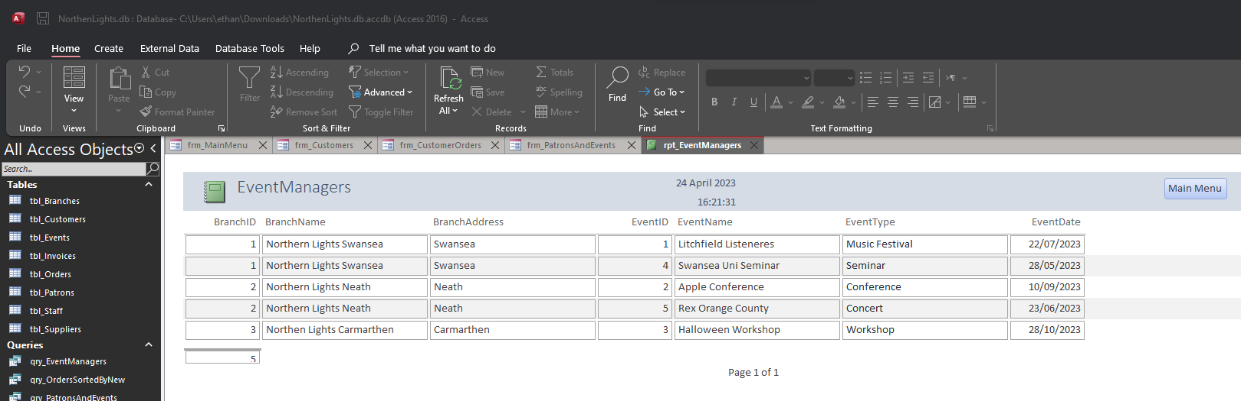
Customer Orders (Newest to oldest) [Includes Calculation] pt.1
This table allows the company to view all orders sorted by date and allows them to see the profits from selling tickets. It can allow the company to calculate yearly and monthly profits. And allows the clients to have an idea of how many people are attending their events.
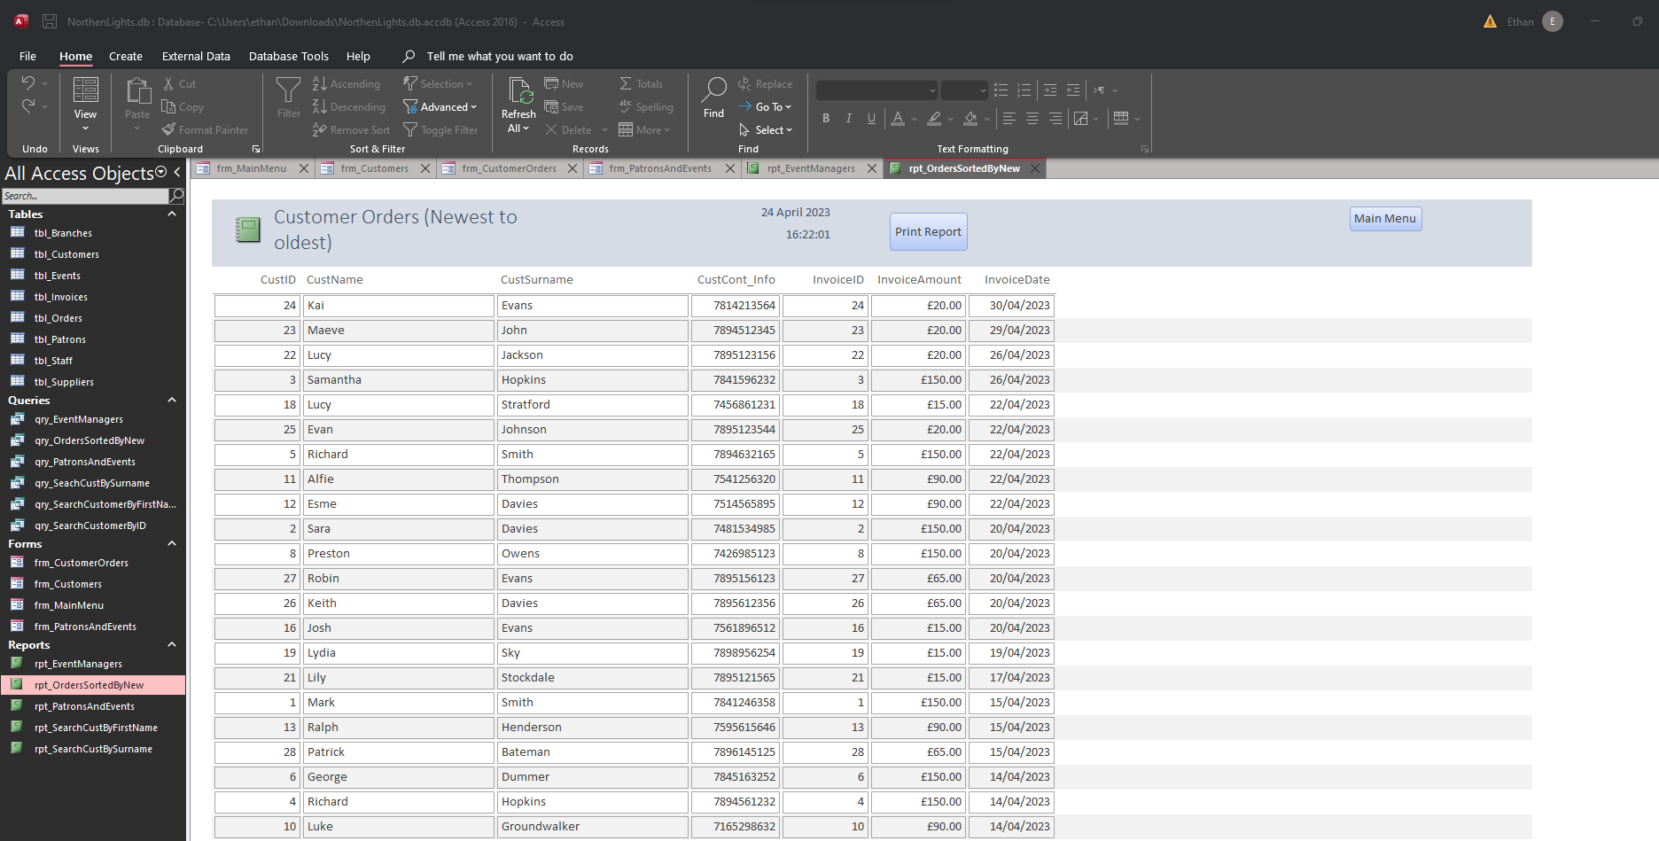

Pt.2
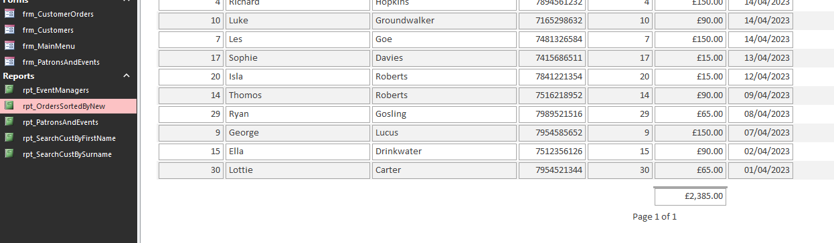
Patron and Events Report
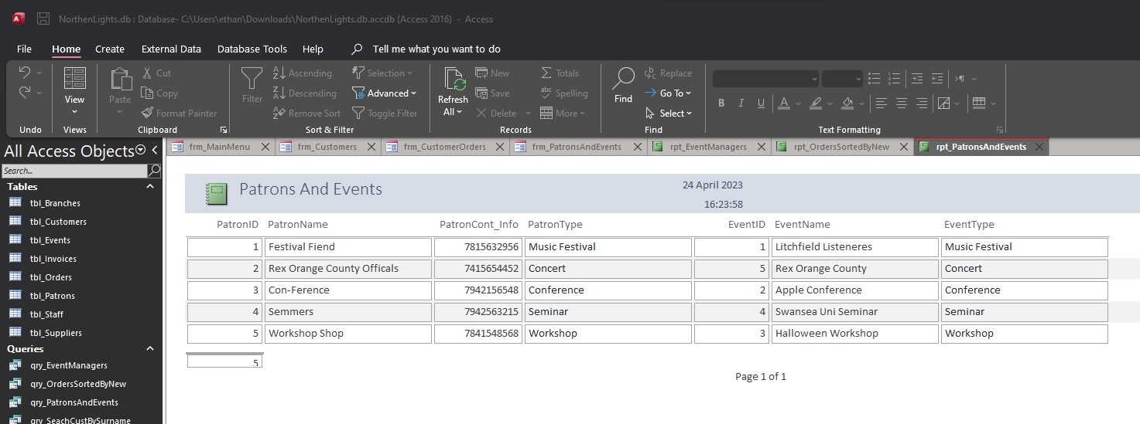

Search customer by first name report
This report allows the user to search for customers on the database and put them into a form. This form can then be printed by using the macro button on the form. The printed form can then be stored physically or can be mailed to the customer as a receipt for their purchase. There is also a “search for another customer” button on the form which allows the user to search for another customer without having to restart the form.
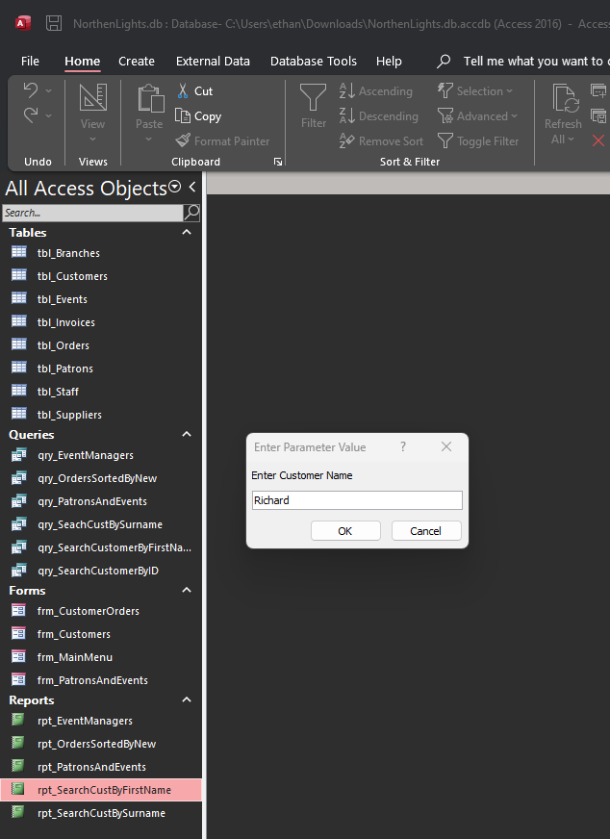
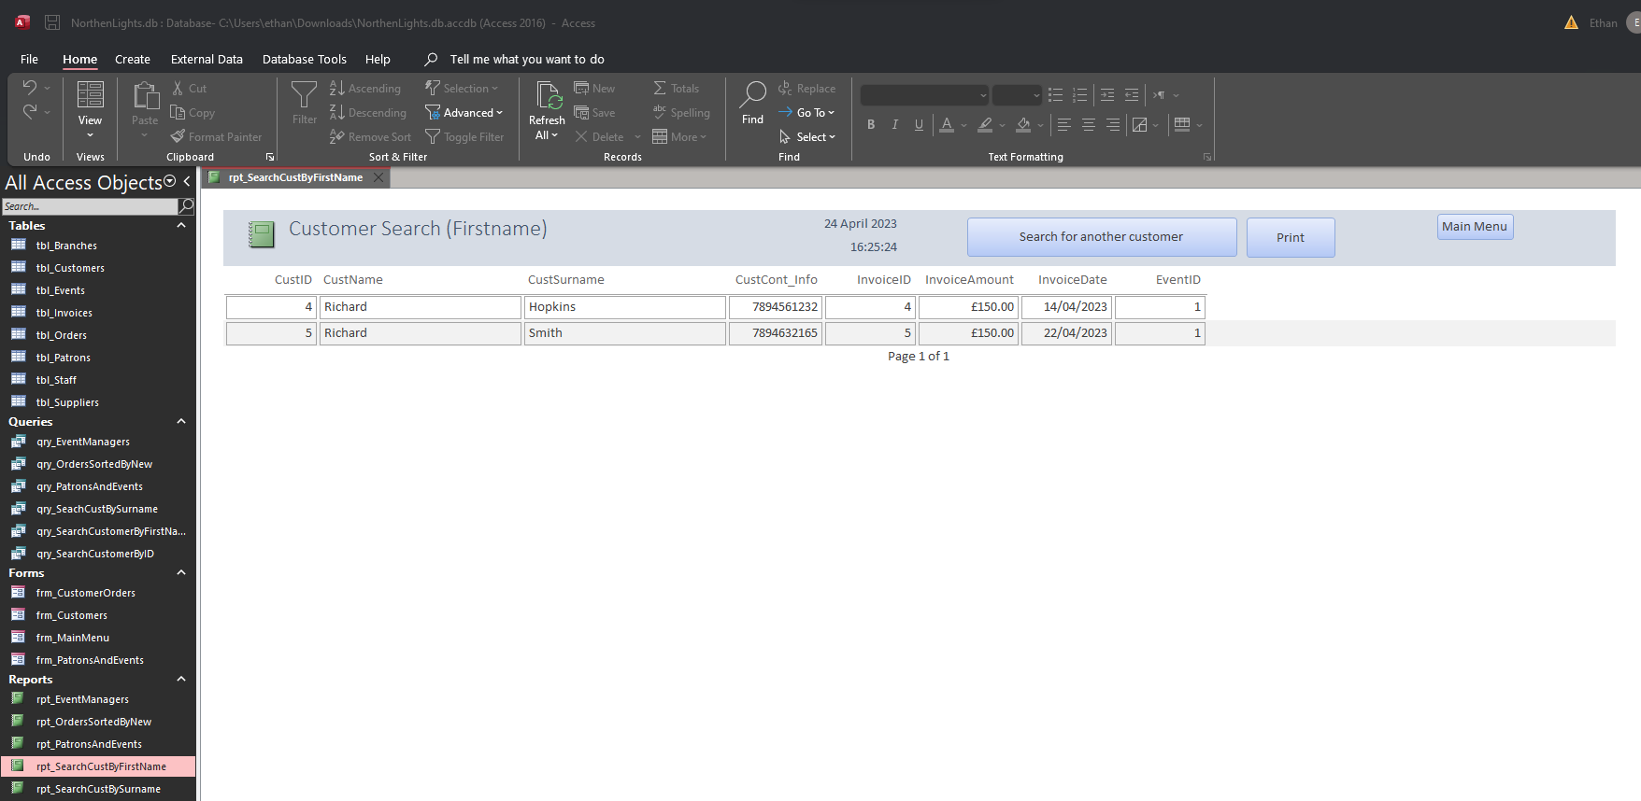

Search customer by surname
Same as previous report but for surname.
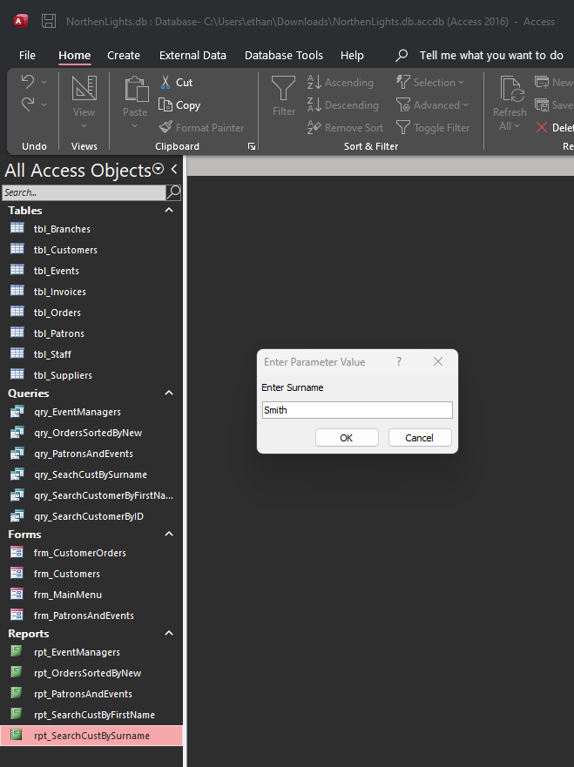

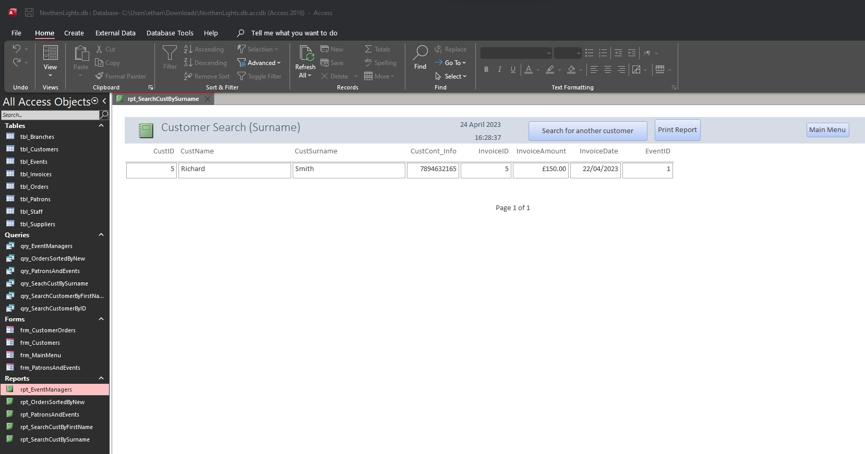

User Guide

Locate the Database File on the computer and double click it.

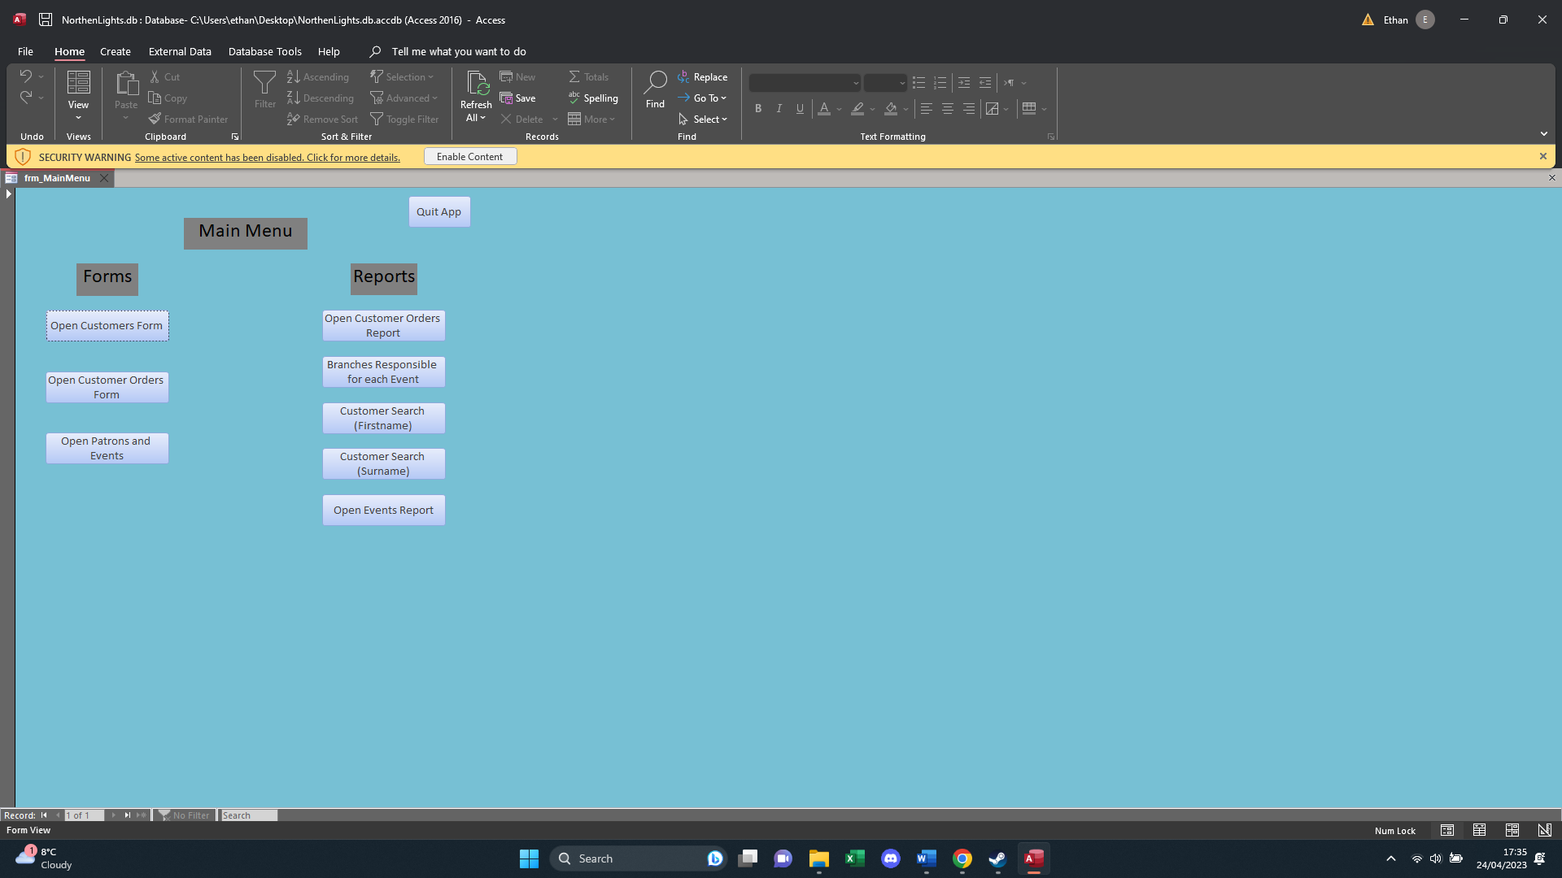
You will be met with this menu. Select “enable content” before moving on.
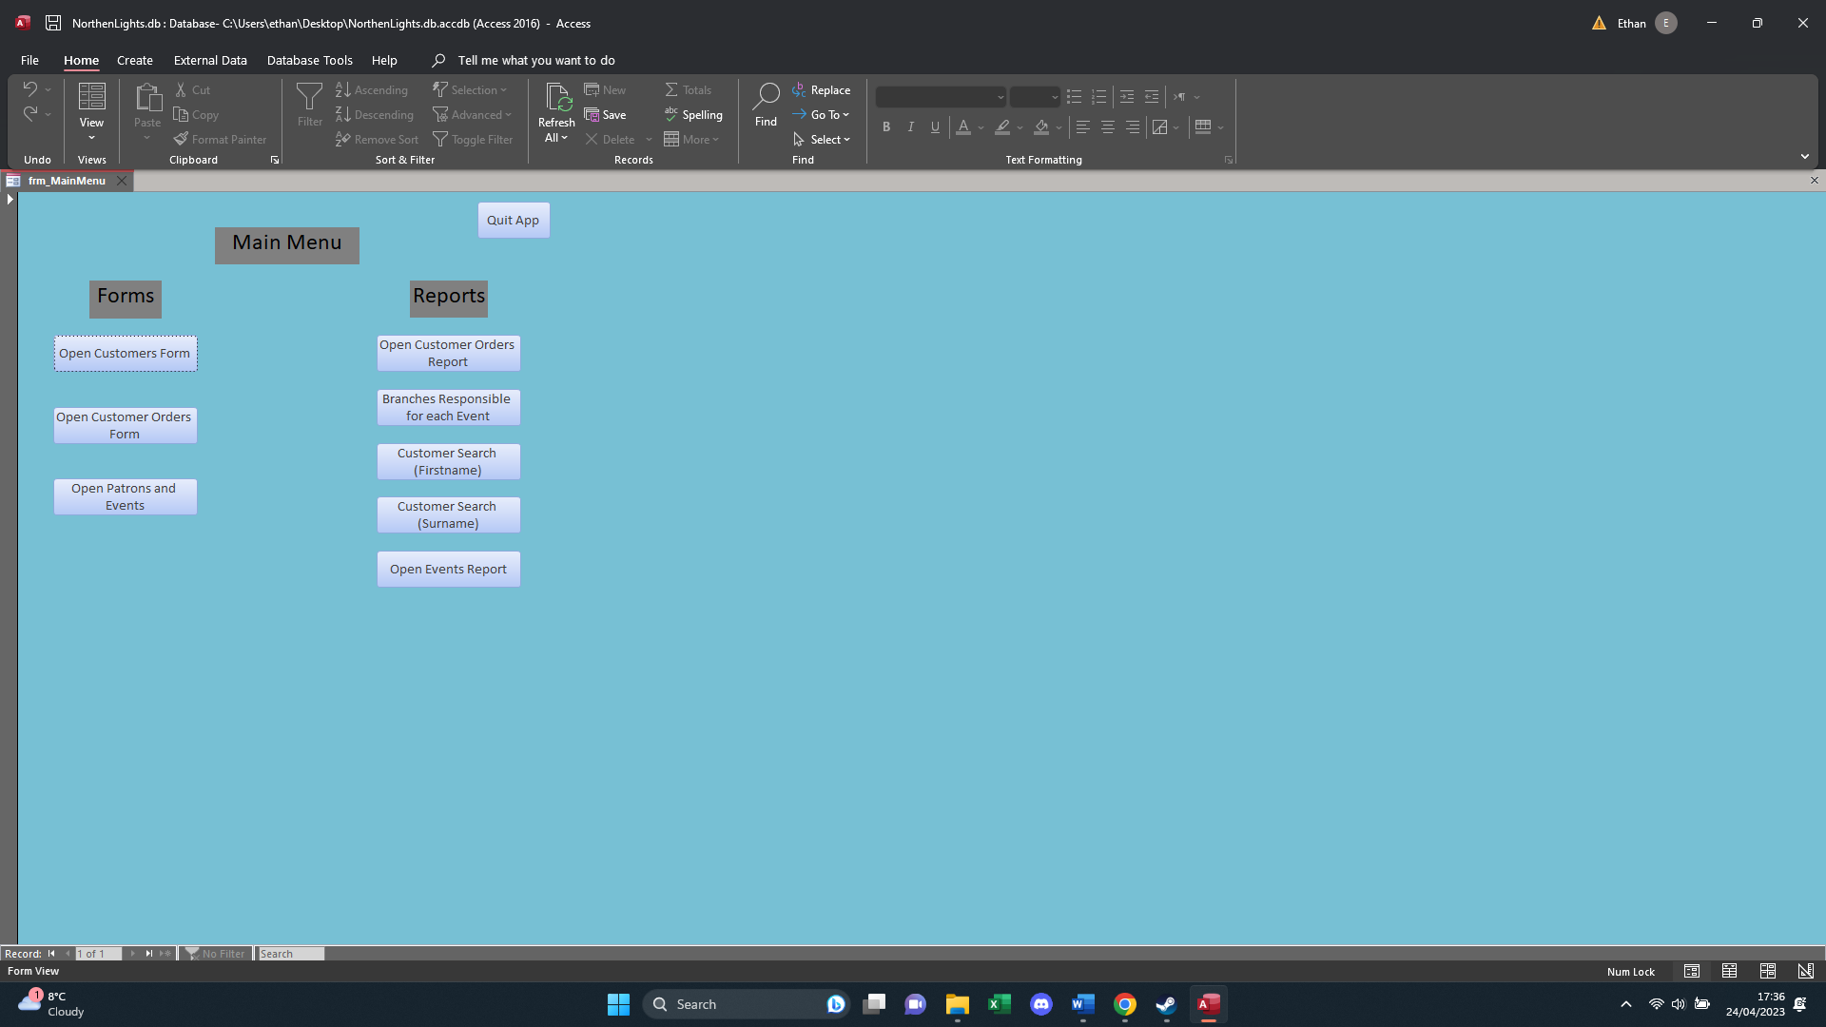
From here you can select where in the database you want to go. For this example, select “Open customer form”.

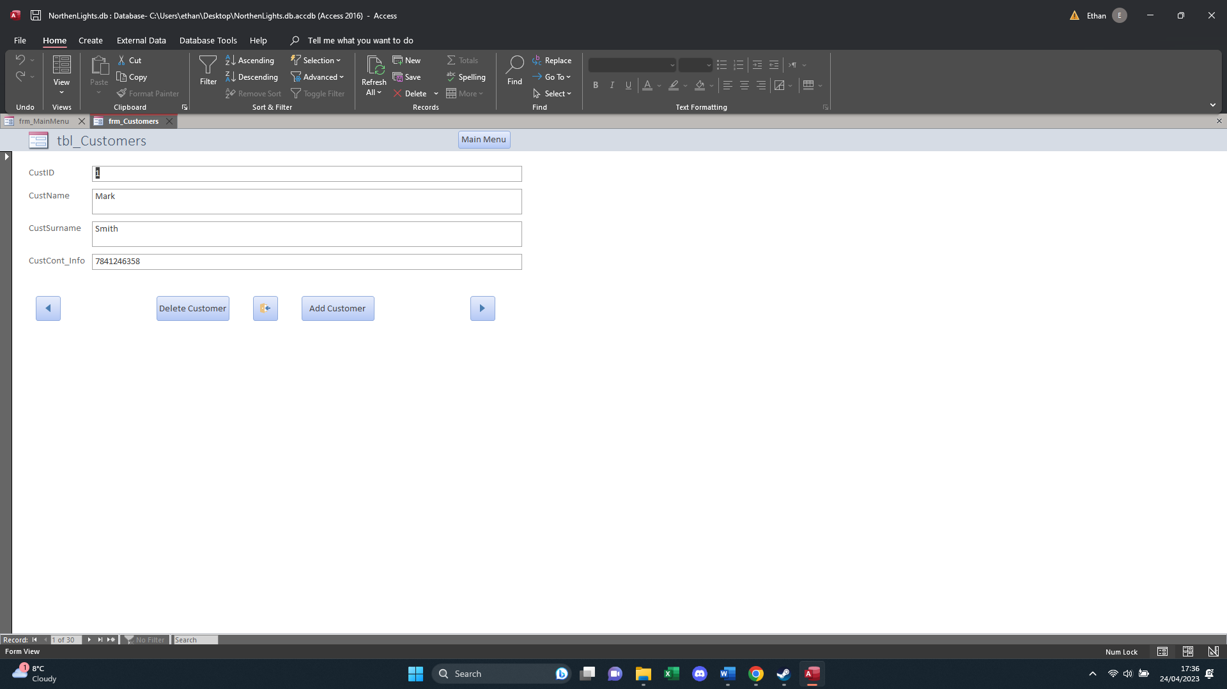
You will be met with this screen. From here you can use the buttons located on the form to do actions such as looking at the next customer in the database, adding a customer, removing a customer, or changing the existing data by clicking on the field you wish to change.

To return to the main menu. Press the main menu button in the top right corner. By doing so you will be met with this screen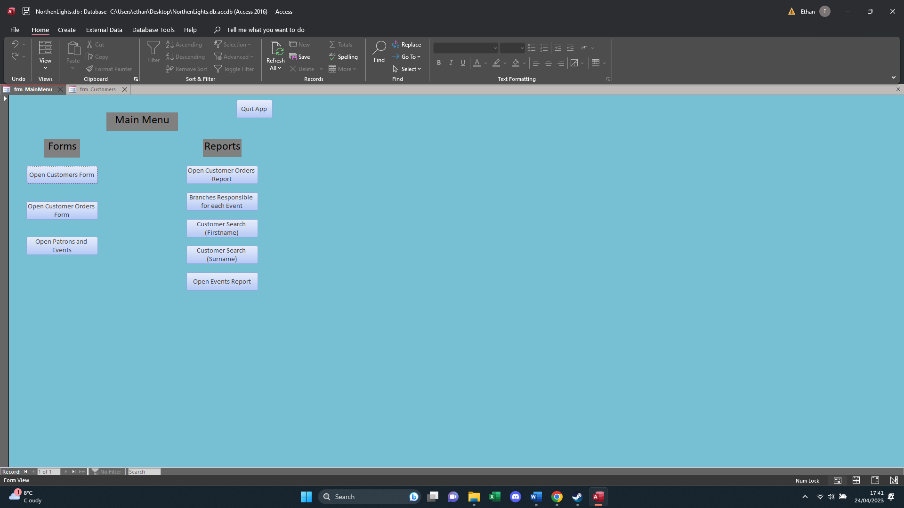
Next we are going to look at a report.
Click on the “Open customer Orders Report”. After doing so you will be met with this report.
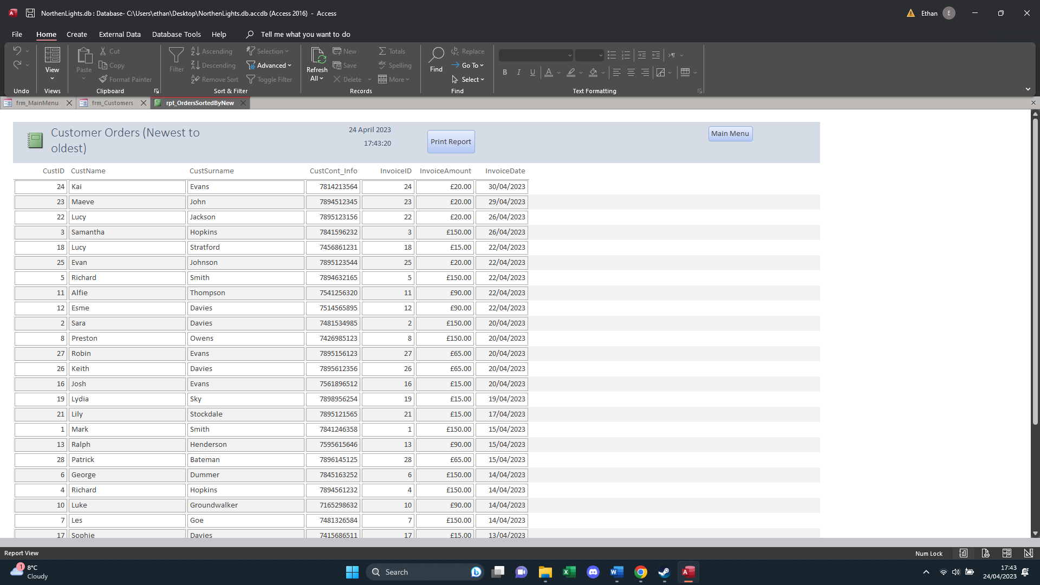
This report shows all orders from newest to oldest. It includes buttons such as the print button which allows the user to print the current table shown. Scrolling down on the document will show the total amount of money the company has made from these orders. From here the company can calculate quarterly and yearly profits.
Clicking the main menu button in the top right corner will return the user to the main menu.
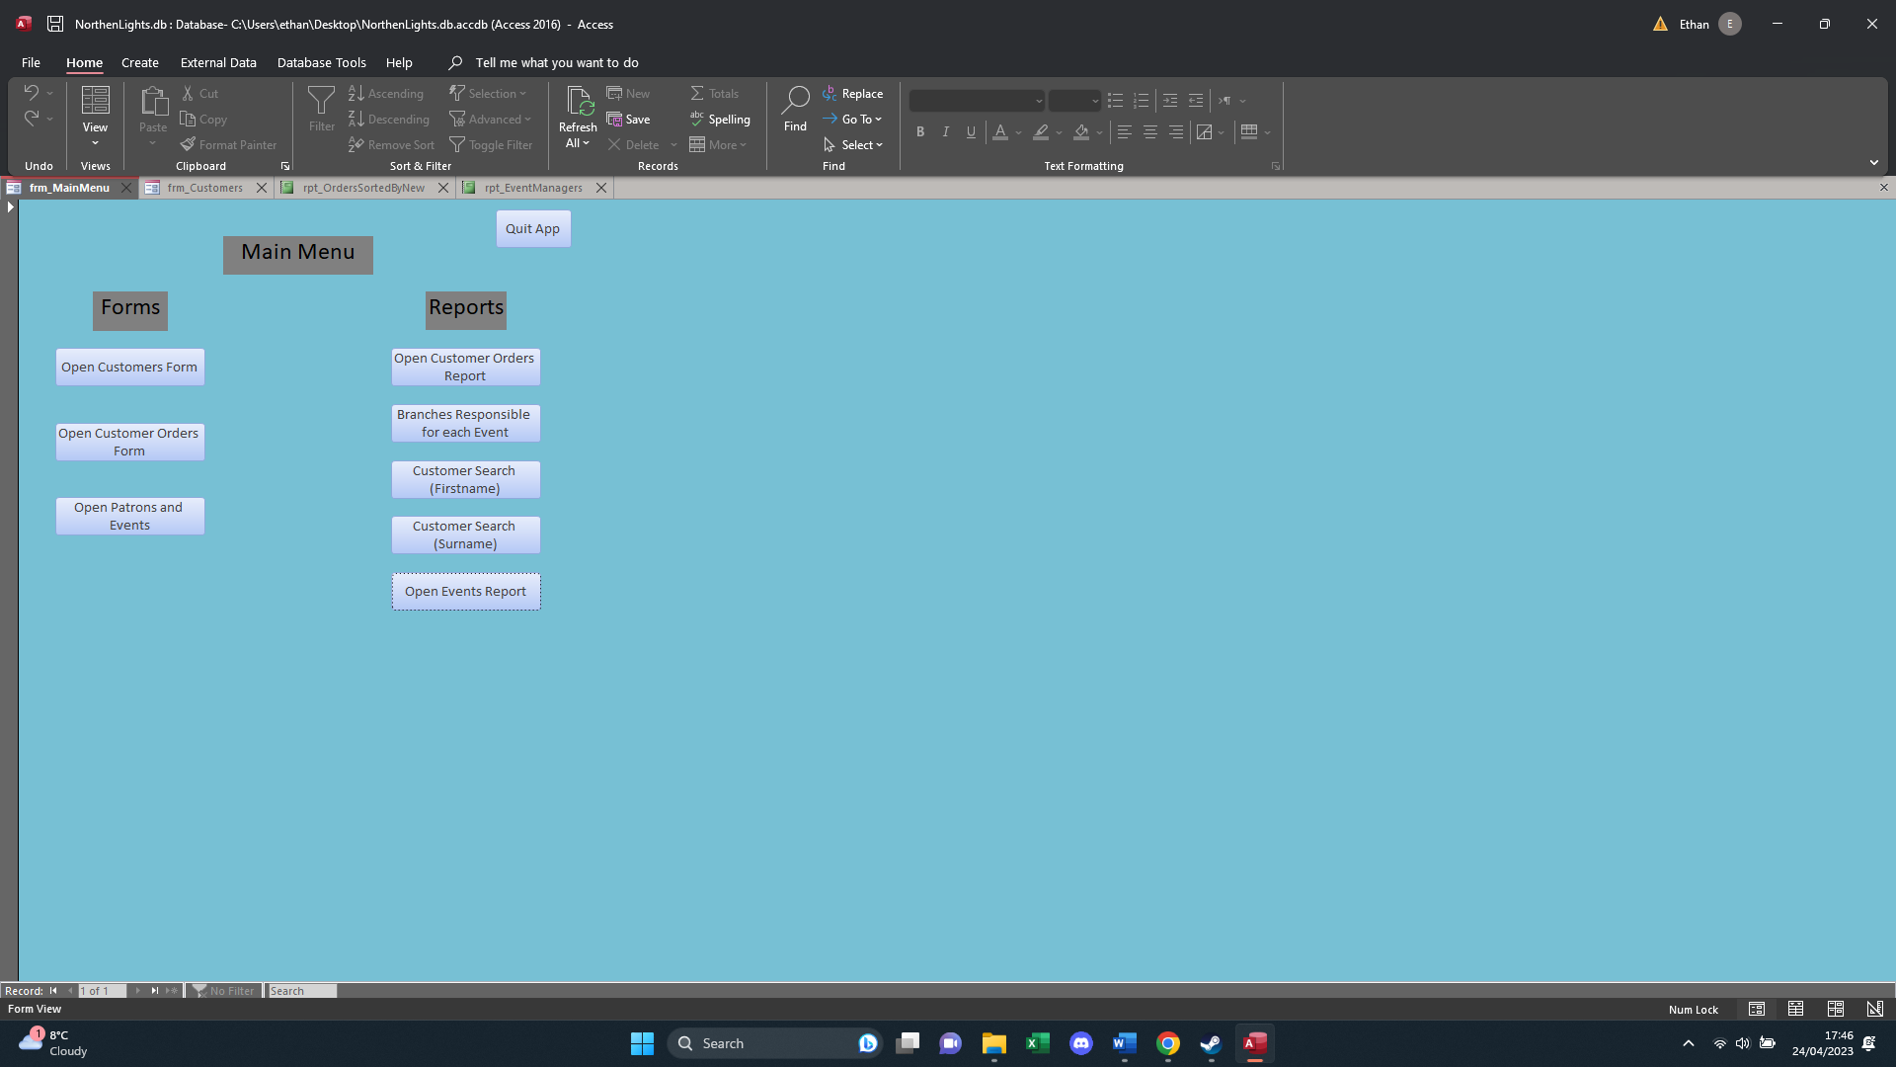
Lastly we will be looking at the “Customer Search” forms. For this example I will be looking at the “Customer Search First Names”.
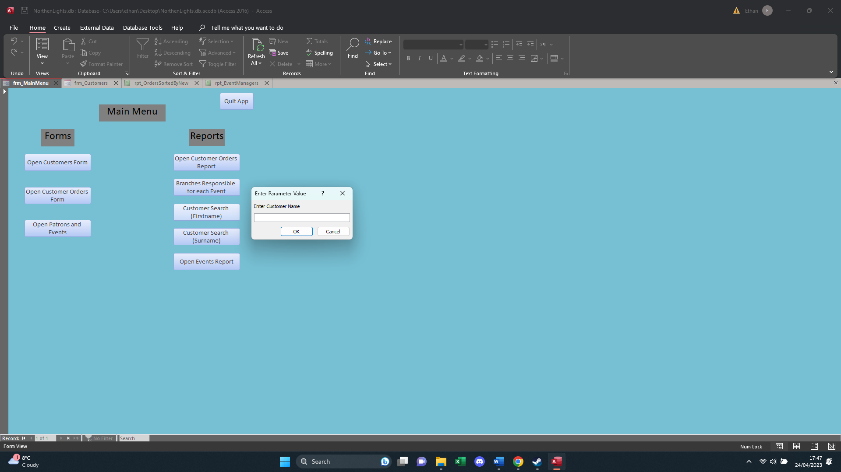
After clicking the button we are met with a text box requesting a name. we input the name we are looking for and then click “Ok”.
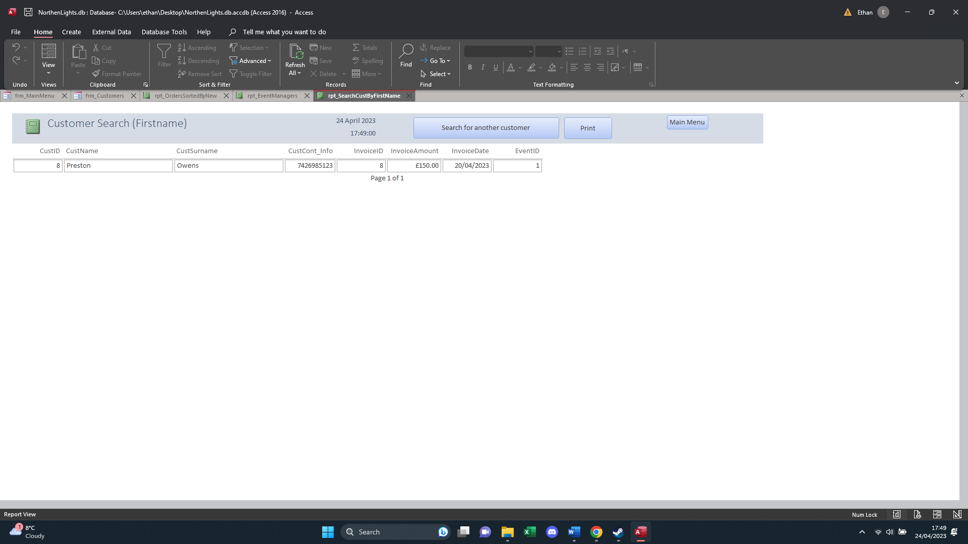
After clicking Ok we are met with a form that shows us anyone on the database with the first name we inputted. It shows us information about the customer such as what event they purchased a ticket for, their contact information, how much they paid for their ticket, and when they aid for it. There are buttons that allow us to search for another customer, print the form out, or to return to the main menu.

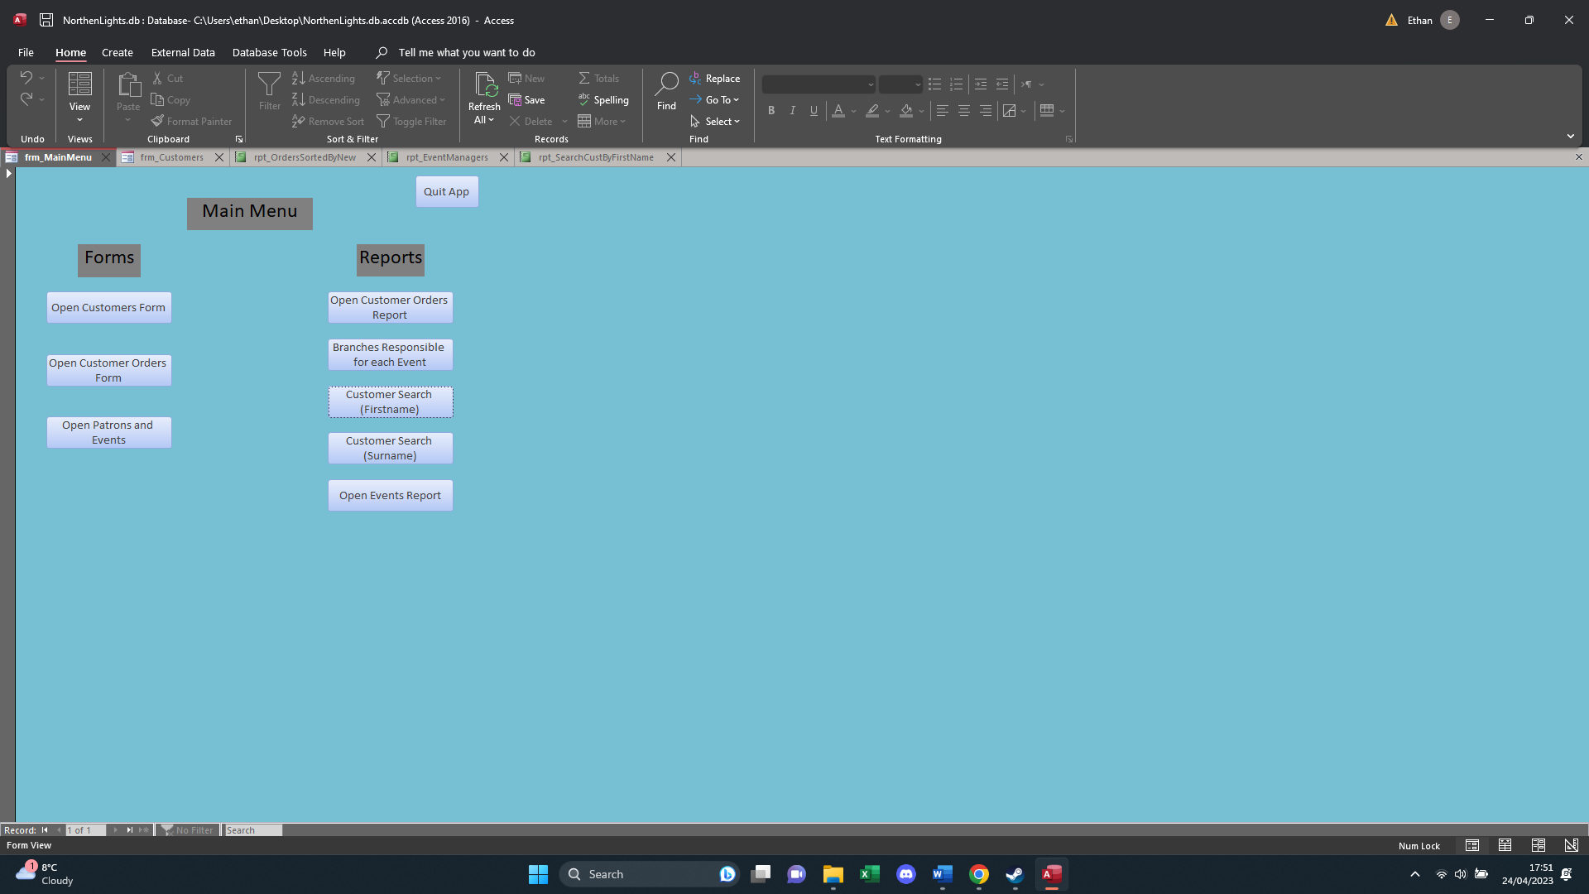
After returning to the main menu, we are ready to close the document. We can do this by clicking the “Quit App” button in the top right corner of the menu. After clicking it you will be met with your desktop home screen.


