STUDENT NAME: ADEBOMI OLUYINKA SALU
STUDENT NUMBER: 1809923
MODULE NAME: MANAGING PERFORMANCE
MODULE CODE: LCMB7013
TITLE OF ASSIGNMENT: MANAGING PERFORMANCE
LECTURER: DR REXON NTING
SUBMISSION DEADLINE: 4TH MAY 2022
WORD COUNT: 5000 WORDS +/- 10%

TABLE OF CONTENT
EXECUTIVE SUMMARY
INTRODUCTION
SECTION ONE:
- AN OVERVIEW OF SAINCO AND CONCEPTS OF TRADITIONAL MANAGEMENT STYLE IN ORGANISATIONS.
SECTION TWO:
- A HISTORICAL ANALYSIS OF PERFORMANCE MANAGEMENT AND THE IMPORTANCE IN ORGANISATIONS LIKE SAINCO.
- A CRITICAL REVIEW OF TRADITIONAL AND MODERN PERFORMANCE MANAGEMENT PRACTICES.
- BARRIERS OF PERFORMANCE MANAGEMENT.
SECTION THREE:
- ORGANISATIONAL AND EMPLOYEE CONCERNS:
SECTION FOUR:
- EMPLOYEE ENGAGEMENT AND INVOLVEMENT.
- ENHANCING EMPLOYEE ENGAGEMENT IN SAINCO.
SECTION FIVE:
- RECOMMENDATIONS: SHORT AND LONG TERM.
- CONCLUSION
REFERENCES

EXECUTIVE SUMMARY
“It is curious that we spend more time congratulating people who have succeeded than encouraging people who have not.”
(By Neil DeGrasse Tyson).
This Report has been motivated by the proposition and evidence that ‘there is more to Performance Management than appraising employees’ in organisations. The purpose of this report is to examine SainCo, a long-established family run and traditional retail organisation with 2000 employees in ten different locations, and the need to become competitive in the retail industry of the modern business world. SainCo acknowledges the necessity of embracing the contemporary Performance Management concepts and practices and needs to make changes by integrating the new approach in line with the organisation’s business goals. To achieve this purpose, a strategy must be put in place on the best way of achieving this goal; resulting in a strategic performance management that is integrated, a continuous process and designed for SainCo. Therefore, pertinent to the new performance management ‘blueprint’ are the evaluation of the autocratic management style with suggestions on contemporary or transformational styles of leadership, employee concerns and engagement, integrating learning and performance and the principles which can be applied going forward.

INTRODUCTION
In recent years, corporate executives, and human resources (HR) professionals have increasingly been viewing the traditional annual Performance Appraisal (PA) as outdated and view the review system as doing more harm than good to employees and their employers (Armstrong & Mitchell, 2019, p.58). As pointed out by both authors, 6% of all Fortune 500 companies are disposing off the numerical rankings in their performance appraisal system and are now embracing a more holistic performance management. Despite this observation, it is also argued that because organisations need ways of evaluating their employees for reasons like, pay rise, promotions, training and development, discipline and dismissal or termination of employment, (amongst many other reasons), performance appraisals should be improved into performance management instead of disposing of it completely (Armstrong & Mitchell, 2019, p.60). Torrington, et al. (2014, p.196) supports this argument because HR professionals and leaders in organisations are updating and incorporating the old traditional appraisal system into the modern performance management system.
Performance Management (PM) can be defined as “a wide variety of activities, policies, procedures, and interventions designed to help employees to improve their performance” (DeNisi & Murphy, 2017). It begins with appraisal, setting goals, training and development, feedback, and reward. The process incorporates formal and informal intertwined performance management practices and processes (in addition to those mentioned before) like induction, job design, coaching and mentoring, career development, talent management, competency framework and remunerations (Hutchinson, 2013). Additionally, it is suggested that performance management as a strategic process should be regarded as a continous cycle linking several HR activities together at the individual and operational level, making it a flexible process tailored to modern organisations. Starting from employee recruitment and selection (reinforcing the A in AMO model of performance) because the individuals selected have shown the ability to perform well and fit in with the organisational values.
The CEO of SainCo (UK) has recognised the need and the importance for the organisation to embrace modern performance management concepts and practices on the realisation that their current approach is no longer relevant. Therefore, enlisted the services of a Human Resource Consulting Firm to offer solutions to their concerns regarding new approaches to how performance management is handled in order to remain competitive. SainCo is a traditional family-run business with an autocratic style of management, situated in ten different locations. As an organisation with an autocratic style of leadership, it can be argued that SainCo’s leaders have complete power over their employees with little opportunity for them to make suggestions, which is a form of ‘Transactional’ leadership style (Amanchukwu, et al., 2015). The main issue of focus adreesed in this report lies with the change in the current business environment in which SainCo operates and wants to adapt new concepts and practices of performance management.
The first section of this report gives a brief overview of SainCo and the traditional management style in organisations in general. Section two analyses the history of Perfomance Management and its importance in an organisation like SainCo. There will be a critical review the traditional and modern performance management practices and also evaluate the barriers of performance management. The third section addresses organisational and employee concerns in general and which could be specific to SainCo. The fourth section is concerned with employee engagement and involvement, how Sainco could enhance the engagement of their employees with the help of models and frameworks. Finally, the last section will be about recommendatios of moderm performance management techniques and practices to achieve competitive advantage in the retail industry in the short and long term.

SECTION ONE
AN OVERVIEW OF SAINCO AND CONCEPTS OF TRADITIONAL MANAGEMENT STYLE IN ORGANISATIONS:
Studies have found that family businesses exist globally in all forms and sizes, and in the UK, about 4.8 million businesses fall under the category and within medium to large organisations (Taubert, 2018). Established in this case study is that SainCo is a deep-rooted family run traditional organisation with an autocratic management style with roots in the UK. This means the organisation have a hierarchical structure with the driving force at the top, meaning it is a top-down power structure and employees answer to a chain of command. Despite SainCo being a family run business, it falls into the bracket of a forward thinker innovative business that values their heritage and culture, cares for their employee wellbeing; looking in the long run to enable it gaining competitive edge. Hence, the CEO of SainCo becoming convinced that making changes to the way the organisation practices traditional performance appraisal by seeking the expertise of the Human resources Consulting firm on how to move forward into modern Performance Management concepts and practices. Adapting to the contemporary business world by staying relevant and taking a long term and sustainable outlook enables family business survival (Taubert, 2018).
Historically, management experts agrees that there are different leadership and management styles used in organisations. Khan, et al. (2016) opines that leadership styles fall into two categories of Transactional (a contingent-reward leadership) and Transformational (focuses on interactions with employees based on common beliefs, values and goals) styles. Added to this, studies have also shown that in addition, frequently used styles in organisations are Autocratic, Authoritarian, Democrative, Bureaucratic and Laissez-Faire styles of leadership (Khan, et al., 2015). SainCo being a traditional organisation have used the autocratic (top-down) style of management which is often regarded as a classical approach where the decision-making authority lies with the leaders or the managers in all the ten different locations. Traditional leaders focuses on improving their business proposition and their position in the industry by providing guidance for employees to do their jobs (Tait, 2020). It can therefore be argued that SainCo CEO and other managers encourage their subordinates through guidance in performing their daily duties at work.
Some studies have found that the autocratic style of leadership have been critisised in the past couple of decades because of the high level of absenteeism and employee turnover, sighting a couple of reasons which are; the reliance on threats and purnishment in influencing employees, discouraging employee input tereby lack of trust and hieracchy is promoted (Khan, et al., 2015). In contrast to this opinion, Khan and colleages also pointed out some advantages for organisations that use this style of leadership because it could be the most appropriate style to use depending on the type of business like where a high-volume production is needed daily, employees working best when directed with set rules and having security in the management style. It is therefore evident how SainCo have been able to expand their traditional family-run business over ten locations with 2000 employees.
Furthermore, due to SainCo’s decision to make changes to how employee appraisal is practised, because the organisation leaders have recognised that to attain sustainability which is crucial to the survival of the business, it now realises that there is more to performance management than appraising their employees. Moving away from task-oriented to people-oriented by valuing participation over heirachy and consulting others before making decisions (Fries, et al., 2021). The CEO’s ability to make a quick decision is based on what is known to be traits of an autocratic leader. Being able to display knowledge and competency in making the right decision for the organisation is regarded as an effective leadership style, given the stuation.

SECTION TWO
A HISTORICAL ANALYSIS OF PERFORMANCE MANAGEMENT AND THE IMPORTANCE IN ORGANISATIONS:
Research into Performance Management (modern term) and Performance Appraisal (traditional term) has a long history with many researchers and academic authors coming up with different trends and beliefs about both practices. Torrington, et al. (2014) agrees by stating that Performance Appraisal have been in operation in many organisations since the 1950s, and also pointing out the difference with modern Performance Management Systems (PMS). History also shows that PA dates back to ancient China and the 19th century in the constitute evidence of metric rating (as written by Murphy and Cleveland in 1995), and psychological research article (by Thorndike in 1920) helped galvanised PA for 50 years more (DeNisi & Murphy, 2017). Both authors laid emphasis on ‘The Journal of Applied Psychology (JAP) which came out with several articles at different times showing the trends in PA categories and the percentage of research done from 1970 – 2000. This research trend, though not fully capturing the development of the different ideas in the different fields, it gives an idea on PA trends over a period of 30 years, as shown in Figure 1 below:
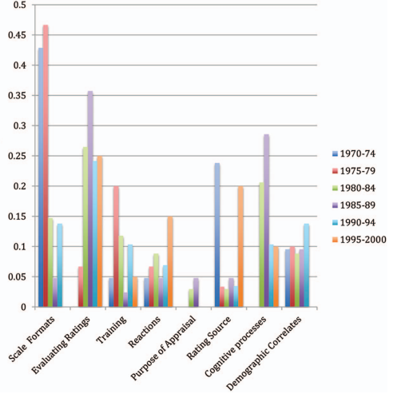
(Fig.1) Trends in Performance Appraisal Research from 1970-2000. (Source: Journal of Applied Psychology)
According to (Radnor & Barnes, 2007), Performance appraisal has been showing a move towards performance management measures in recent years and moved into three conducts which are, expanding the unit of analysis, strengthening of performance measures, and enlarging the performance measures range. This is a more holistic way of measuring employee performance in organisations that wants to grow into the future. Traditional PA have produced a more formal process of reviewing employees (Torrington, et al., 2014), needed to evaluate employees for pay increase, promotions, skill improvement, guidance, discipline, and termination of employment (Armstrong & Mitchell, 2019, p. 60). For this reason, PA measurement in organisation need to be streamlined and evolved into a more holistic PM practices.
Therefore, SainCo’s traditional practices of appraising its employees does not need to be abolished completely. It is suggested that importantly, the practices which have produced positive results for the employers, and retained their employees in all their ten locations may be improved in 3 ways which are firstly, to have frequent and informal reviews through discusiions on a weekly, monthly or quaterly intervals so that problems which could arise can be noted and measures put in place to sort out. Secondly, modernise the heavy-based numerical scales and check-off boxes of the traditional method and introduce effective technology with simple questions focusing on the future purpose and objectives, and not past mistakes. Thirdly, allow enough time to address employee concerns, taking ownership of their career development and also allowing the PM discussion to be a two-way discussion and not a unilateral meeting (Armstrong & Mitchell, 2019). Radnor & Barnes (2007) argues that the need for productivity will always be in existence in organisations therefore the development of PM measures are necessary.
Capri, et al. (2017) agrees, and proposes that the importance of performance management in organisations can be found in the way the practice aligns both formal and informal processes by positioning the employees, the organisational resources and systems to meet their strategic objectives. This system enables employers to spot potential problems and in the case of SainCo, the managers in all the ten locations could be trained in the new PM process so that adjustments could be made to problems ‘spotted’ thereby keeping the retail business on track. As sainCo is a retail business where daily sales target need to be met, having a strong performance management depends on a simple princilple of ‘what gets measured gets done’ Capri, et al. (2017) and SainCo managers may regularly monitor the new metrics from the new morderm PM system so that there is continuos engagement with employees, discussing progress in meeting targets, good performances rewarded and underperformance is helped with actions in place.
A CRITICAL REVIEW OF TRADITIONAL AND MODERN PERFORMANCE MANAGEMENT PRACTICES AND TECHNIQUES:
In the wider business environment, Performance Management systems has changed, and reports shows that it is still changing. It can also be argued that nine out of ten organisations in the global business world are uncertain about changing from the traditional system of generating performance scores for employees, to a renewed and modernised performance management system (Ewenstein, et al., 2016). Although the uncertainties are there, reports show that managers feel the traditional performance appraisal has become time consuming, demotivating, unhelpful and excessively subjective.
Other studies have also drawn attention to the central position of line managers in the traditional performance appraisal system. Keegan & Den-Hartog (2018) highlights the prominent position of the triad comprising line managers, employees and HR department in an organisation and noted that line managers especially are responsible for measuring the performance, communicating evaluation and assisting in improvement of their team members. This could also be true to the activities of line managers in a contemporary business organisation that practices the mordern performance management system. SainCo’s current practices could be similar which is why the move to adapt mordern PM measures is paramount.
Traditional organisations are known to have limited scope in the actions of their employees, exhibited when employees are tasked to specific job activities and not encouraged to develop other skills. Example of this could be found in a manufacturing company for cars where every employee is in a division of labour, specifically producing the same part of the car throughout their tenure as an employee. However, because of innovation, evolution and technology, things have changed. In addition, these changes are also evident in the same example of car manufacturing companies where innovative technology in the form of robots have taken charge of some manpower. As a result, Performance Appraisal practices in such a company must be adapted to measuring the trained skills of the employee manning the technology in terms of productivity and profitability. These changes in technology facilitates larger products, leading to larger profits for the organisation. One could also argue that it creates a gap in how employee performance is measured.
Furthermore, communication technology has impacted the business world in the way communication is done in the contemporary world. The emergence of emails, zoom calls and meetings, social media, LinkedIn, amongst others are electronic ways of sending messages to colleagues or organisational information to be passed around, which impacts employer’s ability to measure their employee’s performance positively or negatively, depending on how it is used and controlled. Research supports this by showing that this technological advancement can have positive or negative impact on measuring employee performance depending on the application. Another example could be found in Banks call-centres where performances of staff are measured in form of a percentage to the ratio of calls attended to and the time spent in satisfying the customer or client. Studies have shown that some financial establishments like banks, expect their call-centre staff to pick up a call at first ring and be able to give quality service. It could be argued that, though the managers at the call-centres expect good service quality in all calls, performances of the staff are measured by how many calls is taken within a set period within the key performance indicator (KPI) for increase in profits. This could be a contradiction to a more holistic practice of measuring performance management. It is important to note that the research on traditional and modern Performance management practices is not conclusive because of mixed messages and challenges faced by some organisations in operationalising the practice and choosing the effective concept at their workplace.
BARRIERS OF PERFORMANCE MANAGEMENT:
As the concept of Performance Management is gaining momentum in the business world, so has the issue of the barriers faced by those implementing the practice in organisation. The question then arises that, how effective is performance management and what sort of problems are encountered in the process of operationalising it? What are the consequences of an unsatisfactory performance management? Torrington, et al. (2014) suggests that due to findings from academic research over the years, mixed messages have come out which could be because most organisations fail to evaluate their performance management systems. Stressing that a report from ‘CIPD in 2005’ showed 61% of companies surveyed believed their system was effective, 68% rated it excellent however, without a clear evidence of how the evaluation was done. Walia (2014) agrees and also added that the responsibility is sometimes shouldered by no one in the organisation. However, reafirms that PM has become a crucial tool for business success.
One major problem encountered in the process of operationalising PM as research has found is that of poorly designed performance management which has too many goals to be achieved and sometimes sub-goals within the major goals. This usually happens where there are conflicting interests by different stakeholders of the organisation. It has been suggested that a way of solving this may be to simplify the measures, bringing in a balanced approach. Other key challenges presented by Torrington, et al. (2014) are:
- It is more HR driven and not within the control of line managers, making them the weak link. In this instance, HR professionals and line managers need to work togetherin developng the right system that works for their organisation.
- Inadequate integration of activities which arguably contradicts a major advantage of performance management having the scope to integrate activities regarding managing employee performance.
- Conflict of interest and favouritism from line managers for employees they like.
- Insufficient training for managers on new perfomance management process.
In addition to the points raised above, more challenges come in form of increase in organisational bureaucracy, too much time on administration of the process, increased control, pressure and stress.
Consequenses of an unsatisfacory or a poorly designed and implemented performance management could lead to employees feeling demoralised, not motivated to work or give their best at work, feeling distressed about going to work and mental health issues. As SianCo is seeking the expertise of experts in the field by enploying a consultance firm to design a modern performance management concepts and processes, this move have erased the notion of having a poorly designed blueprint. Therefore it is suggested that implementation should be the next stage. Singh & Twalo (2014) agrees in their article by stating that it is crucial for managers to ensure their subordinate’s output is in cognizance with the organisational goals because a poorly implemented PMS would impact on all ponits mentione above.

SECTION THREE
ORGANISATIONAL AND EMPLOYEE CONCERNS:
Employees feel that employer’s approach to performance appraisal is more individualistic. Foundational to this and organisational and employee concerns regarding performance management is to understand the link between performance appraisal and culture. Both notion and concept cannot work without the other. This is more evident in traditional organisation with a hierarchical style of management like SainCo. Cho & Payne (2016) highlights the influence of cultural values on performance management especially as there is increasing diversity in the workplace with people from different culture and beliefs work together. The concern that may arise is in form of employees not trusting the performance management system their organisation has in place because of the diversity. Cho and Payne sighted an example of a multinational company managers deciding on how effective a general performance appraisal system will be, and as ‘Hofstede’ ointed out in his research in 2001, that with a strong effect of cultural values on behavioural and cognitive processes and functions.
It can be argued that most concerns are tailored towards the traditional employee appraisal rather than the modern employee management as research has shown. SainCo’s management style is autocratic, they have the top-down approach to employee appraisal where open and frank discussion was not encouraged. Therefore, a more collaborative approach of the modern performance management concept could be adapted. Employees enjoy discussions before decisions are made and encouraged to work and solve problems as a team. Meaning the more employees perform as a group, the more the organisation operate as a ‘we’ not ‘I’. To corroborate this, current research has indicated that teamwork is encouraged and celebrated in the workplace and despite some organisations not having the modern PMS in place yet, they are starting to explore the elements of the modern practices of PM (Darino & Johnson, 2020).
Employees may lack the knowledge about their employer’s expectations which could lead to a negative effect and result for the employer. Regarding this issue, it is suggested that the CEO of SainCo communicates the proposed changes and the entire plan regarding when the new practices would take effect to be communicated to all managers and line managers in all the ten locations so that the information is passed to the rest of the employee. Furthermore, it can be argued that a change management plan is required; firstly, because every business changes leads to a legion of positive or negative consequences, and secondly, to be able to manage expectations of the new PMS (Hughes, 2020). Employee’s disengagement is another issue which generally leads to less productivity. Employee’s dissatisfaction with their jobs which is a factor from lack of knowledge about what area they are being assessed regarding their performance, this leads to lack of motivation leading to attrition at work.
Stress and mental health issues is another concern of employees. Research suggests that organisations that applies ‘High Performance Work Practices’ (HPWP) though beneficial in increasing individual outcomes, leading to organisational advantage; has also shown that there is a negative side or a ‘rhetoric versus reality’ aspect to it which may lead to stress or mental health issues with employees and ultimately lead to high turnover (Topcic, et al., 2016).

SECTION FOUR
EMPLOYEE ENGAGEMENT AND INVOLVEMENT:
One of the earliest definition for employee engagement was by Kahn in 1990 whose definition states that “psychological state experienced by employees in relation to their work, together with associated behaviours”; and in Stacey in 2009 defined it as “an individual’s purpose and focused energy, evident to others in the display of personal initiative, adaptability, effort and persistence directed towards organizational goals” (Armstrong, 2018). Employee involvement (which is referred to as job involvement in some literatures) on the other hand can be defined as the level of value that employee places on their job coupled with the level of active participation in their job and their perceived performance level (Scrima, et al., 2014). Therefore, it is evident as that both terms may seem to indicate the same process, research has shown that there is a difference between engagement and involvement, however, it is assumed that employee’s active involvement leads to engagement.
Research has suggested that for organisations to achieve a successful implementation of organisational change, employee engagement plays a crucial role, in addition to the enablement of organisation becoming agile especially in adapting to a changing business market (Robertson-Smith & Markwick, 2009). Research suggests that as much as employee engagement is a relatively new concept, attention on it has been on the rise especially in these current global changes affecting employees and their employers. Hutchinson (2013) reported that the UK government have taken a great interest in the concept and therefore commisioned a report on the issue with conclusions stating “a wider take-up of engagement approaches could impact positively on UK competitiveness and performance” (a report by MacLeod and Clarke, 2009). Employer practices also have its influence on employee engagement as shown in Figure 2, showing the link between the activities of the employer and employee engagement (Vance, 2006).
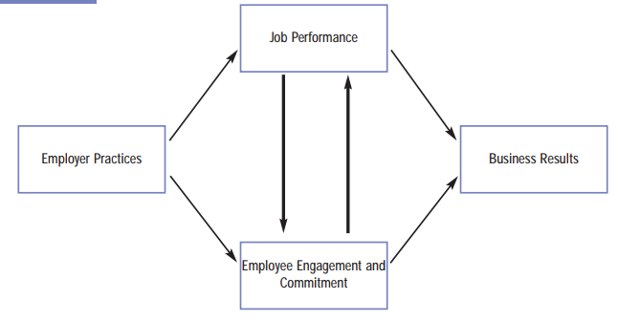
(Fig 2.) Illustration for Employment Practices and Engagement. (Source: Author’s illustration in ‘Employee Engagement and Commitment’)
This illustration shows the the link of how employyer practices essentially influences business results in organisations. This process begins with employer practices like job, task involved in the job, recruitment and selection, training and development, performance management, and remunerations (Vance, 2006).
Central to employee engagement and performance in the workplace, is the ‘Psychological Contract’ which generally supports a high level of employee engagement. For organisations to be able to successfully manage their employee’s expectations from the recruitment stage, human resources department need to design, implement, and ensure there is clarity on the organisational brand, communication is always effective, the management style is transformational, manage employee’s expectations of their job and have a system that measures employee performance on a regular basis to improve performance (Wong, 2022). These are all the factors of a psychological contract. According to Chaubey, et al. (2015), psychological contract relies on employees and their employer’s obligation, the perception of mutual trust and understanding and the perceived reciprocity from the employer forming a strong psychological contract. In agreement, (Sachdeva, 2020) adds how an American scholar named ‘Rousseau’ redefined psychological contract as a joint accountability between employers and employees, depicting trust in relationship.

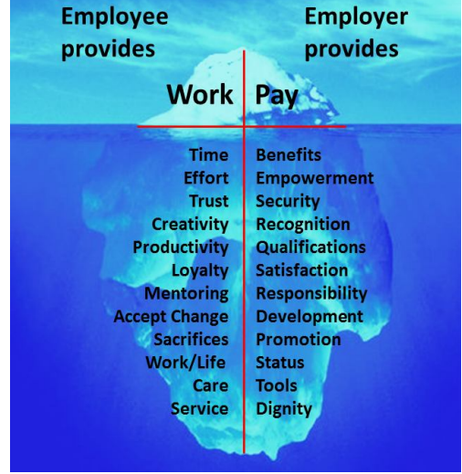
(Fig 3.) The Iceberg Model of Psychological Contract. (Source: aujournals.com)
Consequently, SainCo as a forward looking traditional organisation could use the concepts of a simple and uncomplicated psychological model known as the ‘Iceberg’ Psychological model as shown in Figure 3 above. Showing the formal and perceived contract provided by the employer on the right side and the employee on the left side. The connection of SainCo’s employees starts from the point of recruitment and interview with the perception of what is expected as work in form of time and effort put into work, creativity of the employee, their loyalty, willingness to accept change, care, service, work-life balance, which leads to productivity and helps engagement. In return for job done, sainCo provides Benefits, reward, job security, empowerment,training and development, promotion and dignity at work. In summary, the factors above the sea level is the contract the employer and employee provides each other and the factors below sea level are the perceived contract which is the psychological contract that is invisible however is perceived.
ENHANCING EMPLOYEE ENGAGEMENT AT SAINCO:
Translate strategy into action using the Balanced Scorecard framework:
The Balanced Scorecard (BSC) framework according to Robert Kaplan and David Norton is a method that effectively interprets an organisation’s vision and mission into a practical operational plan of action. Looking back in history, an article in the Harvard Business Review by Kaplan and Norton (generally known as the architects of BSC) identified how during a ‘leading edge of performance measurement’ research project which lasted over a year, they came up with a ‘balanced scorecard’ intended to provide managers with a set of comprehensive measures for understanding their business (Kaplan & Norton, 1992). Hutchinson (2013) pointed out that it was foreseen as a performance measurement tool initially, and later developed as a strategic management system for linking organisational long-term strategy to individual and business objectives. By complimenting financial measures with operational measures, customer satisfaction, internal processes and innovation activities (Kaplan & Norton, 1992); moving away from traditional performance evaluations which is based on financial measures, to a more holistic view of performance (Hutchinson, 2013). Figure 4 is a general overview of a balanced scorecard.
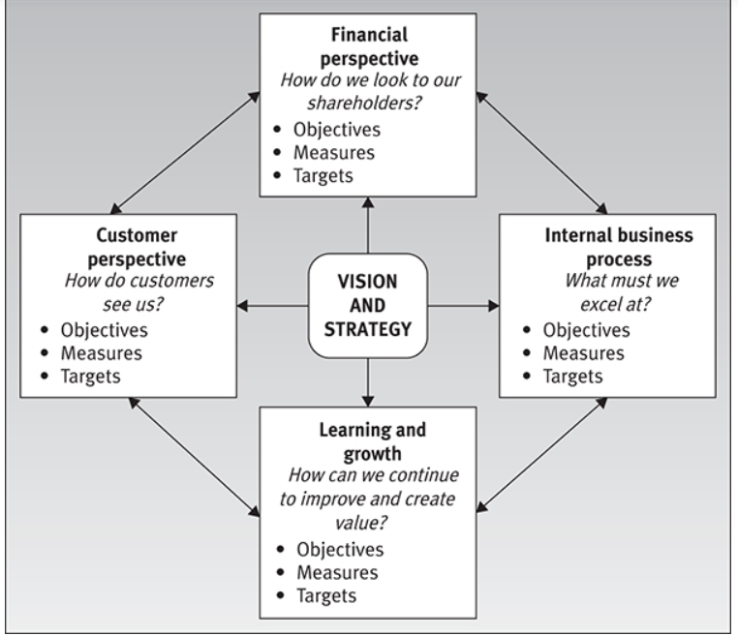
(Fig.4) A Balanced Scorecard. (Source: Kaplan and Norton 1996)
Therefore, it can be suggested that the BSC could help SainCo communicate the business end goals and overall strategy to the employees, align all day-today activities in all the ten locations, prioritise projects (for example, adapting the modern performance management concept), and continuously measure and monitor all the activities for added value to the organisation. It is suggested that SainCo may consider the four aspects of the BSC illustration in Figure 4 by, looking at the financial perspective of their retail business which would facilitate achieving organisational goals, choosing the internal business process to focus on, developing skills within SainCo for future purposes and becoming more customer focused.

Training, Development and Motivation:
The AMO model (Ability, Motivation and Opportunity) is an important model to training and development and motivation of employees in an organisation. The model was first introduced by Bailey in (1993) and developed by Applebaum et al in (2000). Research has found that it has become a frequently used model for deciding on the human resources policies will be effective and to implement and have a positive impact on employee performance (Hutchinson, 2013). Hutchinson went further by breaking down the 3 parts to the framework; 1. Ability, which is influenced by recruitment and selection process, making sure that competent employees are selected before progressing into learning, training, and development. 2. Motivation, which ensures that there are extrinsic and intrinsic rewards from performance review, encouraging feedback leading to training and development, and secured job roles that facilitates work-life balance. 3. Opportunity, which is determined by teamwork, engaging in new plans, communication, self-reliance, rotation of jobs, outlining high-performance working practices in organisations. Figure 5 shows the factors discussed above encouraging employees to show positive discretionary behaviour (middle section) for improved employee performance.
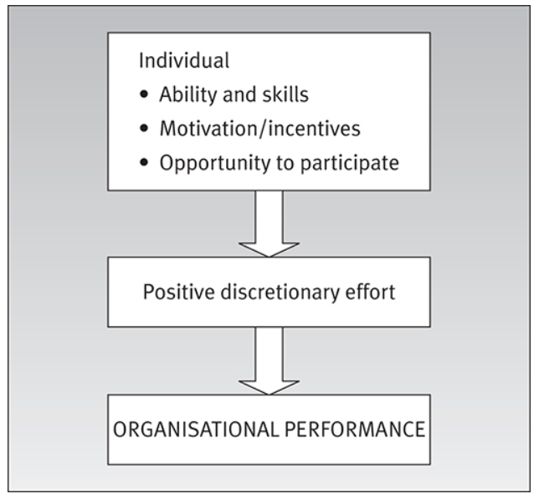
(Fig. 5) The AMO model of Performance. (Source: from Performance management by S. Hutchinson – adapted from Applebaum 2000).
Equally important are the role of line managers in managing performance in organisations, specifically at SainCo being the specific company of discussion. It is suggested that the line managers at all the ten locations may adopt the role of the company’s HR agent to mediate the message of the change in the way the employee’s performance measures would be changing. CIPD (2008) suggests that coaching in organisations provides organisational and employee benefits such as incresed individual performance, effective communication process, increse in productivity, much clarity on goals and objectives, efficient knowledge-sharing processes, increase in creativity, improved employee engagement and efficient and effective leaders.

CONCLUSION
In conclusion, it can be seen that there is a lot more to Performance Management than taking employees through the end of year review and appraisal for the purpose of promotion, pay review or dismissal. It is evident that Performance Management is a key factor in influencing organisational efficiency despite arguments regarding the weather organisations should abide with the traditional practices or adopt the contemporary practices of performance management. Research has shown that organisations are better off combining the best aspects of the existing form of appraising their staff with the modern practices for the benefits of their employees, for long-term sustainability and productive growth.
Evidently, research has shown that many are proposing the application of modern practices of performance management, others are still arguing that the traditional appraisal should still be applied hence most are choosing the best part of both in alignment with the organisational goals, objectives, vision, and mission. The changes that organisations are making to the ay appraisals is done can be called experimental in some cases however, the new pattern of performance management is emerging.

RECOMMENDATIONS: SHORT AND LONG TERM
In summary, below are suggested recommendations in form of actions that SainCo may consider taking going forward with the new Performance Management practices to enable the organisation to achieve its competitive edge in the business world. These recommendations are broken down into short-term and long-term actions.
SHORT TERM:
- Ensure employees understand the reason for the changes from the traditional once in a year appraisal to a modern and more holistic measurement practices.
- Discussions with line managers from all ten locations to have them on board so that there is easy communication to other employees.
- Set out immediate training for identified gaps for line managers and other employees.
- Be empathetic towards employee concerns about the changes.
- Clear process of the new concept through effective communication and making information about the organisational operation transparent and ethical.
- Coaching and mentoring to be provided through the line managers.
- Provision of training and development formally and informally.
- Performance review to be done periodically rather than once a year.
- Encourage feedback and teamwork.
- Performance management practices to be monitored and evaluated constantly to measure its effectiveness and success.
LONG TERM:
- Adoption of AI and automation and redesigning work processes which could lead to a reduction in specific routine tasks especially where there is high physical closeness (Lund, et al., 2021).
- Long-term training and development of all employees to acquire mor skills.
- Paying employees, the right salaries for long-term sustainability and retainment of employees.
- Continuous interest in employee wellbeing and mental health for work-life balance.
- Opportunities for employees who are not performing well to have access to training and skill development to avoid attrition.
- Availability of long-term career development for all employees should be conducive to the changing business environment especially at the current time of recovery from covid-19.
- Adapt the review system to the contemporary ways of working by changing from analysing productivity and salary review to a more holistic and sustainable concept for the future.

REFERENCES

Amanchukwu, R. N., Stanley, G. J. & Ololube, N. P., 2015. A review of leadership theories, principles and styles and their relevance to educational management. Scientific and academic publishing Journal, 6(14), pp. 6-14.
Armstrong, M., 2018. Armstrong's handbook of performance management : an evidence-based guide to delivering high performance. 6th ed. London; New York: Kogan Page.
Armstrong, S. & Mitchell, B., 2019. The Essential HR Handbook. 1st ed. Newburyport: Career Press.
Capri, R., Douglas , J. & Gascon, F., 2017. Performance management: Why keeping score is so important, and so hard. McKinsey&Company, 4th October, pp. 1-11.
Chaubey, D. S., Thapliyal, S. P. & Bisht, S., 2015. Analysis of Psychological Contract at the Workplace: A Cluster Analysis. Journal of Management Convergence, 6(2), pp. 1-55.
Cho, I. & Payne, S. C., 2016. Other Important Questions: When, How, and Why Do Cultural Values Influence Performance Management?. Industrial and Organisational Psychology, 9(2), pp. 343-350.
CIPD, 2008. Coaching at the sharp end: Developing and supporting line managers as a coach, London: Chartered Institute of Personnel Development.
Darino, L. & Johnson, C., 2020. McKinsey & Conpany: From me to we: the next shift in performance management. [Online]
Available at: https://www.mckinsey.com/business-functions/people-and-organizational-performance/our-insights/the-organization-blog/from-me-to-we-the-next-shift-in-performance-management
[Accessed 29th April 2022].
DeNisi, A. S. & Murphy, K. R., 2017. Performance Appraisal and Performance Management: 100 Years of progress?. Journal of Applied Psychology, 102(3), pp. 421-433.
Ewenstein, B., Hancock, B. & Komm, A., 2016. Ahead of the curve: The future of performance management. McKinsey Quaterly, 2 May, pp. 64-73.
Fries, A., Kammerlander, N. & Leitterstorf, M., 2021. Leadership Styles and Leadership Behaviors in Family Firms: A Systematic Literature Review. Journal of Family Business Strategy, 12(1), pp. 1-16.
Hughes, R., 2020. ITProPortal: There’s no time for change management during Covid-19, but there must be time to change management. [Online]
Available at: https://www.itproportal.com/features/theres-no-time-for-change-management-during-covid-19-but-there-must-be-time-to-change-management/
[Accessed 29th April 2022].
Hutchinson, S., 2013. Performance Management: Theory and Practice, London: Charered Institute of Personnel Development.
Kaplan, R. S. & Norton, D. P., 1992. The Balanced Score Card - Measures that Drive Performance, Boston: Harvard Business Review.
Keegan, A. & Den-Hartog, D., 2018. Doing it for themselves? Performance appraisal in project-based organisations, the role of employees, and challenges to theory. Human Resource Management Journal, 29(2), pp. 217-237.
Khan, M. S. et al., 2015. The Styles of Leadership: A Critical Review. International Institute for Science, Technology and Education E-Journals, 5(3), pp. 87-93.
Khan, Z. A., Allah, N. & Khan, I., 2016. Leadership Theories and Styles: A Literature Review. Journal of Resources Development and Management, 16(1), pp. 1-7.
Lund, S. et al., 2021. The future of work after covid-19, USA: McKinsey & Company.
Radnor, Z. J. & Barnes, D., 2007. Historical analysis of performance measurement and management in operations management. International Journal of Productivity and Performance Management, 56(5), pp. 384-396.
Robertson-Smith, G. & Markwick, C., 2009. Employee Engagement: A review of current thinking, Brighton: Institute of Employment Studies.
Sachdeva, G., 2020. Impact of Psychological Contract on Employees’ Performance: A Review. In: E. Baykal, ed. Handbook of research on positive organizational behavior for improved workplace performance. Hershey, Pennyslvania: IGI Global, pp. 12-20.
Scrima, F., Lorito, L., Parry, E. & Falgares, G., 2014. The mediating role of work engagement on the relationship between job involvement and affective commitment. International Journal of Human Resource Management, 25(15), pp. 2159-2173.
Singh, P. & Twalo, T. G., 2015. Effects Of Poorly Implemented Performance Management Systems On The Job Behavior And Performance Of Employees. International Business & Economics Research Journal, 14(1), pp. 79-94.
Tait, B., 2020. Traditional Leadership Vs. Servant Leadership. Forbes Coaches Council, 11th March, pp. 1-2.
Taubert, R. P., 2018. Companies House: Running a family business. [Online]
Available at: https://companieshouse.blog.gov.uk/2018/11/16/running-a-family-business/
[Accessed 27th April 2022].
Topcic, M., Baum, M. & Kabst, R., 2016. Are high-performance work practices related to individually perceived stress? A job demands-resources perspective. The International Journal Of Human Resource Management, 27(1), pp. 45-66.
Torrington, D., Hall, L., Taylor, S. & Atkinson, C., 2014. Human Resource Management. 9th ed. Harlow: Pearson Education Limited.
Vance, R. J., 2006. Employee Engagement and Commitment: A guide to understanding, measuring and increasing engagement in your organisation. 1st ed. USA: SHRM Foundation.
Walia, S., 2014. Barriers to effective performance management. Internetional Journal of Current Research, 6(11), pp. 9896-9902.
Wong, W., 2022. The Psychological Contract, London: Chartered Institute of Personnel Development.

