Cursive is Humanity

Rachael May Williams
Student Number - 1703699
BA Hons Graphic Design
Word Count – 5544
Tutor – Donna Williams

Submitted in partial fulfilment of the requirements for the degree of BA (Hons) UWTSD, Swansea, and the date of presentation.
Table of Contents
Topic Summary
Page 3
Introduction
Page 4
History of Handwriting
Page 5
Why is handwriting important
Page 8
How we learn
Page 12
What is happening in schools today UK, France and USA
Page 15
How hand drawn type is coming back
Page 19
Conclusion
Page 27
Bibliography
Page 29

Topic Summary
I chose this topic to write about because it fascinates me how everyone is taught the same in school, following a print-out dot to dot letter and then form their style of handwriting. Some people's handwriting is similar but never identical and for over 7 billion people in the world, it amazes me. I will also be looking at how the use of digital means of learning has overtaken traditional methods of writing down information.

Is the increase of technology a good thing in the modern day and age when it comes to teaching children? In this independent inquiry I explore the decrease of handwriting and how a new digital age is taking over. Artists and designers are moving with this evolving way of working, but is that making hand drawn/written typography more of a luxury product? I will look at evidence both for and against the argument that handwriting is dying out, and then conclude with my own thoughts and opinions based on the research I have done.
1. Introduction
The use of chalkboard signs, handwritten adverts and messages are becoming more frequent with smaller businesses; it gives the reader a sense of personality over the more rigid, slab serif or san serif fonts utilised by their corporate rivals. But that is the very few, and not everyone appreciates this form of art, some people will take a picture of a beautifully handwritten sign and others will just walk past like they haven’t even seen it. The perks of a handwritten sign are far outweighed by the efficiency of mass printed alternatives. It would be far quicker to make 100 printed signs than it would be to make 100 handwritten ones. We live in a modern time, and everything can be faster and somewhat cheaper on a computer, but that takes some of the love out of handwritten typography.

Throughout history, we have always looked for faster, more efficient ways of transporting information across greater distances. This has been explored a number of ways, from signal fires on the Great Wall of China, to semaphore flags that communicate messages from ship to shore; the invention of morse code - literally sending a message from one destination to another letter by letter, to the use of electrotonic mail. An indisputably faster way to send a message by comparison. However, through this way of communicating, the art of handwriting letters is in decline. In this dissertation I will be investigating how handwriting is taught, why is it not keeping up with modern technology and how it is evolving with the constant changing world.

2. History of Handwriting
“Writing is one of mankind’s most enduring technologies. For fifty-six hundred years, this ability to transmit thoughts over generations, to give instructions to express ourselves to communicate ideas has allowed us to make vast strides in our understanding of the universe, our understanding of each other, and our understanding of ourselves.” (Hensher 2013)

Informally, we can think of information as a message, stored or transmitted, using different mediums and different platforms. When painting, the artist is representing a message using a continuous pattern, with a seemingly endless number of possible forms. You are free to express yourself. When humans began developing writing systems, we naturally had to divide our world into a finite number of atomic units that we express using symbols. Any written language can be thought of this way. Messages are formed by arranging symbols in a specific pattern. This began with Egyptians inventing hieroglyphs, which progressed into a system of 26 symbols in agreement with signs. The principle of the consonant alphabet widely accepted by 2000bc, creating the very foundation of what governs commination as we know it today.

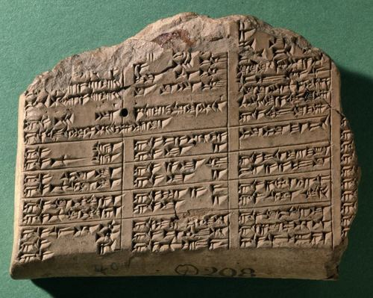
Figure 1 - Ancient Cuneiform (Mark, 2018)
Wedge-shaped tools called ‘cuneus’ applied to clay produce a form of writing called cuneiform. A form of writing that only contain about two dozen distinct letters.
“Cuneiform is a system of writing first developed by the ancient Sumerians of Mesopotamia c.2500-2000bc.” (Mark, 2018).
Scribes are trained at special schools, performing exercises in writing over and over again, much like how we were taught in school. Ira Spar (2004) writes:
“It constitutes the beginning of a true writing system characterized by a complex combination of word-signs and phonograms—signs for vowels and syllables—that allowed the scribe to express ideas.”
This form of writing needed a lot of skill as it was set into the clay which can be very hard to work with, but this form of written commination was used until 2000 B.C, where it was replaced by a language that used pictographic tablets.
The development of alphabets resulted in a Phoenician alphabet with 22 consonants around 1000bc. Other writing systems quickly follow, including Greek, Hebrew, Arabic, and others which have not survived. All of these demonstrate the personal ability to write letters, as well as carved or engraved forms. From this point on, it’s all handwriting.
The way we write today is completely different to how we wrote 100 years ago; the language has changed but the letters have stayed the same. The way handwritten letters are now and the way we comminute could still change in the future. We are a species who are always looking to improve what we already have. Is the takeover of technology just the same as when paper took over from leathers and animal skin?
3. Why is handwriting important
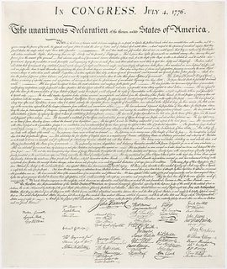
Handwriting is important because it reflects each individual person, we’re people not machines. The world deems each person to have a digital foot print, but couldn’t it be said that we have a cursive footprint as well.
Figure 2: The Declaration of Independence (Geerkens, 2017)
The Declaration of Independence, which historians believe was engrossed by Timothy Matlack, is a work of art in itself. It was handwritten instead of type set, not only because it’s harder to duplicate, but also because there was more significance to a handwritten, legal document when typeset was the norm for the era. They had the ability to type set this important document, but they chose to physically handwrite it to show its importance. The gravity of the situation, that putting pen to paper would change the world as they knew it, needed to be realised. For this, a handwritten document was much more substantial.
“That task merited a more hallowed document than a typeset sheet — a handwritten one, penned by a scribe. As importantly, it called for accountability from the men who endorsed it. Diethorn says the Declaration of Independence served as a roll call for the men who supported the revolution and, consequently, treason against Britain. Including all those signatures on a handwritten page was appropriate for the significance of the dangerous commitment they'd made to revolution.” (Edwards, 2015)

This could be considered evidence to suggest that even when more advanced technology existed, handwritten methods still had their place. Although current day digital printing has replaced hand written methods, it still has its place. Writing down a shopping list, writing a birthday card, taking down a phone message, handwriting is part of our daily lives. In recent years, modern technology has dramatically changed the way we communicate through writing. However, despite the increased use of computers for writing, the skill of handwriting remains important in most schools, employment, and everyday life.

Oscar, Saunders (Handwriting, 2019) an A-Level student, has had problems with the legibility of handwriting for some years, he has been permitted to use the keyboard to write his exams. However, for him, this does not solve all his problems although it may make his scripts easier for the examiners to read.

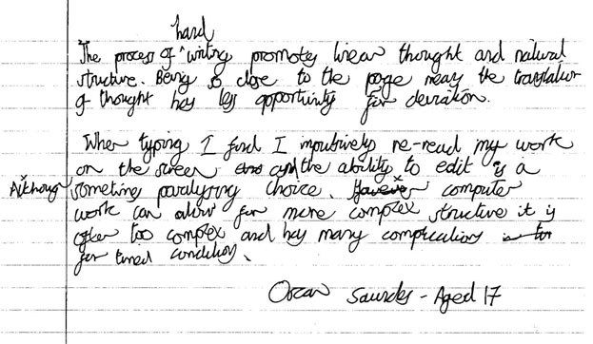Figure 3: National Handwriting Association (2019)
“The process of handwriting promotes clear thought and natural structure. Being so close to the page means that translation of thought has less opportunity for deviation.
When typing I find I compulsively re-read my work on the screen and the ability to edit is sometimes paralysing, although computer work can allow for more complex structure, it is often too complex and has many complications for timed conditions. - Oscar Aged 17 years (National Handwriting Association, 2019)

Handwriting is almost as personal to you as your finger prints. It is so much more personal to receive something from a loved one that is personal; a hand signed birthday card means so much more than a printed one from an online store that’s sent straight to the front door. There are additional benefits to digital alternatives however, such as efficiency.

Maybe for education, computer screens are faster, but when typing something in to a word document you aren’t absorbing the information as you would when writing with a pen to paper. That brain to muscle connection is not the same when typing on a keyboard.

Cursive handwriting is proven to achieve the same brain development levels as when learning to ride a bike or drive a car. It’s all linked to the connection from brain to muscle, and it becomes natural after time. When writing a letter and looking at your handwriting, you are somewhat proud of what you have done. There’s more personality, and more of an emotional connection in what you have done compared to just typing in to a computer, just as when you are a child a you’ve completed your first painting or your first letter to Santa, you cannot wait to run home to show your parents. This is not too dissimilar to the reasoning behind having the Declaration of Independence scribed – the humanity of the written word was important.

4. How we learn
“Neuroscientists and psychologists are beginning to raise questions about whether handwriting has unique value. Studies indicate that children who learn to write by hand well (and before they learn to write via keyboard) learn to read quicker, retain information better, and generate ideas easier”’ (Learning Liftoff, 2018)

When being taught handwriting in school’s there are a lot of factors that we don’t think of; penmen ship, how the paper is laid out in front of us and how we sit when we are writing something important. When we were younger, it was taught to us the same way. There were right and left-handed people but every child in that classroom was given the same tools to learn how to write. So why is everyone’s handwriting different? Understandably, everyone is different and not everyone’s brains and bodies work the same way. Children’s handwriting is often messy, not on the line, a bit hard to read but often children’s handwriting looks similar. It’s not until a couple of years down the road of education does everyone’s induvial style develop.
“What is learned about handwriting in the early days at school will affect children for many years to come. Providing enough priority is given to skill training and handwriting is taught systematically but imaginatively from the start of formal teaching.” (Sassoon, 1995)

The first thing children are taught to write in school, after basic letters and shapes, is their name. Usually, it would be printed in an easy font to read, with no sharp edges for the child to then trace.

We use handwriting to communicate language. “The First Drawing” by Mordicai Gerstain, tells the story of a stone age boy frantic to show his family what the mammoth he has seen looks like. His cave drawing is viewed as remarkable. From early days, symbols have been established to represent our spoken language and allow us to converse and keep information stored on a physical thing. Learning to write should be like magic for children, that their written work, through pictures/drawings or otherwise, communicates their ideas to many others. It is a very natural process to want to put pen to paper. From very early on, man has felt the need to make marks.

A Child ability to form letters while learning needs to be closely monitored, to prevent them from making bad habits. If them bad habits are left unchecked, they can be difficult to “unlearn” and hold back their developed of joined handwriting. A lot of practice is required for a readable formation of letters to become automatic, or almost thoughtless. Developing fluent handwriting is key to enabling them to write at greater speed. So, they can concentrate more on the content and quality of their writing and not forming letters.

Good handwriting says a lot about your child’s personality and confidence levels. According to Dr Anita Gautam (2017), “Handwriting is the mirror to a person’s personality. A lot can be understood by only looking at the handwriting of a person. If the writing is sloppy and filled with spelling mistakes, it shows the writer is a lazy and careless person. You have to put in effort to have good handwriting.”

There are so many benefits of teaching handwriting to children and it is a sad reality that technology is taking over. It is easier for the teachers to teach in some respect but there is no individuality in typing words into a computer. Research shows that cursive handwriting helps students with dyslexia, a disorder that makes it different to interpret letters and words. It boosts memory, hand-eye coordination and stimulates brain development, which is something that would benefit people who struggle with interpreting words and letters. “Some of the most recent research in the fMRI studies is showing us that when the hands are involved, it’s a stronger association for learning and memory. When people write things, they remember them longer.” Marilyn Zecher (2014). This means the slow decrease of cursive handwriting being taught in school is not going to help these children who struggle with dyslexia. Cursive handwriting supports the growth of learning because it helps facilitate deeper and more critical thinking. Dyslexia is a language processing disorder that can hinder reading, spelling, and writing but this research shows that cursive handwriting helps with the learning and growth of the person who is struggling with it.
5. What is happening in school today UK, France and USA
The teaching of writing is often early in most nursery schools, sometimes even in the first year of kindergarten. But it is especially in the second year of school that this teaching takes its place. First, capital letters are discussed. Easier to draw, they allow pupils to quickly write meaningful words, firstly their first name. This passage through this type of writing before addressing the cursive writing required by the curricula may seem unnecessary to some since it will not be the usual writing. However, it offers many advantages, it makes it possible to awaken pupils' interest in the written language, their pride in writing their first name, whose importance is known for the development of the self-image, it facilitates the tests of writing, as it is now required in curricula. In addition, thanks to adapted situations, the teacher can lead them to acquire knowledge on the functioning of the written language: respect for the order of letters, the trajectory of writing, name, and sound of letters, visual discrimination, correspondence between the written channel and the spoken channel. Margaret Brown stated in her article (2018) that:
“The earlier children master handwriting skills, the better they will do academically. Despite that fact, however, more and more schools find it difficult to ensure that there is adequate time for handwriting instruction. In fact, 85 percent of teachers do not learn how to teach handwriting. So, it may not be a surprise to learn that 10-30 percent of elementary school students struggle with handwriting.”

Handwriting has changed in the way children are taught in schools today. Blackboards have been changed to interactive smartboards. Most notebooks have changed to laptops and iPads. But is this a good thing? The fact that typing on a computer is taking over handwriting is making everything faster, from the way we take notes to communication. Schools are putting more money into technology than putting the hours in to teach children how to write with a pen and paper. Children are familiar with spell checkers on their computers, most children don’t know how to spell. The physical act of handwriting boosts kinaesthetic learning, therefore, the child writing will learn how to spell instead of a computer telling them the word is wrong. “As someone practises/practices(AmE) handwriting, they’re becoming accustomed to the fluid motions designed to craft each letter. Over time, creating these letters becomes an automatic response, much like muscle memory.” (Mest, 2019)
On a Facebook post for UK teachers I asked the question: ‘As a teacher of young children, do you think cursive writing is still relevant to teach in this age when technology is taking over?’ the response was mixed. Sarah Thomas wrote, “pushing for cursive handwriting in primary school (because no one cares once out of kS2), is utterly pointless and actually quite damaging”, (Thomas 2019), then she continues to say that it is out dated and a lot of children struggle with handwriting in schools.

My thought on this matter led me to consider that people are getting lazy with the way that we teach children. I understand that some children struggle with writing, but does typing on a keyboard teach the children anything? Was this the case when the older generations were in school? If they were struggling, there was no way out; they had to learn cursive handwriting as there was no other choice. Gone are the days when students had designated writing classes, in which they used workbooks with dotted lines to practise forming the perfect loops for Ls and Ys under the watchful eye of their teacher.

Some believe cursive writing is no longer a necessary skill and wastes valuable teaching time. Shilo Stagg, a mother in the USA isn’t happy that cursive handwriting isn’t being taught in her daughter’s school, so she decided to teach her daughter herself, "I teach Lexie how to write myself, but a few people I know think it’s a waste of time. I don’t think it’s a waste of time. I think it will be useful for her and I can’t believe the schools don’t teach it anymore.” Shilo Stagg (2018) says. As schools are putting more of their money and effort in to technology, a lot of parents are having to teach their own children handwriting, as some think it’s still important in this day and age and are not ready for technology to take over. According to The Labrador Voice (2018) “While the curriculum does not include cursive writing as a mandatory learning expectation, cursive writing is included as an example of how a learning expectation in achieved.”

In France, children are expected to use cursive as soon as they start to write in kindergarten. But a quarter of the French pupils who were taught cursive exclusively and were still using it in the fourth grade, had largely abandoned it for a mixed style by the fifth grade. They had apparently taken on a manuscript style from their reading experience since it more closely resembles print, even without being taught it explicitly according to Philip Ball (2016), “So, whereas some American schools aren’t teaching handwriting anymore and are just relying on computers and keyboards for teaching, French schools expect students to use it. The cursive form is virtually universal and highly standardized.”

Not teaching cursive writing is disconnecting people from the past. When doing research, I was shocked to find out that some children can’t read handwritten letters. So, what happens if you wanted to learn about your past and find a handwritten letter that a great-grandmother has written, and you can’t read it on your own? There is an emotional side to handwriting and people do not think about that when they take it out of the school curriculum.

6. How hand drawn type is coming back
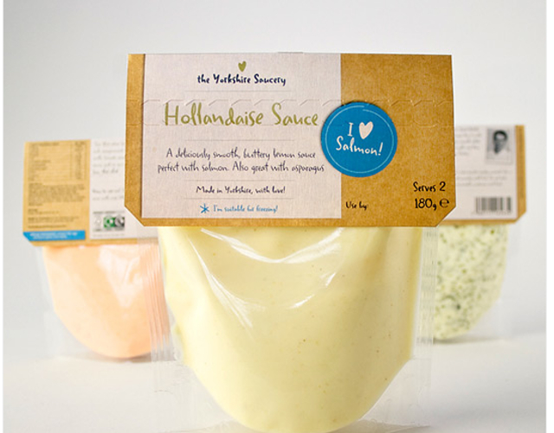
A lot of designers, illustrators, and art directors are struggling to stand out in a digital age, so they want to make themselves seen by bringing back hand-drawn typography and it is becoming a growing trend in print and digital media. These fonts, however similar to handwriting they try to be, they do not have the character or variation each time a letter is written. The flaws, the imperfections are in essence humanity, and you cannot get the same feeling and effect from a look alike handwritten font. It is very uniform unlike real handwriting which isn’t constant, there are some similarities in the letters but not one is identical. Calligraphy used on addressing a wedding invitation signifies that is it is a luxury item, however a similar effect can be obtained with script fonts utilising printing techniques, such as spot UV or sliver foil. The usage of hand-drawn typography does have its place. It communicates formality with distinct references to the past. This “old-fashioned” feel can bring up sentimental emotions of long-lost love notes for example.
Figure 4 – Hollandaise (Conti, 2018)
The choice to use a handwritten style on the packaging in Figure 4 makes it feel so much more personal than if it was in a more modern font such as Helvetica. It has the same feeling as an old cookbook that your nan wrote the recipe in and was passed down to you. It feels like it was made with love instead of mass produced in a factory. It is still not authentic, but is this the new form that handwriting will take? We now have the technology and ability to turn handwriting in to digital fonts. Having your own personal handwriting as a font that can be shared and disrupted digitally, it encapsulates your penmanship and brings it forward in to the digital age, taking what is now considered a primitive method of communication and making it digital could be the new progression of handwriting. This however does rely on handwriting being taught in the first place.

The same goes to shop signs, instead of buying printed window stickers a lot of businesses are getting a typography artist to draw on the window which also gives you a feeling of love and the fact that time and effort has been put into the advertisement, especially when the typography artist can add their flair to the often boring view of windows that are on the high street, it can be a beautiful thing. It would draw in people and a lot more walkers by would stop and read what it says.
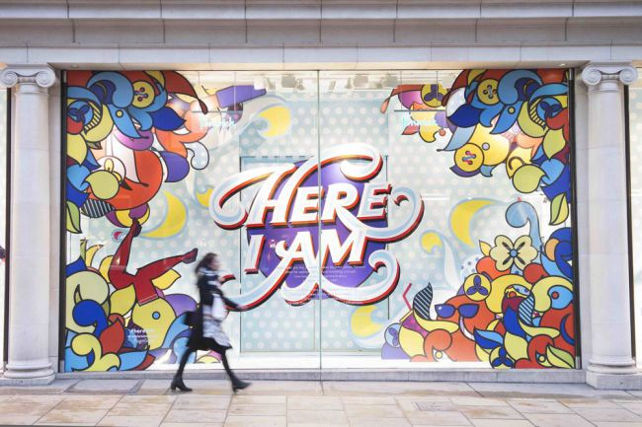
Figure 5: Typographic Window Display (Maine, 2015)
Creative studio ROBU were invited by Fenwick of Bond St. (ROBO, 2015) to create the branding and window installations for its first campaign of 2015. It is bright, stands out and has the artist, Andrei Robu, own personal flair. The inspiration was taken by Fenwick himself, the man shouted ‘I am here’ as took his first steps into his store on Bond Street. Fenwick is a luxury fashion store and the shuttle involvement of buttons, legs with tights and shoes on and other clothing items just makes this window display so fun and easy to change the physical clothing display behind it. The handwriting element of this display is bold and would make you stop. It is beautifully done, with the contrast of colours. The mix of uniform lettering and the curves that look to be inspired by cursive handwriting brings together a style that a lot of hand typographers do to make they’re work look neat and easier to read for the viewer.


Starbucks have also jumped on the handwritten sign bandwagon that most independent coffee shops are doing. White chalk on and blackboard, which brings back the feeling of handwritten, but also to simpler times of writing a message for a lot of people to see such as in a classroom where a lot of eyes would have needed to read what was written on the board. Jaymie McAmmond and award-winning freelance graphic designer and illustrator based in Toronto did the coffee shops chalkboard art shown in Figure 6. The retro-style infographic depicts how to enjoy freshly ground Starbucks coffee from the comfort of your own home.
Figure 6: Starbucks (Maine, 2014)
The thing with handwritten signs, advertisements, and memorials no two are the same and that makes it so special. People like different in this day and age where everything is similar, many like to be unique and handwritten signs work hand in hand with that which therefore draws people in and gets their attention. There is still a market for the ‘vintage’ way of designing, bring the old way of advertising back into modern times and proven to be popular and now becoming the ‘norm’.

In a society obsessed with technological advancement, it takes extreme passion to save a dwindling artform. In the Civil War era, good handwriting was a sign on success, but as we know in modern day, we have traded that skill for laptops and iPads, however there are people who are mastering penmanship. "One of the longest, oldest romances is between the eye and the hand," Weidmann (2015) explains in a YouTube video. He goes on to talk about how he loves what is now considered a dying artform. There are only 12 living master penmen in existence, Weidmann being the youngest. A master penman is a title given to those who had a distinguished level of superiority in penmanship and the calligraphic arts. During the golden age of penmanship, from the Civil War on, penmanship were your ticket to success in business. There were penmanship schools and the way they would graduate was to create their own certificate and only the highest quality they were given the master penman title. Weidmann (2015) continues to say, “there is so much self-expression in it that it is seen as an art form, but it serves a functional purpose.”

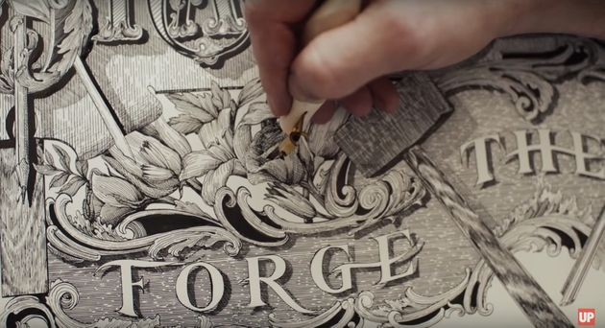
Figure 7: Master Penman (Frank, 2015)
The way Wedimann using his calligraphy skills in with fine art is beautiful. The distinction between language and image starts to blur as the penman renovates every letter into a hypnotic arrangement of shadow and line. Each piece he creates in memorising.

Another way hand drawn type is coming back is in the form of digital art. A lot of typographers are looking for modern ways of show casing there work and in a world of Facebook and Instagram, which are digital platforms. Even though it’s not traditional, it still shows the skill of a conventional calligrapher just with modern media. A hand lettering artist that is becoming big on the social media platforms in Ian Barnard. Even though he still uses pen to paper, he also is a digital typography artist that uses an iPad to create most of his work. Hand rendered type reminds of us of the ‘old-fashion’ calligraphy.

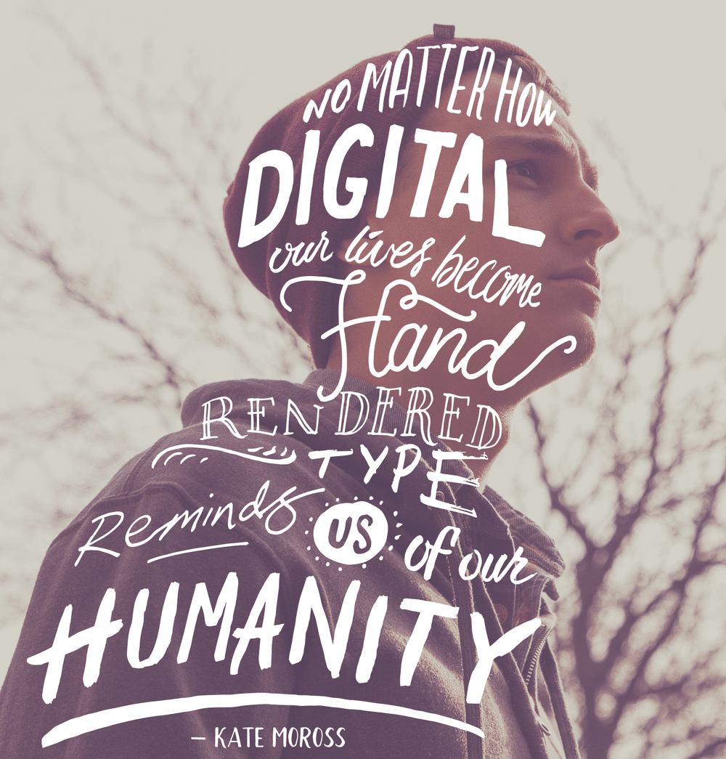
Figure 8: Humanity (Barnard, 2015)
Barnard uses an iPad app called Procreate to design his digital work. Digital art is easier in some respects as if you make a mistake you can delete it straight away instead of rubbing it out or having to start from the beginning. Also, instead of having hundreds of pens and pencils that can break and be lost in a studio they are all in one programme saved on to a computer which is easier to look for. But it does not have the same feel. When authentic handwriting has been done with pen to paper, you can see the slight indent in the page that it’s written on, where the pen flows and a little bit of ink doesn’t hit the page. Even though that is mimicked extremely well on procreate, you can tell it’s digital. But in this day and age where technology is taking over this is a good thing? Artists are moving on with modern time but still using their artistic skills. Is a screen much different to paper when it comes to this type of art? With this art you still get a personal feel to it as it is hand drawn and rustic, there is still the slight mistakes that happen when drawing on an actual canvas or paper. Looking back at the hollandaise sauce packaging (Figure 4), this style of designing would have given it a more personal feel rather than it being a font that imitated handwriting. This could be the future of keeping the creative people still doing what they love but keeping up with the forever evolving technology.

7. Conclusion
Is cursive handwriting lost in modern times? I think it is, but there is a new era of calligraphy coming through, ink to paper is dying but the new age of stylus to screen is taking over. I think that isn’t quite the same, but the art of handwriting is still there. Even though, I use the iPad app procreate to create some of my work, I still feel like it isn’t the same as pen to paper. This is a way to keep cursive handwriting alive in the modern day and it’s brilliant. People are so attached to social media, designers have a new way to show the skill they have with ease, and people are responding and liking it.

With the raise of technology, the uniqueness of sign-writing typographers are growing and that is a good thing. It’s bringing back an old way of advertising and showing off what skills the artist has. The authenticity makes it individual and unique. People are starving for this image and sense of gifted craft. But that doesn’t go to say that printed advertising is not good or well designed. It’s a different skill, and they are both needed in today’s world.

All that said, the fact that some schools aren’t teaching cursive handwriting, let alone just normal handwriting, is unforgivable. It’s like handwritten letters are like becoming cave man carvings to the new generation of this world. After researching the benefits of handwriting and how the brain connects to the word more and you learn the spelling and don’t have to reply on spell checker which is on the computer, it baffles me how it is being taken out of the school curriculum. You have a sense of pride in what you have done, you do not get that with type on a computer. Even though some children who struggle with handwriting, and it would be beneficial for them to learn and write on a computer screen, that is completely plausible. Understandably, they are putting their money in to teaching children about computers and that is what children need in the modern day, but the scary fact that some children can’t read a handwritten note is frightening. Researching about cursive handwriting, all the archive’s I came across of people writing love letters to each other, or letters of importance. The fact that in say as little as 10 years, children who are the future of this world will not be able to read what their ancestors have written, it hit home when I found a poem that my mother wrote when she was my age, and if I couldn’t read that I would have felt so disconnected from her, it’s a snippet of her past, of her memory, it’s my family’s history and to have the ability to read that I am grateful that I was brought up when I was and not today as I might not of had that luxury.

As I said earlier, we are humans we are not machines. Computers can crash and everything can be lost at a touch of a button, but there are handwritten documents that have stood the test of time and that says so much. People are starting to rely on computers too much. Yes, it is faster in now a day and age to send an email instead of writing and posting a letter, and yes, sending an email more efficient and can get out to a lot more people than one handwritten letter can. Understandably, not everyone’s handwriting is easy to read, but everyone can read a sentence typed in ‘Helvetica’ but there is no personality in that. Looking at an age where handwriting is all that there was, to now where it is rapidly decreasing and not being taught in some schools is understandable but still very sad to see. Writing is seen as expressing our personality. With what we are writing, the mistakes that we make, the miss shaped letters, not one ‘a’ looking like the next. Every one of this earth has their own personal handwriting. Everyone’s handwriting is unique, but we are all taught the same way. With more than 7 billion people of this earth, just like our brains and personalities, our handwriting is a reflection of us on paper and should we throw that away?

Bibliography
Books

Hensher, P (2013). The Missing Ink: The lost art of handwriting (and why it still matters) (Accessed at: 7 November 2019)

Sassoon, R (1995). Handwriting: The way to teach it. (Accessed at: 2 November 2019)

Websites
Spar, I. (2004) The Origins of Writing. Available at: https://www.metmuseum.org/toah/hd/wrtg/hd_wrtg.htm (Accessed at: 3 November 2019)

Edwards, P. (2015) They had printing presses in 1776. So why was the Declaration of Independence handwritten? Available at: https://www.vox.com/platform/amp/2015/7/29/9061831/declaration-of-independence-handwritten (Accessed at: 16 November 2019)

Mest. S (2019) 7 Ways Handwriting Improves Spelling. Available at: https://howtospell.co.uk/7-Ways-Handwriting-Improves-Your-Spelling (Accessed at: 5 November 2019)

Mullaley.R (2018) Many are shocked that students in Newfoundland and Labrador aren’t taught handwriting in school, but is it necessary? Avaliable at: https://www.thelabradorvoice.ca/news/local/many-are-shocked-that-students-in-newfoundland-and-labrador-arent-taught-handwriting-in-school-but-is-it-necessary-239941/(Accessed at: 3 November 2019)

Shilo Stagg (2018) Is cursive writing a lost art or needless skill? Avaliable at: https://www.saltwire.com/news/local/many-are-shocked-that-students-in-newfoundland-and-labrador-arent-taught-handwriting-in-school-but-is-it-necessary-239941/?location=newfoundland-labrador (Accessed at: 4 November 2019)

National Handwriting Association (2019) Why is handwriting important?
Available at: https://nha-handwriting.org.uk/handwriting/why-is-handwriting-important/ (Accessed at: 3 November 2019)

Ghosh, L (N/A) Why Writing Is Still Important For Your Child In The Digital Age
Available at: https://www.parentcircle.com/article/why-writing-is-still-important-for-your-child-in-the-digital-age/ (Accessed at 9 December 2019)

Brown, M (2018) In digital age, handwriting is still important for long-term academic success Available at: https://todaysmoderneducator.com/2018/05/08/digital-age-handwriting-still-important-long-term-success/#.Xdw7YS2caqA (Accessed at: 10 November 2019)

Zecher,M (2014) How cursive can help students with dyslexia connect the dots. Available at: https://www.pbs.org/newshour/education/connecting-dots-role-cursive-dyslexia-therapy (Accessed at: 17 November 2019)

Ball, P (2016) Cursive Handwriting and Other Education Myths Available at:http://nautil.us/issue/40/learning/cursive-handwriting-and-other-education-myths (Accessed at: 2 December 2019)

Frank.P (2015) Meet The World's Youngest Living Master Penman Available at:https://www.huffingtonpost.co.uk/entry/meet-the-youngest-living-master- penman_n_55c91007e4b0f1cbf1e60326?ri18n=true (Accessed at: 6 December 2019)

UPROXX (2015) Master Penman Jake Weidmann | HUMAN Available at: https://www.youtube.com/watch?v=KvSyQDu49pI (Accessed at: 6 December 2019)

Figures
Figure 1: Mark, J. (2018) Ancient cuneiform. Available at: https://www.ancient.eu/cuneiform/ (Accessed at: 2 November 2019)

Figure 2: Geerkens, P (2017) Declaration of Independence.
Avaliable at: https://history.stackexchange.com/questions/42320/why-was-the-declaration-of-independence-handwritten-rather-than-printed-with-a
(Accessed at: 20 November 2019)

Figure 3: National Handwriting Association (2019) Why is Handwriting Important?
Available at:
https://nha-handwriting.org.uk/handwriting/why-is-handwriting-important/ (Accessed at: 2 November 2019)

Figure 4: Conti. H (2018) Hollandaise. Available at:
https://speckyboy.com/the-beauty-of-the-hand-drawn-typography-trend-in-design/ (Accessed at: 4 November 2019)

Figure 5: Maine. S (2015) Typographic Window Display.
Available at: https://www.creativebloq.com/creativity/typographic-window-display-glass-act-11513967 (Accessed at: 4 November 2019)

Figure 6: Maine. S (2014) Starbucks. Available at:
https://www.creativebloq.com/computer-arts/5-breathtaking-typography-murals-51411638 (Accessed at: 6 November 2019)

Figure 7: Frank, P (2015) Youngest Living Penman.
Available at: https://www.huffingtonpost.co.uk/entry/meet-the-youngest-living-master-penman_n_55c91007e4b0f1cbf1e60326?ri18n=true (Accessed at: 6 December 2019)

Figure 8: Penney, M (2016) Humanity.
Available at: https://www.sessions.edu/notes-on-design/interview-with-ian-barnard/ (Accessed at: 8 December 2019)

