Student Name: Sana Quyyam
Student Number: 2312087
Link: https://github.com/SanaQuyyam/Smart-Home-Manager/tree/main
Course Title: Bsc Computing
Module: Scripting and Programming Concepts
Module Code: ACCA5036

Table of Contents
2.0 REQUIREMENT ANALYSIS 3
3.0 SOFTWARE DESIGN AND DEVELOPMENT 4
3.1 Design 5
3.1.1 Flowchart 5
3.1.2 Pseudocode 6
3.2 Implementation Decision 8
3.2.1 Data Structures 8
3.2.2 Programming Constructs 9
3.2.3 Python Modules and Libraries 10
4.0 TESTING AND DEBUGGING 11
4.1 Role of Testing in Software Environment 11
4.2 Type of Errors in Programming 11
4.3 Example of Test Cases 12
5.0 EVALUATION 13
5.1 Challenges Faced 13
5.2 Future Improvements 14
5.3 Self-Reflections 14

1.0 INTRODUCTION
The Smart Home Device Manager has been created to solve the need for a tidy and efficient solution to manage classroom devices at Bright Minds Academy. Currently, products like smart lights, projectors and thermostats are operated by hand, making it hard for employees to understand the status, location and use of these devices. This manual method can cause confusion, late detection of device problems, and even multiple versions of data in multiple rooms with the use of multiple devices. As smart devices grow in number, the ability to track them manually becomes more relevant and more substantial, thus lowering the overall efficiency of an operation in the learning environment. This software solution aims to offer a streamlined system where staff can control all smart devices from one application. It allows people to register new devices, mark them as Operational or not, scan the list, which includes all registered devices and enter their name into the search for a specific device. The system provides a single location for this information, provides visibility, and keeps device information current and available.

2.0 REQUIREMENT ANALYSIS
The Smart Home Device Manager aims to solve the operational issues that Bright Minds Academy encounters when trying to manually organise classroom devices. The focus of the system is on delivering a set of basic functions that directly meet problem requirements, with simple and usable solutions. The feature prioritisation approach that uses the MoSCoW method (Table 1) is used to ensure the most critical system requirements are completed first. The "Must Have" features form the foundation of the prototype, including the ability to add new devices, update their status, display all stored devices, and search for a specific device. Such functions represent fundamental data management functions that are crucial in small information systems where simplicity and readability levels are emphasised over complexity [1].
Table 1: MoSCow Table
Priority | Meaning | Features for your Smart Home Manager
Must Have | Essential features the brief explicitly asks for. | - Add new devices (name and room)  - Update device status (online/offline/maintenance)  - View a list of all devices  - Search for a specific device
Should Have | Important but not vital for the bare minimum. | - Input validation (e.g., stopping the user from entering a blank name)
Could Have | Nice bonuses if you have extra time. | - A "clear screen" function to make the menu look neat (like the movie rental example).
Won't Have | Excluded intentionally based on the brief. | - A database (using lists/dictionaries instead)  - Real-time control or automation

Additionally, in order to improve the reliability of the system and reduce the likelihood of erroneous entry, "Should Have" elements such as data validation are implemented, a principle known as "human factor" in software design [2]. Enhancements such as "Could Have" features provide a better experience for the user, but are not a necessary part of the system, and may be added for an optional benefit. Importantly, some features are purposefully omitted as per Table 1 because they do not fit the scope and constraints of the project, and cannot be integrated into the application. The Input-Process-Output (IPO) model in Table 2 further clarifies the functional processes of the system.
Table 2: IPO Table
Function | Input | Process | Output
Add Device | User types: Device Name, Room | The program takes the inputs and adds them as a new entry into the Python dictionary. | "Device successfully added!" message printed to screen.
Search Device | User types: Search Term | The program checks if the search term matches any keys in the dictionary. | Prints the device's room and status, OR prints "Device not found."

The hierarchical design of the system mirrors the flow of the system, with the main menu as the centre of control, and the core functions linked at the branch level. With the design of the system, if these points are understood, it will be easier to navigate from the main menu to the core functions, an operation which should be quick and effective for the user.

Figure 1: Structured Diagram

3.0 SOFTWARE DESIGN AND DEVELOPMENT
The software design and development stage is crucial to getting the identified requirements into a structured, working solution. This stage is to make sure that the system is not only working but also efficient, maintainable, and client desired. The software design offers a clear blueprint of how the system will function, which helps to guide the software development process and minimise the potential for errors or inconsistencies during implementation. Lado states that a clear design process helps to increase the quality of the system by helping the system developers to visualise the system architecture, data flow, and system interaction with users prior to coding [3]. The system logic and navigation are represented in this project using the design techniques such as flowcharts, pseudocode and structured diagrams. These tools facilitate problem-solving by decomposing the processes into smaller parts similar to modular programming [4]. The development phase then converts these designs to a functioning Python program utilising suitable data structures, control structures and user-defined functions. The systematic design-to-implementation approach guarantees the final solution will be reliable, easy to use, and meet the operational requirements of the Smart Home Device Manager.

3.1 Design

3.1.1 Flowchart
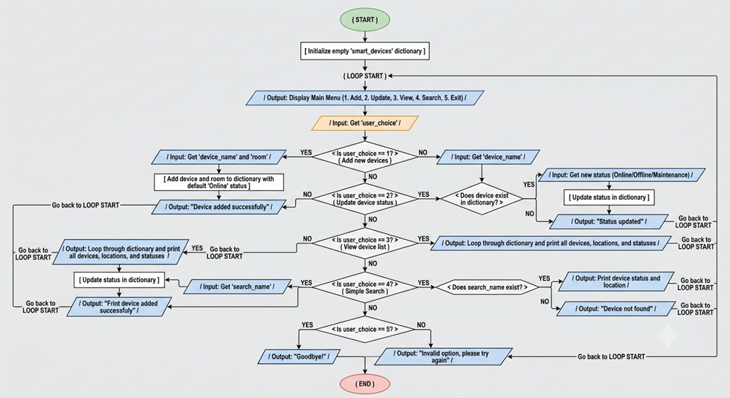
Figure 2: Flowchart Screenshot
A flowchart is a diagram that shows an algorithm or a process through symbols and standard flow lines, and displays the order in which operations, decisions, and data flow through a system. It offers a graphical way to describe the logic of a program, so that complicated logic can be more easily understood and communicated. In software engineering, flowcharts are extensively used tools for software development since they promote structured thinking, prevent ambiguities and assist software developers in the identification of logical errors before implementation [5]. In this project, the flowchart shown in Figure 2 is used to design the logic of the smart home device manager, which provides a very clear diagram of processing the user's inputs and generating its output. The main aim of this flowchart is to generate a user-friendly and menu-driven control flow of the program. It ensures that all functional requirements that were used are logically sequenced and connected.
This structured representation is very useful for modular development and closely resembles best practices in procedural, or step-wise refinement programming, where steps are small and can be repeated [6]. Furthermore, the consistency of using common flowchart symbols, such as ovals indicating entry and exit points, rectangles for processes, parallelograms for inputs and outputs, and diamonds for decision-making, improves clarity and uniformity. At the starting point of the flowchart, an empty dictionary named 'smart_devices' is created to store the data structure. This data structure will be a dictionary named 'smart_devices', which is initialised as an empty dictionary. The program then continues in a loop, and after each operation, it will see the main menu re-displayed. This type of loop is necessary to keep the user engaged throughout the running of the program. The system will display all the main menu options and ask the user to select whether they want to add a device, update its status, view all devices, search for a device, or exit the system.
Input from the user is collected and checked in a sequence of decision nodes. When option 1 is chosen, the program prompts the user to enter the device name and room and takes this in, saving it in the dictionary in a default state of "Online." Finally, a message pops up to say that the person has been confirmed, and then it returns to the main loop. In path option 2, the program prompts for the name of a device and then sees if it is in the dictionary. If it is identified, the user is asked to enter a new status, and the status is updated and confirmed. If the device is not found, it prints an error message. The program repeats through the devices stored in the list and prints out their information in option 3. Option 4 supports searching by the name of the device and provides conditional output features if the device exists. Last but not least, option 5 ends the program. This ensures a robust and usable conclusion, with an error message and a redirect to the main menu for all invalid inputs.

3.1.2 Pseudocode
Table 3: Pseudocode
START PROGRAM
Create an empty dictionary called smart_devices
LOOP FOREVER:
DISPLAY "1. Add Device, 2. Update Status, 3. View, 4. Search, 5. Exit"
INPUT user_choice

IF user_choice is "1" THEN
INPUT device_name
INPUT room_name
ADD to smart_devices
ELSE IF user_choice is "5" THEN
DISPLAY "Goodbye!"
BREAK LOOP
END IF
END LOOP
END PROGRAM

Pseudocode is a semi-formal, structured algorithm description in plain language using simplified programming syntax rules and structures, which does not strictly follow any particular programming language syntax [7]. It helps developers visualise a solution and communicate ideas clearly at design time. Unlike actual code, pseudocode is designed to be easy to understand and keep to the point, and this ease of understanding and clarity of logic make it useful in software development for planning, debugging, and discussion purposes. This project, specifically, the pseudocode, is a key stage between the conceptual design (the previous component, see Figure 2) and the actual Python coding. The main purpose is to decompose the functionality of the system into well-defined and clearly sequential steps that are representative of the required operations of the Smart Home Device Manager. Overall, pseudocode allows for the system to be logically structured in advance, including such aspects of the system as adding devices, managing user interaction, etc. and exiting the system.
This minimises the ambiguity and enables the detection of missing steps or inefficiencies to be detected early in development, prior to coding, following the best practices of structured programming. The pseudocode starts with an empty dictionary called smart_devices that serves as the main data store. This is crucial because a unique device ID will be used to store and retrieve device information for the duration of the program. A dictionary is used because it must have an efficient key-based retrieval mechanism in which each device name is linked to its respective information. After that, the program will run a loop with a "LOOP FOREVER" construct that will keep the system running and continually present the user with options. It is a fundamental loop function in menu-driven applications that facilitates continuous interaction with the application until it is specifically desired to exit the interaction. The program displays a menu and asks for the user's input within the loop. This input is then evaluated using conditional statements, and an action is taken accordingly.
For example, if the user chooses "1", then the pseudocode tells the program to prompt for the room and the device name, and add them to the dictionary. This shows how the input is taken into the system, worked on, and changed into useful information. Likewise, if the user presses "5", the program will print out a "goodbye! --- ending program" message and break out of the loop, ending the program. The pseudocode presented is comparatively simplified, but describes a scalable structure that can be expanded to accommodate more functionality, including the ability to update the status of a device, to view all the devices stored, and to search through the stored devices. In converting this pseudocode to Python, each of the logical blocks is directly translated to a programming element. While "next" is used for the loop, if-elif-else structures are used to implement conditional branches, and dictionary operations are performed using Python's built-in data handling capabilities. Through this direct mapping, there is a seamless flow from design to implementation, code is easier to read, and there are fewer logical discrepancies, resulting in a stronger software solution that can be easily maintained over time.

3.2 Implementation Decision

3.2.1 Data Structures
A data structure is a systematic way of organising, storing, and managing data in a computer system so that it can be accessed and modified efficiently [8]. It establishes a relationship between data elements and operations performed on them, which is a crucial part of software design. The efficiency of a program, its scalability, and maintainability are significantly affected by the data structure selected. For small-scale applications, choosing a simple and effective data structure is crucial to ensure simplicity and usability, while also avoiding unnecessary complexity. A dictionary (also called a hash map) is chosen as the main data structure used within the Smart Home Device Manager. As it is a problem requiring the device information to be stored and retrieved based on unique identifiers like the device name, this choice makes sense.
In Python, dictionaries can store data with key-value pairs, with each key representing a device name and the value being another dictionary that stores information about the device, including the location of the room and the status of the device. This architecture allows for efficient data retrieval, often in a constant time of O (1), making it a suitable structure for technology information queries and updates [9]. Dictionaries offer a more efficient and scalable solution for this kind of application than lists, which need sequential searching. This dictionary, smart_devices, houses the main information of the system. Entries in the dictionary are identified by the device name, and the value is a representation of the data grouped by attributes like “room” and “status.” This nesting enables logical organisation and future extension of the system, for instance, via additional attributes such as last usage time and type of device.
Using dictionaries fits with the need not to integrate a database and to have a structured approach to data storage. Various values are used in the program to aid the user in processing its data. The option selected from the main menu is stored in the variable user_choice, which is an important variable to control the flow of the program with conditional statements. Variables such as device_name and room_name are used to capture user input when adding new devices, ensuring that relevant information is stored accurately. The search_name is just an example of a variable that is used to process user queries against the keys in the dictionary. Furthermore, a variable called status is used for updating the status of devices, which can indicate if a device is online, offline or in maintenance mode. In summary, using a dictionary as the main data structure guarantees efficient data management, ease of implementation, and adherence to the system's functional needs.

3.2.2 Programming Constructs
Programming constructs are the basic units of a programming language that help control the flow of a program and organise its logic, including sequences, selections, iterations and modularisation [10]. These constructs allow algorithms to be expressed in executable instructions without losing insight and in a structured way. To produce code that is functional, readable, maintainable, and scalable, features and programming constructs must be used effectively [11]. Structured Programming constructs like Conditional Statements, Loops and Functions play a significant role in controlling complexity and consistency of expression in Structured Programming. In the Smart Home Device Manager, a range of programming constructs is employed to fulfil the functions the system requires. Sequential execution is the basis of the program; instructions are executed one after another in a logical order, e.g., menu first, then asking the user for input.
This is supported by selection constructs, mostly through the use of an if statement, elif and else statements. The use of these conditional structures enables the program to take on the ability to change behaviour based on variations in user input. For instance, if someone clicks a button in a menu, the program checks the input and carries out the associated section of code, like adding a device or changing its status. This method allows for having a combination of multiple functions integrated into a single and unified system. Iteration is another key construct used in the program, implemented through a while True loop. This loop will allow the system to loop and continuously display the menu until the user quits the program. In interactive applications, loops are frequently used to keep users engaged and to support several operations in one session [12]. If iteration wasn't included, the program would only run once, which would make it very limited in use.
In addition, User-defined functions (UDFs) are included for the convenience of modularity and code organisation. When functionalities like 'Add device', 'Update status', 'View devices', and 'Search' are broken down into separate functions, it becomes easier to read, test and maintain the program. The modular design in software engineering is a widely used method to decrease the amount of duplicate code and increase reuse [4]. A single function is responsible for a single task, thereby making the whole system more structured and easier to debug. System robustness is achieved by the incorporation of error handling and validation in the input. For example, to check if a user has selected a number from a menu that is outside of the valid range, conditional checks are performed, and if it is not present, an error message is displayed, and then another check is performed to prompt the user to enter a correct value. Likewise, validation stops blank fields from being entered (e. g., device names) and restricts the status values to a list of only known values, such as "Online", "Offline" or "Maintenance". These are crucial in the process of making the software free of runtime errors and data integrity, key principles to ensure that it works reliably. In summary, the use of selection, iteration, modular functions, and validation constructs ensures proper working of the program and that it fulfils user requirements.

3.2.3 Python Modules and Libraries
Modules and libraries are blocks of pre-written code that contain useful functions, classes, and tools that can be reused to build software and to help drive the development process [13]. Usually, a module is a single file of Python definitions and statements, and a library is a larger collection of related modules organised as an extension of functionality. Modularity and libraries help developers avoid coding basic features directly, rather than relying on custom modules, thus ensuring code efficiency, legibility, and maintainability. This conforms with the long-standing software engineering principles of reusability and modularity to gain productivity in software development [14]. The implementation is mainly based on the built-in features of the Python language, but due to the small scale of the application, it is not limited by an extensive set of external libraries. The function is implemented using only common Python constructs like dictionaries, input/output functions, and control flow.
Some built-in modules are, however, optional to improve the user experience and functionality. For example, the os module can be used to create a "clear screen" feature that can help to make the command line easier to read by erasing previous text. This helps to give a cleaner and friendlier user interaction, particularly in programs with menus which have multiple output statements. In addition, the use of the sys module can be extended to more explicitly deal with termination of the program, including termination with the exit command, which is sys.exit(). This gives a more controlled and standardised method to exit (unwind) the application, as opposed to breaking out of loops.
All external libraries are restricted for use on purpose because they prevent the use of simple concepts, and the simplicity of the project is a requirement. Adding advanced libraries or frameworks will result in unnecessary complexity and may also potentially make it harder to see the core learning objectives of the assignment. Rather, the emphasis is on showing that the fundamentals of Python (data structures, handling input from users, and logical control of flow) are understood. Moreover, built-in modules are portable and easy to run since they are already installed in the base Python installation and don't require setup. This is especially relevant in an academic environment with a program that is likely to be used on various systems when it is tested. In summary, the decision to use Python with limited modules and functions showcases a thoughtful approach to writing code with efficiency, user-friendliness, and best practices, while maintaining the project's scope and goals.

4.0 TESTING AND DEBUGGING

4.1 Role of Testing in the Software Environment
Program testing is a systematic evaluation of a program to find the defects, verify functions and ensure that the program satisfies the specified requirements [6]. This is an essential stage in software development that can identify issues that might not be apparent in design or development. Robust testing helps to ensure the system's functionality in different scenarios, leading to greater reliability and user satisfaction. The value of programme testing is that it helps to reduce failures and increase the quality of software. Developers can trust that each piece of the Smart Home Device Manager, like adding devices, updating status, and searching, will work correctly with structured testing. Testing also helps to confirm that the input validation mechanisms are functioning properly, thus eliminating invalid or unintended data from causing disruption. As pointed out by Powell, if a defect is detected early, it will be cheaper and less work to fix, because problems discovered later in development are often more involved [15]. In addition, testing increases the level of confidence of the users as the software will not act unexpectedly or differently every time. This project incorporates test cases, such as invalid inputs or missing device names, to make the program robust, user-friendly, and able to perform well in real-life use cases.

4.2 Types of Errors in Programming
Errors in programming are faults or mistakes in the program that give wrong output or results [16]. These errors can occur at different stages of development and are generally categorised into syntax errors, runtime errors, and logical errors. Knowing what these errors are and how to fix them is a crucial step in debugging and making a program more reliable. Syntax errors are caused by the code breaking the syntax rules of the programming language, for example, if Python code is not indented or has missing brackets. Usually, these errors can be discovered by the interpreter before the execution and corrected by changing the code structure. Runtime errors are errors that happen during the running of the program, for example, dividing by zero or trying to access data that was never stored. Validation and exception handling can be employed to solve these problems. Logical errors are harder to detect since the program does not crash, but it does not give the correct results. For instance, if the status of a device is updated incorrectly in the Smart Home Device Manager, this information might not be correct in the outputs. When troubleshooting, it is important to test and scrutinise the logic of the program. Common techniques used to find and correct these problems include step-by-step tracing and validation of test cases [17].

4.3 Example of Test Cases
Test cases were designed to systematically check that the functions of the Smart Home Device Manager work as expected with both valid and invalid cases. The aim of these test cases is to validate fundamental features like adding a device, updating status and searching records, producing correct output from correct input and incorrect output from incorrect input. For real usage scenarios, the program was run in PyCharm with different inputs as shown in Figure 3. In Figure 4, inputs that are valid are stored and retrieved properly, showing that the validation logic and validation mechanisms have been successful, and the device can be stored correctly based on its available capabilities.
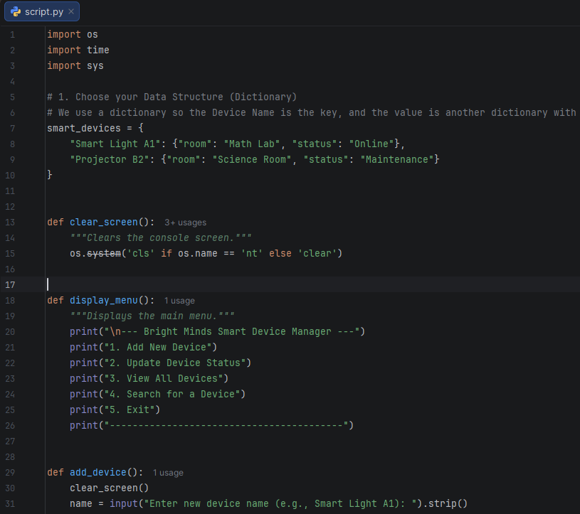
Figure 3: Input Code in PyCharm
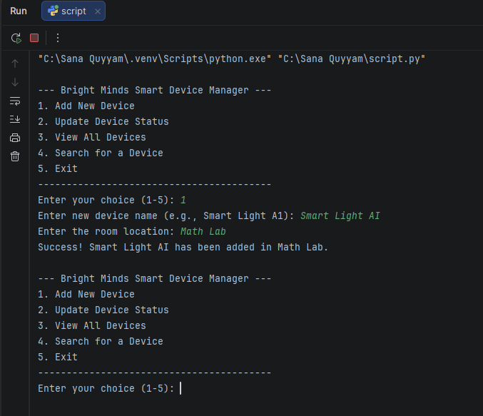
Figure 4: Successful Program Execution

5.0 EVALUATION

5.1 Challenges Faced
A major problem in this project was the process of converting system requirements into a clear, structured and functional program design. The process of including several features, including adding devices, updating their status, displaying all records, and creating search functionality within an integrated whole, was a thorough logical process. At first, it was hard for me to keep the flow of the program simple and not have redundant code. When creating the menu-driven interface, this challenge became more apparent as I had to make sure that the program would keep running until a user exited it. To overcome this problem, I improved my flowchart and pseudocode, and I can draw a clear picture to plan the structure of my program and have a stable loop-based system. A major hurdle was dealing with dictionaries for device data storage and retrieval.
Though a basic dictionary is useful for key value pairs, I first had trouble setting up the data properly, especially when assigning multiple attributes like room or status to a single device. Occasional data overwrite or wrong access to data due to faulty key handling. A way to explain this is to first practice smaller dictionary-based examples and then test every operation before being put into the program. Moreover, applying input validation was more complicated than anticipated. Having to check multiple conditions to prevent the input of invalid menu options and empty values made it more complex. I used systematic testing of edge cases and carefully checked the validation logic to make sure that the program would deal with errors in a nice fashion.

5.2 Future Improvements
In the next phase of this project, I would make a few changes to make the project more functional and extendable for future use. The current system is limited by the fact that it relies on memory storage in a dictionary in Python, which means all the data will be lost when the program is closed. For this, I would use the file handling approach (JSON or CSV files), or maybe even a small, simple database like SQLite. This would enable the device information to be stored and recalled across sessions, and be much more useful for real-world use within an educational context. Further enhancements would include the creation of a graphical user interface (GUI).
I could create an interface with buttons, input fields and visual prompts with libraries such as Tkinter, greatly enhancing interaction and accessibility. This will also minimise user input errors and create a greater ease of use. Also, I would extend the functionality of the system with additional features like device categorisation, usage tracking and status history. For instance, the last active time of each device can be stored, and help staff catch trends in usage and highlight underused resources. I would also add the ability to filter the search by multiple properties, like room and/or status.

5.3 Self-Reflections
The topics from this project enabled me to gain a deeper understanding of how to write software more effectively, from theory to practice. I started with a simple grasp of Python syntax, but for this project, I had to be more critical when it comes to program structure, data organisation, and user interaction. Before coding, I was able to design the system using flowcharts and pseudocode, which greatly helped me to plan my system and not have logical errors. This made it clear that it is essential to clearly design a software project before coding it. I also improved my ability to use a dictionary, especially to store and handle information efficiently. Using searching and device status updating features enabled me to appreciate the real-world impact of data structures on program performance and usability. Also, I learned how to write modular text, making it easier to read and maintain my program with functions. I acquired the skills necessary to recognise various types of errors and also to address them methodically by testing and validating. In conclusion, this project helped me to build my problem-solving skills, boost my confidence in coding, and get insights about building user-friendly software solutions.

References
[1] E. W. Sholeha et al., “Utilization of the AgriTrack Information System to Strengthen Smart Farming Practices in Small-Scale Hydroponic Enterprises,” Journal of Information Systems and Informatics, vol. 7, no. 4, pp. 4249–4270, Dec. 2025, doi: https://doi.org/10.63158/journalisi.v7i4.1385.
[2] Johan Cederbladh, A. Cicchetti, and J. Suryadevara, “Early Validation and Verification of System Behaviour in Model-Based Systems Engineering: A Systematic Literature Review,” ACM Transactions on Software Engineering and Methodology, vol. 33, no. 3, Nov. 2023, doi: https://doi.org/10.1145/3631976.
[3] M. J. LADO, Data Modeling and Process Analysis. Amazon Digital Services LLC - Kdp, 2025, 2025.
[4] A. Shukla, “Modern JavaScript Frameworks and JavaScript’s Future as a FullStack Programming Language,” Journal of Artificial Intelligence & Cloud Computing, vol. 2, no. 4, pp. 1–5, Dec. 2023, doi: https://doi.org/10.47363/jaicc/2023(2)144.
[5] M. Andrzejewska and A. Stolińska, “Do Structured Flowcharts Outperform Pseudocode? Evidence From Eye Movements,” IEEE Access, vol. 10, pp. 132965–132975, 2022, doi: https://doi.org/10.1109/ACCESS.2022.3230981.
[6] E. Papagiannidis, I. M. Enholm, C. Dremel, P. Mikalef, and J. Krogstie, “Toward AI Governance: Identifying Best Practices and Potential Barriers and Outcomes,” Information Systems Frontiers, vol. 25, no. 1, Apr. 2022, doi: https://doi.org/10.1007/s10796-022-10251-y.
[7] Kuldeep Vayadande, P. A. Bailke, Anita Bapu Dombale, V. R. Dange, and A. M. Kulkarni, “Converting Pseudo Code to Code,” Wiley Online Library, pp. 57–68, Jun. 2024, doi: https://doi.org/10.1002/9781394214167.ch6.
[8] Q. Wei, B. Li, W. Chang, Z. Jia, Z. Shen*, and Z. Shao, “A Survey of Blockchain Data Management Systems,” ACM Transactions on Embedded Computing Systems, vol. 21, no. 3, Jan. 2022, doi: https://doi.org/10.1145/3502741.
[9] A. L. Muddana and S. Vinayakam, “Built-in Data Structure: Dictionary,” Python for Data Science, pp. 137–152, 2024, doi: https://doi.org/10.1007/978-3-031-52473-8_7.
[10] I. Moraiti, A. Fotoglou, and A. Drigas, “Coding with block programming languages in educational robotics and mobiles, improve problem solving, creativity & critical thinking skills,” International Journal of Interactive Mobile Technologies (iJIM), vol. 16, no. 20, pp. 59–78, Oct. 2022, doi: https://doi.org/10.3991/ijim.v16i20.34247.
[11] Y. Zhang, L. Paquette, J. D. Pinto, and Aysa Xuemo Fan, “Utilizing programming traces to explore and model the dimensions of novices’ code‐writing skill,” Computer Applications in Engineering Education, vol. 31, no. 4, pp. 1041–1058, Mar. 2023, doi: https://doi.org/10.1002/cae.22622.
[12] H. Shin, J. Park, J. Yu, J. Kim, H. Y. Kim, and C. Oh, “Looping In: Exploring Feedback Strategies to Motivate Human Engagement in Interactive Machine Learning,” International Journal of Human-Computer Interaction, vol. 41, no. 14, pp. 1–18, Oct. 2024, doi: https://doi.org/10.1080/10447318.2024.2413293.
[13] L. Chiodini, J. Bevilacqua, and M. Hauswirth, “The Toolbox of Functions: Teaching Code Reuse in Schools,” Association for Computing Machinery, pp. 185–189, May 2025, doi: https://doi.org/10.1145/3723010.3723029.
[14] I. Kolawole and A. Fakokunde, “Improving Software Development with Continuous Integration and Deployment for Agile DevOps in Engineering Practices,” International Journal of Computer Applications Technology and Research, Dec. 2024, doi: https://doi.org/10.7753/IJCATR1401.1002.
[15] D. Powell, M. C. Magnanini, M. Colledani, and O. Myklebust, “Advancing zero defect manufacturing: A state-of-the-art perspective and future research directions,” Computers in Industry, vol. 136, p. 103596, Apr. 2022, doi: https://doi.org/10.1016/j.compind.2021.103596.

