York Museums Trust Public Programme Proposal Form
Please email to exhibitions@ymt.org.uk once completed

What is the title of your  proposal? | Lost: A reconstructed history of this statue from Ancient Egypt to Modern Britain
Date proposal submitted | Fifth of November 2022
Please provide your name  and contact details | Eira Smith 2104412@student.uwtsd.ac.uk
Is it an idea for:  Event Exhibition  Subject / anniversary Communications campaign Research and Development Don’t know yet | The idea is for a pop-up exhibition that will last a week with data gathering in the form of a poll at the exhibition
Elevator pitch: in no more  than three sentences summarise your proposal | Reconstruct the history of the Ancient Egyptian statue.  Discus the Ethics of keeping the statue in the UK.  Gather data through a poll of what the people who see this exhibition think of the Ethics of keeping the statue.

Who are the target  audience?  Reference Audience Spectrum segments if known.  If not known, who do you think this would this appeal to? | The target audience will be the general public specifically Eighteen to thirty as people in this age demographic will probably be more receptive to the message in the exhibition.  Another section of the general public who would be attracted are academics as this topic of weather it is ethical to keep objects stolen from the Global South during the British Empire in museums instead of returning them to their countries of origin.
What is the budget? | £2,000 sourced through crowdfunding.
Are there any fundraising  opportunities? | Even more crowdfunding could be done to help extend the scope or length of the exhibition.
Are there any partnership  opportunities? | The decolonising working group which provides advice on ow to decolonise museums. And the museum of British colonialism.
Are there any other similar  shows / events happening regionally or nationally? | There are similar concepts to this in museums throughout the UK such as the Collecting and Empire trail in the British Museum through various galleries. This is similar because it focuses on the fact that a lot of objects in museums tend to have been obtained through the colonial period via conquest and theft. This is far more ambitious than what I am proposing but shows that there is interest in exploring the ethics of keeping objects obtained through colonialism in museums.
Does it draw on any of  YMT’s collections, or is inspired by them? | It will draw on the Ancient Egyptian objects in the collection such as the canopic jars and the Ushabti.
Proposed location / gallery  for your idea. | A single gallery with the statue as the centre piece with the canopic jars and Ushabti surrounding it
Who have you consulted  with at YMT or externally? | Head of public engagement collections and curatorial – Jo Killeya

How is this project unique  for YMT? | This project is unique because it shines a light on lesser known objects taken from places colonised by the British Empire this will help with decolonising museums on a greater scale as it will bring attention to this sort of item this could benefit YMT as it will help emphasise the use of local history in museums as is the case with YMT.
When would this project be  delivered? Does it link to any critical dates? | The project would begin on the twenty-eighth of February 2023 the 101st anniversary of the official independence of Egypt from the British Empire.
Please add relevant images | 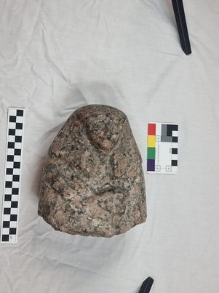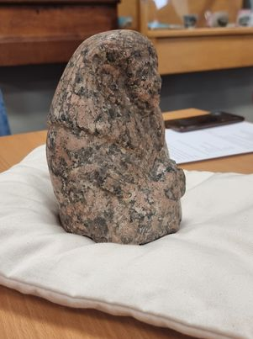

When you have completed your proposal please email to: exhibitions@ymt.org.uk
Many thanks for submitting your proposal. We will be in touch once the proposal has been reviewed.

