DS 1 Assignment

My Screenshots/Photos

Screenshot/Photo 1

[Write what this shows of your digital life]
I use WhatsApp’s to connect with the people I care most about privately and it also helps me communicated with my customers effortlessly.
WhatsApp’s application us very important because of the security features that protect end to end conversation.
I will need help on how to fully configure my business catalogue which will be very useful in my day to day running of my business.

Screenshot/Photo 2
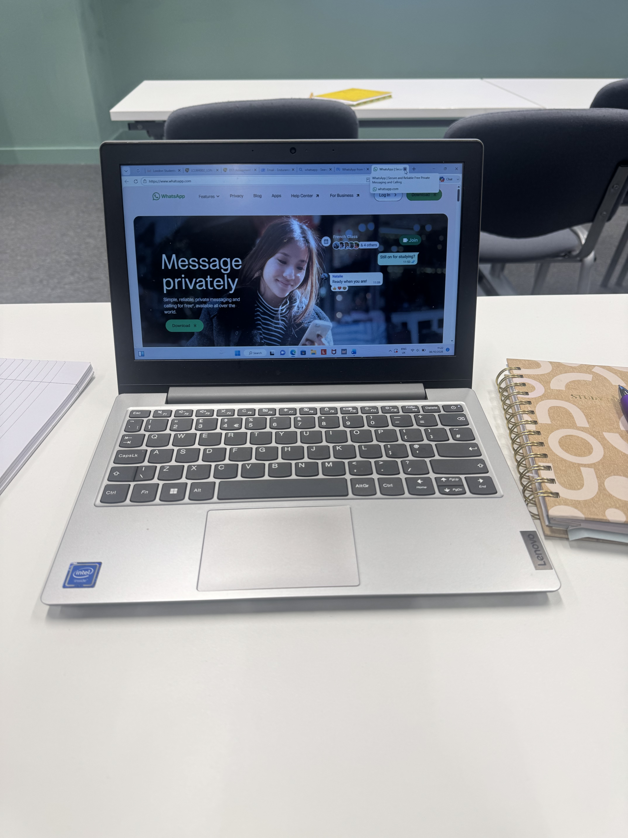
This is the screenshot of my laptop which I use on a daily basic to enable me sent and receives emails, fills online application and do my school work.

Screenshot/Photo 3
[Insert Photo/Screenshot below]
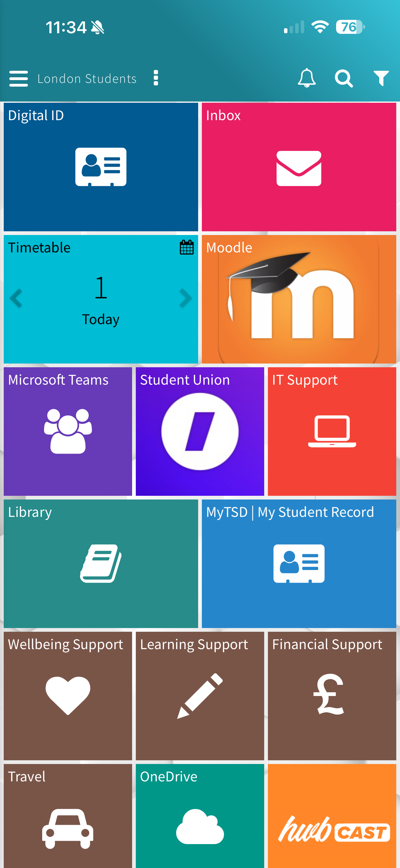
[Write what this shows of your digital life]
Hwb uwtsd.
I HWB to access all my school works, it enables me to communication with the university via my email box and access all my academic resources and submit all my assessment via Moodle.
It also helps me to access all other academic support and opportunity available during my study duration.

Screenshot/Photo 4
[Insert Photo/Screenshot below]

[Write what this shows of your digital life]
This is a trading app called trading 212.
It’s a financial digital stools which I used in my daily life to generate and build wealth.
I buy stocks and other investments packages.
It helps me to save towards retirements and makes me feel confidents with my finances.

Screenshot/Photo 5
[Insert Photo/Screenshot below]
 llyods bank
[Write what this shows of your digital life]
This my banking app for llyods bank.
Its helps me to do my day to day living expenses and transaction, paying for any bills and payment.
I used this digital tools to access my wages and other incomes where I do not need to go the bank.

Screenshot/Photo 6
[Insert Photo/Screenshot below]

Youtube is an digital platform I use to watch video, plat cartoons for my children and share videos of my cooking content.

My Short Reflection
- Write 5–8 simple sentences about your digital life.
- You can use the sentence starters below if helpful.
I use digital tools daily to help with my daily life, like communicating with my family,
Shopping and doing my online studies.
It helps me to find learn new things and find information easily and quickly.
I use digital tools like Youtube to watch moving and other educational video.
Social media digital tools helps me to show case my products to customers across the world.

Sentence starters
- I use digital tools to …
- I feel confident when I …
- I want to improve …
- I often use these tools: …
- I sometimes feel nervous about …
- I hope this module will help me …
- Digital skills are important for me because …
You can write more if you want.

Submission Checklist
Before you submit, please check:
​​​ ☒ I added 4–6 screenshots
☒ I wrote short sentences for each screenshot
☒ I wrote my short reflection
☒ My work is my own
☒ My file opens correctly
​​☒ My file opens correctly

