To Dr Juan A Ferriz-Papi.
Tim Rees.
1807470.
HND Quantity Surveying.
ACBA5000/ACBA5007.
Modern and Traditional Construction. Managing the Design and Construction Process / Civil Engineering Technology.

Submission Date: 23/01/2020.

Table of contents
Cover Page – Page 1.
Table of contents – Page 2.
- Aim of this report – Page 3.

- Excavation works to be carried out – Page 3.

- Solutions used for basement construction – Page 4.

- Drainage systems used during all the construction process, both permanent and temporary. – Page 5.

- Solution for the façade of the vertical envelope. – Page 6.

- Conclusion. Page 7.

- References. - Pages 7-8.

- Appendixes. Pages 8 – 18.

- Aim of the report.

It is considered the hypothetical scenario of the construction of a squared 20-storey building with three car-park underground floors is to replace the area which is currently being used as the Paxton Street car park. The proposed building has a 30-metre-side footprint and it is placed in the centre of the plot. According to the proposed site shown in appendix 1 and the soil cross section shown in appendix 2, the client has requested the design of the following:
Excavation works to be carried out
Drainage systems used during all the construction process, as well as permanent solutions to implement considering the proximity to the sea and the high level of the water table.
Solutions used for basement construction, both temporary and permanent. This provides an explanation of the stages of the construction techniques that have been applied during this stage.
Solution for the façade of the vertical envelope.

- Excavation works that are required to be carried out.

Prior to any excavation works are carried out for the proposed foundation, the site should be cleared of all brushwood, tree stumps and vegetation. The roots of the of all tree should also be removed to at least 30 cm below the level of the proposed foundation (The Constructor, 2019). It is known that the proposed building is to have a 30-metre squared side footprint and is to be placed in the middle of the site shown in appendix 1. Calculations shown in appendix 3 show that the total amount that is required to be excavated is 22434.5m3 (after bulking factor). Considering the aforementioned, the use of a Backacter that is fitted with a boom and bucket arm or a dipper arm that excavates downwards as they are suitable for carrying out trench, foundation and basements excavations. The depth of the dig can exceed 10m with the use of an extension arm. Using the calculations shown in appendix 3 the use of 2 dumpers working consecutively would allow for continuous excavation with the excavator having to stop. When carrying out excavation, this will be done with vertical walls (Designingbuildings.co.uk, 2019).
When carrying excavations such as these CDM regulations 2015 tell us that site-specific risk assessments and method statements will be carried out by appointed and competent personnel. These documents will be kept on site and continually reviewed throughout the process. Some safety protections that can be implemented during the excavation phase might include appropriate segregation in which the excavation site is correctly fenced so that non permitted personnel are not able to access the site. Other measures can include, correctly placed walkways that separate any foot traffic from plant machinery and a security turnstile that requires identity verification prior to allowing access to the excavation area (Chudley and Greeno, 2017).
Considering the aforementioned, plant machinery that is required to carry out this process is an Excavator with 0.8m3 bucket, 2 Dumpers with 30m3 capacity.

- Solutions used for basement construction.

When constructing a basement with the proposed specifications, due to the firm subsoils on the proposed site a method such as complete excavation can be suitable, this is a method that allows the centre of the basement to be excavated first which allows the basement slab to be cast. This provides protection to the subsoil at formation level (Chudley and Greeno, 2017). During a process such as complete excavation, the perimeter of the basement can be supported with the use of raking struts that may be pitched from 1the edge of the basement slab (Chudley and Greeno, 2017). An example of this can be seen in appendix 4.
(Chudley and Greeno, 2017) Tells us that when constructing a basement suitable for an underground car park the basements floors can be constructed as excavation proceeds thereby maximising progress. An example of some of consecutive stages of this process outlined by (Chudley and Greeno, 2017) might include; First, ground water controls/dewatering installed and activated (subject to sub-surface composition and water table height). Second, cast in-situ concrete diaphragm perimeter walls installed, possibly using contiguous or secant piling methods. Third, holes bored for piled foundations. Fifth, steel reinforcement cage positioned in boreholes. Sixth, Load-bearing plunge columns (standard steel UC sections) lowered inside reinforcement cage. Seventh, boreholes concreted to ground level. Eighth, in-situ reinforced concrete slab cast at ground level with shuttering to create suitable size opening for excavation plant access. Ninth, superstructure commences. Tenth, subsoil extracted through slab opening. Eleventh, after initial soil removal, small Backacter now able to operate below ground floor slab. Twelfth, first basement formation level established and in-situ concrete floor slab cast with suitable size opening to access the next level down. Thirteenth, excavation procedure repeated to formation level of second basement floor and slab cast with access void if further sub-floors required. Fourteenth, basement construction completed with waterproofing (tanking) and finishes. Appendix 5 shows typical details of these stages.
Regarding waterproofing the use of External Mastic Asphalt Taking is a suitable method as it not only prevents the ingress of water but also provides protection to the main structure of the basement (Chudley and Greeno, 2017). Appendix 6 shows typical details for the tanking process.

- Drainage systems used during all the construction process, as well as permanent solutions to implement considering the proximity to the sea and the high level of the water table.

When considering drainage solutions both permanent and temporary, factors that must be considered include the refuse storage of solid waste materials for dwellings, waste disposal, treating wastewater, pollution prevention and whether the use of separate drainage systems is required (Approved Document H). As the site is situated very close to the sea considerations for the potential of flooding must be made. These considerations might include possibilities for drainage of the water table or the diversion of streams and rivers and their relative tributaries (Chudley and Greeno, 2017).
When considering a permanent drainage solution, a common type of system such as a separate system can be used. This is a type of system in which the surface water waste is collected into separate drains to the foul water waste from the building. See appendix 7 for an example of this system.
When implementing a permanent drainage solution, a manhole or inspection chamber must be installed. This will be placed in accordance with Approved document H of the Uk Building regulations. The size of this manhole or inspection chamber houses drains of which the diameter and number of branch drains are to be in line the BS EN 752: Drain and water systems outside buildings (Chudley and Greeno, 2017). Example of details of the proposed inspection chamber shown in appendix 8. Once the permanent drainage system has been installed it will then be water tested for to ensure for water tightness in accordance with Approved document H.
When considering temporary drainage systems to allow the construction of a building in a location such as the proposed then it is possible that the dewatering of the excavations site might be required. This alongside drainage of the high water table will require a environmental permit if the liquid that is discharged contains contaminants or if the activity is to last longer than 3 consecutive months. (GOV.UK, 2020)
In order to carry out an activity such as the dewatering of the excavation site and the lowering of the water a table, a system such as a well point system can be used. (Ferriz-Papi, 2020) This is suitable due to the high water table which may need to be lowered to carry out the excavation works. These systems are easy to use and cheap and is implemented before the excavation works. This system works by jetting a series of well points into the subsoil, these are then connected to a vacuum pump. An example of this system is shown in appendix 9.

- Solution for the façade of the vertical envelope.

When considering a solution for the façade of the vertical envelope the main functions of this façade are to control solar gain, ventilation, allow acceptable light levels, provide weather tightness, provide resistance to wind, provide adequate insulation both thermal and acoustic (Ferriz-Papi, 2020). Another function of this façade is to provide separation between the outside and inside environments while still allowing a visual connection with the outside from inside the premises (Ferriz-Papi, 2020). These are also characteristics that are required by UK Building Regulations Part F. The minimum U-values that are required can be found in Approved Document L1A and L2A .
For the façade of the vertical envelope of this building I propose the use of a curtain wall system. Curtain wall systems are non-structural cladding systems for the external walls of buildings. Basic requirements for a curtain wall are to provide resistance to penetration by the elements, meeting the required level for fire resistance and be easy to fix and being easy to assemble and maintain. Other requirements are to meet the required level of sound and thermal insulation and to also provide for thermal and structural movements Curtain wall systems are also typically suitable for large, multi-storey buildings such as the proposed(Chudley and Greeno, 2017). Using a system such as a curtain wall allows for separation of the interior from the exterior. A curtain wall system will only support its own weight and the loads imposed on them which they then transfer back to the primary structure of the building(Chudley and Greeno, 2017). Curtain wall systems are also typically suitable for large, multi-storey buildings such as the proposed(Chudley and Greeno, 2017). Details of a typical curtain wall system are shown in appendix 10.
The curtain wall systems will be made up of a lightweight aluminium frame onto which reinforced fibre infill panels are to be fixed.
The infill panels will be a composite panel in which the faces of the panel will contain an insulated core made from a material such as polyethylene (pe). In this case the curtain wall will be fixed using a four-edge system, this will rely on structural adhesion.
This adhesion will be carried out with the use of silicone bonding between the infill panels and support frame (Chudley and Greeno, 2017. This solution also complies with BS EN 13830.
When considering the fixing for the curtain wall to the main structure the curtain wall will be constructed using a utilised system in which the infill panels will be prefabricated off site. This will allow for maximum efficiency when constructing the façade as the benefits of factory condition manufacturing and quality control will allow for a smaller installation time on site (Chudley and Greeno, 2017).

6.0 Conclusion.
In conclusion, I have throughout this assignment learnt various new methods and solutions that can be used to overcome factors that arise in the built environment in the area in which we are. Using research, references, calculations and drawings I have addressed the key points outlined in the assignment brief which are to provide solutions for the proposed excavation works, solutions used for the construction of the basement structure, implementation of drainage systems both permanent and temporary and a solution for the façade of the vertical envelop of this building.

7.0 References
The Constructor. (2019). Excavation Procedure for Foundation - Setting out, Safety Measures. [online] Available at: https://theconstructor.org/geotechnical/excavation-for-foundation/5613/ [Accessed 5 Dec. 2019].

Designingbuildings.co.uk. (2019). Excavating plant. [online] Available at: https://www.designingbuildings.co.uk/wiki/Excavating_plant#Backacter [Accessed 8 Dec. 2019].

Chudley, R. and Greeno, R. (2017). BUILDING CONSTRUCTION HANDBOOK. [Place of publication not identified]: ROUTLEDGE.

Ferriz-Papi, D. (2020). UWTSD Moodle 2019/20: ACBA5000 Facades Part 1. [online] Moodle.uwtsd.ac.uk. Available at: https://moodle.uwtsd.ac.uk/course/view.php?id=6551
Ferriz-Papi, D. (2020). UWTSD Moodle 2019/20: ACBA5000 Dewatering of ground . [online] Moodle.uwtsd.ac.uk. Available at: https://moodle.uwtsd.ac.uk/course/view.php?id=6551

Ferriz-Papi, D. (2020). UWTSD Moodle 2019/20: ACBA5000 Facades Part 2. [online] Moodle.uwtsd.ac.uk. Available at: https://moodle.uwtsd.ac.uk/course/view.php?id=6551 [Accessed 17 Jan. 2020].
GOV.UK. (2020). Temporary dewatering from excavations to surface water. [online] Available at: https://www.gov.uk/government/publications/temporary-dewatering-from-excavations-to-surface-water/temporary-dewatering-from-excavations-to-surface-water.
Community.dur.ac.uk. (2020). Earthworks. [online] Available at: https://community.dur.ac.uk/~des0www4/cal/roads/earthwk/earthwk.html.
UK Building Regulations Approved Document F: Ventilation. (2013).
UK Building Regulations Approved Document H: Drainage and Waste Disposal. (2013).
UK Building Regulations Approved Document C: Site preparation and resistance to contaminates and moisture. (2013).
UK Building Regulations Approved Document L1A: Conservation of fuel and power in new dwellings (2016).
BS EN 752: drain and water systems outside buildings. (2008). BSI.
BS EN 13830: Curtain Walling. (2015). BSI.
- Appendixes. 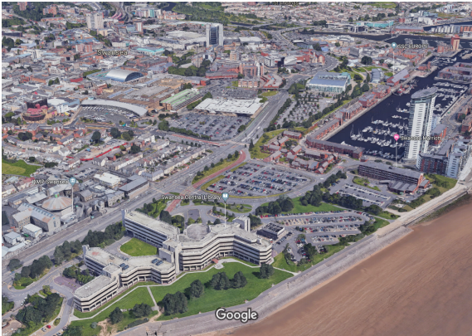Appendix 1 showing the outline of the proposed site. (Image taken from google earth).

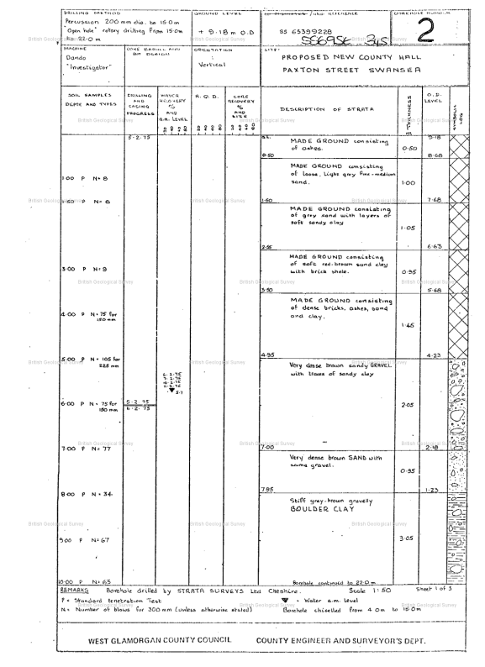Appendix 2 showing the results of bore hole testing. (Image taken from assignment brief)

Appendix 3. Calculations for the excavations and dumper details.
Amount to be excavated.
Vo (Original Volume) = 30mx30mx18.3m ( 18.3m average height of 3 storeys taken from Chudley Greeno 2017)
Vo (original Volume) = 16,470m3
Gravel/ Clay subsoil bulk factor = 1.35 ( Taken from https://community.dur.ac.uk/~des0www4/cal/roads/earthwk/earthwk.html )
Vb (Bulk volume) = 16,470 x 1.35
Vb (Bulk volume) 22,234.5m3.

Dumper cycle time.
Known facts:
3-minute tipping time.
Dumper has 30m3 capacity and 30 mph speed.
Excavator has a 0.8m3 bucket.
Excavator takes an average of 40 seconds to excavate and download.
Known Plant facts taken from Lecture slide (Ferriz-Papi, 2020).
Time to fill dumper = 30m3/0.8m3 x 40 = 1500 seconds = 25 minutes.
Complete cycle time = 5/30 x 9.6 mins (journey time from site to dumping site for each leg of the journey)
Complete cycle time = 9.6+9.6+25+3 = 47.2 mins.
Complete cycle time of dumper = 47.2 mins.

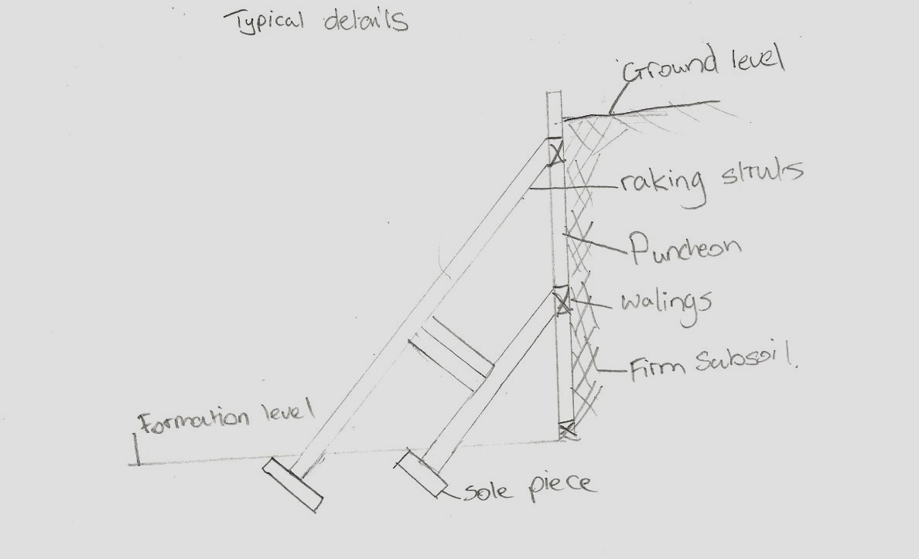
Appendix 4 showing typical details of raking strut.

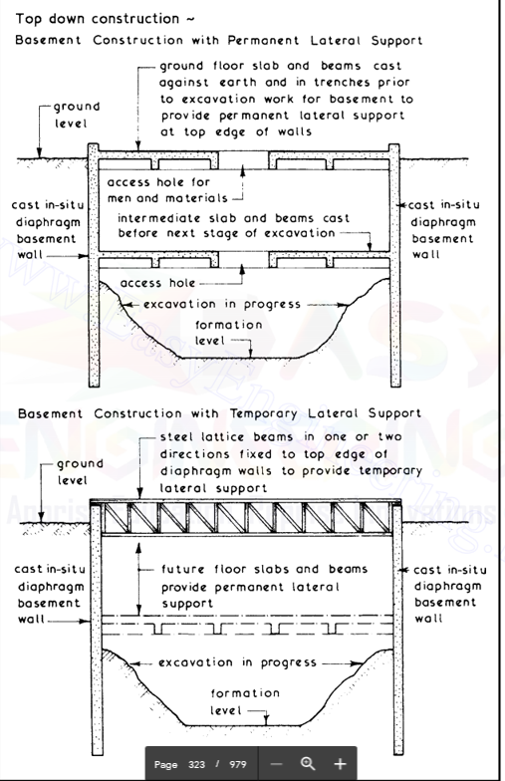
Appendix 5 showing typical details of stages of basement construction. Image taken from Chudley Greeno 2017.

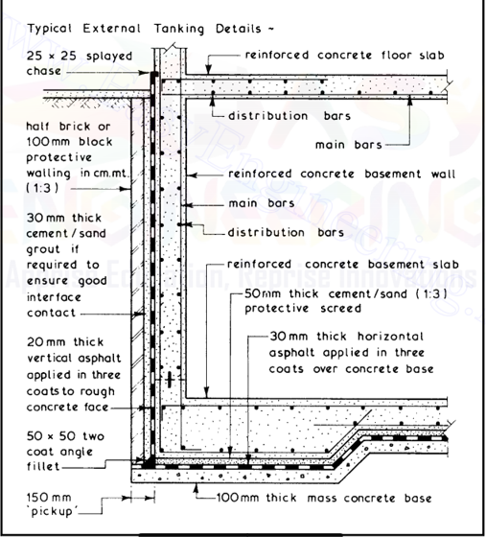
Appendix 6 showing typical details of tanking process. Image taken from Chudley Greeno 2017.

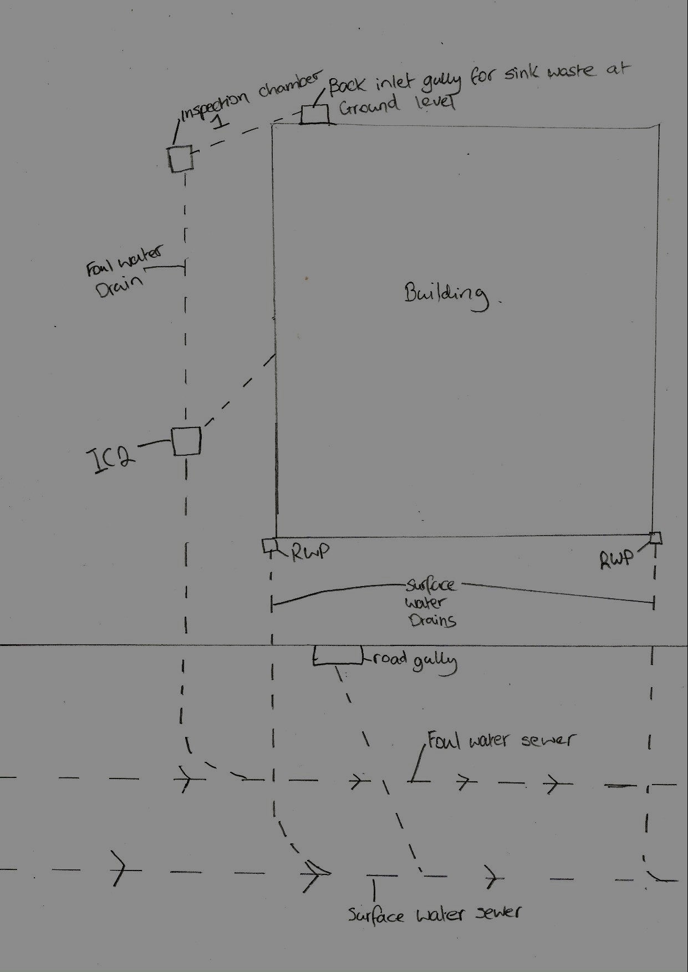
Appendix 7 Showing example of proposed drainage system.

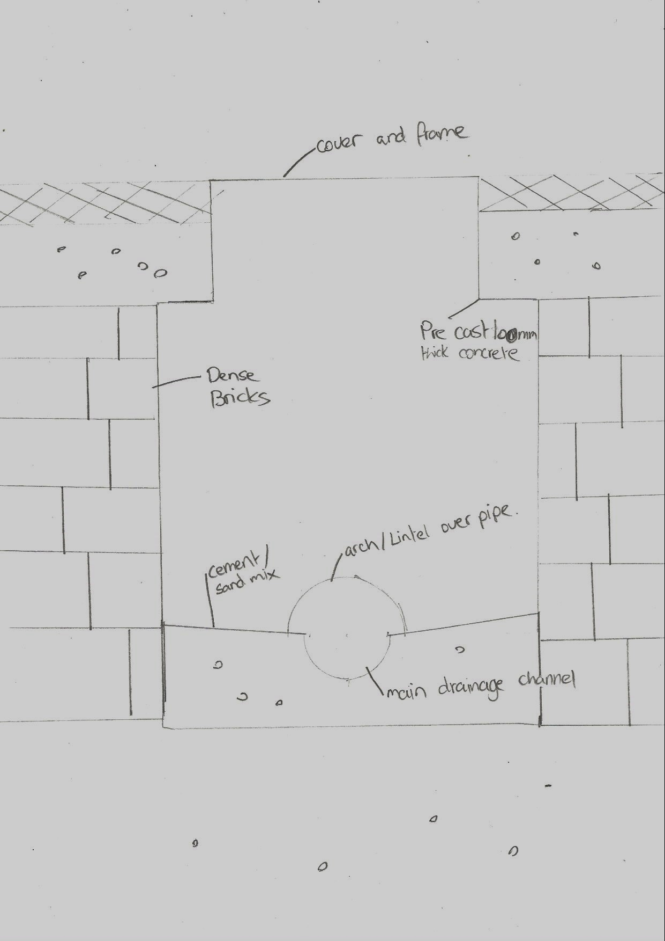
Appendix 8 showing details of inspection chamber.

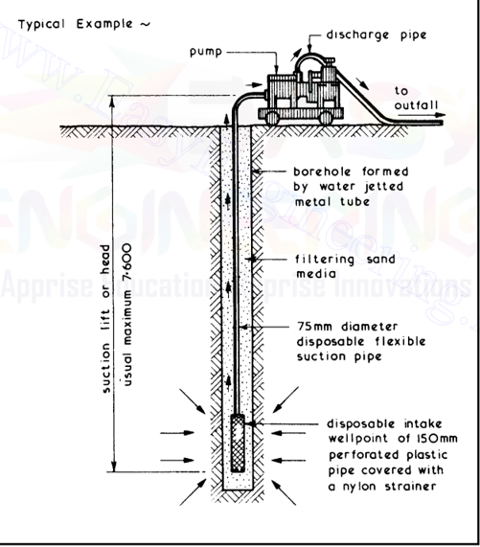
Appendix 9 showing example of the dewatering process. (Image taken from Chudley Greenon 2017).

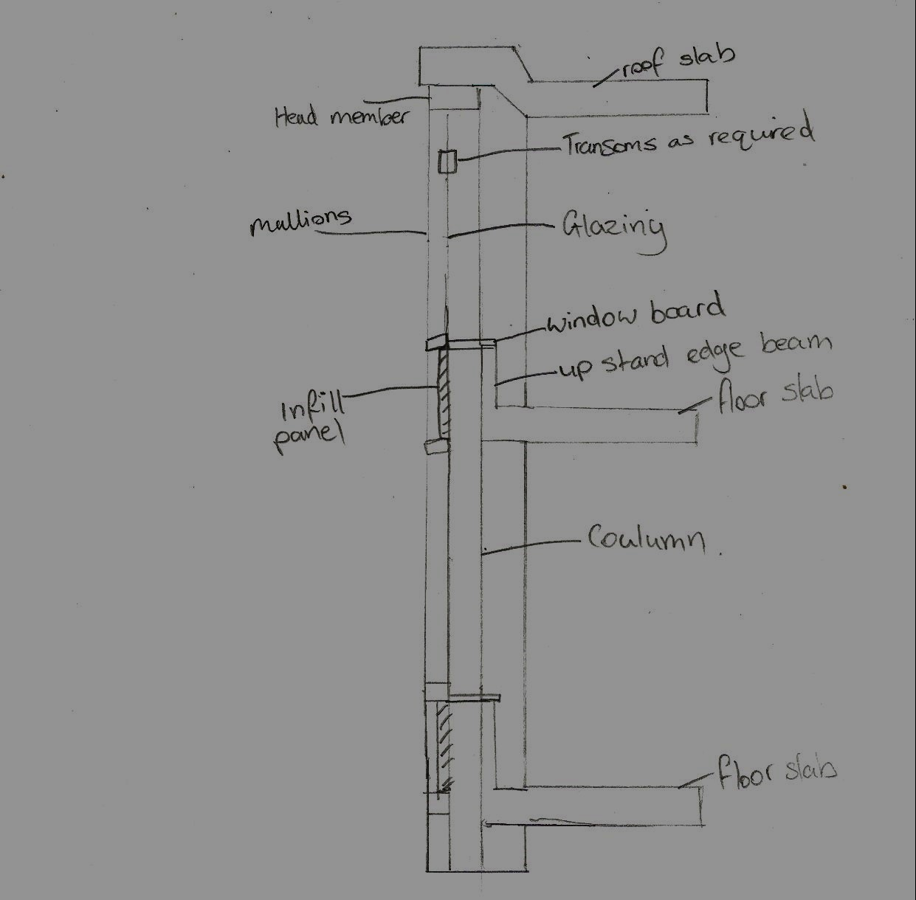
Appendix 10 showing example of details for curtain wall system.

