DS 1 Template

My Screenshots/Photos
- Please add 4–6 screenshots or photos of your digital life.
- You can use your phone or laptop.
- For each screenshot, write one or two sentences explaining what it shows.

Screenshot/Photo 1
[Insert Photo/Screenshot below]
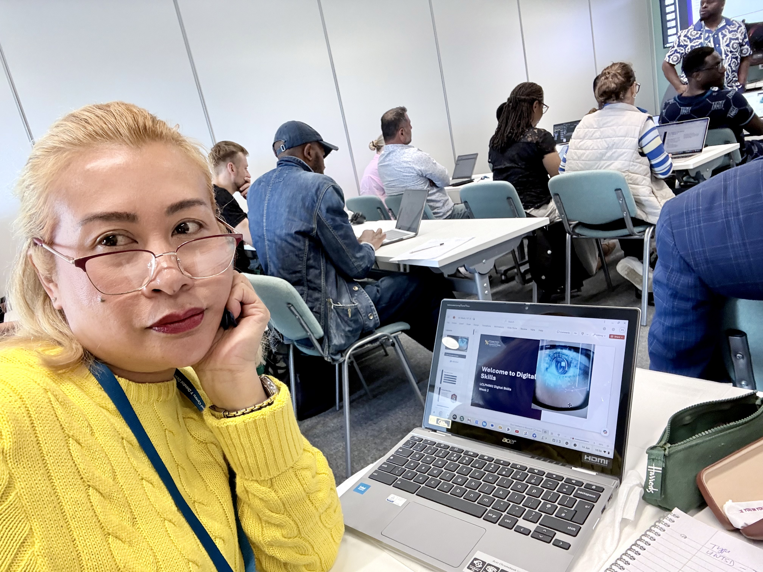
This was taken during week 2 session. On my laptop its shows the slide that I have downloaded.

Screenshot/Photo 2
[Insert Photo/Screenshot below]
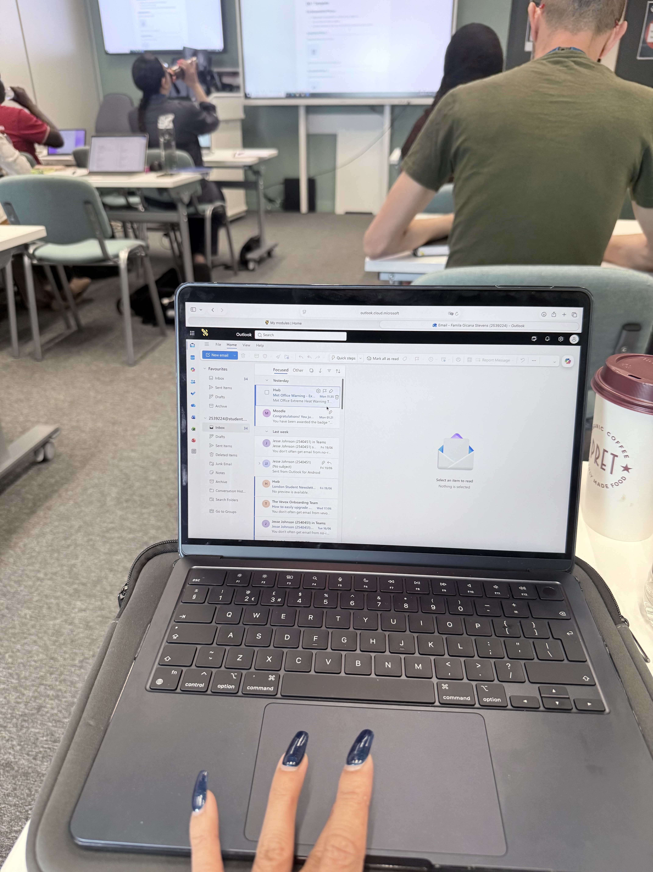
It shows that I am checking my email on my university Hwb. Accessing through outlook.

Screenshot/Photo 3
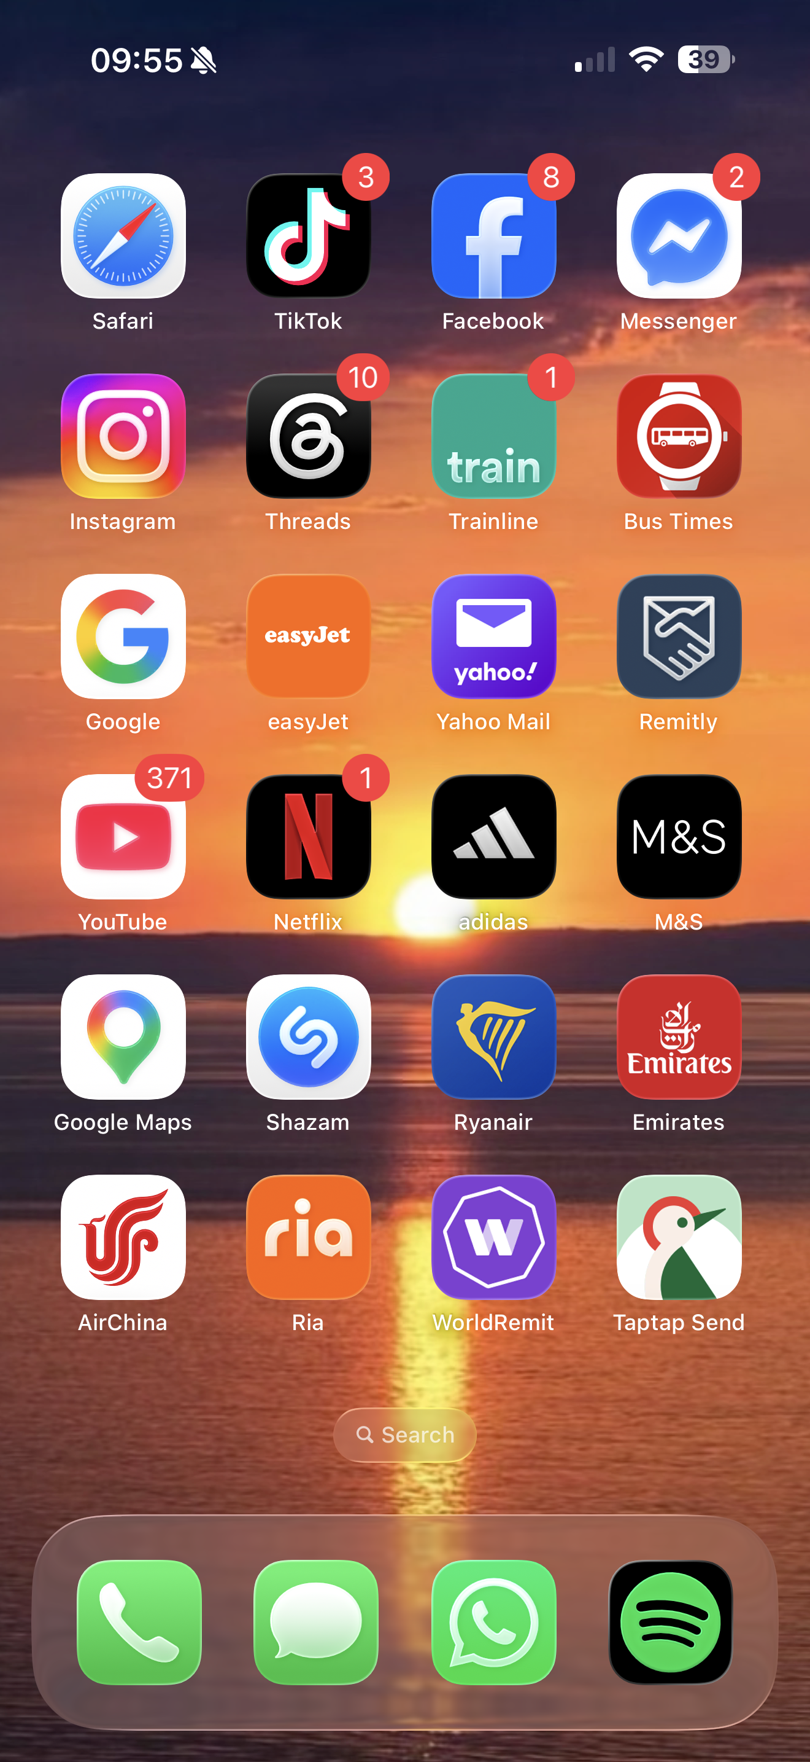
This shows my phone home screen. These apps are organised so its easy for me to access each of them.

Screenshot/Photo 4
[Insert Photo/Screenshot below]
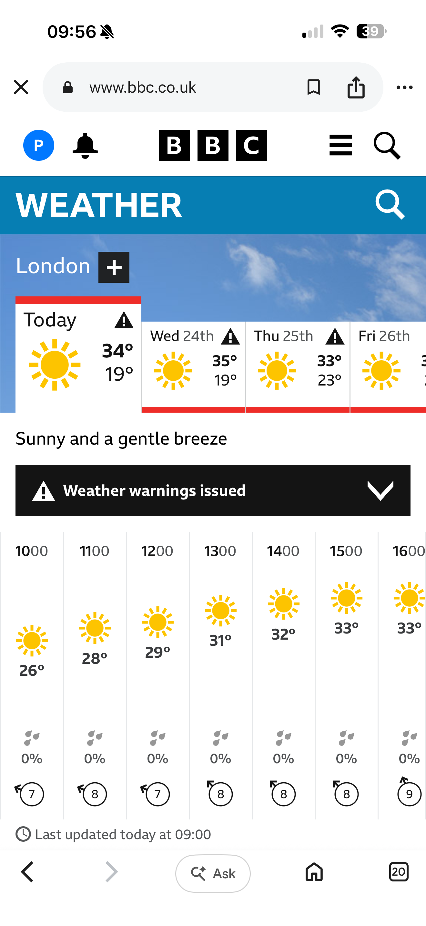This is the weather forecast for the day. It is my habit to check the weather first thing in the morning.

Screenshot/Photo 5
[Insert Photo/Screenshot below]
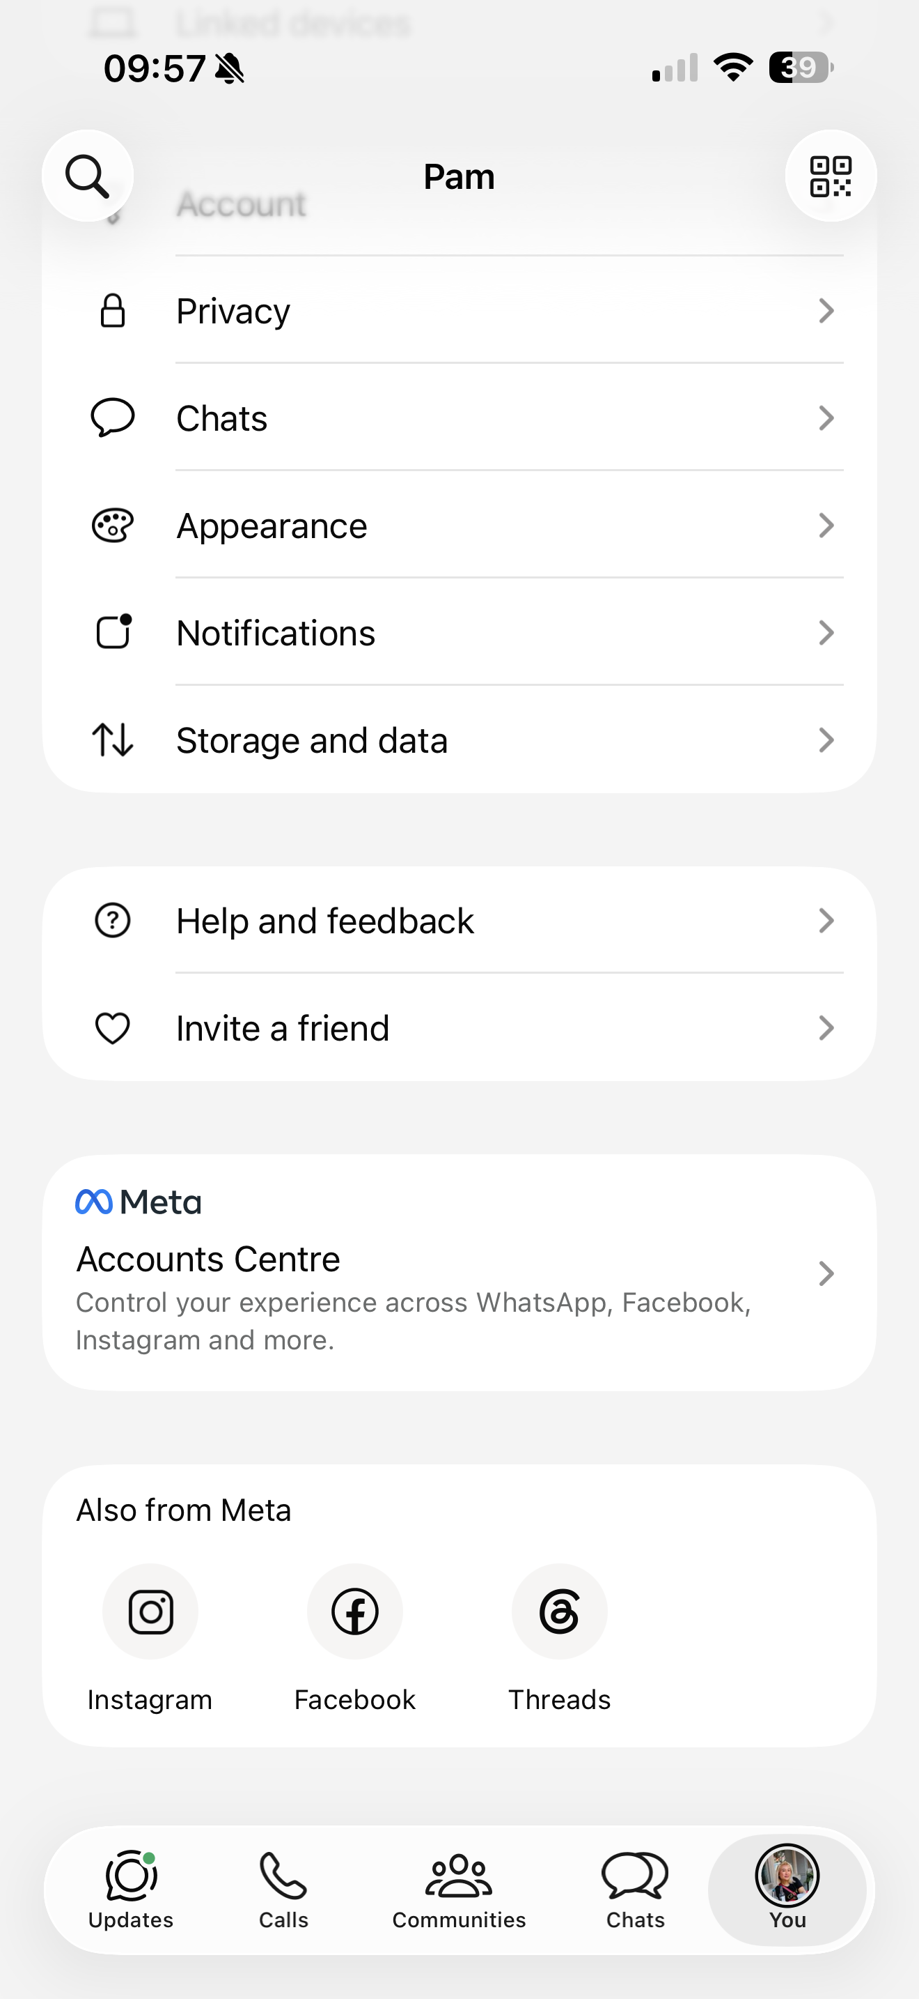
This screen shows that my WhatsApp account is all linked to my Instagram, Facebook and Threads. All control by Meta accounts centre.

Screenshot/Photo 6
[Insert Photo/Screenshot below]
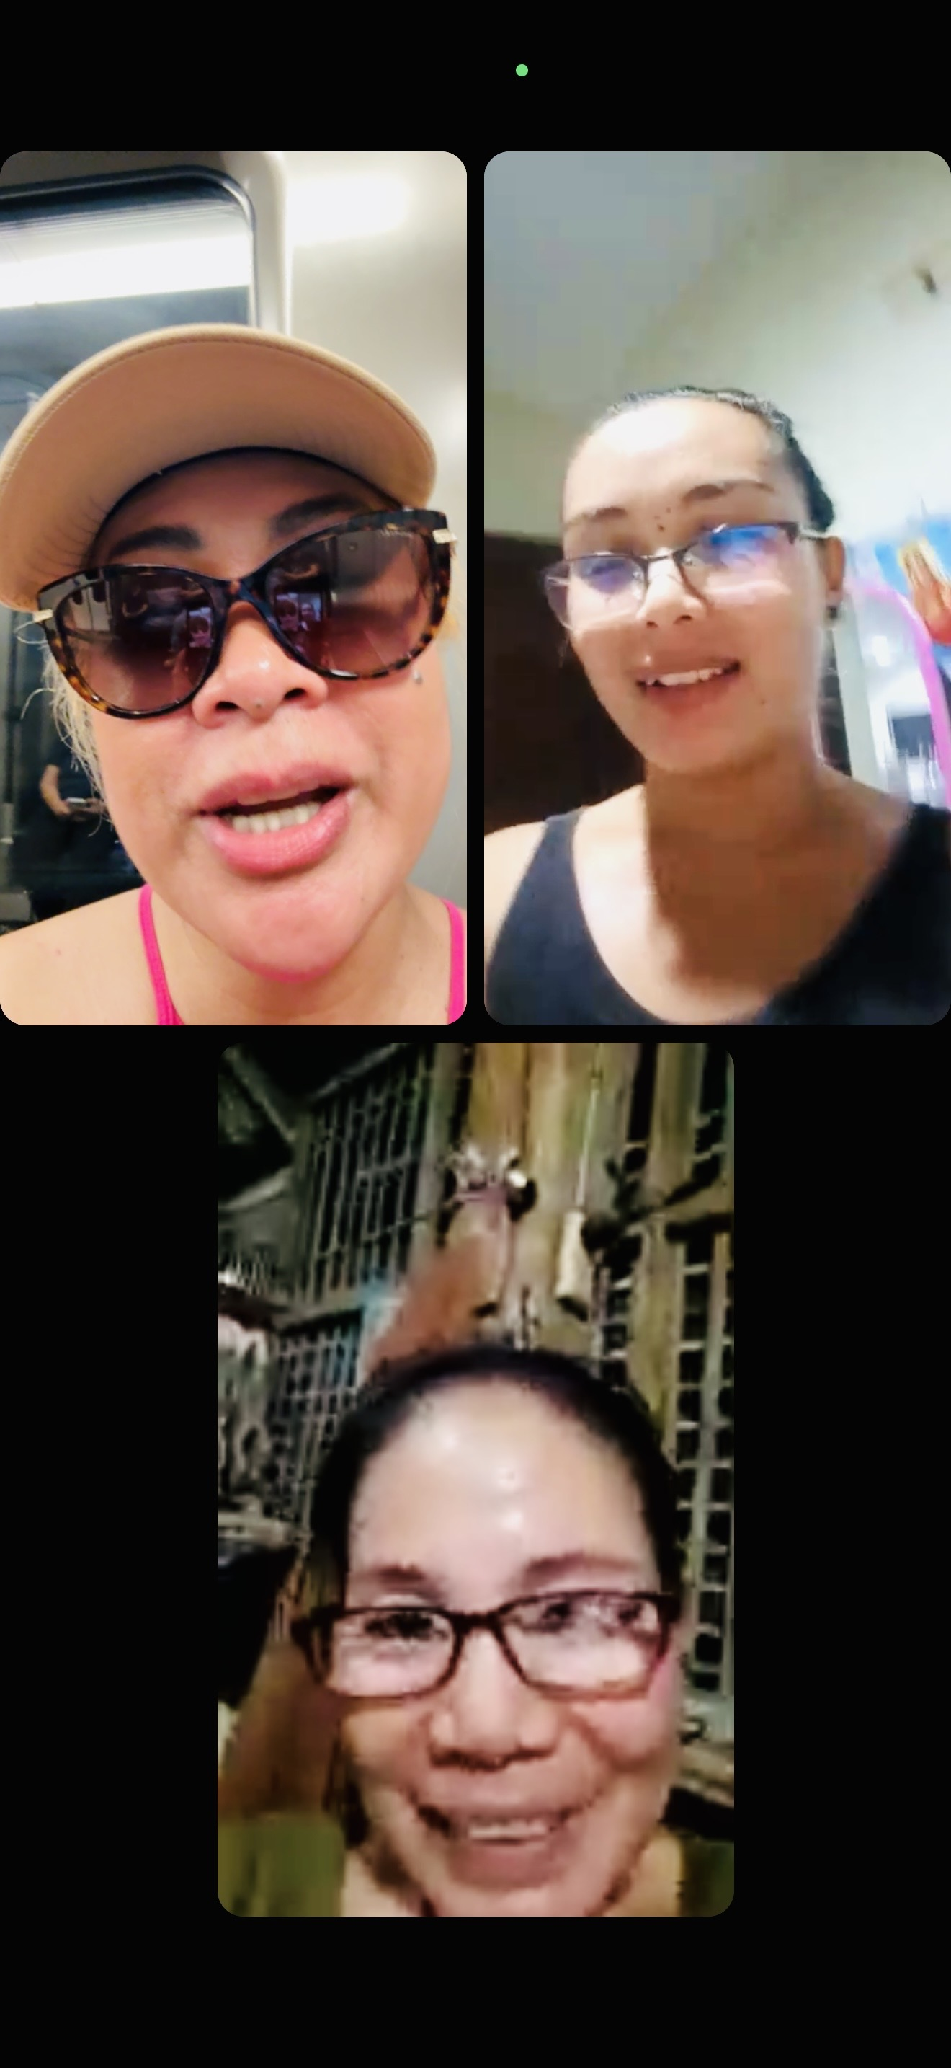
This screen shot shows that I am using a group video call through Facebook messenger. To reach and being updated of my family in the Philippines.

My Short Reflection
- Write 5–8 simple sentences about your digital life.
- You can use the sentence starters below if helpful.
On my first day (week 1) I have learned how to sign in at Digi Centre. I also sign up for university library. Manage to explore my university hub.
On week 2 I join the session through VEVOX. Learned how to organise my reading material and exploring LinkedIn.
By week 3 have managed to put everything together for my DS1 assessment.
I am a little nervous on my first day but now I am more comfortable using Moodle and accessing it. But with the guide of my tutor, I gain more confident in every class session.
I am hoping to gain more understanding on this Moodle.

Sentence starters
- I use digital tools to …
- I feel confident when I …
- I want to improve …
- I often use these tools: …
- I sometimes feel nervous about …
- I hope this module will help me …
- Digital skills are important for me because …
You can write more if you want.

Submission Checklist
Before you submit, please check:
​​​ ☐ I added 4–6 screenshots
☐ I wrote short sentences for each screenshot
☐ I wrote my short reflection
☐ My work is my own
☐ My file opens correctly
​​☐ My file opens correctly

