ASSIGNMENT COMPONENT 2: WRITTEN REPORT

Table of Contents
Introduction 3
Literature-based background 3
Research aim & objectives 3
Research question 4
Rationale 4
Research methods 4
Research design 5
Recruitment, sampling & Participants 6
Data collection methods 6
Data analysis techniques 6
Ethical considerations 7
Results 7
Discussion 17
Conclusion 17
References 19

Introduction
The generation is transforming eating behaviours with each passing day. Different macro-environmental factors are responsible for the changes in the food habits of students these days. Not everyone is fond of one pattern of food items. Postgraduate students are seen to be heavily concerned with their health. Most of the students are health-conscious as they do not want to gain weight. The demand for fast food is growing fast. However, one proportion of the students shows an intention of prohibiting fast food. They are more focused on eating healthy food. This study is going to discuss “several factors that influence eating behaviour among postgraduate students in public universities” based on a “focus group discussion”. In this regard, some students of UK-based universities will be surveyed to gather responses on this matter.

Literature-based background
Students are getting aware of the harmful food items which are resulting in a growing interest in consuming healthy products (Browning et al. 2021). However, some proportion of students is still interested in eating fast food items and other junk foods. The pattern of eating habits is seen to transform from one country to another. Findings say that “insufficient income”, “University-related stress”, and “lack of taste in meals”, and “absence of nutritional knowledge” and “involvement with peers” are responsible for the eating habit of postgraduate students. Apart from that, the “cost of food”, “reliance on the university food outlets”, and “availability of food items” in the university campus and food outlets and social media platforms influence the eating habits of students.

Research aim & objectives
This research is going to understand several factors that are responsible for the different eating habits of students in the university. This report has gone through different opinions of students for understanding these influencing factors (Martínez-de-Quel et al. 2021). The target is to gather data on the changing eating habits of students.
Some of the objectives are as follows,
- To discuss the pattern of postgraduate students' eating habits in a public University
- To identify different factors that influence the eating behaviour among those students in a public University
- To look into the students' opinions on their own eating habits at the University
- To recommend public universities some way to make students aware of healthy eating habits in postgraduate students

Research question
Research questions are placed in this area in a manner so that they can do justice to the adopted research objectives. The strategies to gain maximum real-time data based on this topic. All the research questions are included in this area for satisfying the need of each research objective. A synopsis of research questions is mentioned in the below portion.
- What is the pattern of postgraduate students' eating habits in a public University?
- What are the different factors that influence the eating behaviour among those students in a public University?
- What are the students' opinions on their own eating habits at the University?
- What can be recommended to public universities to make students aware of healthy eating habits in postgraduate students?

Rationale
This research is significant to identify the influencing factors that change the eating pattern of students. This research is important to realise the psychology of postgraduate students behind the selection of their eating habits in a public University in the UK (Trigueros et al. 2020). The reason behind the selection of some particular food options can be easily identified. Cases are seen where students are not aware of healthy food consumption. In this regard, the university authorities mistake strict action to educate their students regarding healthy eating habits. This research has also shed light on the role of Universities to make their students eat healthy.

Research methods
Research methods are important to collect reliable and evident based data from different sources. Adoption of some particular research tool is important to enrich the data collection process. Research methodology is a process of selecting suitable research methods for the research so that efficient data sets can be collected. Research onion has been selected to choose different research methods from each layer of this onion-shaped research tool (Jufri et al. 2019). This research tool offers the research team more than one option of research philosophies, approaches and designs. The strategy is to find some of the most relevant data sources that can justify this research topic.
Research philosophy represents the philosophical outline of the research. The selection has been made based on the objectives collected on this topic. This tool has the capability of offering a system where the research team can express their thoughts based on the collected primary data sources. The study aims to formulate the research problem with the help of this research tool. A philosophical point of view is helpful for carrying out a detailed research outline. The selection of the school helps in the creation of a critical analysis of the topic. The philosophical instrument is linked with the systematic data analysis process (Bauer et al. 2021).
The researchers have selected "positivism philosophy" as this satisfies the requirement of numerical data analysis. The research team can easily go through the statistical comparison between collected data sets with the help of this philosophy. The justification for selecting this research tool is to develop a project which is full of statistical comparisons of the gathered responses. Researchers can easily set up the research outline by comparing primary data sets.
The research approach is also an essential tool for the analytical understanding of the collected data sets. This research tool is helpful for performing data collection, interpretation and analysis efficiently. The idea is to include logical development of the chosen content based on fact-based research (Al-Ababneh, 2020). The research approach is also helpful to develop a hypothetical understanding of the primary and secondary data sets. This research tool can support the researchers in involving the best possible way of data collection and analysis within this research.
In this regard, the research team has selected a "deductive approach" to conduct this study. This tool helps in the development of an accurate model of statistical data sets. The justification for selecting this research tool is to involve an empirical understanding of the primary data sources. This research tool is useful in bringing a generalised conclusion based on the selected data sources. The selection has been made to get the best outlook of several influencing factors that changes the eating behaviour of postgraduate University students.

Research design
Research design is helpful for the creation of a systematic framework of research. The design guides the research team in the formulation of a particular research pattern. This research tool is helpful for the creation of a suitable justification behind all those influencing factors that impact the eating behaviours of students. Researchers can easily compare and contrast each collected primary response from the students with the help of this research design (Sileyew, 2019). A "descriptive design" has been chosen to provide a clear direction for the research. This research tool supports the development of this discussion with a decent explanation.

Recruitment, sampling & Participants
The research followed a "survey" to conduct the primary data collection. The researchers have selected candidates from the UK-based public universities. All the participants are students who are doing their postgraduate courses at public universities in the UK. There is no particular pattern for selecting participants. They only have to belong to the postgraduate course section of that public university. Hence, the "random probability sampling" strategy has been followed throughout this research (Hosseini et al. 2019). Ten research questions are placed to know about the chosen research area in the selected public universities of the UK. A hundred students are picked to do the survey. Hence, the sample size of this research is 100.

Data collection methods
Data is collected from the real-life opinions of the students. Hence, a "quantitative data collection" process has been followed in this research. "Likert-chart questions" along with some basic demographic questions are placed in this survey. The researchers have focused on collecting first-hand data from the research participants. No vulnerable groups of the population are involved in this data collection process (Crowe and Yue, 2019). Data is collected and stored in an Excel sheet which will be password protected. Statistical development of gathered responses has been done for the development of a graph on the collective responses under each research sample.

Data analysis techniques
The data analysis has been performed by comparing the real-life opinions of the participants. Each sample contains five options under all types of question samples. A detailed comparison between datasets has been performed in this regard. The formation of graphs has also been performed by looking at the probability of students ticking both positive and negative options under each sample.

Ethical considerations
The research team has provided a decent focus on maintaining the anonymity of selected participants. No uncomfortable and personal questions are asked in this process. Students are allowed to leave the process if they feel uncomfortable. They can skip any question if they do not want to answer it (Armond et al. 2021). "Data Collection Act, 2018" is maintained throughout the data collection process. Data privacy and confidentiality are also prioritised in this regard. The research team has taken permission from the university authority at first before the selection of the research sample. Ethical considerations are placed in the first place of this data collection and analysis process. Students are not pressurised to take part in this research as well. The research team has provided a detailed significance and objectives of this study for increasing their motivation. This has been done to make them aware of their contribution to this research. After this session, students can decide on their participation.

Results
The research has gathered students’ responses under ten research samples that are listed and analysed in the below portion.
Q1. What is your gender?
Responses | No of responses | Percentage of responses
Male | 55 | 55
Female | 45 | 45
Do not want to answer | 0 | 0
TOTAL | 100 | 100
Table 1: First sample
This sample shows that the research has chosen 45 female students and 55 male students for this research.
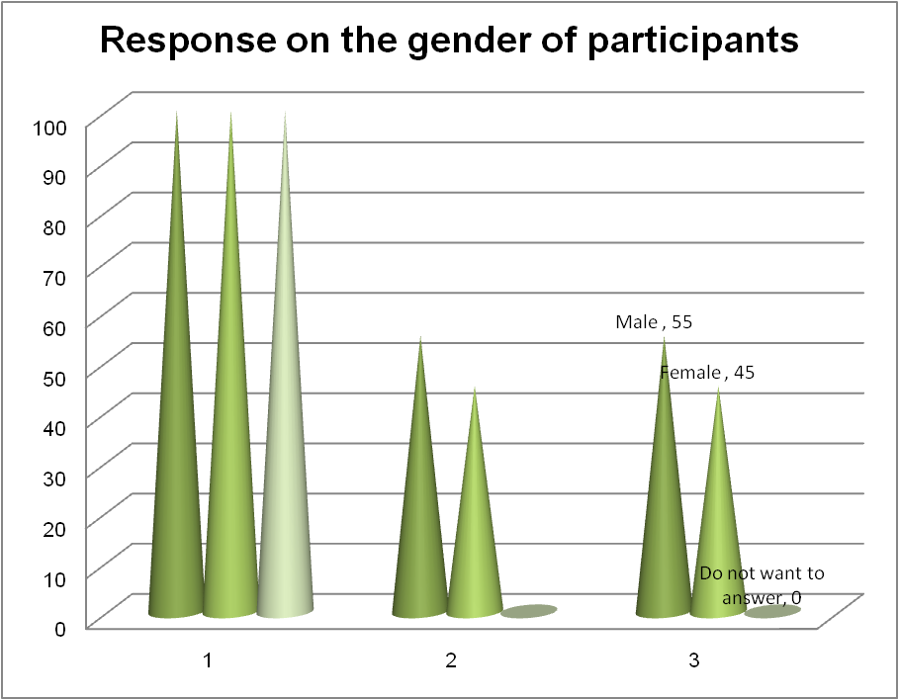
Figure 1: Graph on first sample
Q2. What is your year of post-graduation at this university?
Responses | No of responses | Percentage of responses
1st year | 55 | 55
2nd year | 20 | 20
3rd year | 15 | 15
Final year | 10 | 10
TOTAL | 100 | 100
Table 2: Second sample
This sample represents that the researcher included most of the first year students in this research. The senior batches are mostly unavailable due to their course curriculum and short deadlines of projects.
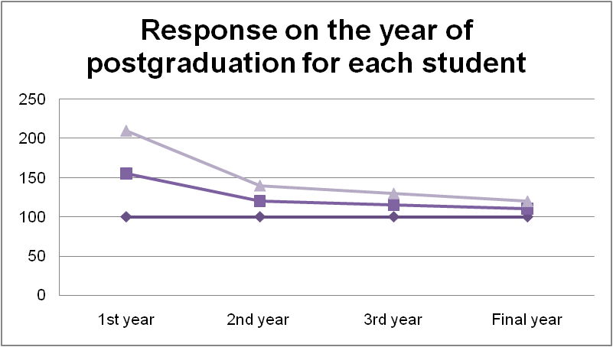
Figure 2: Graph on second sample
Q3. How far do you agree that you agree that your course curriculum has a huge impact on the eating time and habits?
Responses | No of responses | Percentage of responses
Strongly agree | 35 | 35
Agree | 50 | 50
Neutral | 0 | 0
Disagree | 5 | 5
Strongly disagree | 10 | 10
TOTAL | 100 | 100
Table 3: Third sample
This sample asks students regarding the impact of their course curriculum on the eating time and behaviour. Fifty students have agreed with this, while another thirty-five have strongly agreed regarding the influence of course on their eating habits. The study pressure and pattern of study changes with the course curriculums, which influences the eating choices.
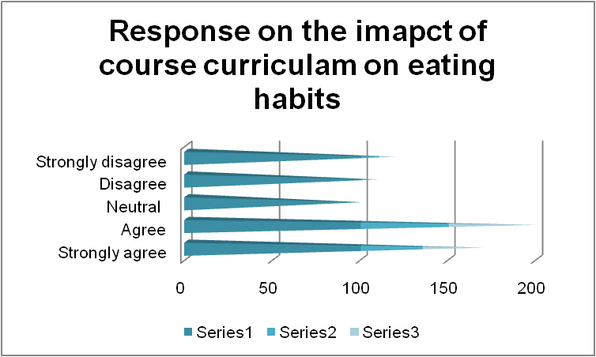
Figure 3: Graph on third sample
Q4. How far do you agree that the availability of the food items influences the eating decision of students?
Responses | No of responses | Percentage of responses
Strongly agree | 70 | 70
Agree | 30 | 30
Neutral | 0 | 0
Disagree | 0 | 0
Strongly disagree | 0 | 0
TOTAL | 100 | 100
Table 4: Fourth sample
This sample states that the availability of food items influences the eating decisions of students as the sample has received 70% responses in the "strongly agree" and 30% responses in the "agree" options that clearly reveals the power of food availability in the differing eating behaviour of students in universities.
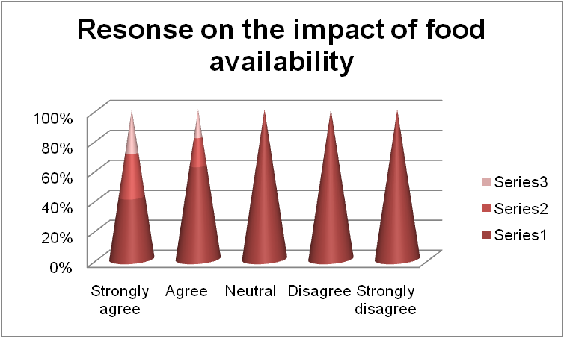
Figure 4: Graph on fourth sample
Q5. Do you believe that your university offers a decent variety of meal options for its students?
Responses | No of responses | Percentage of responses
Strongly believe | 30 | 30
Believe | 10 | 10
Neutral | 10 | 10
Disbelieve | 30 | 30
Strongly disbelieve | 20 | 20
TOTAL | 100 | 100
Table 5: Fifth sample
The sample asks students regarding their opinions on the variety of food items sold in their university campus. Thirty participants strongly believe and 10 other students also believe this. However, thirty students disbelieve on the variety of food items sold in the University campus along with another twenty students, who strongly disbelieve this.
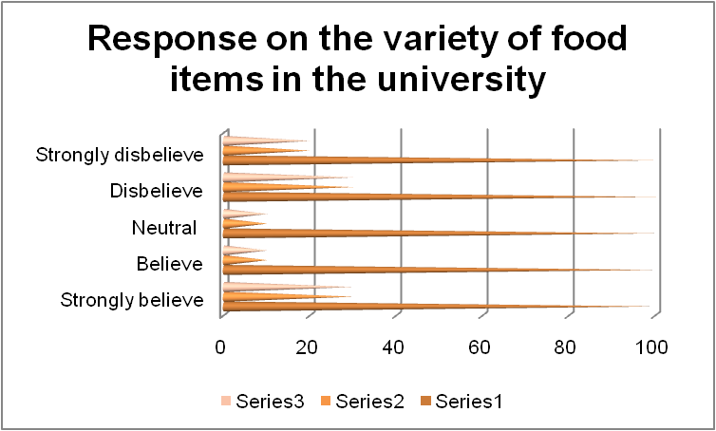
Figure 5: Graph on fifth sample
Q6. How far do you agree that your university authority wants its students to eat healthy food items?
Responses | No of responses | Percentage of responses
Strongly agree | 45 | 45
Agree | 30 | 30
Neutral | 10 | 10
Disagree | 10 | 10
Strongly disagree | 5 | 5
TOTAL | 100 | 100
Table 6: Sixth sample
This sample gathers responses on the willingness of University authority for making their students eat healthy food items. Forty-five students say that they strongly agree on this along with thirty other participants who agree with this as well. However, ten participants preferred to stay neutral on this along with ten who disagreed with this. Neutral responses represent the unwillingness of students to express an honest response. Negative responses raise question on the university reputation.
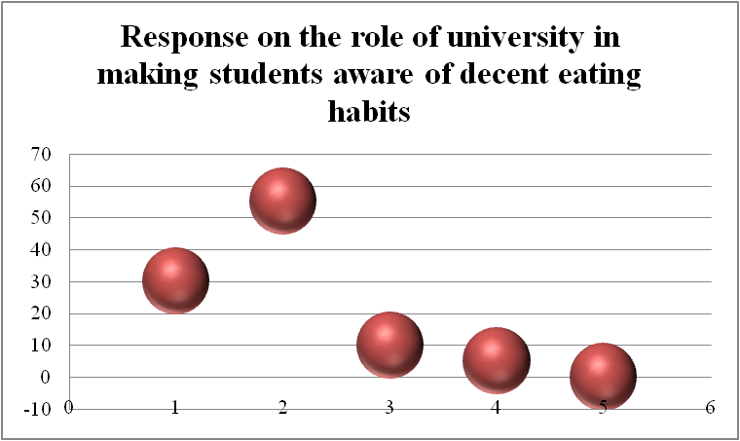
Figure 6: Graph on sixth sample
Q7. Do you believe that the management must make students aware to eat healthily for a better academic performance?
Responses | No of responses | Percentage of responses
Strongly believe | 30 | 30
Believe | 55 | 55
Neutral | 10 | 10
Disbelieve | 5 | 5
Strongly disbelieve | 0 | 0
TOTAL | 100 | 100
Table 7: Seventh sample
This sample asks students regarding their opinion on the university's role to inform them about healthy eating habits. Most of the students have agreed as the option receives 55% of overall responses. It can be said that students think that their university is responsible for making them aware of healthy eating habits for a better academic performance.
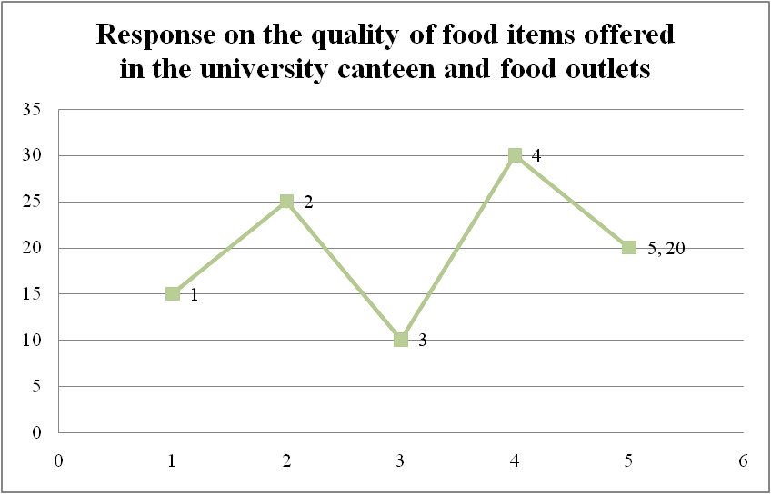
Figure 7: Graph on seventh sample
Q8. How far do you agree that the university canteen and other food outlets offer decent quality food items?
Responses | No of responses | Percentage of responses
Strongly agree | 15 | 15
Agree | 25 | 25
Neutral | 10 | 10
Disagree | 30 | 30
Strongly disagree | 20 | 20
TOTAL | 100 | 100
Table 8: Eighth sample
This sample is used to gather responses regarding the quality maintained by the University canteen and other food outlets. This sample receives most of the responses in the negative and neutral options that reflect that University canteens and food outlets do not maintain proper food quality.
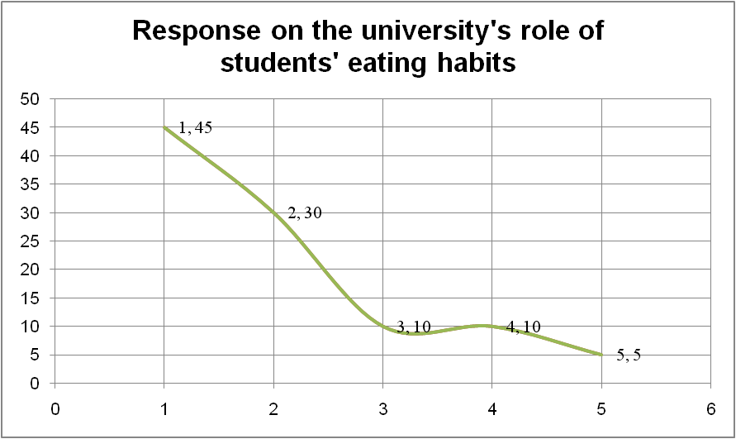
Figure 8: Graph on eighth sample
Q9. How far do you agree that the choice of eating time is influenced by the study pressure?
Responses | No of responses | Percentage of responses
Strongly agree | 80 | 80
Agree | 20 | 20
Neutral | 0 | 0
Disagree | 0 | 0
Strongly disagree | 0 | 0
TOTAL | 100 | 100
Table 9: Ninth sample
This sample includes data on the influence of study pressure in the choice of eating time of students. 80% of students have strongly agreed to this along with the remaining 20% who have also agreed to this. This can be said that students often face irregular eating time due to the excessive study pressure.
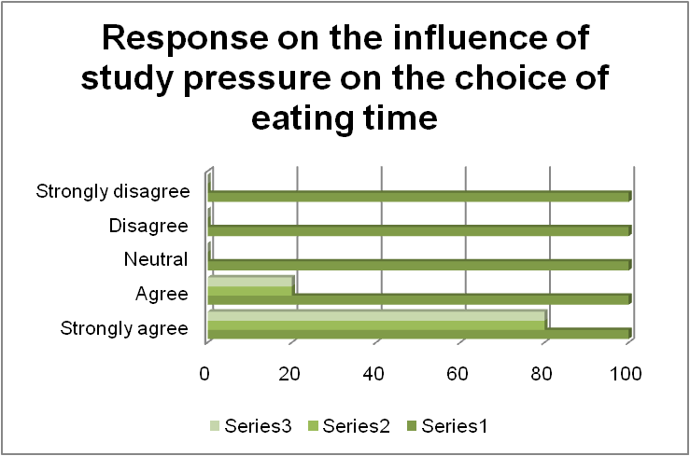
Figure 9: Graph on ninth sample
Q10. What would you like to suggest to your university for shifting students' interest towards nutritious eating behaviours?
Responses | No of responses | Percentage of responses
Maintaining food quality at the canteens | 45 | 45
Offering branded food outlets at the university premises | 20 | 20
Educating students regarding healthy eating | 10 | 10
Providing sufficient time for lunch break regardless of the study pressure | 15 | 15
Arranging campaigns to aware students regarding decent eating proportion and timing | 10 | 10
TOTAL | 100 | 100
Table 10: Tenth sample
This last sample includes data on the students' opinions on the role of University in improving their nutritious eating behaviours. Most of the students think that maintaining food quality at the canteens and food outlets is important for the university. Others have also shown their preferences for universities' role in educating students and providing them sufficient time for lunch breaks regardless of the study pressure. Some students have also taken the option that says awareness arranging campaigns is necessary.
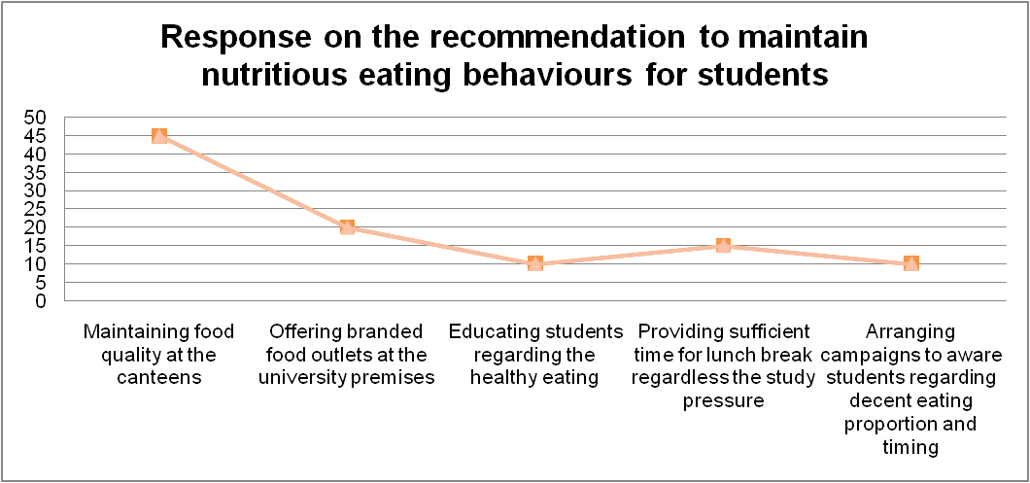
Figure 10: Graph on tenth sample

Discussion
The collected data sets have clearly indicated that the university authority must take strict actions to maintain their students' eating habits. Serving food items below qualities standard at the University canteens and food outlets should be prohibited by the management (Nguyen et al. 2019). Cases are seen where students get a limited options for choosing their meals while studying in a public University, which is a huge concern for them. This needs to be changed as well. They should encourage students to eat healthy and maintain a decent time of eating in a day which is needed for their mental and physical growth.

Conclusion
The research has gone through several aspects of students' lifestyles, study pressure and the availability of food at the University premises to identify their different eating behaviour. Even the role of University authorities to make their students aware of nutritious food consumption has also been analysed in the survey. It can be concluded that more than one factor is responsible for the changing eating habits of students. The analysis makes it clear that most of the students try to avoid the headache of preparing food on their own while studying at a university. They always want to eat readymade food from the canteens and other food outlets within the university premises. Even though they are aware of the fact that not all food outlets provide quality and nutritious food items, they are left with no choice but to eat those food items as they are outside of their homes. Cases are seen where students get unlimited options for choosing their meals while studying in a public University, which is a huge concern for them. Some cases of illness and poor health conditions of students are also revealed in this study. It can be concluded that the university authority must take care of their students' health. The authority must educate their students on eating healthy so that they can focus on their curriculum better.

References
Al-Ababneh, M.M., 2020. Linking ontology, epistemology and research methodology. Science & Philosophy, 8(1), pp.75-91.
Armond, A.C.V., Gordijn, B., Lewis, J., Hosseini, M., Bodnár, J.K., Holm, S. and Kakuk, P., 2021. A scoping review of the literature featuring research ethics and research integrity cases. BMC Medical Ethics, 22(1), pp.1-14.
Bauer, G.R., Churchill, S.M., Mahendran, M., Walwyn, C., Lizotte, D. and Villa-Rueda, A.A., 2021. Intersectionality in quantitative research: A systematic review of its emergence and applications of theory and methods. SSM-population health, 14, p.100798.
Browning, M.H., Larson, L.R., Sharaievska, I., Rigolon, A., McAnirlin, O., Mullenbach, L., Cloutier, S., Vu, T.M., Thomsen, J., Reigner, N. and Metcalf, E.C., 2021. Psychological impacts from COVID-19 among university students: Risk factors across seven states in the United States. PloS one, 16(1), p.e0245327.
Crowe, A.R. and Yue, W., 2019. Semi-quantitative determination of protein expression using immunohistochemistry staining and analysis: an integrated protocol. Bio-protocol, 9(24), pp.e3465-e3465.
Hosseini, S., Ivanov, D. and Dolgui, A., 2019. Review of quantitative methods for supply chain resilience analysis. Transportation research part E: logistics and transportation review, 125, pp.285-307.
Jufri, F.H., Widiputra, V. and Jung, J., 2019. State-of-the-art review on power grid resilience to extreme weather events: Definitions, frameworks, quantitative assessment methodologies, and enhancement strategies. Applied energy, 239, pp.1049-1065.
Martínez-de-Quel, Ó., Suárez-Iglesias, D., López-Flores, M. and Pérez, C.A., 2021. Physical activity, dietary habits and sleep quality before and during COVID-19 lockdown: A longitudinal study. Appetite, 158, p.105019.
Nguyen, H.V., Nguyen, N., Nguyen, B.K., Lobo, A. and Vu, P.A., 2019. Organic food purchases in an emerging market: The influence of consumers’ personal factors and green marketing practices of food stores. International journal of environmental research and public health, 16(6), p.1037.
Sileyew, K.J., 2019. Research design and methodology. Cyberspace, pp.1-12.
Trigueros, R., Padilla, A.M., Aguilar-Parra, J.M., Rocamora, P., Morales-Gázquez, M.J. and López-Liria, R., 2020. The influence of emotional intelligence on resilience, test anxiety, academic stress and the Mediterranean diet. A study with university students. International journal of environmental research and public health, 17(6), p.2071.

