An Overview of Structural Equation Modelling (SEM)and key elements

The term ‘SEM’ may be used to covers several different types of modelling (including path analysis and regression modelling – see below).
For an introduction to the topic overall, see Curran-Bauer Analytics YouTube channel ( Prof Patrick Curran): https://www.youtube.com/watch?v=wHFrgp3SQMI
(All analyses indicated can be undertaken using SPSS AMOS which produces the required diagrams. For tutorials based on the use of AMOS, see James Gaskin’s YouTube channel).
SEM involves the following key steps:
- Specification: what are the variables and likely paths?
- Identification: what values are available for each element?
- Estimation
- Evaluation: is the model a good fit?
- Re-specification: if necessary
- Interpretation: what does this mean for the topic involved?

Path analysis
For an overview, see: https://www.youtube.com/watch?v=QkXTdTCF3PI
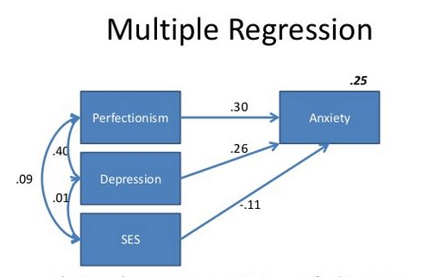
A Path Analysis is a structural model (path model) of relationships between observed variables (or indicators). Diagrammatically, these are shown as boxes. Arrows (paths) point from boxes which are independent variables (IV) (or exogenous variables) to dependent variables (DV) (or endogenous variables) showing which factor influences which. These diagrams can initially be put together based on supposition (this is specification). The strength of relationships between pairs of variables (or factor loadings) can be expressed using standardised slopes of the regression line or ‘Beta coefficients’. This involves multiple regression analysis to examine the relationship between several IV (‘predictors) and one DV (‘criterion’) to give a ‘regression model’. Several regressions may need to be undertaken to complete the whole path analysis (can a be done in SPSS or AMOS).
See https://www.youtube.com/watch?v=SsurWx_SGKI for path analysis. For more details of regression see: https://www.spss-tutorials.com/linear-regression-in-spss-example/ plus https://www.spss-tutorials.com/multiple-linear-regression/#betacoef .
Note also that R values in regression outputs are correlation coefficients, and R² x100 gives the % of the DV explained by the IV in question.
Additional ‘factors’ influencing the DV may be included to account for unexplained effect (‘residuals’ or ‘disturbances’).
The ANOVA available during a regression analysis (SPSS) indicates the significance of the independent variables taken together.

Path analysis diagrams may be very complex:
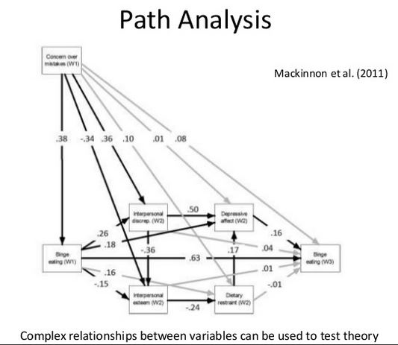
Where factors are present as a ‘string’, ie. not just a single IV to DV path, the intervening factors are called ‘mediators’.

Factor analysis

Factor analysis is a process which identifies latent variables that affect observed variables (such as responses to questionnaire questions). It is based on correlation (SPSS required). It allows the construction of a measurement model as shown below. In such models, latent variables are depicted as ovals. Confirmatory Factor Analysis is used rather than Exploratory Factor Analysis (ie. there is an a priori assumption about the identity of the latent variables: specification).
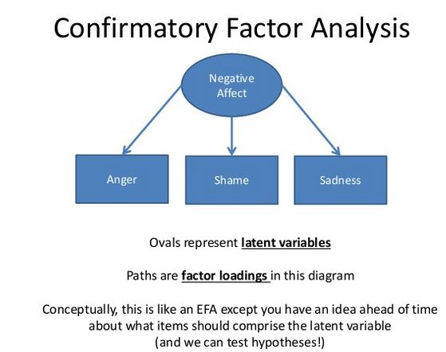
Note that in FA, factor loadings may be correlation coefficients. However, in an SEM overall, they are usually regression coefficients.
See https://www.youtube.com/watch?v=COud3zGnwoM for a video outlining Confirmatory Factor Analysis in the context of SEM. CFA is generally done via SEM using AMOS (see https://www.youtube.com/watch?v=JkZGWUUjdLg ).
[For Exploratory Factor Analysis, which aims to identify latent variables, see https://www.youtube.com/watch?v=ajvpIACCyd4 : factor reduction using Principal Components Analysis within SPSS].

Structural equation modelling (SEM)
For a thorough discussion of the key principles, see https://www.youtube.com/watch?v=CXuAjv-aVSY.
SEM generally incorporates both a measurement model and a structural model. The model may be complex and requires careful specification. It is often used to test theories about paths and factors (requires SPSS AMOS or equivalent). Error variables are generally added to endogenous variables.

Note conventions for diagrams:
Latent variables are drawn as circles. Measured variables are drawn as squares. Numbers on straight arrows (‘factor loadings’) are generally Beta coefficients. Double-headed arrows represent correlation coefficients between pairs of variables.

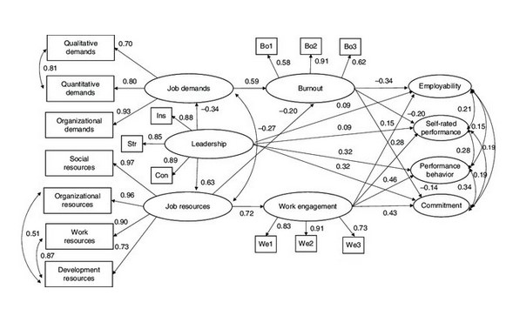
For a short tutorial on undertaking SEM in AMOS using just latent variables see https://www.youtube.com/watch?v=JkZGWUUjdLg (James Gaskin).
For an AMOS User’s Guide, see: http://www.sussex.ac.uk/its/pdfs/SPSS_Amos_User_Guide_22.pdf

