 | Student No: | 2221755  Raluca Georgiana Rogoz
 | Module Title: | Operating Hotel Facilities
 | Module Code: | BMIH4006
 | Lecturer: | Muhammad Cassamo
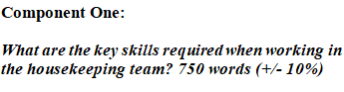

A hotel’s functionalities are served by its housekeeping staff and their indispensable skills and traits are essential for maintaining the standard benchmark of a prominent hotel like Premier Inn. In this reflective report, I will discuss about fundamental skills of Premier Inn’s housekeeping service. I will use Gibbs's reflective model to reflect on my experience as a housekeeper at Premier Inn Hotel (Adeani et al., 2020).

Discovering the Skills Critical for Premier Inn Hotel’s (city Maidstone) Housekeeping Team
The housekeeping team of Premier Inn (city Maidstone) Hotel needs some key skills and capabilities to operate effectively. Some key skills are:
Efficiency: Housekeepers need to perform efficiently to handle large occupancy rates especially. The massive brand reputation of Premier Inn requires its housekeeping crews to have excellent time management during quick turnaround of guestrooms, so they do not compromise quality service (Davras, 2019).
Precisions: Housekeeping in Premier Inn needs special focus and precision points to keep every corner and room clean so the hotel can maintain its high standard of cleanliness. Through cleaning and inspecting every element is possible to sustain the brand image (Rohaeni et al., 2021).
Flexibility: The hotel environment is very variable and dynamic. The housekeepers must be flexible to provide any sudden requirements of the guests or to change the timetable to utilize the full potential of the guestroom services so the guests can get maximum satisfaction (Espellita, 2019).

Communication: The housekeeping staff must communicate with colleagues, interact with staff from other hotels and inform information to front desk or supervisor. Whether they interact with the guests or ask for new supply requests for guest service, communication is a must skill.
Team Collaboration: Hotel activities are achieved through teamwork and at Premier Inn, housekeeping staff must collaborate to perform every task properly. Teamwork ensures that tasks are assigned effectively and by collective effort maximum customer service will be provided (Srivastava, 2020).

Reflecting on the Housekeeping Experience Utilising the Gibbs Model
Gibbs's reflective model provides an excellent reflective assessment of the housekeeping experience at the Premier Inn Hotel.
Description: While working as housekeeping at the Premier Inn Hotel, my main task is to keep the guestrooms prepared by carrying out several room cleaning acts such as vacuuming, sweeping, trash disposal, rechecking room facilities and preparing the beds with clean sheets ensuring quick guest service (Rohaeni et al., 2021).
Feelings: The everyday housekeeping procedure makes me go through several emotional feelings. When the rooms are clean and guests can have maximum satisfaction, I feel a sense of success. However, sometimes the load of work and erratic atmosphere makes me exhausted. This means the activities should be more effective.
Evaluation: The high standard of Premier Inn Hotel ensures that all efforts are given full dedication and precision to provide guest service. The guests recognise the precision and efficiency put forward which enlightens the staff. However, the tasks being repetitive can exhaust the staff to perform effectively (Srivastava, 2020).
Analysis: through the experience I have realized the compelling roles of housekeeping activities coupled with efficiency, teamwork, flexibility, and collaboration are simply indispensable. These functions not only ensure housekeeping excellence but also highlight the brand and its customer’s experiences.
Conclusion: I have decided to further enhance my housekeeping attributes such as teamwork and collaboration. I am focused on developing my housekeeping collaboration and instilling a bond and relationship of encouragement in my workplace. I hope to make the entire housekeeping staff work as an interactive group (Espellita, 2019).

Action Plan: I will increase my effort to further enhance housekeeping skills by attending workshops which will improve my competency as well as enhance the functions of my team. I will investigate Premier Inn’s housekeeping thoroughly to identify any potential improvement areas and put it on my enhancement list (Adeani et al., 2020)

The housekeeping skills and capabilities are what keep the high standard of Premier Inn Hotel and ensure excellent customer satisfaction. The Gibbs reflective model has highlighted my service as housekeeping through a competitive manner and continued growth. The mentioned housekeeping attributes are crucial for maintaining Premier Inn’s standard function, and I must improve my housekeeping traits to provide more contributions (Davras, 2019).

Words-766

Component Two: Housekeeping cleaning checklist
Contribution to Overall Module Assessment: 25%
Housekeeping Cleaning Checklist
Name: Mr X ----------------------- Location: Premiere Inn ( city Maidstone ) --------------------- Start Date: 03-11-2023
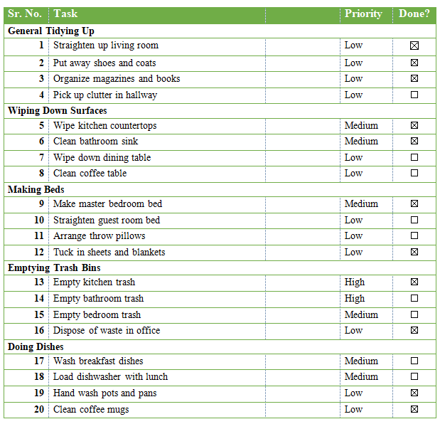

Based on your completed checklist you will need to write 500 words in essay format discussing the following:

How will you guarantee that the rooms are cleaned in accordance with brand guidelines?
To ensure that rooms are cleaned to brand standards, the checklist process should align brand requirements given by Premier Inn Hotel with its general cleaning tasks. To keep the room clean, a proper outline will be developed that will clarify how every area of each room, surface corners, floors and amenities will be cleaned thoroughly. The outline will also specify which tools and cleansers will be utilized, both of which will be recommended by the hotel. There will be a systematic review of the completed checklist and the team will inspect the tasks thoroughly to ensure they comply with the standards provided by Premier Inn. A regular training process will be developed to make sure housekeeping is updated with the hotel’s requirements and any changes in the checklist should be communicated to them to ensure an efficient and detailed cleaning process (Rinekasari et al., 2019).
How would you implement these changes to increase team effectiveness?
Improving team effectiveness is crucial for housekeeping at Premier Inn Hotel. For this, there should be a clear communication channel within the hotel setting so that housekeeping staff can interact with each other. They will conduct regular team meetings where housekeepers will discuss housekeeping practices, challenges and solutions which will highlight the crucial role of collaboration. Effective task delegation will be utilized to ensure that tasks are assigned effectively, and this task delegation process should rotate in a cycle to prevent exhaustion and encourage all the members to improve skills and achieve proficiency in various room cleaning tasks. Recognising and rewarding excellent performance such as monthly bonuses, or incentives will increase their performance and effectiveness as a team (Ngoepe, 2021).
Why do you believe your list to be the most useful?
The checklist is developed by focusing on the brand standard of Premier Inn Hotel, so best effective tasks are included in the checklist. The checklist offers a detailed process and instructions covering every area of room cleaning. So, the responsible teams can easily understand their task and methods to perform their tasks diligently. There is significant room for flexibility and adaptability which can be modified if there are any changes in the room settings and variations in guests’ preferences. Also, any changes in cleaning standards by Premier Inn Hotel can be adapted quickly and any changes in room facilities will be handled efficiently. The checklist has much room for continuous improvement and team members can provide feedback related to the effectiveness of the checklist or any input suggestions will be addressed promptly. The checklist will be constantly updated based on ongoing industry trends, hotel requirements and guest feedback (Chan et al., 2021).

Words-566

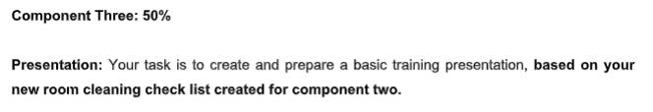

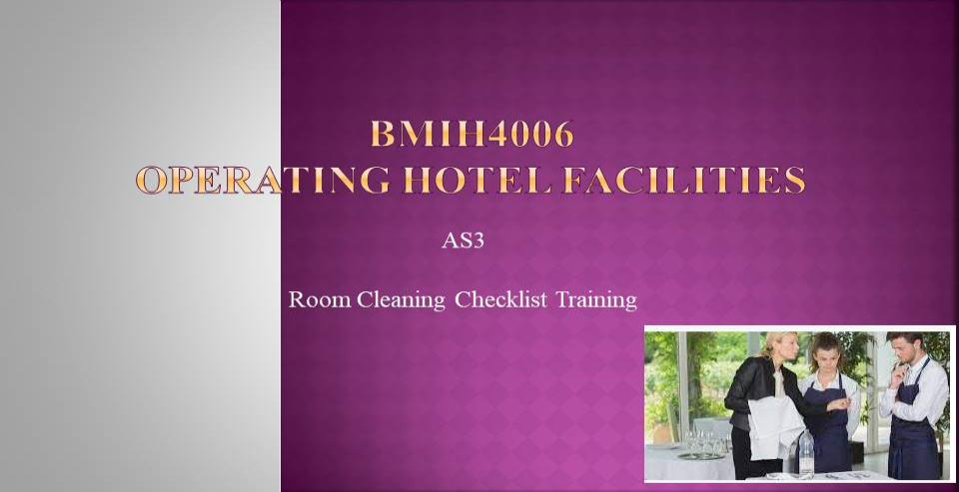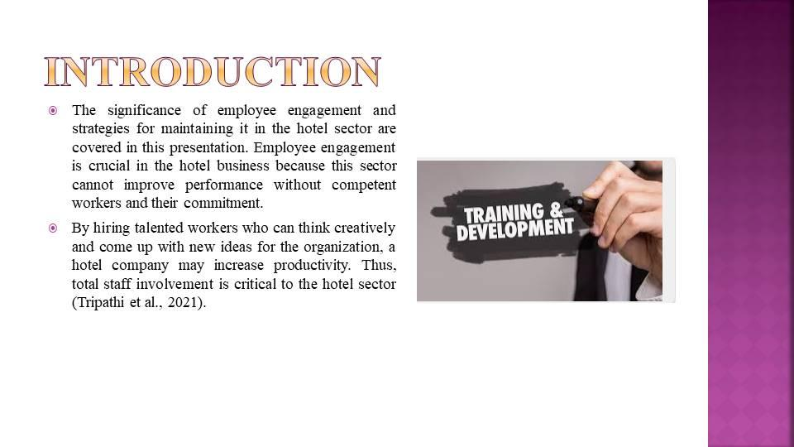
The significance of employee engagement and strategies for maintaining it in the hotel sector are covered in this presentation. Employee engagement is crucial in the hotel business because this sector cannot improve performance without competent workers and their commitment. By hiring talented workers who can think creatively and come up with new ideas for the organization, a hotel company may increase productivity. Thus, total staff involvement is critical to the hotel sector (Tripathi et al., 2021).

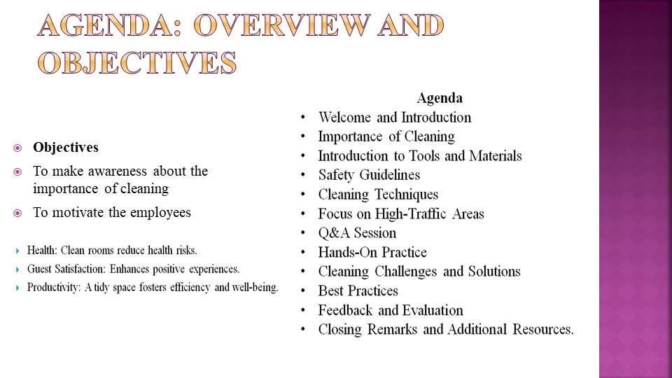
This hotel has ninety total rooms, all of which are opulent. This hotel is where royalty come to spend their holidays and quality time (Choi et al, 2021). In many firms, the idea of corporate social responsibility, or CSR, is still developing. More awareness of corporate and social welfare has led to the development of the idea. The integration of social, ethical, and environmental issues into business operations and stakeholder relations is included by these two principles for organizations. Environmental, social, and economic effects of a company's operations are taken into consideration by CSR. Data transparency may improve the two departments' collaboration. It is advantageous to support staff members and decision-makers in developing a workable strategy and remedies for any problems that could arise in the company.
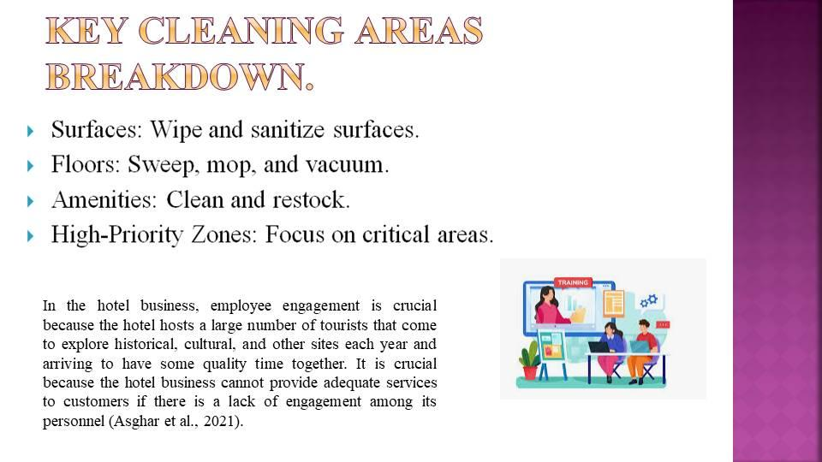

In the hotel business, employee engagement is crucial because the hotel hosts a large number of tourists that come to explore historical, cultural, and other sites each year and arriving to have some quality time together. It is crucial because the hotel business cannot provide adequate services to customers if there is a lack of engagement among its personnel (Asghar et al., 2021). Running a coffee shop like "Hotel Trinity" doesn't come with too many obstacles, and the proprietor can make his profit with ease. The company plan should not be very expensive, and because its running costs are lower than those of its competitors, the owner will make more money. Proper business idea generation is necessary for the effective and profitable operation of a new firm. The coffee shop "Hotel Trinity" also pinpoints a few simple yet clever business concepts that may help the enterprise accomplish its goals. Below is a discussion of the idea generation process
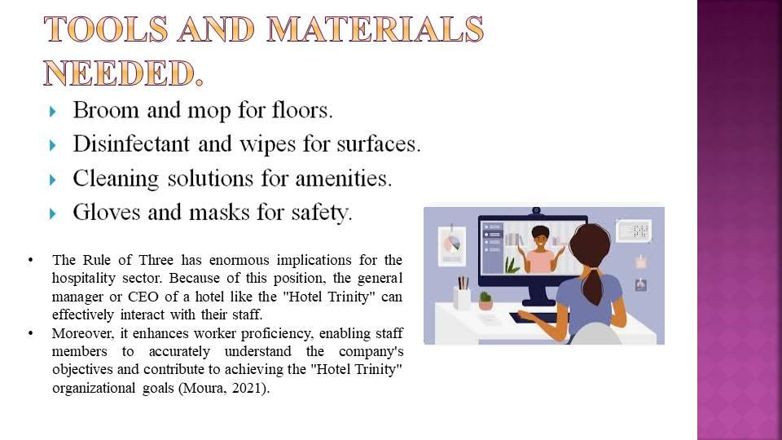
The Rule of Three has enormous implications for the hospitality sector. Because of this position, the general manager or CEO of a hotel like the "Hotel Trinity" can effectively interact with their staff. Moreover, it enhances worker proficiency, enabling staff members to accurately understand the company's objectives and contribute to achieving the "Hotel Trinity" organizational goals (Moura, 2021).
There are several strategies to maintain staff engagement in the hospitality sector. The hotel chain is able to provide appropriate training for its staff. Additionally, they may set up a system of rewards for the worker. And those that do well get a second chance from the hotel administration. Effective employee engagement in the hotel business is also greatly influenced by proper incentive. According to Choi et al. (2021) a hefty wage is also a very successful tool for keeping staff involved with the "Hotel Trinity."
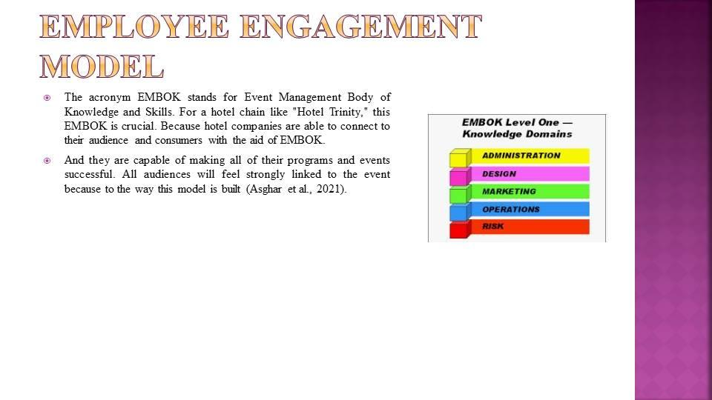
The acronym EMBOK stands for Event Management Body of Knowledge and Skills. For a hotel chain like "Hotel Trinity," this EMBOK is crucial. Because hotel companies are able to connect to their audience and consumers with the aid of EMBOK. And they are capable of making all of their programs and events successful. All audiences will feel strongly linked to the event because to the way this model is built (Asghar et al., 2021). The employee engagement paradigm has several benefits. The hotel corporation can effectively execute all of its events when they use this approach inside their organization. The hotel business may guarantee and establish an employee safety system that encourages full participation from all workers in their job. Employees feel more protected while work, which helps them perform better (Rabiul et al., 2021).
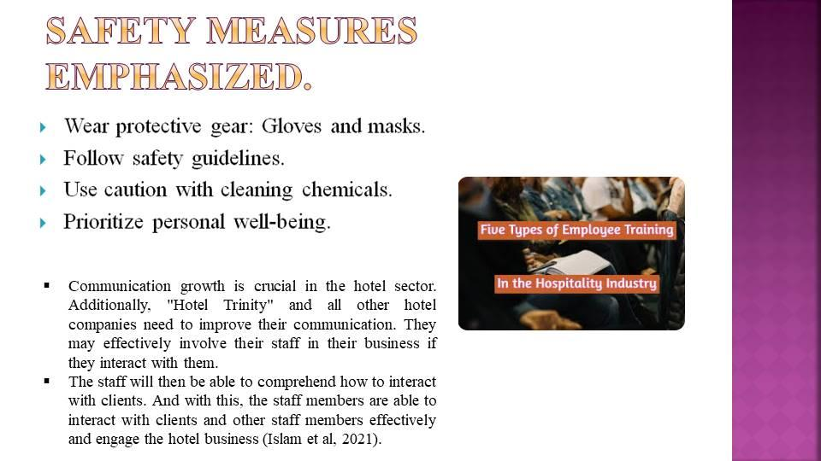
Communication growth is crucial in the hotel sector. Additionally, "Hotel Trinity" and all other hotel companies need to improve their communication. They may effectively involve their staff in their business if they interact with them. The staff will then be able to comprehend how to interact with clients. And with this, the staff members are able to interact with clients and other staff members effectively and engage the hotel business (Islam et al, 2021). Because the supplies needed for the company are not very costly, a coffee shop is a business that can get by with a modest investment. A new coffee shop called "Hotel Trinity" uses an inexpensive business approach to provide traditional coffee to the local community (Issa et al, 2014).
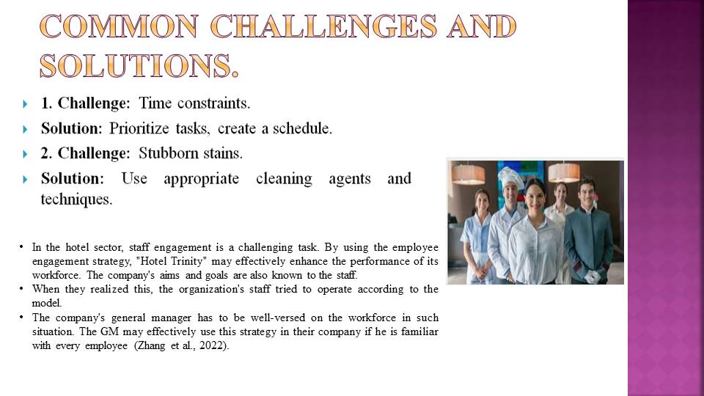

In the hotel sector, staff engagement is a challenging task. By using the employee engagement strategy, "Hotel Trinity" may effectively enhance the performance of its workforce. The company's aims and goals are also known to the staff. When they realized this, the organization's staff tried to operate according to the model. The company's general manager has to be well-versed on the workforce in such situation. The GM may effectively use this strategy in their company if he is familiar with every employee (Zhang et al., 2022). Both locals and tourists may enjoy more leisure time in green spaces and public realm areas, which also enhance quality of life. To promote sustainable mobility, London must invest in bike lanes and public transport systems. More funding is nonetheless required for environmental initiatives including encouraging tourists to reduce their carbon footprint and using renewable energy sources

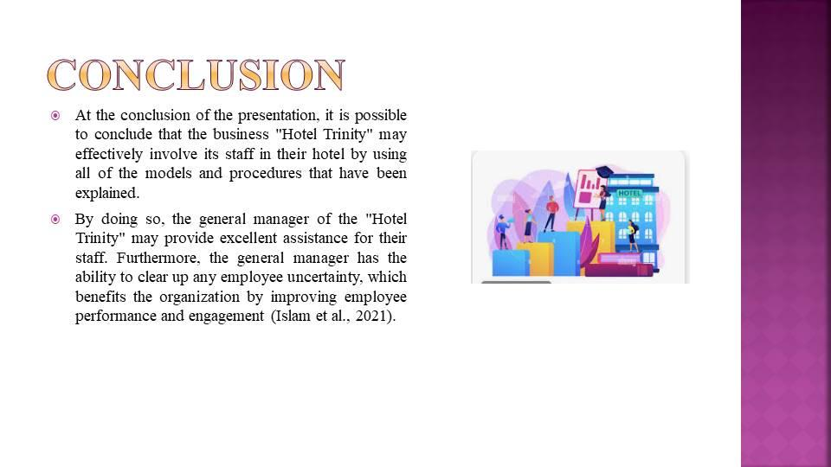
At the conclusion of the presentation, it is possible to conclude that the business "Hotel Trinity" may effectively involve its staff in their hotel by using all of the models and procedures that have been explained. And by doing so, the general manager of the "Hotel Trinity" may provide excellent assistance for their staff. Furthermore, the general manager has the ability to clear up any employee uncertainty, which benefits the organization by improving employee performance and engagement (Islam et al., 2021).
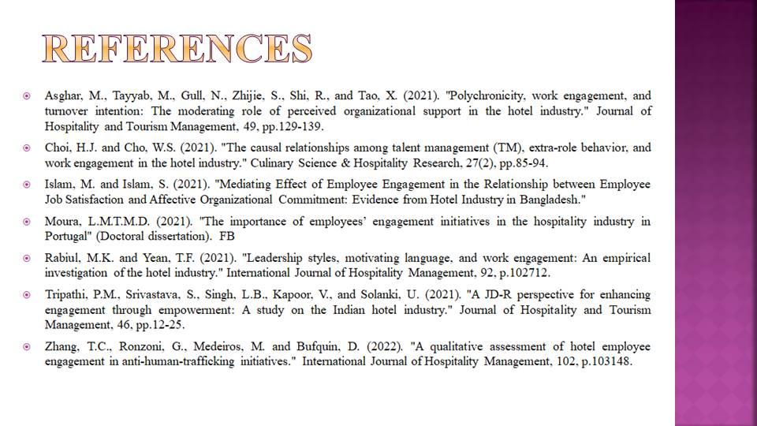

References
Adeani, I.S., Febriani, R.B., & Syafryadin, S. (2020). Using GIBBS’ reflective cycle in making reflections of literary analysis. Indonesian EFL Journal, 6(2), 139-148.
Asghar, M., Tayyab, M., Gull, N., Zhijie, S., Shi, R., & Tao, X. (2021). Polychronicity, work engagement, and turnover intention: The moderating role of perceived organizational support in the hotel industry. Journal of Hospitality and Tourism Management, 49, 129-139.
Chan, J., Gao, Y.L., & McGinley, S. (2021). Updates in service standards in hotels: how COVID-19 changed operations. International Journal of Contemporary Hospitality Management, 33(5), 1668-1687.
Choi, H.J., & Cho, W.S. (2021). The causal relationships among talent management (TM), extra-role behavior, and work engagement in the hotel industry. Culinary Science & Hospitality Research, 27(2), 85-94.
Davras, Ö., & Caber, M. (2019). Analysis of hotel services by their symmetric and asymmetric effects on overall customer satisfaction: A comparison of market segments. International Journal of Hospitality Management, 81, 83-93.
Espellita, S., & Maravilla Jr, V.S. (2019). Employable skills for hospitality graduates as perceived among hotel supervisors in Cebu City. Journal of Economics and Business, 2(2).
Islam, M., & Islam, S. (2021). Mediating Effect of Employee Engagement in the Relationship between Employee Job Satisfaction and Affective Organizational Commitment: Evidence from Hotel Industry.
Moura, L.M.T.M.D. (2021). The importance of employees’ engagement initiatives in the hospitality industry in Portugal (Doctoral dissertation). Rabby_FB.
Ngoepe, L.L. (2021). Hotel employability of hospitality graduates from private academic institutions (Doctoral dissertation, University of Johannesburg).
Rabiul, M.K., & Yean, T.F. (2021). Leadership styles, motivating language, and work engagement: An empirical investigation of the hotel industry. International Journal of Hospitality Management, 92, p.102712.
Rinekasari, N.R., Jubaedah, Y., & Sobariah, S.N. (2019). Standard Operating Procedure of Housekeeping Adaptation: The Development of Assessment Tools in Cleaning Bathroom Practices at Vocational High School. KnE Social Sciences, 150-161.
Rohaeni, N., Yusuf, S.F., Jubaedah, Y., & Sunarsih, M. (2021, February). The Analysis of Hotel Linen Cleaning Standard in Housekeeping Department. In 6th UPI International Conference on TVET 2020 (TVET 2020) (pp. 263-266). Atlantis Press.
Srivastava, A., & Kumar, V. (2020). Hotel attributes and overall customer satisfaction: What did COVID-19 change? Tourism Management Perspectives, 40, p.100867.
Tripathi, P.M., Srivastava, S., Singh, L.B., Kapoor, V., & Solanki, U. (2021). A JD-R perspective for enhancing engagement through empowerment: A study on the Indian hotel industry. Journal of Hospitality and Tourism Management, 46, 12-25.
Zhang, T.C., Ronzoni, G., Medeiros, M., & Bufquin, D. (2022). A qualitative assessment of hotel employee engagement in anti-human-trafficking initiatives. International Journal of Hospitality Management, 102, p.103148.

