
Joshua Hanbury

Usability Engineering
Assignment 2

Contents
Usability review 3
Display 1 – British Museum 3
Display 2 – Louvre 6
Recommended interface evaluation strategy 8
Interactive static exhibit 8
Evaluation Strategy 8
Evaluation timeline 9
Augmented reality exhibit 9
Evaluation Strategy 9
Evaluation timeline 10
Guidelines and Accessibility 11
Usability guidelines 11
Accessibility recommendations 11
Virtual & Augmented Reality 13
Background of VR systems 13
Proposed AR Exhibit 13
Hardware 14
Software design 14
Sketches 14
Bibliography 17

Usability review

Display 1 – British Museum
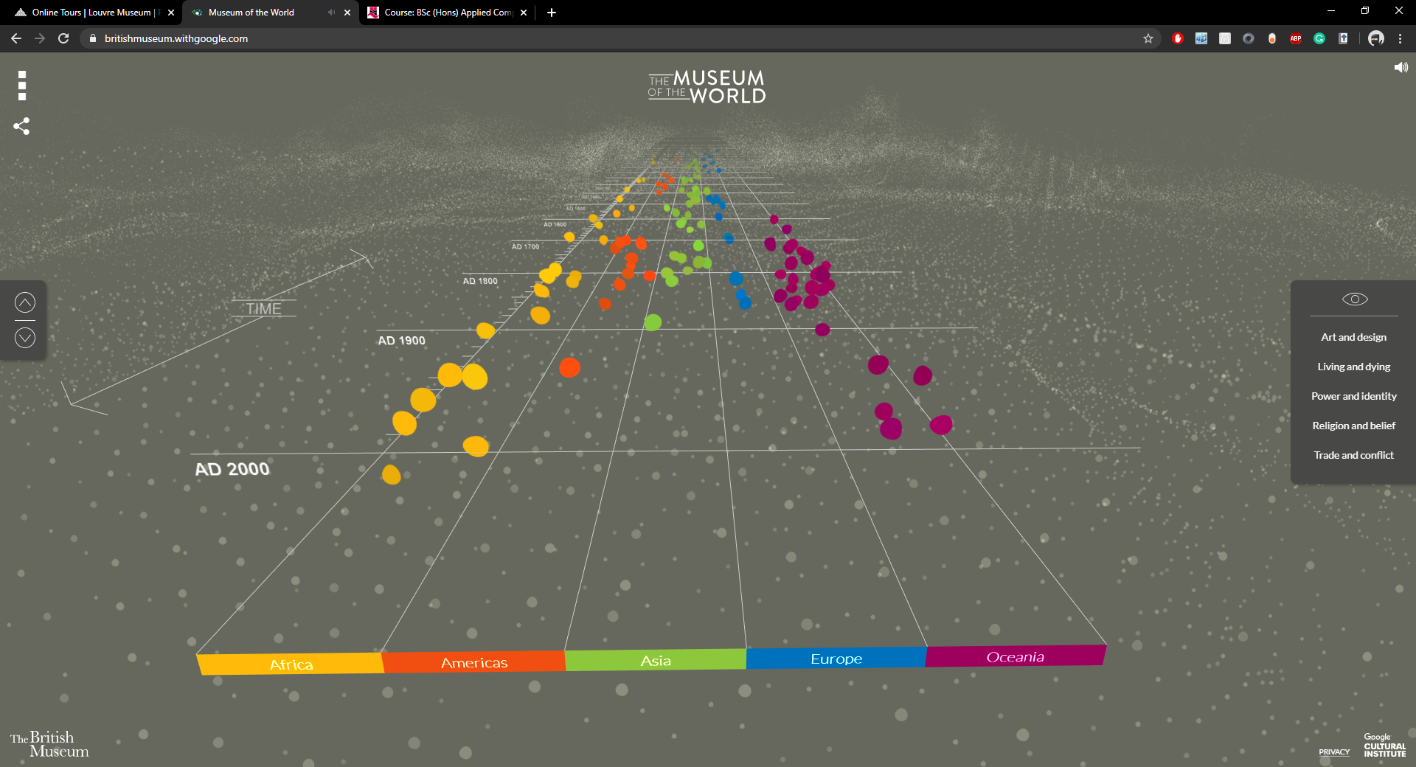
This display by the British Museum allows for users to navigate their virtual exhibitions through the use of an interactive timeline where users can search for items from the Year and Location factors.
This is a very attractive display which clearly outlines what data is available through the use of blips or dots which can be selected by users. The timeline can be scrolled through using the mouse wheel or the arrows located at the side of the screen. When hovering over the dots on the timeline the webpage gives a different toned beep to display that the dot is being hovered over. As you scroll through the timeline you will also find audio bleeps as you would when hovering over the dots.
Another feature provided by the British museum is the sorting facility which allows users to only see exhibits on subjects they want. This can be done through the selection of topics on the right hand side of the web page.
The timeline can also be navigated through the left side menu where dates can be chosen to be jumped to on the timeline. The top right of the webpage also shows a volume icon which, when selected, will mute all audio of the web page.

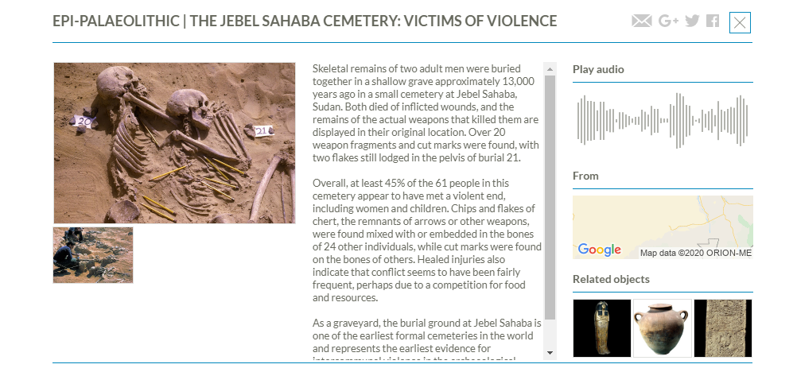
Above is an image of what a display looks like when selected from the timeline. All of the relevant information such as the image, descriptive text and name is all clear and available to the user. It provides accessibility through vision, images, and audio using a playable audio clip on the side. Touch can be incorporated for some displays which have 360 imagery and can be moved around virtually. Below, I have made a sketch of the display screen, showing the functionality each section provides alongside some improvements I have suggested.
Within the sketch below, I have added in improvements including:
- A font size modifier within the informative text section. The text is one size and could be troublesome for users with visual issues. The option to increase and decrease fonts will assist them in their browsing of the displays.
- A brightness / view mode modifier at the top. This will allow for the brightness to be changed to allow for a darker / lighter viewing mode. It will also allow for users to select a light or dark theme to the display.
The layout of displays also allow for easy use on touchscreen devices, making its compatibility and usability across devices very good. This could be a future implementation to allow for the online displays to be displayed on tablets or kiosks to accommodate those who may not be able to see the displays themselves.
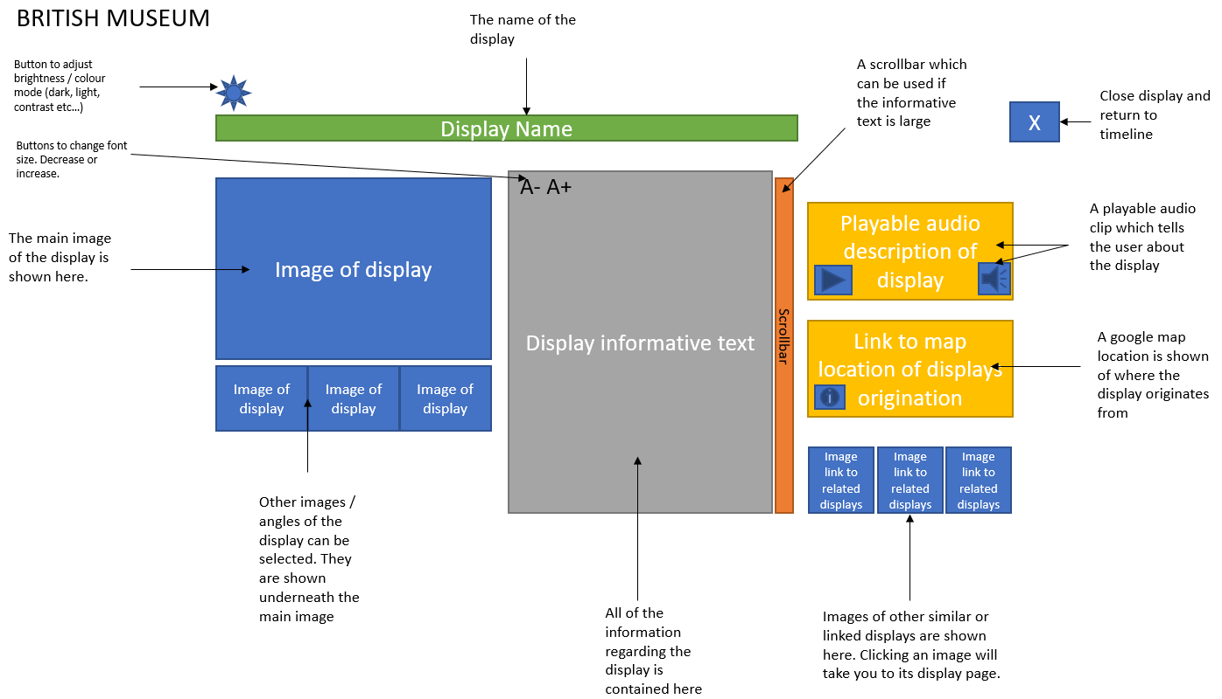

Display 2 – Louvre
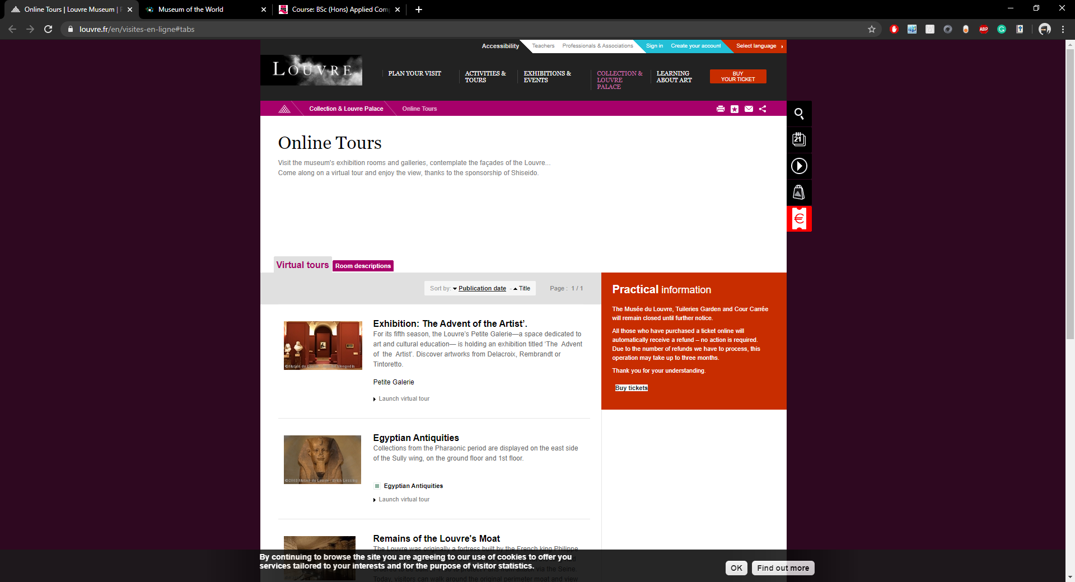
Display 2, the louvre, is what I will be displaying as my “bad” example during the evaluation. The louvre offers a different type of tour, where users can select the exhibition of their choice and indulge in an experience which aims to replicate walking through the museum. It is a very immersive and interesting type of exhibition where users can feel as thought they are in the museum themselves. Users navigate through the museum by selecting arrows on the floor or areas to visit.
Exhibits can be viewed when close enough, with an image of a magnifying glass showing that more info can be provided by selecting it. During use of the exhibit I found it tough to efficiently “walk through” or navigate the exhibition which was a downfall during use.
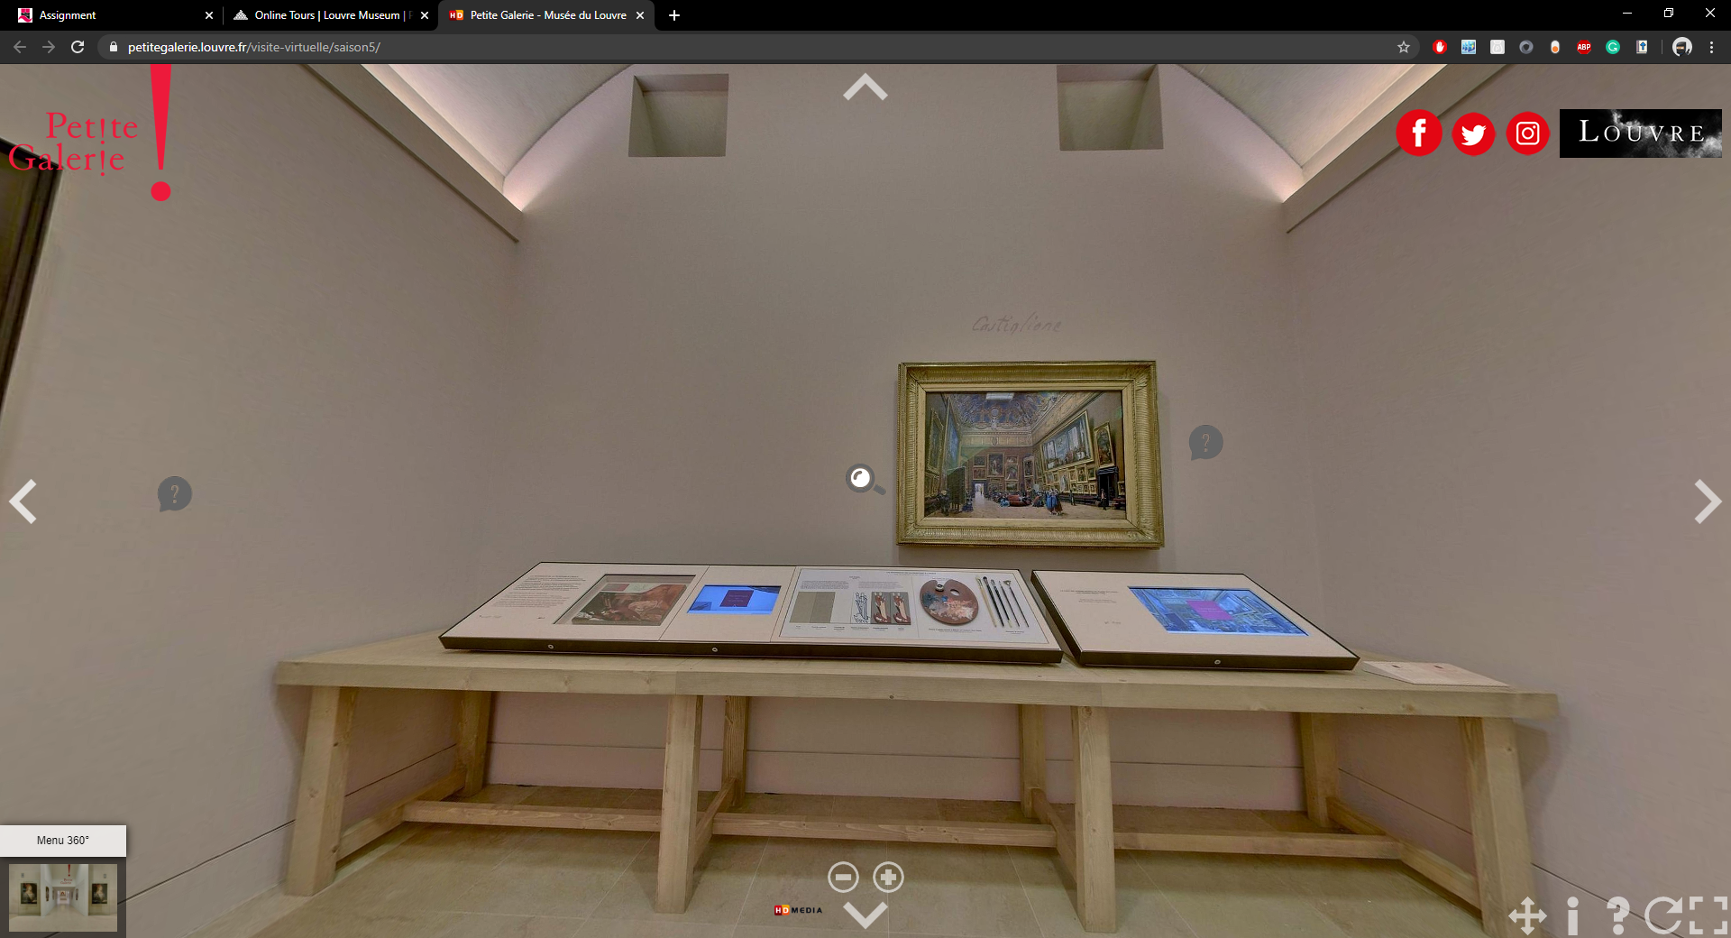
Above, is an image of what the navigation of the online museum appears as. This is a random section of displays found during navigation of the museum. In the image you can see all of the features which the louvre offers in their online exhibits, in this case, you can walk around the museum and view the displays. I find that the louvre offers more accessibility and usability functionality than the British museum through this use of symbiology. All of the features and usage a user can have with the application is identified using symbiology such as magnifying glasses to zoom in, question marks to learn more and arrows to navigate. There are also icons at the bottom right of the page which allow for further functions to be used such as changing the navigation method, further information, help, turning off the auto-rotation feature and finally, going Fullscreen mode. However, as mentioned before, the navigation of the museum is very poor, and it is difficult to move from position to position. All of the path’s users can follow make it very restricted and, in many circumstances, you cannot backtrack to a previous position without reloading the page. The affordance of the application is also impressive, as most of the icons and features are easily identifiable to their purpose and will carry out the actions expected by the user.
In the sketch below I have mapped all of the features on the page and what each feature does. I have also made some small recommendations which would improve the usability of the online museum exhibit view. The main recommendation I have made for this online exhibition is the ability to change language. The symbiology works very well as there is no language barrier, but when a display is selected, the information is only displayed in French which is not of use to non-French speakers such as me.
For usability purposes, I believe the method of navigation should be changed to allow for easier movement. This could be done using a map from above with clickable positions to be placed at. This would be very simple to use and understandable by most users. It will be an improvement over the current “click to go” navigation method which rarely works.
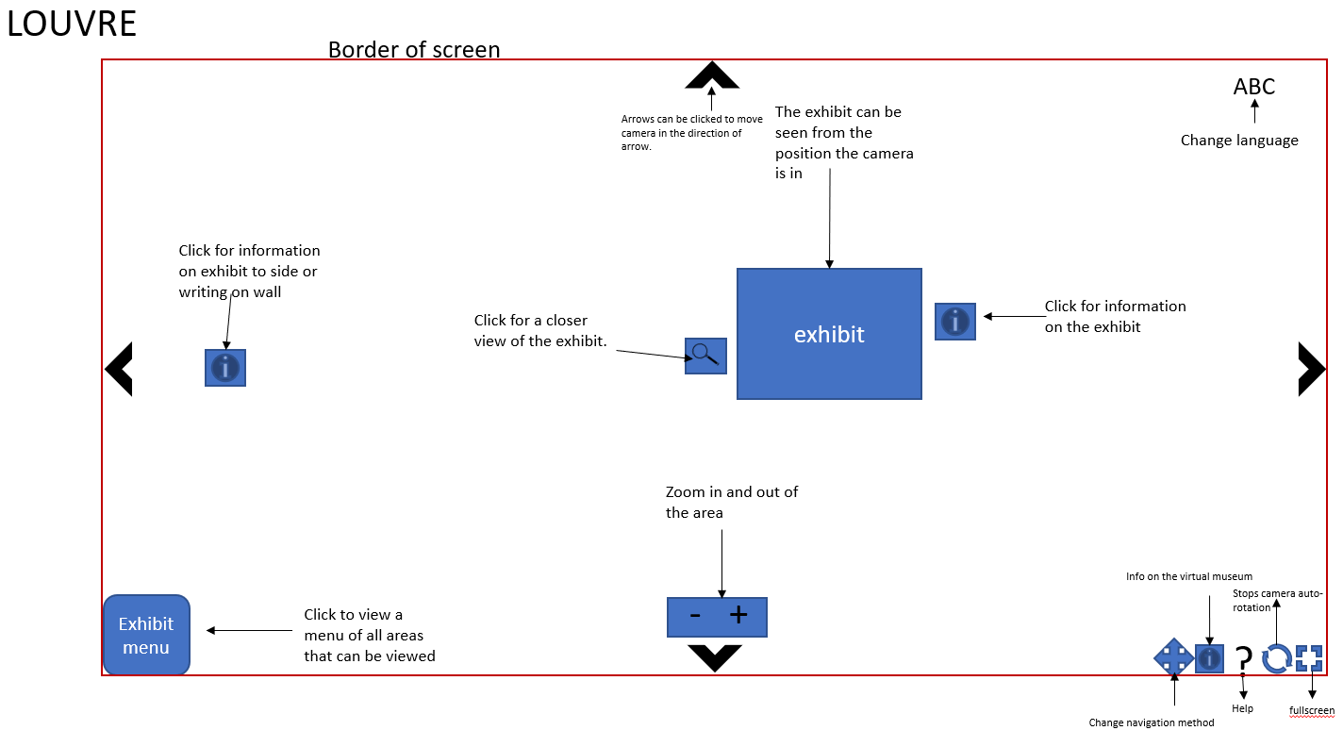

Recommended interface evaluation strategy
Here I will be designing a recommended interface evaluation strategy for two new exhibits at the museums I have researched.

Interactive static exhibit
For an interactive static exhibit, I propose a kiosk system at the Louvre. This system would incorporate their tactic of online tours, allowing for users to virtually tour the museum at a kiosk. This would allow for users to select any exhibit in the museum and view it on the kiosk in whatever language they desire for reading, as the information given at the displays is all in French. This would allow for users of any language to learn of the displays and not have a barrier stopping them from seeing any displays they may not be able to get to. 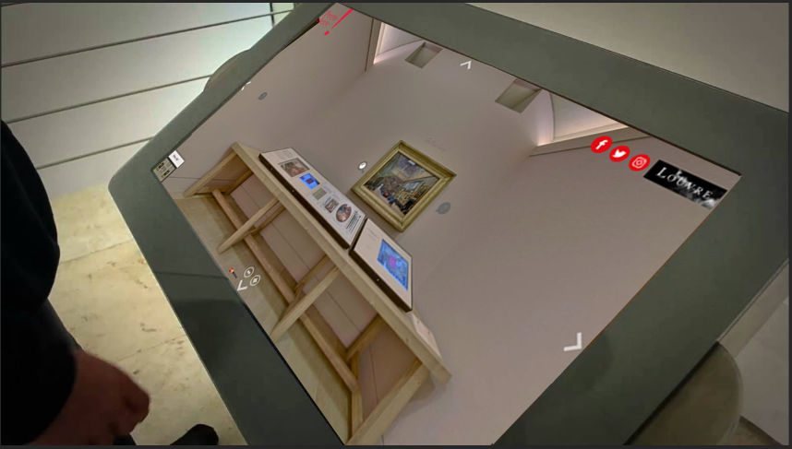

Evaluation Strategy
The strategy will involve the usage of many different tests. This will ensure the interface and usability of the exhibit is at a good standard and any issues will be found and fixed. The evaluation for this static exhibit will include the following:
- Heuristic Review
  - A heuristic review / evaluation is a technique for usability engineering to locate issues within usability and interface design which can later be corrected. There is a set of evaluations used to complete a heuristic review correctly to find issues. For this, typically, heuristics are identified and then evaluators will go through the resource that requires evaluation.
- Functionality testing
  - Functionality testing will take place to ensure all of the functionality and affordance of the application works as designed. This will be important in ensuring that functionality of the usability features, such as brightness and font changes, work as they were designed to, providing usability features to users.
- Compatibility testing
  - It is crucial that the exhibit will work on different devices with different software, operating systems or hardware. The exhibit will be used on a kiosk, but alternatives will need to be provided for those who cannot use the kiosks. This may be in the form of tablets or differently configured kiosks. To ensure the exhibit works on all of these different types of technology there will be compatibility testing required to ensure all features work on all of the different machines.
- User testing
  - User testing will finalise the evaluation strategy for this exhibit. Users will test the applications on the different kiosks and devices to ensure it works correctly and can be used by all different types of users.

Evaluation timeline
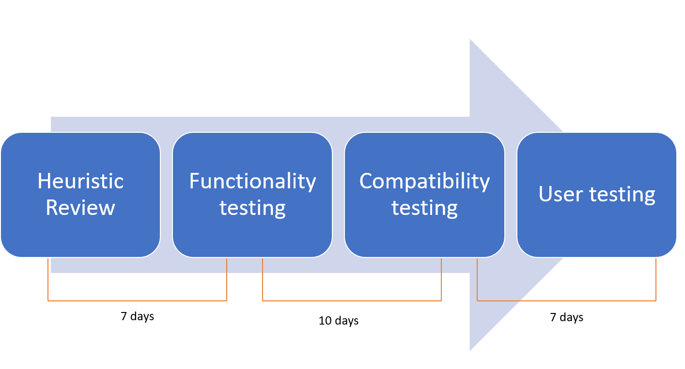

Augmented reality exhibit
For augmented reality, I would like to incorporate a new exhibit which allows for users at the Louvre to use provided smart tablets to view a display and be provided with all of the information regarding it. This will be done by aiming the camera at the displays which can then be interacted with on the tablet to display information and potentially allow for children to play games regarding the display for learning and entertainment purposes.
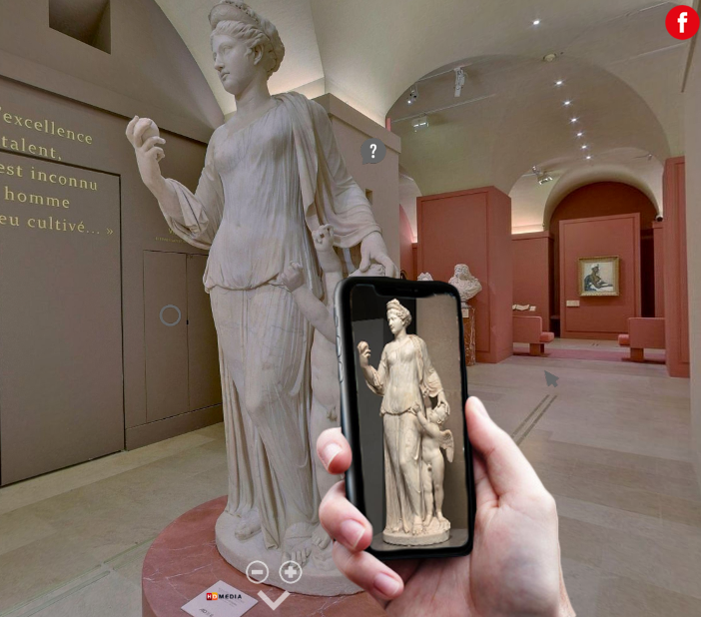

Evaluation Strategy

- Heuristic Review
- Compatibility testing
- Focus groups
  - Focus groups will be used to allow for users of different technological capabilities to come together and give their opinions and thoughts on the exhibit. This will allow for users with disabilities or handicaps to give their opinions on the exhibit to identify any issues or points they find positive. With a discussion of different types of people being undertaken, an evaluation can be formed on the usability of the exhibit from multiple different users’ standpoints.
It is also important that an evaluation of augmented reality placemaking exhibits is included within the strategy to ensure that the augmented reality exhibit follows patterns and trends of other popular exhibits to ensure a positive exhibit is created.

Evaluation timeline
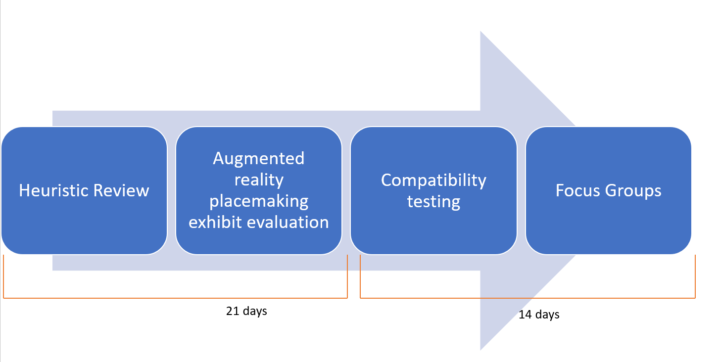
[1,2,3,4,5,6,7]

Guidelines and Accessibility
This section will be focused on the museum exhibits previously mentioned. The exhibits will be analysed in their application of usability and the accessibility guidelines applied to the exhibits.

Usability guidelines
The British museum uses a large amount of audio feedback to users of their virtual museum. When users hover over different blips of the timeline, an audible noise, such as a singular tone, is played to let the user know that they are hovering over a clickable element. If this is an issue, it can be turned off using the audio button at the top right of the screen. The British museum uses lots of symbiology including the use of the audio button, navigation arrows, a 3 box menu button, an eye for the viewing of categories and a return to start function upon clicking the logo.
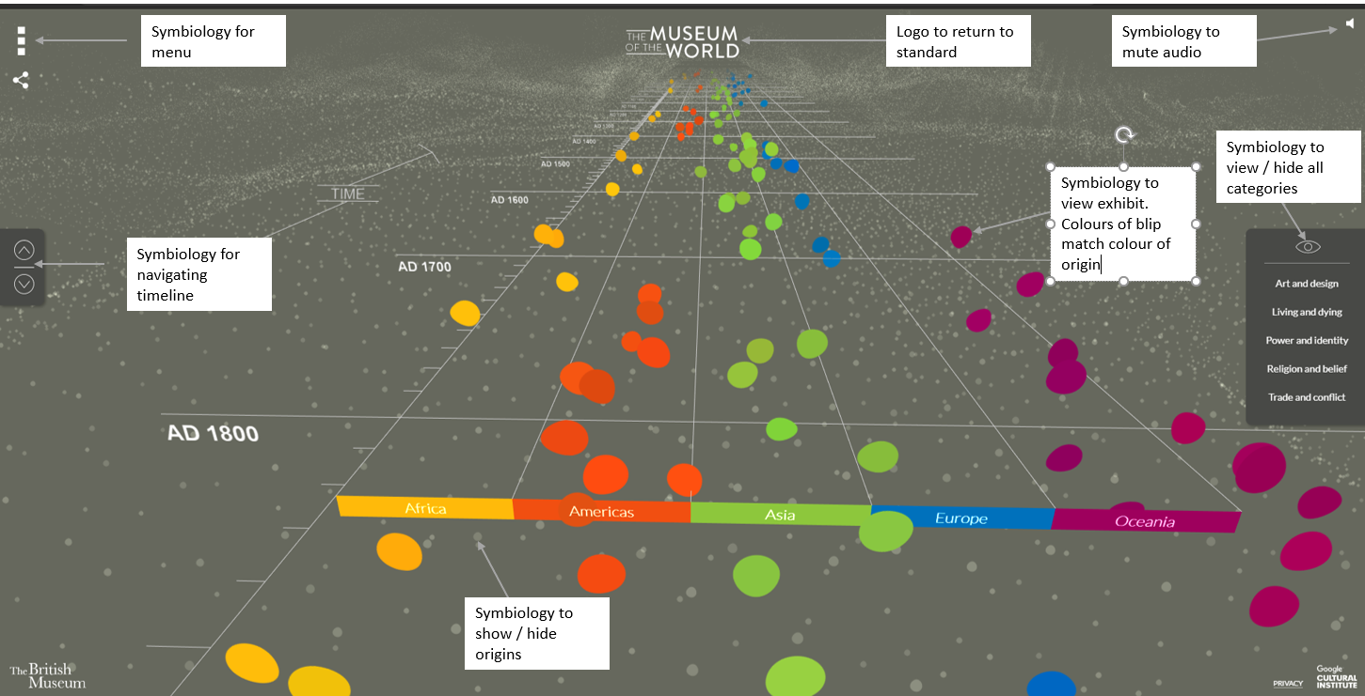
I believe that the way which the British Museum has designed their online museum complies with some of Dix’s usability guidelines. The main guidelines being Learnability and predictability. The application is very learnable as the features do not change and what they do is very basic and is represented well through the symbiology. The predictability follow suit. It is very predictable of what is going to happen based on the user’s actions. It is also very predictable on what each symbiology will do when clicked.
I found that the British museum also follow Schneiderman’s rule of “strive for consistency” and “keep users in control”. The entire application is consistent and there isn’t a moment where I do not feel in control of the application, making it very usable.
However, “keep users in control” is one of Schneiderman’s eight golden rules of interface design. This is a rule I do not feel applies to the louvre as it can be difficult to navigate, often making me feel as though I am not in control, but instead, the application is forcing me to navigate to areas I have no choice over.

Accessibility recommendations
Here are some recommendations for usability I believe that museum exhibits, including the two above, should include:
- Predictability – Dix
  - It is crucial that users can predict what will happen regarding the actions they take. If not, they may find themselves at the wrong pages or with the wrong settings as the features are not as they predicted.
- Keep users in control – Schneiderman
  - If users are using an online museum they need to feel as natural as possible and be allowed the freedom of being in control. If not, they may not enjoy the experience and ultimately not use the application.
- Permit easy reversal of actions – Schneiderman
  - If a user ends up something, they don’t want to be they should be able to go back. Likewise, if they change settings and don’t like them, they should be able to revert.
- Customisability – Dix
  - A user must be allowed to customise their experience. This may be font sizes, brightness or language. This ensures usability for all users and gives them a higher sense of being in control.

Web designers and novel museum exhibit designers must also follow similar accessibility advice. W3C and WAI is a web organisation with accessibility policies and standards set out to ensure web accessibility is provided by websites. Here are some of the policies and standards from WAI which apply to both web and novel museum exhibit designers:
- Captions and other alternatives for multimedia
  - Those who may be blind should be provided audio descriptions for videos
- Content can be presented in different ways
  - Relates to the previous point. Audio, braille, video and different language selection should be available.
- Content does not cause seizures and physical reactions
  - Content should be appropriately designed and placed to ensure physical reactions or seizures do not occur. For example, font colours and background colours should not clash or be too bright.
- Text is readable and understandable
  - A sensible font should be used, and the text should not be too small. “handwritten” or informal fonts should not be used as people may not be able to read it.
All of these policies should be considered in the online exhibits looked at within the report. The British museum in particular accommodates most of these policies through their ability to provide audio descriptions for exhibits, clear text and sensible colour usage on the timeline which does not make the colourful blips a risk to users who may be prone to seizures.

Virtual & Augmented Reality
Virtual reality and augmented reality are two different types of ways users can be immersed into something virtual or computerised. While virtual reality aims to place users in a virtual environment, Augmented reality adds a segment of virtualisation to an aspect of reality.

Background of VR systems
With VR becoming more and more popular in the modern day, it is a surprise to hear that the one of the first VR and AR headsets was created in 1968 by Ivan Sutherland alongside his concept of “ultimate display”. His concept consisted of a computer controlled existence where users could not differentiate the virtual world and reality. He described his headset as a “window into a virtual world”. His theory of a computer controlled existence has been proved and is used today within VR for multiple purposes. Gaming especially, as users can be put into a fantasy world or environment where they can perform all of the same actions as they would in reality. In 1968, the head mount created by Sutherland, known as “The Sword of Damocles”, was too heavy to wear and required to be suspended from the ceiling where users would be placed into the headset. Today, headsets can be freely worn and are lighter than motorcycle helmets.
[10,11,12]
While Virtual Reality and Sutherlands concept aims to place a user into a different reality, augmented reality is more of a mix between virtual and reality. Through the use of AR equipment, users can mix their reality with something virtual. Some principles of Sutherland’s concept still apply, such as his theory of a “window into a virtual world”. While you are still in reality, you may use AR to overlay something artificially or computer generated to give you a different experience. Users may still be immersed in AR as they are in VR. Popular game Pokémon Go is an AR application which immerses users into the combination of the real world, and the world of Pokémon. Through the use of their camera they can virtually catch and fight Pokémon which are seamlessly Infront of them using their phone camera. This immerses users into the world of Pokémon without requiring them to be fully set into the environment as they would with a VR application.
[13,14,15]

Proposed AR Exhibit
I will now be proposing an AR exhibit regarding Welsh heritage. Margam castle is a Welsh mansion built in the 19th century. Onsite at Margam Castle is an exhibition of the history of the mansion and the families that have lived within it. It also contains information of the local town of Port Talbot. There is also a small area for children to learn. This is a fantastic venue to incorporate an AR exhibit which can be used by all age groups. Behind Margam Castle, located high up on a mountain is Capel Mair. Capel Mair is a 15th century chapel. It was built to allow for peasants to worship within, as they were not allowed in the abbey. This day, it stands alone on the mountain with only the walls and window foundations in place.
As the chapel rests high up on a hill, it is only accessible by a poorly managed dirt path at an incline. Elderly and disabled people are not able to access the chapel at all, as the only way to get to its location is the dirt path. The path is also very unstable after rain and during wind, making it inaccessible to many people.
A perfect exhibit for the chapel would reside within Margam castle alongside the other exhibits. As the chapel is inaccessible, an AR exhibit would be a good method of displaying Welsh heritage, chapel Mair, to those who wish to see it but cannot access it. This would also bring more publicity to the chapel which is a historic landmark and deserve more recognition.
My AR exhibit would be a smaller model of the chapel, that can be virtually toured using tablets, phones and smart devices that download an app. When in Margam castle users can walk around the model and access the AR functionality using their devices to be displayed information and a “real view” of what the chapel looks like.
[8]
A similar project can be seen on Google arts & culture which allows for a virtual tour of Edinburgh castle which has been brought to light amongst the lockdown due to Covid-19. Visit Scotland has their own App which integrates augmented reality to allow for users to virtually tour Edinburgh castle and other locations. This is a good motivation and inspiration to implement the AR exhibit for Chapel Mair. [9]

Hardware
To make this accessible to all, the hardware required is simply a smart device with a working camera. This can be a phone or tablet. Provided the camera works, users can aim their phone at the model of the chapel to walk around and view information on the chapel. Users do not have to walk themselves but can move around by aiming the camera or using an onscreen navigation system using arrows. Onsite tablets will be provided for users who do not have mobile devices. A 360 degree camera will be used to photograph the chapel for use within the software.

Software design
The software will be an application designed for this exhibit. The software will include all of the accessibility features required to make the app usable by everyone. The software will utilise the camera so users can aim at areas they wish to go to, or alternatively scan a QR code and navigate around a virtual tour of the chapel made up of real photos.

Sketches
Here are some sketches on what I believe the exhibit will contain. The image transparency in the sketches are not as it would appear in the final product.
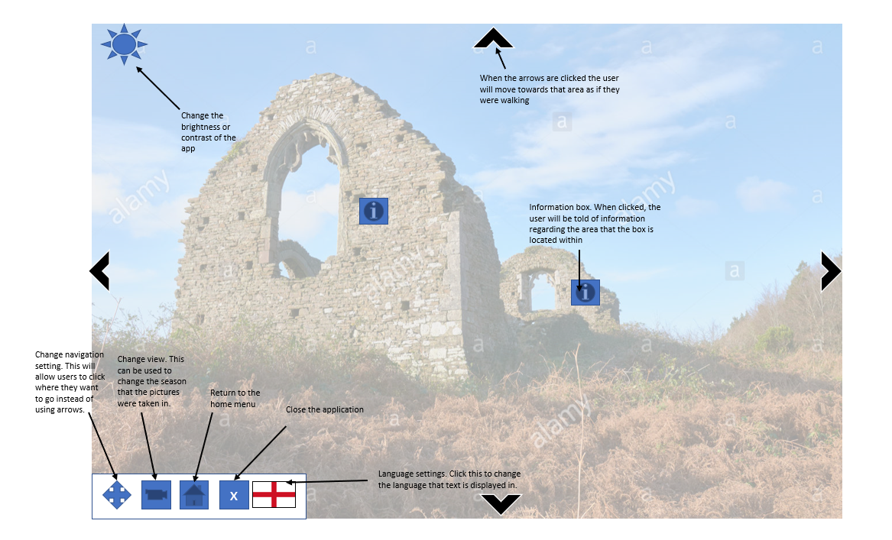
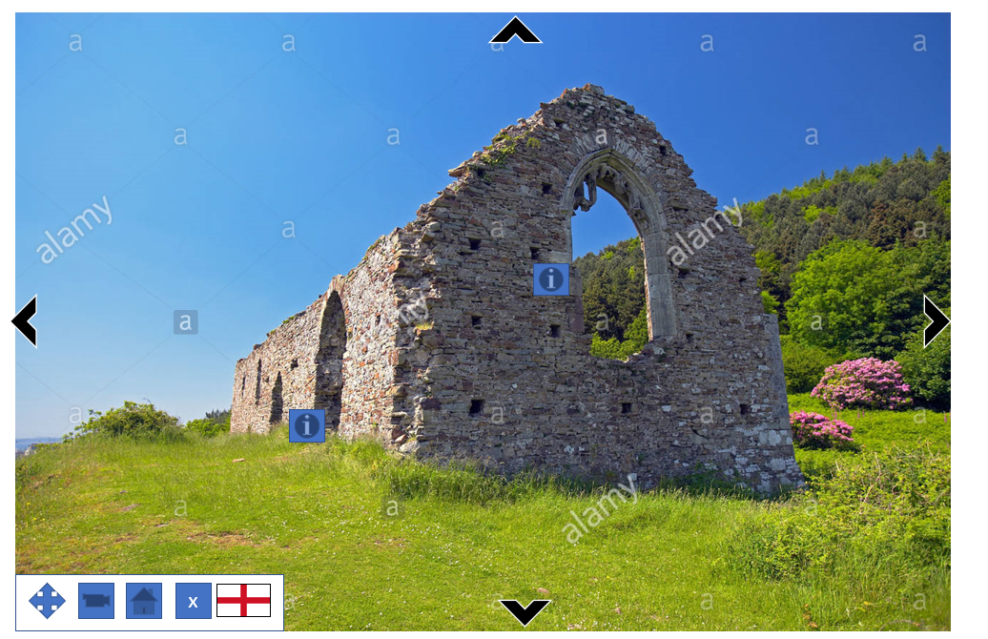
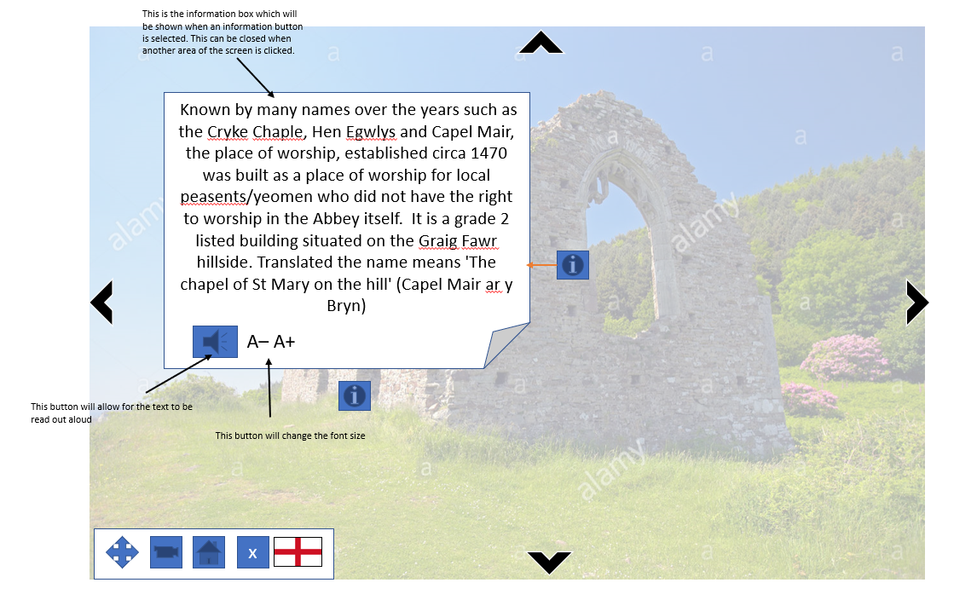
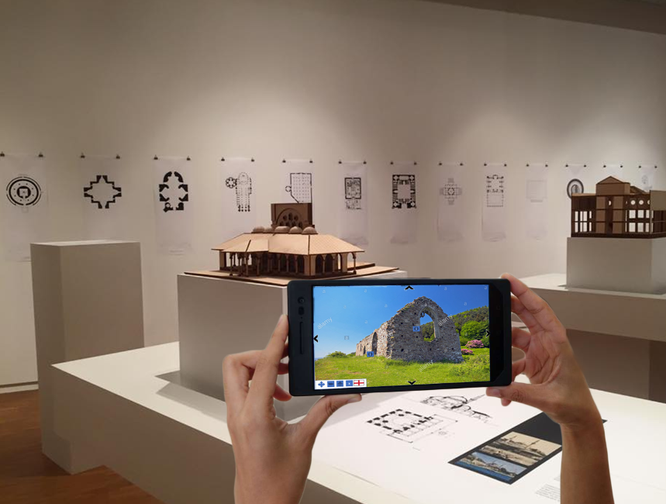

Bibliography
1.Usability Evaluation Basics | Usability.gov [Internet]. Usability.gov. 2020 [cited 2020 May 20]. Available from: https://www.usability.gov/what-and-why/usability-evaluation.html

2.Marcio Silva C, Macedo V, Lemos R, Okimoto MLLR. Evaluating Quality and Usability of the User Interface: A Practical Study on Comparing Methods with and without Users. Design, User Experience, and Usability Theories, Methods, and Tools for Designing the User Experience [Internet]. 2014 [cited 2020 May 20];318–28. Available from: https://link.springer.com/chapter/10.1007/978-3-319-07668-3_31

3.Stone D, Jarrett C, Woodroffe M. User Interface Design and Evaluation [Internet]. Google Books. 2010 [cited 2020 May 20]. Available from: https://books.google.co.uk/books?id=VvSoyqPBPbMC&pg=PA450&lpg=PA450&dq=interface+evaluation+strategy&source=bl&ots=d7Q1V0qNQd&sig=ACfU3U1bK5S_i5UydbUxDJRJOhCgsclScA&hl=en&sa=X&ved=2ahUKEwjr58SN3MLpAhUHVBUIHSQWBR0Q6AEwDXoECAwQAQ#v=onepage&q=interface%20evaluation%20strategy&f=false

4.The Evaluation of Interactive Systems The why, what, where, and when of evaluation [Internet]. Available from: https://info.sice.indiana.edu/~dingying/Teaching/S519/new/EvaluationofInteractiveSystems.pdf

5.Heuristic Evaluation: How-To: Article by Jakob Nielsen [Internet]. Nielsen Norman Group. 2020 [cited 2020 May 20]. Available from: https://www.nngroup.com/articles/how-to-conduct-a-heuristic-evaluation/

6.Assistant Secretary for Public Affairs. Heuristic Evaluations and Expert Reviews | Usability.gov [Internet]. Usability.gov. 2020 [cited 2020 May 20]. Available from: https://www.usability.gov/how-to-and-tools/methods/heuristic-evaluation.html

7.10 Heuristics for User Interface Design: Article by Jakob Nielsen [Internet]. Nielsen Norman Group. 2019 [cited 2020 May 20]. Available from: https://www.nngroup.com/articles/ten-usability-heuristics/

8.Margam Castle [Internet]. Margamcountrypark.co.uk. 2017 [cited 2020 May 20]. Available from: http://www.margamcountrypark.co.uk/1242

9.It’s virtually Edinburgh... [Internet]. belfasttelegraph. BelfastTelegraph.co.uk; 2020 [cited 2020 May 20]. Available from: https://www.belfasttelegraph.co.uk/travel/its-virtually-edinburgh-39206684.html

10.History Of Virtual Reality - Virtual Reality Society [Internet]. Virtual Reality Society. 2017 [cited 2020 May 20]. Available from: https://www.vrs.org.uk/virtual-reality/history.html

11.The History of Virtual Reality – ImmotionVR [Internet]. Immotionvr.com. 2018 [cited 2020 May 20]. Available from: https://immotionvr.com/blog/the-history-of-virtual-reality/

12.History of Virtual Reality [Internet]. The Franklin Institute. 2016 [cited 2020 May 20]. Available from: https://www.fi.edu/virtual-reality/history-of-virtual-reality

13.Catch Pokémon in the Real World with Pokémon GO! [Internet]. Pokemongo.com. 2020 [cited 2020 May 20]. Available from: https://www.pokemongo.com/en-gb/

14.What’s the Difference Between AR, VR, and MR? [Internet]. The Franklin Institute. 2017 [cited 2020 May 20]. Available from: https://www.fi.edu/difference-between-ar-vr-and-mr

15.Cipresso P, Giglioli IAC, Raya MA, Riva G. The Past, Present, and Future of Virtual and Augmented Reality Research: A Network and Cluster Analysis of the Literature. Frontiers in Psychology [Internet]. 2018 Nov 6 [cited 2020 May 20];9. Available from: https://www.ncbi.nlm.nih.gov/pmc/articles/PMC6232426/

16.w3c_wai. Accessibility Principles [Internet]. Web Accessibility Initiative (WAI). 2019 [cited 2020 May 20]. Available from: https://www.w3.org/WAI/fundamentals/accessibility-principles/

