

Student NAME: EMMA RYDER
STUDENT ID: 2221740
MODULE CODE: LCBB614
ASSESMENT TYPE: COMPONENT 1 WHRITTEN RESEARCH PROPOSAL
WORDS: 1,000

Table of Contents
Introduction 3
Justification of the Research 4
Literature Review 5
Research Methodology 6
References (Harvard Style) 8

Topic Title: The Impact of market adaption STRATEGIES On COSTA COFFEE in the UK
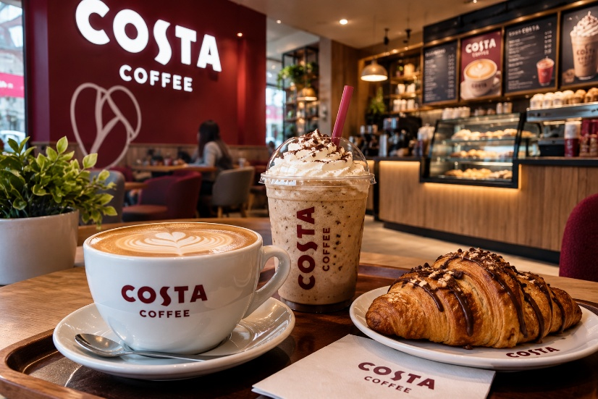

Introduction
The UK coffee business is a competitive market that requires the company to introduce new products and their marketing plans to meet changing customer taste. Costa Coffee is a well-known coffee business in the UK which is an interesting case for assessing how a business adapts to the market to differentiate itself and compete. Market orientation, according to (Kohli and Jaworski, 1990) provides the understanding of the changing wants of the consumers and changing market conditions. The importance of customer orientation and a competitor’s awareness is the key towards profitability by (Narver and Slater, 1990). The study intends to understand how Costa Coffee is changing its products and marketing strategies in reaction to changing consumer tastes within the UK coffee market. Emphasis will be placed on product differentiation, customer satisfaction and competitive positioning. By using existing marketing theories, the aim of the research is to enhance the understanding of consumer perception and the competitive positioning in the UK coffee market by adapting to the market.

Research Aim
The aim of this research is to investigate the impact of market adaptation strategies on Costa Coffee’s competitive positioning in the UK coffee industry, with particular emphasis on product differentiation, changing consumer preferences and customer satisfaction.
2. Research Objectives
- To examine the market adaptation strategies adopted by Costa Coffee in the UK, particularly in relation to product differentiation and marketing activities.
- To investigate how changing consumer preferences influence Costa Coffee’s product development and marketing strategies.
- To explore how Costa Coffee’s market adaptation strategies contribute to customer satisfaction and perceived competitive positioning within the UK coffee industry.
3. Research Questions
- What market adaptation strategies does Costa Coffee adopt within the UK coffee industry?
- How does Costa Coffee use product differentiation to distinguish its products and services from competitors?
- How do changing consumer preferences influence Costa Coffee’s product development and marketing strategies?
- How do consumers perceive the relationship between Costa Coffee’s market adaptation strategies, customer satisfaction and competitive positioning?

Justification of the Research
Market adaptation is a vital consideration in the world of strategic marketing for organisations in competitive industries. Organizations must grasp the consumers’ changing tastes for products and adapt their goods and marketing activities accordingly. (Kohli and Jaworski, 1990) propose the main task of generating market intelligence and responding to consumer needs.
Costa Coffee is a handy case study for market adaptation and product differentiation in the UK. Analysing its range of products, marketing activities and consumer perceptions will help you understand the relevance of established marketing theories to the coffee industry.
(Narver and Slater , 1990) have found that market orientation is positively related to profitability which suggests that understanding the consumers and competitors is crucial.
Through theoretical application, this research studies Costa Coffee’s adaptation strategies and their relationship with customer satisfaction and perceived position of competitive advantage.
The study could assist marketing professionals and contribute to the academic understanding of market adaptation on the UK coffee market.

Literature Review
Market adaptation and product differentiation strategic marketing concept definition and examples. Market adaptation refers to the adjustment of products, services and marketing strategies to the demands of a specific market. To differentiate their products from others, businesses try to develop a unique identity.
According to (Porter, 1985), differentiation is a competitive strategy to create distinct value for a consumer. Within the coffee industry, differentiation could be achieved through product quality, beverage innovation, brand identity, pricing and customer experience. The concepts provide a basis for the analysis of marketing strategies of Costa Coffee.
Market orientation refers to the generation of market intelligence, dissemination of intelligence across the organisation, and responding to the requirements of the market. According to (Kohli and Jaworski, 1990), this is what market orientation entails. This research proposal could be used to investigate how Costa Coffee may respond to changing tastes in coffee.
(Narver and Slater , 1990) examine how market orientation influences organisational performance in their study The Effect of a Market Orientation on Business Profitability. According to their findings, business profits are related to understanding customers and competitors. This view is relevant for looking at how Costa Coffee has positioned itself competitively, although the study will not measure financial performance as such.
(Slater and Narver , 2000) investigated this relationship further in both product and service businesses, offering further empirical confirmation of a market orientation-profitability relationship. Their research shows that market orientation is relevant to a variety of businesses.
Nonetheless, the studies outlined so far focused mainly on market orientation at the organisation level and not at the consumer level for a coffee company. As such, the proposed research will apply existing marketing theories to Costa Coffee and investigate how UK consumers perceive its product differentiation and market adaptation efforts.

Research Methodology
A case study of Costa Coffee will be undertaken for the qualitative research in this study. (Yin, 2018) maintain that case study research enables researchers to understand contemporary phenomena in real-life contexts. This methodology is appropriate to study customer views about adaptation strategies of Costa Coffee.
We will conduct semi-structured interviews with approximately 10–15 UK consumers of Costa Coffee products to obtain primary data. The purposive sampling will be used in choosing the participants that have relevant experience of the brand.
The interviews will assess what consumers think about product differentiation, beverage innovation, pricing, marketing activities and customer satisfaction. Participants will be able to explain their preferences and experiences in detail with open-ended questions.
I will use information from textbooks and marketing journals on Costa Coffee for the project. Since the product is known worldwide, I will use secondary data for each topic. These sources will anchor the theoretical framework with significant contextual material.
The interview data will be reviewed, analysed and coded. (Braun and Clarke , 2006) describe thematic analysis as an accessible and flexible method for identifying, analysing and reporting patterns. Through this method, we will be able to find recurring themes about market adaptation, product differentiation and various consumer preferences.
Ethical aspects will encompass informed consent, voluntary participation, confidentiality and secure data keeping. In line with the university's ethical guidelines, the participants will be informed about the purpose of the research and their right to withdraw anytime.
The study will be limited by its relatively small sample size and by consumer perceptions. The research will yield qualitative insights rather than statistical representative conclusions about either all UK consumers or the financial performance of the Costa Coffee brand.

References (Harvard Style)

Braun, V. and Clarke, V. (2006) ‘Using thematic analysis in psychology’, Qualitative Research in Psychology, 3(2), pp. 77–101. Available at: https://doi.org/10.1191/1478088706qp063oa.
Costa Coffee (n.d.) Our menu. Available at: https://www.costa.co.uk/menu
Kohli, A.K. and Jaworski, B.J. (1990) ‘Market orientation: The construct, research propositions, and managerial implications’, Journal of Marketing, 54(2), pp. 1–18. Available at: https://doi.org/10.1177/002224299005400201.
Kotler, P. and Keller, K.L. (2016) Marketing Management. 15th edn. Harlow: Pearson.
Narver, J.C. and Slater, S.F. (1990) ‘The effect of a market orientation on business profitability’, Journal of Marketing, 54(4), pp. 20–35. Available at: https://doi.org/10.1177/002224299005400403.
Pine, B.J. and Gilmore, J.H. (1998) ‘Welcome to the experience economy’, Harvard Business Review, 76(4), pp. 97–105.
Porter, M.E. (1985) Competitive Advantage: Creating and Sustaining Superior Performance. New York: Free Press.
Slater, S.F. and Narver, J.C. (2000) ‘The positive effect of a market orientation on business profitability: A balanced replication’, Journal of Business Research, 48(1), pp. 69–73. Available at: https://doi.org/10.1016/S0148-2963(98)00077-0.
Vargo, S.L. and Lusch, R.F. (2004) ‘Evolving to a new dominant logic for marketing’, Journal of Marketing, 68(1), pp. 1–17. Available at: https://doi.org/10.1509/jmkg.68.1.1.24036.
Yin, R.K. (2018) Case Study Research and Applications: Design and Methods. 6th edn. Thousand Oaks, CA: SAGE Publications.

