NAME: Nazma Iqbal
Student ID: 2239683
Module Code: LCHS4003
Module: Introduction to Health and Social Care
Lecturer: DR Helen Parsons

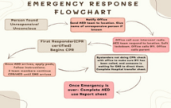
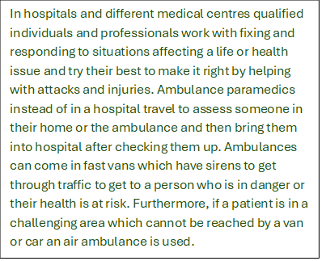
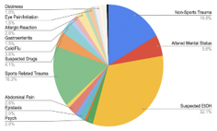
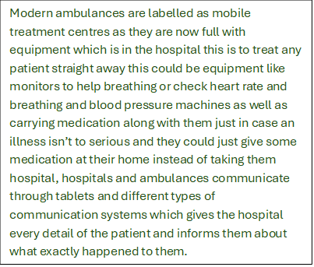
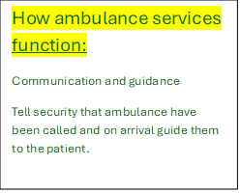
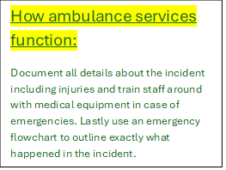
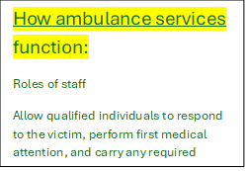
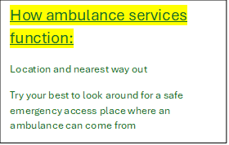
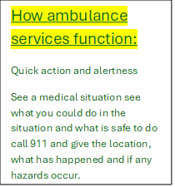
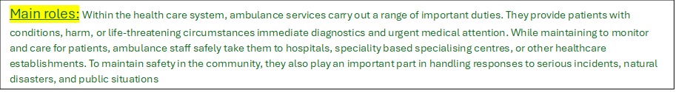
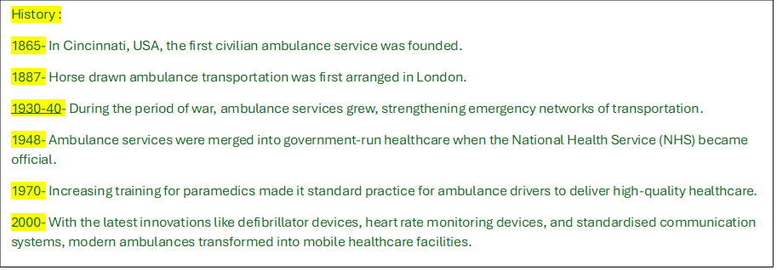
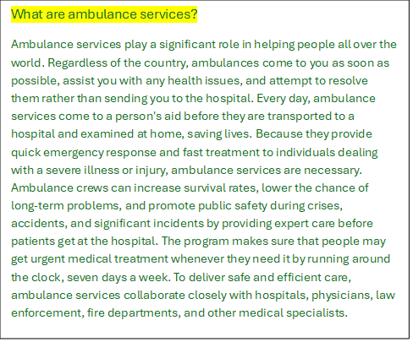
https://www.ambulance.nsw.gov.au/__data/assets/pdf_file/0007/552607/Medical-Emergency-
https://www.wmas.nhs.uk/
Ambulance Services



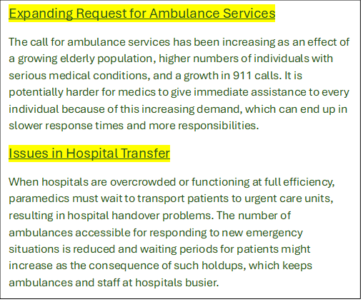



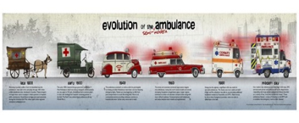
Task 2
Introduction
Residential homes are very important for elderly people who need a place to live, have someone look after them and help them with things they can’t do independently anymore. These people are mainly people with disabilities who can’t do anything by themselves and need help with the simplest tasks or people who have illnesses which are not short term some of these simple tasks include showering, eating, finding clothes or getting dressed. The main thing for a care home is to show all residents respect and treat each one fairly and give them a good quality of life.
In the 1500s and 1600s residential homes started becoming discovered but before that when elderly people couldn’t live independently anymore or needed help with daily tasks and someone to give them support they got sent to workhouses these workhouses weren’t very pleasant to live in and were nothing compared to residential homes today, the living conditions were not good at all no one had any privacy or freedom of speech or choice but it wasn’t a big deal to the people looking after them because at that time their only aim was to give them support and give them a place to stay.
As time went on peoples thinking and opinions and views started changing about elderly people in care, they decided to create charity organisations which they thought could help the vulnerable elderly and support them a little more than the support they were already receiving. The government came out with the welfare state straight after the second world war this is where the public funded and made all these services available for every elderly or vulnerable person making them get all the support they need.
Then again, another change came after a few years which changed how health and social care services were seen, this big change was the National assistance act 1948 which introduced residential homes and ended the workhouse where treatment wasn’t very good.
A big advantage of care homes was that they received equal support care and treatment. This was very helpful for people who couldn’t do the simplest of things e.g. walking or not caring for themselves properly. In residential homes group activities are always on to help residents socialise and make friends so they don’t feel lonely.
Even though there are many advantages of being in a care home there are also many disadvantages which are not spoken about enough. Independence could be a big disadvantage as many residents may not have a say or choice when it comes to making decisions about their life or even any privacy. The care quality commission is an inspection organisation which inspects and checks on care homes to ensure they are safe and residents are getting the care they need.
Residential homes play a big role in Improving resident’s quality of life this is by giving them a safe place to live and making them feel safe in the care home, they also try to give them the exact care they need without disregarding their needs and wants. Taking part in social events and activities help residents feel less lonely as well as building connections with people around them this helps them feel comfortable and safe.
In conclusion care homes have changed massively from workhouses to residential care they have changed from people living in poorly workhouses to people living in safe residential care homes where safety and respect matters more than anything. There are some things which are not right and care workers are still working on improving them such as staff not being enough but still, they try their best to give good quality care to these residents meeting their needs and giving them full support.

https://www.carehome.co.uk/advice/what-is-a-residential-care-home
https://www.carehome.co.uk/advice/a-history-of-care-homes
https://academic.oup.com/book/6324/chapter/150014021
https://navigator.health.org.uk/theme/national-assistance-act-1948
https://ukcareguide.co.uk/main-advantages-disadvantages-live-care/

