

Introduction to Virtual Production (ACCA4034)
Oubaida El Asri Taliouan – 2419262

Table of contents:
- Introduction
- Pre-Production
- Production
- Post-Production
  - Introduction
  - Challenge with the first shot
  - Tracking issues
  - Background issues
  - Shifting focus to a simple shot
  - Subject isolation
  - Laser effects and background adjustments
  - Colour correction and grading
  - Final export
- Final Thoughts
- References

Introduction:
This is a reflective account on my project, in which I applied my knowledge of various virtual production techniques to create a final shot. This included 3D tracking, motion tracking and colour grading among others. To make my reflective account easier to follow, I have broken it down into 3 main stages: my pre-production, production and post-production. I have as well included my final thoughts and reflections.

Pre-Production:
I was inspired by scenes in Ocean’s Twelve [1] and Escape Room: Tournament of Champions [2] as in figure 1 and 2 to create a scene where a character must avoid lasers to reach a destination.
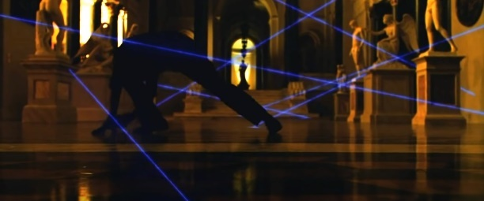
Figure 1 - Ocean's Twelve
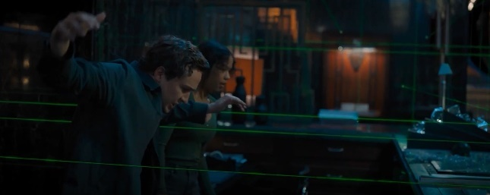
Figure 2 - Escape Room: Tournament of Champions
To start, I drew a storyboard to assist me in visualizing how my idea would come together as shown in figure 3. I abandoned the idea of a thief stealing jewellery as it was very ambitious.
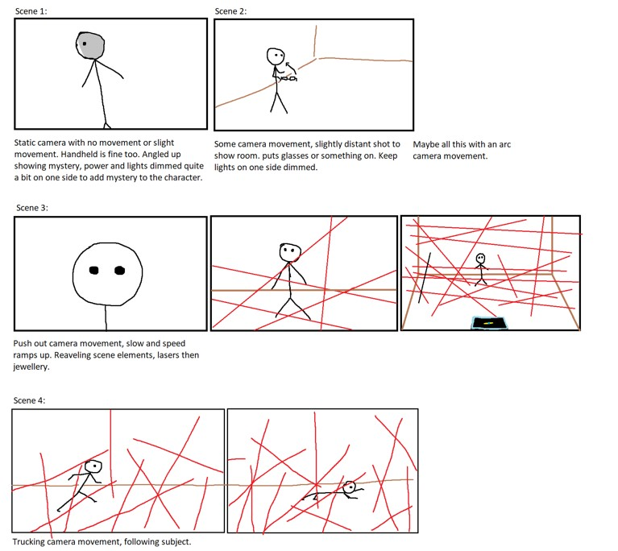
Figure 3 – Storyboard

Production:
The production process was not excessively complicated. I filmed the actor from multiple angles, as an example refer to figure 4.1 and 4.2. Most shots I captured at a standard 25fps to give the footage that cinematic feel, though I did capture a few in 50fps to slightly slowdown in post-production. For the shots that required simple camera movement like panning, I used a tripod, for the more complex shots that required intricate angles, dolly camera movement or any other sophisticated camera movement, I resorted to handheld camera movement. This resulted in a noticeable difference between the stable and unstable shots, making the poorly handheld camera movement shots stand out.
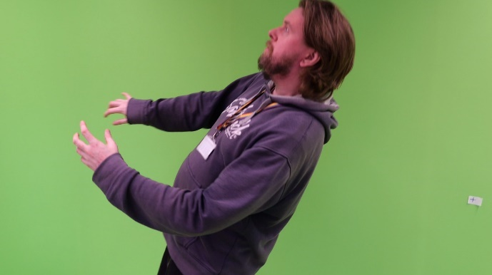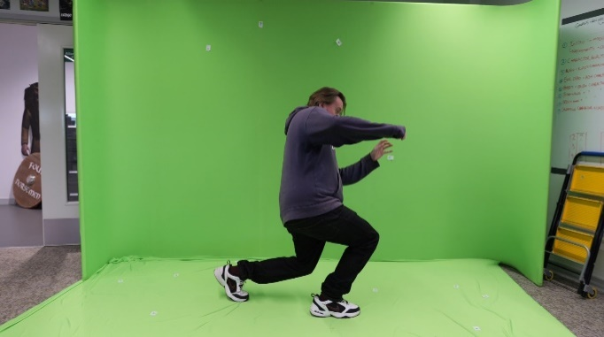
Figure 4.1 - Shot 1 Figure 4.2 - Shot 2
The actor was filmed in front of a green screen. Tracking markers were placed both behind the actor and on the ground. I decided to not use any lighting equipment as I wanted soft lighting for the scenes, without any strong shadows.
I ran into two main issues whilst filming. The first was motion blur, especially on the handheld shots as shown in figure 5. It made it hard to track during rapid movements. The second were the tracking markers. They were not clear, especially from a distance, which made it hard to track during post-production.
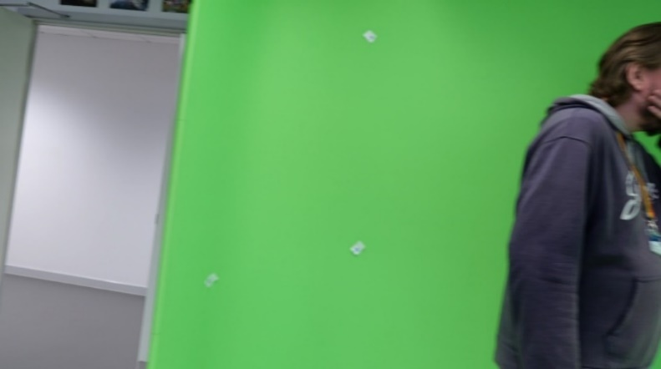
Figure 5 - Shot with motion blur

Post-Production:
Introduction
Looking back on the post-production process, I encountered a series of challenges that led me to changed many of my original plans. Initially, I aspired to create a short film/scene with various shots from different angles, after working on the first shot, it quickly became clear that it would be a more complicated task than I had foreseen.

Challenges with the first shot
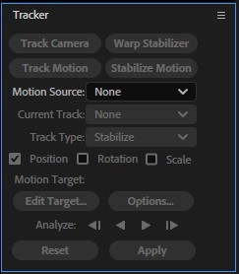
The first shot I worked on introduces the main character, and it was intended to be the opening frame of the storyboard. Since the shot was handheld, there was a lot to tackle. My priority was to stabilize the shaky camera motion. I used the stabilize motion tool and warp stabilizer (shown in figure 6), which helped to some extent, however, it introduced new issues. The shot began to look unnatural due to the warping effects. The shot was also cropped as shown in figure 7.1, to cover this I scaled the plate, but that ended up in an excessive zoom as shown in figure 7.2.

Figure 6 – After Effects stabilizing tools used
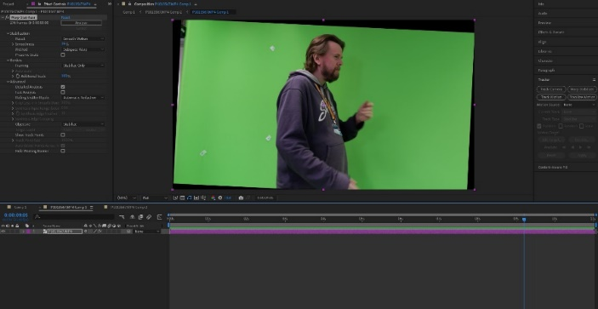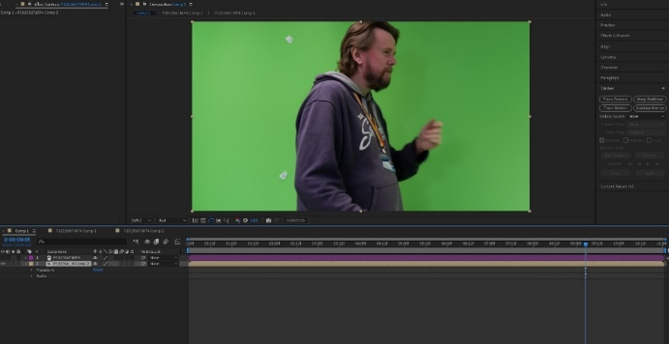
Figure 7.1 - Cropping from stabilizing Figure 7.2 – Manual Scaling to hide cropping

Tracking issues
Another issue I encountered was the clarity of the tracking markers. The motion blur in the shot made it impossible to track the markers correctly. I tried everything I could think of; motion tracking, 3D tracking, even increasing the contrast of the plate to make the tracking markers stand out more, but it all accomplished nothing. I also gave MochaAE [3] a go, but the motion blur made it impossible to track.

Background issues
Adding a tracked background to the shot without any tracking data was out of the question. My goal was to remove the green screen and replace it with a 3D environment. Even if I managed to track the shot, I would require exporting the After Effects [4] camera tracking data into Blender [5]. There is a freely available plugin [6] that can achieve this. The plugin did not work as I had hoped, which I’ll explain my experience with it in more detail later in the laser effects and background adjustment section.

Shifting focus to a simple shot
After a lot of trial and error I came to the realization that most of my shots would not work. Excluding those with minimal camera movement or very simple camera angles. I decided to focus on a simple shot. The shot is of the actor walking across a greenscreen whilst the camera slightly panned to the subject. The idea was to have the actor avoid motionless lasers which would be tracked to the camera’s movement.
I began by tracking the shot with After Effects’ [4] default motion tracking tool, but the result was not smooth, it essentially did track the shot, but it would twitch a lot. As an alternative I tried MochaAE [3], but this resulted in the same complication. In the end I used the default 3D tracking tool (I turned the plate achromatic and increased its contrast as shown in figure 8 for better tracking).
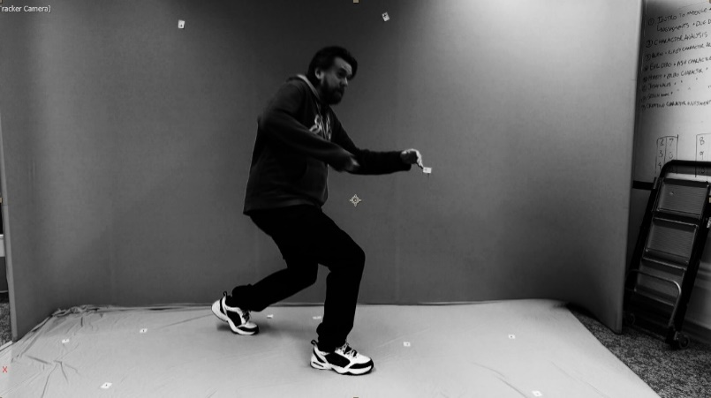
Figure 8 - Achromatic shot with increased contrast
This time it did work; I was able to attach elements that tracked correctly and smoothly. However, I encountered another issue, the elements were not being tracked to the tracking markers. Instead, it tracked to some other areas of the shot, these areas had minuscule tracking points in the 3D Camera Tracking tool (the tracking points shown on the far right of figure 9) which suggests that the tool deems these areas to be very far away from the camera, although they were not.
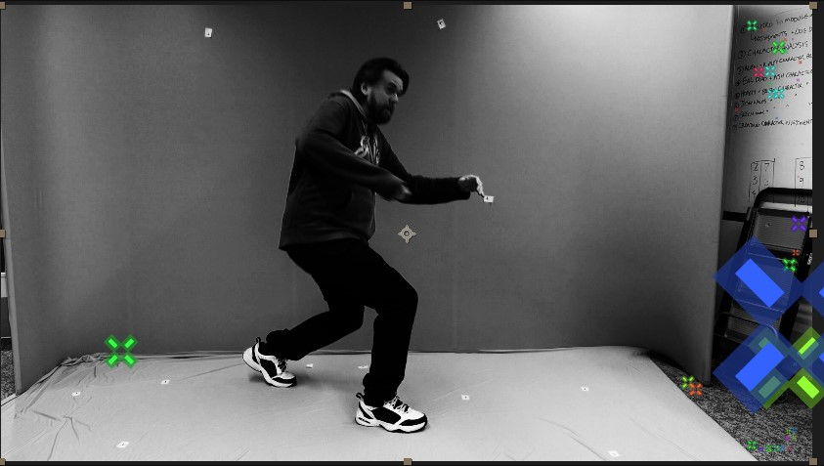
Figure 9 - Tracking points on shot
This forced me to scale up the tracked elements an absurd amount (in the millions) to be true to scale as shown in figure 10 by the scale and position of the lasers. Overall, the tracking of the shot was successful.
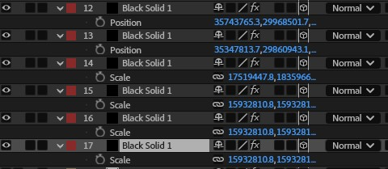
Figure 10 - Scale and position of lasers

Subject isolation
Following that, I keyed out the green screen using the Keylight effect. I enabled the screen matte view to refine the keying without altering the alpha as shown in figure 11.
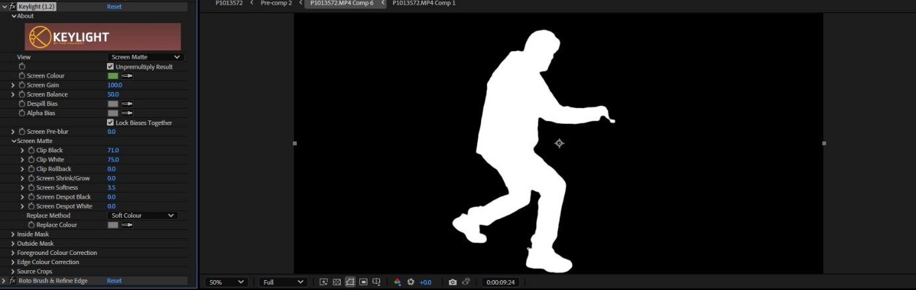
Figure 11 - Screen matte option enabled on shot
I masked out the tracking markers, and then I rotoscoped the subject. This is necessary because the subject sometimes overlapped the tracking markers. The difference is shown between figure 12.1 and figure 12.2. Both are showing the alpha channel, figure 12.2 shows how the rotoscoping looked after removing the trackers.
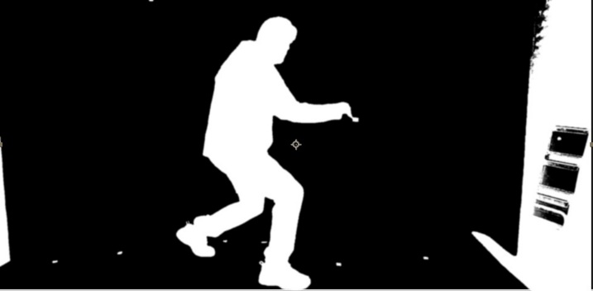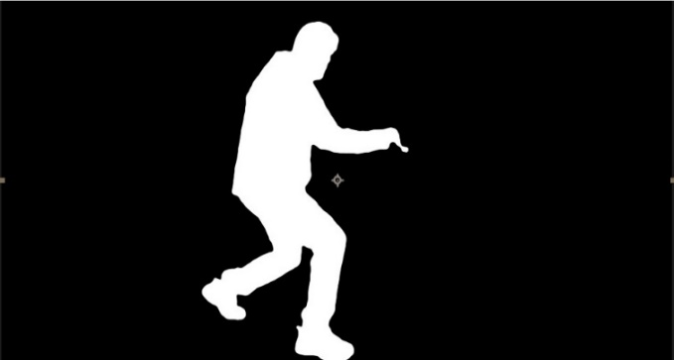
Figure 12.1 - Plate alpha pre-rotoscoping Figure 12.2 - Plate alpha post-rotoscoping
Keylight did not completely remove all the green spill, but this did not pose an issue as the final scene had green colour grading.

Laser effects and background adjustments
For the laser elements, I used a free plugin named Saber [7] from Video Copilot [8]. It allowed me to create the laser beams and tweak the parameters to fit the scene. I placed some lasers in the foreground and added a slight blur to add more depth to the scene this can be seen in figure 13.
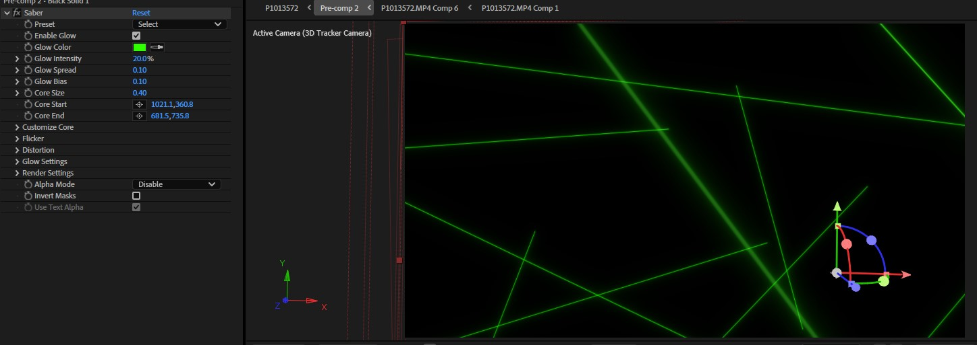
Figure 13 - Screenshot showcasing multiple instances of the Saber plugin
As for the background, I faced a few challenges. I found a free 3D asset [9] online, which I used for the background the one in figure 14.
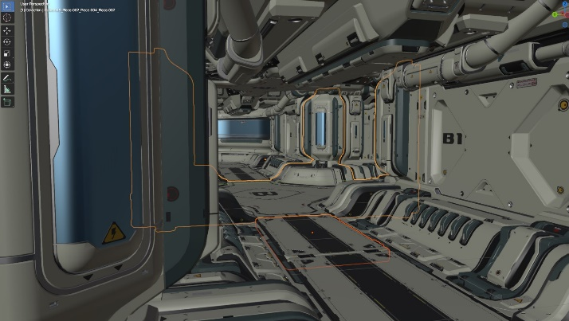
Figure 14 - 3D asset
I also used a free plugin [6] that exports After Effects [4] camera tracking data to Blender [5]. Unfortunately, the camera tracking did not work as expected, the imported tracking data into blender was buggy. After multiple failed attempts, I decided to opt for a simpler approach. I took a screenshot of the 3D environment [9] and used that as the background. It worked for this shot, but it was not ideal because it limited how flexible the background could be in other shots with more complex camera movement.

Colour correction and grading
Once the background and other elements were in place, I proceeded to colour correct. I adjusted the colours of the background and the subject to be more cohesive together as shown by the difference between figure 15.1 and 15.2.
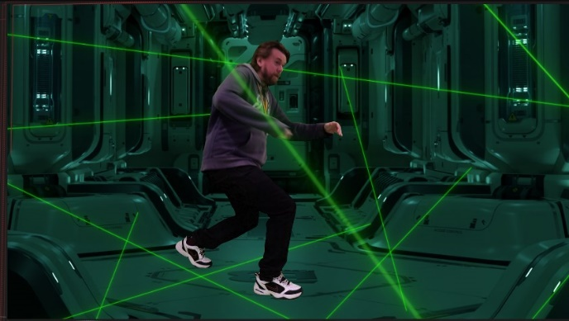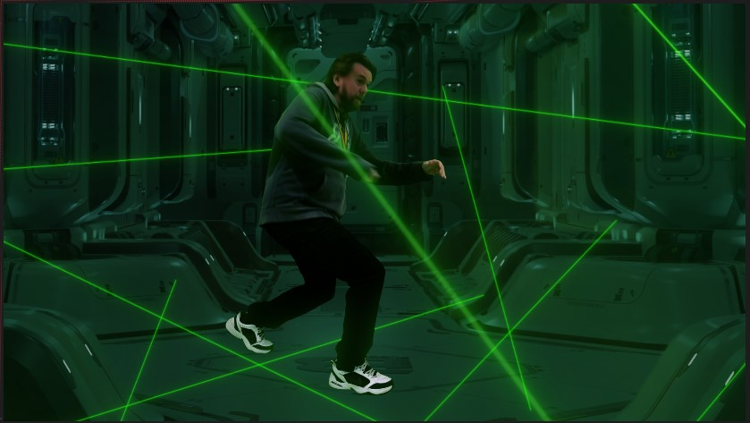
Figure 15.1 – Before colour correction Figure 15.2 - After colour correction
I masked out a few areas where the subject’s foot should not be visible and created two instances of the subject, one above the lasers and another below. This helped emphasize the idea that the subject was avoiding these lasers and added some depth to the scene.
With colour correction done, I moved to colour grading. With an adjustment layer I added a slight grading to the entire scene. The final colour grading is shown in figure 16.
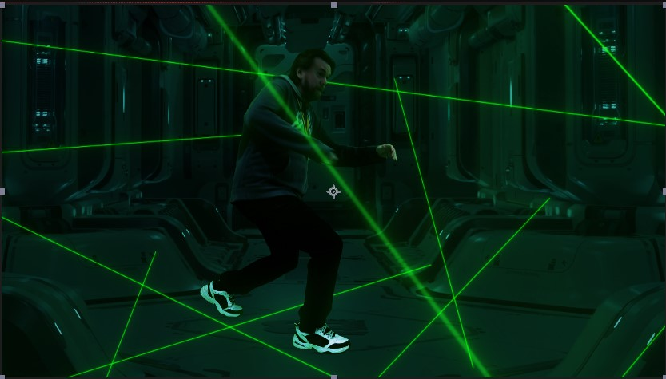
Figure 16 - Scene with colour grading
I also added some camera movements by scaling and adjusting the position of the plate. It followed the subject to make the scene more dynamic. To give it a cinematic feel, I applied a lens blur at the beginning of the scene using a 0.6 aspect ratio on the iris as shown in figure 17.
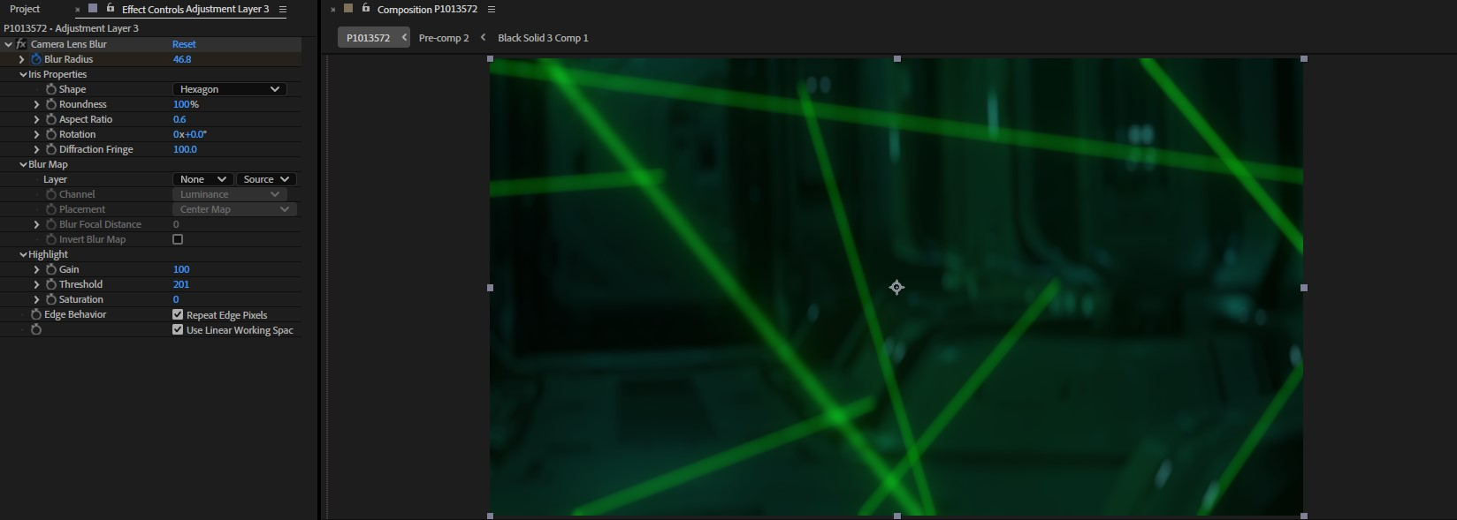
Figure 17 - Lens blur on scene

Final export
Finally, I exported the scene in H.264 format. This codec is great for a project like this because it has a small file size and does not compress the quality excessively. I exported the final scene in 1080p at 25fps.

Final Thoughts:
Looking back, I did manage to put together a scene that involved tracking, rotoscoping and other key techniques. But I can’t say that I’m completely happy with the final result. I didn’t quite achieve my original goal of having multiple shots, and the overall quality was lacking. Despite using the necessary fundamental techniques, I found that the project fell short in terms of presentation. For instance, the colour grading was very excessive to my liking, and I was unsuccessful at creating a realistic shadow for the subject or any at all. I was also disappointed with the background, it was just a static screenshot, so it lacked depth.
I also feel that the lasers could’ve been improved. This could be done by reducing their glow adding subtle details, such as imperfections, or reflecting them on the ground such as the example shown in figure 18.
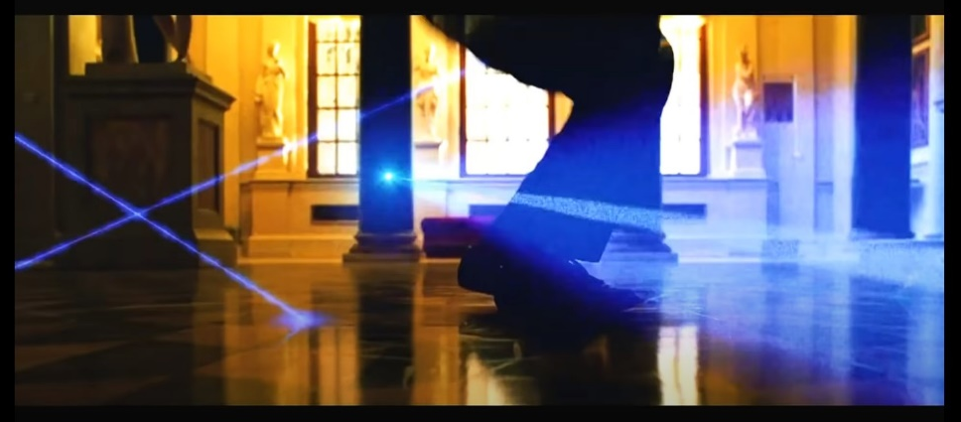
Figure 18 - Ocen's Twelve laser reflection
On top of the technical challenges, I also had quite a few creative blocks along the way, due to abundance of challenges that I faced, which discouraged me. This taught me to be more realistic about the projects I take on and to manage my time better.
I also learnt that post-production does not have to be exclusively worked on after the filming process. Often revisiting the original production and making adjustments is required. Which I wish I had applied to my project.

References:
[1] Ocean’s Twelve, Warner Bros: California, 2004
[2] Escape Room: Tournament of Champions, Columbia Pictures: California, Original Film: California, 2021
[3] MochaAE, 5.5.1, [Software], Boris FX: Boston, Massachusetts, 2017
[4] After Effects, 25.0, [Software], Adobe: San Jose, California, 2024
[5] Blender, 4.0.2, [Software], Blender Studio: Amsterdam, 2024
[6] Import After Effects Tracking Data into Blender | No Plugin | Motion Tracking Tutorial, Twan Oligschlaeger, https://www.youtube.com/watch?v=BlkJ_WWdtkQ&ab_channel=TwanOligschlaeger, 2024
[7] Saber, 1.0.40, [Software], Video Copilot: California, 2016
[8] Video Copilot, Andrew Kramer: South California, 2005
[9] Sci Fi Hallway Assetpack Free too), Seesha, https://sketchfab.com/3d-models/sci-fi-hallway-assetpack-free-too-783450ff49c94409939925f2ca677222, 2024

