Embedding Sustainability within Organisations (BMGM5000)

Evaluating Sustainability: Comparative Case Study Analysis – McDonald’s UK vs KFC UK

Module lead
Ruth Taylor-Davies BA (hons),MSc.,MA,AHI
ruth,taylor-davies@uwtsd.ac.uk
by
Amdadur Rashid Masum (2128870)
2128870@student.uwtsd.ac.uk

Word Count: 2104

Table of Contents
- Introduction
- Principles and Pillars of Sustainable Gastronomy
- McDonald’s UK Sustainability Analysis
- KFC UK Sustainability Analysis
- Comparative Critical Analysis
- Relevant Regulations and Legislation
- Circular Economy Analysis
- Recommendations
- Conclusion
- References
Appendix
Figure 1: Three Pillars of Sustainability
Figure 2: The United Nations Sustainable Development Goals
Use of Generative AI in Assessment
For this assessment, you I have used ChatGPT to support my research, including searching for bibliography, using tools to summarise, compare and interrogate materials. Check text/creation for grammatical and syntactical mistakes, including rephrasing of my own work within specific standards.

1. Introduction
In today's global foodservice industry, sustainability has emerged as a critical priority for major restaurant chains. As global environmental challenges, changing consumer expectations, and increasing regulatory pressures grow, many foodservice brands have reevaluated their operations to reduce their ecological footprint, improve waste management, and ensure ethical sourcing. This report critically examines the sustainability initiatives of McDonald’s UK and KFC UK, two of the largest fast-food chains operating in the UK, by assessing their approaches to environmental, social, and economic sustainability. The evaluation will use relevant sustainability frameworks such as Stakeholder Theory (Freeman, 2020) and the Circular Economy (Ellen MacArthur Foundation, 2019), and it will identify how both brands address sustainability challenges in the foodservice sector.
2. Principles and Pillars of Sustainable Gastronomy
Sustainable gastronomy refers to the practice of responsible food production, preparation, and consumption, with a focus on reducing the environmental footprint, promoting social equity, and ensuring long-term economic viability. A sustainable agrifood system provides food security and nutrition for everyone without compromising the ability of future generations to do the same. It must be economically viable, socially beneficial, and environmentally responsible, ensuring long-term sustainability across all three areas (FAO, 2025).
The three core pillars of sustainable gastronomy are:
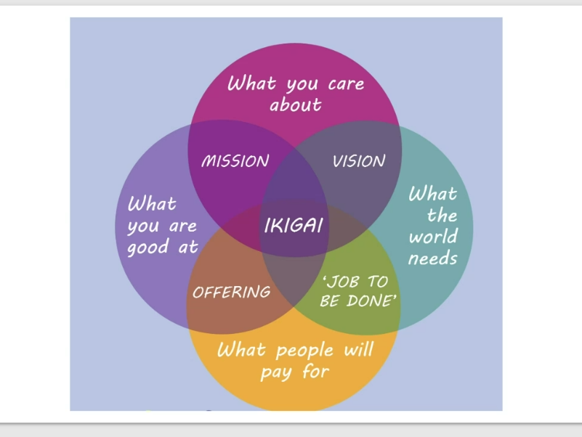
Figure 1: three pillars of sustainability (Zenbird, 2024)

Environmental sustainability: This focuses on reducing resource consumption, conserving biodiversity, reducing waste, and mitigating the impacts of climate change (Zenbird, 2024).
Social sustainability: Involves improving the well-being of workers, promoting fair labour practices, and contributing to local communities (Zenbird, 2024).
Economic sustainability: Ensures long-term profitability while supporting ethical supply chains and reducing negative economic impacts (Zenbird, 2024).

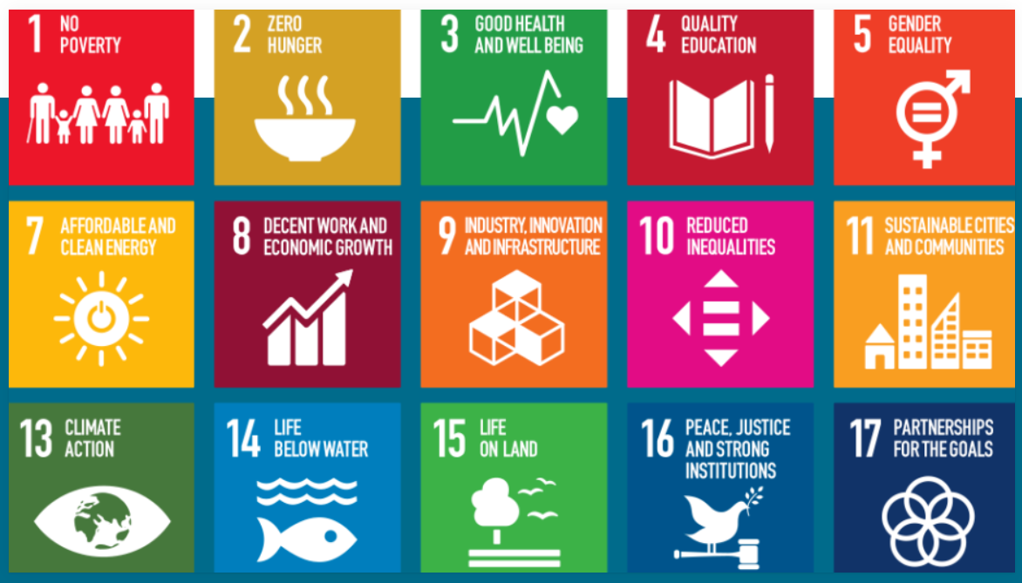
Figure 2: The United Nations Sustainable Development Goals (NEMO, 2020)
The United Nations Sustainable Development Goals (SDGs) are closely linked to sustainable gastronomy, particularly SDG 2 (Zero Hunger), SDG 12 (Responsible Consumption and Production), and SDG 13 (Climate Action). These goals highlight the interconnectedness of food production and global sustainability challenges (NEMO, 2020).

3. McDonald’s UK Sustainability Analysis
McDonald’s UK has demonstrated a strong commitment to sustainability through its Plan for Change strategy. Key initiatives include:
Net-zero emissions: McDonald’s has set a goal to reach net-zero greenhouse gas emissions by 2040, with interim science-based targets for 2025 (McDonald’s, 2023).
Sustainable sourcing: McDonald’s UK has achieved 100% sustainable sourcing of critical ingredients such as coffee, fish, palm oil, and beef through certification schemes like Fairtrade and Rainforest Alliance (McDonald’s, 2023).
Renewable energy: All UK restaurants are now powered by 100% renewable electricity, and the brand has integrated renewable energy into its supply chains (McDonald’s, 2023).
Eco-restaurants: The company has piloted eco-restaurants that feature sustainable materials, energy-efficient lighting, and water-saving technologies.
McDonald’s UK aligns its business strategy with environmental, social, and economic objectives, ensuring profitability while mitigating environmental harm. However, despite these successes, McDonald’s faces criticism for the environmental impact of its beef supply chain, which remains a significant source of greenhouse gas emissions (Poore and Nemecek, 2018). According to Stakeholder Theory (Freeman, 2020), McDonald’s has engaged extensively with stakeholders, but challenges in mitigating the full impact of its supply chains persist.

4. KFC UK Sustainability Analysis
KFC UK has focused its sustainability efforts on specific areas, particularly animal welfare and waste management. Key initiatives include:
Animal welfare: KFC is committed to improving poultry welfare through the Better Chicken Commitment, which ensures higher welfare standards for chicken farming (KFC, 2024).
Plastic waste: The brand has pledged to eliminate non-recyclable plastics by 2025 and aims to reduce plastic packaging overall (KFC, 2024).
Renewable energy: KFC’s outlets are powered with 100% renewable electricity, aligning with the company’s broader sustainability goals (KFC, 2024).
Food Redistribution: KFC UK has partnered with FareShare, redistributing surplus food to support local communities and reduce food waste (KFC, 2024).
However, KFC UK has not yet made the same level of commitment as McDonald’s regarding broader climate action. While the company has significant efforts in animal welfare and waste management, it lacks a comprehensive net-zero emissions target and does not engage in the same breadth of sustainable sourcing (RSPCA, 2025). According to Carlos Gonzalez Fischer et al. (2016) suggests that KFC’s sustainability efforts may be more reactive, shaped by industry standards and societal pressures rather than a proactive leadership stance. McDonald’s UK and KFC UK are likely subject to the UK Plastic Packaging Tax and have responded by reducing plastic use, increasing recycled content in packaging to qualify for tax exemptions, and exploring sustainable material alternatives. This has led both companies to adjust their packaging strategies to meet environmental goals and minimise financial and reputational risks (HM Revenue & Customs, 2021).

5. Comparative Analysis of Sustainability Initiatives
When comparing McDonald’s UK and KFC UK, several differences emerge across their sustainability initiatives. McDonald’s shows a stronger commitment to climate action, with a formal net-zero target by 2040 and broader sustainable sourcing, including beef and fish. In contrast, KFC UK’s focus remains narrower, particularly centred on animal welfare and plastic waste reduction, with no formal net-zero commitment (McDonald’s, 2023; KFC, 2024). They can look into other restaurants are moving with completely zero waste (World's Table, 2024).
Regarding supply chain sustainability, McDonald’s adopts a comprehensive approach, ensuring certified sourcing across a range of ingredients like coffee, fish, and palm oil, while KFC’s initiatives focus mainly on poultry welfare (KFC, 2024). McDonald’s broader supply chain policies reflect a holistic strategy that engages with various environmental, social, and economic dimensions, while KFC’s more narrow focus targets specific issues within its operations.
On waste management, McDonald’s is piloting reusable packaging schemes in collaboration with Loop (McDonald’s, 2023), while KFC focuses primarily on eliminating plastic packaging and adopting compostable materials. Although both brands have shown a commitment to waste reduction, McDonald’s appears to have a more comprehensive approach, experimenting with circular economy models such as reuse and recycling (McDonald’s, 2023).
In terms of reporting transparency, McDonald’s publishes detailed annual sustainability reports that are subject to third-party audits, enhancing the credibility of its claims (McDonald’s, 2023). In contrast, KFC’s public reporting is more limited and lacks the level of transparency seen at McDonald’s (KFC, 2024).

6. Relevant Regulations and Legislation
Both McDonald’s UK and KFC UK are subject to a range of regulations that guide their sustainability practices, including:
The Environment Act 2021: Legislation focused on waste management and biodiversity conservation (legislation.gov.uk, 1990).
Plastic Packaging Tax 2022: A tax on plastic packaging that contains less than 30% recycled content (HM Revenue & Customs, 2021).
Food Waste Regulations 2011 (2024 update): Legislation requiring businesses to segregate and report food waste (The National Archives, 2011).
Climate Change Act 2008 (Amended 2019): The UK’s legally binding commitment to achieving net-zero emissions by 2050 (GOV.UK, 2014).
McDonald’s UK has been notably proactive in aligning with the regulatory requirements surrounding sustainability, particularly in the areas of climate action and energy transition. The company’s commitment to achieving net-zero emissions by 2040 and transitioning to 100% renewable energy across its UK operations is in direct response to the increasing pressure from both government regulations and industry standards (McDonald’s, 2023). The Climate Change Act 2008 commits the UK to reducing greenhouse gas emissions by at least 80% by 2050 compared to 1990 levels, with interim carbon budgets to track progress, including a 34% reduction target by 2020(GOV.UK, 2014). In contrast, KFC UK’s sustainability strategy appears to have some notable gaps, particularly in the area of climate strategy disclosures. While the company has made efforts to reduce plastic waste and improve animal welfare standards, it faces potential risks by failing to fully embrace the Task Force on Climate-related Financial Disclosures (TCFD) framework, which was established to improve transparency in climate-related financial risks and opportunities (HM Treasury, 2024). According to Carbon Trust (2021), businesses that are not clear in their climate disclosures could face scrutiny from regulators, investors, and consumers, especially as the UK government tightens its climate-related financial reporting requirements.

7. Circular Economy Analysis
The Circular Economy (CE) model represents a shift from the traditional linear “take, make, dispose” approach to a more sustainable model where products and resources are continuously reused and regenerated (Ellen MacArthur Foundation, 2020). This approach is increasingly relevant in industries such as fast food, which rely heavily on single-use packaging and resource-intensive supply chains (Carlos Gonzalez Fischer et al., 2016). According to WRAP (2024) global environmental action NGO dedicated to transforming product and food systems to promote circular living. For over two decades, WRAP has implemented programs aimed at reducing waste, improving resource efficiency, and fostering sustainable practices across various industries.
McDonald’s UK has taken several significant steps in adopting circular economy practices, including collaborating with Loop to pilot reusable packaging schemes (McDonald’s, 2023) and constructing eco-stores using recycled materials (McDonald’s, 2023). These initiatives reflect McDonald’s commitment to reducing waste and increasing resource efficiency, aiming to make 100% of its packaging recyclable, reusable, or compostable by 2025.
KFC UK, by contrast, focuses mainly on recyclability and compostable materials rather than adopting more comprehensive reuse models. Although KFC’s focus on plastic waste reduction is commendable, its limited adoption of circular economy principles, such as product reuse, places it behind McDonald’s in this area (Ellen MacArthur Foundation, 2020).

8. Recommendations
To enhance its sustainability efforts, McDonald’s UK should prioritise accelerating the reduction of beef-related emissions by sourcing alternative protein options, such as plant-based alternatives, which have a lower environmental impact compared to traditional beef (Poore and Nemecek, 2018). Additionally, expanding reusable packaging schemes beyond pilot locations is essential, aiming for widespread implementation across all outlets, which would significantly reduce waste associated with single-use packaging (McDonald’s, 2023). Furthermore, McDonald’s should deepen its circular economy efforts by partnering with innovative companies focused on resource recovery and recycling, ensuring that its operations align with the principles of a circular economy, which emphasizes resource efficiency and waste reduction (Ellen MacArthur Foundation, 2020).
Also, its important prevent food waste within their internal supply chains, rather than relying on reactive measures like discounting. Using expert interviews, it identifies 21 waste prevention strategies across inbound logistics, warehousing, distribution, and stores. The research highlights that although these measures can be impactful, they are underused due to implementation challenges. It offers a structured approach to tackling food waste and categorises barriers to adopting such strategies. (Winkler, Ostermeier and Hübner, 2023)
To further strengthen its sustainability efforts, KFC UK should establish clear science-based net-zero targets, aligning with the UK’s legal commitment to reduce carbon emissions by 2050 (GOV.UK, 2014). This would require the development of a comprehensive strategy that focuses not only on reducing direct emissions from its restaurants but also on addressing emissions across its supply chain, particularly from poultry farming, which contributes significantly to the company’s overall environmental impact (KFC, 2024). Additionally, KFC should pilot reusable packaging models, complementing their current efforts in promoting compostable packaging. Expanding the use of reusable containers would align with the principles of a circular economy, reducing waste and improving resource efficiency (World's Table, 2024). Furthermore, enhancing the transparency of KFC’s sustainability reporting would be crucial, especially through third-party audits. Independent verification ensures credibility and builds stakeholder trust, which is essential for maintaining consumer confidence and meeting regulatory expectations (KFC, 2024).
Also, according to Barber (2014) the importance of resilience thinking, which enables societies to adapt to and recover from environmental, economic, and social shocks. Furthermore, risk management should be integrated into sustainability planning to proactively address uncertainties and promote sustainable outcomes for future generations.

9. Conclusion
Both McDonald’s UK and KFC UK have demonstrated significant progress in embracing sustainability within their operations, with each brand taking distinct yet impactful approaches. McDonald’s UK, as a global leader in the fast-food sector, has integrated sustainability at the core of its business strategy. The company has set an ambitious target to achieve net-zero emissions by 2040, alongside broad commitments to sustainable sourcing, climate action, and circular economy practices (McDonald’s, 2023). McDonald’s efforts to transition towards eco-restaurants and pilot reusable packaging initiatives, as well as its commitment to renewable energy across all UK outlets, underscore its proactive stance on sustainability (McDonald’s, 2023). KFC UK, while also making important strides, has focused its sustainability initiatives primarily on animal welfare and waste management. The company’s commitment to improving poultry welfare through the Better Chicken Commitment and its pledge to reduce plastic waste through more compostable packaging are commendable steps in the right direction (KFC, 2024).
In conclusion, while both McDonald’s UK and KFC UK have made meaningful contributions to sustainability, they must further innovate and align their operations with broader global sustainability goals. According to Barber (2014) by adopting more systemic, forward-thinking strategies, both companies can continue to play a vital role in transforming the foodservice industry, ensuring that future generations inherit a more sustainable, ethical, and resilient food system.

10.Reference list
Barber, D. (2014). The Third Plate. Penguin Group US.
Carbon Trust (2021). Home | Carbon Trust. [online] www.carbontrust.com. Available at: https://www.carbontrust.com/ [Accessed 19 Apr. 2025].
Carlos Gonzalez Fischer, Garnett, T., And, F. and Oxford., O. (2016). Plates, pyramids, and planets : developments in national healthy and sustainable dietary guidelines : a state of play assessment. Rome, Italy: Food And Agriculture Organization Of The United Nations ; [Oxford.
Ellen MacArthur Foundation (2020). Ellen MacArthur on the Basics of the Circular Economy. [online] www.youtube.com. Available at: https://www.youtube.com/watch?v=NBEvJwTxs4w [Accessed 19 Apr. 2025].
FAO (2025). Food Systems | Food and Agriculture Organization of the United Nations. [online] www.fao.org. Available at: https://www.fao.org/food-systems/en/ [Accessed 22 Apr. 2025].
Freeman, R.E. (2020). The Power of and : Responsible Business without trade-offs. New York: Columbia University Press.
GOV.UK (2014). Climate Change. [online] GOV.UK. Available at: https://www.gov.uk/guidance/climate-change [Accessed 21 Apr. 2025].
HM Revenue & Customs (2021). Plastic Packaging Tax: Steps to Take. [online] GOV.UK. Available at: https://www.gov.uk/guidance/check-if-you-need-to-register-for-plastic-packaging-tax [Accessed 22 Apr. 2025].
HM Treasury (2024). Task Force on Climate-related Financial Disclosure (TCFD) Aligned Disclosure Application Guidance. [online] GOV.UK. Available at: https://www.gov.uk/government/publications/tcfd-aligned-disclosure-application-guidance/task-force-on-climate-related-financial-disclosure-tcfd-aligned-disclosure-application-guidance [Accessed 17 Apr. 2025].
KFC (2024). The Goodness behind the Bucket at KFC UK. [online] www.kfc.co.uk. Available at: https://www.kfc.co.uk/behind-the-bucket [Accessed 10 Apr. 2025].
legislation.gov.uk (1990). Environmental Protection Act 1990. [online] Legislation.gov.uk. Available at: https://www.legislation.gov.uk/ukpga/1990/43/contents [Accessed 23 Apr. 2025].
McDonald's (2023). The Detail behind Our Plan for Change | McDonald’s UK. [online] www.mcdonalds.com. Available at: https://www.mcdonalds.com/gb/en-gb/our-plan-for-change/our-plan.html [Accessed 12 Apr. 2025].
NEMO (2020). NEMO will contribute with expertise on the SDGs in a structured dialogue with the European Commission. [online] NEMO - The Network of European Museum Organisations. Available at: https://www.ne-mo.org/news-events/article/nemo-will-contribute-with-expertise-on-the-sdgs-in-a-structured-dialogue-with-the-european-commission/ [Accessed 20 Apr. 2025].
Poore, J. and Nemecek, T. (2018). Reducing Food’s Environmental Impacts through Producers and Consumers. Science, [online] 360(6392), pp.987–992. doi:https://doi.org/10.1126/science.aaq0216.
RSPCA (2025). Who Are RSPCA Assured. [online] RSPCA Assured. Available at: https://www.rspcaassured.org.uk/about-us/the-big-issues-facing-britain-s-farm-animals/ [Accessed 24 Apr. 2025].
The National Archives (2011). The Waste (England and Wales) Regulations 2011. [online] Legislation.gov.uk. Available at: https://www.legislation.gov.uk/uksi/2011/988/contents/made [Accessed 20 Apr. 2025].
UK Government (2015). Modern Slavery Act 2015. [online] www.legislation.gov.uk. Available at: https://www.legislation.gov.uk/ukpga/2015/30/contents/enacted [Accessed 18 Apr. 2025].
Winkler, T., Ostermeier, M. and Hübner, A. (2023). Proactive Food Waste Prevention in Grocery Retail Supply Chains – an Exploratory Study. International Journal of Physical Distribution & Logistics Management, [online] 53(11), pp.125–156. doi:https://doi.org/10.1108/ijpdlm-12-2022-0383.
World's Table (2024). World’s First ‘zero-waste’ Restaurant without a Single Bin. [online] BBC Reel. Available at: https://www.bbc.co.uk/reel/video/p0hs7sj4/world-s-first-zero-waste-restaurant-without-a-single-bin [Accessed 25 Apr. 2025].
WRAP (2024). WRAP: Leading the Way to Circular Living. [online] YouTube. Available at: https://www.youtube.com/watch?v=cTD-X0lhMWY [Accessed 25 Apr. 2025].
Zenbird (2024). 3 Pillars of Sustainability and the Triple Bottom Line | Sustainability from Japan. [online] Zenbird. Available at: https://zenbird.media/3-pillars-of-sustainability-and-the-triple-bottom-line/ [Accessed 19 Apr. 2025].

