Noemi Bregolin (2030799)

CINEWORLD GROUP PLC


Table of Contents
Introduction 2
Cineworld Group Profile 3
Strategic Choices 3
Corporate strategies 3
Business strategies 4
Interactive strategies 4
Cinegroup direction 5
Resources and capabilities 6
Tangible resources and organizational capabilities 8
Intangible resources 8
Resources and capabilities alignment with strategies 8
VRIO 8
Value chain 9
Strategy in action 10 Sustainability effort evaluation 13
Sustainability strategy 13 Alignment with corporate strategies 13 Recommendations 15
Conclusion 15
Reference list 17
Appendix A 18

INTRODUCTION

The purpose of the report is to provide a strategic review of the corporate and business strategies of Cineworld Group PLC. A strategy review is structured by initially identifying the choice of strategies and the resources and capabilities used by the company to understand their alignment with strategic choices. Next, an evaluation of the strategic implementation is conducted, to identify new market adjacency opportunities, and create new competitive advantages. The focus will switch to external factors, specifically sustainability and the environment, and on how the company has moved to create further advantages. The result of a strategic review is a clear set of strategic recommendations and a future roadmap for the company.

CINEWORLD GROUP PLC PROFILE

Cineworld Group plc was founded in 1995, initially as a private company and is a formidable film group on the European scene. It was re-registered as a limited company in May 2006 and listed on the London Stock Exchange in May 2007, however until August of this year (Careers.Cineworld, 2023). The locations in which it operates are the United Kingdom, Ireland, Poland, the Czech Republic, Slovakia, Hungary, Bulgaria, Romania, Israel, and the United States. (Cineworld, 2021)

STRATEGIC CHOICES
BUSINESS AND CORPORATE STRATEGIES

Strategy is defined as an overall plan, aimed to pursue the organization's main objective. It focuses on identifying the company's opportunity in the market and the effective usage of resources and capabilities to reach the organizational purpose.
The strategies are defined in two primary levels:
- Corporate-level strategy relates to the organisation's overall purpose and how value is added to the activities that are part of the organisational whole. Outline what business the company is in.
- Business-level strategy relates to the individual business and it in the market. It focuses on competition for the client and against rival companies in such a way as to create added value to the resources and competitive advantages of the same resources.
(Lynch, 2021)
CORPORATE STRATEGIES

Provide best cinema experience | A good experience consists of several factors: variety of retail offerings (through the availability of different types of films, locations, and technologies) and excellent customer service (through trained employees) (Cineworld Group LPC, 2022).
Be technological leaders in the industry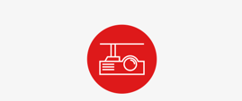 | Providing best visuals and audio by strengthening the relationship with technological partners (Cineworld Group LPC, 2022).
Expand and enhance the estate | Taking into consideration location, accessibility, competition, and economical factors (Cineworld Group LPC, 2022).
Drive value for shareholders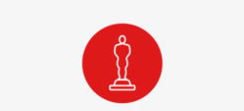 | Keep focus on increasing revenues, focusing on cash control. In this way its’ possible to reward shareholders (Cineworld Group LPC, 2022).

BUSINESS STRATEGY
Cineworld adopted a generic strategy and hybrid model which consists of a combination of differentiation and low cost. (Whittington et al., 2020)
Organizational separation | A company can create separate strategic business units (SBUs), each pursuing different generic strategies and with different cost structures (Whittington et al., 2020). Cineworld Group PLC consists of Cineworld, Picture House, Cinema City, Yes Planet, and Regal (Careers.Cineworld, 2023).
Technological innovation | The technological part is aimed at safeguarding costs and improving quality (Whittington et al., 2020) Technology is used to improve intangible resources (service) and the company's capabilities and safeguard management costs (Corehr, 2023).

Interactive strategy
Cineworld utilized game theory to predict competitors' moves and respond to the pandemic by increasing ticket prices. Despite competitors lowering prices, Cineworld increased prices by 40% to cover expenses and attract viewers with excellent content timing (Shoffman, 2021)
Low cost of tickets would increase the demand and achieve an economy of scale (Whittington et al., 2020) however during challenging times with site closures, demand couldn’t rise significantly.

CINEGROUP DIRECTION
The Ansoff matrix is a 2-by-2 framework which allows product-based companies to identify risks and opportunities arising in growth strategies. It was developed by the mathematician H. Igor Ansoff in 1957. (Peterdy, 2022)
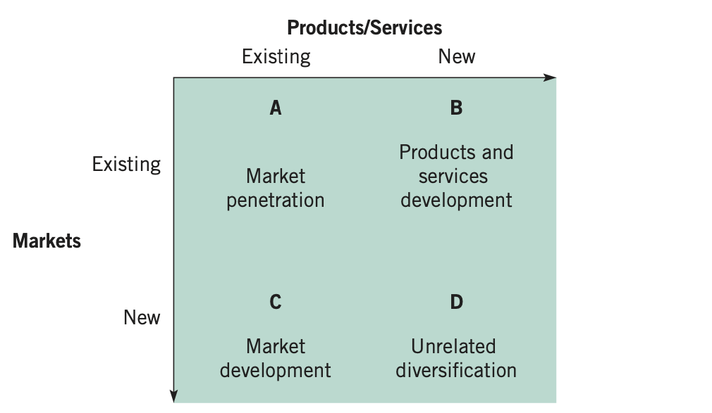(Whittington et al., 2020)
By applying the Ansoff matrix to Cineworld, the company strategy direction is aiming at point B and C diversification, as differentiates the technological range of products and focuses on opening sites worldwide, with a related connection to the original product. Efficiency is improved by involving an organization's existing resources and capabilities in new markets, expanding corporate management capabilities and internal operations (Whittington et al., 2020). Therefore, diversification creates an opportunity for the company to strengthen day-to-day activity and safety, to tailor contents and refurbishment depending on local demographics and site opening, enhance expansion and online offering. (Cineworld, 2021) The scope is maintaining low the power of buyers, rivalry, and the threat of new entrants.

RESOURCES AND CAPABILITIES

Resources are the elements that an organization possesses, i.e. the assets which contribute to the value-added of the company (Lynch, 2021).
Tangible resources are the simplest to identify as they constitute the physical part contributing to added value. These can be of various types, such as financial, human, and physical resources. (Lynch, 2021)
Intangible resources contribute to added value. However, they are not physical but related to technology, service, and brand name.
On the other hand, capabilities are the skills and competencies that the organization possesses, allowing it to make the best use of the resources available to create value. In other words, they represent managerial skills leadership, which refers to a series of attitudes that help a person plan, establish priorities, and achieve their objectives. Organizational capabilities refer to the skills and routines that create competitive advantages. (Lynch, 2021)

 | TANGIBLE RESOURCES | ORGANIZATIONAL CAPABILITIES
Physical | Cineworld currently has a total of 751 sites, 9189 screens, including 132 IMAX screens, 98 4DX screens, 73 ScreenX, 120 PLF.(Cineworld Group LPC, 2022). | Cineworld leverages physical resources and technological advancements to enhance customer experience, using screening rooms for private hires, events, company screenings, and school bookings (Cineworld, 2023).
Human | Cineworld has 28,000 employees, with the head office employing 1077 and cinema staff reaching 26,905. HR departments focus on shareholders, customers, and stakeholders. | Giving support to employees with a value-based culture, trainings, and development. (Cineworld Group LPC, 2022).
Financial | In 2021, Cineworld Group LPC reported revenue of 1,804.9m, gross profit of 541.7m, and EBIT of 454.9m, despite a £3.9bn debt burden from post-pandemic competition and competition with screening services. | The company is focusing on timely delivery of goods and services, ensuring return on profit, cash generation, and liquidity protection due to increased demand and COVID-19 inactivity (Cineworld Group LPC, 2022).

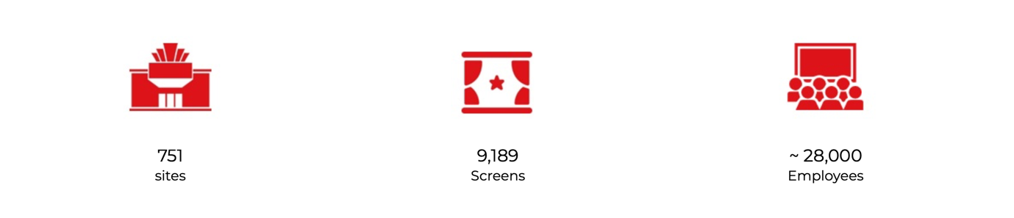
Intangible resources

- Company’s value and brand reputation
The company's value is summed by the principles of integrity, respect, and fairness. The name of the company is strongly recognized worldwide. However, in recent times, it has been put to the test by streaming competitors, such as Netflix. (Light, 2020)

- Technology development
Cineworld has invested mainly in technological development in various objects for employee management, customer care and service quality. Technological resources to improve the service are C3D, 4DX, IMAX, ScreenX, Premium Large Format (Superscreen and RPX) and VIP auditoriums (Cineworld Group LPC, 2022).
Customer loyalty occurs thanks to "My Cineworld membership" and "My Cineworld Plus membership", which offer discounts and IT systems to manage bookings and ticketing, available via the functional website application. (Cineworld, 2023)
The digital experience improvement also concerns personnel management with CoreHR, internet and mobile service, which helps improve management times, efficiency and security for Attendance, Payroll, rosters, People Management, Manager Self-Service, Employee Self-Service, and Analytics. (Corehr, 2023)

- Service level
The service reflects the company's values and attention to technology by providing 'The Best Place to watch a movie', with cutting-edge screens and a trained team (Cineworld Group LPC, 2022).

RESOURCES AND CAPABILITIES ALIGNMENT WITH STRATEGIES

The analysis of the company's resources and capabilities has a dual purpose:
1) Identify where value is added to the organization
2) Identify the company's competitive advantages (Lynch, 2021) The main interest is the distinctive resources and capabilities because they are aimed at identifying competitive advantages rather than competitive needs (threshold) (Whittington et al., 2020).

VRIO
The VRIO model was proposed by Jay Berney and had the objective of identifying and classifying the resources that a company possesses. (Lynch, 2021)

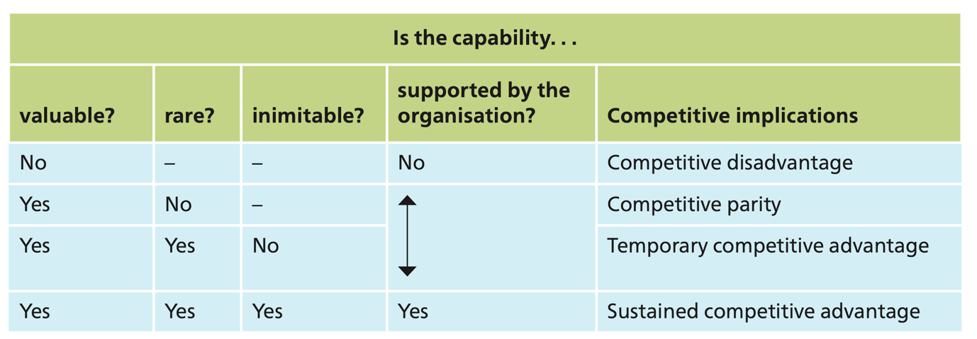
(Whittington et al., 2020)

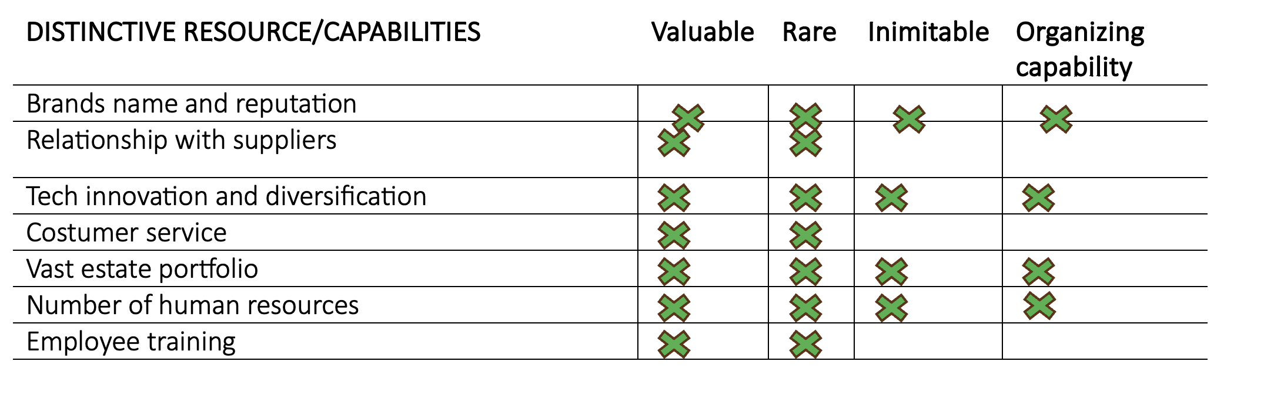

VALUE CHAIN

The Value Chain identifies the main company activities aimed at increasing the product’s value (Whittington et al., 2020).
From the VRIO, a strong competitive parity is evident. However, Cineworld stands out from its competitors for its brand name, reputation, diversification, innovation, estate portfolio and number of employees.
The strategies chosen by Cineworld can be defined as aligned with resources and capabilities, as they are mainly aimed at keeping the support activities of the value chain strong since Cineworld is a distributor.
Unused competitive advantages can be strengthened by improving primary activities, such as marketing and sales, to distinguish the company from streaming competitors.

STRATEGY IN ACTION
EVALUATION
The SAF model is essential for assessing how well a firm has executed strategies based on targets (Whittington et al., 2020) The evaluation consists of defining whether the strategy is suitable, acceptable, and feasible, referring to the external and internal background.

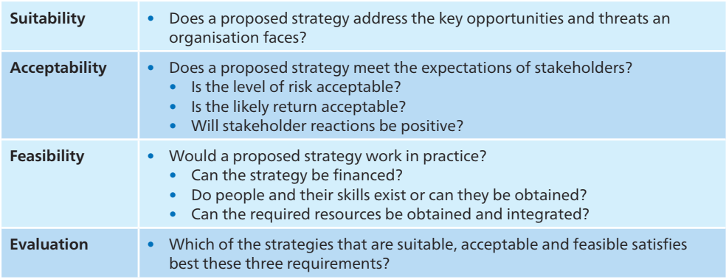(Whittington et al., 2020)
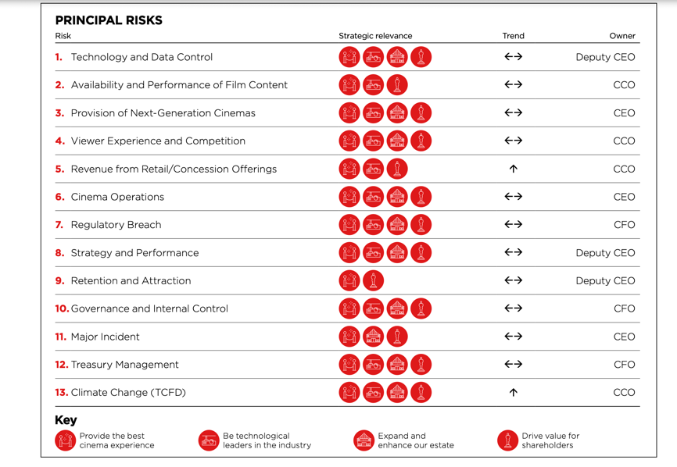
The picture shows company risks and the relations to the strategies. They are used as background for the accountability analysis.
(Cineworld Group LPC, 2022)

Provide the best cinema experience.
The strategy can intelligently adapt to the company's internal strengths, i.e. its vast network base and broad service portfolio (Marketline, 2023a). Greater control of operational functions is required through existing skills in staff development (through training and procurement) is the key to ensuring strategic sustainability. It also dovetails perfectly with the values of integrity, respect, and fairness. (Cineworld Group LPC, 2022). The type of strategy is acceptable for stakeholders, from internal staff to customers, even at a social level; it constitutes an opportunity for integration and collective well-being.

Be technological leaders in the industry / technological innovation.
Having an extensive service network that operates globally, a technological improvement indeed constitutes security for the company's strengths, as it provides greater control over employees with advanced IT systems and offers diversification, making content tailored to the preferences of local cultures (Cineworld Group LPC, 2022). It, therefore, constitutes an advantage for stakeholders, making it acceptable. However, streaming platforms have constituted a strong preference in recent years (Light, 2020). For this reason, the company cannot underestimate technological development since the competence between rivals is high, and it also keeps the power of buyers low, providing an innovative multiplicity of choices.

Expand and enhance the estate.
This point already encompasses the company's strengths and opportunities in the UK (Marketline, 2023a). However, the market targeted for expansion requires a solid strategic analysis. Regulatory breaches such as licensing, health and safety, food and drinks retailing, and minimum wage can put management skills at significant risk if operating in a new territory. New markets are also risky on a cultural level, from personnel management to the availability of content (Cineworld Group LPC, 2022). However, they also constitute a promotional and staff transfer opportunity (always under the firm control of the senior management team), allowing Cineworld to forge relationships with suppliers at a local level (Cineworld Group LPC, 2022).

Drive value for shareholders
The strategy set by Cineworld turned out to be unsustainable, as the financial situation first led to the postponement of payment to shareholders and subsequently to the withdrawal of the listing on the London Stock Exchange (Careers.Cineworld, 2023).

FEASIBILITY
The feasibility of all strategies strictly depends on the ongoing financial situation of the company. The post-pandemic period led to a financial collapse due to the weakening of the number of audiences and consequently of revenues. The group expects to emerge from bankruptcy through a debt reconstruction plan, which so far consists of raising $800m from the sale of rights and accessing $1.46bn in funds. (BBC News, 2023)
The 2022 company's financial statement showed greater control of expenses and costs, improved loss before tax and lower EPS (Cineworld Group LPC, 2022). However, recovery of funds is unlikely in 2023, due to factors such as great competition from streaming services, refusal by buyers in the US and UK to buy the business, (BBC News, 2023) and increased taxes (Marketline, 2023b). The strategies in question are feasible only if they do not require further investment of financial funds. The technology part can help save management costs and attract new customers. Providing the best cinema experience strategy must be maintained, especially in still operational sites. However, expansion into further territories is too risky given the financial situation.

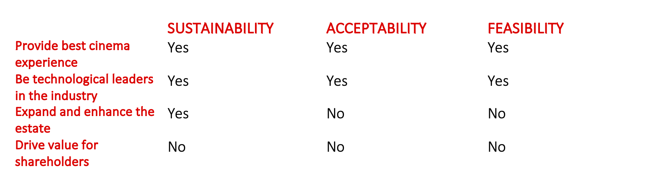

SUSTAINABILITY EFFORT EVALUATION

Sustainability strategy
Cineworld Group aims to achieve net zero carbon emissions by 2050, focusing on direct and indirect emissions from its activities. The company has implemented:
-A Decarbonisation Strategy, focusing on people, technology, and process changes. It will address transitional risks, including increased pressure on businesses, and incorporate physical risks into risk identification and management processes.
- An energy reduction strategy focusing on consumption reduction through behavioural change and analysis of energy use, with a primary focus on electricity.
The Risk Management Committee monitors and manages climate-related risks, reporting to the Board on their assessment. The company engages with employees to review current and emerging risks, with risk assessments conducted with senior staff in major operating territories. (Cineworld Group LPC, 2022).

Alignment with corporate strategies
 | Company achievements | Goals for 2022 | Sustainability alignment
 | -Reopened estate and raised over $424.9m of liquidity. -Online booking penetration in USA raised to 54% | - -Improve Health and safety, spending level vs price ticket increase, online selling |  | Focus on local demographics, employee well-being, customer happiness, and brand loyalty through the promotion and distribution of locally made films.
 | -USA and EU largest operators of IMAX screens, and only one in UK for 4DX. -2,039 laser projectors installed. | Keep on investing on premium format and implementing laser projectors. | -Energy conservation with the introduction of laser projectors -Guarantee stakeholders' safety requirements - Preserve long-term partnership with technological partners
 | Ten new locations in the UK, Romania, and US, seven renovations completed, 23 underperforming facilities closed, and low revenue impact emissions intensity ratio. | Closing losses-causing sites and opening new ones, while also reducing ecological footprint through renovation and energy projects. | Enhancing the durability of renovations through collaboration with local governments and implementing new construction methods that use less energy.
 | - $424.9 million raised in Q4 2021 due to reduced theatre closures and increased cash flow. -Postponed $92 million from shareholder payment and imposed a financial covenant waiver until June 2022. | -Generating operating cash flow and reducing debt. -Employee involvement. | -Proactive and efficient estate administration. -Involvement with charities and local communities -Support from employees -Less food waste and single-use plastics.
(Cineworld Group LPC, 2022)

RECOMMENDATIONS
The SAF analysis helped identify challenges in applying strategies that primarily relate to financing maturity, COVID-19 recovery, real estate, technology investments and distributor relationships. Competition in the streaming industry has changed the cultural level of the future visibility of film programs. Focusing on content exclusivity, site locations, and technological development can be a solution over competitors. Cineworld must guarantee a time horizon focusing on strengthening active sites and obtaining finance from selling inactive ones. A geographical expansion can only be carried out following a secure financial situation.

CONCLUSION
To increase market shares, companies can adopt strategies like product improvement, expansion, marketing, advertising, entering new markets, or partnering, focusing on understanding the target market and customer needs. The company's strategic feasibility was damaged by the exit from the London Stock Exchange, however, Cineworld has shown a certain readiness to adopt solutions aimed directly at debt collection and to focus on maintaining the strategic implementation towards the maintenance of effective operational activities.

REFERENCE LIST
BBC News (2023). Cineworld screens stay open despite administration. [online] 26 Jun. Available at: https://www.bbc.co.uk/news/business-66017633?ssp=1&setlang=en-GB&safesearch=moderate [Accessed 16 Nov. 2023].
Careers.Cineworld (2023), About Us, [online] Available at: https://careers.cineworld.co.uk/about-us?source=google.com [Accessed 16 Nov. 2023].
Cineworld (2023), Join My Cineworld to manage your e-tickets and bookings online, [online] www.cineworld.co.uk. Available at: https://www.cineworld.co.uk/static/en/uk/my-cineworld#promoTab2 [Accessed 16 Nov. 2023].
Cineworld Group LPC (2022), Feel more at Cineworld, [online] Available at: https://www.cineworldplc.com/sites/cineworld-plc/files/reports-presentation/2022/annual-report-2021.pdf [Accessed 15 Nov. 2023].
Cineworld (2021), Key Facts, [online] Available at: https://www.cineworldplc.com/en/about-us/key-facts#:~:text=Cineworld%20Group%20plc%20was%20founded [Accessed 16 Nov. 2023].
Corehr (2023), Cineworld’s HR Innovation Transforms Employee Experience and Saves Every Manager 5 Hours a Week. [online] Available at: https://www.theaccessgroup.com/media/34092/cineworld-corehr-customersuccessstory-1.pdf [Accessed 16 Nov. 2023].
Light, L., (2020), An Unhappy Ending For Movie Theater Chains AMC And Cineworld, [online] Forbes. Available at: https://www.forbes.com/sites/larrylight/2020/05/05/an-unhappy-ending-for-movie-theater-chains-amc-and-cineworld/ [Accessed 16 Nov. 2023].
Lynch R., (2021), Strategic management. 8th ed., [online] Harlow, United Kingdom ; New York: Pearson Education Limited, Available at: https://eu.alma.exlibrisgroup.com/leganto/readinglist/citation/6431305270002421?auth=SAML [Accessed 15 Nov. 2023].
Marketline. (2020), Global Movies & Entertainment Market: Value Chain Analysis, [online] Available at: https://advantage.marketline.com/Analysis/details/global-movies-entertainment-market-value-chain-analysis-63155 [Accessed 25 Nov. 2023].
Marketline. (2023a), MarketLine Intelligence Center, [online] Available at: https://advantage.marketline.com/Company/Profile/cineworld-group-plc?swot [Accessed 9 Nov. 2023].
Marketline. (2023b), United Kingdom In-depth PESTLE Insights, [online] Available at: https://advantage.marketline.com/Analysis/details/country-analysis-report-united-kingdom-in-depth-pestle-insights-25880 [Accessed 24 Nov. 2023].
Peterdy K. (2022), Ansoff Matrix. [online] Corporate Finance Institute. Available at: https://corporatefinanceinstitute.com/resources/management/ansoff-matrix/ [Accessed 19 Nov. 2023].
Shoffman, M. (2021), Cineworld hasn’t pushed up prices - but here is why customers are paying more, [online] The Sun. Available at: https://www.thesun.co.uk/money/15851354/cineworld-hasnt-pushed-up-prices-why-customers-paying-more/ [Accessed 24 Nov. 2023].
Whittington, R., Regner, P., Angwin, D., Johnson, G. and Scholes, K. (2020), Exploring Strategy. 12th ed. Hoboken: Pearson.

APPENDIX A:
The strategic choices and actions were conducted on internal and external analysis of Cineworld Group PLC. Cineworld SWOT and value chain analysis were utilized to identify the internal characteristics and operation of the company, while the UK PESTLE represented external factors.

- Cineworld Group PLC SWOT
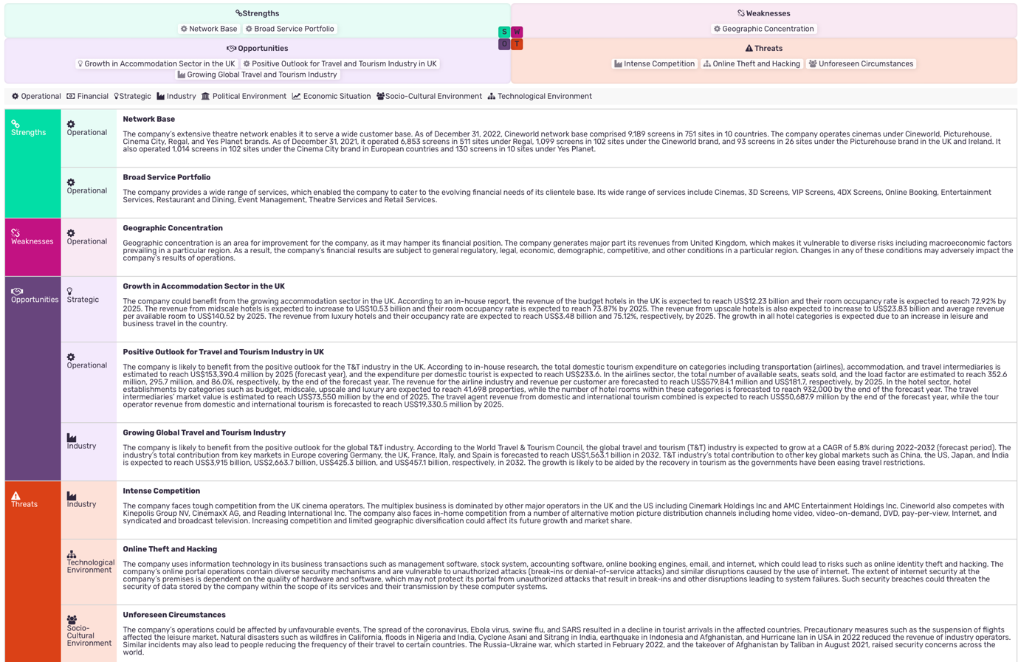
(Marketline, 2023a)

- Cineworld Group PLC Value Chain
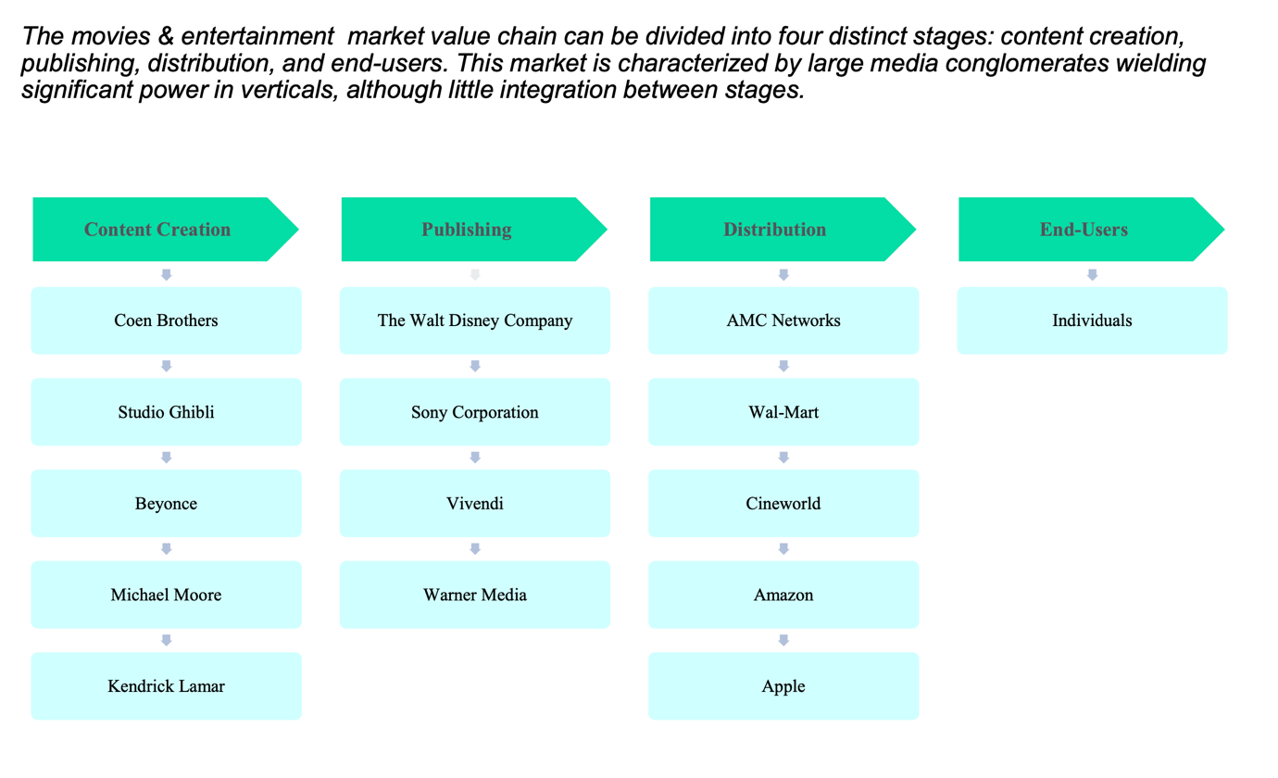(Marketline, 2020)
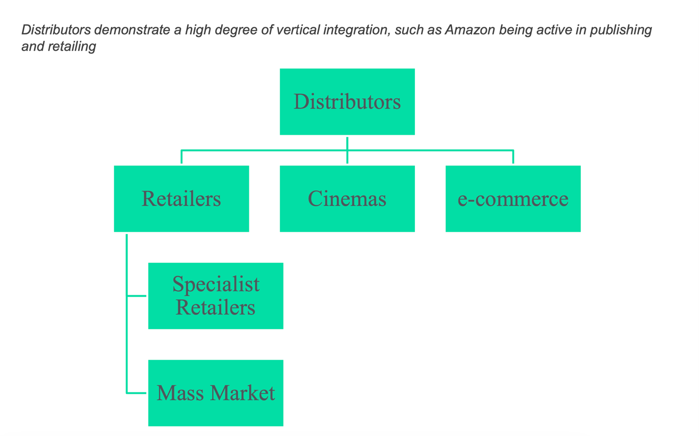
(Marketline, 2020)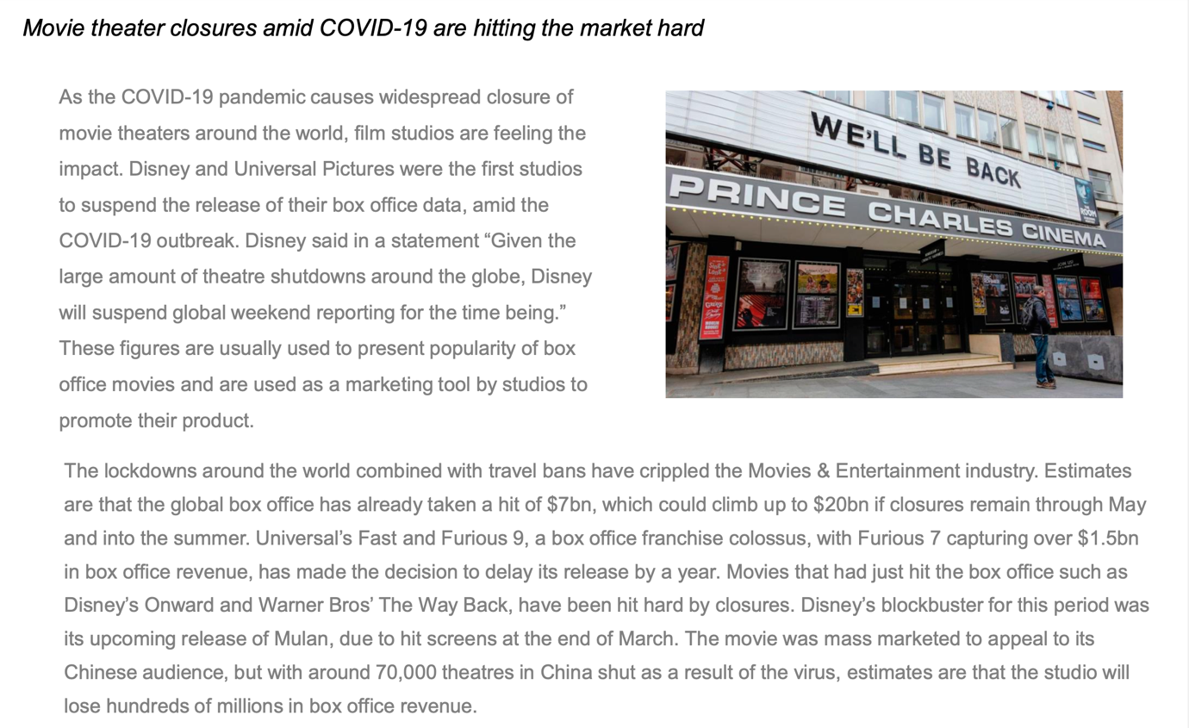
(Marketline, 2020)
- UK PESTLE
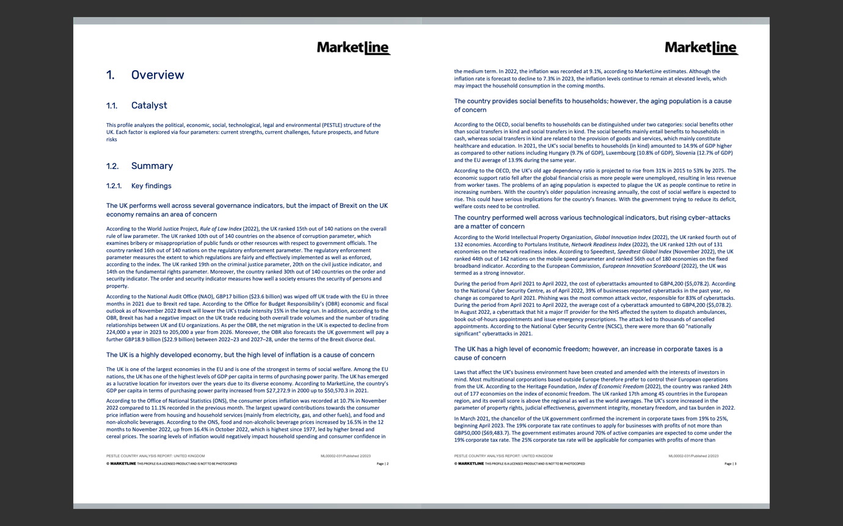
(Marketline, 2023b)
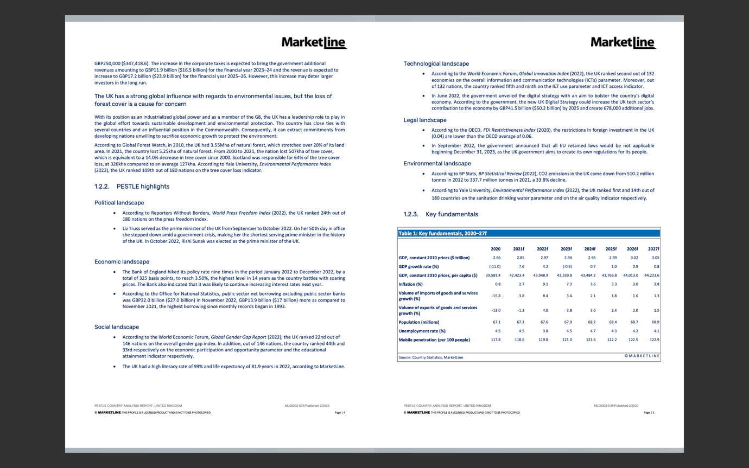
(Marketline, 2023b)

