Austin Hooper (1700481)

BSc Software Engineering

DATE
Database Management Systems
Cycles to Share Database
Table of Contents
1. Introduction 4
2. Database Performance Tuning 1
2.1. Index Considerations 1
2.2. Bike Index 1
2.3. Account Index 2
2.4. Rental Index 2
2.5. Alternative / Additional Indexes 2
3. Distributed Database Schema 3
3.1. Bike Table Fragmentation 4
3.2. Rental Table Fragmentation 6
3.3. Account Table Fragmentation 8
3.4. AccountSubscription Table Fragmentation 10
3.5. RentalBike Table Fragmentation 11
3.6. Duplicated Relations 12
4. Conclusion 13
References 14
Bibliography 15

Figure 1 – Bike fragment 4
Figure 2 - Bikes separated based on station code 5
Figure 3 - Rental fragment 6
Figure 4 - Rentals separated by pickup station 7
Figure 5 - Account fragmentation (finance fragment) 8
Figure 6 - Account fragmentation (HR fragments) 8
Figure 7 - AccountSubscription fragment 10
Figure 8 - RentalBike fragment 11

Introduction

This report discusses database performance tuning and distributed database design. Section 2 discusses and justifies the indexes implemented in SQL file 1, and section 3 discusses the proposed distributed databases design for Cycles to Share. Section 4 concludes, followed by a references list and bibliography.

Database Performance Tuning

Database performance can be enhanced in a number of ways, some significant methods being indexing, partitioning and RAID implementation [1]. This section discusses index considerations for the implemented database. The choice of columns to index is important as it can have negative effects if the wrong columns are chosen, as discussed by Shasha [2].

2.1. Index Considerations

The cities table would be a good candidate for column indexing if there were more city records. However, as the system is limited to Wales only, there will only be a small number of city records and thus indexing columns in this table has no benefit, and would likely degrade performance.
The same is true of the stations table as there will be few of them given the limitation within Wales, so none of this table’s columns are suitable for indexing.
None of the columns in the tariff rate table are suitable for indexing for the same reason as the city and stations tables. There are currently five records for tariff rates and even if more were added in the future, there would never be enough records for indexing to be beneficial.

2.2. Bike Index

Though there are few fields in the bike table, there will be many records for individual bikes, and this justifies indexing in this table. The station code column was chosen for indexing as it is likely customers would want to know what bikes are at a given station (e.g. a station local to them) in order to rent it.
An anticipated query would be:
SELECT * FROM Bike WHERE StationCode = <Value>
Other queries benefiting from this index are likely to be read and update queries.
A bike’s city code may rarely change if a customer returns a bike to a different station than they picked it up from, but this is expected to be infrequent enough that indexing it is still highly beneficial.
The implemented index is:
CREATE INDEX IX_Bike_StationCode ON Bike (StationCode)

The bike status column was not indexed for two main reasons. Firstly, it is a column whose data is expected to frequently update as bikes are dropped off, rented and repaired. Secondly, columns with low cardinality do not benefit from indexing [3].

2.3. Account Index

The account table was chosen for indexing as searches for accounts are likely to be frequent. An example scenario is a customer not remembering their account number, and the store worker searching for their account by first name, surname and email. An expected query using these parameters would be:
SELECT * FROM Account WHERE FirstName = 'VALUE' AND Surname = 'VALUE' AND Email = 'VALUE'
Queries benefiting from this index would mostly be read queries, with an example discussed above.
The implemented index is:
CREATE INDEX IX_Account_FirstName_Surname_Email ON Account (FirstName, Surname, Email)

2.4. Rental Index

The rental index was created to improve performance when finding any rentals associated with a given account. For this reason, the rental number was included as part of the index, despite being a primary index itself, and this index must therefore be unique. A query on the database which would benefit from this index might be:
SELECT RentalNo FROM Rental WHERE AccountNo = 'A000004'
It is likely that create and read queries would be most common here and would benefit most from the index.
The implemented index is:
CREATE UNIQUE INDEX IX_Rental_RentalNo_AccountNo ON Rental (AccountNo, RentalNo)

2.5. Alternative / Additional Indexes

Another viable index would be in the account subscription table, indexing the subscription ID and account number as there are likely multiple subscriptions per account.
Another would be to index the return station column in the RentalBike table as it is likely to be frequently checked.

3. Distributed Database Schema

Distributed database design techniques are categorised as being either fragmentation, allocation or replication [4]. This section primarily discusses fragmentation and replication. Fragmentation is controlling where database information is stored at a table level [5].
Fragmentation must meet the three correctness rules, as described by Chhanda [6]. Assuming a relation, R, is fragmented as R₁, R₂, … R_{n}, then:
- Completeness – Each item in R must appear in at least one of the fragments R_{i}.
- Reconstruction – It must be possible to reconstruct the original relation from fragments R₁, R₂, … R_{n.}
- Disjointness – If a data item is found in any given fragment, it must not be in another fragment. Primary keys are an exception, as they may be duplicated in vertical fragmentation to allow for reconstruction.

3.1. Bike Table Fragmentation

The Bike table has been fragmented horizontally by the StationCode column. This was done to allow each station to store data on the bikes they currently have available, allowing for faster access. It is likely that a customer would go to a specific station and want to rent one of their bikes, so this allows for faster access to all local bikes.
The fragmentation is noted as:
B1: σ_{StationCode} = 'S0001' (Bike)
B2: σ_{StationCode} = 'S0002' (Bike)
etc.

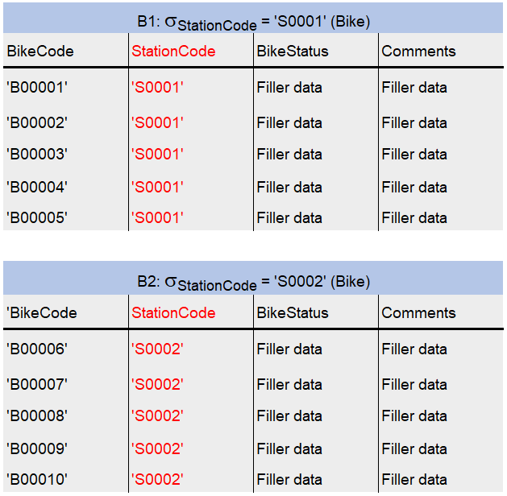
See below a representation of this.
Figure 1 – Bike fragment

This fragmentation meets the completeness aspect of correctness as each table row appears in at least one fragment.
It meets the disjointness aspect of correctness as a bike may change stations but can only be in one station at any given time.
The fragment can be reconstructed using a union, as described by W3Schools [7]:
Original Bike Relation = B1 ∪ B2 ∪ B3 etc.
This fragmentation would result in a similar setup to the below data split in figure 2, implemented as several SELECT queries with WHERE clauses having varying station codes, for example:
SELECT * FROM Bike WHERE StationCode = 'S0001';
SELECT * FROM Bike WHERE StationCode = 'S0002';
SELECT * FROM Bike WHERE StationCode = 'S0003';

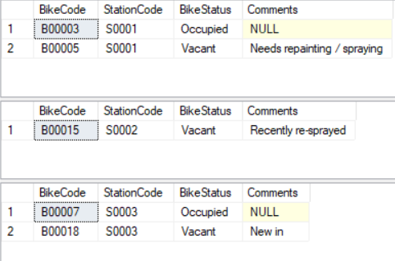
These would result in:
Figure 2 - Bikes separated based on station code

3.2. Rental Table Fragmentation

The Rental table was fragmented horizontally, by pick up station. This is similar to the Bike table, and is done so that each station only holds records of rentals which are being picked up at that particular station.
The fragmentation is noted as:
R1: σ_{PickupStation} = 'S0001' (Rental)
R2: σ_{PickupStation} = 'S0002' (Rental)
etc.

See below a representation of this:
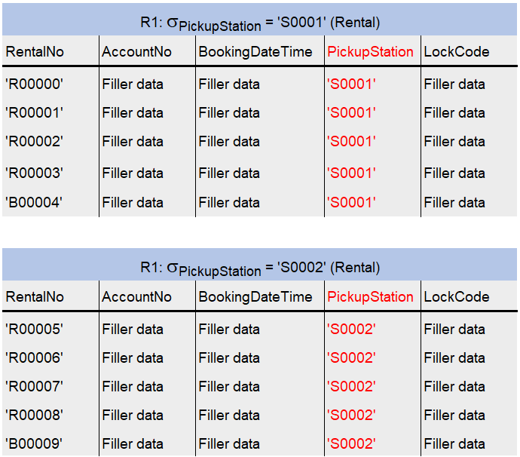

Figure 3 - Rental fragment

The fragmentation would be similar to the result of the below queries:
SELECT * FROM Rental WHERE PickupStation = 'S0001';
SELECT * FROM Rental WHERE PickupStation = 'S0002';
SELECT * FROM Rental WHERE PickupStation = 'S0003';

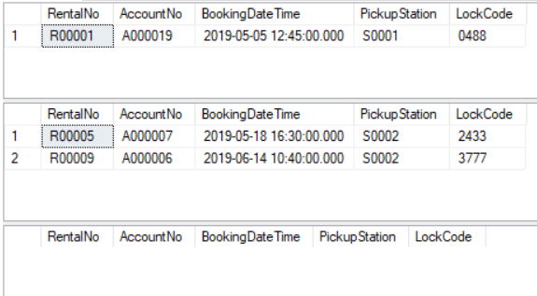
The result would be:
Figure 4 - Rentals separated by pickup station

This fragmentation meets the correctness in the same way as the Bike table.

3.3. Account Table Fragmentation

A mixed / hybrid fragmentation was applied to the Account table. Firstly, vertical fragmentation was applied to achieve a fragment for the finance department, and a fragment for HR. The HR fragment was then further fragmented horizontally by CityCode, which would allow for the account’s details to only be stored in stations in the city they live in.
This fragmentation is noted as:
Finance department:
A1: Π AccountNo, PaymentDate, PaymentCard, PaymentCardCVC (Account)

HR department:
A2: Π AccountNo, RegistrationDate, FirstName, Surname, DateOfBirth, Email, Password, PhoneNumber, Address, CityCode, Postcode (Account)

The HR fragment can be further fragmented as:
A2.1: σ_{CityCode} = 'C0001' (A2)
A2.2: σ_{CityCode} = 'C0002' (A2)
Etc.
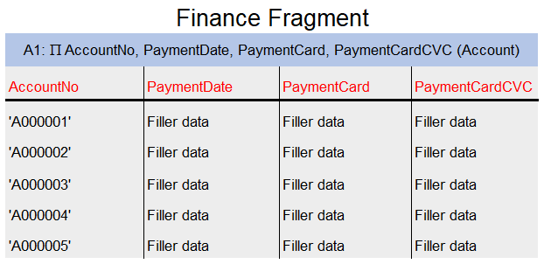
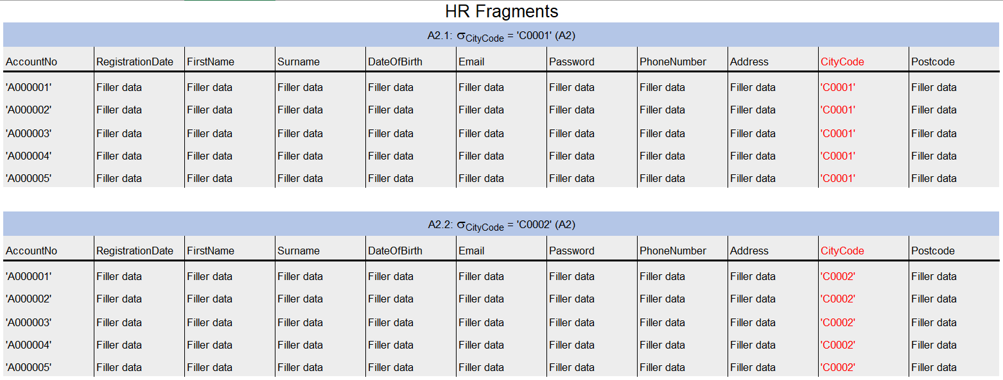
See below a representation of this:
Figure 5 - Account fragmentation (finance fragment)
Figure 6 - Account fragmentation (HR fragments)
This fragmentation meets the completeness aspect of fragmentation correctness as all columns from the original relation are present in either the finance vertical fragment or the HR vertical fragment. The further horizontal fragments within the HR fragment are complete as every record is present.
The fragmentation meets the disjointness aspect of correctness as the initial two vertical fragments contain duplicates of only the AccountNo primary key. Additionally, each account fragment may only be in one city at any given time.
The fragments can be reconstructed using a union on all horizontal fragments, then a further natural join on the resulting fragment and the finance fragment:
A1 ⋈ (A2.1 ∪ A2.2 ∪ A2.3 etc)

3.4. AccountSubscription Table Fragmentation

The AccountSubscription table uses a derived fragmentation based on the Account table. This is so that each city’s stations only store account subscription records associated with accounts that have their city code.

The fragmentation is noted as:
S1 = S ⊳ CityCode A2 (A2 is horizontal Account fragment where CityCode = ‘C0001’)
S2 = S ⊳ CityCode A2 (A2 is horizontal Account fragment where CityCode = ‘C0002’)
Etc.

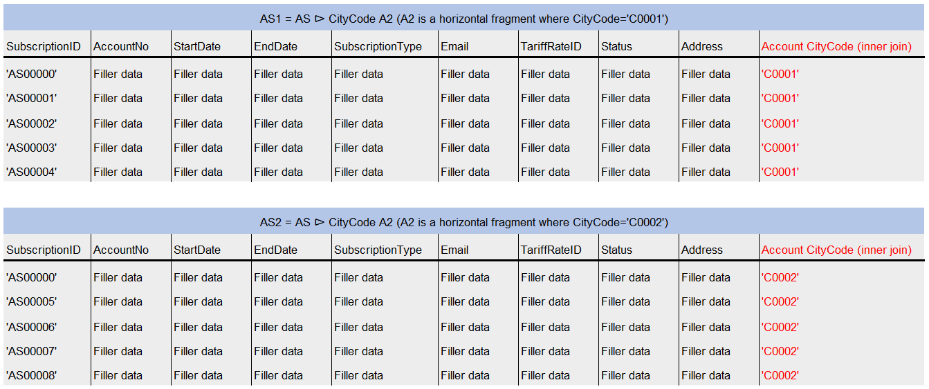
See below a representation:
Figure 7 - AccountSubscription fragment

This fragmentation meets the completeness aspect of fragmentation correctness as each row appears in at least one fragment.
It meets the disjointness aspect of correctness as each account may have only one city code at any given time.

Original AccountSubscription relation = S1 ∪ S2 ∪ S3 etc.

3.5. RentalBike Table Fragmentation

The RentalBike table was fragmented horizontally based on its ReturnStation column, so that each station only stores RentalBike records for those which return the bike to that station. Alternatively, a hybrid fragmentation could have been implemented so that the Swansea station holds all the financial information from the table.
Figure 8 - RentalBike fragment

This meets fragmentation correctness in the same way as the Bike and Rental tables.

3.6. Duplicated Relations

The Station, City and TariffRate tables have not been fragmented as they are small tables with few records, rarely being updated. Because of this, fragmentation would provide no benefit and a better solution would be to duplicate these small tables across all databases.

Conclusion

This report has discussed indexes for performance tuning and proposed a distributed database design for the Cycles to Share business.

References

[1] Y. Alsultanny, “Database management and partitioning to improve database processing performance,” J. Database Mark. Cust. Strateg. Manag., vol. 17, no. 3–4, pp. 271–276, Sep. 2010.
[2] D. E. Shasha and P. Bonnet, Database tuning : principles, experiments, and troubleshooting techniques. San Francisco: Morgan Kaufmann Publishers, 2003.
[3] Ember Crooks, “Why low cardinality indexes negatively impact performance,” 2013. [Online]. Available: https://www.ibm.com/developerworks/data/library/techarticle/dm-1309cardinal/index.html. [Accessed: 25-Mar-2019].
[4] D. Nashat and A. A. Amer, “A Comprehensive Taxonomy of Fragmentation and Allocation Techniques in Distributed Database Design,” ACM Comput. Surv., vol. 51, no. 1, pp. 1–25, Jan. 2018.
[5] IBM, “What is fragmentation?,” 2014. [Online]. Available: https://www.ibm.com/support/knowledgecenter/en/SSGU8G_12.1.0/com.ibm.ddi.doc/ids_ddi_084.htm. [Accessed: 27-Mar-2019].
[6] C. Ray, Distributed Database Systems. Pearson Education India, 2012.
[7] W3Schools.com, “SQL UNION Operator,” 2018. [Online]. Available: https://www.w3schools.com/sql/sql_union.asp. [Accessed: 27-Mar-2019].

Bibliography

Corban Works LLC, “Generate a Random Name - Random, England/Wales, United Kingdom - Fake Name Generator,” 2019. [Online]. Available: https://www.fakenamegenerator.com/gen-random-en-uk.php. [Accessed: 29-Mar-2019].
NumberGenerator.org, “Random 4 Digit Number Generator.” [Online]. Available: https://numbergenerator.org/random-4-digit-number-generator. [Accessed: 29-Mar-2019].
RANDOM.org, “RANDOM.ORG - Calendar Date Generator,” 2019. [Online]. Available: https://www.random.org/calendar-dates/. [Accessed: 29-Mar-2019].
Shopify, “Business Name Generator - Free Company Name Generator.” [Online]. Available: https://www.shopify.com/tools/business-name-generator. [Accessed: 29-Mar-2019].

