

Data based business report on maintaining WIP stock levels to improve lead time
By
Graham Jones
2313935

Degree Apprenticeship in Logistics and Supply Chain Management
19th February 2024
Data Analytics Principles (ACMA4016)

Executive Summary
The standard lead time for customer orders is six weeks, this is down to the amount of time it takes for steel coil to be manufactured and delivered to site. I propose that by keeping work in progress (WIP) stock at various points of the supply chain at a certain level the business could offer a premium service where lead time is reduced from six weeks to two weeks. To do this I will gather data, analyse and identify the most frequently used dimensions in finished orders and work out a suitable volume to keep for each of these sizes.
Table of contents
- Executive Summary………………………………………………………………………….2
- Introduction……………………………………………………………………………………2
  - Opportunity………………………………………………………………………………3
- Data Required………………………………………………………………………………..3
  - Data Collection………………………………………………………………………….4
  - Data Preparation……………………………………………………………………….5
  - Data Analysis……………………………………………………………………………7
- Conclusion……………………………………………………………………………………8
- Appendix……………………………………………………………………………………..9
List of figures
- List of identified planning materials……………………………………………………….4
- Sample of inputted customer data………………………………………………………..5
- Planning materials removed due to in-frequency……………………………………….5
- Data set with calculations for average, min and max values…………………………..6
- Data set with standard deviation………………………………………………………….7
- Final data set preparation………………………………………………………………….8
Introduction
Tata Steel Colors is a downstream operation (DSO) of Tata Steel UK located in Shotton, North Wales. The site produces seven thousand tonnes per week of painted finished steel for the construction sector, the painted finished product can have any dimensions, a range of embossing available and a vast catalogue of colours applied. The standard lead time for a customer order is six weeks, this is mainly due to the production process for the steel coil that is used on site which is produced at Tata Steel main steel making plant in Port Talbot and is transported up to Shotton via rail service. The steel is delivered to the site in coil form weighing twenty four tonnes per coil and orders are taken in increments of twelve tonnes.
Opportunity
According to Will Kenton’s (2023) report, on the website Investopedia, reducing lead time can streamline operations and improve productivity which in turn can increase output and generate more revenue for a business. Whereas longer lead times can negatively effect sales and manufacturing processes.
I propose within this report that by identifying, within Tata Steel Colors standard steel grade, the most frequently used steel dimensions and by working out a weekly volume for each size the business could keep stock at various points within the supply chain that could in turn reduce the lead time for customers’ orders from six weeks to two weeks. The two week lead time is the lead time for paint and chemicals required in the process to be manufactured and delivered to site, which are produced by external companies.
Data Required
The first stage of the steel making process is the slab manufacturing in the blast furnace, from previous experience we know that our most produced steel slab in the standard grade are two sizes 1220mm wide and 1270mm wide. The 1220mm wide slab can be trimmed at the hot mill to supply coil widths of 1170mm to 1220mm and the 1270mm wide slab can be trimmed to supply coil at 1225mm to 1270mm wide, both for gauges of 04mm to 0.7mm. So to start with we will be collecting the tonnages ordered by customers on a weekly basis between 1170mm to 1220mm wide and gauge at 0.4mm to 0.7mm. This will make the first part of the supply chain very simple where the blast furnace will only need to produce a set volume of two slab sizes each week which can then be trimmed as needed at the hot mill.
Using the above criteria Fig1 below has a list of thirty eight planning materials that are within the ranges we will be collecting data on.
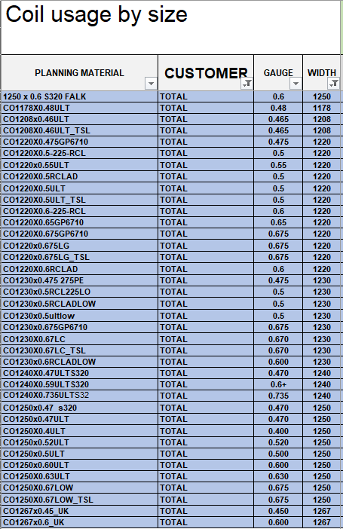
fig1 – list of identified planning materials
Data Collection
The data will be collected by the Customer Services Representatives (CSR) team and inputted into a data set spreadsheet I have created. The data to be inputted is the planning material to be used, customer name, what week the finished material should be available for delivery and tonnage required. This data is stored and can be extracted from our companies SAP ERP system to be manually inputted into the data set spreadsheet. The data will go back to the start of quarter three (Week40 of 2023) all the way to the most recent completed week (Week11 of 2024), so the initial sample set will comprise of twenty three weeks’ worth of data and will continue to grow as more weeks are completed.
An example of the data inputted can be found in the below figure.
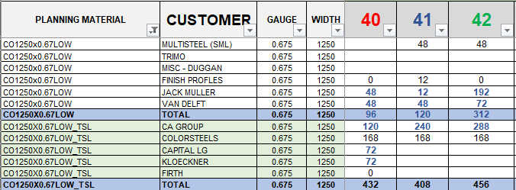
Fig2 – Sample of inputted customer data
Data Preparation
As the data that is being collected is all structured quantitative data it should be very easy to prepare and extract the information we require to make decisions on inventory levels required to support the proposal. Firstly we will find our most frequently used sizes, to do this within the excel document we will put a count on the number of times a non-zero value is given in the planning materials total for the week, any planning material’s that are ordered less than half the available weeks (for purposes 11 out of 23) will be removed from the project.
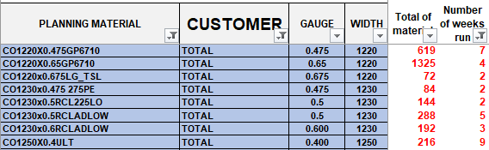
Fig3 – Planning materials removed due to in-frequency
Next step with the remaining planning materials is to take the total tonnage amount ordered for each planning material and dividing it by the number of weeks the planning material has been ordered to give us the average amount ordered. Also added to data set spreadsheet a max tonnage week reference and a min week tonnage reference (Excluding zeroes).
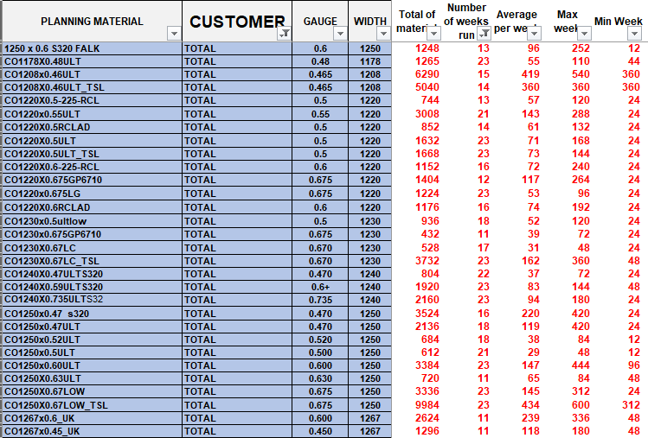
Figure4 – Data set with calculations for average, max and min values added.
The final part of the data preparation is to work out and add in the standard deviation for the volume of each planning material which will help to see how the ordering volumes vary and also negate the impact of any high or low anomalies in the data set (excluding zero values).
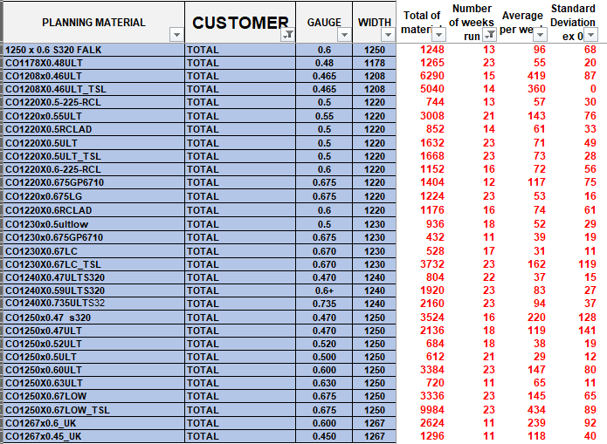
Figure5 – Data set with Standard deviation
Data Analysis
With the data set now compiled and formula in place the next stage is to calculate a acceptable level of stock to maintain in work in progress (WIP) intermediate stock. Combing the average order load per week with the standard deviation gives the volume to aim for (Target Stock) and then, as all coil is supplied at twenty four tonne per coil, we round up to the nearest multiple of twenty four to come to the desired order point.
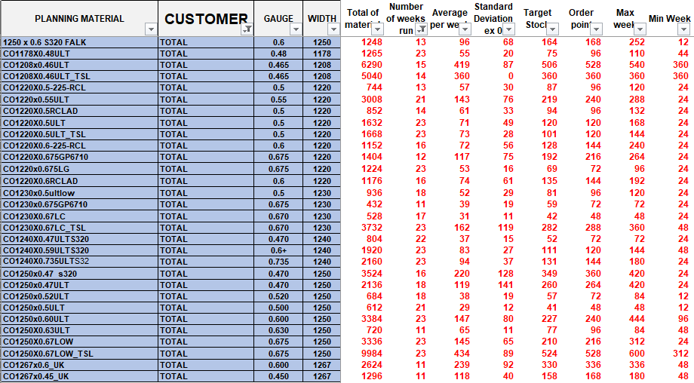
Figure6 – Final data set preparation
This order volume can then be offered to customers on a shorter lead time and then as it is consumed from WIP stock it can be replenished from stock placed at various points in the supply chain, if the same WIP stock is placed before each unit for each planning material size.
Conclusion
Once the initial stock is in place and starts to come through at various points along the supply chain this proposal can be up and running within four to five weeks offering customer increased flexibility in the order placement for the final finished product knowing that the steel coil will be coming through the pipeline. The plan will be to keep the data set updated on a weekly basis with new tonnages so that the order point volume can be reviewed on a regular basis, initially every quarter. Eventually as the data set expands with the customer data quota’s could be evaluated per customer rather than a first come first served basis, as Tata Steel Colors can see which customers are the more frequent purchasers of each size and as such order capacity can be distributed accordingly.
In theory this could provide, on average, almost three thousand tonnes; approximately 43% of total manufacturing capacity per week at a reduced lead time offering with a premium charge for the service.

Appendix / References
Kenton, W. (2023) Lead time: Definition, how it works, and example. Available at https://www.investopedia.com/terms/l/leadtime.asp#:~:text=Reducing%20lead%20time%20can%20streamline,affect%20sales%20and%20manufacturing%20processes. (Accessed 21st February 2024)

Jones, G. (2024) Coil usage 2023-2024 data set. Attached spreadsheet.

