Assignment 1 – Contemporary issues within the police force.

Is it time to arm all UK police officers?

This essay will discuss the arguments for and against the question; should all UK police officers be armed? In 2019, the home office (2022) reported that out of 123,171 police officers in the UK, only 6,653 (5.4%) of them were armed. This essay will go on to discuss the petition that was put forward by the UK government (2023) in 2012. The case of Fiona Bone and Nicola Hughes will be explored, as well as a graph to show the increase and decrease in gun crime over the last few years. Then evaluating the appropriate measures in order to combat this, finished with a conclusion.

On 9 August 2012, the UK Government (2023) started a petition to gather people’s views and opinions on the question; should all police officers be armed? They set themselves a goal of 10.000 signatures. However, after running the petition for 6 months, only 83 people had signed it. In result of this, the petition was closed, and UK police officers weren’t armed. If more people had signed the petition, there would have been a higher change of all UK police officers being armed, which leads to the argument that the UK would be a safer place if the petition was more successful.

The police federation (2019) expresses their concerns on routinely arming all UK police officers. He states that on average, the officers in the UK pull the trigger 2 to 3 times a year, suggesting that it is not often that the armed response weapons are needed, and the likelihood of all police officers to need to carry a gun is very minimal. This supports the argument made by the police chief because it is unnecessary to train and arm all police officers if the armed response officers that we have already, aren’t needing to use their equipment very often. It will be very costly and time consuming when there are many other things that require more police attention.

In the UK, the armed response team have their own duties within the UK. Some of their responsibilities include:

- Responding to high-risk incidents
- Reassuring the publics safety at big events
- Providing enhanced and ballistic medical attention in order to save lives
- Collaborating closely with partners, e.g., the military (Met police, 2023).

With the use of armed response weapons being so low, as well as the number of incidents where the armed response is needed in comparison to the ordinary police, there is little need for all police officers in the UK to be armed.

However, the UK government (2023) suggests that the armed response units don’t have enough time to respond to every single gun related incident, which is resulting in a lot more lives being lost because ordinary police officers don’t have the ability to apprehend individuals that they believe to be armed. They also argue that in result of police officers not being armed, they have to waste time calling and waiting for backup, whereas if they were armed then they could deal with the situation at hand. This undermines the police federations (2019) opinion on the matter, because they say that it isn’t often that the armed response team need to pull the trigger. However, there are cases where police officers have lost their lives in high-risk incidents, e.g., Fiona Bone and Nicola Hughes (2012) whereas if they were armed, it may not have led to the loss of life.

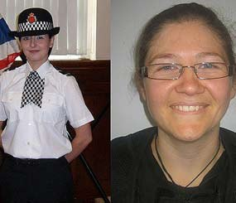
(Police1, 2012).

In 2012, the lives of two unarmed female police officers, Fiona Bone and Nicola Hughes were lost on the line of duty after the gunman, Dale Cregan set off a grenade at them in London, just outside of Manchester. If the police officers were armed, there may have been a different outcome. The chief constable responded to this incident by saying (BBC News, 2022),

"We are passionate that the British style of policing is routinely unarmed policing. We know from the experience in America and other countries that having armed officers certainly does not mean, sadly, that police officers do not end up getting shot dead." (Police1, 2012).

Kelly (2012) argues that arming all UK police officers diminishes Robert Peels work when he formed the Metropolitan police, where there was a big fear of the military. It also undermines the principle of policing by consent, they are trained to protect the public. However, instead it can make the public fear them and cause distrust in the communities.

The police chief says that it has been considered to arm all front-line police officers in England and Wales. However, he argues that it would be very expensive to provide a gun for all officers, as well as additional money for training and other resources. Every officer would need to take time off to train in order to be able to use their equipment appropriately while obeying the law. This means that police officers will be stretched, and the police forces wouldn’t be as efficient of effective because they would be short staffed while officers are training (Dodd, 2017).

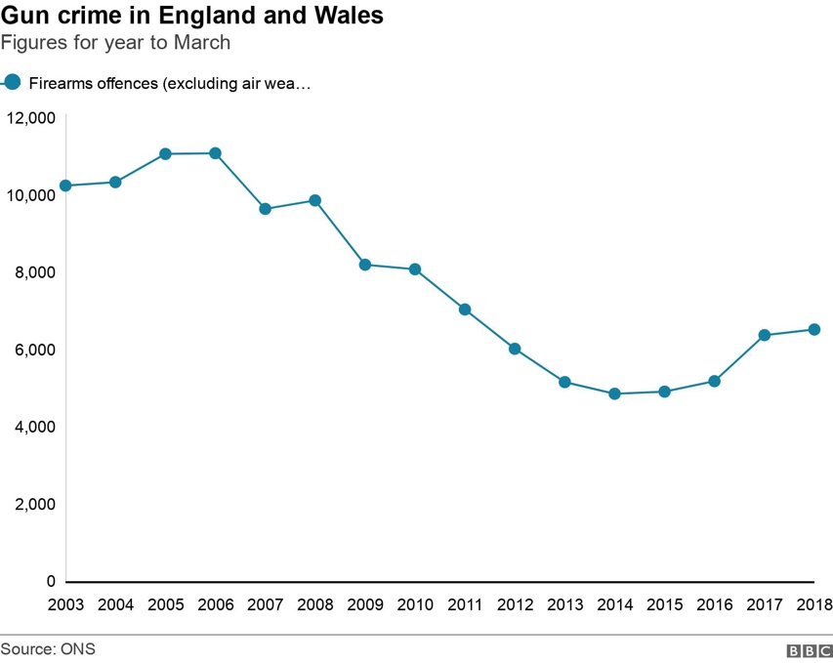 (BBC News, 2017)

This is a scatter graph that shows the rising number of gun related crime in the UK. While it has decreased from the years of 2005-2006, it slowly started to creep back up in 2017-2018, meaning the armed response team are dealing with more major incidents (BBC News, 2019). Police officers have a duty to protect the public and make them feel safe. Therefore, if the high-risk incidents are increasing in the UK, it is their responsibility to do everything they can to try to prevent it and make the public feel safe in their communities, which includes arming police officers to try to reduce the crimes.

Overall, there are many arguments for and against arming all police officers. However, it is clear that big and effective decisions need to be made in order to serve the public appropriately. The case of Fiona Bone and Nicola Hughes and many other fatal cases is a very good starting point when making their decisions. Having said that, the police federation (2019) and Dodd (2017) suggest that it is costly, and the armed response don’t use their weapons very often, meaning it is unnecessary to spend hundreds and thousands of pounds on training and equipment. The desire for more armed response officers isn’t major at the moment, but it is still something to be considered in the near future.

Reference

UK government (2023). Petitions, Arm all police officers in Britain. Available at https://petition.parliament.uk/archived/petitions/2885. Accessed on 16th February 2023.

Home office (2022). Politics. Are the British police armed? https://www.politics.co.uk/reference/police-arms-and-weaponry/. Accessed on 16th February 2023.

Kelly. J (2012). BBC. Why British police don’t have guns. Available at https://www.bbc.co.uk/news/magazine-19641398. Accessed on 16th February 2023.

Dodd. V (2017). Police chiefs to discuss offering guns to all frontline officers. Available at https://www.theguardian.com/uk-news/2017/jun/23/police-chiefs-to-discuss-offering-guns-to-all-frontline-officers. Accessed on 16th February 2023.

Police federation (2019). Should police be routinely armed? Available at https://www.polfed.org/news/latest-news/2019/should-police-be-routinely-armed/. Accessed on 17th February 2023.

Met Police (2023). Authorised firearms officer. Available at https://www.met.police.uk/car/careers/met/police-officer-roles/police-constable/overview/roles-and-opportunities/authorised-firearms-officer/. Accessed on 20th February 2023.

Police1 (2012). 2 unarmed female cops ‘lured to their deaths’ in UK. Available at https://www.police1.com/women-officers/articles/2-unarmed-female-cops-lured-to-their-deaths-in-uk-Gez7ihsa4OZwkGkc/. Accessed on 20th February 2023.

BBC News (2022). PCs Nicola Hughes and Fiona Bone murders: No moving on, father says. Available at https://www.bbc.co.uk/news/uk-england-manchester-62919175. Accessed on 20th February 2023.

BBC News (2019). Gun crime highest for a decade for four police forces. Available at https://www.bbc.co.uk/news/uk-england-47157967. Accessed on 20th February 2023.

