
The Heat Exchanger

A Laboratory Analysis

Oliver Duane
Motorsport Engineering BEng
Thermofluid Mechanics
Lecturer: Rob Goodson
M5X00406
5/4/2019

Contents
List of Figures 2
Notation 3
Abstract 4
Introduction 4
Function of a heat exchanger 4
Types of Heat Exchanger 4
The heat exchanger employed in this experiment 5
The ideal heat exchanger 5
Experiment 1 - The Effect of Varying Water Flow Rate 5
Aim 5
Methodology 5
Analysis 6
Results Table 6
Calculating heat transfer U 6
Charts 9
Experiment 2 - The Effect of Varying Air Flow Rate 12
Aim 12
Methodology 12
Analysis 12
Results table 12
Charts 13
Experiment 3 - Effect of Varying temperature (Driving Force) 16
Aim 16
Methodology 16
Analysis 16
Charts 16
Conclusions 18
Future improvements 18
Bibliography 18

List of Figures
Figure 1 TecQuipment TD1007 Heat Exchanger (TecQuipment Ltd, 2014) 5
Figure 2 Experiment 1. Results table 6
Figure 3 Exp. 1. Heat transfer 9
Figure 4 Exp. 1. Temp. efficiencies 10
Figure 5 Exp.1. Heat transfer coefficient 11
Figure 6 Exp. 2. results table 12
Figure 7 Exp. 2. Power output 13
Figure 8 Exp. 2. Temp. efficiencies 14
Figure 9 Exp. 2. Heat transfer coefficient 15
Figure 10 Exp. 3. results table 16
Figure 11 Exp. 3. Power output 45deg 16
Figure 12 Exp. 3. Temp efficiencies 45deg 17
Figure 13 Exp. 3. Heat transfer coefficient 45deg 18

Notation
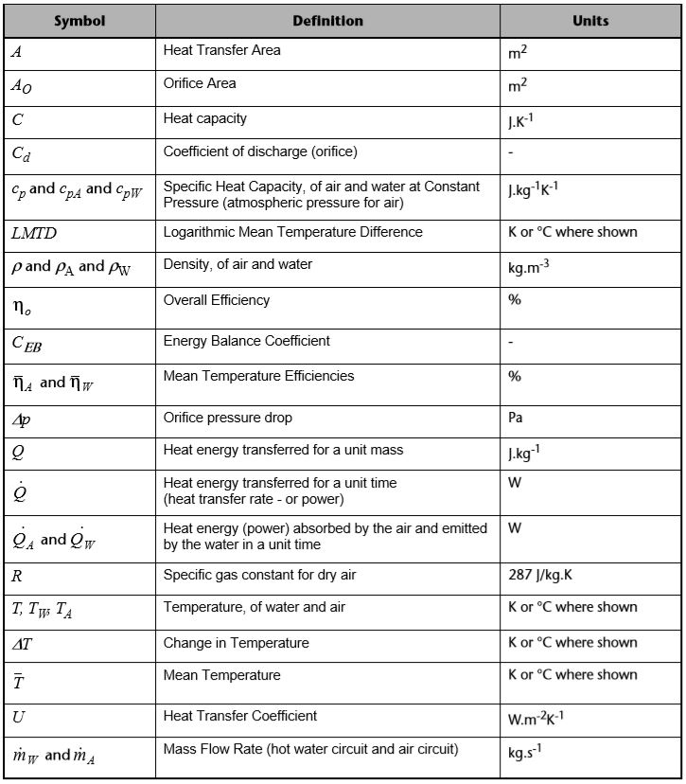

Abstract

Heat exchange is a very common occurrence. When the sun heats the earth in the morning, or when our blood regulates our body temperature, heat is exchanged.
We can use knowledge of these processes to heat our houses and cool our engines.
In this analysis of a laboratory experiment, we look at data gathered from a heat-exchanger (a purpose-built machine for demonstration) that moves air past tubes containing heated flowing water, very much like a “radiator” (or more accurately a “convector”) of an Internal Combustion Engine.

Introduction
The control of heat has been a fundamental factor in technological development. As is often the case though, there are ways to enhance that control to achieve better performance or make things that were previously not possible. To enable better control, a better understanding of the thermodynamic processes is required.

Function of a heat exchanger
A Heat Exchanger is a device with the specific purpose of efficiently moving heat from one place to another. When it is necessary to increase or reduce the temperature of a mass or a system, a heat exchanger of some form can be employed. This is generally achieved with the use of a fluid as a heat-carrying medium, as fluids:
- can have a high Specific Heat Capacity;
- are easily moved through tubes;
- naturally follows the contours of the surfaces to be heated or cooled, maximising contact area.

Types of Heat Exchanger
- Parallel flow
- In line
- Opposite flow
- Double tube
- Single-pass
- Multi-pass

The heat exchanger employed in this experiment
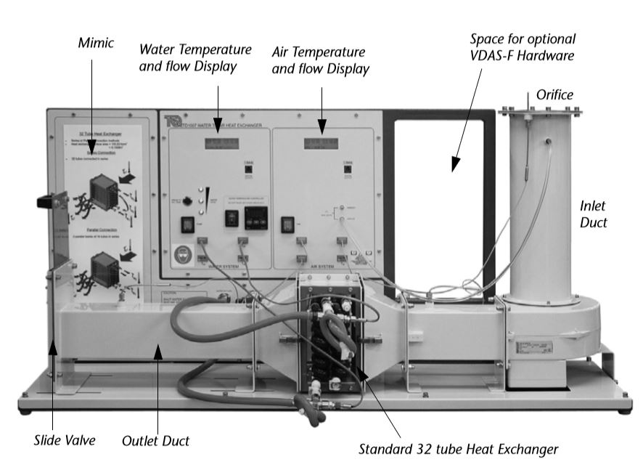
Figure 1 TecQuipment TD1007 Heat Exchanger (TecQuipment Ltd, 2014)
For this lab test a double tube, single pass, water to air heat exchanger is being used.
Water is heated in a tank to a specified temperature. It is pumped through two tubes at a specified rate which pass perpendicular to forced air flow. The airflow is restricted by decreasing the aperture where the air exits. Pressure readings at the intake and exit enable the air velocity to be calculated.

The ideal heat exchanger
If there was no heat loss or gain through the boundary, the heat emitted by the water should be the same as absorbed by the air,
Uw = Ua
so the losses or gains through the boundary can be found
Uw – Ua = Boundary work
(Fermi, 1936)

Experiment 1 - The Effect of Varying Water Flow Rate

Aim
The aim of the first experiment was to examine how changes to water flow rates affect performance, i.e. the amount of heat transfer, Q.

Methodology
- A standard 32 tube heat exchanger was connected for parallel flow;
- The heater tank temperature was set at 60°C;
- Ambient air pressure was logged;
- The orifice diameter was logged;
- The fan was switched on and the slide valve was set to give an orifice pressure drop of 250 Pa (+/- 5 Pa tolerance);
- The pump was switched on and the water flow set to 2.25 L/minute (+/- 0.01 L/minute);
- Five minutes were allowed for the temperatures to stabilize, then all readings were recorded;
- Water and air flows were checked regularly and adjusted when necessary;
- The procedure was repeated for the lower water flow rates of 1.75, 1.25, 0.75 and 0.25 L/min.

Analysis

Results Table
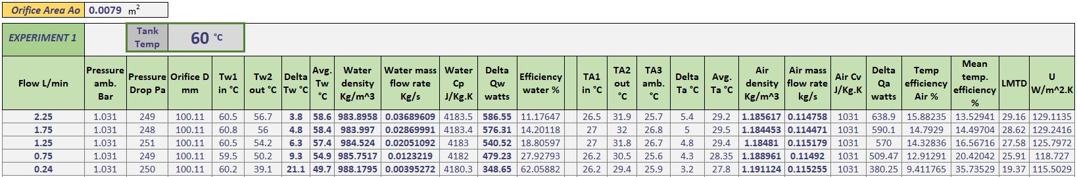
Figure 2 Experiment 1. Results table

Calculating heat transfer U
Several calculations are necessary before heat transfer can be determined.
Firstly, the mass flow rate of both water and air need to be found. As the densities change with heat, the average temperatures are used to simplify the calculation.
Average water calculation:
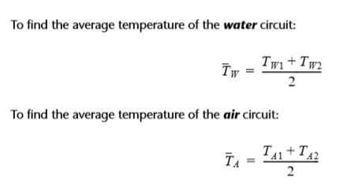
Average air calculation:
Using the average temperature, water density was calculated.
Water density calculation:
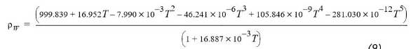
The water mass flow can now be found using the following calculation.
Water mass flow calculation:
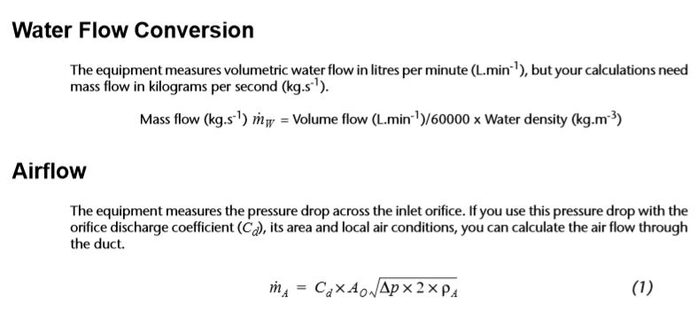
Air density is found using the following calculation.
Air density calculation:
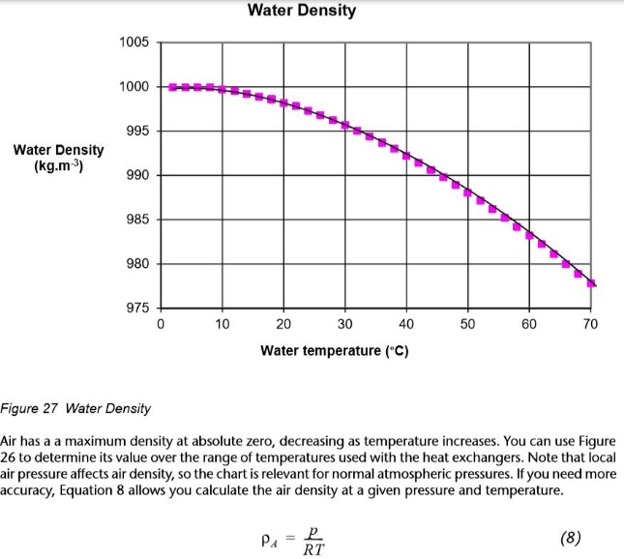
Air mass flowrate is found using the following calculation.
Air mass flowrate:
The specific heat capacity of water was found (assuming “isobaric” constant pressure):
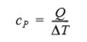
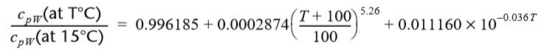
The specific heat capacity of air was assumed to be 1005 J/kg.K as it remains relatively constant for the temperature range used in the heat exchanger (according to the user manual for the machine).
Heat emitted from water:
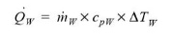
Heat absorbed by the air:
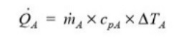
The energy balance coefficient is the relationship between the energy absorbed by the air, and the energy emitted by the water.
Energy balance coefficient:
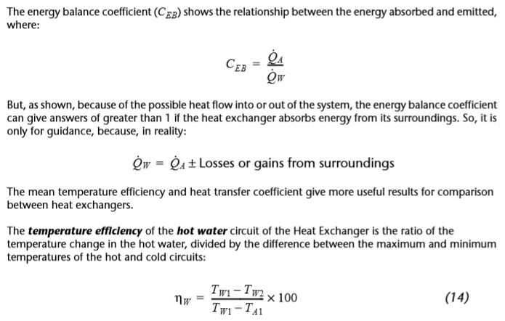
However, due to the heat exchanger being “non-ideal” i.e. some losses or gains from the surroundings, it can be more useful to use mean temperature efficiencies and the heat transfer coefficients to compare the results.
Temperature efficiencies:
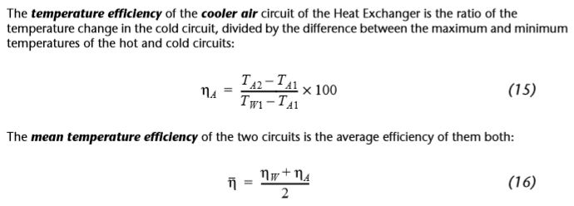
Mean temperature efficiency:
The overall heat transfer coefficient (U) for each flow was calculated using the LMTD – a logarithmic average between the temperature differences used to measure the driving force of heat transfer.
Logarithmic mean temperature difference:
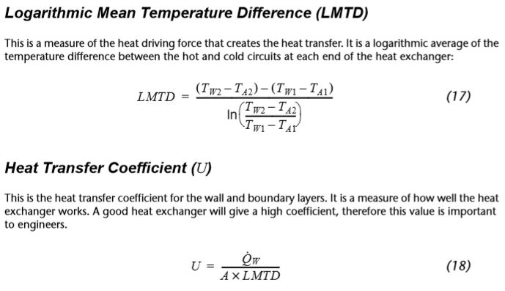
The heat transfer coefficient was then found.
Heat transfer coefficient (U):

Charts
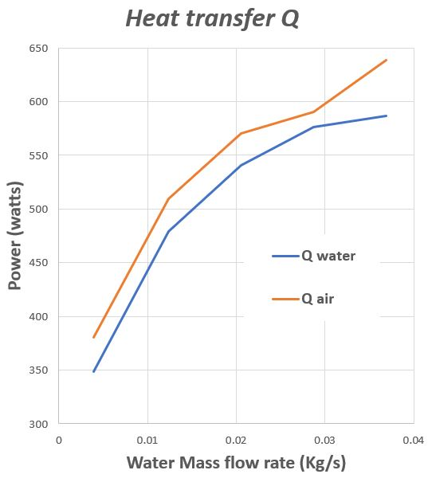
Figure 3 Exp. 1. Heat transfer
Heat emitted by the heat exchanger (Qwater) and the heat absorbed into the air (Qair).
The two lines shown in the above chart show a clear correlation but are off-set from each other. It shows that significantly more heat was absorbed by the air than was emitted by the water.

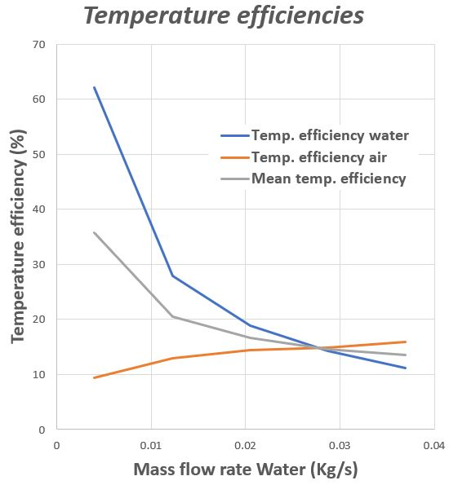
Figure 4 Exp. 1. Temp. efficiencies
The temperature efficiency of water increases exponentially as zero mass flow rate of water is approached. As water mass flow increases, the temperature efficiency reduces, as the water in the tubes is exposed to the airflow for less time.
The temperature efficiency of air, however, increases with the water mass flow rate, but levels off.
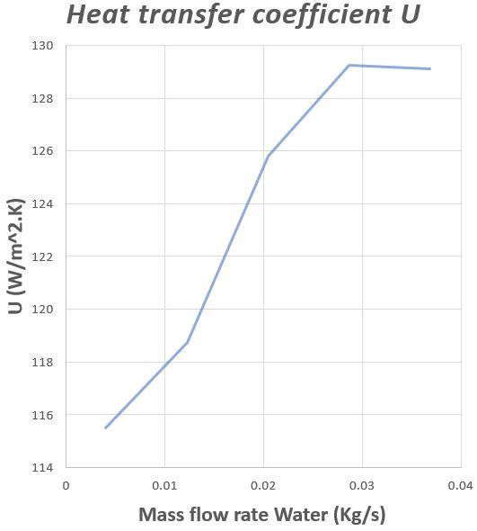
Figure 5 Exp.1. Heat transfer coefficient
The heat transfer coefficient shows that performance improves with increases to water mass flow, but levels off at around 0.03 Kg/s and possibly begins to fall. This suggests that there is an optimum water mass flow rate for the tested airflow.

Experiment 2 - The Effect of Varying Air Flow Rate

Aim
The aim of this experiment is to find out how air flow rate affects heat transfer performance U.

Methodology
- The heat exchanger was set for a parallel flow and the water tank temperature set to 60°C.
- Ambient air pressure and orifice diameter was recorded.
- The fan was switched on and the slide valve set give an orifice pressure drop of 250 Pa (+/- 5 Pa).
- The water pump was switched on the and the flow set to 0.25 L/minute (+/- 0.01 L/minute).
- At least five minutes was allowed for the temperatures to stabilize, then readings were recorded.
- Water and air flows were regularly checked and adjusted as necessary.
- The procedure was repeated for the lower air flow rates of 200, 150, 100 and 50 Pa pressure drop.

Analysis

Results table
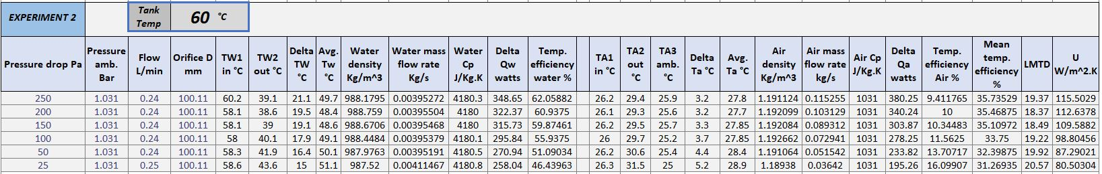
Figure 6 Exp. 2. results table

Charts
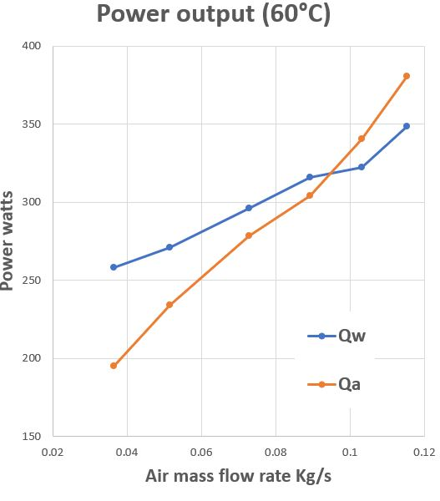
Figure 7 Exp. 2. Power output
The power output chart shows the heat emitted by the water and the heat absorbed by the air.
At lower rates of air-flow, it is apparent that more heat is emitted by the water than is absorbed by the air. The lower air-flow rate could mean that the heat emitted by the heat exchanger has more time to leak out of the system boundary.
Both increase relatively linearly with airflow-rate increase, and do not appear to level-out at the range tested. This suggests that the air-flow rate could be raised to increase the amount of heat transfer.

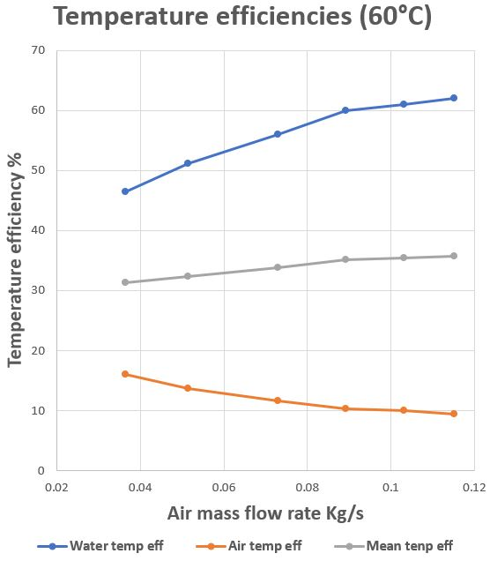
Figure 8 Exp. 2. Temp. efficiencies
The temperature efficiency of water increases with air-flow, while the efficiency for air decreases. The results appear to be levelling off, so suggest ever smaller gains as air-flow increases. However, as the velocity of the air-flow increases, air-friction could reduce the heat emitted from the heat exchanger.
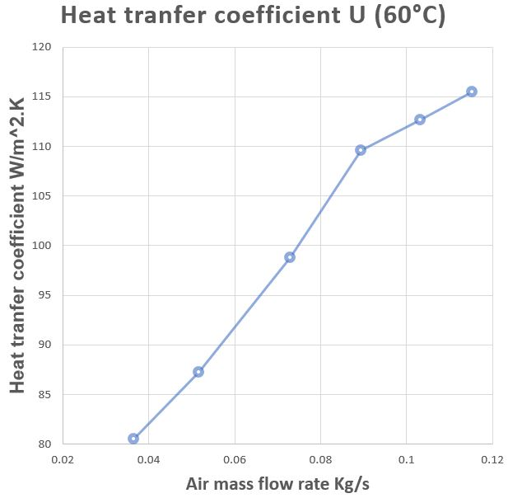
Figure 9 Exp. 2. Heat transfer coefficient
The effect of air-flow rate on performance (heat transfer, U) is shown in the above graph. The results show a very linear trend up to around 0.09 Kg/s of air-flow, and then a different linear trend of reduced performance. The velocity of the air in the tube at 0.09 Kg/s may cause turbulence at this speed.
Increasing air-flow rate again appears to increase heat transfer, but with decreasing gains.

Experiment 3 - Effect of Varying temperature (Driving Force)

Aim
The aim of the third experiment was to explore how water temperature affects the performance.

Methodology
Experiment 2. was repeated, with the only difference being the water supply temperature set at 45°C.

Analysis
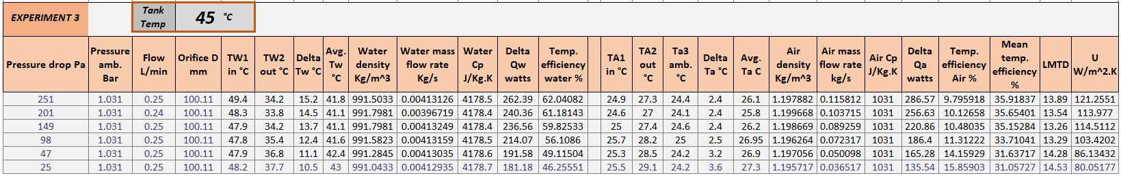
Figure 10 Exp. 3. results table

Charts
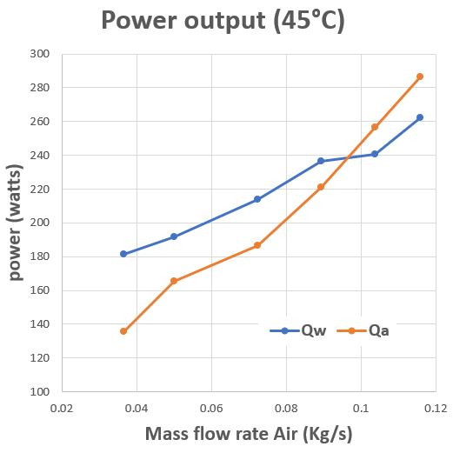
Figure 11 Exp. 3. Power output 45deg
Reducing the 60°C water supply temperature by 15°C means a reduction of less than 5% of the absolute temperature. However, the amount of heat emitted by the water was reduced by approximately 25%. Interestingly, 15°C is 25% of 60°C.
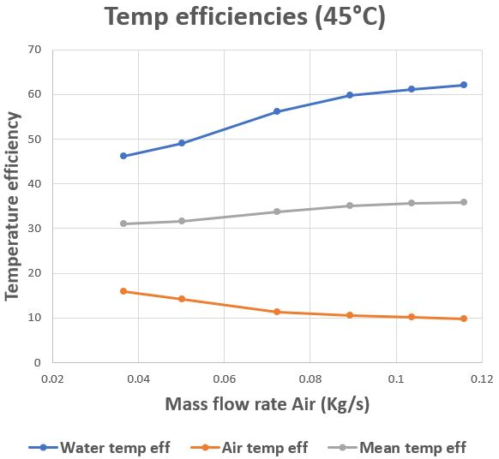
Figure 12 Exp. 3. Temp efficiencies 45deg
The temperature efficiencies and heat transfer coefficient for the 45°C water supply shows similar results to the 60°C experiment.

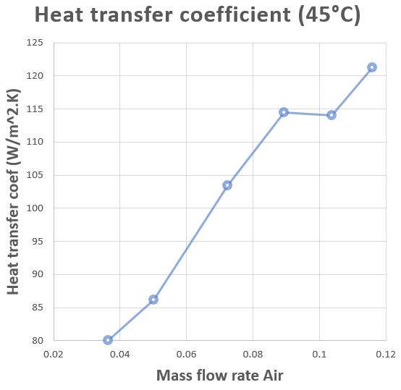
Figure 13 Exp. 3. Heat transfer coefficient 45deg

Conclusions
The experiments performed have demonstrated a correlation between the flow rates of the water and air in their respective circuits, and the degree of heat transfer observed.
Despite careful measurements, the slightly erratic results suggest a margin of error, it may be that environmental factors have a more significant influence than anticipated (Van Ness, 1983)
The air travelled through the tube at high velocity, producing a lot of turbulence, evidenced by the noise produced. The friction of the turbulence and the heat and power from the fan motor could affect readings from the heat sensor.

Future improvements
- Accuracy could be improved by repeating the experiments several times and taking an average of the results.
- The tube could be insulated to reduce heat loss/gain through boundary walls.
- Turbulence should be minimised.
- Heat sources (such as fan motor) should be isolated from the tube as much as possible.

Bibliography
Fermi, E. (1936). Thermodynamics. New York: Dover.
TecQuipment Ltd. (2014). TD1007 Water to Air Heat Exchangers User Guide.
Van Ness, H. C. (1983). Understanding Thermodynamics. New York: Dover.

