

Professional career development report

Student name: Keti Veselinova
Student ID: 2030287

Module name: Professional Career Development
Module code: (BMSW4005_LON)
Lecturer name: Bianca Sanfilippo
Contents
Introduction…..1
Gibbs’ Reflective Cycle….3
Skills and knowledge ….4
My personal strengths and areas for further development….5
SWOT Analysis……6
My employment goals and my professional career plan/development plan…..6
My short-medium-long term targets for development of my own professional career plan……..7
Conclusion…..8
References
Appendix A: ‘The question asked as interviewer in the role play’ (A)
Appendix B: ‘Application Form completed as applicant for role play’ (A1)
Introduction
In this report will be developed on the basis of "professional career development", the report will reflect with the help of the Gibbs’ reflective cycle. In addition, different knowledge and skills will be assessed, which contributes to effective work.
In addition, personal strengths and different areas for further development will be demonstrated.
However, I will create a personal SWOT analysis will also done to identify one’s own potential weakness.
In addition, the report will develop a personal development plan. in addition to using the smart frame, a "professional career plan" will be demonstrated. Here the long-term goal will be created. The report contains some of the documents in the appendix as well as the candidate and the interviewer.
Gibbs’ Reflective Cycle
The Gibbs Reflective Cycle is among the most commonly used reflective models leading to many measures. Graham Gibbs created this reflective model for learning environments in 1988. (Markkanen et al, 2020). It provides a structure to research interactions and the cyclical nature of the system helps to prepare and learn from events that have been good or that have been bad. This model is a perfect way to create encounters that can be either a scenario or a self-contained encounter one often experiences. In the beginning, Gibbs advocated this model in repetitive scenarios, but even with particular interactions, the general rules and phases are relevant. This model is an outstanding way to interact with an experience. This may be a separate occurrence, or a regularly seen scenario, for instance, conferences with a group with which you have to work. In origin, Gibbs promoted its use in repetitive cases, but for particular interactions, the phases and concepts apply equally well. If you have an independent perspective, one can make the action plan specific to see how the observations can be applied in the future.
Figure: Gibbs’ Reflective Cycle Source: www.mmc.ac.uk
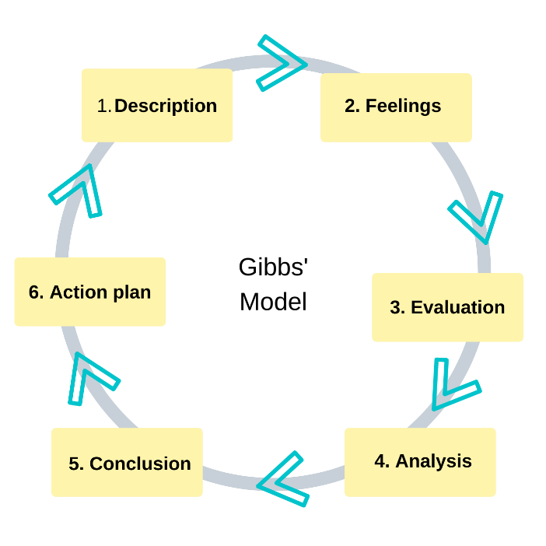
Description:
Time-management is the topic which I selected first among all others. This is since time is a critical factor, because is limited and thus it has to be utilised wisely. In my work and private life, I have put a significant attention on how to best allocate my time in order to achieve the best possible results within certain time constraints. I refer to constrains which are imposed by factors, such as commute to work, the university’s agenda, personal appointments, work arrangements and family tasks. Most of the people I know complain about not having enough time and therefore they are not able to realise all of their aspirations. I agree to some extent that time in never enough, however it can be managed, and results can be improved. This was one of the very first learning experiences which I had in my student life and one of the very first things which I had to address in order to improve my performance and meet the targets set by the agenda.
According to Tracy (2017), procrastination is the deliberate delay or postponement of work until the last minute or after their deadline has passed. This has been defined as one of the major predicaments for success. Procrastination according to most academics is a type of self-regulation failure defined by the illogical deferral of activities despite the possibility of meeting negative repercussions. The author stresses on the importance of first deciding what outcome has to be achieved, followed by deliberate planning of actions and activities which support the execution of the plan. I have reflected on this matter many times because I have noticed that without proper time management, I often failed to meet deadlines or struggled with completion at the last minute. Therefore, I followed the advice of the author and planned things in advance, using my Google Calendar and other indispensable tools, such as the Evernote app. This experience was extremely valuable for me, because I learned how to apply the so called ‘Law of the three’ (Tracy, 2017). This means that every day I plan my three most critical activities which usually account for around ninety percent of my success and achievements. Have to do these first before doing anything else.
Feelings: I did not know effective time control tactics until I learned this module. Nevertheless, I realized that time management is a crucial feature of those who want to be effective following studying this Module. At first, I seemed to have some problems with the subject because it was hard to learn the time management methods, but with the passing of time, it eventually became successful.
Evaluation: The high-quality functional application focused on time management was the theme that has been incredibly useful in that learning module. The cumulative learning was highly motivating, as it helped gain morale and fulfilled several tasks. However, it was not useful for any person, since each has his or her own strengths and weak points. The adverse side of this module is that it is effective.
Analysis: The explanation that this study module has been successful is that time management has now become an important part of everybody's lives in today's society. The execution of time management led to tremendous expertise in time usage as needed. The detrimental side of this education is that it does not demonstrate time management according to the skill of a person. The strategies described in the time control module did not seem to work for those persons who were relatively slow during learning.
Skills and knowledge which contribute toward working effectively
My vision of effective work is to have teamwork understanding among colleagues to work as a whole to achieve success. In addition, there is a lot of good organized work, and problem solving as a skill is also very important for teamwork.
I can also add that being careful observant, smart to keep calm during a dynamic period of your working day is a very good quality and skill.
My personal strengths and areas for further development
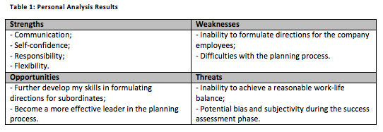
My employment goals and develop a personal action plan/development plan

My professional career pathway is: To Continue University at the moment
What are my current strengths?
My current strengths are to stay calm in a dynamic environment, I am also a positive person and most of the time I find a way out of the problem. I can also say that my strong point is talking, someone's promise that it should be so just agree with me. maybe I see the positive side of things and I succeed in communicating with anyone, I can say that this is my strength.
What are my achievements and areas of success since the beginning of the module/programme.
My successes are the first few of which is Language, improve my language helped me a lot to understand the UK rules of the workplace or the way also how to start where we go wrong in our job application or how to improve our job application. How to have a conversation during a job interview. It also helped me know where to go, what I want to move forward in my life, what my future profession will be.
Now I know what I need exactly for my future.

In what areas do I need to develop?
I want to develop in the field of the vision of the people and I think that I have the talent to fix people to solve their problems to help in one way or another. I also want to develop in the field of learning something long after this course, I realized that man is what is in his mind, I found myself and I know in which direction to develop in the future.

Why is it important to improve in these areas?
Why is it important to improve in these areas?
Since I want to become a leader of a large group of people in our job company, I would like to improve all the lessons on managing and leading people how to solve problems, as well as leading a team in this area in the formation I want to improve.

What further action do I need to take now?

Actions to be taken – things to do, people to see ( give dates)
The next step after I finish this course is to extend my education for another two years until I finish it. I would also like to enroll in an online course in addition which would help me to develop myself in this field which will be my future profession.

My short - medium – long term targets for the development of my own professional career pathway (using Specific, Measurable, Agreed, Realistic, Time-bound –SMART targets)

Short-term plan (3 -6 months) | To enroll in an online people leadership course
Specific | No
Measurable | No
Agreed | Yes
Realistic | 100%
Time-Bound

Medium-term plan (1-2 years) | Continue a education
Specific

Measurable

Agreed

Realistic

Time-Bound

Long-term plan (2-5 years) | To become successful manager
Specific

Agreed

Realistic

Time-Bound

References

Gibbs, G. (1988) Learning by Doing: A guide to teaching and learning methods. Further Education Unit. Oxford Polytechnic: Oxford
https://www.oxford-royale.com/articles/improve-underperforming-grades/ ( accesed: 6th May 2022
https://grammar.yourdictionary.com/style-and-usage/causes-of-poor-writing-and-communication-in-the-workplace.html accesed: 6th May 2022

https://www.ukessays.com/essays/communications/challenges- workplace-communication-3479.php#_Toc392859692 accesed:6th May2022

Appendix A: The questions asked as interviewer in the role play (A1)

Q1 Tall as about yourself?
Q2 Why do you want this job?
Q3 What are your strengths?
Q4What’s your biggest weakness?
Q5 What’s tour ideal work environment ?

Appendix B: Application Form completed as applicant for the role play (A1).

Job application form

Application for [job title] -
Your details

Name: Keti Veselinova

Education and training
Please give details:
Education: secondary education and Beauty Coursess
2000-2018 - 69 Sou Dimitur Marinov
Microblading Eyebrows

Qualifications
Please give details:

-Driver
-Cosmetic
-Eyebrows dasign
-Microblading makeup

Employment history
Your current or most recent employer

Name of employer: Contrackt Candles and Diffusers

Job title: Factory Operative

Length of time with employer: 2 Montht

Reason for leaving: I leave my last job due health issue

Previous employers
Please tell us about other jobs you have done and about the skills you used or learned in those jobs.

I was working manager casino in Germany I got my skills how to manage the people and hoe to create good communication with them.

Supporting statement
Please tell us why you applied for this job and why you think you are the best person for the job.

Right to work in the UK
Do you need a work permit to work in the UK? Yes / No
References
Please give the names and contact details of 2 people who we can ask to give you a reference. We may ask them before an employment offer is made. We will not ask your current employer until we get your permission.
Declaration
I confirm that to the best of my knowledge the information I have provided on this form is correct and I accept that providing deliberately false information could result in my dismissal.

Name: Keti Veselinova

Signature: Keti Veselinova

Date:6th May 2022

