

Name: Elisa Rosell Monares
Student Number: 2510396
Module Code: (LCHS 4010__LON)
Module Title: Psychology in Health and Social Care
Lecturer Name: Brian Mashumba
Assignment title: Component 2. Essay

Table of Contents

1.Introduction
2. Main Body: Social media and adolescent mental health
3. Negative effects of social media
4. Positive effects of social media
5. Psychodynamic Theory: Freud
6. Lifespan Theory: Erikson’s Psychosocial Development
7. Implications for Health and Social Care
8. Conclusion
9. References

Title:

Discuss the Impact of Social Media on Health in Adolescence

Introduction:

Adolescence is an important period of human development, usually related with significant physical, emotional, psychological and social changes. During this period, young people develop their identity, become more independent and place greater importance on friendships and peer partnerships, At the same time, social media has become an important part of everyday life for many adolescences. Platforms such as Instagram’s, TikTok, Snapchat and Facebook allow young people to express, share information’s, express themselves and maintain relationships. However, frequent or problematic media use may also be associated with mental health difficulties, including anxiety, depression, low self-esteem, body-image concerns and sleep problems. Research suggests that the relationship is complex and depends on how social media is used, the type of content viewed and individual characteristics (Orben et al, 2024).
This report discusses the impact of social media on adolescent mental health. It considers both positive and negative effects and explain how comparison, cyberbullying, appearance-related content, social connection and problematic use may influence psychological well-being. The report also submit two developmental perspectives: Freuds Psychodynamic Theory and Erikson’s Lifespan/Psychosocial Theory. These theories provide different ways of understanding adolescent behaviour, emotional development and identify formation. The discussion recognises that social media should not automatically evaluated harmful because its effects differ between individuals and circumstances.
Main Body
Social media and adolescent mental health
Social media refers to online platforms that allow individuals to communicate, create and share content and communicate with other people. Adolescents are particularly active users because social media can provide opportunities for communication, friendship, entertainment, education and self-expression. Therefore, its influence on mental health can be both positive and negative.

A major worried is the association between social media use and internalising symptoms such as depression and anxiety. Fassi et al. (2024) conducted a systematic review and meta-analysis of 143 studies involving more than one million adolescents. Their findings identified positive association between social media use and internalising symptoms, although the strength of these relationships varied. This suggests that social media may be relevant to adolescent mental health but does not prove that social media alone causes mental health problems.
Similarly, a systematic review examining social media and anxiety found that more than half of the included studies reported positive associations, particularly when social media use was measured in terms of problematic use or excessive time spent online (Keles et al, 2025). This is important because the first-rate and pattern of social media use may matter more than simply whether an adolescent uses social media.
Negative effects of social media
One possible negative effect is social comparison. Adolescents may compare their appearance, relationships, achievements and lifestyles with carefully selected images presented by others. Social media often shows idealised versions of people’s lives rather than their complete experiences. This can create unrealistic expectations and feelings of inadequacy. Adolescents who repeatedly compare themselves with others may develop lower self-esteem or dissatisfaction with their appearance.
Body image is particularly relevant because many social media platforms are highly visual. A systematic review of TikTok and adolescent mental health found concerns relating to body image, self-esteem and problematic use, although Tik Tok can also provide opportunities for self-expression and peer connection (Conte et al, 2025). Therefore, the same platform can have different effects depending on the content an adolescent encounter and how they interact with it.
Cyberbullying is another potential risk. Traditional bullying can continue through social media outside school hours, meaning that adolescents may feel that there is no safe space away from negative comments or harassment. Cyberbullying may contribute to emotional distress, anxiety, loneliness and reduce self-esteem. Young people may also experience pressure to respond quickly to messages, maintain online friendships or receive approval through likes and comments.
Problematic social media use can also affect well-being. A systematic review found that problematic social media use was associated with depression, anxiety and poorer well-being, while the relationship between ordinary social media use, and mental health was weaker and more inconsistent (Social Media Use, Mental Health and Sleep, 2024). This distinction is important is because high use does not necessarily mean that every adolescent will experience poor mental health.
Positive effects of social media
Social media can also have positive effects on adolescent mental health. It can help young people maintain friendships, especially when they are geographically separated from friends or have difficulty communicating face-to-face. Online communities can sometimes reduce feelings of isolation by helping young people feel that they belong to a group.
The National Academies of Sciences, Engineering, and Medicine (2024) emphasised that social media has both potential benefits and risks for young people. Therefore, it is more appropriate to consider the quality of online experiences rather than simply treating all social use as harmful. Factors such as the adolescent’s individual characteristics, the content they see, their interactions with others and the design of the platform can all influence outcomes (Orben et al, 2024).
Psychodynamic Theory: Freud
Freud’s Psychodynamic Theory provides one way of understanding human behaviour through unconscious psychological processes and conflicts. Freud proposed that personality consists of three interacting components: the id, ego and superego. The id represents instinctive desires and seeks immediate satisfaction. The superego represents internalised rules, values and morals standards, while the ego attempts to balance the demands of the id, the superego and external reality (Freud, 1905).
Freud’s psychosexual theory proposes several stages of development, including oral, anal, phallic, latency and genital stages. Adolescence. Is associated with the genital stage, during which sexual feelings and relationships become particularly significant. Although Freud’s theory has been criticised for being difficult to test scientifically and for placing considerable emphasis on sexuality, it remains historically important in the development of psychological theory.
Freud’s theory can be applied cautiously to social media use. For example, adolescents may use social to seek approval, attention or acceptance from others. From a psychodynamic perspective, repeated attempts to receive likes, comments or positive responses could be interpreted as relating to underlying emotional needs and desires. However, this should not be regarded as evidence that Freud’s theory directly explains social media behaviour because modern social media environments did not exist when Freud developed his theory.
The psychodynamic perspective can nevertheless encourage professionals to consider that visible online behaviour may be influenced by deeper emotional experiences. For example, an adolescent who frequently seeks reassurance online may be experiencing insecurity or difficulties with self-worth. Understanding the emotional needs behind behaviour may help professionals provide appropriate support rather than simply telling the young person to stop using social media.
Lifespan Theory: Erikson’s Psychosocial Development
Erikson’s theory provides a particularly useful perspective for understanding adolescence because it views development as continuing throughout the lifespan. Erikson proposed eight psychosocial stages, with each stage involving a developmental challenge or crisis. Adolescence is primarily associated with the stage of identity versus role confusion. During this stage, young people different roles, values, beliefs and relationships in an attempt to develop a stable sense of identity (Erikson, 1968).
Social media can become an important environment for identity development Adolescents may experiment with different ways of presenting themselves through photographs, usernames, clothing, interests, opinions and online communities. This can provide opportunities to explore who they are and how they wish others to perceive them.
Erikson’s theory therefore helps explain why social media may have a particularly strong psychological impact during adolescence. Young people are already attempting to answer questions such as ‘’Who am I?’’, ‘’Where do I belong?’ and ‘’How do other people see me?’’ Social media can increase opportunities for exploration but can also increase pressure to present an ideal identity.
OpenStax (2024) explains that Erikson’s identity versus-role -confusion stage involves exploring different identities and roles. Developing a stronger sense of identity can provide stability, whereas difficulties with identity development may provide to feelings of confusions. Social media can therefore become either a supportive environment for identity exploration or a source of pressure and comparison.
For example, an adolescent may follow positive communities that encourage creativity, education on healthy interests. This may strengthen their sense of belonging. In contrast, an adolescent who constantly compares their appearance or achievements with influencers may feel that they do not meet social expectations. This could contribute to low self-esteem or identity confusion.
Erikson’s theory also supports the idea that social development continues beyond adolescence. Identity is not permanently completed at the end of teenage years but can continue to expand and change throughout adulthood (Oxford Research Encyclopaedia of Psychology, 2017). This lifespan perspective is useful because experiences with social media during adolescence may form part of a person’s continuing development of self-concept and relationships.
Implications for health and social care
Health and social care professionals have an important role in supporting adolescents to use social media safely. Professionals should avoid assuming that all social media use is harmful. Instead, they should consider the adolescents individual circumstances, emotional well-being, online experiences and patterns of use.
Professionals can encourage adolescents to develop healthy digital habits, maintain offline relationships, obtain adequate sleep and seek help when online experiences become distressing. Parents and carers can also be encouraged to communicate openly with young people about social media rather than relying only on strict restrictions.
Schools and health services can provide education about cyberbullying, social comparison, privacy, misinformation and healthy online behaviour. If an adolescent shows persistent symptoms of anxiety, depression, withdrawal or significant changes in behaviour, appropriate mental health support should be considered.
The evidence also recommends that responsibility should not rest entirely with young people. Orben et al. (2024) argue that platform design and wider social factors are important in understanding risks. Consequently, safer platform design, appropriate regulation, digital accessible mental health services are all relevant to protecting adolescent well-being

Conclusion
In conclusion, social media has a complex relationship with adolescent mental health. It can provide opportunities for communication, friendship, self-expression, creativity and social support, but problematic use and negative online experiences may be associated with anxiety, depression, low self-esteem, body image concerns and poorer well-being. Current research does not support a simple conclusion that social media is always harmful. Instead, the impact depends on the individual adolescent, how social media is used, the content encountered and the social environment.
Freud’s Psychodynamic Theory provides a perspective for considering unconscious emotional needs, desires and conflicts that may influence behaviour, although its application to modern social media should be treated cautiously. Erikson’s Lifespan/Psychosocial Theory is particularly relevant because adolescence involves the important developmental challenge of identity exploration, belonging and self-expression while also creating pressures associated with comparison and social approval.
Overall, health and social care professionals should promote balanced and informed social media use rather than simply encouraging adolescents to avoid social media. Supporting healthy relationships, emotional resilience, digital literacy and positive identity development can help adolescents gain the benefits of social media while reducing potential risks to their mental health.
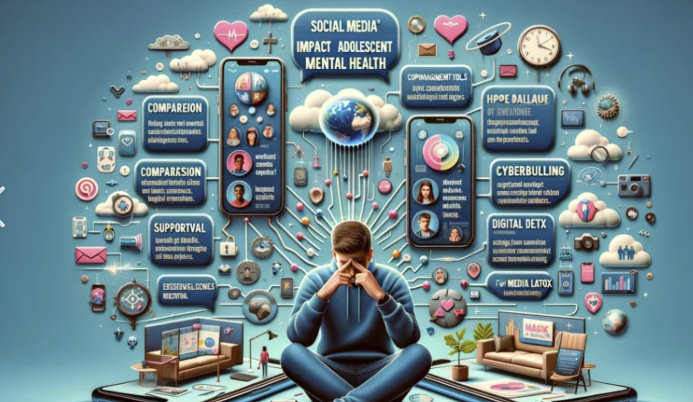

References

Conte, G, Di lorio, G, Esposito, Romano, S, Panvino , F.,Maggi,S.,Atomonte,B.,Casini, M.P., Ferrara, M. and Terrinoni, A. (2025) ‘Scrolling through adolescence: a systematic review of the impact of Tk Tok on adolescent mental health’, European Child &Adolescent Psychiatry, 34, pp.1511-1527. Available at: -Springer Nature (Accessed: 14 August 2026).
Erikson, E.H. (1968) Identity: Youth and Crisis. New York: W.W. Norton.
Fassi, l,. Thomas, K., Parry, D.A,. Leyland -Craggs, A., Ford, T.J. and Orben, A, (2024) ‘Social Media Use and Internalising Symptoms in Clinical and Community Adolescent Samples: A Systematic Review and Meta Analysis’, JAMA Paediatrics (Accessed: 14 August 2026).
Freud, S. (1905) Three Essays on the Theory of sexuality. Leipzig and Viena: Franz Deuticke.
Jungselius, B. (2024) ‘ A scoping review of current research on social media use among children and adolescents’, Discover Psychology, 4, Article 116. Available at: Springer Nature (Accessed: 14 August 2026).
Keles, B., McCrae, N. and Grealish, A. (2025) ‘Associations Between Social Media use and Anxiety Among Adolescents: A Systematic Review Study’, Journal of Adolescent Health, 76 (1), pp. 18-28. Available at: ScienceDirect (Accessed: 14 August 2026).
National Academics of Science, Engineering, and Medicine (2024) ‘Social media and adolescent mental health: A consensus report’, PNAS Nexus, 3(2). Available at: PNAS Nexus (Accessed: 14 August 2026)
Orben, A,.Meir,.A,.Dalgleish,. T. and Blakemore,-J. (2024) ‘Mechanisms linking social media use to adolescent mental health vulnerability’,. Nurture Reviews Psychology,3,pp.407-423.Available at: Nature Reviews Psychology (Accessed: 14 August 2026).
OpenStax (2024) ‘Theories of adolescent socioemotional development’, in Lifespan Development. Available at: OpenStax Lifespan Development (Accessed 14 August 2026).
‘Social media use., mental health and sleep: A systematic review with meta-analyses’ (2024), Journal of Affective Disorders, 367, pp. 701-712. Available at: ScienceDirect (Accessed 14 August 2026).

