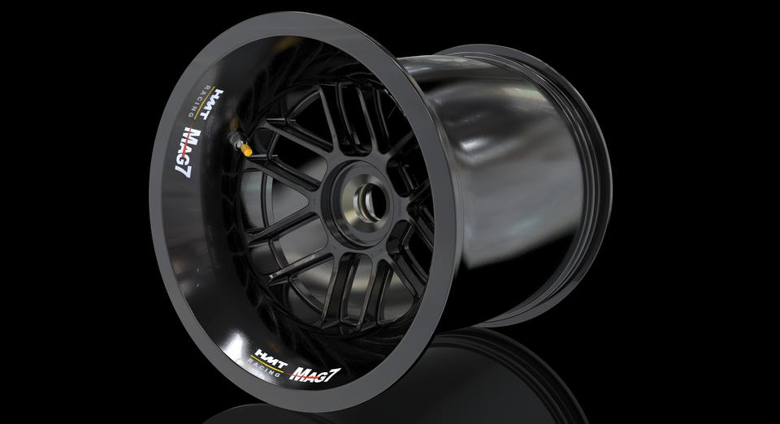

Analysis and Recommendations for the Minimization of Material Failures
  - Mechanisms of Material Failure
Milo Ward | ACEA7010 | 12/01/21
Contents
Table of Figures 1
Table of Tables 2
Introduction 2
History and Development 2
Principles of the Material and Part 4
Hot Rolling 5
Failure Analysis Hot Rolling Wheel Failure 5
MicroStructural Study 6
Scanning Electron Microscopy 6
Hardness Survey 7
Universal Testing Machine 7
Conclusion on Failure Report 8
Magnesium Alloy 8
Conclusion 10
References 11

Table of Figures
Figure 1 Model T Wooden Spokes (Ford Model T | Under the Hollywood Sign, n.d.) 3
Figure 2 Alloy wheel on CNC Machine ((236) Axis CNC machining car wheels - YouTube, n.d.) 5
Figure 3 Process of Hot Forming Steel Wheels (Bhattacharyya et al., 2008) 5
Figure 4 Cross Section of weld on the two sections of wheel (Bhattacharyya et al., 2008) 6
Figure 5 Fractograph of the wheel rim crack (Bhattacharyya et al., 2008) 7
Figure 6 Hardness Variation throughout the weld and necking 7
Figure 7 Failure of the wheel along the weld line 8
Figure 8 Magnesium Motorcycle Wheel Failure (Wheel Failure - 2011 WSBK Donington | South Bay Riders, n.d.) 10

Table of Tables
Table 1 Output data from UTM 8
Table 2 Properties of AZ80 Magnesium (Magnesium AZ80 Alloy (UNS M11800), n.d.) 9

Introduction
The following report will investigate analysis and recommendations for the minimization of material failures of alloy and magnesium wheels for automotive use. Briefly looking at the history and development of automotive wheels, why the development went the way that is used now. Then progressing further onto the materials and production of the wheels and the effect this has on the strength of the wheel. Furthermore, looking at previous reports that have investigated the failure of the wheels, what caused the failure and possible ways that the design or processed could be changed to prevent a failure occurring again.

History and Development
The wheels on a car are one of the most important aspects, not just for the aesthetics, but for the fuel economy and the handling of the vehicle. Due to the wheels being part of the unsprung mass and rotational, they are one of the most crucial parts of the vehicle. The lower the weight of the wheel, the less mass that must be rotated which in turn improves the handling and acceleration of the vehicle.(Czypionka & Kienhöfer, 2019)
However, a wheel cannot be made to the lightest specification, especially on a road vehicle due to conditions that the wheel would be under, from taking large forces due to potholes or bumps in the road and the lateral load that the wheel would be under while turning. Before going into development, alloy wheels are put through vigorous testing, completing over 300,000KM of various road and weather conditions, including extreme cold weather and extreme potholes to make sure the designs are sufficient for road use.(Alloy Wheels - Genuine Ford Accessories | Ford UK, n.d.)
The very first automobiles on the road started by taking wheel design inspiration from horse drawn carriages, using spokes under tension to hold the hub to the rim, often seen on bicycles still today. (History of the Wheel - autoevolution, n.d.) The Ford Model T for example, first used a wooden wheel with tires wrapped around the outside to keep production cost down. However, this was changed to steel welded spoked wheels quickly after going into production due to the wooden wheels being prone to failure on the rough road surfaces of the time.
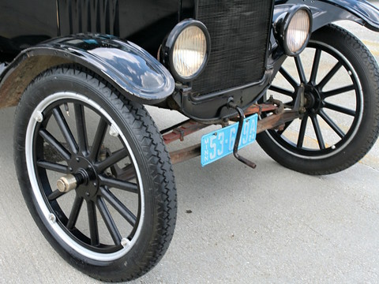
Figure 1 Model T Wooden Spokes (Ford Model T | Under the Hollywood Sign, n.d.)
As the development progressed forward, in the mid-1920s stamped steel disks were becoming common on vehicles. This required stamping out the internal part of wheel out of sheet metal, this was then welded or riveted to the rim. This design allowed mass production as the parts could be manufactured faster and cheaper than the time-consuming spoked method. This design also had the added benefit of the extra strength in the wheel to deal with uneven road surfaces when compared to spoked wheels which could come lose or bend. (History of the Automotive Wheel |, n.d.)c vd
Until the 1960’s, the most common design was a mixture of the stamped steel disks wheels and the steel spokes laced to a center hub. However, with technological improvements in aluminum casting allowed for mass production wheels to take a step forward. (The Three Most Significant Advances in Alloy Metallurgy Since Federation ( 1901 ) – An Australian Perspective, n.d.) (Casting aluminum and magnesium had been previously used to produce wheels for racing or land speed record attempts but these were much too costly for mass production.) With the production of aluminum becoming more prominent, this allowed the metal to be poured into steel molds while it was in a molten state and solidify without causing porosities in the cooling metal like it had done before. Add to this, new cooling and heat treatments that increase the molecular strength of the material, suddenly cast aluminum created the perfect wheel. Lighter than steel and reducing the rolling inertia while being strong enough to withstand the forces that the wheel would be put through while in use.
With technology always improving, in the last couple of decades different materials have been seen on high end production cars, such as Koenigsegg’s carbon fiber wheels (The Koenigsegg Carbon Fiber Wheel is So Light You Can Throw It Around | Carbon Fiber Gear, n.d.) and forged magnesium being introduced into hyper cars. Due to decrease in weight and increase in strength when compared to aluminum, allowing for better handling while still being able to deal with uneven road surfaces. Although, this improvement comes at an increase in cost with the carbon fiber wheels costing $50,000 per set.(Would You Spend $50,000 On A Set Of Koenigsegg Wheels? | CarBuzz, n.d.)

Principles of the Material and Part
To produce a wheel with the correct properties, the material and production of the wheel play a crucial role in producing these properties. (The Strength Difference Between Cast, Flow Formed and Forged Wheels, n.d.)The method that produces the strongest wheels is forging, however this does come at a larger cost that other methods.
The first step in forging a wheel is a cold forged stamping process, this works by using stamping the aluminum in between steel dyes, using immense pressure to force the aluminum to compress into the shape of the die and causing a compressed grain structure.
Once this step has been completed, the wheel is spun forged, this takes the barrel that had been compressed in the first step. Then hydraulic rollers are used to create the lips and adjusting the width of the barrel to the desired size and shape. This compacts the grain structure further and increases the strength of the wheel.(How forged wheels is made (by PPE), n.d.)
The next step is to heat treat the material, this will reinstate the structural integrity of the material and by heating the material. By heating the material between 400-600 degree Celsius, this stabilizes the molecular pressure inside the material. If the material was heated to the melting point, the properties such as tensile strength, ductility and fracture toughness may be affected and be sufficiently less than needed.(Heat Treating of Aluminum Alloys, 1991)
The final step for heat treatment is to quench the material, by cooling the material to almost room temperature. This locks in the molecular pressure change that occurred when the material is heat treated in the previous step. Rapid quenching of the aluminum can also reduce the corrosive properties of the material which is a crucial property of alloy wheels to increase the longevity of its life and reduction of failures. One issue that can occur when heat treating the material is the different thicknesses of the piece cooling at different rates. These processes are also known as artificial ageing. (Machining and heat treatment - OZ Racing, n.d.)
The final step in producing the aluminum wheels is the heat-treated blanks are placed into five axis cnc machines and the designed face for the wheel is applied before being finished by head to remove sharp edges and unwanted material.

Figure 2 Alloy wheel on CNC Machine ((236) Axis CNC machining car wheels - YouTube, n.d.)

Hot Rolling
Hot rolling is a technique that is used when producing steel wheels rather than alloy wheels that could use the forging method above. Hot rolling steel produces an extremely strong wheel at a low cost but with an increase in weight compared to forged.
The process of hot rolling is by heating the metal sheets, they are then fed through various rollers which manipulate the metal into the desired shape. Normally two separate sides are produced through the steam rollers, these sides are then flash butt welded together, followed by a press being used to produce the final lips on the wheels. (Bhattacharyya et al., 2008)
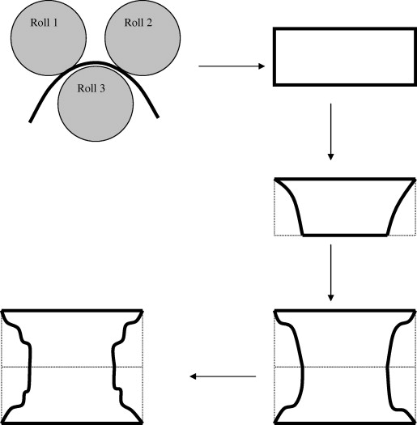
Figure 3 Process of Hot Forming Steel Wheels (Bhattacharyya et al., 2008)

Failure Analysis Hot Rolling Wheel Failure
Figure 3 was taken from a report that was analyzing the formation of cracks that can occur in the production of hot rolling steel wheels. The failure that was observed was cracking along the weld line that was used to weld the two hot rolled parts together. Five wheels that the failure had occurred in were analyzed to produce more reliable data.
When welding material together, extreme heat is put into the surrounding metal as the filler material is being laid down, with the extreme heat, this also thins the material around the weld as the material blends into the filler material to form the weld, this process is also known as thinning. It was noted in this study that the fracturs were occurring in the necking that is occurring at a 45 degrees angle. This occurred in all the wheel specimens that were chosen.

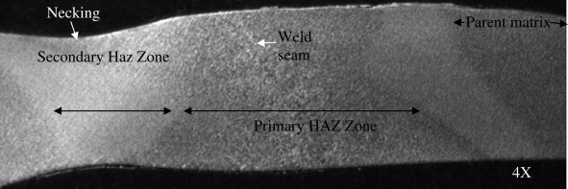
Figure 4 Cross Section of weld on the two sections of wheel (Bhattacharyya et al., 2008)
The thinning in this study, reduces the thickness of the material around the necking, from 11mm to 6mm thick. It is at this point that the wheel is most prone to fractures.

MicroStructural Study
Furthering analysis was completed on the specimens, with a microstructural study being completed on the various wheels. It was seen that Widmanstatten ferrite matrix, this is a crystallized structure that is in a geometrical pattern, this can be seen at the weld location.

Scanning Electron Microscopy
The failures were then analyzed using a scanning electron microscope technique, after being ultrasonically cleaned. This study reported that using this method there was no sign of blowhole or inclusions in the weld, furthermore, it was seen that the steel was free from making or casting methods. Therefore, it was deduced it was the mechanical properties of strip weld that was used to weld both parts together.
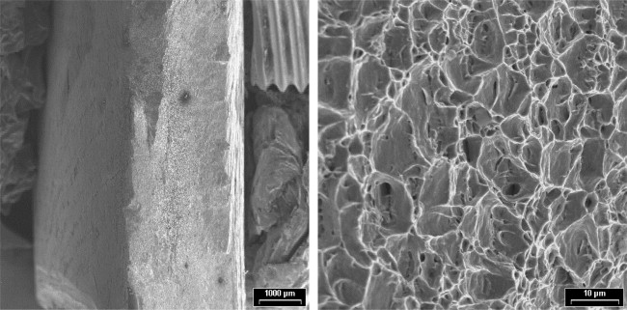
Figure 5 Fractograph of the wheel rim crack (Bhattacharyya et al., 2008)

Hardness Survey
A hardness survey was completed on the weld and the surrounding area, these were measured using the ‘HV’ scale and the Vickers hardness testing machine using a load of 30kilograms across the weld on the rim.
The highest hardness rating was 245HV on the weld, on the necking of the weld it dropped to as low as 45HV. This shows that the hardness level significantly drops off from the weld to the necking area next to the world. Suggesting, that at the necking the material is drastically weaker than at the weld.
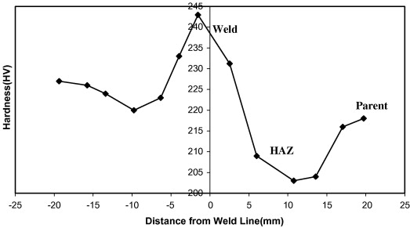
Figure 6 Hardness Variation throughout the weld and necking

Universal Testing Machine
The next analysis stage was to look at the physical properties, due to the processes that the metal has gone through to form the wheel, such as the rolling and welding, this has changed the properties of the material at various sections. Using a 100-ton universal testing machine (UTM) the yield strength, ultimate tensile strength and the elongation can be calculated.
Sample | YS(MPa) | UTS (MPa) | % Elongation
Input HR for failed rim | 336 | 405 | 36
Input HR for good rim | 284 | 370 | 36
Input HR for good rim | 296 | 372 | 38
Table 1 Output data from UTM
From this data, it can be calculated that the yield ratio for the failed rim was 0.81, which is higher than the yield ratio of 0.71 of the wheels that have not failed. It can be seen in the data, that the UTS and the YS for the failed rim is considerably higher than the rims that did not break.

Conclusion on Failure Report
From the above analysis, the bending of the material resulted in an increase in stress around that area. With the increase in the UTS and yield strength of the material around the weld, the piece becomes vulnerable to crack at the necking point. Then, when put under load, the failure can occur. This failure could be presented by making changes to the process that would results in a lower UTS and yield strength of the parts and around the weld that joins the two pieces.
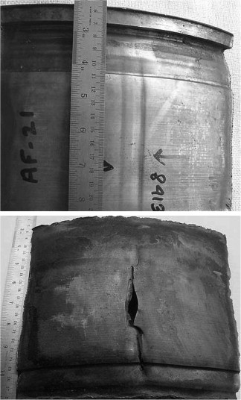
Figure 7 Failure of the wheel along the weld line

Magnesium Alloy
In terms of racing, lighter materials are often used due to cost saving not being as large as an issue when compared to mass production of vehicles. It can also be assumed that the road surface on a racetrack will have considerably less potholes than those that can be found on the public roads. Therefore, the properties that are wanted from the material is suddenly very different.
There are various types of magnesium alloy, the following research was conducted on AZ70 and AZ80 magnesium, one of the strongest but most expensive magnesium alloys there is. The properties of magnesium are:

Properties | Metric | Imperial
Tensile strength | 380 MPa | 55100 psi
Yield strength (strain 0.200%) | 275 MPa | 39900 psi
Shear strength | 165 MPa | 23900 psi
Compressive yield strength (at 0.2% offset) | 240 MPa | 34800 psi
Shear modulus (typical for steel) | 17 GPa | 2470 ksi
Elastic modulus | 44.8 GPa | 6498 ksi
Poisson's ratio | 0.35 | 0.35
Elongation at break (in 50 mm) | 7% | 7%
Hardness, Brinell (500 kg load, 10 mm ball) | 82 | 82
Hardness, Knoop (estimated from Brinell) | 106 | 106
Hardness, Rockwell A (estimated from Brinell) | 35 | 35
Hardness, Rockwell B (estimated from Brinell) | 50 | 50
Hardness, Vickers (estimated from Brinell) | 93 | 93
Machinability (relative rating, 100 best) | 100 | 100
Table 2 Properties of AZ80 Magnesium (Magnesium AZ80 Alloy (UNS M11800), n.d.)
One flaw that magnesium does have that is crucial to the life of a wheel is corrosion, with untreated magnesium being prone to corrosion. With a wheel often being used in a variety of weather conditions, a coating is needed to aid in rectifying this situation. The coating that is often used is ‘Electroless Nickel Plating,’ this is done by submerging the wheel in a predetermined chemical bath. (Protecting magnesium components from corrosion and wear, n.d.) Although the wheel is not under the same loads as a mass production wheel with hitting potholes, however there is the consistent running over kerbing throughout the track.
The fatigue life of the wheel is the major consideration in racing and there are multiple factors that affect the fatigue life of the magnesium wheel. The first factor is stress concentration, this could occur when the wheel is being forged if a minor defect or flaw can not sustain the same stress that the undamaged part could. To reduce the chance of a part with a defect making it into use, the parts are often using shot peening to reduces these edges. Often in the design of the piece, sharp edges are reduced and unnecessary procedures in the production stage is reduced. (Fang, 2009)
Another factor is the applied load, this is the number of cycles to failure when the applied load increases. When designing the part, this is a crucial area to design the part for, making sure the load will not exceed the fatigue life of the wheel. This is affected by the composition of the magnesium that is used, if a higher percentage of manganese is used, this would increase the strength and hardness of the alloy would increase, but this comes at a decrease in ductility and impact resistance. (Salihu et al., n.d.)
The forging process that was the described at the beginning of the report is a crucial step in producing a wheel that would minimize the risk of failure. If the magnesium alloy wheel were cast, there would be the chance of porosity in the wheel, whereas when the magnesium alloy is forged, the molecules are compressed, closing gaps that may have occurred when creating the block.
After this the magnesium block is machines into the desired shaped of the wheel, the CNC machine cuts out the shape that is needed and trims off excess material on the wheel.
Furthermore, a forged magnesium wheel goes through similar heat treatment processes stated earlier in the report. This allows the compressed molecules to stabilize so that the strength is kept in the wheel.

Conclusion
Avoiding a catastrophic failure in a wheel is crucial in both mass production steel/aluminum wheels to high-cost magnesium alloy racing wheels. If money is no object, then magnesium alloy and the cold forging process, this will produce the highest quality wheels, achieving the lightest wheels which increases the performance of the vehicle by increasing the fuel economy, acceleration, and the handling of the vehicle. For racing application, this would be the best wheel design to have, hence why it can be seen in Formula One. Although, this decreases in weight and increase in strength does come at an increase in cost, it does also come with the chance of a catastrophic failure. Due to the increase in hardness and reduction in ductility, if a crack were to occur and reach a critical point, a failure could occur, and the wheel could collapse.
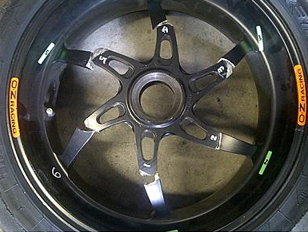
Figure 8 Magnesium Motorcycle Wheel Failure (Wheel Failure - 2011 WSBK Donington | South Bay Riders, n.d.)
For mass production, casting aluminum will produces the best wheels for the best price, although there is a chance of porosity, at the correct temperature and the correct tooling there should be a minimal chance for this to occur. Although heavier than magnesium, with the reduction in cost, for a mass-produced performance car this is the best compromise for handling and performance, cost, and ability to deal with changing road surfaces that may cause large impacts and loads on the wheels.
In terms of performance, the hot rolled steel is most prone to a failure, this is due to the welding and the inconsistency this can cause in the surrounding material. However, if produced correctly, the wheel does provide a cheap, mass production and high strength wheel. Perfect for high production rates and everyday use that can take abuse up to a certain point. However, as seen in the report above, the production method does play a crucial part in reducing the risk of a failure.

References
(236) Axis CNC machining car wheels - YouTube. (n.d.). Retrieved January 8, 2021, from https://www.youtube.com/watch?v=r38CJD56zk8&ab_channel=ZhuJake
Alloy Wheels - Genuine Ford Accessories | Ford UK. (n.d.). Retrieved January 7, 2021, from https://www.ford.co.uk/shop/add-ons/accessories/car/ford-alloy-wheels
Bhattacharyya, S., Adhikary, M., Das, M. B., & Sarkar, S. (2008). Failure analysis of cracking in wheel rims - material and manufacturing aspects. Engineering Failure Analysis, 15(5), 547–554. https://doi.org/10.1016/j.engfailanal.2007.04.007
Czypionka, S., & Kienhöfer, F. (2019). Weight reduction of a carbon fiber composite wheel. Science and Engineering of Composite Materials, 26(1), 338–346. https://doi.org/10.1515/secm-2019-0018
Fang. (2009). Understanding the microstructure and fatigue behavior of magnesium alloys. University of Leicester. /articles/thesis/Understanding_the_microstructure_and_fatigue_behavior_of_magnesium_alloys/10098458/1
Ford Model T | Under the Hollywood Sign. (n.d.). Retrieved January 7, 2021, from https://underthehollywoodsign.wordpress.com/tag/ford-model-t/
Heat Treating of Aluminum Alloys. (1991). https://doi.org/10.1361/asmhba0001205
History of the Automotive Wheel |. (n.d.). Retrieved January 7, 2021, from https://thewheelsmith.net/history-of-the-automotive-wheel
History of the Wheel - autoevolution. (n.d.). Retrieved January 7, 2021, from https://www.autoevolution.com/news/history-of-the-wheel-7334.html
How forged wheels is made (by PPE). (n.d.). Retrieved January 8, 2021, from http://www.propioneer.co/wheels-how-its-made
Machining and heat treatment - OZ Racing. (n.d.). Retrieved January 8, 2021, from https://www.ozracing.com/world-of-oz/technology/production/669-machining-and-heat-treatment
Magnesium AZ80 Alloy (UNS M11800). (n.d.). Retrieved January 10, 2021, from https://www.azom.com/article.aspx?ArticleID=6709
Protecting magnesium components from corrosion and wear. (n.d.). Retrieved January 10, 2021, from https://blog.keronite.com/protecting-magnesium-components-from-corrosion-and-wear
Salihu, S. A., Isah, A., & Evarastics, P. (n.d.). Influence of Magnesium Addition on Mechanical Properties and Microstructure of Al-Cu-Mg Alloy. In IOSR Journal of Pharmacy and Biological Sciences (IOSR-JPBS (Vol. 4, Issue 5). Retrieved January 10, 2021, from www.iosrjournals.orgwww.iosrjournals.org
The Koenigsegg Carbon Fiber Wheel is So Light You Can Throw It Around | Carbon Fiber Gear. (n.d.). Retrieved January 7, 2021, from https://blog.carbonfibergear.com/the-koenigsegg-carbon-fiber-wheel-is-so-light-you-can-throw-it-around/
The Strength Difference Between Cast, Flow Formed and Forged Wheels. (n.d.). Retrieved January 8, 2021, from https://www.turnology.com/tech-stories/the-strength-difference-between-cast-flow-formed-and-forged-wheels/
The Three Most Significant Advances in Alloy Metallurgy Since Federation ( 1901 ) – An Australian Perspective. (n.d.). Retrieved January 7, 2021, from https://www.azom.com/article.aspx?ArticleID=2124
Wheel Failure - 2011 WSBK Donington | South Bay Riders. (n.d.). Retrieved January 10, 2021, from https://www.southbayriders.com/forums/threads/107638/
Would You Spend $50,000 On A Set Of Koenigsegg Wheels? | CarBuzz. (n.d.). Retrieved January 7, 2021, from https://carbuzz.com/news/would-you-spend-50-000-on-a-set-of-koenigsegg-wheels

