Name | Student Number | Date | Lecturer’s Name | Your score
Aurora Tecaru | 2440082 | 30/06/2025 | Ellie Ristic | To be filled by the marker  ___/40
You will have 90 minutes to complete this assessment. It is divided into three sections: note-taking, paraphrasing and writing a paragraph.
---------------------------------------------------------------------------------------------------------------------
1. Take diagrammatic notes from the passage below using the space provided:

The university experience is not just about subject knowledge, but also about developing skills that will equip you for your future life. For starters, it's impossible to graduate without a range of people skills under your belt. You'll meet new people from different backgrounds. You'll also interact with lecturers, tutors and university staff almost daily. Another life lesson that university teaches you is taking responsibility for yourself, your own schedule and learning. A lot of university study is self-directed - it's up to you to plan and organise your work, juggle multiple projects and manage deadlines – you will need to develop self-motivation if you want to succeed. Let’s not forget learning how to overcome obstacles; whether academic, work-related or personal, you'll face your fair share of hurdles as a student, but you will develop resourcefulness and resilience in the process. If you were a bit unorganised before you went to university, you won't be by the time you leave. To successfully navigate student life you'll need to handle a variety of study, work, social and personal commitments and the only way to do this is with organisation and time management. Finally, university provides plenty of opportunities to work on and boost your confidence: you'll work in groups, deliver presentations, complete assessments and maybe even become a class representative.
Adapted from: https://www.prospects.ac.uk/applying-for-university/university-life/7-life-skills-youll-learn-at-university

Space for your notes (max 12 marks):

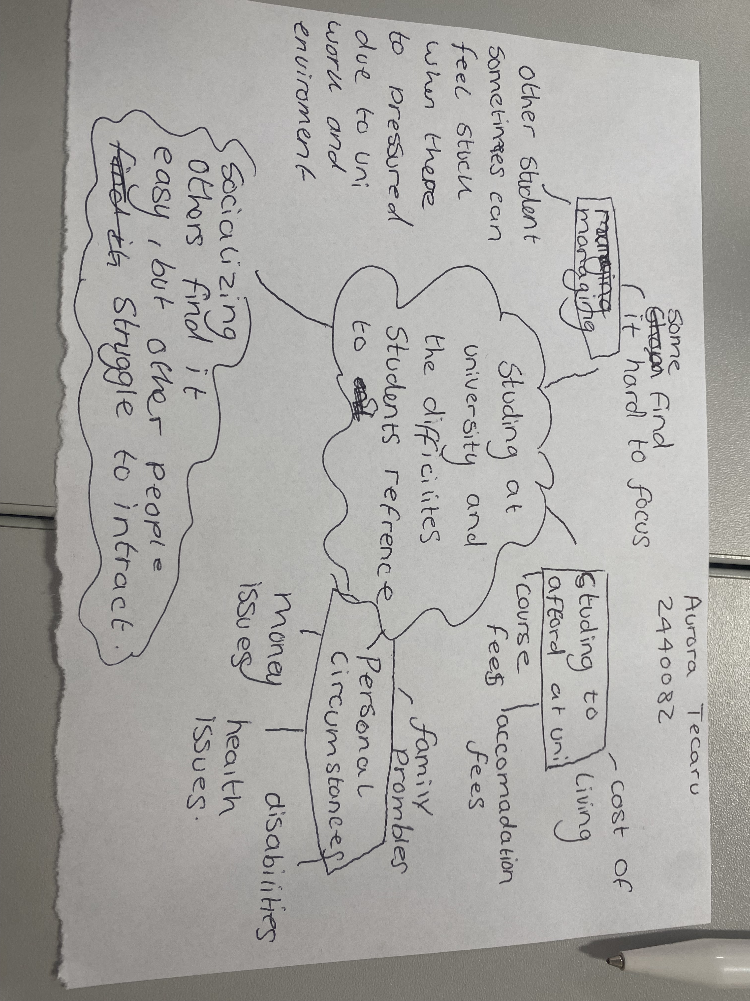

2. Paraphrase the following sentences (max 3 marks for each, max 12 marks in total):

- To successfully navigate student life you will need to handle a variety commitments.

To successfully manage a good student life you would need to accomplish many commitments for examples being on time for you’re classes being on good behaviour ,completing all your assessments and work because you ned to stay on track so when you finish uni so you get good grades and can move up to start a new level a new year on learning and socializing with teachers,friends and others around you.
- You will need to develop self-motivation if you want to succeed at university.

You need to develop self-motivation when you are at you uni because self motivation is the best power a person can have in life motivating yourself gives you the learning to motivate to do many things yourself when others can or not help, because at uni everything depends on person who is doing their courses and assessments so they succeed in life and have better learning experience .
- Many students find it challenging to manage stress during assessment periods.

Assessment can be very stressful and challenging because some others don’t revise before there assessment and don’t pay attention when in class so that’s why they struggle and find it stressful because their not prepared and organised when there are assessments ,so therefore you should always be prepared and organised so you know what’s coming.

- Frequent reading can help you become a more effective communicator.

Reading can help you communicate better because you learning as you are reading and understanding and communication is the key in uni helps you when you need something also you interact with friends,family,teachers and others talking more makes you more confident and builds that up for you.

e

3. Write a well-structured paragraph (8 sentences) on the following topic:

Effective time management techniques for university students

Your paragraph must be written in full sentences (no bullet points) and in an academic style.

(max 16 marks in total)

The best time management techniques is always being on time for classes ,but you need to be organised and prepared. Many students who are coming from abroad find it a struggle because their studying in uk. Maybe they don’t understand English and find it hard to corporate and understands teachers and students around them. They can’t focus to learn because they find it a struggle and stressful that’s why the uni should always give the best support for others that are coming abroad .Being on time is key because you need a much time when you are studying. You’re brain has to have the time to processes everything at once . When you are learning or doing assessments you brain is prepared what to expert and you don’t have to stress and struggle because you don’t know what to do.Therefore time is key to evething arounds it shows respect to yourself and others that you care and understand.

