
APPENDIX GA36c

LEVEL 6 ASSESSMENT SPECIFICATION

 | Student name: | Morgan Lloyd | Student ID number: | 296463
 | Programme: | Applied Computing
 | Module: | Data Warehousing and Data Mining
 | Module code: | ACCA6026 | Contribution to Overall Module Assessment (%): | 50%
 | Lecturer: | John Williams | Internal Verifier: | Bev Holland
 | Assignment Title: | Data Warehousing | Word count (or equivalent): | 3000
 | Submission deadline: | 28th January 2022 | Return date of provisional marks & written feedback: | 25th February 2022
 | Submission method: | All written assessments, where practical and possible, must be submitted via Turnitin unless otherwise instructed by the Lecturer. (Please DO NOT put this assessment specification into Turnitin or it will match many similarities with other students’ submissions.)  Alternative submission method (if applicable):  Late submission of the assessment will result in a late penalty mark. Penalties for late submission: Up to one week late, maximum mark of 40%. Over one week late, 0%. Only the Extenuating Circumstances Panel may approve a change to submission dates.
 | Academic honesty / referencing: | Academic honesty is required. In the main body of your submission you must give credit to authors on whose research and ideas your work is based. Append to your submission a reference list that indicates the books, articles, etc. that you have used, cited or quoted in order to complete this assessment.
Module Learning Outcomes (from module syllabus)
Upon the successful completion of this module, the student should be able to:
- Analyse critically the structure, capabilities and role of a data warehouse within a modern business environment.
- Select and perform appropriate data analysis and reporting on data within a data warehouse environment and critically evaluate the results
- Provide business intelligence through the creative application of appropriate data mining processes and the critical evaluation of their results.

STUDENT FEEDBACK FORM

This section details the extent to which the assessment criteria are demonstrated by you, which in turn determines your mark. The marks available for each category of skill are shown. Lecturers will use the space provided to comment on the achievement of the task(s), including those areas in which you have performed well and areas that would benefit from development/improvement.

Generic Assessment Criteria | Marks  available | Marks  awarded
1. Engagement with Literature Skills
.
Sections 1, 4  Engagement with an extensive range of relevant and credible literature, informed by the latest research. Consistently accurate application of referencing. | 10 | 7.5
2. Knowledge and Understanding Skills

Sections 2, 3  Coherent and detailed knowledge and systematic understanding of the principles and theories of current research and scholarship. Clear awareness of challenges to established views. | 15 | 11
3. Cognitive and Intellectual Skills

Sections 3.5  excellent critical thinking, analysis, synthesis and evaluation based on selected evidence. Ability to investigate information and make strong, persuasive, arguments and good judgements. Evidence of independent thought and ability to ‘see beyond the question’. | 25 | 18.5
4. Practical Application Skills

Section 3, 4  High levels of application and deployment skills, drawing skilfully on the latest research within the discipline. Can identify complex problems and propose sophisticated solutions. Assimilation and development of cutting edge processes and techniques. | 35 | 27
5. Transferable Skills for Life and Professional Practice

Sections 5, 6  Can communicate well, confidently and consistently in a suitable format. Work is coherent, fluent, well-structured and organised however missing grade page. Demonstrates very good graduate employment skills. | 15 | 10

Assessment Mark (Assessment marks are subject to ratification at the Exam Board. These comments and marks are to give feedback on module work and are for guidance only until they are confirmed. ) | Late Submission Penalties (tick if appropriate) |  | 74%

Data Warehousing & Data Mining – Assignment 2



Student Name: Morgan Lloyd
Student Number: 296463
Contents
1. Data Mining – Application 3
2. Data set 4
3. Analysis 5
3.1 Linear Regression & One-R 6
3.2 J48 13
3.3 K Nearest Neighbour (KNN) 15
3.4 Logistic Regression 19
4. Business Recommendations 20
5. Reflection 21
References 22

- Data Mining – Application

Due to the increasing rate of technology the generation and storage of data have risen. Businesses, governments and organisations need to make sense of this large quantity of data to help make decisions. This is achieved through data mining. Data mining is the extraction of useful patterns or knowledge from large data sources such as data warehouses to explain a phenomenon to aid business decisions. Below figure 1 shows the process of data mining. [1]
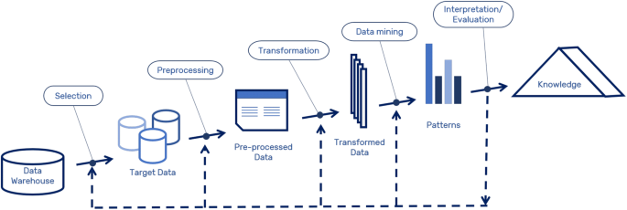
Figure 1 – [2]

Data mining utilises techniques from statistics and machine learning to ‘mine’ the data for knowledge. According to Kamber, these techniques and models can be classified into two categories:

- Descriptive – Clustering, summarisation and association rules.
- Predictive – Classification, regression and time series.[1]

Predictive mining techniques use historical data to make predictions about unidentified values. Whereas descriptive mining identifies patterns on a current data set.[3] Predictive mining is commonly used in fraud detection. The Irish tax and customs authority used predictive mining to develop business intelligence tools to allow them to detect fraud in real-time. [4] Descriptive methods such as clustering are commonly used in electronic commerce to identify customers most likely to purchase or to tailor recommendations for them as shown in case study research by Rezaian. [5]

- Data set

The blood data has 748 instances with five attributes and zero missing instances. The five attributes are all numeric apart from the donation value which is a nominal value. Below is a table detailing the attributes in the data set:

Attribute Name | Type | Description | Example
Recency | Numeric | Months since last donation | 12 – Twelve months since last donation
Frequency | Numeric | Total number of donations | 3 – Donated three times
Monetary | Numeric | Total blood donated in c.c. | 1250 – The amount donated in c.c.
Time | Numeric | Months since first donation | 2 – Two months since first donation
Donated | Nominal | Nominal value for showing if someone has donated | 2 – Donated  1 – Not donated

To familiarise myself with the data I loaded it into Weka and used the pre-processing tab and the visualise boundary tools to determine the relationships of the data. Below in figure 2 shows the distribution of donations against frequency and recency in the boundary visualiser.
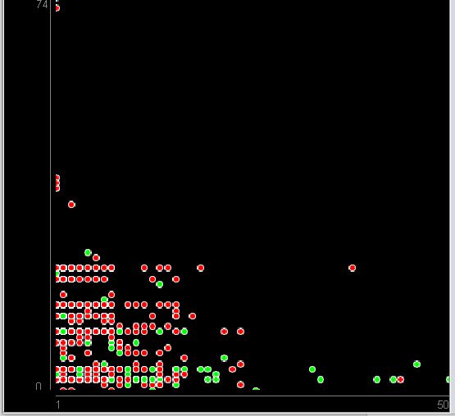

Figure 2

From the pre-processing tab further characteristics of then numeric attributes were obtained as shown in the table below:

Attribute Name | Minimum | Maximum | Mean | Standard Deviation | Distinct
Recency | 0 | 74 | 9.507 | 8.095 | 31
Frequency | 1 | 50 | 5.515 | 5.839 | 33
Monetary | 250 | 12500 | 1378.676 | 1459.827 | 33
Time | 2 | 98 | 34.282 | 24.377 | 78

The monetary attribute is much larger in size and will perhaps have to be normalised for analysis to work well on some algorithms.

- Analysis

Below I will be analysing the data set discussed in section 2. This section will cover pre-processing and post-processing of the data for selected analysis methods. The analysis methods selected include:
- Linear regression
- J48 decision tree
- Nearest neighbours
- Logistic regression

  - Linear Regression & One-R

Linear regression is used to find out the linear relationship between an input variable and a dependent output variable.[6] In Weka, we can save this relationship model and use it to predict future numeric outputs. However, due to the data set using multiple input variables, I used a multiple linear regression model to predict if someone will donate blood. Figure 3 shows a simple linear regression relationship.
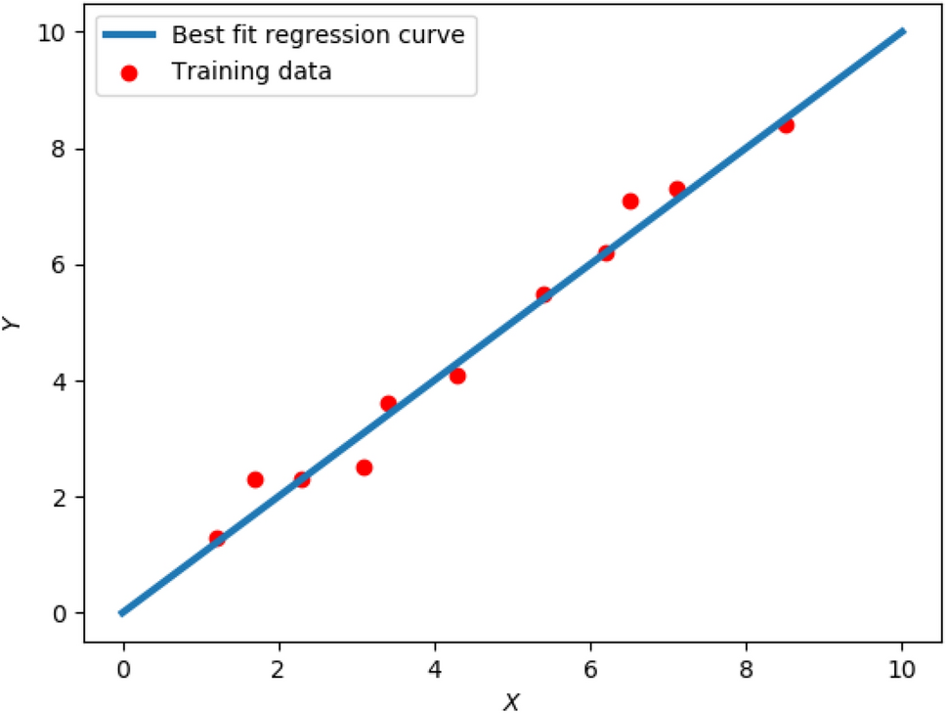
Figure 3 – Linear regression – [7]
Pre-processing
As linear regression models in Weka only work for numeric attributes, the output variable (donations) will need to be converted from nominal to numeric. This is done by applying the Nominal to Binary filter within in Weka to the donations class. Below in figure 4 shows the changes applied:
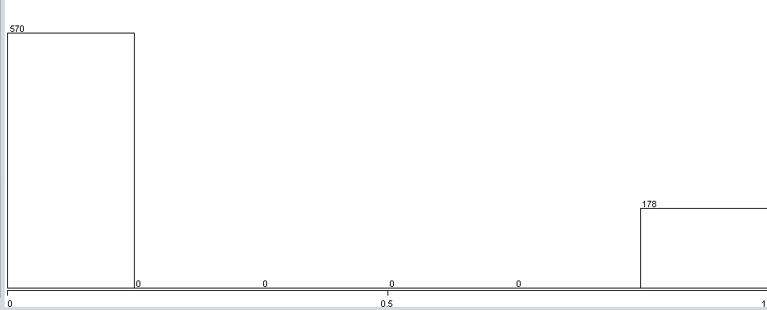


Figure 4 – Nominal to Binary Filter

Results
Using the linear regression classifier algorithm in Weka and setting the class as donated the regression model output found below was generated upon running.

Donated=

-0.01 * Recency +
0.0115 * Frequency +
0 * Monetary +
-0.0036 * Time +
0.3292

=== Summary ===

Correlation coefficient 0.3592
Mean absolute error 0.3243
Root mean squared error 0.3974
Relative absolute error 89.4298 %
Root relative squared error 93.3244 %
Total Number of Instances 748

The model shows that the monetary attribute has no statistical relevance on if someone donates or not as it has been removed. Weka removes attributes that don’t contribute. Currently, this model provides no useable way to classify if someone will donate as the output is numeric, not nominal as shown below in figure 5. To resolve this, I will pre-process the data again.
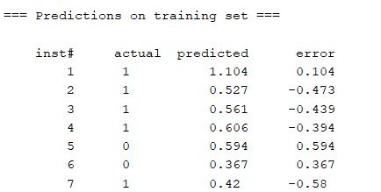
Value does not tell us anything yet.
Figure 5

Pre-processing linear regression 2
To make the predicted values observed above useful I created a new attribute with those values by using the add classification filter. I converted the donated attribute back to nominal using the numeric to nominal filter. I used both these attributes together using the one-R algorithm which creates a one-level decision tree for classification based on error rate.[8] So, the final result will allow us to classify the predicted values from the linear regression into either donated or not donated based on one rule.

Results
Upon running the one-R algorithm the results shown for the classification were very accurate as shown below. However, the rule for classification was overfitted. To resolve this the minimum bucket size was changed from 5 to 20.

One-R minimum bucket size 5
Accuracy | Rule
Correctly Classified Instances 619 82.754 %  Incorrectly Classified Instances 129 17.246 % | 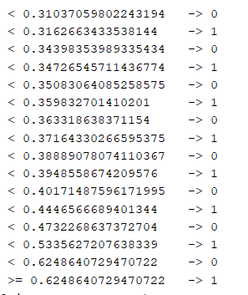

One-R minimum bucket size 20
As you can see the rule has massively improved and can now be used to predict donations with reasonable accuracy.
Accuracy | Rule
Correctly Classified Instances 586 78.3422 %  Incorrectly Classified Instances 162 21.6578 % | classification:  < 0.3255806864504157 0  >= 0.3255806864504157 1

  - J48

J48 is a Weka algorithm that is based on the c4.5 algorithm. The algorithm is a predictive decision tree classifier which creates a tree model with nodes that branch to a decision. Each node contains an attribute within the data and the algorithm decides the most important attribute based on the value of normalised information gain. It has been selected for the analysis of the dataset as the problem is about classifying blood donors which works well the J48 decision tree as it can show us which attributes are most important in the dataset for someone donating or not. [9,10]
Pre-processing & post-processing
Pre-processing for the J48 started with discretisation which proved to lower the accuracy of the model compared to running it without pre-processing any of the data. Additionally, the removal of duplicate values showed no results on the data. Below shows the accuracy comparison from the results run:

Correctly Classified Instances 570 76.2032 %

Correctly Classified Instances 605 80.8824 %

For post-processing the tree was changed from pruned to un-pruned to see if the format of the tree changed or if the algorithm removed any attributes, no effect was observed.
Results
Below is the J48 tree that had the best accuracy which is represented in the correctly classified instances. This factor is important for the classification of the donors as the more accurate the model is the better it can predict with reasonable certainty.
From observing the tree, it is obvious that recency, frequency and time are the most important contributors to the donation class. People who last donated (recency) more than 6 months ago are more likely to not donate again. People who last donated less than or equal to six months and have donated less than or equal to four times are also more likely to not donate. People who are more likely to donate are those who have donated more than four times and first donated less than forty-nine months ago. People who have a frequency more than 24 months are also more likely to donate. It is observed that the quantity of blood donated (monetary) has not effect on the classification.
J48 pruned tree
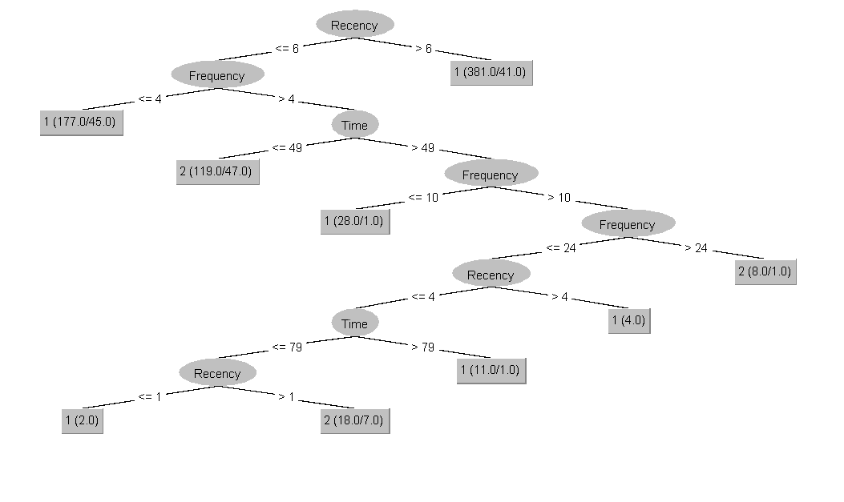
Figure 6

Correctly Classified Instances 605 80.8824 %

Confusion Matrix
a b
515 55 | a = 1
88 90 | b = 2

Application of J48
Using the tree model found above I have created a simple excel formula for handling the cases up to the fifth outcome node. Users working at the blood donation centre can insert the values into excel and from the formula provided below they can see if someone will likely donate or not based on the J48 algorithm rule.

=IF(B5>6,1,IF(AND(B5<=6,C5<=4),1,IF(AND(C5>4,E5<=49),2,IF(AND(E5>49,C5<=10),1,IF(C5>10,2,"")))))
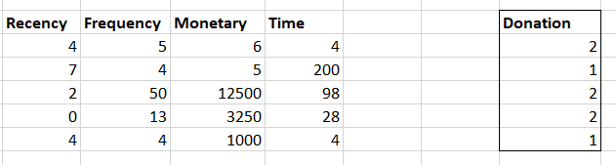
Figure 7
  - K Nearest Neighbour (KNN)
I have selected to use this algorithm as it can be used to predict if someone will donate or not as KNN is a classification algorithm. The KNN algorithm uses a known dataset of data points, each data point is in a known class. Using the known data points, predictions on what a new data points class can be made based on the nearest data points to that new entry.[11] The K value specifies the number of neighbours to classify a value. Below in figure 8 shows the nearest neighbour algorithm.
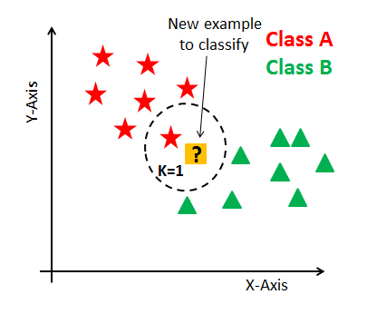
Figure 8 – [12]
Pre-processing
For the pre-processing normalisation of the data was used on all attributes to ensure that one of the attributes did not skew the data as KNN works on distance measures. From observing the dataset monetary was most likely to skew the data due to the size of the values. To test this method, I used the original data as my known dataset and created a new testing set ARFF file with known values from the original data and replaced the donation value with question marks to see if the algorithm can predict known values correctly as well as new ones. Below shows the test ARFF file changes.
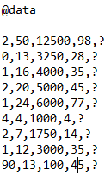

Figure 9
Results
The KNN lazy iBk classification algorithm was run multiple times for varying values of K (neighbours). Before that the ZeroR algorithm was run to find a baseline performance as suggested by Sayad. [ 13] The baseline being 76.2% correctly classified instances. If the lazy iBk algorithm is below or the same as the baseline we know that it is not good analysis method. Below are the varying values of K and correctly classified instances associated with that K value.

Value of K | Accuracy
1
3
5 | 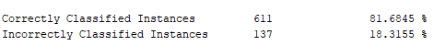

As you can see from the table above with an increasing value of K the accuracy of the model drops. The final value of K selected for this model was three as value of one may be too sensitive to noise and reduces the generalisability of the data. [14]
The test ARFF was loaded into Weka using the supplied test set option. Below are two results one from the original data set which is located on the left and on the right is the modified test ARFF data. As you can see the test set has predicted the donation value correctly (3rd column), as the first eight instances are the same as the training set.

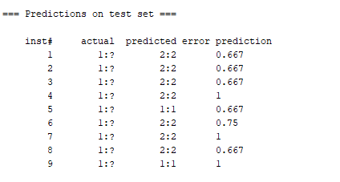
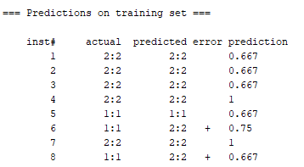
Training Set Test Set
Figure 10

To ensure the predictions work for new values I created a new test file with values similar to the first three instances found in the original data. The instances of data in the test set highlighted in red should all be predicted to be donated (2) as the values are the very similar to the ones in the original file that are highlighted red:
Original | Test 2 data
@data  2,50,12500,98,2  0,13,3250,28,2  1,16,4000,35,2  2,20,5000,45,2  1,24,6000,77,1  4,4,1000,4,1  2,7,1750,14,2  1,12,3000,35,1  2,9,2250,22,2  5,46,11500,98,2 | @data  2,50,12500,98,?  0,13,3250,28,?  1,16,4000,35,?  2,20,5000,45,?  1,24,6000,77,?  3,25,7500,89,?  45,2,8000,1,?  1,24,6000,77,?  3,58,13000,99,?  1,17,3400,34,?

Below shows the results of the test 2 data. As you can see the algorithm has predicted the new data points correctly as the bottom two values are the same prediction value as the top values (close neighbours). From this we can predict future instances with reasonable certainty.
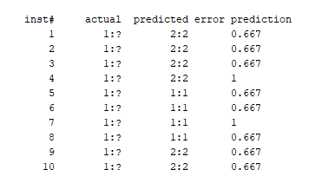
Figure 11

Application
The KNN algorithm as it does not generate a rule that we can apply like found in the decision tree section. The best way to apply for everyday use would be to create a CSV file through excel with columns for frequency, recency, monetary, time and donation. Inside the donation column you would set the value for all instances as question marks. The rest of the columns you would set as the target donors’ values. Now the file can be transformed into an ARFF easily for prediction.

  - Logistic Regression
Logistic regression is a classification algorithm within Weka. Typically, logistic regression is utilised for binary classification problems, such as the classification of blood donors. Logistic regression differs from linear regression as the predicted probability is in the range of 0-1 (binary). [ 15] I have chosen to use the analysis method as we are seeking to predict if someone will donate (1) or won’t donate (2), which is a binary classification problem.
Pre-Processing
The pre-processing done before running the logistic regression analysis included discretizing the data. This was done as research has shown that discretization of continuous variables improves accuracy.[16]
Results
Below are the results from the discretized data using the logistic classifier in Weka. As you can see the correctly classified instances is very good at 80%. However, the majority of these correctly classified instances with the value of 1 (not donated). Out of all the instances with a donated value of 2 only 34.8% (62) were correct. This suggests that this model is perhaps not the best analysis method for the problem when compared to other classification methods.
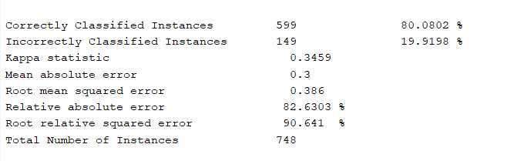
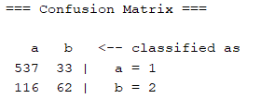
Figure 12

Application
This method can be applied to new unknown data to predict whether they would donate or not. This is achieved by loading in an ARFF file and the model from above into the supplied test set option with unknown values for donation as shown below in the left column. In the left-hand column is two new data instances. In the middle is the actual values found in the original ARFF file. On the right is results from the prediction test and the blue values representing the incorrect predictions.
As you can see the test has shown that the model is bad at correctly classifying people who will likely donate (1) as it got half wrong. However, the model predicted known not donate values correctly.

Test data | Real data | Results from test
2,50,12500,98,?  0,13,3250,28,?  1,16,4000,35,?  2,20,5000,45,?  1,24,6000,77,?  4,23,5750,58,?  0,3,750,4,?  2,10,2500,28,?  1,13,3250,47,?  2,6,1500,15,?  2,49,12470,90,?  1,12,3240,46,? | 2,50,12500,98,2  0,13,3250,28,2  1,16,4000,35,2  2,20,5000,45,2  1,24,6000,77,1  4,23,5750,58,1  0,3,750,4,1  2,10,2500,28,2  1,13,3250,47,1  2,6,1500,15,2 | inst# actual predicted  1 1:? 2:2  2 1:? 2:2  3 1:? 2:2  4 1:? 2:2  5 1:? 2:2  6 1:? 2:2  7 1:? 1:1  8 1:? 2:2  9 1:? 2:2  10 1:? 1:1  11 1:? 2:2  12 1:? 2:2

- Business Recommendations
From the analysis results I would recommend the company use the J48 algorithm in combination with the KNN algorithm as they presented the largest accuracy percentages and useable models. From the J48 model it is clear that monetary attribute for blood donors is not a factor that is useful for predicting if someone will donate and should be ignored.
However, from the J48 it is clear that those who first donated less than 49 months ago were more likely to donate. So, from this I would recommend targeting those individuals who are more likely to donate with adverts or reminders to sign up to donate again. I would also recommend the J48 tree be used for quick classification of single instances of new donors as it allows for quick interpretation. It would also be advisable to target the individuals with a high frequency of donations as they have been classified as people more likely to donate again as well. Those who last donated more than six months ago should not be the front of the targeting campaign as they have been predicted to not donate the most.
I would also recommend that the business use the Excel formula provided in the J48 section of this report for quick classification for future data sets for use by their own analysts. The KNN algorithm should be utilised for larger predictions that get mass loaded in Weka so that you can classify correctly and quickly and from the predictions target the users more likely to donate.

- Reflection

From the analysis of the data using the methods selected in this report I believe that the selection of the J48 decision tree algorithm worked well in comparison to the regression classification methods. The J48 provided a high accuracy for both classifications of the donation attribute, whereas the logistic regression algorithm proved to be overall accurate at 80% but was not accurate for classifying people who are likely to donate as was evident in the confusion matrix. Additionally, the J48 was very simple to use for future predictions as it outputs a useable rule for use in applications. If I was to do this again in the future I would create a simple C# forms application using the J48 rule so users at the blood donation service could input the attribute values for new instances and get a response back on if that person will likely donate.
The KNN algorithm was also successful in determining classification of donors with a high accuracy of 82%. I think the KNN is good for the prediction analysis of the large datasets as you can input question marks in place of attributes to guess the classification of that new data. The accuracy of the model could be improved by using more advanced pre-processing and this is something I would do differently if I was to do it again. Another disadvantage with this model of classification is the accuracy discrepancy as the value of neighbours increases.
I would not use linear regression again for this kind of problem as it is not suited to classification of binary values compared to the other ones I used. If I was to do it again, I would also explore additional classification algorithms such as other decision trees to see if they provide accurate results for this problem.

References
- Han J, Kamber M, Pei J. Data Mining Concept and Techniques. 3rd ed. Waltham: Morgan Kaufmann; 2022. Pages 3-17. [Internet] 2012 [Cited 1st January 2022] Available from: http://myweb.sabanciuniv.edu/rdehkharghani/files/2016/02/The-Morgan-Kaufmann-Series-in-Data-Management-Systems-Jiawei-Han-Micheline-Kamber-Jian-Pei-Data-Mining.-Concepts-and-Techniques-3rd-Edition-Morgan-Kaufmann-2011.pdf

- Rotondo A, Quilligan F. Evolution Paths for Knowledge Discovery and Data Mining Process Models. SN Computer Science [Internet]. 2020 [cited 2nd January 2022];1(2). Available from: https://link.springer.com/article/10.1007/s42979-020-0117-6

- Funatsu K, Hasegawa K. Knowledge-oriented applications in data mining. Rijeka: In-Tech; 2011.Pages 54-56. [Internet] 2011 [cited 2nd January 2022] Available from: https://books.google.co.uk/books?hl=en&lr=&id=CLqZDwAAQBAJ&oi=fnd&pg=PA53&dq=descriptive+vs+predictive+mining&ots=9kFetIx-hO&sig=YJU1-EKZ-Z55JefMZzG0jOIf5yA&redir_esc=y#v=onepage&q=descriptive%20vs%20predictive%20mining&f=false

- Using analytics to predict fraud [Internet]. Sas.com. 2022 [cited 1 January 2022]. Available from: https://www.sas.com/en_my/customers/irish-tax-and-customers.html

- Rezaeian A. Measuring Customers Satisfaction of E- Commerce Sites Using Clustering Techniques: Case Study of Nyazco Website. International Journal of Management, Accounting and Economics [Internet]. 2022 [cited 5th January 2022];3(1):61-74.Availablefrom: https://www.ijmae.com/article_115230_1f84f8d85dd35c37a0993a1df06143d3.pdf

- Seltman H. Experimental Design and Analysis. Simple Linear Regression [Internet]. 2018 [cited 6th January 2022]. Available from: https://www.stat.cmu.edu/~hseltman/309/Book/Book.pdf

- 7. Date P. Adiabatic quantum linear regression [Internet]. Scientific Reports; 2022. [Cited 2nd January 2022] Available from: https://www.nature.com/articles/s41598-021-01445-6

- Ali S. On learning algorithm selection for classification. Applied Soft Computing [Internet]. 2022 [cited 10 January 2022]; 6:119-138. Available from: http://citeseerx.ist.psu.edu/viewdoc/download?doi=10.1.1.471.5770&rep=rep1&type=pdf

- 9. Farhad A. Comparative Study of J48, Naive Bayes and One-R Classification Technique for Credit Card Fraud Detection using WEKA. Advances in Computational Sciences and Technology [Internet]. 2022 [cited 11 January 2022];10(6):1731-1743. Available from: https://www.ripublication.com/acst17/acstv10n6_19.pdf

- Anan N, Thri V. Performance and Classification Evaluation of J48 Algorithm and Kendall’s Based J48 Algorithm (KNJ48). International Journal of Computer Trends and Technology [Internet]. 2018 [cited 13 January 2022];59(2):73-80. Available from: http://www.ijcttjournal.org/archives/ijctt-v59p112

- Sutton M. Introduction to k Nearest Neighbour Classification and Condensed Nearest Neighbour Data Reduction [Internet]. Math.le.ac.uk. 2022 [cited 14 January 2022]. Available from: http://www.math.le.ac.uk/people/ag153/homepage/KNN/OliverKNN_Talk.pdf

- Navlani A. KNN Classification using Scikit-learn [Internet]. 2022 [cited 15 January 2022]. Available from: https://www.datacamp.com/community/tutorials/k-nearest-neighbor-classification-scikit-learn

- Sayad S. ZeroR [Internet]. Saedsayad.com. [cited 15 January 2022]. Available from: https://www.saedsayad.com/zeror.htm

- 14. Qi Y. K-nearest-neighbor Classifier / Bias-Variance Tradeoff. Presentation presented at; 2016. [Internet] 2016 [Cited 15th January 2022]. Available from: https://www.cs.virginia.edu/yanjun/teach/2016f/lecture/16f-L15-KNN.pdf

- Belyadi H, Haghighat A. Supervised learning. Machine Learning Guide for Oil and Gas Using Python [Internet]. 2021 [cited 17 January 2022];169-295. Available from: https://www.sciencedirect.com/science/article/pii/B9780128219294000044

- Grzenda W. The Role of Discretization of Continuous Variables in Socioeconomic Classification Models on the Example of Logistic Regression Models and Artificial Neural Networks. Studies in Classification, Data Analysis, and Knowledge Organization [Internet]. 2020 [cited 16 January 2022];35-51. Available from: https://link.springer.com/chapter/10.1007/978-3-030-52348-0_3

