

Assessment 1 – Reading Task Template
Upload your photo of your A3 in-class notes here:
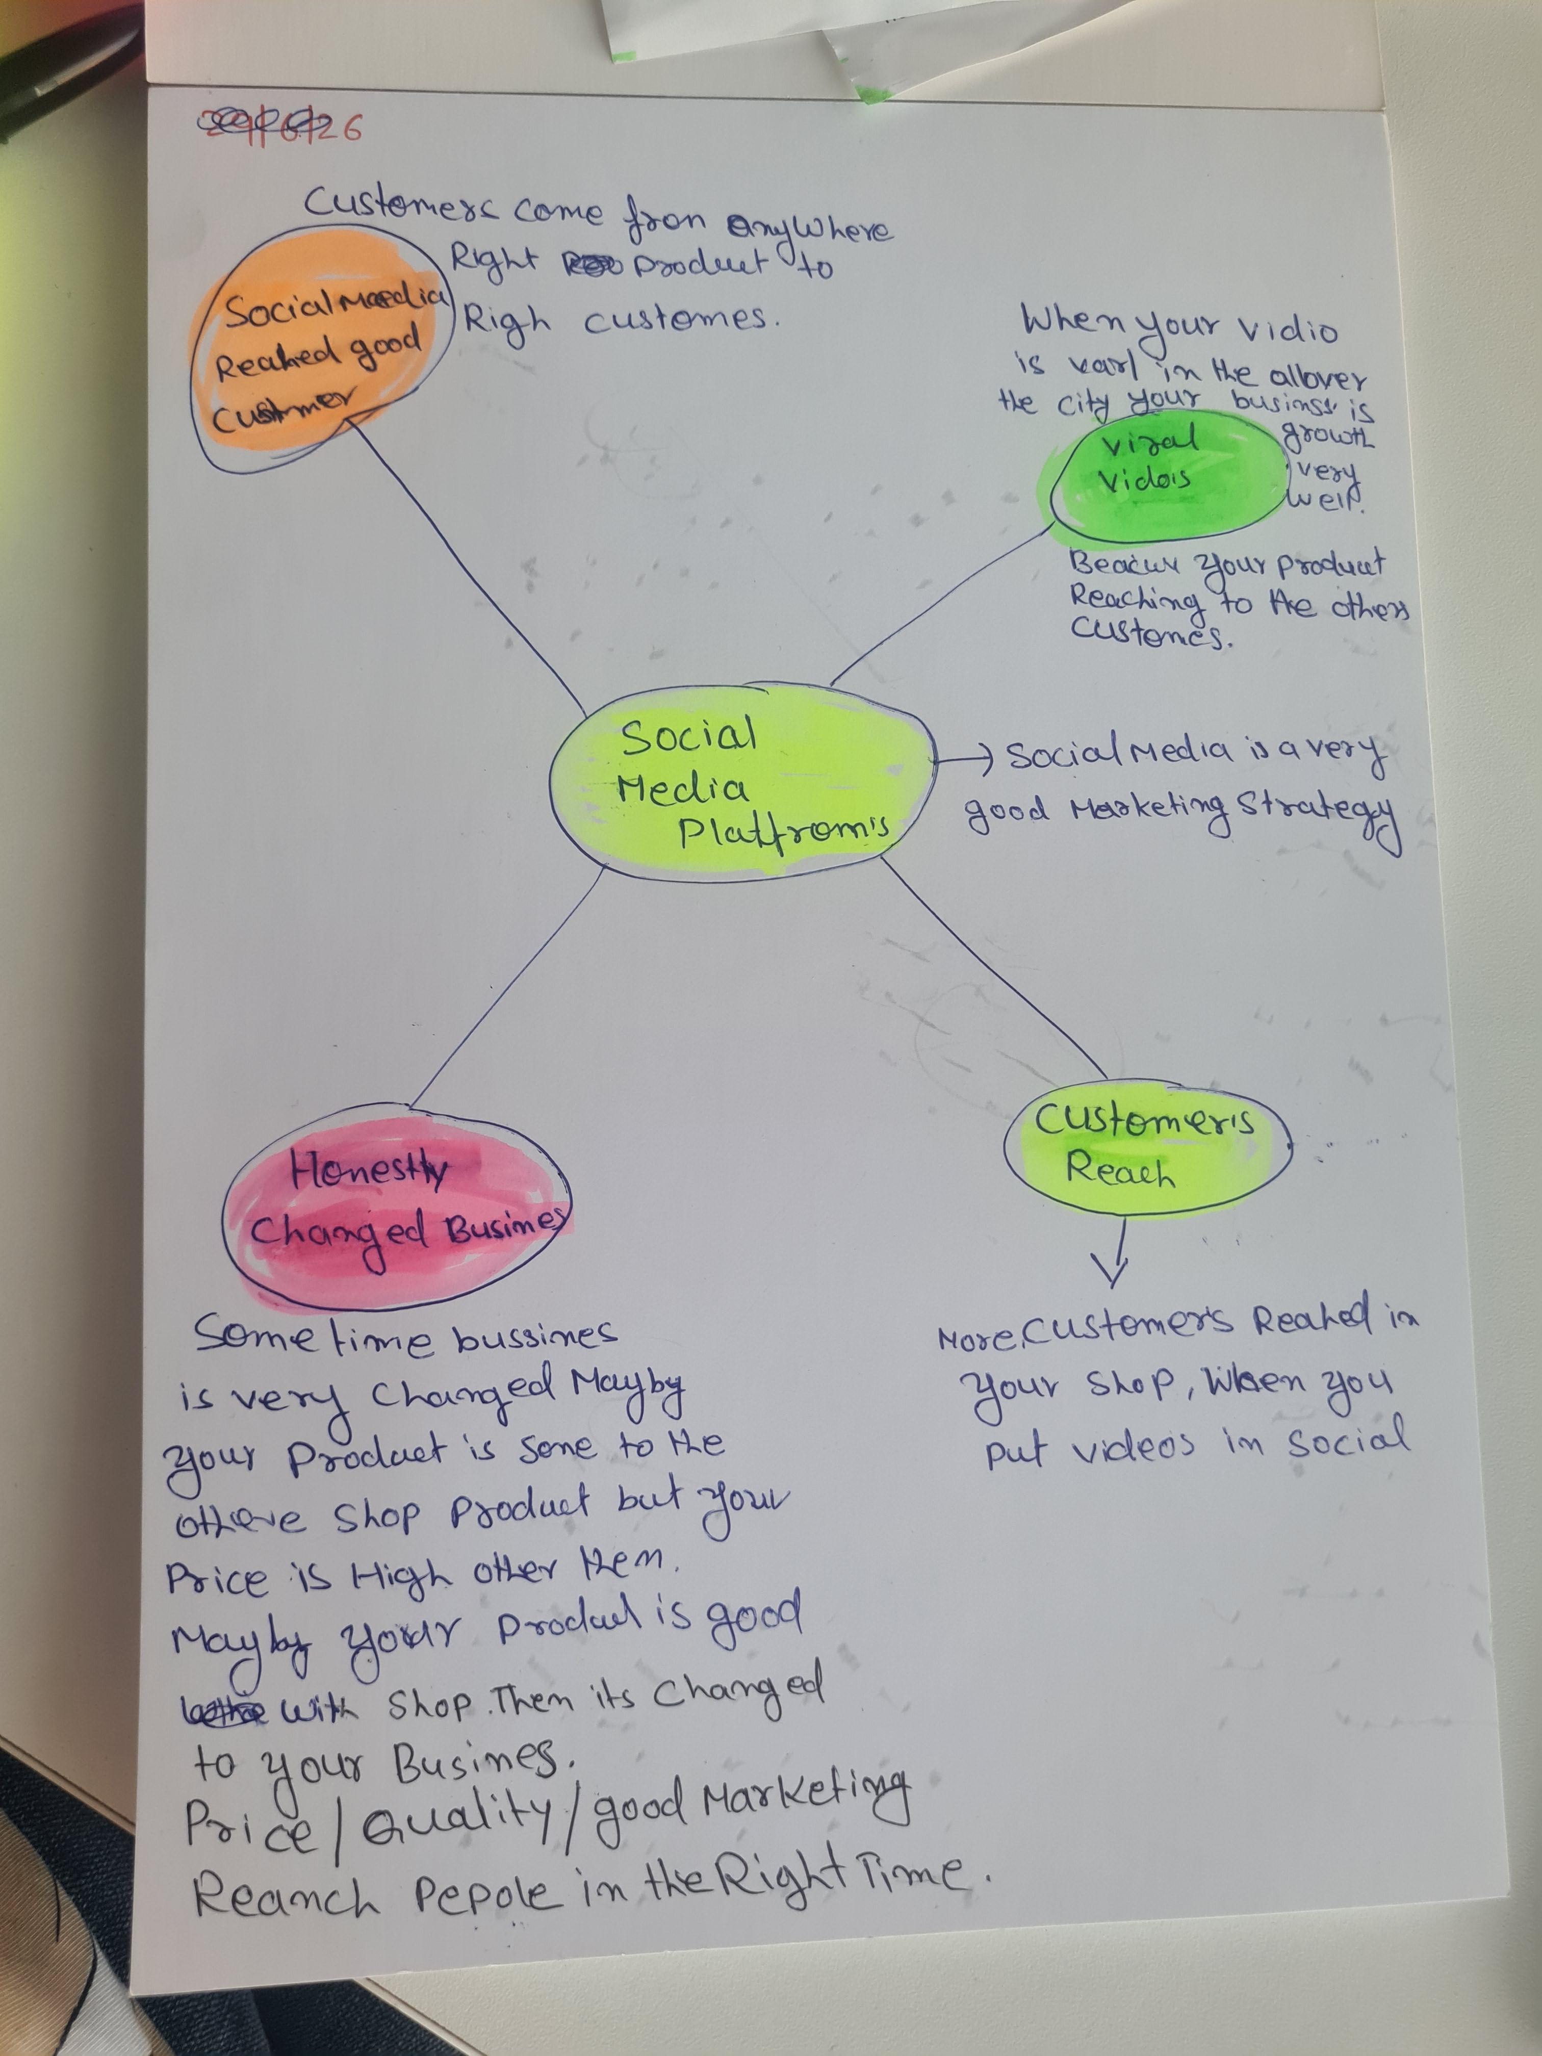

1. Answer these questions using the sentence starters below
a. What is the main idea of the text?
The main idea is that social media/ marketing / right people reach out .

b. What are two key points?
One key point is making businesses videos and put in social media for reach more people.
Another key point is you. Can grow your business by market strategy and compering your business growth.
c. What part of the text did you find most important? Why?
The most important part is the marketing is very important in your business.
d. Was anything unclear or difficult to understand?
I was not sure about
e. How did your group help you understand the text better?
My group helped me to gives other ideas and more key point .
2. One sentence reflection
Question: What did you find challenging about this task?
The hardest part was some time difficult to reach right people.

