LV6 Contemporary Themes
– Conference Learning Log

Student Name: | Mohammed Salah uddin(1705014)

Week 1 | Monday June 1st 2020
Planning: selection theme
. Conference online because COVID-19
.Spilt three group (management/marketing/technical)each group 2 student
.Group chat what’s up
. Attendees every meeting
Select Guest and speakers

Organising: Team selection management-Mohammed and Khalique. Marketing-Sattar and faruki
And technical Shams and Motin
.Friday group netting

Managing:Coronavirus effect our communications that’s why we are group chat Friday to update and progress our conference
. Ensure everyone what they needs
.Follow our deadline conference

Marketing: . Name to conference decide on
.current target market
. Focus logo
: Focus company
: who will be viewing conference

Technical:
Design logo and website easy way to further student can study or watch easily
: Back support It 24 hours

Problems/Resolution Action Plan:Attendance problem but we manage grant chat what’s up

Focus for the Week: COVID-19 that’s why we cannot meting university but our hard working we do online conversation and conference
:UWTSD cannot provide yet any technical support but we use our WiFi and internet facilities

Student Signature:mohammed Salah Uddin

__________________________________

Date:
01/06/20
_________________________________

Week 2 | June 8/2020
Planning:Profile upload website
:Nominate project manager (leader)
: Decided brand name and logo by vote
Important to member meting attend

Organising:Finally selection team leader and his work what to do.
: majority student vote for logos name and website to finalised
: start email to viewers to join conference

Managing:I tried hardly to promote meting attend our members
:Technical team provides their design to members vote
:Members commitment our deadline
:Preparation to week 3
: Manage our company fund to spend
: Report group to ensure progressing
:All minutes have been into group chat

Marketing: Generates public feelings
:Develop colour and design to showings public
:Decide to logically support our company and appoint brand embrasador to company

Technical:technical team hard work to make website colour and logo
:Arrange one to one talk with team
:Setting video online our deadline

Problems/Resolution Action Plan :Issues attendance our commitment to success conference
: it is hard to make any decisions but majority decision be allowed to set anything

Focus for the Week: : UWTSD help desk not helping properly

: marketing team communications other members to work well

Student Signature:Mohammed Salah Uddin

__________________________________

Date:08/06/20

_________________________________

Week 3 | June 15/2020
Planning:Updates and progress
: Attendance meting
: Conference logos, website confirmed
:Everyone have confirmed their work going perfectly
: themes will be name HOSPITRINITY

:

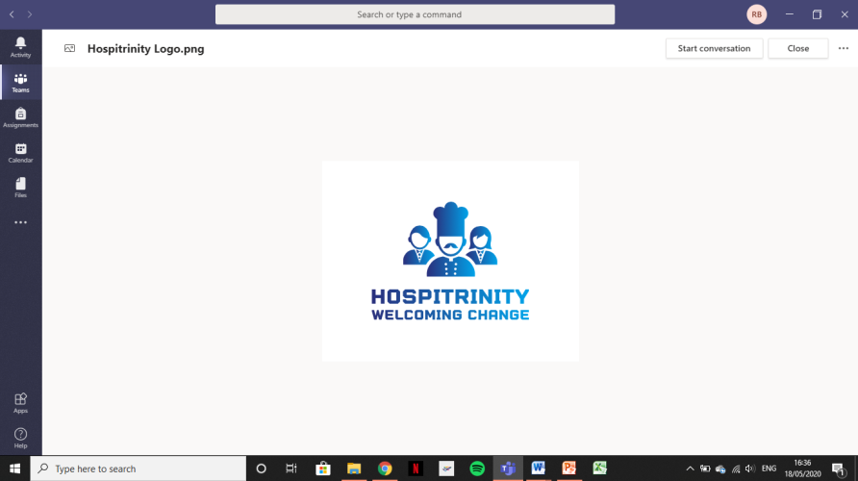

Organising:Recap previous deadline update
:Planning to meting Khalique need any change website or logos and discussion conference
:How to spend conference fund to discuss

Managing: Planning conference venue . Accommodation, activities and catering

: Emailed Guest and speaker
Goggles follow
:making business plan

Technical: Design logo and media printing brochures

Problems/Resolution Action Plan : we have no computer to do electronically design website but our teacher ensure we can get next week from university

Focus for the Week:
Few members not attending our online meeting myself and Khalique manage all

Student Signature:Mohammed Salah Uddin

__________________________________

Date:15/6/20

_________________________________

Week 4 | June22/2020
Planning: updates and progress our previous agendas
:Everyone have got laptop from university and planning to electronically
Made our website
: Everyone photo upload our website
: what’s up group chat updates

Organising: Planning to undertake our meeting and conference news to possible newsletter
:organise my best time to spend time to Contemporary them
:Everyone chose their own video set to contemporary themes

: conference president and speaker email to confirmation

Managing: What’s up chat has been updated
:confirmed and everyone voted to logo our website
: Attendees our every meeting is essential

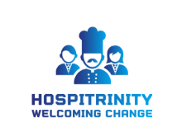

Marketing: finally invitation letter sent people to attend our conference
:Update news letter our conference

Problems/Resolution Action Plan :

- Was problem laptop but UWTSD give us laptop for study , problems solved

- We found laptop not working properly but I use mobile word my self
Focus for the Week: UWTSD proved laptop (faulty)
And help desk not helping

Student Signature:Mohammed Salah Uddin

__________________________________

Date:22/6/20

_________________________________

Week 5 | June 29/2020
Planning: contemporary themes paper more focus on presentation on the time because deadline 6th june20
:Explain to website COVID-19 our conference break out
:Make a space our website to people subscribe to a news letter

:Virtual conference explanation

Organising: For presentation picking case study
: Preparing slide show
: Technical side virtual conference
: Manage finale report to member to preparation 6th July

Managing: Finally double cheek update our group chat what’s up
: To our website finalised our introduction and executive summary
: confident members to virtual conference deadline

Marketing: Marketing team explain to virtual conference cost and live conference cost
: Member happy to virtual conference to cheap to live conference
:Create a section to newsletter subscribe to our guests

Technical: Uploads video our website to done before 6th July
:Technical team make a room for assignment upload website too is well
: finals check technical side and logistics support side

Problems/Resolution Action Plan :Technical issue was big problem and our help desk UWTSD not helping properly but my few friends help and we resolve the problem

Focus for the Week: practice virtual conference

Student Signature: Mohammed Salah Uddin

__________________________________

June 29/20
Date:

_________________________________

Week 6 – Final Week | Monday June 1st, 2020
Planning: any outstanding work must have completed before 6th June
:Everyone upload presentation website
: Planning to meet Uwtsd technical team to make sure everything fine
: looking budget and need to carefully spend money
:Guest finally confirmed attend virtual meeting

Organising: Progress all work and members suggests and their all work finally management team approved for final virtual conference

Managing: what’s up group chat finally updates all work
: Finally meting minutes upload website

Marketing: Invitation people and guest email upload to Microsoft team
:HOSPITRINITY info updates website
:Budget and invite updates finally confirmed

Technical: finally John and Sam watch our website and confirm it’s excellent
: upload website to guest and invite people to connect You Tube allow to watch

Problems/Resolution Action Plan :Few member not contact management team but management team hardly work and resolved to ahed conference finally

Focus for the Week: All done for conference and ready to 6th July 20 our virtual conference

Student Signature: Mohammed Salah Uddin

__________________________________

Date:6/7/20

_________________________________

Conference Review | Planning; Organisation; Management; Marketing of the Event and Conference Delivery

I can say I can learned how to virtual conference and live conference compare and it is very easy to virtual conference. Because of COVID 19 we are not allowed to live conference that’s why we do virtual conference and no need to bus fair , no need s to manage conference room or chair table or food for guest. It is very cheap to live conference. Some of our members not helping properly but management team hard work finally we successfully and pleased with the end result. Making conference I meet lots of new people and share our knowledge each other it’s really good for me .Over all I really enjoyed everything.

