Assessment

On

Models of Communication and Skills of Communication

Module: Effective Team Working and Communication ( BMSW4002_LON)

Student: Sajeda Akter ( 2018704)

Lecturer : Saqib Shamim

Introduction
Communication is the act of giving, getting, and sharing data -- in other words, talking or composing, and tuning in or perusing. Great communicators tune in carefully, talk or type in clearly, and regard distinctive conclusions. “Communication is the imparting or interchange of thoughts, opinions, or information by speech, writing, or signs”-American College Dictionary. The word communication has numerous repercussions. It is essentially a handle of interaction with the individuals and their environment. Communication is one of the basic social abilities required for any person to outlive within the world. Viably communicating guarantees that you simply not as it were pass on your message to somebody but moreover let them know almost your sentiments and feelings. There are some barriers that can affect the communication process such as, physical barriers, perceptual barriers, emotional barriers, cultural barriers etc. Because of barriers or lack of communication several things that can happen such as, Misunderstandings, missed opportunities, unnecessary conflict, spreading misleading information, mistrust, low morale and can be a broken company culture in a work place.

Models of communication:
The reason of a “model” is to offer a visual representation of a concept with the aim of encouraging the understanding of it. Customarily talking, there are three standard models of the communication prepare: Linear, Intuitively, and Value-based, and each offers a marginally diverse viewpoint on the communication process.

communication models clarify the components of the communication prepare, process, for example, setting, sender, recipient, encoding, translating, channel, message, feedback and noise. These are the nine components of communication that portray the whole process of communication. However, a few communication models don't have all these components. For illustration, the direct demonstrate of communication does not have criticism. The communication show moreover clarifies the variables that anticipate successful communication, known as boundaries or commotion in communication. Communication boundaries or communication commotions bar compelling communication forms.

In broad communication models are mainly in three types:
- Linear Models of Communication
- Interactive Models of Communication
- Transactional Models of Communication
- Linear models of communication:
There’s a bit of a talk about almost the Linear Communication model and how it recognizes (or doesn’t recognize) the concept of feedback. The linear model’s behaviour is belied a false representation of by its title, where a sender encodes a message through a channel and the message is decoded by the receiver. It is straight-line communication found ordinarily in mass communication; think tv, radio, daily papers, etc. Agreeing to this show, there's no implies for prompt feedback.
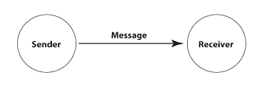

Shannon and Weaver model of communication:
Shannon and Weaver were the primary to show the linear model of Communication in 1949′s The Scientific Theory of Communication. Suffice to say that this hypothesis has gotten to be less significant in reverse extent to the propels of communication innovation, particularly non-linear shapes of electronic communication where it’s not continuously clear who is the sender and who is the receiver.
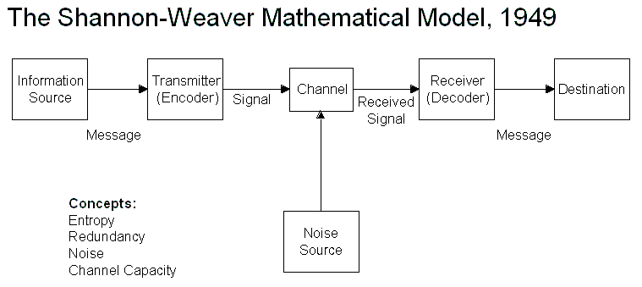
Concepts in Shannon Weaver model:
Sender (Data source) – Sender is the individual who makes the message, chooses the channel and sends the message.
Encoder (Transmitter) –Encoder is the sender who uses machine, which changes over message into signals or binary data. It might too straightforwardly allude to the machine.
Channel –Channel is the medium utilized to send message. Decoder (Recipient) – Decoder is the machine utilized to change over signals or parallel information into message or the collector who interprets the message from signals.
Receiver (Destination) –Receiver is the individual who gets the message or the put where the message must reach. The recipient gives input agreeing to the message.
Noise –Noise is the physical unsettling influences like environment, individuals, etc. which does not let the message get to the recipient as what is sent. Noise is the same as the barrier of the communication.

Berlo’s SMCR Model of Communication
In 1960, David Berlo developed Berlo’s Sender-Message-Channel-Receiver (SMCR) model of communication from Shannon Weaver’s Model of Communication (1949). He described factors affecting the individual components in the communication making the communication more efficient. The model moreover centre’s on encoding and decoding which happens before sender sends the message and before recipient gets the message respectively.
Berlo’s Show has basically, four components to depict the communication process. They are sender, message, channel and collector. Each of the component is influenced by numerous factors. Berlo focuses on both verbal and non-verbal communication components to communicate information.

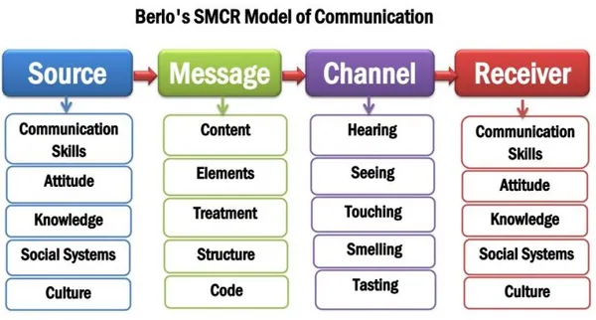
- Interactive Models of Communication
The interactive model of communication refers to the two-way method of communication with feedback. However, feedback is not simultaneous, so it provides slow and indirect feedback. Sometimes, the communication can be linear if receivers do not reply to senders. The interactive model of communication indicates mediated and internet-based communication. As an example, Schramm’s model of communication is an example of interactive models of communication.

Schramm’s model of communication

Wilber Schramm proposed the model of communication in 1954. Information is of no utilize unless and until it is carefully put into words and passed on to others. Encoding plays an awfully important role since it starts the method of communication by changing over the thought into substance. When the data comes to the beneficiary his prime responsibility is to get it what the speaker intends to communicate. Unless and until the moment party is able to get it or interpret the data what the sender needs to communicate, the message is really of no use. In this way encoding and translating are two most critical variables of a successful communication without which information can never stream between two people. Schramm’s model too rotates around the over guideline. According to the Schramm’s model, coding and translating are the two basic forms of an effective communication.
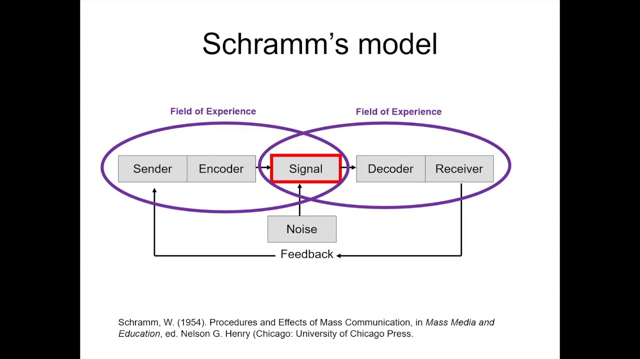

- Transactional Models of Communication
The transitional model of communication appears like a two-way process of communication with quick criticism. Concurrent feedback is the basic component of the transitional models of communication. So, the communication process will not get to be value-based in case there's no feedback. The feedback is coordinate and exceptionally quick. The receiver is compelled to provide instant feedback. The major distinction between the interactive and transactional models is circuitous and direct feedback.

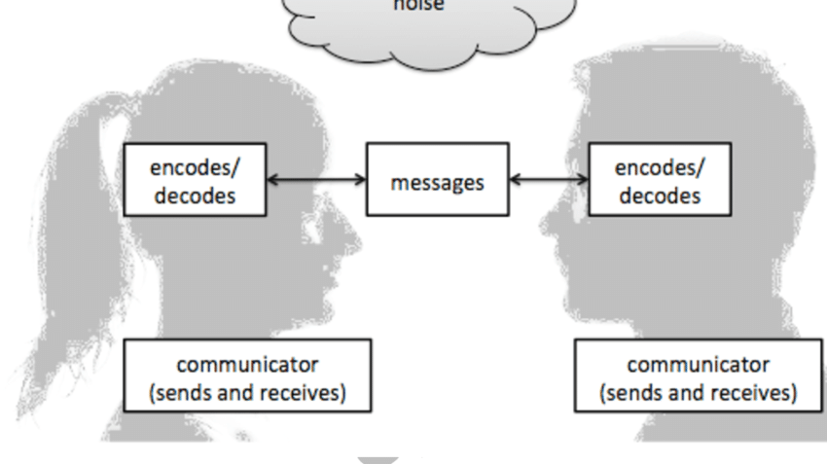

Communication models are basic instruments to get it the communication processes. Communication models display detailed data with respect to the communication process as well as outline the stream of information. Hence, they have a colossal positive affect on the research by presenting numerous conceptual systems of communication forms. Also, the demonstrate presents the components of the communication handle. Besides, the show of communication gives tips about how communicators can communicate viably. They speak to the barrier or commotion that deterrent the method of communication. They too clarify the complexities of the communication system. At last, the show proposes to bring change within the communication handle to maintain a strategic distance from conflict.

Communication Barrier:

Noise is one of the foremost common barriers in communication. It is any tireless or random unsettling influence which diminishes, obscures or confounds the clarity of a message. Physical boundaries are closely related to noise as they can deter the communication transmission process. Communication barriers include poor listening skills; insufficient sharing of information; differences in interpretation and perception; and nonverbal cues being ignored or missed.

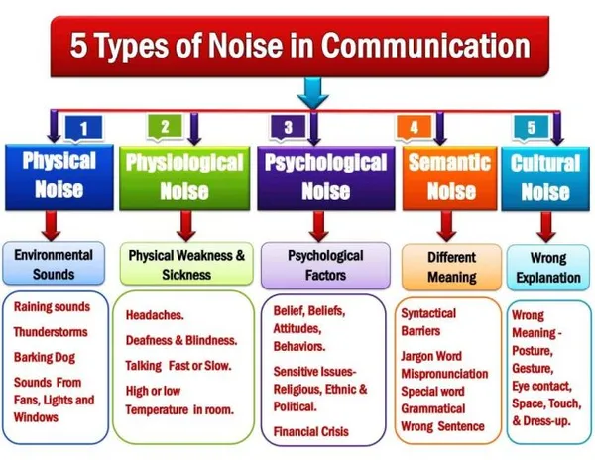

Example of a noise in communication: One day I was very sick as I had a very bad headache and was taking rest at home. My medicine was finished so I called my husband’s mobile phone to bring some medicine. Our only son was watching his favourite tv series with high volume. Therefore, I was not sure whether my husband clearly understand what medicine he needs to buy or not. so, I needed to tell him again to make sure he got my message perfectly. In this situation of mine, TV sound is a kind of physical noise and my headache is an example of physiological noise.
Communication Skills:
People communicate with each other in a number of ways that depend upon the message and its context in which it is being sent. Choice of communication channel and your style of communicating also affects communication (Rutherford & Andrea J, 2007). There are 5 main types of communication:
- Verbal communication
- Non-verbal communication
- Written communications
- Formal & informal communication
- Visual communication
Verbal communication: Verbal communication is the thing we say. When individuals consider the word communication, they regularly think almost the act of talking. We depend on verbal communication to trade messages with one another and create as people. The term verbal communication frequently brings out the thought of talked communication, but composed communication is additionally portion of verbal communication. Reading a book is nothing but interpreting the authors’ composed verbal communication in order to learn more about communication. Verbal communication can be both written and spoken. Verbal communication can be oral or written
No-verbal communication: Non-Verbal Communication is the method of passing on meaning without the utilize of words either composed or talked. In other words, any communication made between two or more people through the utilize of facial expressions, hand developments, body language, gesture, facial expressions, posture, tone, signals and signs and pitch of voice.

Listening: Listening is another kind of communication skill. The average person can remember nearly 50% of what they hear (Crockett,2011). Listening can be Active listening or Empathetic listening. Active listening is paying attention and not doing other things like looking at the phone, filing the nails with an assumption that the other person is going to say or complete their sentences. On the other hand, Empathetic listening is listening and trying to feel the speaker’s emotion.

Types of communication:
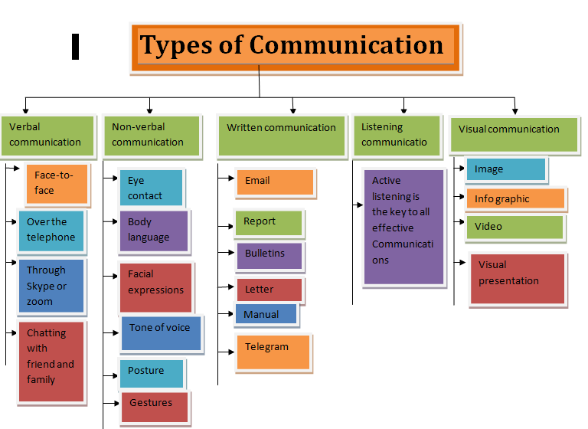

Poor communication has very severe affect on our daily life specially at workplace (Raman. 2011). Due to poor communication several things that can happen such as, Misunderstandings, missed opportunities, unnecessary conflict, spreading misleading information, mistrust, low morale and can be a broken company culture in a work place.

Example of a poor communication at work place: I work in a primary school as a teaching assistant. English is not my first language so there is some communication gap. I have few other colleagues who are also came from different non-English-speaking countries. One day our head teacher called for a meeting of all staff and quickly gave some instruction about the day’s task. She is from Wales and speaks very fast. On that day she was in a hurrey so, she passed the message and leaves the room. We didn’t get the time to ask her more question to clarify her instruction. I was not the only person on that situation, few of my colleagues were as well. So, we discussed with some other teachers to understand her message properly. This confusion could have been avoided if my head teacher spent some more time and take our feedback to make sure she conveyed her message properly.

Conclusion:
Communication is one of the basic social abilities required for any person to outlive within the world. Viably communicating guarantees that you simply not as it were pass on your message to somebody but moreover let them know almost your sentiments and feelings. The important communication models are Shannon Weaver model (1948), Berlo’s SMCR model of communication (1969) and Schramm’s communication model (1954) , There are some barriers that can affect the communication process such as, physical barriers, perceptual barriers, emotional barriers, cultural barriers etc. Because of barriers or lack of communication several things that can happen such as, Misunderstandings, missed opportunities, unnecessary conflict, spreading misleading information, mistrust, low morale and can be a broken company culture in a work place.

Reference:
Raman, Meenakshi & Sangeeta Sharma. Technical Communication: Principles and Practice. Second Edition. New Delhi: Oxford University Press, 2011.

Rutherford, Andrea J. Basic Communication Skills for Technology: Second Edition. Delhi: Pearson Education, 2007.

Kobiruzzaman, M. M. (2021). Models of Communication, 3 Types of Communication Models Linear, Interactive & Transactional.

Newsmoor- Educational Website For Online Learning. https://newsmoor.com/3-types-of-communication-models-linear-interactive-transactional/

7 problems good communicators are able to avoid:
https://fairygodboss.com/career-topics/lack-of-communication (Accessed: 23 October 2017).

