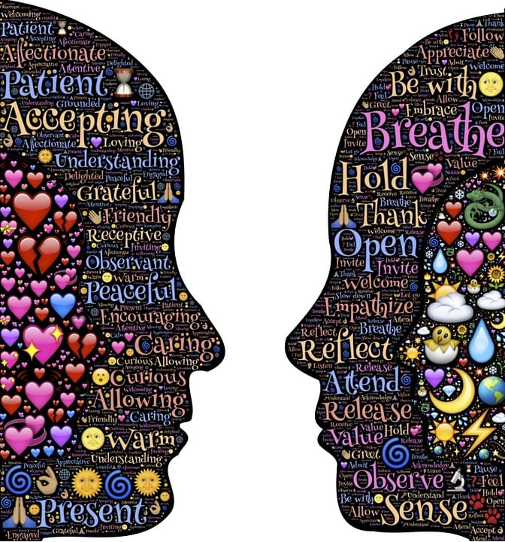
Describe and Discuss the Counselling Skills Areas of Competence that will be required for the Role of Social Prescriber Based on the Counselling Skills Areas of Competence Document. Module: ECPS4015

(ECPS4015)

AI Acknowledgement
I acknowledge using Grammarly (https://www.grammarly.com/) on 28th February 2025 to check my work using the prompt:
1. Please check the following work for readability, grammar, spellings, paragraph formation, syntax and check my APA citation references are correct.
I acknowledge the use of ChatGPT (https://chatgpt.com/) on 10th February 2025 to look for articles using the prompt(s):
1. Please find me relevant peer-reviewed articles about the counselling skills areas of competence needed for a social prescriber using embedded counselling skills, refer to the BACP guidelines
2. Please find me relevant peer-reviewed articles about social prescribers working in Wales.
3. What do social prescribers do?
4. What are the most important counselling skills areas of competence in the BACP framework guidelines?
I confirm that I have not presented any AI generated text as my work. I confirm I have copies of my drafts, notes, and other resources I used before, and after the use of AI tools, which I may be asked to provide in evidence.
Counselling skills encompass the values, ethics, knowledge and communication abilities needed to support a client's emotional health and wellbeing. These are not exclusive to professional counsellors; many individuals use them to enhance their primary roles. The application of these skills varies depending on the user and the context in which they are employed (BACP, 2020a ).
The chosen vignette to be discussed for this essay is P, who has been working as a social prescriber in a local mental health charity in Wales for several years, where social prescribing is being offered to some of its clients. One of P's many skill sets is embedded counselling skills within the role.
The role of a social prescriber involves connecting individuals with community services and support to improve their health and well-being using embedded counselling skills. (NHS, 2023).
Based on the British Association for Counselling and Psychotherapy (BACP) Counselling Skills Competence Framework, several key areas of competence are essential for this role. Social prescribers must comply with
the legal, professional, and ethical standards of the framework, ensuring client confidentiality and the maintenance of professional boundaries. Ethical standards are there to help professionals conduct themselves sincerely with transparency. Confidentiality is important, to keep the client's personal information protected unless there is a risk of harm to the client or others. Boundaries ensure the relationship between the professional and client remains appropriate (BACP, 2020a).
The ability to communicate empathically and without judgment is vital.
Effective use of listening and responding skills is essential to understanding the clients' needs and providing appropriate support. Being able to identify and respond to risks and emergencies quickly and effectively is also a crucial competency (BACP, 2020a).
Establishing and Maintaining good Relationships with clients, establishing trust, and providing a safe space to open up are important skills. Good communication both verbally and nonverbally, using active listening skills alongside interpersonal skills with the client, other professionals, and family members where necessary, is essential. Likewise, self-awareness and reflection are essential attributes to master for this helping profession, as they promote personal growth for the professional and can be taught to the client (BACP, 2020a).
These competencies ensure that social prescribers can provide safe, ethical, and effective support to their clients, helping them navigate community resources and improve their overall well-being (BACP, 2020b). Social prescribing skills include identifying when the client needs to talk and attending using the appropriate skills, providing a safe listening space and referring them for additional help and support when necessary (BACP, 2020a).
The BACP framework outlines five essential areas of competence for safe and effective use of embedded counselling skills in a primary professional role: Active listening and response skills, use of empathy, professional working relationship and positive personal attributes (BACP, 2020a).

Most professionals will already have the skills, abilities and competencies relevant to their roles; the BACP framework offers counselling skills and values to enhance these interpersonal relationships. The competence framework defines the expertise, capabilities, behaviours and attitudes needed to use counselling skills safely and successfully within relevant professional roles and settings. It enables the social prescriber to recognise the clients' needs and the limits of their ability. This ensures they work competently and refer to other service providers as necessary. The helping professional must possess the following values: respect for the client's rights, commitment to alleviating their stress and commitment to enhancing their wellbeing (BACP, 2020a).
Professional conduct is an important aspect embedded within the counselling skills framework, adhering to legal requirements such as the equality and discrimination acts, client consent and the data protection laws, client confidentiality is essential. Working sensitively and empathically, utilising emotional intelligence skills, within the limits of personal and professional ability and counselling in diverse settings and situations requires understanding both of oneself and others. When working with clients, it is important to be able to recognise that other people’s values, beliefs and principles often differ from one's own. Helping professions using embedded counselling, require excellent communication skills (BACP, 2020a).
Carl Rogers' person-centred theory and humanistic client-centred approach to counselling is popular amongst counselling professions. Carl Rogers identified the core conditions as unconditional positive regard for others, working with empathy and congruence. The conditions of unconditional positive regard, acceptance and authenticity are useful in all human interactions, especially in counselling and are essential skills to have, helping facilitate self-discovery and growth of the client (Rogers, 1957).
Egan (1998) states that it is important to recognise that many roles benefit from understanding and working with a counselling model and a helping skills approach. Egan’s Skilled Helper Model, for example, is a basic three-stage model that is useful in helping a client to actively tell their story and understand their situation through the stages of identifying the issues, envisioning desired goals, and developing a plan to achieve them by building on their personal strengths, abilities and resources. Knowledge of counselling models is a helpful skill to learn.
Egan (1998) states that to effectively implement this model, it is crucial to identify and use listening and responding skills, maintain a good communication style, and practice self-awareness. Providing personal and professional support, as well as a safe and accepting listening space. This enables the development of a nurturing therapeutic relationship that focuses on the client, their desires, requirements and capabilities, while being respectful and ethical.
Ongoing Self-care is integral to the competence framework, as it allows professionals to offer care and esteem to others. Personal development enhances self-awareness, which is a key feature of this framework. The BACP competence framework ensures that professionals have the knowledge, skills, and understanding to recognise and effectively meet clients’ needs and refer them to the appropriate people, authorities and establishments when necessary (BACP, 2020a).

The ability to use counselling skills safely, lawfully and ethically within a professional framework is crucial. This includes the correct use of boundaries, confidentiality and data protection requirements. It is important to communicate and work while maintaining personal awareness of one’s limitations. Professionals must be able to establish and explain the importance of boundaries, understand, explain and maintain confidentiality, and ensure safeguarding as necessary. Working together to access appropriate services is essential (BACP, 2020b).
The counselling skills competence framework can be used when providing counselling support and advice to clients, to help identify what they need and want, and to ensure appropriate care while signposting clients to appropriate agencies and organisations to make the best use of these resources. Social prescribers need to understand and work within the Equality Act 2010, by recognising and addressing any prejudice or biased beliefs, helping with an open mind, without judgment, and within the boundaries of confidentiality and consent (BACP, 2020b).
Social prescribers help with mental health needs, isolation, health issues, and complex social needs, providing links to well-being activities, community, personal care, and health and wellbeing services. They work as part of a multidisciplinary team. Social prescribing is a way to connect the client with community-based services, groups and activities that meet their social, and emotional needs, thereby improving their health and well-being, and reducing isolation. This promotes an increased, active involvement with one's physical and mental wellbeing and links to their community. Social prescribing is a means for healthcare professionals to refer patients via a link worker to non-clinical services. Social prescribing is an important role, helping people identify issues affecting their health and well-being, and co-produce a personalised care plan. In Wales, social prescribers facilitate a connection between the public and community support to better manage their health and well-being with an emphasis on a holistic approach, not just treating the condition or disease. (Senedd Cymru, 2021)

The Welsh social prescribing model has a person-centred approach, and integrates with multi-disciplinary services to provide a forward-thinking approach. The Welsh Government is currently committing to the rollout of social prescribing across Wales. The Welsh social prescribing model establishes standards and guidance on how socially prescribed activities should be delivered across Wales. The model is currently being developed with an emphasis on alleviating pressures on the NHS while improving the mental health and wellbeing of the general population in Wales (Welsh Government, 2024).

The Welsh social prescribing model contains useful information on how to connect individuals and how to empower them to recognise and utilise their own needs. The framework provides clarity, guidance, support, skills and legal requirements for social prescribing with an emphasis on the importance of how to integrate community care and client empowerment supported by the social prescriber. (Welsh Government, 2024).

There are some key Legislations to be aware of, such as the Well-being of Future Generations (Wales) Act 2015. This act places a duty on the working standards and approach needed to improve the social, economic and cultural well-being of individuals in Wales. The Social Services and Well-being (Wales) Act 2014, provides an emphasis on early interventions, improving the support available and the early usage of community-based services. The Public Health (Wales) Act 2017 and The Healthier Wales Plan for Health and Social Care Act (2018) also provide frameworks for improving the health and well-being of individuals and the quality of the skill set and support needed (Welsh Government, 2024).
References
British Association for Counselling and Psychotherapy. (2020a). A counselling skills competence framework. BACP. Retrieved from https://www.bacp.co.uk/media/2041/bacp-counselling-skills-competence-framework-oct20.pdf
British Association for Counselling and Psychotherapy. (2020b). A guide to the counselling skills competency framework. BACP. Retrieved from https://www.bacp.co.uk/media/2042/bacp-guide-to-counselling-skills-competency-framework-oct20.pdf
Egan, G. (1998). The Skilled Helper – a problem management approach to helping( 6th ed). California: Brooks Cole,
Rogers, C. (1957) The necessary and sufficient conditions of therapeutic personality change. Journal of Consulting Psychology, Vol. 21(2), pp.95-103
NHS. (2023). Social prescribing. Retrieved from: https://www.wngland.nhs.uk/personalisedcare/social-prescribing/
Senedd Cymru. (2021). Social prescribing research briefing. Retrieved from https://senedd.wales/committees/health-and-social-care-committee/social-prescribing/
Welsh Government. (2024). National framework for social prescribing. Retrieved from https://www.gov.wales/national-framework-social-prescribing-html

