Therapy Assistant Practitioner:
Demonstrating Practice Logbook

Name: Tesni Fakes
Supervising Therapist/ Mentor: Chinazom Alio
Date commenced: 7th January 2025

The content page includes a check list of evidence to be collected with columns to help correspond the continents.

Contents | Pages | Appendix
- Log of supporting documents from mentor:  - Log of assessments and goal setting.  - Log of a wide range of assessments.  - Log of clinical interventions within scope of practice.  - Log of risk a risk assessment and how it informs practice.  - Report on learner’s time and workload management.  - Log of compliance with mandatory training.  - Copy of a recent Personal Development Appraisal Review (PDAR).  - Copy of recent supervision records (at least two).  - Completed peer review sheet. | 4-6  7-12  13-16  17-26  27  28  29-34  35 – 47  48-49 | A  B-D  E-G  H-J  K  L  M  N  O

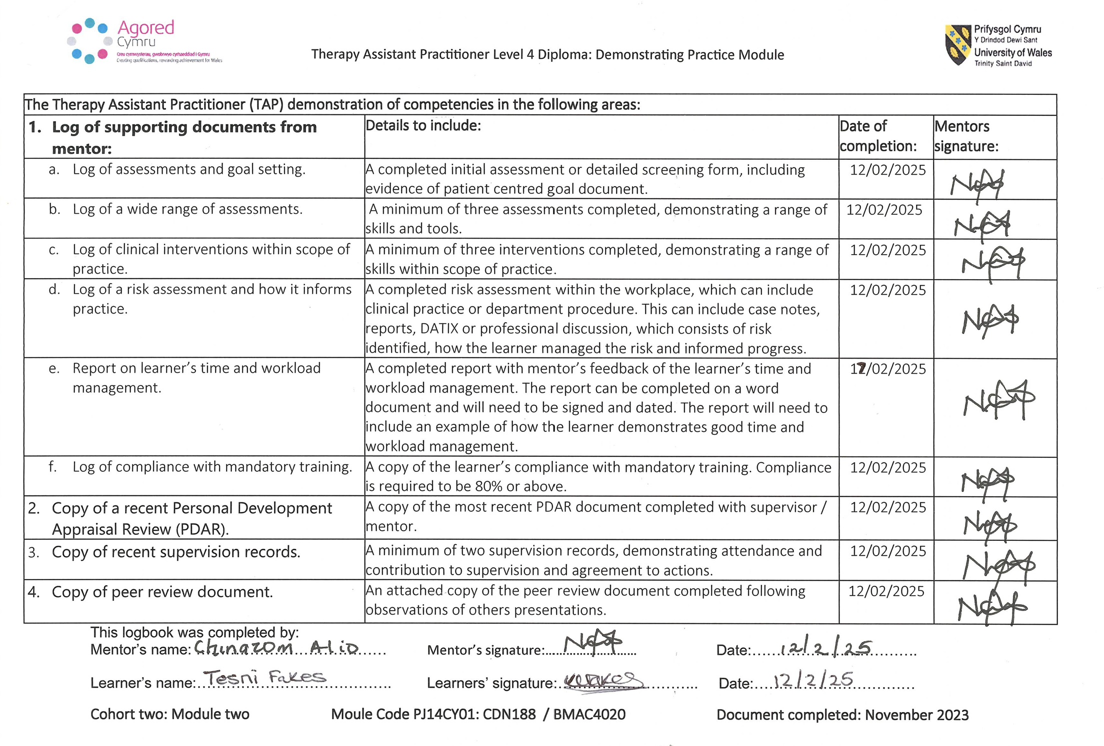
1a) Log of assessment and goal setting

I have included an example of some initial assessment notes which can be seen in Appendix A. To ensure confidentiality is maintained all patient identifiable details have been removed.

Appendix A

Intermediate Care Team - Tesni Fakes (Therapy Assistant Practitioner)
NHS number:
Background information
Visit completed on 20th September at 12:30pm. Introduced myself, my role and explained the reason for my visit, Pt consented to visit and for information to be shared with other relevant services. Pt was able to communicate verbally. Verbal consent given for initial assessment and therapy input. Pts son and daughter in law present during visit, verbal consent given for them to be present.
Cognitive – No concerns surrounding pts cognition at time of assessment
Reason for referral/date of referral/who referred: Reduced mobility and struggling with sit to stand from chair.
Personal Circumstances: Admitted to GGH on 11/08/24 following a fall a few days previous, alongside reduced mobility and confidence. Discharged home on 13/09/24 with CAS supporting.
PMHx: Arthritis, hypertension, depression, fluid retention
Medication: Apixiban, Ramipril, Prednisolone, Isosobride mononitrate, Folic acid, Bisoprolol, omeprazole, Furosemide, Mirtazapine, Colecalciferol, Fybrogel, Ferrous fumerate,
Social Situation: Pt lives alone in a privately owned bungalow. She is currently in receipt of CAS three times a day. Her son Mark and daughter in law Rose live 20 miles away but they are very supportive and assist with domestic tasks such as the cleaning and changing the bed sheets. She has another daughter called Deborah who comes to stay with her at the weekends. She has a lifeline in situ. She already has a fully adapted wet room and a bariatric mowbray over the toilet.
Other relevant professionals involved: CAS (Provider- MIHomeCare)
NOK name and contact number:
Functional Assessment
Mobility: Pt uses a Rollator Zimmer frame to mobilise short distances around her property, but over the last few weeks has only been managing to mobilise to and from the toilet. She expressed she would like to be able to mobilise into her kitchen to prepare herself a drink and sit in the chair in the kitchen. Pain from her arthritis can limit her mobility. She previously used a kitchen trolley to mobilise but feels more secure on the rollator zimmer frame with a caddy.
Falls: Her most recent fall was in August 2024, however she reports she did not fall all the way to floor and describes this more as a slip. She is unable to recall the reason for the slip.
Stairs: N/A
Chair: Pt has a riser recliner chair in situ in her micro-environment bedroom/living room. In the kitchen she has a bariatric chair with arms which is adjusted to the highest position to support her with sit to stands. Observed pt sit to stand and stand to sit independently using the chair riser functions. Kitchen chairs transfer not observed on this visit but agreed this was one of her goals.
Bed: Profiling bed with a bed support handle in situ. She required AO1 to transfer in and out of the bed. She states in the morning she is very stiff so struggles to get up, but CAS are supporting her to do this, they place the sani chair alongside the bed for her to transfer to, so she can be wheeled to the bathroom for her wash.
Toilet/commode: Toilet is raised with a bariatric mowbray, observed transferring on and off of the toilet independently. Sani Chair set at appropriate height to enable her to safely transfer on and off.
Wheelchair: N/a
Activities of daily living (ADL’S)
Washing and Dressing: CAS are currently supporting Pt to complete her wash, she is currently having a strip wash. She is currently transferring to the sani chair from the bed and being wheeled to the bathroom due to stiffness first thing. Hoping to return to using the shower as she regains her confidence and mobility improves. Level access shower in situ.
Bath/shower: Walk in shower/wetroom in situ. reports she was showering x1 a week prior to hospital.
Continence: She reports she is not incontinent but wears pads during the day. Overnight she wears a large pad, as she is unable to get out of bed independently to toilet.
Nighttime needs: Pad overnight due to difficulties getting out of bed independently
Feeding: No concerns reported, able to feed herself, no assistance or equipment required.
Medication: She has a nomad tray for her medications which enable her to manage and administer medication independently
Nutrition and Hydration: Slightly lower appetite than usual but not concerned about any weight loss at present. Dietetics referral not required at this time
Domestic Tasks of Daily living (DADL’S)
Meal preparation: CAS are currently supporting with meal preparation, but she advised she was previously able to do a light lunch. Rose advised she was really beginning to struggle with these tasks prior to hospital.
Shopping: Pts son does online Tesco order for her.
Household chores: Daughters and daughter in law are supporting with household chores but she is going to get someone in to support with tasks.
Driving: N/A
Cognitive: No concerns identified. Orientated in time, date and place
Patient Goals:
1) Improve mobility with RZF - aim to return to kitchen
2) Drink preparation
3) Showering
Intervention/Treatment:
Seated Exercises (Sheet provided) - x8-10 Hip flexion, x8-10 knee extension, x10 toe raises, x10 heel raises, x5 hip abduction. Advised to complete daily as able with arthritic pain. If unable to complete full repetitions, advised to complete as many as she could and progress as able.
Outcome/Analysis: Pt is motivated to progress, but can be limited by her arthritic pain, advised to continue taking her regular pain relief as prescribed to keep on top of pain. Strength and range of movement reduced due to arthritis and weakness. exercises more difficult to complete on the right leg. Encouraged to complete exercise program daily as able to tolerate to build strength in legs.
EQ-5D-5L completed.
Plan: Revisit next week for ongoing therapy input.

1b) Log of a wide range of assessments
In my role as a Therapy Assistant Practitioner in the Intermediate Care team, I carry out a variety of assessments for example dietetics assessments like in appendix B, shower assessments like in appendix C and physiotherapy functional assessments in appendix D.

Appendix B
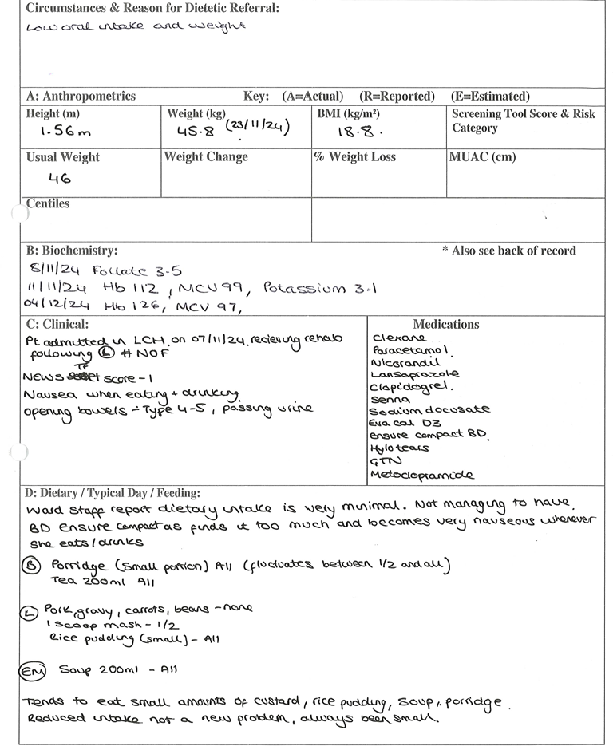
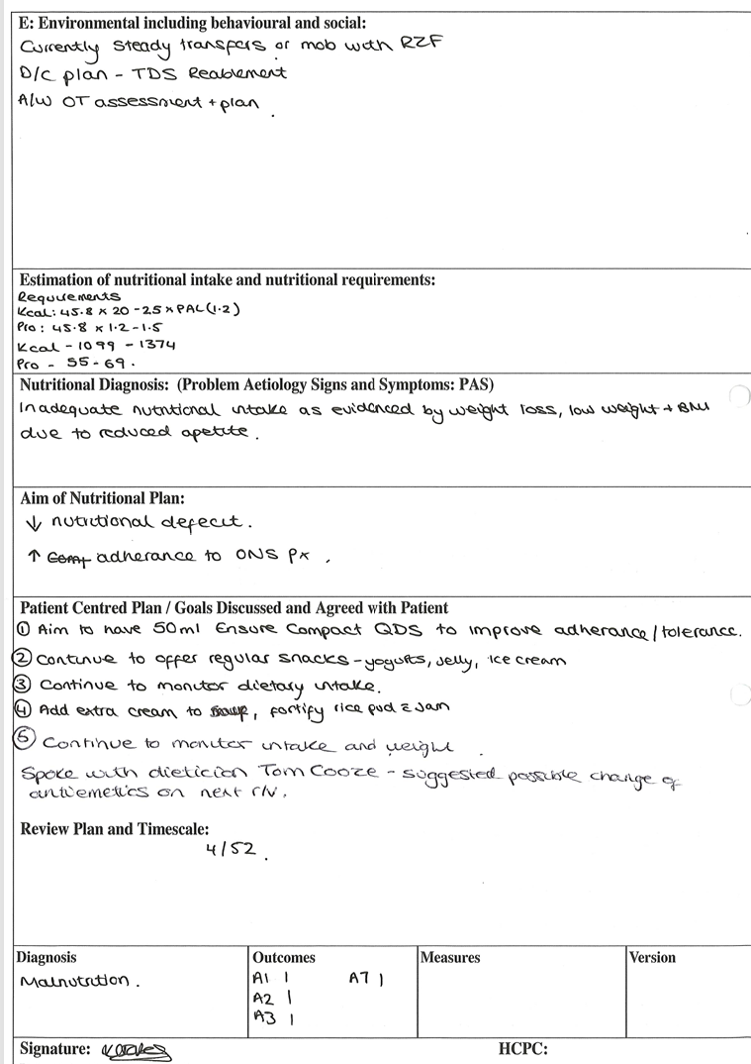
Appendix C

Intermediate Care Team - Tesni Fakes (Therapy Assistant Practitioner)

Patients Name:
DOB:
Address:
NHS number:
Visit conducted on 22/01/2024 at 9:30am in patients own home.
S) On arrival knocked on the front door before entering property. Called through to pt who called me through to the bedroom where she was sat in her chair. She advised she is doing well and feeling quite good in herself. She stated she feels her walking has improved and was keen to go straight to the shower this morning. Verbal consent given.
O) Sit to stand from chair independently. Mobilised to her bed independently to retrieve her clean clothes for post shower. She then mobilised using x1 walking stick and holding her clean clothes in the other approx 10 metres to the bathroom. Placed a clean towel on the perching stool, where she sat and began to undress independently. Sit to stand from perching stool independently before transferring into the shower independently using x1 grab rail. Operated shower controls independently. Washed body independently using her hands to lather her skin with soap. Managed to shampoo her own hair and rinse off with water by tilting her head forward to meet the shower head. Safely transferred out of the shower independently using x1 grab rail. Using towel, she dried her front independently, and most of her back. Used the towel draped over perching stool to dry areas of her back she could not reach. Independently got re-dressed whilst sitting on perching stool. Mobilised back to bedroom independently using walking stick. Sat in armchair. Minimal assistance given to plug hair dryer in but managed to independently use hair dryer and brush to dry and style her hair.
A) Patient was able to initiate the process of undressing and showering independently. No assistance required to undress or transfer into the shower. She was able to operate shower controls independently and managed to complete body and hair wash with no assistance. Since previous visit she has taken on board the advice given to lean her head forward to wash her hair due to the reduced movement in her shoulders and placed shampoo at a lower level for her to reach herself, this has allowed her to wash her hair independently, compared to the minimal assistance required previously. Once she had finished showering, she managed to dry herself independently using a towel, she also managed to dry her back easier with the towel draped over the perching stool as suggested previously, but reminded her she could also consider a towel robe. No issues identified with re dressing. She has increased independence since previous visit but still lacks confidence, so agreed to complete another visit to build confidence but encouraged her to try showering independently, even if it was on a day when daughter was somewhere else in the house, so she could get used to completing without direct supervision.
P) Revisit for confidence building with showering
Appendix D

Intermediate Care Team – Tesni Fakes (Therapy Assistant Practitioner) - Initial Assessment.

Assessment Details: Initial assessment completed on 10/01/2025 at 11:15am Tesni Fakes
(Therapy Assistant Practitioner). Introduced myself, purpose for visit and established preferred
name. Informed verbal consent gained for assessment and for pts friend to be present
throughout visit.

NHS number:
NOK details:

S) Pt reported he had been finding tasks challenging since coming home but was keen to progress at home. Informed him that support from reablement would commence this afternoon.

Present condition: Reduced mobility/ deconditioning following long hospital admission (4/12).

History of present condition: Admitted to GGH on 31/08/2024 following a fall where his right
knee gave way causing him to fall down 6 steps at home, resulting in multiple rib #s,
an undisplaced fracture of right side superior pubic ramus and right sacroiliac joint

PMHx: R cerebellar cavernoma, osteomyelitis T10, spondylydiscitis T10, T11 and L1
L2, epididymorchitis, depression, fluid overload

Medications: Atorvastatin 20mg, Cyanocobalamin 50microgram, Metformin 1g modified-release
tablets, Allopurinol 300mg tablets, Mirtazapine 30mg tablets, Bisoprolol 3.75mg
tablets, Dapagliflozin 10mg tablets, Folic acid 5mg tablets, Omeprazole 20mg gastro-resistant
capsules, Lactulose, senna, Zomorph 10mg modified-release capsules.

Social history and functional status: Pts wife passed away whilst he was in hospital and was
unable to attend the funeral. He is now living alone but has good support from his friend and his
wife. He is currently downstairs living in a single slated bed. His friends are supporting with
breakfast and evening meals, pt advised he does not typically eat anything at lunchtime. During
the day he manages to mobilise to the bathroom using RZF or uses urine bottles. Consent given
for referral to bereavement team for support. Would like to progress off of the RZF for more
freedom of movement.

Other relevant professionals involved: Reablement starting 10/01/2025 and referred to
neurosurgery for follow up for cerebellar cavernoma

Consent: Verbal consent gained for assessment and treatment.

Initial functional assessment:
Pt reports pain in seated position across lumbar spine/belt region and a stretch pain in posterior
thigh ? hamstring tightness.
Blood pressure checked in sitting 115/80 and standing 120/84. No postural drop noted. No
giddiness or dizziness reported during functional assessment.
Bilateral foot and ankle swelling noted but no pain on palpation.
Full functional ROM

Grading of Muscle strength
Right Hip Flexion 3/5 (Pain on lifting)
Left Hip Flexion 4/5
Right Knee extension 3+/5 involuntary contraction on extension to flexion, jerky movement noted
Left Knee Extension 4/5
Bilateral Ankle DF/PF 4+/5

Intact sensation - no numbness or abnormal sensations.

Mobility – Currently mobilising with step through gait using a RZF in the downstairs in his
property. Short stride length and flexed posture due to pain in back.

Transfers
Bed – Observed pt sit to edge of bed from supine independently, but with a little bit of difficulty
due to pain in his lower back, he reports this is much more difficult in the morning due to stiffness
and pain. ?bed support handle to support with repositioning and transfer.
Toilet - 6 inch raised toilet seat in situ. Observed stand to sit and sit to stand independent.
Shower - Walk in shower with small threshold to enter. Shower chair with arms in place. Height
and chair integrity checked. Suction grab rail in situ and checked secure on wall, the wall is
unsuitable for fixed grabrail due to it being plaster board, stressed the importance of checking
suction cups are secure before pulling on rail, advised to push up from arms on shower chair and
avoid pulling on grab rail where possible. Observed pt safely transfer in and out of shower. Stand
to sit and sit to stand from shower chair independent.
Chair - Observed stand to sit and sit to stand to sofa independent

Meal Preparation – Friends are currently supporting with meals and are happy to continue
providing support.

Eating and drinking – He reported that he had lost 4 stone whilst in hospital due to disliking
hospital food. No concerns reported with feeding.

Nutritional Screening
Weight - 85kg (10/01/25) Previous weight 76.2kg (15/12/24) and approx 101kg prior to admission. Height - 6 ft 2 inch / 1.87m
Eating/Drinking - Pt reports that he is eating better now that he is home, advising he did not enjoy
hospital meals. Friend is cooking breakfast and evening meals for him. He has never really been
an eater at lunchtime.

Typical day
Breakfast - Bacon and egg sandwich
Lunch - UFIT high protein drink
Dinner - Cooked dinners eg Curry and rice, Sunday roast, steak and chips

Physiotherapy diagnosis/ impression: Pt is currently limited by his back pain. There is some
quadricep weakness and hamstring tightness. He has rehab potential, with lower limb
strengthening and balance exercises it is likely that this man can progress and regain function.

Treatment goals:
1) Progress mobility - aim to get on x2 elbow crutches
2) Outdoor Mobility
3) Return to upstairs living
4) Return to driving

Action / Treatment plan:
- TAP to deliver home exercise strength and balance programme and progress mobility as able
- Refer to bereavement service
- Order bed support handle to support with bed transfers. (Bed rail risk assessment – attached to
Case note)

Review date: Week beginning 13/01/2025

1c) Log of clinical interventions within scope of practice.

Appendix E, F and G are examples of clinical interventions delivered within my scope of practice.

Appendix E
S) Discussion with Physiotherapist who raised concerns over pts use of the bed lever and asked for review. On arrival, knocked on door before calling through, met pt in corridor. Introduced myself and purpose for my visit. Pt reports she has been managing to get in and out of bed independently, but she has repositioned the bed lever to be at hip height to act as a block to stop her falling out of bed. Questioned if she fell out of bed frequently to which she said she has done in the past when she had a single bed and therefore, she is very anxious about this. Advised her it was not safe to use the bed lever in this way due to the risk of entrapment and that it should not be used to prevent falling out of bed, as that was not its designed purpose. Pt was understanding of the risk.
Explained that due to her current mobility, the fact she is living alone, and the type of bed she has that cot sides would not be appropriate either. Informed her also we would not prescribe cot sides purely to prevent rolling out of bed. Suggested moving her bed against the wall and returning the bed lever to correct position. With the bed lever back in the correct position educated her on how to use this to improve her positioning in the bed to ensure that she was high enough and central in the bed, so if she was to roll, she would remain on her bed rather than the floor. Reassured her that if she was to fall, she should use her lifeline pendent and that should give her some reassurance. She agreed it would be worth giving this a go, however, was not sure how she would manage to move the furniture in her bedroom, advised I would speak with care and repair with her consent to support her in moving the furniture. Verbal consent given. Advised her I would also be contacting CICES to inform them that this bed support handle had not been secured with the straps, so that this could be rectified to support her safety.
O) Met Pt in the hallway with her RZF. Pt mobilised to her bedroom independently with RZF. Demonstrated independent bed transfer. Pt mobilised 8m back to living room with RZF independently but occasionally furniture walking along route Left RZF 1m from armchair and furniture walked back to armchair where she sat down. As I was leaving Pt sit to stand independent, then furniture walked to front door. Advised to use her frame.
A) Pt is very anxious about falling out of bed, happy to try moving the bed against the wall and reposition bed lever to correct position to see if this helps reduce anxiety and reduce risk of entrapment. Query if she is using the RZF correctly as noticed patient furniture walk a lot rather than using frame. Discussed speaking with care and repair about installing some additional mop stick rails in hallway due to furniture walking to improve patient safety. Verbal consent given.
P) Feedback to physio outcome of visit. Refer to care and repair for mopstick rails and discuss moving bed. Contacted stores to notify them I had discovered a bed support handle which had not been secured with straps.
Appendix F
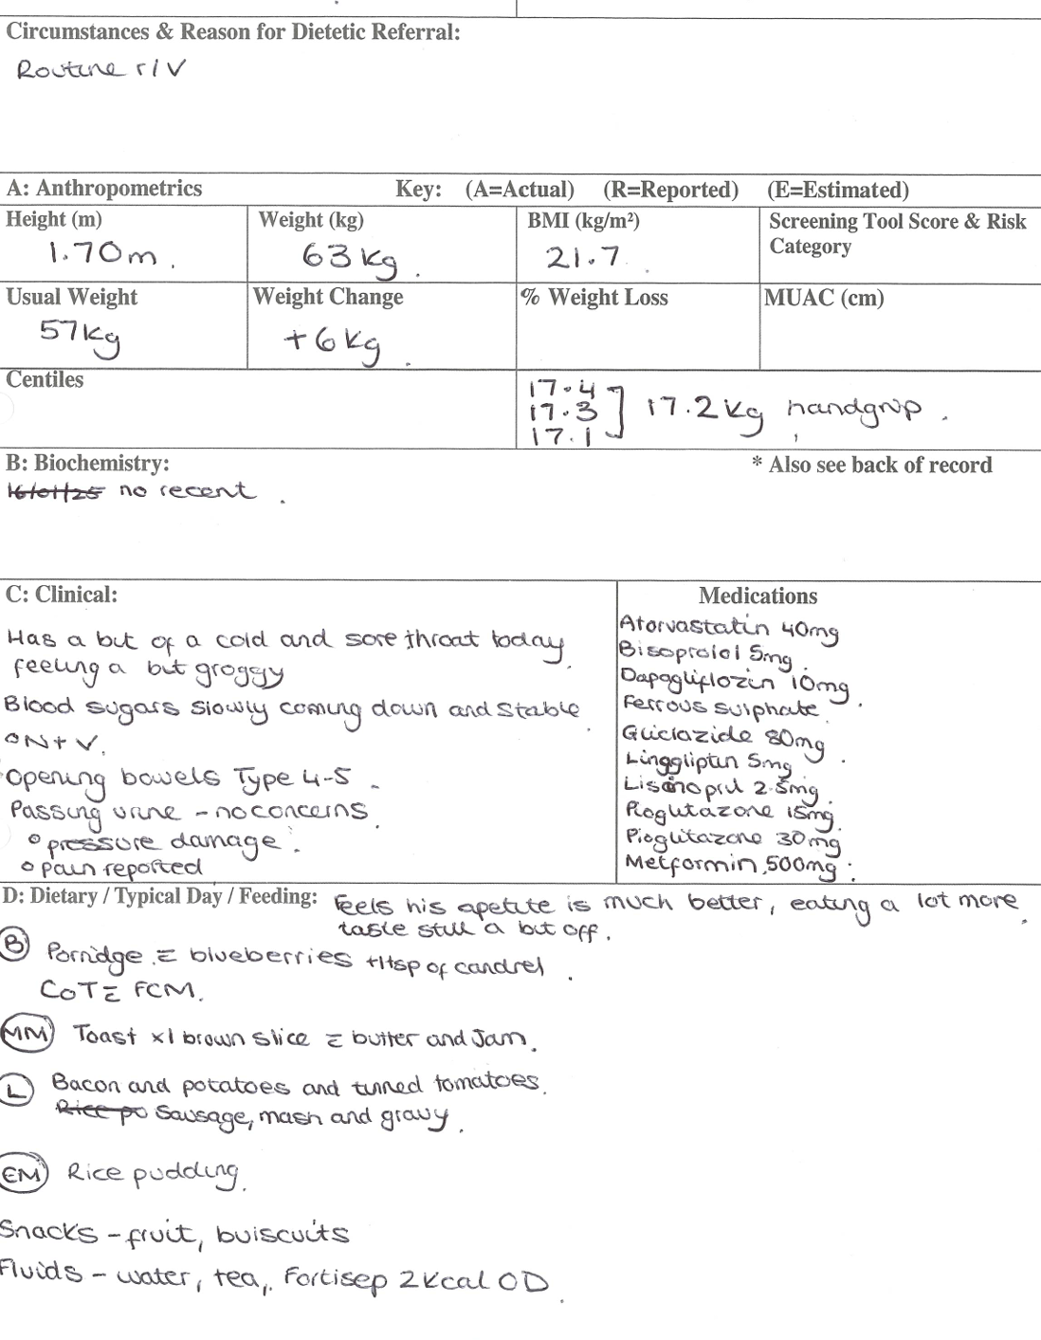
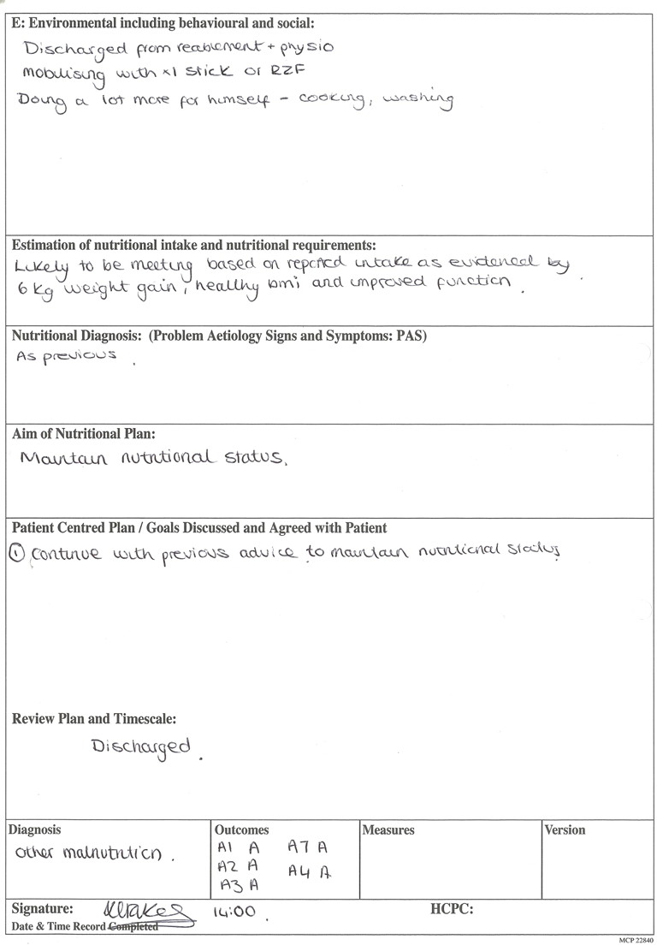
Appendix G

ICMDT - Tesni Fakes (Therapy Assistant Practitioner)
S) Telephone call made to arrange visit, verbal consent given. On arrival gained entry through unlocked door as advised by Pt. Pt sat on the edge of bed on arrival. Pt reports he is feeling a bit stronger and more balanced. He advised he attended DVT clinic yesterday and there was no sign of DVT so he has been discharged. He has an appointment with rheumatology on 11/04/25 at 15:30. He advised they have increased his oramorph so he can now have up to 10ml. He asked if I knew anything about pain clinic as he was told he would be referred, advised I would look into this. Discussed doing some more balance work and trying to mobilise with elbow crutches. Verbal consent given for input.
O) Sit to stand from edge of bed independent. Standing marching x20. 44 second unsupported stand with feet in parallel and eyes open. 40 second unsupported stand with feet in parallel and eyes closed with close supervision from therapist.
1st attempt - 38 second unsupported stand with feet together and eyes open.
2nd attempt - 45 second unsupported stand with feet together and eyes open.
sized crutches - took a few steps using crutches, would benefit from some slightly taller crutches.
Stand to sit back to bed independent
A) Pt noticeably stronger and improvements in balance since previous visit. Managed unsupported standing in parallel with eyes open and with eyes closed, also managed to stand unsupported with feet together and eyes open. Managed okay with crutches however would benefit from taller crutches if available. Will continue with balance exercises on next visit.
P) For ongoing input. Will review. Try find taller crutches.

1d) Log of a risk assessment and how it informs practice.

Working in the community as Therapy Assistant Practitioner, I am often required to prescribe equipment, I complete my assessments and clinically justify the need for equipment in my documentation as well as to assess and manage risk, an example of my documentation can be seen in appendix H. I also carry out the relevant risk assessments regularly, an example of a risk assessment I undertake is when prescribing bed support handles as can be seen in appendix J.

Appendix H

ICMDT – Tesni Fakes (Therapy Assistant Practitioner)

S) Initial Assessment completed on the 08/01/2024 at 13:00pm. Introduced myself, purpose of visit and established pts preferred name. Informed verbal consent gained for input from the pt. The pts husband was also present and consent gained for him to be present throughout the visit.

Current presenting problem - The pts husband is due to go for planned surgery tomorrow (9-1-
24). During his admission and recovery, it was the pts wishes to have Reablement to work on
gaining more independence with PADLS and DADLs. Usually, the pts husband would assist her
with many of these tasks. The patients immediate family will also be staying with the pt during
this time to support with anything in between the Reablement calls.

PMHx - Irregular Heart Beat, Spinal problems for over 10 years had back surgery 10yrs ago to
place a plate insitu in the Lumbar region, Decreased standing balance and decreased strength in
the lower limbs as a consequence.

Medication- Apixiban,Tidiem, Zomorph BD.

Social History and Environment- The pt lives in a privately owned bungalow with her
husband. The pt and her husband both collectively carry out the domestic tasks as well as the
grocery shopping. The patient reported that she does need assistance to ascend and descend
the step leading into her shower. Shower chair and rail insitu.

Falls within the last 12 months = 0. (1 previous fall in the kitchen over 1 year ago)

O)
- Patient has a kyphotic posture
- Full Active Range of movements throughout the 4 limbs.
- Grade IV / V power in the left Upper and lower limbs.
- Grade V / V power in the right upper and lower limbs.
- Sit to stand and stand to sit from armchair, dining chair, toilet and bed = Independent
- Bed mobility and bed transfers = either required assistance from her husband or could manage
independently, but the pt was pulling herself up from the bed with the use of the side cabinet and
walker. It was discussed and agreed to try pt with a bed support handle. Measured from head of
bed to top of patient’s shoulder when in supine. (Risk assessment form completed and attached
to case note, handle to be fitted 17&quot; from the top of the bed).
- The patient mobilised throughout her bungalow well, independently with the use of a privately
purchased, compact 4 wheeled walker using a 3-point step- through gait.

Assessment of Static standing balance
- Unsupported with feet at shoulder width apart = 4 secs and 5 secs.
- Unsupported with feet together = 2 secs and 3 secs.
- Evidence of inversion of the left ankle.

Treatment
- Advice provided to the pt to purchase and wear a more supporting pair of slippers/shoes.
- Recommendation given to remove all 3 x rugs in the home as they are a trip hazard.
- The patient went through lower limb strengthening exercises in sitting with no issues today (Hip
flexion x10, knee flexion x10, hip abduction x10, knee extension x10). Pt agreed to complete
these exercises herself x2/daily.

A) Patient is high functioning. Her standing balance is problematic and therefore would benefit
from input from therapy assistant practitioner to deliver balance exercise programme.

P)
- Order a bed support handle (Bed Grab Handle Risk Assessment - Please see attached.)
Equipment ordered for delivery and fitting from CICES (Order no: 108507)
- TAP to continue input to provide standing balance exercises.
- TAP to review bed transfers on delivery of equipment.

Appendix J
Bed Grab Handles
(ALSO KNOWN AS BED STICKS, BED LeverS OR bED LoopS)
RISK ASSESSMENT
Person’s Details
Name: |  | DOB: |  | NHS / WCCIS No:
Mavis Georgina Alexander |  | 29/09/1934 |  | 419-010-6240
Address: |  |  |  | Tel No:
3 Gilfach Y Gog, Penygroes, Llanelli, SA14 7RJ |  |  |  | 01269 831001
Assessor Details:
Name: | Tesni Fakes |  | Assessment Date: |  | 08/01/2024
Designation: | Theraoy Assistant Practitioner |  |  |  | 08/01/2024

Refer to assessment documentation for relevant medical information, details of the difficulties managing transfers on/off bed and bed mobility, and specifics of the equipment already in situ.

Are you prescribing only or prescribing and fitting the grab handle? (Please tick)

Prescribing only (complete section A only) Prescribing and fitting (complete section A+ B
Any checks in the red boxes requires further details. If further risk assessment details need to be evidenced – risk matrix to be used.

SECTION A

Factors to consider when prescribing a bed grab handle | Yes | No | If red box ticked add further details here
Would the provision of the bed grab handle increase the risk of injury to the person? |  | X
Would the provision of the bed grab handle increase the risk of injury to the formal/ informal carer? |  | X
Are there cognitive/ behavioural factors that could increase the risk of entrapment? |  | X
Are there Mental Health risk factors that could increase the risk of injury to the person? |  | X
Does the occupant/ carer have sufficient comprehension to understand risk factors? | X
Has the person sufficient understanding to use the equipment safely? | X
Are there involuntary or repetitive movements that would increase the risk of injury or entrapment? |  | X
Do the physical build/ characteristics of the bed occupant increase the risk of entrapment due to the occupants HEAD size? BODY size? |  | X
Consider the position of the bed grab handle at the time a person goes to sleep; is there a risk of entrapment whilst sleeping? |  | X
Has the person sufficient head, trunk and upper limb strength and coordination to use the equipment safely? | X
Would the provision of the bed grab handle increase the risk to skin integrity and tissue viability? |  | X
Does the position of bed grab handle impede transfers in and out of bed? |  | X
Do any other family members use the bed (e.g. children, babies)? | X |  | Husband sleeps and gets in and out of the bed on opposite side of the bed
Do you consider the risks to the occupant/carer having a bed grab handle to be less than the risk of not providing the item? | X |  | Other options required to be documented in casenote(s).  If ‘yes’ and special advice/provisions provided - document in the risk reduction plan (below).

Positioning on bed: - Bed end to bed grab handle (please tick) less than 60mm or greater than 318mm Pease specify 431mm

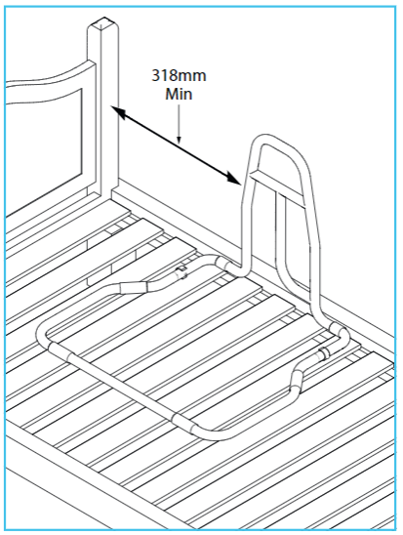
Indicate on the bed diagram below the position of the bed grab handle and any measurements to assist with fitting
Bed
Headboard

Foot board

SECTION B

Factors to consider when fitting a bed grab handle | Yes | No | If red box ticked add further details here
Is the mattress in good condition and the correct size and shape to fit the bed?

Is the gap between the headboard or footboard and the end of the bed grab handle greater than 318mm?

(refer to manufacturer’s instructions)

Is the bed grab handle compatible with the bed used? Ensure bed grab handle straps can be securely fixed to bed.

Is any existing equipment in use compatible with the bed, properly fitted, and maintained? There should not be gaps or traps that may allow an occupant to become entrapped.

Where the occupant/ carer is fitting the bed grab handle, have they been given clear instructions on how and where to fit the equipment?

Have you advised the occupant/ carer to check the fitting of the equipment regularly?

Has a copy of the bed grab handle manufacturer’s instructions been provided?

Risk Reduction Plan
List below any actions required to reduce the risks identified above i.e. training/ instructions

Action | Person responsible  to action | Date actioned
Explained the risks and correct use of equipment to the patient who was accepting and understanding of the risks associated with bed support handles.  Delivery instructions provided to equipment stores including clear instructions on how and where to fit the equipment.  Therapy Practitioner to come out and review bed transfers once equipment has been fitted to ensure correct use. | Tesni Fakes  Tesni Fakes  Tesni Fakes | 08/01/2024  08/01/2024  To be actioned when equipment is delivered week of 15/01/24

Signature of Assessor: T. Fakes …………………………………….……….. Date: 08/01/

1e) Report on learner’s time and workload management.

A written statement from my mentor, reporting on caseload and workload management can be seen in appendix K.

Appendix K

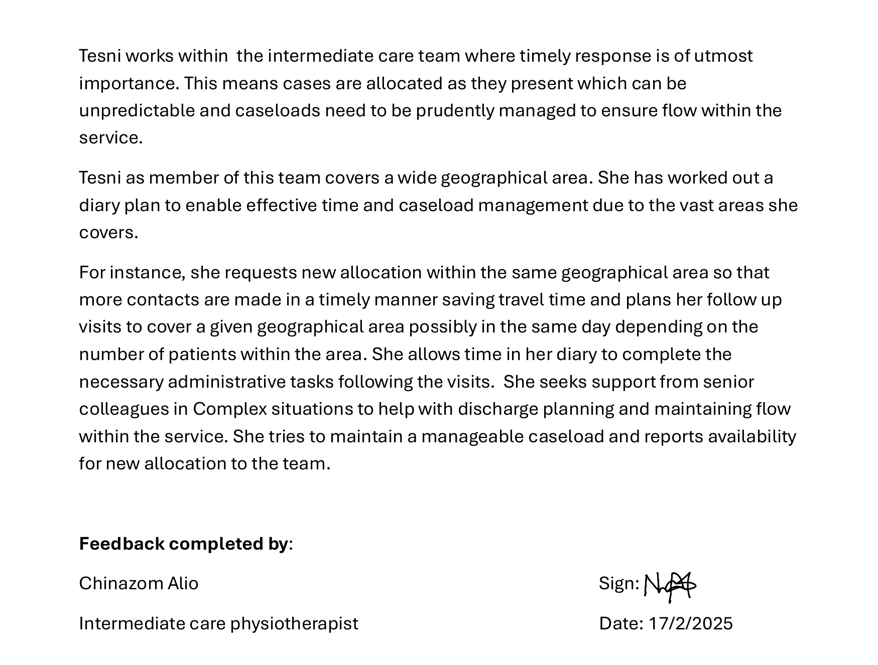

1f) Log of compliance with mandatory training

Compliance to mandatory training is essential in the role of the Therapy Assistant Practitioner. Appendix L demonstrates my compliance to mandatory training.

Appendix L

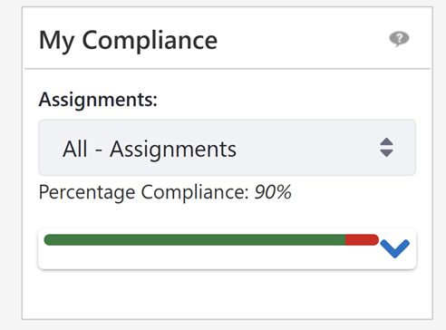

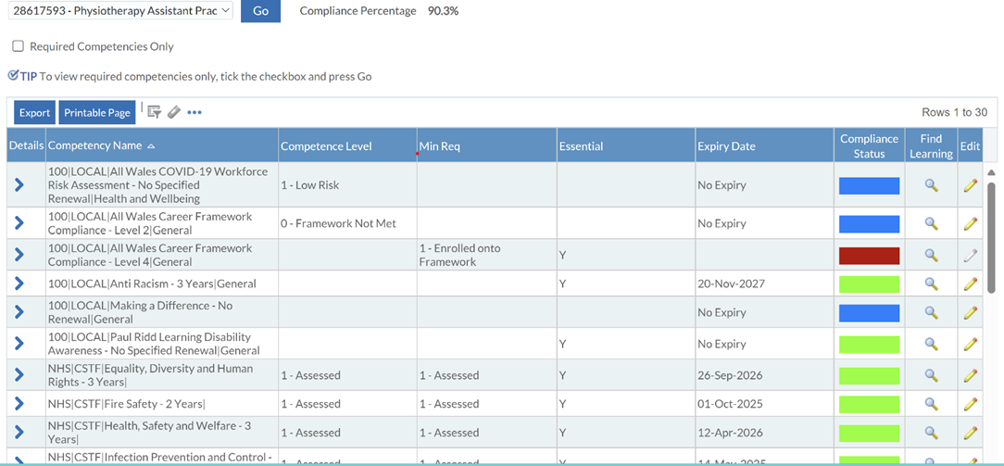

2) Copy of recent PADR Review
Appendix M

PERFORMANCE APPRAISAL DEVELOPMENT REVIEW

CORE PADR

My Details / My Appraiser’s Details
My Name: | Tesni Fakes | My Job Title: | Therapy Assistant Practitioner
Department: | ICMDT | County: | Carmarthenshire
Review Period Start Date: | 05/03/24 | Review Period End Date | March 2025
Appraiser Name: | Leanne Walters | Appraiser Job Title | Lead physio
Date: | 05/03/24 | My Pay Number: | 28617593
Personal Review of Objectives– to be completed by the appraisee during the discussion
a) What have been the successes for me this year?
- Continuing to work well within an integrated MDT and multi-agency team.
- I have attended and completed a ‘Therapy Expo’ National Parkinson’s Exhibition and Conference at Birmingham – 2 Days – 23rd and 24th Nov, 2023.
- Continued to gain knowledge and skills in Dietetics and OT as well as Physiotherapy within this TAP role.
- I completed my B4 OT competencies on 23rd February 2024.
- I am continuing to complete my AGORED – L3 Physiotherapy and Occupational Therapy Diploma.
- I have been working well within the bed based and community setting.
- I assisted Rached Budge; Dietitian complete an audit for Amman Valley Hospital – Patient scoring on the MUST Tool and been correctly referred to Dietetics.
- I assisted Leanne Walters with producing a training pack for HCSWs within ICMDT.
- I devised a STATS guide for the whole of the Community Physio service.
- I am competent in my ability to know when is the correct time to hand over or discharge my patients.
- Completed MUST screening on ESR

b) What have been the challenges for me this year?
- The biggest and most stressful challenge for me this year was to be the main carer for my dear Grandmother and work full time. Sadly, my grandmother passed away in December 2023. I am left with a different kind of challenge now since her passing – Grieving and adapting and accepting.
- Managing my own caseload can be challenging at times. My calls are better located Geographically compared to last year.
- Complex cases i.e. safeguarding issues etc.

Objective Setting
What are my TEAM objectives for the next year?
- Continue to manage my caseload and support in the team’s objectives, which is to prevent admissions and free up capacity for other services.
- Support the team with difficult patient’s/families.
- Encouraging patient empowerment.
- Continue to have the confidence to recognise scope of practice.
- Continue to contribute effectively within the MDT.
What are my PERSONAL objectives for the next year (Max 8 objectives)? Use SMART Guidance. How do they relate to the Organisational Values? (click here Hywel Dda University Health Board | Values - Introduction for further guidance)
  Working together to be the best we can be |   Striving to Develop & deliver excellent services |   Putting People at the heart of everything we do

Core Objectives
Objectives | Expected outcome/measure of achievement | Target date | Support/action by Manager/others | Progress Review date
1.Complete mandatory training | 100% compliance on ESR | April 2024 | 90% compliance at present | 05-04-2024
2. Engage with & complete yearly PADR | ESR data compliance | March 2025 | Tesni is happy to engage in PADR & contributes towards appropriate objectives | March 2025
3. Ensure compliance with the Welsh Language Standards and promote and facilitate the use of the Welsh Language in the workplace | WLS compliance | March 2025 | Tesni will read the Welsh language standards – she is able to speak level 2 Welsh | March 2025
Personal Objectives
4. Promote the care and Rehabilitation process for Parkinson’s patients. | To present the information that I gained from attending the course in Birmingham to the ICMDT therapies team. | April 2024 | Encourage Tesni to complete this & support with dedicated time to complete | May 2024
5. Further Develop knowledge & skills within physio & OT | Complete the L3 AGORED Cymru Physio and OT modules. | March 2025 | Encourage Tesni to complete this & support with dedicated time to complete. Leanne to also be the AGORED assessor. | March 2025
6. Become an I.T. Champion for this team | Look into and complete an I.T Champion course | March 2025 | Encourage Tesni to complete this & support with dedicated time to complete. | March 2025
7. To complete the Welsh language course | Look into completing the Welsh language course available to employees of HDDUHB | March 2025 | Encourage Tesni to complete this & support with dedicated time to complete. | March 2025

Personal Development Plan
Identify below the learning & development needs required to fulfil/maintain your personal objectives
Development to meet objectives Refer to Appendix 5
- Await dates for course The Welsh language course.
- Continue with AGORED Cymru modules.
- Look into dates for I.T Champion course.

General Comments
General comments regarding this review period
Tesni is feeling happy and content with her TAP role. She would however love the opportunity to further progress her career and become a band 5 specialist TAP.
Tesni is also considering looking into completing a degree in Dietetics.
This year has been more challenging emotionally, but Tesni has done well to get through it and still manage to produce such good work.
What are my career aspirations for the next 12 months?
Continue to develop skills & knowledge within the MDT.
Develop another case study/patient story.
Tesni is looking forward to attending the DMRC insight day in Loughborough – 20th March 2024. This may help further with inspiring her to further develop in a certain aspect.

Summary (To be completed by Appraiser)
Provide a summary of your overall assessment of the individual’s performance during the review period, including any areas requiring improvement.
Tesni plays a very important part within the ICMDT. She has great knowledge and skills as a generic Band 4 TAP, which really benefits the patients and support the registrants.
She has developed her communication skills greatly, during this review period and has gain so much confidence when verbally communicating with patients and families on the telephone.
Her time management and prioritisation skills have continued to develop to a great standard.
Tesni is always happy to help all other members of the tam and nothing is too much for her. She is a go-to person when it comes to I.T issues in particular.
It is an honour to have such a kind, professional, caring individual within our special team. I look forward to further supporting Tesni and see her continue to develop further.

Pay Progression (To be completed by Appraiser)
Step 1
Is this PADR a pay affecting progression appraisal? Yes – Due in June 2024 No (if yes go to Step 2 below)
(See the All Wales Pay Progression Policy)
Step 2
Has the appraisee achieved their objectives for the previous year and met the standards of the pay progression policy, see below?

1 | Appraisee has achieved their objectives | Yes |  | No
2. | The appraisal process has been completed within the last 12 months and outcomes are in line with the organisation’s standards | Yes |  | No
3. | The appraise has achieved 100% compliance for mandatory training | Yes |  | No
4. | There is no formal capability process in place for the appraisee | Agree |  | Disagree
5. | There is no formal disciplinary sanction live on the appraisee’s record | Agree |  | Disagree
6. | The appraiser must complete the Pay Affecting Progression Appraisal on ESR (See ESR MSS41 online training) | Completed

I am committing to this by signing :  T. Fakes | Date:  05-03-2024
My appraiser agrees by signing :  Leanne Walters L. Walters | Date:  05-03-2024
Date of Next Review: 04-03- 2025

3) Copy of recent supervision records (at least two).

Appendix N
Physiotherapy/Dietetic/OT Service
Record of Individual Supervision
Name of Supervisee: | Tesni Fakes | Name of Supervisor: | Leanne Walters
Date:  Time: | 14/10/24  09.30am | Venue: | Ty Parcyrhun
PADR Date: | 04th March 2025 | Date of previous supervision: | 06-08-24
Mandatory Training: | 76% | Current Working Pattern: | Full time- 9 Days a fortnight
Annual Leave Balance: | 54.5hrs / 6.5 days | Sickness: | 3 days sickness leave and 26 days bereavement leave

Standing topics to be discussed in every individual supervision session
Issue/ Key item discussed | Discussion | Actions agreed | Timescale | By whom
Individual Wellbeing | Tesni suffered an episode of vertigo recently and since then has suffered with an increase in fatigue levels. She finds that she is fatigued during the day and at bedtime is wide awake and thus is unable to sleep until the early hours. It is therefore a vicious cycle.  She continues to experience some dizzy spells and nausea.  Tesni is continuing to exercise regularly and is socially more active. She has lost approximately 1 ½ stones in weight. She is healthy eating. She is building a better routine.  Tesni continues to have headaches intermittently. There are lesions present in the white matter in the frontal lobe. This could be caused by the migraines it was reported. If Tesni continues to struggle in 3 months’ time she is to be reviewed.  Tesni also clenches her teeth badly at night, which is believed to also be causing the headaches. She now wears a sleep clench inhibitor. This she reports is helping.  It has been a very emotional few weeks between her health-related problems, starting university and it was her grandmother’s heavenly birthday last week and the burial of her ashes on Saturday. | Tesni to keep liaising with me as to how she is feeling and if a referral to Occ Health will be needed re insomnia.  Tesni has started taking lions Maid herbal remedy for alertness and concentration and this she feels is helping.  Leanne advised Tesni to ask her GP to have a blood for a full blood count levels.  Tesni to continue to liaise with her GP as he has advised that if her symptoms persist after 4 weeks he will refer her to ENT to assess if she is suffering from Meniere’s Disease.  Continue to monitor and re assessment with the consultant if it is required.  Tesni is to continue to pace herself in the workplace and if she is not feeling well on the day and is unable to drive she is to either be office based if well enough or takes sick leave.  Tesni is to keep liaising with me on how she is feeling. She knows that she can contact me at any time and can take time out to have a well being and supportive chat. | Ongoing  Ongoing | Leanne and Tesni  Tesni and Leanne
Patient Case study including  review of clinical record  (to be brought by supervisee) | Tesni’s caseload = 10 active pts on caseload, 1 of which now require Dietetic input too. There is also 2 new dietetic patients to be seen. All apart from 1 pt are up in Llandysul, St.Clears, Pencader, Llanllwni.  1= PER49172 = Difficulties in discharging this pt about month ago. He has now come back through from ART ? Vestibular problems. Tesni requested for Chinazom to carry out a joint visit with her. This visit went well. They are now working together on moving this gent forward and creating a plan for discharge. This pt had #his wrist and Chinazom had organised for his GP to organise for transport and for an x-ray to be carried out.  2= PER33915 = Severe arthritis. In a lot of pain. Tesni is working with her to improve her mobility and be able to get to the kitchen to make herself drinks and food. Tesni wont be long before discharging her.  3= PER65668 = ON caseload for 2 weeks. Post stroke a few months ago, had a fall and been in LCH. Needs mobility progression. Working on bed transfers too. Katie Fink also involved. | Tesni must continue to review her caseload and not be afraid to t/f cases over to the other TAPS if they are geographically in that area.  Tesni reported that she is more conscious of ensuring that she is allowing herself enough time to type up her pt notes and stats. This month she reports that she has not typed up notes retrospectively. Leanne advised that this is essential. Leanne agrees that Tesni needs to timetable in protected time each afternoon for notes and stats. She is also now timetabling in time for travel etc. | Ongoing | Tesni
Review of CPD portfolio/ Evidence of CPD activity since previous supervision | Tesni has started the L4 AGORED course, which started in Sept ’24. | This going well.
Review of actions from  previous supervision | Tesni had previously reported there were a few issues re TAP- Emma Hughes. Tesni reports today that she feels Emma may be working a little better currently compared to previously.  Therapy car – Tesni and Gerallt are not happy with the use and location of the therapy car. It is being used now by colleagues in Llanelli for non-urgent calls and on Friday 11-10-24 Emma H had it on a normal call in Trimsaran and it was not there for crisis calls. This does not fall in with the therapy car criteria for use.  Work base – This is still not changed. Indeg had previously mentioned that she was going to look into changing the bases. This is unfair for the Ammanford staff considering that there is no therapy car based there thus Llanelli colleagues have their base as Llanelli as well as using the therapy car. | Monitor this  Leanne to speak to Indeg  Leanne to speak to Indeg | Ongoing  Within 2 weeks  Within 2 weeks | Leanne and Tesni  Leanne  Leanne

Additional Topics brought to supervision for discussion:
Issue/ Key item discussed | Discussion | Actions agreed | Timescale | By whom
Notes audit  EQ5D | Leanne looked over adhoc Tesni’s case recordings/notes today.  1 = PER33915  Follow up visit completed – The notes were typed in SOAP format and included all the information that was required to be recorded. Each section was well documented, and it had a good analysis and clear plan moving forward with the patient.  2 = PER56622  Initial assessment – Tesni completed a combined OT/PT initial assessment form. It was fruitful with information. There was a clear PMH, Medication Hx, social Hx was also well documented with lots of information, but at the same time concise. Tesni included a clear list of pt centred goals as well as a plan.  Tesni is completing this requirement with her patients. She has not yet recorded the outcomes on the spreadsheet as she plans to record them at the point of discharge. As it look like therapists apart from 1 are not recording the EQ5D it was agreed that Tesni will record onto the spread sheet at the point of initial assessment and then go back on to record at the point of discharge. | Leanne is very happy with Tesni’s case recordings. They are clear and concise and include everything that is required by the note keeping standards.  Tesni to continue to complete notes to this high standard.  Tesni to record onto the spread sheet on both initial and discharge. | Ongoing  Ongoing | Tesni  Tesni

Work Plan:
Duty/Project/Meeting or Group representation: | Frequency and time taken | Progress/Status/Update/Actions outstanding | Priority | Target Date | PROGRESS
Presenting on Parkinson’s Disease in the in service ICMDT meeting | Tesni to liaise with Chinazom for a date | Finish the presentation and liaise with Chinazom re a date to present. | Moderate | December 2024 | Has started the presentation – plan to present in Feb or March in service training.
Date of next individual supervision: | 25-11-2024 @ 8.30am L. Walters T. Fakes

Physiotherapy/Dietetic/OT Service
Record of Individual Supervision
Name of Supervisee: | Tesni Fakes | Name of Supervisor: | Leanne Walters
Date:  Time: | 17/11/24  08.00am | Venue: | Ty Parcyrhun
PADR Date: | 04th March 2025 | Date of previous supervision: | 14-10-24
Mandatory Training: | 86%(MAN Handlingx2+L4 NVQ) | Current Working Pattern: | Full time- 9 Days a fortnight
Annual Leave Balance: | 46.17hrs / 5.5 days | Sickness: | 3 days sickness leave and 26 days bereavement leave

Standing topics to be discussed in every individual supervision session
Issue/ Key item discussed | Discussion | Actions agreed | Timescale | By whom
Individual Wellbeing | Tesni has not suffered another episode of vertigo since her last supervision. However, she reports that she remains suffering with fatigue and believes this is due to feeling overwhelmed. She finds that she is fatigued during the day and at bedtime is wide awake and thus is unable to sleep until the early hours. It is therefore a vicious cycle. Tesni reports that she is used to this as it is chronic.  Tesni is continuing to exercise regularly and is socially more active. She has lost approximately 1 ½ stones in weight. She is healthy eating. She is building a better routine.  Previous supervision Tesni reported that she continues to have headaches intermittently. There are lesions present in the white matter in the frontal lobe. This could be caused by the migraines it was reported. If Tesni continues to struggle in 3 months’ time she is to be reviewed.  Today she reported that she is experiencing more headaches than previously, she does feel that they are caused by stress. She’s had 2x deadlines for submitting university assignments and a presentation as well as keeping up with her caseload.  Tesni reported that she is feeling particularly anxious about her financial situation. She advised today that she only has £1 in her bank account until pay day in 2 days’ time. Out of her pay this month a large sum of it will be going out to pay back her credit, which she has had to use throughout the month too. The reason she is going into negative credit recently is due to her petrol costs for her vehicle. She is travelling to cover calls North and West of the county. Llandysul, Llanybydde, Llanllwni, Llanglydwen, Llangynnog etc…  An example on her SEL in October was – 15day = £190.83, 13 days - £158.93, 19days - £126.09.  It is 19 miles from Home to GGH(base) thus is losing 38miles/day / 190miles/week = £85.50/week. Plus Tesni has to pay up front for Eastgate car parking fees. Tesni therefore tries to limit/avoid coming to Eastgate as she does not get paid for travelling to and from there as well as not having the money to pay for the car park ticket each time. This has a detrimental effect on her well being and mental health and she feels that she may not have a choice but to look for other job opportunities that may arise where she does not have all this outlay.  Eg of a call Tesni went out on Friday 15-11-24 – 70m return from her home = She Could only claim for 32m = £31.50 - £14.40 = loss of £17.10.  Work base – This is still not changed. Indeg had previously mentioned that she was going to look into changing the bases. This is unfair for the Ammanford staff considering that there is no therapy car based there thus Llanelli colleagues have their base as Llanelli as well as using the therapy car. | Tesni to keep liaising with me as to how she is feeling and if a referral to Occ Health will be needed re insomnia.  Tesni continues taking lions Maid herbal remedy for alertness and concentration and this she feels is helping.  Leanne advised Tesni to ask her GP to have a blood test for her full blood count levels. Tesni will look into this.  Tesni is to keep liaising with me on how she is feeling. She knows that she can contact me at any time and can take time out to have a well being and supportive chat.  Leanne to speak to management re this situation urgently.  Leanne to speak to management re this situation urgently. | Ongoing  Ongoing  By end of the week  By end of the week | Leanne and Tesni  Tesni and Leanne  Leanne  Leanne
Patient Case study including  review of clinical record  (to be brought by supervisee) | Tesni’s caseload = 10 active pts on caseload,  PER: 49172  AP – Tesni has had joint input and support with this complex Gent from Chinazom. They are due to complete his service this pm.  PER33808  WIC – Pt is currently at TPP. It was agreed that Emma H – TAP covers the OT element of TPP. However Leanne Murphy allocated this pt to Tesni to take out and fit a Mowbray. This has meant that Tesni has had to liaise with Lisa May about the needs, liaise with the pt’s daughter too, to organise for the delivery and fitting of this piece of equipment before Tuesday 19-11-2024. This has put Tesni under a little extra stress as she has spent time liaising to organise this and was meant to travel from Ammanford to stores in Llanelli to collect the Mowbray and then bring it back to Ammanford to fit it on the Monday – 19/11/24. Tesni is concerned as she has never seen this pt, does not know how hight the Mowbray needs to be too and does not have capacity to review again this week.  PER43627  PL – Pt of Katie Fink’s. She is asking for a riser recliner armchair and is currently sleeping in a mechanical non electric armchair. Tesni feels this puts the pt at risk as it has no pressure relief built in as she sleeps in it and unable to push down through her arms to raise up to a standing position. When in standing also, the pt uses her walking stick to push the leg raiser in.  The pt is however currently requesting to go in to placement permanently. | Tesni must continue to review her caseload and not be afraid to t/f cases over to the other TAPS if they are geographically in that area.  Tesni reported that she is more conscious of ensuring that she is allowing herself enough time to type up her pt notes and stats. This month she reports that she has not typed up notes retrospectively. Leanne advised that this is essential. Leanne agrees that Tesni needs to timetable in protected time each afternoon for notes and stats. She is also now timetabling in time for travel etc.  Leanne advised Tesni to speak to Emma Dickeson re this situation. It is not TPP that have requested this – it is Lisa May who has requested this as her daughter has asked for it. Tesni is to complete a follow up call to the pt on Wednesday morning and if there is an issue if Tesni is unable to call on Wednesday she is to hand it over to Gerallt or Emma H.  Leanne advised to see what the outcome is re the pt going into placement or not. If she doesn’t Tesni to speak to Katie Fink re ordering her an armchair. | Ongoing  Tesni  Ongoing | Tesni  Tesni  Tesni
Review of CPD portfolio/ Evidence of CPD activity since previous supervision | Tesni continues with her L4 AGORED course, which started in Sept ’24. It is going well, but it is stressful trying to manage her caseload as well as complete all the assignments and attend lectures.  Tesni reported that she has had very positive feedback so far from her lecturer.  Tesni and I are due to attend a progress review on 27th November ’24. | This is going well. It is important that Tesni paces herself. | Continue | Tesni
Review of actions from  previous supervision | EQ5D - Tesni is completing this requirement with her patients. She has not yet recorded the outcomes on the spreadsheet as she plans to record them at the point of discharge. As it look like therapists apart from 1 are not recording the EQ5D it was agreed that Tesni will record onto the spread sheet at the point of initial assessment and then go back on to record at the point of discharge.  Tesni reports that she is completing this. | Continue with this | Ongoing | Leanne and Tesni

Additional Topics brought to supervision for discussion:
Issue/ Key item discussed | Discussion | Actions agreed | Timescale | By whom
Mandatory Training  TOIL | Leanne has been chasing Tesni up to complete her mandatory training, which she has done this month. She is unable to get herself up to 100% due to having to wait until 2025 for manual handling training L1 and L2.  Tesni has requested to take TOIL at the end of the working day on 24-12-2024. To leave at 13.50hrs thus taking 3hrs of TOIL.  She needs to travel up to her family home in Berkshire for xmas and the traffic will be heavy.  Tesni has asked to take TOIL on Wed 20-11-2024 for a GP appt - ?1/2hr. | Tesni to attend manual handling training at the 1st available opportunity.  Leanne has agreed this with Tesni.  Leanne has agreed to this. | End of Jan 2025 | Tesni  Leanne  Leanne

- Completed peer review sheet.

Appendix O


Therapy Assistant Practitioner:
Demonstrating Practice
Peer Review Feedback form

This peer review feedback was completed by: Tesni Fakes Date: 11/02/2025

The following tables will contain peer review feedback on presentations demonstrating quality improvement projects, using a PDSA cycle.

Feedback one: | Presentation topic: Consent - Amy
Congratulations | What does the presenter do well? What were the presenters’ main points?  Represented data in a clear way and was able to discuss the results, in a relatable way by putting it into context about how many hours in the working day could be put to better use if they were not seeing individuals that had not consented in the first place, and she backed herself up with imagery. Main points included nearly 75% of patients did not know they had been referred. Nearly 50% of patients did not give consent for referral.
Ask for clarifying questions. | What aspects of the presentation were confusing or unclear? Why?  Referred to her job but she never made it clear as to where she was based, which team until quite late in the presentation which would have supported what she was saying and provided more context.  What suggestions (at least 2) do you have for the presenter, in order to improve this presentation?  - Flow of presentation - Use less filler words like umm  - Clearly introduce herself and her role to provide full context to her quality improvement project
Request more. | What would you like to know more about the topic?  How could you go about educating others in ensuring they have gained consent – There is already mandatory training in place but what more can you do?  Did you do anything resolve the fact a number of patients answering that they did not consent for referrals.
Evaluate its value. | What specific details would you take forward into your own practice?  Importance of ensuring individuals are consenting and aware that they are being referred to a service.
Summarize | What new information have you learnt? Has this influenced you to think differently?  I was shocked to learn how many individuals, had not consented to the service, therefore, it encourages me to ensure I have fully informed patients and make sure it is clear I have their consent.

This peer review feedback was completed by: Tesni Fakes Date: 18/02/2025

Feedback two: | Presentation topic: Ferrule maintenance - Dylan
Congratulations | What does the presenter do well? What were the presenters main points?  Dylan spoke with a good pace, ensuring the point he made were clear and that the presentation flowed. Key points included integrity of walking aids is crucial in ensuring patients safety and supporting individuals to increase independence, stability, confidence and posture and to limit pain. Prior to Dylans input regular checks on ferrule integrity did not seem to be happening but following his PDSA cycle this seems to have improved.
Ask for clarifying questions. | What aspects of the presentation were confusing or unclear? Why?  Sometimes the presentation could be hard to follow due to layout and colouring of slides  What specific suggestions (at least 2) do you have for revising the unclear parts of this presentation?  - Could improve the colours of slides – it was difficult to read citations as they were white on a bright green background.  - Accuracy of citations – noticed one citation was walkingsticks.co.uk
Request more. | What would you like to know more about the topic?  What advice would you provide to patients in the community to support safe maintenance, and to support with fault reporting. Is there potential to create a guidance sheet to give to patients when issuing equipment.
Evaluate its value. | What specific details would you take forward into your own practice?  Remembering the importance of checking the integrity of ferrules on each visit not just initial visit, as wear and tear can happen at different rates depending on use of mobility aids between therapy visits.
Summarize | What new information have you learnt? Has this influenced you to think differently?  Shocked to learn that not many professionals were regularly checking the integrity of walking aid ferrules. Influencing me to check that my own team are checking and reporting these issues to minimise risks to our patients in the community.

