
Skills for the Workplace
Module Assignment Submission
Student Name: | Anamaria Bock
Student Number: | 2114314
Module No: | BMSK4006
Module Title: | Part 1 Business Plan

Statement of Confirmation of Authenticity
By the act of making this submission, the student declares that this is the work of the student named above. The work has not, in whole or in part, been knowingly presented elsewhere for assessment, or where assessment has been built on a previous assessment, this has been identified. Where materials have been used from other sources it has been properly acknowledged. If this statement is untrue, the student acknowledges that an assessment offence has been committed.
Attention is drawn to the plagiarism and unfair practice policies of both the University and of ILM.

Table of Contents
Title Page 3
Executive Summary 4
Introduction 5
Layout and structure 6
Marketing Plan 6
Market Analysis and Competition 6
Pricing Strategy 9
Sales and Distribution 12
Advertising and Promotion 14
Operating Plan 14
Financial Plan 15
References 16
Appendices 16

Title Page

Go nuts, donuts

Owners: Anamaria Bock and Marius Bock

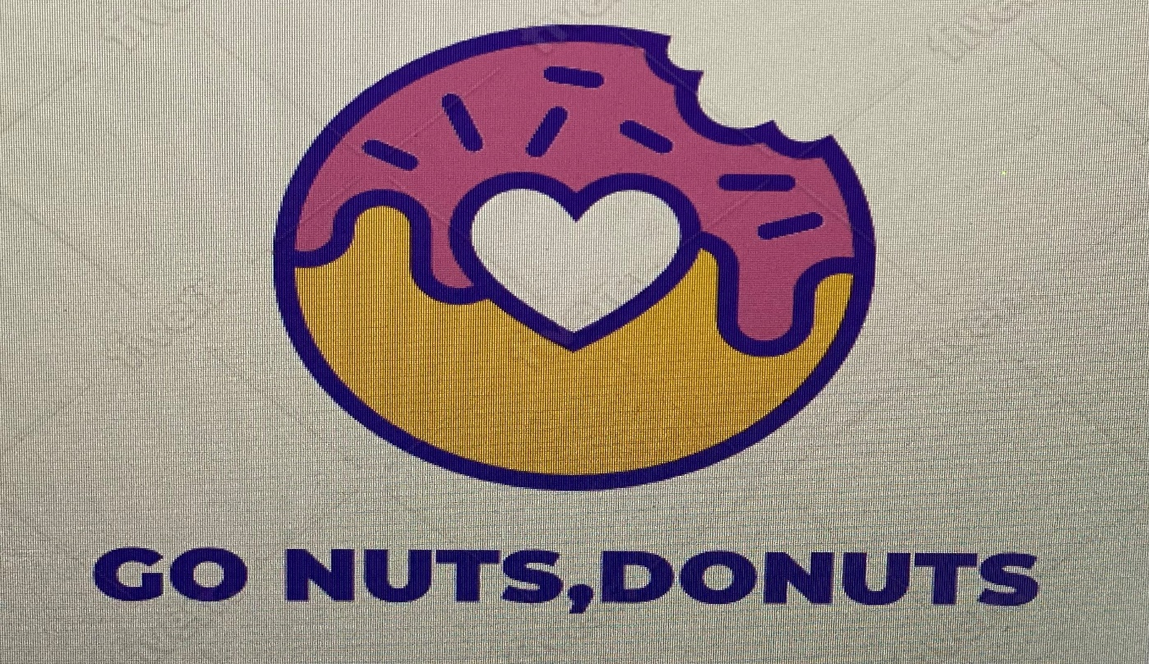

Executive Summary
A dream come true; this is the best sentence for what is coming next. We are a young family chasing a dream that finally came true, to start our own business, to make people smile with our mouth-watering product. Couple of years ago we started working in a donuts kiosk, more like a fixed van, in Mc Arthur Glenn, Bridgend and we enjoyed it a lot. When the lease expired, the owner didn’t want to renew it so that was the moment when we decided to take this opportunity to invest our savings in something that we knew it’s going to work because we are hardworking and passionate about customer service. So here we are selling our delicious donuts, me and my husband working hard and trying to improve, to keep our customers happy and bring even more new customers. Our purpose: to “bake” everyone happy, to put a smile on every person’s face when tasting our simple but fresh and delicious donuts. Our products: donuts and coffee, the best combination ever.

Introduction
The main idea came from our latest job, as we used to work as elf employed for a lady who managed to do a huge business after started selling candy floss on the street. After her lease expired, we decided we can do it on our own, so we started planning everything. It is a small family business classed as a partnership as it is me and my husband as owners and we share the profit. We decided to form a partnership because tax and national insurance will be lower than for a limited company and we complete each other as we have different complementary skills. We do not need any employees as we sell only two products in a small kiosk, more like a fix van. So, after applying for a permit in Bridgend Borough Council we have been approved to open our own business. Our main product is hot fresh donuts, amazingly easy to make as it requires just the donut mix powder that will be mixed with water and fried in oil… voila, quick and easy, SOOO delicious! Then we added coffee as well to keep the adults happy as well because what else goes better with a donut if not a coffee. We also have six tables with four chairs each, it is service counter, so everyone will order and pay at the counter, when terribly busy it requires me and my husband to be both there but that is the case for weekends and bank holidays only. After one year, seeing that everything goes as planned we decided to add soft vanilla ice cream as it will be a great seller during the summer. We were pleased to notice that kids loved and enjoyed it not just during the summer so now we have 3 product that are selling very good.

Layout and structure
Location: Mc Arthur Glenn Designer Outlet
Equipment: electric donut machine, commercial espresso coffee machine, small fridge, carpigiani ice cream machine
Product: donuts, coffee, ice cream
Distribution: no deliveries, only selling at the counter
Health and safety: Level 2 food hygiene for Catering and Retail (see appendix 1)
Licences: no licence required, only approval from the council to open and then the regular food hygiene inspection every year.

Marketing Plan

Market Analysis and Competition
We are currently using a cost leader strategy in our marketing position. So, we decided to sell something exceptionally good at a fair price so people will want to try it as it is accessible and after trying it, they will be our loyal customers as they will fall in love with our simple but tasty donuts. Our unique seller point is that our donuts are cooked in front of the customer, they roll in the sugar in a big round plate which rotates continuously, so much fun for the kids, and then go straight in a takeaway bag to make another customer happy.
After making a PEST analysis we can say that the only factors that could probably affect our business are the economic factors- such as an economic crisis when people don’t want to spend money or don’t have money to spend and also the political factors – for example the covid 19 lockdown when all the businesses were forced to close them door for a long period of time, than all social distancing rules, all together could damage or even destroy a small business like ours.

Swot analysis
Strengths | Weaknesses | Opportunities | Threats
Our fresh delicious donuts  Hard working and motivated owners  Excellent customers service that makes our customers want to come back all the time  Best coffee in the outlet due to Marius being a qualified barista | Not enough choices for certain customers  Not enough resources yet to open another shop | To expand, open another shop and hire more people could bring more profit. | The competitors, any move from them that could make the customers run to buy from them, even if the product is similar but so different.

A very interesting marketing model called 7Ps was written by Jerome McCarthy in 1960 and it refers to all the parts involved in a business and makes you think how you can improve your business, give the customer the best, come with something new to keep the customer interested.
If we refer to our own business the 7Ps are:
- Product- hot delicious donuts that everyone loves. In the future we are thinking to add some icing and sprinkles on top, maybe some chocolate and fruit flavoured jelly so we bring something new and exciting for our customers
- Price- our prices are not the lowest not the highest. They are accessible for all Mc Arthur Glenn shoppers
- Place – an image to love, or small pink van already looks delicious, and the smell will make everyone want to approach
- Promotion- we are promoting our donuts van on social media having a Facebook page that we keep updated, we post on local pages as well to remind people that we are still there and new promotions going on.
- People- not much to say here as it’s just us, my husband and me, working hard to put a smile on every customer’s face.
- Process- the process of serving a customer is short and entertaining as our automatic donuts machine is flipping the donuts on both sides in the oil and then throws them in sugar. It takes 2 minutes for 10 donuts to be cooked so in the meantime we can have a talk with the customers about their day or about the shop because most of the times they are really impressed to see the donuts frying process that they want to know more.
- Physical evidence- we are wearing a nice uniform, white shirt, hair up, apron, black trousers and black shoes and always gloves to avoid any contact with the customers food. We also ask our most loyal customers kindly if they could write a review on our Facebook page because it will help us a lot to grow our confidence.

Competitors analysis
Our competitors are a very well-known brand Krispy Kreme. Their strength is their name, as they are a huge brand and everyone knows about them, even if they have high prices, people are still buying from them because their product is good. They are making fundraisings as well which is something that everyone appreciates nowadays. This is a successful strategy as people will always want to help others.
I think their weakness is that they can’t prove their product is always fresh, I had customers complaining about them donuts being not as fresh as they’re saying.
Our target- the local people in Bridgend, this way we will have loyal customers but also the people travelling from surroundings and there are plenty. Our most loyal customers are the children.
We have 2 main marketing objectives that we want to achieve as soon as possible, and we work hard for it. First: Customer satisfaction, because if they are happy, we are happy; and the second one generation of profit, because this is the reason why

Pricing Strategy
We decided to price our product using the neutral pricing strategy as we thought it will be the most effective for us. We have researched our competitors price list, but our prices will be a bit lower as our product is slightly different, we do simple sugar donuts, but they do the fancy ones, with icing and all the sprinkles on top.
So, for the donuts we need only the mixture which we buy from Middleton mix, and it’s called American Doughnut style 123. We pay £50 for one 12,5 kg bag of mix; we can do 400 donuts with one bag. And then we add water to it, which is tap water, so it is included in the rent bill. The sugar is £3 for a 2 kg bag. 1 bag of sugar is enough for 200 donuts. The oil as well is £40 for 20 litres, and we use 10 litres to fry 400 donuts. We’ll also need napkins for the customers and bags to put the donuts in them. So, 1 pack of 100 napkins is £ 5 and for the bags we pay £10 for 1000. We chose the napkins to be pink and the paper bags are pink stripe because we wanted to personalise a little bit our sweet donuts. Also, the kiosk is pink (see appendix 2) so, we wanted to have a nice match.
For 400 donuts the cost will be:
Donuts mix- £50
Oil- £20 if we add them the result
Sugar- £6 will give us the cost to
Napkins- £20 make 400 donuts which is
Bags- £4 £100
To find the actual cost of making a single donut so we can price it, we will divide the £100 to 400 donuts, so the cost to make a donut is £0,25.
So, one donut cost us to make:

Donuts mix | £0,125
Oil | £0,05
Sugar | £0,015
Napkins | £0,05
Bags | 0,01
Total | £0,25
Comparing the market prices around we have decided to add a mark-up of 200% to a donut so we are now selling the donuts for £0,75 per unit. That’s £0,25 plus 200% which is £,50.
As we are selling coffee as well, we decided to add the overheads on top of the coffee. For the coffee we need the delicious Lavazza Super Crema coffee beans which is £10 for a 1kg bag, and we can do 140 espressos with it. Then we add the sugar, we will use the sugar sticks as it will be more comfortable for the customers as well. The price for the sugar is £5 for 1000 sticks. Take away cups with lids will be £0,30 per unit and milk will be £1,60 per litre.
The price for a simple coffee, called americano will be coffee, sugar, and the cup.
If we can do 140 coffees with one bag of beans, then one coffee will be £10 divided by 140 = £0,07
If 1000 sticks of sugar are £5 than 1 stick will be £0,005 and we roughly consider 3 sticks per coffee, so it will be £0,015 per coffee. We add the cup cost which is £0,30 and then we calculate the overheads as we said we will add them on top of the coffee price.
Overheads – rent, water and electricity all included for £1500 per month. Overheads cost per day will be £50, divided by 8 hours day £6,25. Coffee takes 3 minutes to make, so if we divide £6,25 to 20 will be £0,31 to add to one coffee.
Then for cappuccino and latte coffee we need to add milk only which is £1,60 per litre, and we can make 20 coffees with one litre, so we’ll add £0,08 to an americano to sell it as cappuccino.
 | Americano | Cappuccino /latte coffee
Coffee | £0,07 | £0,07
Sugar | £0,015 | £0,015
Milk | £0 | £0,08
Cup and lid | £0,30 | £0,30
Overheads | £0,31 | £0,31
Total | £0,695 | £0,775
We have decided to add the same mark up for the coffee as for the donuts because our coffee is high quality made by a trained barista who puts a lot of passion in it. So, the cost to make one americano is £0,695 and we add the mark-up of 200%, which is £1,39 and we sell this americano to our customers at the price of £2,08.
The same for the cappuccino and late, the cost to make a cappuccino/latte is £0,775 and we add the mark-up of 200% which is £1,55, total price shown on our price list for our customers is £2,32.

Sales and Distribution
For the moment we decided to sale only at the counter, we do consider doing deliveries as well in the future but we just wanted for the moment to raise more capital so we can start doing that as well. We thought it will be great to do a contract with “just eat” food delivery company, as they have a nice and accessible app on the phone where customers can see if we deliver on not in their area, also you can add pictures and customers can write reviews as well, so it is a really nice way to increase the business and sell more.

Here you have a cashflow forecast for the first year of the business.
Month  Year 2018 | March | April | May | June | July | August | Sept | Oct | Nov | Dec | Jan | Feb
Opening balance | £600 | £4,020 | £6,670 | £9,120 | £12,240 | £15,540 | £19,690 | £22,370 | £24,530 | £25,900 | £30,400 | £30,600
Income  sales | £5,600 | £5,500 | £5,350 | £6,300 | £6,500 | £7,200 | £5,630 | £4,920 | £3,950 | £8,300 | £2,300 | £2,530
Total cash | £6,200 | £9,520 | £12,020 | £15,420 | £18,740 | £22,740 | £25,320 | £27,290 | £28,480 | £34,200 | £32,700 | £33,130
Rent | £1,600 | £1,600 | £1,600 | £1,600 | £1,600 | £1,600 | £1,600 | £1,600 | £1,600 | £1,600 | £1,600 | £1,600
Raw material | £580 | £1,250 | £1,300 | £1,580 | £1,600 | £1,450 | £1,350 | £1,160 | £980 | £2,200 | £500 | £700
Closing balance | £4,020 | £6,670 | £9,120 | £12,240 | £15,540 | £19,690 | £22,370 | £24,530 | £25,900 | £30,400 | £30,600 | £30,830

Profit and loss for the year above (2018)
Profit and loss account for “Go nuts, donuts!” for year 2018
Sales | £64,680
Cost of sales | £14,650
Gross profit | £50,030
Rent | £19,200
Other | 0
Total expenses | £19,200
Net profit | £30,830

Advertising and Promotion
We are on Facebook and Instagram, posting lovely pictures with our delicious donuts and very pretty coffee as our barista in drawing hearts in cappuccinos.

Operating Plan
Our plan is going to operate for the start with 2 people, that’s me and my husband and for the moment is enough because it is an 8-hour shift and Monday to Friday it needs only one person to prepare and serve the coffee and donuts to the customers. As for ten donuts to cook it needs 2 minutes in that time the same person can make a coffee as the donuts machine is automatic, and it takes the donuts out of the oil when they are ready. Just for the weekend it needs 2 people as it is busier, and we can help each other. The location is simply perfect as it is an outlet, so who does not want to buy cheap branded clothes and have a quick snack in between shopping? We plan to employ more people in the future because we want to have a holiday soon, as a family and after that we would like to find another interesting and crowded location to open another small kiosk, so we will need some more people than. The training plans for our future staff are simple, we just want to teach them to do things as good as we do, to explain them how easy this job is and how to have fun and enjoy what they are doing, as customer service is a very relaxing and entertaining thing to do. We are planning to motivate them with bonuses, for example if they will reach £700 sales in a day, they will get £10 bonus. The small van is ours but still we pay to rent the place where we have it located in the outlet and utilities; all together is £1200 per month. We signed a contract for 5 years. In the outlet we have only one competitor selling something similar, but still different, the difference being that we sell plain sugar donuts, and they sell the icing donuts. This is the only disadvantage of the area. We are trying to bring something new that our competitors do not sell and that will be the Mr Whippy ice cream that kids love. If we have to analyse the risk factors that can affect our business, the fire or flooding can for sure affect any business so will affect our as well, new competitors that might sell at a lower price than ours, commercial issues can happen as well, because if we don’t have our donut mix deliver then we don’t have a product to sell. The only licence or permit that we needed was the food business registration. We do not need to play music because you can hear it around the whole outlet playing all day.

Financial Plan
The start up cost of our business was £25,000.
The source of our finance was strictly whatever we managed to save to make this dream come true, so we saved £20,000 and our parents decided to give us a little hand to help us cross the bridge, so the difference of £5,000 was a gift from our parents. The cost of our beautiful pink all equipped van, with an automatic donut machine, coffee machine, sink and a small fridge was £22,000 and we spent £3000 to personalise it with our own product and pricing list and our own name.
The running cost for every month fixed and indirect is the rent which is £1,200 per month and direct and variable will be the donuts mix, coffee, milk, sugar, napkins, oil, and they are called variable because the price may vary.

References
Barrow, C., Barrow, P. & Brown, R. (1998) The business plan workbook. Kogan Page.
Barrow, C., Brown, R. and Clarke, L. (2001) The business enterprise handbook: A complete guide to achieving profitable growth for all entrepreneurs and SMEs. London: Kogan Page.
Friend, G., & Zehle, S. (2009) Guide to business planning. Bloomberg Pres, Cop.
Maund, A. Schriek, M. and Tinkler, P. (2017) Certificate in Higher Education: Skills for the Workplace Student Yearbook. London: Sage Publications Ltd.
Sheedy, M. (2010) The small business success guide. Wrightbooks.

Appendices
1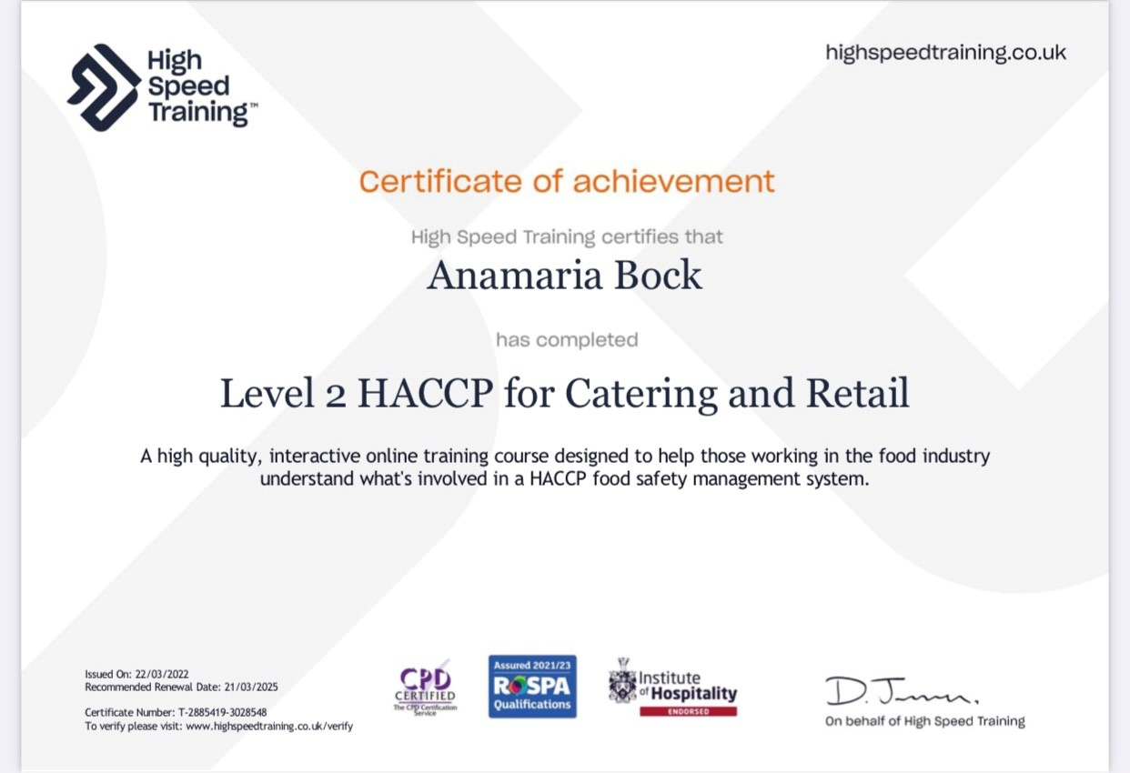

2

