

Student Name: Sharmin Akther

Student ID: 2521545

Module Name: Marketing Management

Module Code: LCMB7024

Topic: Brand Extension of Toyota “Toyota H2Move”

Lecturer’s Name: Dr. Mohammed Tariq

Wordcount: 2679

AI use acknowledgement
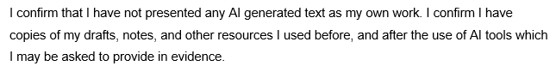

Table of Contents
Introduction 4
Element 1 Poster Presentation 5
Element 2: STDP Analysis for “Toyota H2Move” 5
Segmentation 5
Targeting 6
Differentiation 7
Positioning 7
Element 3: Marketing Mix (4Ps) Strategy for “Toyota H2Move” 9
1. Product 10
2. Pricing 11
3. Place 11
4. Promotion 13
Conclusion 14
Element 4: Reflection Using Gibbs model 14
References 18
Appendix: Element 1: Poster Presentation 20

Introduction
Marketing Management is described as the process that examines, plans, executes and manages programs that are used to create, communicate and provide value to the target customers and meet the organisational goals (Kotler and Armstrong, 2016). With escalating environmental laws and technological growth, companies are moving towards new innovations like brand extension to penetrate the new markets. Toyota H2move is a strategic expansion into hydrogen powered city logistics intregating sustainability and operational efficiency. This report aims to examine how effective segmentation, targeting, differentiation, positioning, and the 4Ps can be used to facilitate the successful market introduction and positioning of Toyota H2Move including rfelection using Gibbs model.

Element 1 Poster Presentation
Poster has been attached in the appendix

Element 2: STDP Analysis for “Toyota H2Move”

Segmentation
Segmentation Market segmentation is the classification of a homogenous market into homogenous segments according to common features (Kotler et Armstrong, 2016). In the case of Toyota H2Move, the four-dimensional segmentation is carried out:
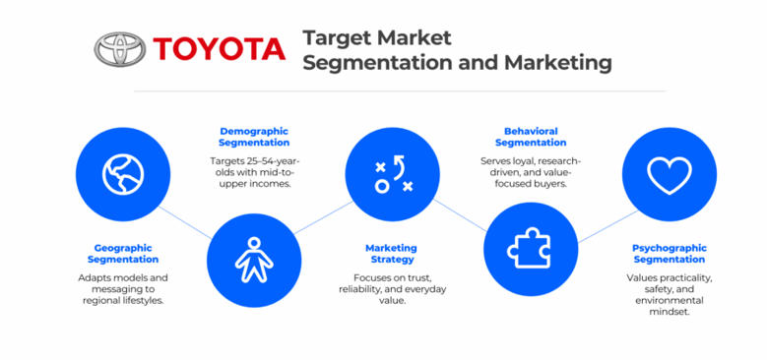
Figure:Market segmentation for
Source: (Toyota plc, 2026)
Geographic Segmentation
Toyota H2Move is focused on big-volume cities in the UK, Germany, France, and Japan where LEZ and ULEZ policies create an opportunity to apply zero emission logistics. The states California and Scandinavia are characterized by high hydrogen infrastructure in the secondary markets that have a significant impact on adoption rates (McKinsey & Company, 2023).
Demographic Segmentation
The main market is to include SMEs with fleets ranging between 5 to 50 vehicles like couriers and e commerce logistics. These enterprises constitute significant portion of commercial clients in Toyota ( Toyota plc, 2026). The fleet managers, aged 25 to 54, are also decision makers interested in cost and compliance.
Psychographic Segmentation
Sustainability and innovation are competitive advantages of target firms. Increased consumer interest in green operations drives logistics companies towards low-emission solutions (NIQ, 2023). They are also pioneers who want efficiency in their operation without losing reliability.
Behavioural Segmentation
Fast refuelling and less downtime gain high frequency urban operators (150-300 km/day) (Toyota Motor Europe, 2026). Fleet continuity and regulatory security are priorities among customers, whereas brand trust increases adoption among existing Toyota clients (Peng et al., 2023).

Targeting
Targeted marketing allows personalized marketing messages to SME operators. Nevertheless, excessive dependence on one segment subject H2Move to industry-specific declines, i.e. low levels of e-commerce (McKinsey & Company, 2023). Focused targeting demands continuous monitoring of the segments and planning of contingents of entering adjacent segments (Kotler et al, 2024).
Primary Target: Urban SME Delivery Fleets
Toyota H2Move uses concentrated targeting, whereby, at the initial launch, the company targets urban-based SME delivery operators. Cooper (2019) defines that highly targeted positioning of specific segments is more effective as compared to market wide approach when the technology of a new product is complex. The market of the European last-mile delivery is considered to be worth 78 billion Euros, where SMEs constitute 62% of the delivery vehicles (Statista, 2025). The market of hydrogen fuel cell cars forecasts a 19.7% CAGR in 2030 (The Business Research Company, 2026). In the UK, the current Professional dealer network of Toyota covers 89% of SME fleets (Toyota plc, 2026).
Secondary Target: Corporate Logistics Operators
Nationwide courier networks and e-commerce fulfilment providers having a fleet size of over 200 cars are scaled efficient but incur a longer long sales cycle. According to Kotabe and Helsen (2022), the differentiated targeting strategies need to be balanced between the attractiveness of the segment and the organisational capability.

Differentiation
Fast Refuelling Capability
Toyota H2Move refuels within less than five minutes compared to 45-90 minutes of battery electric cars, and these capabilities of working as a multi-shift vehicle without pauses (Toyota Motor Europe, 2026). McKinsey & Company (2023) estimates that hydrogen fuel cell cars have 98% operational availability, versus 82% battery-electric cars in high-utilisation delivery.
Subscription-Based Service Model
H2Move provides an all-inclusive subscription (vehicle, maintenance, fuel, fleet software) but not capital purchase and transforms capital expenditure to operational expenditure. The subscription generates switching costs in terms of both term of contract and depth of service relationship (Peng et al., 2023).
Fleet Ecosystem Integration
H2Move would complement a Toyota already available Professional fleet management, which offers telematics and predictive maintenance - a strength not yet attainable by hydrogen startups without a digital infrastructure (Toyota plc, 2026). Nonetheless, Eleksiani et al. (2025) warn that differentiation through software experiences erosion as other companies create similar software.
Hydrogen Supply Guarantee
Toyota will ensure that the partner stations provide hydrogen fuel, which prevents the risk of the fuel desert. According to Toyota Motor Corporation (2025b), the main obstacle identified by 67% of fleet managers considering hydrogen vehicles is a lack of availability of fuel.

Positioning
Positioning Statement
In the case of urban SME delivery fleet operators requiring zero-emission logistics with no operational trade-offs, the current Mirai has a refuelling time of roughly five minutes, so Toyota H2Move offers a subscription based five-minute refuelling option, fleet management, and manufacturer-guaranteed availability of hydrogen (Toyota Motor Corporation, 2025a). The reason is that Toyota integrates more than 30 years of fuel cell technology with commercial vehicle experience in its proposed collaboration with Daimler Truck and Volvo in the cellcentric joint venture (Toyota Motor Europe, 2026).
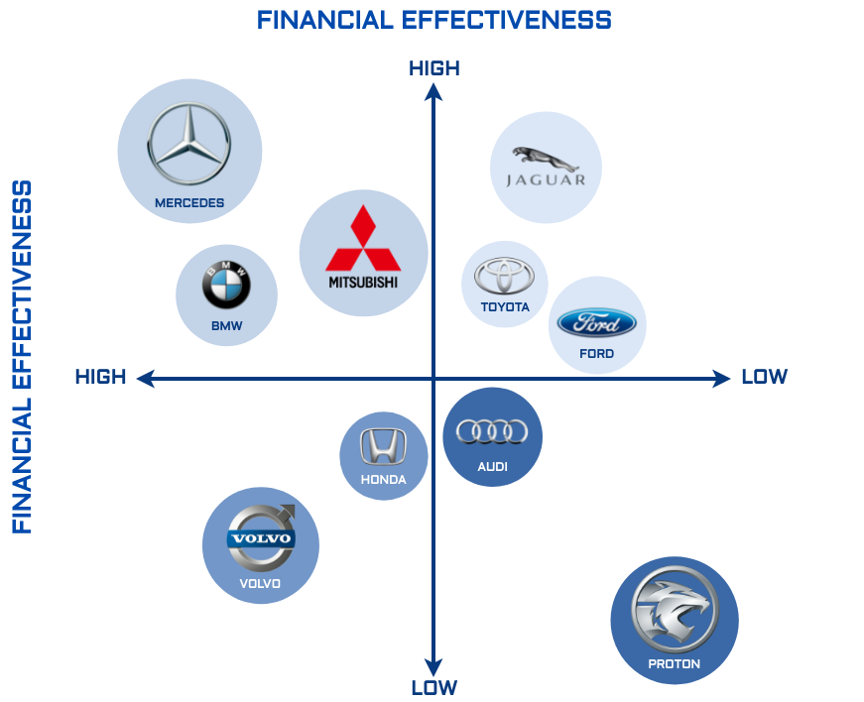
Figure: Positioning Map
Source: (Toyota Motor Europe, 2026)
Competitive Positioning Logic
At the point of operational continuity and complete assurance of total costs, Toyota H2Move will operate where no direct rival is presently in operation (Nkomo, 2019). Comparatively, the battery-electric 2019 Toyota Proace Electric takes 45 minutes to charge to 80% with a 100kW DC fast charger inducing considerable downtime within the multi-shift delivery solution (Toyota plc, 2026). Those supplying hydrogen vehicles do not provide built-in subscription plans, whereas those providing subscription plans do not provide hydrogen engines.
Blue Ocean Assessment
Market realities support the strategic urgency of this positioning. The world fuel cell passenger vehicles fell 54% below highs in 2021, pushing Toyota to shift hydrogen attention to commercial use (McKinsey and Company, 2023). The commercial fleet focus of H2Move skips the troubled passenger car market and supports real operator challenges of reliability and predictable expenses. Its collaboration with cellcentric gives it volume production and infrastructure turnkey capabilities that pure-play hydrogen frameworks cannot bring.

Element 3: Marketing Mix (4Ps) Strategy for “Toyota H2Move”
According to Kotler and Armstrong (2016), marketing mix consistency among each component that supports strategic positioning is the most powerful predictor of market adoption. The 4Ps operate as an integrated system. The service based product positioning is supported by subscription pricing. Toyota Professional centres selective distribution ensures a quality of service expectations. Evidence-based promotion supports quantified value assertions.
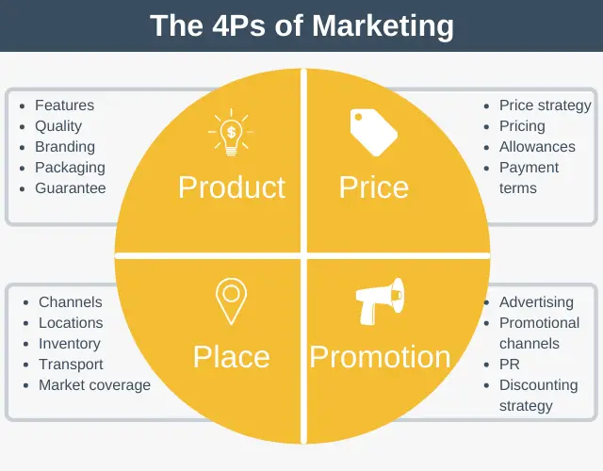
Figure: 4Ps of Marketing Mix
Source: (Kotler and Armstrong, 2016)

1. Product
Core Product Design
Toyota H2Move is a potential hydrogen-powered light commercial vehicle subscription service in urban delivery operations. The design of the product is based on the fuel cell engineering already tested in the Mirai passenger vehicle with a range of about 650 km and a five-minute refuelling (Nkomo, 2019). In a commercial translation, H2Move would use a second generation fuel cell stack by Toyota, scaled to higher duty pack, and payload demands.
Benchmarking Against Existing Products
H2Move specifications are based on the experience of similar commercial hydrogen vehicles coming to the market (Toyota Motor Europe, 2026). The Renault Master H2-Tech, aiming to deliver in 2026, aims at 500km range with a 5-10 minute fueling cycle. The XCIENT Fuel Cell truck currently operational in Switzerland and Germany by Hyundai shows that 98% operational availability in the commercial fleet can be reached by hydrogen powertrains. These similar products prove that the capabilities of H2Move are technically achievable in the existing industry capabilities (Nkomo, 2019).
Augmented Product Features
Based on the current commercial vehicle platform by Toyota, H2Move would connect with Toyota Professional telematics that is currently available in the Proace Electric lineup. The available material by Toyota plc (2026) reports how the current system offers real-time tracking of various vehicles, predictive maintenance alerts and driver behaviour scoring. H2Move would feature hydrogen-specific extensions to this software layer (refuelling station location and real-time hydrogen prices).
Product Strategy Assessment
According to Cooper (2019), effective new products need synergistic product-line fit. H2Move capitalizes on Toyota fuel cell patents worldwide and current business vehicle dealership. Nonetheless, there is complex products risk. The hardware-software-subscription package might be confusing to customers who are used to the clear process of buying a vehicle. Mitigation would need H2Move professionals in Toyota Professional dealerships (Nkomo, 2019).

2. Pricing
Subscription Pricing Architecture
H2Move involves subscription model which transforms capital into operational expenditure. Similar hydrogen cars offer price references. The XCIENT Fuel Cell truck is offered via a subscription program known as Hydrogen Mobility in Switzerland, priced around CHF 1,200/month. Scaling down to less ambitious delivery vans, H2Move (Statista, 2025). Essential subscription would be aimed at £699 per month maintenance and fuel included (Nkomo, 2019).
Value-Based Pricing Justification
The value is measured in terms of operational advantages exhibited by similar products. The Toyota Proace Electric takes 80 minutes to charge with 0-80 percent on 100kW DC fast charger (Toyota Motor Corporation, 2025a). When charging capacities are 1.5 hours per day, driver cost is £30/hour and Bus lost delivery revenue is 50/hour, this saves over 25,000 pounds each year per single vehicle in comparison to battery electric options.
Kotabe and Helsen (2022) state that value-based pricing generates the most revenue during situations where the willingness-to-pay is perceived as the benefit to the customer. Approximately 30% of customer value creation is also captured by H2Move pricing which leaves a lot of excess to facilitate adoption.
Pricing Risks
Volatility risk on fuel is a big risk. The cost of hydrogen differs significantly across the country, with Germany and France showing the highest (€9.50/kg) and the lowest prices (€14/kg) respectively (Statista, 2025). The fixed-price inclusion of fuel by Toyota might be made unprofitable in case of a rise in price of hydrogen. Partial mitigation is provided by hedging strategies, quarterly price adjustment clauses.

3. Place
Distribution Channels
H2Move would leverage the presence of the current Professional dealer network of Toyota, comprising 258 commercial vehicle centres in Europe (Nkomo, 2019). This channel approach builds on the existing infrastructure, bypassing the time and expense of novel distribution building-out. According to Cooper (2019), distribution synergy is one of the predictors of the success of a new product.
Digital Direct Channel
The creation of a subscription would be provided by a special digital channel, where it is also possible to configure and arrange the delivery on your own. This is a hybrid dealer of vehicle service whose digital for subscription management achieves direct relationship benefits with the customer relationship to the dealer network (IPCC, 2022). The effectiveness of direct distribution due to the possibility to achieve better customer data capture and iterations.
Geographic Rollout
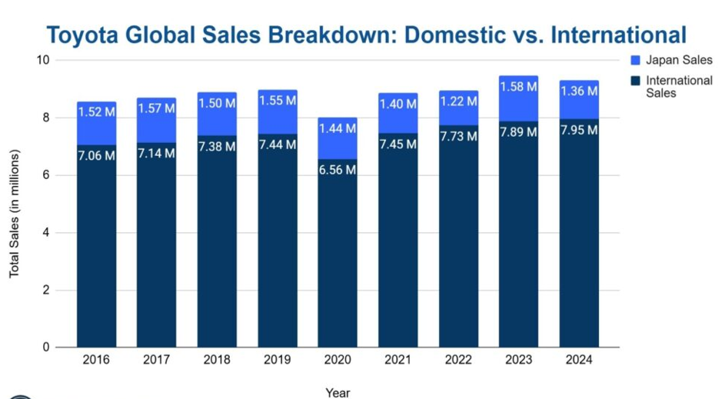
Figure: Toyota global sales breakdown
Source: (Toyota plc ,2026)
Toyota's international sales declined 16% from 1.62 million (2016) to 1.36 million (2024), creating urgency for global expansion (Toyota Motor Corporation, 2025a). Initially they would be introduced in Europe market where there is already a hydrogen refuelling infrastructure. According to the International Energy Agency (2024), these are markets that are hydrogen ready, which have their regulations in support of zero-emission logistics. Phase 2 would go international to Amsterdam, Berlin, and California, where the infrastructure development would provide support rollout timing.
Place Strategy Critique
The variation of service capabilities among dealers is challenging. Not all Toyota commercial centres are immediately hydrogen-certified. Prolonged dealership certification which focuses to change location within the existing hydrogen station coverage does not provide an effective distribution density but does not impact the quality of services (NIQ, 2023).

4. Promotion
Integrated Marketing Communications
Promotion deals with demonstrated measurable operational advantages of similar products. And H2Move would utilize similar performance projections. Kotler et al. (2024) confirm that integrated marketing communications where there is consistency in the messaging through channels yields better brand recall.
Demonstration Programme
A fleet of 50 demonstration vehicles would be used to roll out pilot customers in each of the launch cities to obtain real-life performance information. Future clients were provided with half-day test drives of the vehicles in the same vein as Toyota has its current Proace Electric offering (Toyota Motor Corporation, 2025b) to demonstrate the speed of refuelling and the performance.
Target Audience Messaging
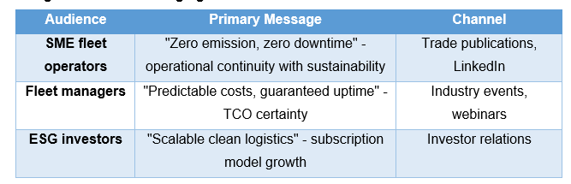

Promotional Assessment
NIQ (2023) discovered that 83 percent of consumers around the world choose responsible brands, which induces downstream pressure on the logistic service providers. H2Move takes advantage of this trend through their sustainability messaging. Nonetheless, the confusion that customers make between hydrogen and battery electric technologies need to be clarified with concise comparative messaging (International Energy Agency, 2024). The promotional campaign would also incorporate an interactive TCO calculator where the fleet operators could compare H2Move and alternatives using their own data of their operations.

Conclusion
Toyota H2Move has strategically aligned brand extension with clear segmentation, targeting and strong differentiation with its hydrogen and subscription services. The positioning responds well to the operational efficiency and sustainability requirements of the urban logistics markets. Additionally, integrated marketing mix supports value creation by innovative products, value based pricing, selected distribution channels, and targeted promotion. In sum, the strategy suggests a good likelihood of market adoption, with infrastructure and cost related issues considered carefully.

Element 4: Reflection Using Gibbs model
Gibbs Reflective Cycle is a six-step model of experience-based learning, including description, feelings, evaluation, analysis, conclusion and action planning. University of Edinburgh (2024) confirms that the model converts the real-life experience into the actionable knowledge, which is especially applicable to the postgraduate level in the field of business.
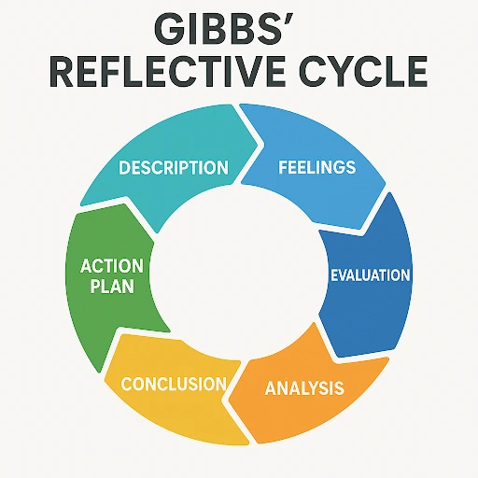
Figure: Gibbs relective cycle
Source: (University of Edinburgh, 2024)
Description
The project required a complete portfolio of the marketing strategy for Toyota H2Move, including STDP, marketing mix and a poster. My key contribution was a brand development presentation, in which I pitched H2Move as a hydrogen-powered logistics brand in line with sustainability and efficiency. The poster also required me to condense complex marketing strategies such as segmentation and positioning and the value proposition into an easy to understand and visually appealing format within a 3-5 minute presentation. The difficulty was the lack of market data, so we relied on benchmarking from Toyota Mirai and other hydrogen-fuelled vehicles to develop a plausible brand strategy.
Feelings
In the beginning, I felt uncertain and lacked confidence, as I did not have any direct data for H2Move. I wondered if it would be acceptable to use data from Toyota Mirai and other similar models. But as I researched the similar brands of the competitors and Teslas existing brands, I had been able to get clear understanding of the Tesla’s new brand “H2Move”. During the presentation, I felt more confident, particularly when presenting the "zero emission, zero downtime" proposition, and being able to effectively answer to the questions asked from my tutor in the class which increased my public speaking confidence.
Evaluation
One of the strengths of my poster presentation was effectively depicting H2Move's branding and business value. Incorporating benchmarking data added to the presentation's authority, as noted by McKinsey and Company (2023) that supports hydrogen mobility. Also, integrating STDP and the 4Ps principles in the poster maintained a coherent strategy as emphasised by Kotler and Armstrong (2016). My storytelling and structured approach aided in the delivery of key messages. But I acknowledged time management issues, as too much research hindered early poster design and practice.

Analysis
This project showed that developing a brand requires not only a deep understanding but also simplification. Kotler et al. (2024) emphasise that integrated marketing communication needs to be clear and consistent, and I used this in condensing strategy into a poster. I discovered how to convert ideas into an actionable brand concept, despite lacking data, through benchmarking and assumptions (Nkomo, 2019). The challenge of translating detailed analysis into a brief narrative was overcome by prioritising messages, using headings and tailoring information to the target audience. Also, feedback and practice aided clarity and confidence in delivery. My perfectionist nature caused time constraints but was resolved by focusing on communication.
Conclusion
In general, the project improved my professional, research and presentation skills. I learned how to deal with limited data, critically assess concepts and communicate effectively. The poster presentation experience boosted my confidence and public presentation skills. Through this project, I learned that effective marketing practice demands sound analysis as well as effective communication.
Action Plan
Development Area | Planned Actions | Timeline | Anticipated Outcome
Research Efficiency | Build source tracker before drafting; allocate dedicated research sessions | 1-2 months | Reduced last-minute pressure
Critical Analysis | Compare 3+ strategic alternatives before selection using decision matrix | 2-4 months | Stronger evidence-based arguments
Time Management | Use Gantt chart with 20% buffer for each project phase | Immediate | Submission without time pressure
Presentation Skills | Practise poster delivery in mock sessions with peer feedback | 1-3 months | Improved clarity and confidence

References
Cooper, R.G. (2019) ‘The drivers of success in new-product development’, Industrial Marketing Management, 76, pp. 36–47.
Eleksiani, N., Strasser, T. and Brantley, J. (2025) ‘Community-level distributed energy systems and carbon intensity reduction’, Renewable and Sustainable Energy Reviews, 189, pp. 114–023.
International Energy Agency (2024) Renewables 2024: Analysis and Forecast to 2030. Paris: IEA. Available at: https://www.iea.org/reports/renewables-2024 (Accessed: 16 April 2026).
IPCC (2022) Climate Change 2022: Mitigation of Climate Change. Contribution of Working Group III to the Sixth Assessment Report of the Intergovernmental Panel on Climate Change. Cambridge: Cambridge University Press.
Kotabe, M.M. and Helsen, K. (2022) Global Marketing Management. Hoboken, NJ: John Wiley & Sons.
Kotler, P. and Armstrong, G. (2016) Principles of Marketing. 16th edn. Harlow: Pearson Education.
Kotler, P., Armstrong, G., Harris, L. and He, H. (2024) Principles of Marketing. 9th European edn. Harlow: Pearson Education.
McKinsey and Company (2023) Hydrogen-powered mobility. Available at: https://www.mckinsey.com/industries/automotive-and-assembly/our-insights/hydrogen-powered-mobility (Accessed: 16 April 2026).
NIQ (2023) Consumers Care About Sustainability. New York: NIQ. Available at: https://nielseniq.com/global/en/insights/report/2023/consumers-care-about-sustainability-and-back-it-up-with-their-wallets/ (Accessed: 16 April 2026).
Nkomo, T., (2019). Analysis of Toyota Motor Corporation [online]
Peng, C., Bijmolt, T. H. A., Völckner, F., & Zhao, H. (2023). A meta-analysis of brand extension success: The effects of parent brand equity and extension fit. Journal of Marketing, 87(6), 906–927. https://doi.org/10.1177/00222429231164654
Statista (2025) Hydrogen vehicles – statistics & facts. Available at: https://www.statista.com/topics/10882/hydrogen-vehicles/ (Accessed: 16 April 2026).
The Business Research Company. (2026, April). Hydrogen fuel cell vehicle market report 2026. https://www.thebusinessresearchcompany.com/report/hydrogen-fuel-cell-vehicle-global-market-report
Toyota plc (2026) Toyota Professional: Business and fleet services. Available at: https://www.toyota.co.uk/business (Accessed: 16 April 2026).
Toyota Motor Corporation (2025a) Sustainability Data Book / Sustainability Report. Available at: https://global.toyota/en/sustainability/report/ (Accessed: 16 April 2026).
Toyota Motor Corporation (2025b) Sales, production, and export results for 2024 (January–December). Available at: https://global.toyota/en/company/profile/production-sales-figures/202412.html
(Accessed: 17 April 2026).
Toyota Motor Europe (2026) Fuel cell electric vehicles (FCEV). Available at: https://www.toyota-europe.com/electrification/fcev (Accessed: 16 April 2026).
University of Edinburgh (2024) Gibbs’ Reflective Cycle. Available at: https://reflection.ed.ac.uk/reflectors-toolkit/reflecting-on-experience/gibbs-reflective-cycle (Accessed: 9 April 2026).

Appendix: Element 1: Poster Presentation


