NAME : MUHAMMED SHEBIL PALLIMALIL
STUDENT NUMBER: 2130892
MODULE :LCMB7001
LECTURER :Tushara Balendran
COURSE :MBA General management
SUBMISSION DATE :09/09/2022
TITLE : Marketing Assignment 1

TABLE OF CONTENTS

INTRODUCTION 3
COMMUNICATION 3
COMMUNICATION MODEL 4
INTEGRATED MARKETING COMMUNICATION 5
PROMOTIONAL STRATEGIES OF NIKE JORDAN AIR SHOES 6
BRANDING AND BRAND EQUITY 7
KELLER’S BRAND EQUITY MODEL 7
AAKER’S BRAND EQUITY MODEL 9
BRAND EQUITY MODEL OF NIKE JORDAN AIR SHOES 9
ADVANTAGES AND DISADVANTAGES OF KELLER BRAND EQUITY MODEL 9
CUSTOMER JOURNEY OF JORDAN AIR SHOES 9
TOTAL ENGAGEMENT MODEL OF JORDAN AIR SHOES 12
CONCLUSION 13
REFERENCES 14

INTRODUCTION
Nike is a multinational American company which deals with the design, development and sales of footwear, other sportswear and various sorts of services. The company is headquartered in Poland (DOWNIE, 2022). Nike markets its products under its brand name as well as under different heads like Nike Pro, Nike +, Nike Golf etc. In the beginning stage, the company was known as Blue Ribbon Sports company later it changed its name to Nike which represents the name of the Greek goddess of victory (Nike, 2022). Jorden Shoes stands as a sponsor of many teams as well as leads several events. Air Jorden Introduces basketball shoes and athletic apparel company which is situated in America. Currently, Air Jorden is owned and operated by Nike. This study is mainly focused on analysing the marketing strategies adopted by the company at the same time we discuss the various communication models and customer journeys of Jorden Shoes. By analysing their marketing strategy, we can analyse how the company meet all the competition and the tactics company uses for meeting their requirements. As communication plays a vital role, we analyse their communication channels and another integrated medium used by Jorden Shoes to create brand awareness among the customers.
COMMUNICATION
Communication is an act of sharing and transferring information from one person to another. For every communication, there will be some elements like sender, receiver, message, and medium. When a message is been transmitted from one person to another there will be several factors like the emotional situation of the sender, the type of medium used, etc will affect the message (Adamstepinski, 2013). Communication is very important as it is a basis of decision making and proper communication gives all the relevant information to the manager regarding decision making. A proper channel of communication increases the efficiency of the management, with effective communication the manager communicates the targets and various instructions to their subordinates. It also increases the corporation and coordination in the organization (Gorden, 2019). A two-way communication process between the workers increases their efficiency and boosts their morale. There are two types of communication formal and informal communication. Under formal communication, all the messages flow in an official manner and through a predetermined channel. It can be both horizontal and vertical communication. Under vertical communication, all the information flows vertically upward or downward. And in horizontal communication, the flow of communication takes place between the departments. The other type of communication is informal communication which doesn't

properly take place. Informal communication spreads rapidly and it is very difficult to determine its source(Evans, 2021).
COMMUNICATION MODEL
Communication models are used to express the communication process that takes place between different personnel. The communication model explains the process with the help of a diagram so that the reader can easily understand the process (Kapur, 2020). The first major communication model was established by Claude Shannon and Warren Weaver for their Bell Telephone Labs in the United States. The purpose of their creation was to ensure that the telephone cables and radio waves are working with their maximum efficiency (Petersons, 2016).
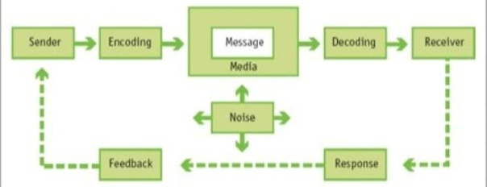
Figure1: Communication Model Source : (Kapur, 2020)
There are various elements in a communication model like the sender who is the person who makes the message and sends the message. The encoder is the device the transmitter employs to transform the information into signals. Channel is the medium used to send messages from one person to another. The decoder is the machine that is used by the receiver to convert the message that is sent in signals into the original message. The recipient is the individual who receives the message and offers input following the information conveyed to him. The noise is a physical disturbance like the environment, the people, etc which hinders the message that is been sent to the receiver (Flensburg, 2009).
The sender sends the message to the receiver through various channels like telephone, e-mail, etc. the message will be sent in a binary form and when it reaches the receiver, he converts the binary code into an original message using the decoder. The message will transmit in a coded language (Al-fedaghi, 2009). While transferring the message it will be affected by

various physical disturbances like noise that hinders the information that is been sent, this noise reduces the capacity of the receiver to decode the signals to their original form. After receiving the message, the receiver must respond in the form of feedback (Grekor, Georgieva and Ibrahim, 2022).
Jorden Shoes uses a strong communicational channel to reach its target consumers in the athletic industry. It communicates to its customers through celebrity endorsement and team sponsorship, which helps them to expand its business operations and create brand awareness among its customers (Costa, Aparicio and Braga, 2012). Currently, Jorden Shoes directly approaches female clients by sending e-mails to encourage them to purchase their shoes (Elleström, 2016).
INTEGRATED MARKETING COMMUNICATIONS
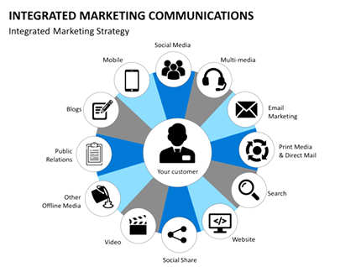
Figure 2: Integrated Marketing Communication Model Source: (NMIMS, 2016)
A multidisciplinary subject called "integrated marketing communication" integrates techniques from both old and new media. The term "integrated marketing communications" refers to a marketing strategy that takes into account an organization's objectives as well as its demands for company growth and upkeep. To outperform rivals and ensure long-term survival, businesses must effectively market their brands among end customers (Camilleri, 2018). The main components of Nike's Jordan air shoes digital integrated marketing communication strategy are its websites, mobile applications, and social media channels. Additionally, the
Jordan shoes are advertises on social media and on search engines to attract potential customers to its site and offerings (Brohi et al., 2016).
PROMOTIONAL STRATEGIES OF JORDAN AIR SHOES
Nike Jordan air shoes marketing tactics aided in the growth of the business into a global behemoth (Govoni, 2012). Jordan air shoes successfully uses social media to connect with its millions of users and draw in new target customers throughout the world. Through a careful balance of Jordon air shoes advertisements and lifestyle content, it has risen to be one of the most popular basketball sneaker line on social media. Since social networking encourages two-way connections between clients and brands, it is beneficial for Nike. Jordan air shoes maximizes this possibility and dominates digital platforms by establishing a sense of community and engagement with its followers. This business also broadened its online presence by setting up many profiles on various social media sites, including Twitter, Facebook, YouTube, and LinkedIn. It has greatly increased awareness of its new markets by utilizing social media to launch various campaigns (van Ee, 2021). One of Nike's Jordan air shoes most effective marketing methods is using advertisements to attract new customers and strengthen brand recognition. It has produced several top-notch commercials that have garnered widespread recognition (Marshall and Morreale, 2018). Magnificently powerful marketing campaigns help Nike's digital strategy. In addition to its bodily benefits, they also advertise its emotional ones. They essentially advance the objective, to put it another way. Jordon shoes also take advantage of unconventional celebrity sponsorships to demonstrate the universality of true athletes. This tactic works well because it evokes strong emotions in potential customers, motivating them to make purchases. Nike's Jordan air shoes promotion is so successful in part because it employs a variety of strategies and a wide range of spokespersons. It uses a variety of marketing techniques to promote its goods, including celebrity and megastar endorsements and joint ventures with major corporations to reach new markets. Public relations are a tactic used by them to market its brand and establish relationships with potential customers. The management of the business is concerned with preserving a positive relationship with both the marketplace and the consumers. This business treats its clients with a kind and approachable demeanor and doesn't wish to sever ties with them (Caetano, 2019). The public relations component of Nike Jordan air shoes is categorized under its specific customer service channel. It prioritizes consumer needs, and it organizes online content into categories based on those needs (Flynn, 2015). Nike successfully ran social campaigns and employed a variety of philanthropic methods as a means of enhancing its

public image. Company has improved its global visibility by sponsoring several sporting events and elite athletes (Nike, 2021). Huge athletic events were sponsored by Nike for Jordan air shoes as a direct way to reach its target audience. Through a direct marketing strategy, this business fosters customer loyalty and raises consumer awareness of Nike Jordan shoes. The business employs salespeople to approach and advertise its products to various sports teams, individuals, and groups in colleges and universities. For the consumer to locate the required Nike products, personalized services are crucial (Nike Inc., 2020). Nike frequently gives targeted clients of Jordan shoes, special deals as part of their sales efforts. This helps the Jordan to gain more customers as well retain them. Nike Jordon shoes employ sales promotions to persuade new customers by assuring them of further advantages, such as the amount they can save by purchasing when reductions and perhaps other special offers are incorporated.
BRANDING AND BRAND EQUITY
A brand is something that is publicly distinguished from comparable products, services, or concepts. Branding refers to the process of creating and advertising a brand's name, characteristics, and identity (Sammut-Bonnici, 2015). Branding is the process by which a business creates its image and differentiates itself from competitors.
Brand equity is a term used frequently in marketing to describe a brand's worth. Consumer perception and engagement with a company have an impact on its worth (Moisescu, 2005). If customers like a company, its brand equity is strong.
BRAND EQUITY MODELS
- Keller’s Brand Equity Model
Keller's brand equity model commonly known as the CBBE model was formed by Kevin Lane Keller. The main objective of this model is to have a strong brand whereby creating a good image in the mind of its users (Kuhn, Alpert and Pope, 2008). When there is a good reputation about the company in the mind of the customer, they will purchase more products from the company. Keller's brand equity model consists of major four components like Identity, Meaning, Response, and Relationship.

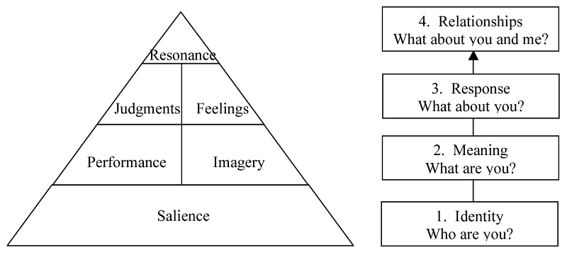
Figure 3: Keller’s brand equity model. Source: (Batheories, 2022)
Identity: Brand equity starts with a brand identity that discusses who you are. It includes brand salience, or creating awareness about the brand and trying to establish a reputation for the brand. Jorden Shoes uses various promotional tools to make its customers aware of new products launched by them.
Meaning: The next step is meaning where we see what you are. Here it includes performance and imagery, where the company indicates how well the product satisfies the needs of their customers. The company tries to meet the expectations of the customers about their products at the same time they try to satisfy their needs. Imagery refers to how well the brand appears in the mind of the customer. As a multinational brand, Jorden Shoes uses celebrity endorsements to grab the attention of its customers.
Response: The third step is the response, which includes judgments and feelings. Here we deal with what about you? Under this step, the customer makes assumptions about the company and its products based on their observations and feelings. They are more judgmental about the various products; they choose the products that give them more satisfaction and have the ability to meet all their needs without compromising their needs.
Relationship: The fourth and final step includes relationships, which consist of resonance. Resonance is how a customer identifies themselves with a particular brand. This comes at the top of the pyramid. By creating a healthy relationship with the company, the customer will have more attachment to the brand. Jorden Shoes always tries to build a healthy relationship with their customers as they believe customers are king and without them, the company can’t survive (Zaki, 2019).

- Aaker’s Brand Equity Model
Aaker's brand equity model is derived from David Aaker. He defines this brand equity model based on the assets and liabilities which are linked to a particular brand. These assets and liabilities may increase or decrease the value of the particular products or services of a brand (Mohan and Sequeira, 2012). Five components come under the Aaker brand equity model they are Brand loyalty, Brand awareness, Perceived quality, Brand associations, and Proprietary assets.
BRAND EQUITY MODEL OF NIKE JORDAN AIR SHOES
The brand equity model adopted by Nike Jordan air shoes is Keller's brand equity model which is customer-based brand equity that takes into account both brand’s self-image and an individual's emotions toward it. As a result, Nike’s Jordan shoes constantly assesses their brand identity to determine whether or not they're headed in the right direction for expansion and customer support (Elizabeth Goudreau, 2017).
ADVANTAGES AND DISADVANTAGES OF KELLER’S BRAND EQUITY MODEL
Most researchers and practitioners in marketing favour Keller's brand equity method, which is the mainstream viewpoint, because they believe that if a brand has no value or significance for consumers, investors, producers, or dealers will also have no use for it. Strong customer-based brand equity has several benefits, including long-term earnings; customers' propensity to look for new sources of distribution on their own; businesses' capacity to charge a price premium; and the efficiency of marketing and communications (Kuhn, Alpert and Pope, 2008). Consumer-based brand equity is described in the literature as a judgment tool that provides managers with a helpful diagnosis of what people believe about companies.
Keller's brand equity model inquiries about heavy investments for their operations, especially for their promotional activities. It involves the use of advertisement for creating a good image in the mind of their customers which leads to the use of expensive way of promotional activities.
CUSTOMER JOURNEY
A customer journey refers to the way a customer interacts with the product or services of a particular brand. It includes direct interactions like contacting the customer service team and indirect interactions like hearing about the brand at an event (Svendsen, 2020). The customer

journey can be interpreted using a map, which shows a unique strategy that is adopted by the company to keep in touch with its customers (Iterable, 2021). The different stages in a customer journey will familiarize the brand and also helps to create a brand image in the minds of the customers. Understanding a customer journey is very important for a business as it gives an idea to the business regarding their potential customers and enables Jorden Shoes to deliver the information as per the needs of their customers (Singh, 2020). This enables Jorden Shoes to improve their overall customer satisfaction thereby creating loyal customers and taking strategy for retaining them. Customer journey mapping enables a business concern to improve decision-making skills and helps the company to understand the needs of their customer.
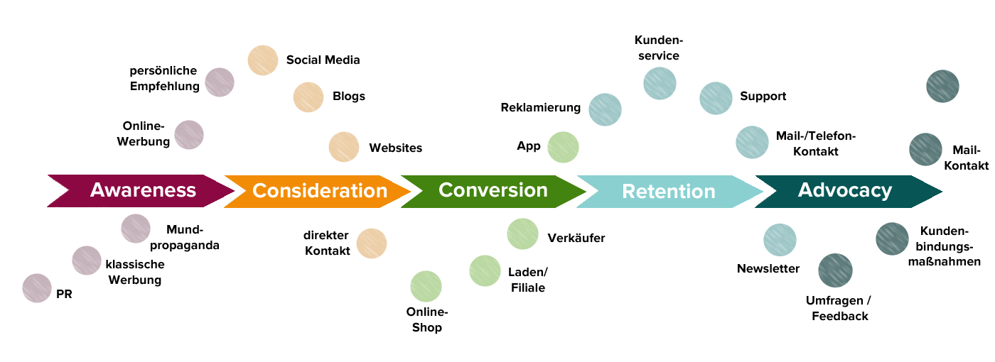Figure 4: customer journey map Source: (Singh, 2022)
The five stages in a customer journey are
Stage 1: Awareness
The first phase of a customer journey includes awareness, where the company creates awareness about their products and services in the mind of their customers. As a multinational company like Jorden Shoes, they ensure their shoes to the users through various mediums like the internet, emails, and other social media platforms. The statistics show that near to 90 percent of people are aware of the existence of Jorden Shoes as a brand. Jorden Shoes believes that physical existence and direct methods will be more effective than advertisements for creating awareness among the users (Hogan, 2021). For creating various touch points the company uses social media advertisement and organizes various events.
Stage 2: Consideration
The next step includes the consideration stage where the consumers have done all the initial research regarding their products. It is during this phase the customer compares its products
with other products of their other competitors available in the market. To stand out, Jorden Shoes uses various promotional tools that differentiate its products from that of its competitors. Jorden Shoes offers a variety of shoes to its members. Also, they incorporate various online membership programs and other events so that they get attention from customers (Bischoff, 2020). To get the customers towards their products they use peer referrals.
Stage 3: Decision
The third phase includes the decision-making process. It is during this phase the customer decides whether to purchase the product or not from the various products that are available in the market. From the various alternatives available in the market the customer chooses the products and services that give maximum satisfaction and also have the ability to satisfy their needs. For this, they look for various reviews and testimonials about the product. Jorden Shoes always cares about the customers they always give priority to their customers. The company always ensures that the problems of their customers are solved quickly using customer service. Jorden Shoes also makes sure that all their shoes are available on the website which enables the customer to purchase their products easily (Sorman, 2022). The company offers an opportunity for its clients to interact with the company representatives and offers various reviews about the company.
Stage 4: Retention
When the customers feel that the product and services can meet their requirements the customers start purchasing products. Once the customer purchases a product of a particular brand the company has to retain them by satisfying their needs and providing products based on their wants. Jorden Shoes ensures that whether the products are purchased from stores or on their website using digital media they focus on providing a loyalty program for their members. The company also increases satisfaction among their customers through unique customer interaction thereby building loyalty in them (Mixon and Horwitz, 2022). For retaining their customers, they use touchpoints like sending thank you letters and survey feedback forms.
Stage 5: Advocacy
The final phase of the customer journey includes advocacy, where the customers are happy with the products and services offered by the company. In this phase, the customers recommend the products and services to their relatives and friends. Winning advocacy is the most difficult stage in the customer journey. It is during this phase the existing customer is encouraged to say
great things about the company. Jorden Shoes improves their customer advocacy by encouraging its user to take membership and avail extra benefits and thereby improve the image of the company in the public (Maechler, Neher and Park, 2016).
It is through the customer journey the company will be able to create a great experience in the mind of their customer by understanding the entire journey that a customer takes before purchasing a product. A customer journey map helps to visualize the different stages that a customer passes with the help of a diagram (Richardson, 2010). Understanding the different stages of a customer, helps the company to achieve its goal by satisfying the needs of the customers and thereby improving their performance.
THE TOTAL ENGAGEMENT MODEL OF NIKE JORDAN AIR SHOES
Everything is combined into a functioning framework via the total engagement model. The secret is concentrating on coordinating all business endeavors, including marketing, customer support, sales, and corporate culture, around a single customer engagement strategy (Roberts, Alpert and Roberts, 2015).
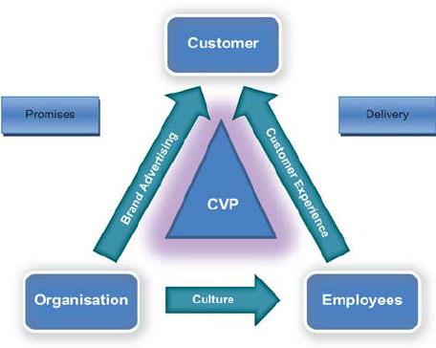
Figure 5: Total engagement model. Source: (Frank Alpert, 2010)
Nike Jordan air shoes offers four main value propositions: private label, innovation, accessibility, and customization (Nike inc, 2019). The business fosters accessibility by providing a wide range of choices. NikeID, a service offered by the company, enables personalization for shoes including Jordan air shoes. Customers can choose the sports style, tread, and color of their shoes, among other features. Nike excels in developing trademarks

which also impacts its brand line Jordan air. The Nike Jordan shoes brand strategy is to establish a strong brand that creates passionate consumer devotion from individuals practically across the globe. This is a result of Air Jordan’s advertising's expressive promotional strategy. Nike's contemporary, practical style and products appeal to people of all ages. Nike Jordan air shoes marketing plan and public image both place a strong emphasis on the ideas of invention and ambiguity (Nike, 2016). Culture is strongest when there isn't any conflict between what happens within a company and what the public expects. Employees have a higher likelihood of offering what clients have grown to expect in this approach. Nike Jordon air shoes has recently made major improvements to both its e-commerce homepage of Nike. These minor things contribute to the client experience and promote customer loyalty.
CONCLUSION
The sneakers and activewear called Air Jordan are made by the American company Nike. This paper reviews Nike's Jordan air shoes unique marketing techniques for boosting brand awareness along with the way they manage and evaluate the consumer experience across several communication channels to meet the expectations of both present and prospective stakeholders. In the athletic apparel market, Jordan sir shoes uses a powerful communication channel to connect with its target customers. In addition, Nike’s Jordan air shoes employs many marketing strategies to raise its profile, and Keller's brand equity is the brand equity model that Nike’s basketball line Jordan air shoes has embraced.

References
Adamstepinski (2013) ‘Communication and team dynamics’, pp. 1–14.
Al-fedaghi, S. (2009) ‘Conceptual Model for Communication’, pp. 1–8.
Bischoff, A. (no date) ‘Customer journey map : The key to understanding your customer’, pp. 1–10.
Brohi, H. et al. (2016) ‘Strategic Marketing Plan of Nike’, SSRN Electronic Journal [Preprint], (April). Available at: https://doi.org/10.2139/ssrn.2760631.
Caetano, N.M.R.P.L. (2019) ‘NIKE MARKETING PLAN -THE LAUNCH OF NIKE ACADEMY IN PORTUGAL Nuno Maria Risques Pereira Lupi Caetano’, (September).
Camilleri, M.A. (2018) ‘Integrated Marketing Communications’, Tourism, Hospitality and Event Management, pp. 85–103. Available at: https://doi.org/10.1007/978-3-319-49849-2_5.
Costa, C.J., Aparicio, M. and Braga, A.S. (2012) ‘Design of Communication : a Review of Theories and Models’, pp. 1–6. Available at: https://doi.org/10.1145/2311917.2311921.
DOWNIE, R. (2022) ‘Nike Stock : Capital Structure Analysis Get a Call For Expert’, pp. 1–8.
van Ee, T. (2021) ‘Nike Inc Strategic Marketing Portfolio’, (October), pp. 1–36. Available at: https://doi.org/10.13140/RG.2.2.17278.51528.
Elizabeth Goudreau (2017) ‘How Brand Equity Has Kept Nike On Top | by Elizabeth Goudreau | Medium’, pp. 2–7. Available at: https://medium.com/@emgoudre/how-brand-equity-has-kept-nike-on-top-3f4ee0814d60.
Elleström, L. (2016) ‘A medium-centered model of communication’, pp. 1–11. Available at: https://doi.org/10.1515/sem-2016-0024.
Evans, A.C. (2021) ‘What is Communication? - Definition & Importance’, pp. 22–24.
Flensburg, P. (2009) ‘An Enhanced Communication Model’, 9, pp. 1–8. Available at: https://doi.org/10.4192/1577-8517-v9.
Flynn, P. (2015) ‘Nike Marketing Strategy: A Company to Imitate’, Accounting, 14(5), p. 21. Available at: https://scholarsarchive.library.albany.edu/honorscollege_accounting/14.
Gorden, G.N. (2019) ‘Menu Search Keyboard _ Arrow _ Down’, Encyclopedia Britannica, pp. 1–6.
Govoni, N.A. (2012) ‘Marketing Plan’, Dictionary of Marketing Communications [Preprint]. Available at: https://doi.org/10.4135/9781452229669.n2044.
Grekor, A.M., Georgieva, S. and Ibrahim, A.A. (2022) ‘Models of Business communication’, pp. 1–6.
Hogan, S. (2021) ‘What is the Customer Journey and Why Do You Need to Create One?’, The Daily Egg, pp. 1–16.
Iterable (2021) ‘Nike ’ s Custome r Experien ce Puts Their Best’.
Kapur, R. (2020) ‘The Models of Communication’, pp. 1–6.
Kuhn, K.A.L., Alpert, F. and Pope, N.K.L. (2008) ‘An application of Keller’s brand equity model in a B2B context’, Qualitative Market Research, 11(1), pp. 40–58. Available at: https://doi.org/10.1108/13522750810845540.
Maechler, N., Neher, K. and Park, R. (2016) ‘From touchpoints to journeys: Seeing the world as customers do’, pp. 1–12.
Marshall, P.D. and Morreale, J. (2018) ‘Advertising and Promotional Culture’, Advertising and Promotional Culture [Preprint], (September 2020). Available at: https://doi.org/10.1057/978-1-137-02625-5.
Mixon, E. and Horwitz, L. (2022) ‘customer journey map’, pp. 1–4.
Mohan, B.C. and Sequeira, A.H. (2012) ‘An Application of David A. Aaker’s Brand Identity Planning Model - A Case Study Approach’, SSRN Electronic Journal [Preprint], (October). Available at: https://doi.org/10.2139/ssrn.2020883.
Moisescu, O.I. (2005) ‘The concept of Brand equity - A comparative approach’, The Proceedings of the international conference, (October 2015), pp. 212–220.
Nike (2016) ‘A Growth Company: Nike’, Nike Inc., p. 10. Available at: http://media.corporate-ir.net/media_files/IROL/10/100529/nike-gs09/docs/nike-growth-story.pdf.
Nike (2018) ‘United States Securities and Exchange Commission 2018 Form 10-K Annual Report pursuant to Section 13 or 15(d) of the Securities Exchange Act of 1934 for the fiscal year ended May 31, 2018: Gilead Sciences’, pp. 1–131. Available at: http://www.gilead.com/ar2015/assets/img/GileadSciences_10K_20160224.pdf.
Nike (2022) ‘Nike just do it Nike In’.
Nike, I. (2021) ‘Annual Report’, Annual report pursuant to section 13 or 15(D) of the securirty exchange act of 1934 for the FISCAL year ended May 31, 2021, p. 102. Available at: https://investors.nike.com/investors/news-events-and-reports/default.aspx.
Nike Inc. (2020) ‘ANNUAL REPORT ON FORM 10-K for Fiscal Year 2020.’, p. 103. Available at: https://s1.q4cdn.com/806093406/files/doc_downloads/2021/NKE-FY20-10K.pdf.
Nike inc (2019) Annual report 2019. Available at: https://www.sec.gov/Archives/edgar/data/1080709/000119312515073420/d833036d10k.htm.
Petersons, A. (2016) ‘( PDF ) COMMUNICATION MODELS AND COMMON BASIS FOR MULTICULTURAL COMMUNICATION IN LATVIA Andris Petersons’, IV, pp. 1–7. Available at: https://doi.org/10.17770/sie2016vol4.1555.
Richardson, A. (2010) ‘Using Customer Journey Maps to Improve Customer Experience’.
Roberts, Christopher, Alpert, F. and Roberts, Carissa (2015) ‘Strategic drivers of customer and employee engagement: Practical applications’, Customer Engagement: Contemporary issues and challeng Svendsen, G. (2020) ‘8 Universal Stages of the Customer Journey.’, Medium, pp. 1–7.
Zaki, R.M. (2019) ‘Branding (Brand Equity Models)’, (February). Available at: https://doi.org/10.13140/RG.2.2.12951.01449.
es, pp. 171–192. Available at: https://doi.org/10.4324/9781315725185-20.
Sammut-Bonnici, T. (2015) ‘Brand and Branding’, Wiley Encyclopedia of Management, 6(January 2015), pp. 1–3. Available at: https://doi.org/10.1002/9781118785317.weom120161.
Singh, P. (2022) ‘Customer Journey Stages : How to Deliver Value at Each Stage What are the Customer Journey Stages ?’, pp. 1–21.
Singh, S. (2020) ‘Nike ’ s journey ,’ p. 9316023.
Sorman, A. (2022) ‘The best way to map the customer journey : take a walk in their shoes’, pp. 1–7.

