Programme: MSc Public Health and Social Care in practice
Module: Population Health and Digital Health Promotion
Module code : LCH7007
Topic: The Power of Digital Health: Can Mobile Apps Tackle the Globle Obesity Crisis
Student Name: Tandel Zarnakumari Harishbhai
Student ID : 2408231
Lecturer Name : Dr Ping Wu

Table of Contents
Task 1: Blog 1: The Power of Digital Health: Can Mobile Apps Tackle the Global Obesity Crisis? 3
Introduction 3
Obesity: A Public Health Concern 3
Rise of mHealth Apps: Utilisation in Health Promotion 4
Efficacy of mHealth Apps 5
Impact of mHealth Apps in Health Promotion 6
Addressing Shortfalls 6
References 7
Task 1: Blog 2: Can AI-Powered Coaching Facilitate Combating Obesity? 9
Obesity: A Public Health Challenge 9
Next-Gen Digital Health Solution - NutriCoach AI 9
NutriCoach AI - For Health Promotion 12
Impact of NutriCoach AI in Health Promotion 13
Shortfall Addressal 13
References 15
Task 2: Poster: The Power of Digital Health: Can Mobile Apps Tackle the Global Obesity Crisis? 16

Topic: The Impact Of an Existing Digital Technology currently Used. for a Digital Health Promotion Intervention

Task 1: The Power of Digital Health: Can Mobile Apps Tackle the global Obesity Crisis?

Introduction
Obesity is one of the most persistent public health concerns globally that affects more than 1 billion individuals (WHO, 2024). It remains a significant risk element for certain cancers, diabetes and cardiovascular diseases that contribute substantially to mortality and morbidity, worldwide. In spite of the various public health initiatives, the obesity rates continue to increase because of the lack of awareness, unhealthy diets and sedentary lifestyles (Tiwari and Balasundaram, 2021; CDC, 2024). One of the digital technologies that have been gaining traction in fighting obesity is mobile health applications (mHealth apps), especially those that focus on modification of lifestyle and management of weight. However, are these apps really effectual? And do these truly make any difference or are there any limitations? These have been explored in the discussion that follows.

Obesity: A Public Health Concern
Since the year 1990, obesity rates have been determined to have quadrupled amongst children and adolescents (5-19 years) and have doubled amongst adults, globally (WHO, 2024). This alarming trend has been associated with the increased costs of healthcare, higher risks of mortality and impact on mental health. The price tag in missed work days and healthcare costs due to obesity has been estimated to be about $2 trillion or 2.8% of yearly worldwide economy (Berman, 2014). Furthermore, obesity has also been determined to reduce life expectancy by about 3-10 years depending on its severity (NHS, 2025). Moreover, there prevails a strong relationship between obesity and psychological issues, especially mood disorders such as depression, anxiety and low self-esteem (Segal and Gunturu, 2024).
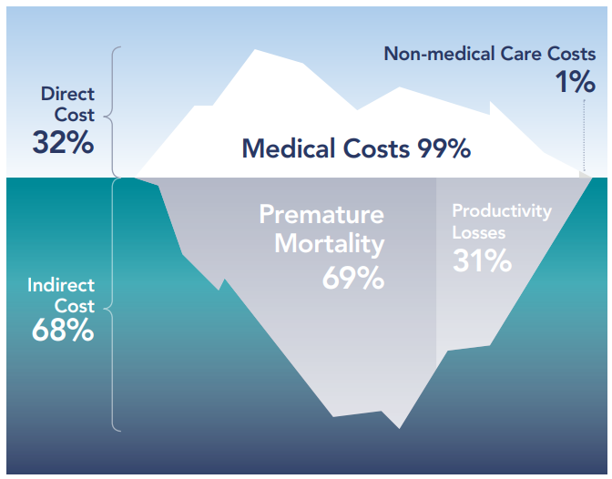
Figure 1: Breakdown of economic costs of obesity
(Source: World Obesity Federation, 2022)

Rise of mHealth Apps: Utilisation in Health Promotion
mHealth technologies such as mHealth apps offer the possibility of cost-efficacious, enhance disease tracking, foster healthy lifestyles, increase adherence, induce positive behaviour as well as patient-centred tools for improving the awareness of disease of an individual (Mahmood et al., 2019). There are several mHealth apps available such as Apple Health, Samsung Health, Google Fit, apart from the available fitness trackers like Apple watches, Fitbits, Samsung watches and Garmin watches (Wells and Spry, 2023). Through integration of behavioural psychology, real-time data and gamification, these apps have helped the users in staying engaged as well as making informed health decisions.
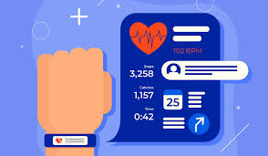


Efficacy of mHealth Apps
Ang et al. (2021) have elucidated that mHealth apps had resulted in weight loss as it enabled monitoring physical activities, diet and weight. Chew et al. (2022) had also highlighted that the users of weight management apps presented higher adherence to exercise and dietary goals as opposed to non-users.
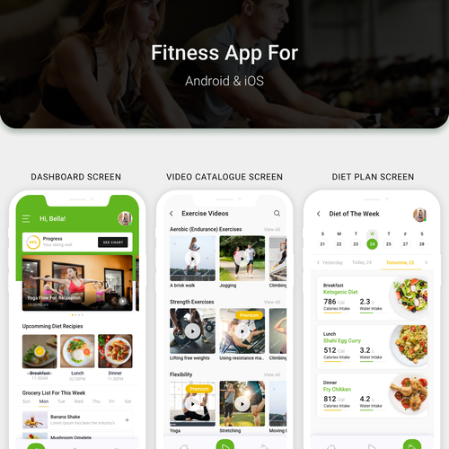
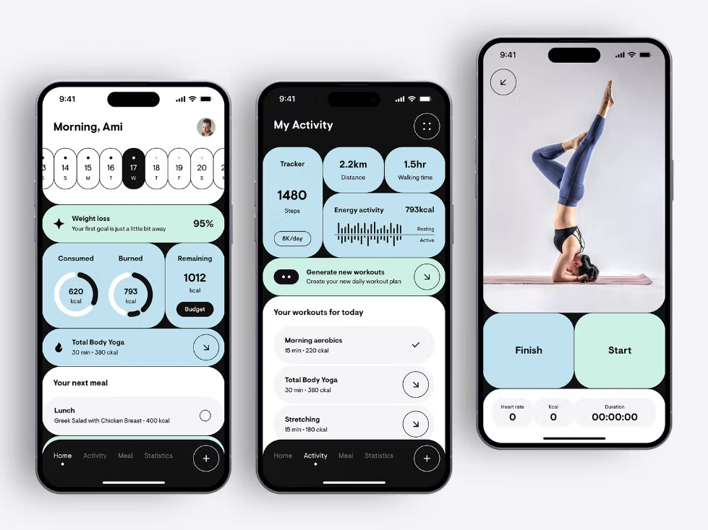

Impact of mHealth Apps in Health Promotion
mHealth apps are available 24x7 and therefore it can be used anywhere and anytime. Furthermore, the AI-driven algorithms also offer customised exercise and diet plans. Additionally, Burke et al. (2025) have illustrated that features such as progress tracking, goal-setting and reminders enhance the long-term adherence. However, studies by Mustafa et al. (2022) have highlighted that more than 50% users stopped using the mHealth apps within 30 days. Giebel et al. (2023) have highlighted that mHealth apps might not be suitable for individuals who have intricate medical conditions or dietary requisites.

Addressing Shortfalls
The efficacies of mHealth apps can be achieved by integration of AI-driven personalisation, which would comprise of using AI for tailoring plans on the basis of lifestyle, metabolic and genetic data. This would facilitate in overcoming the identified challenges.

References
Ang, S.M., Chen, J., Liew, J.H., Johal, J., Dan, Y.Y., Allman-Farinelli, M. and Lim, S.L., 2021. Efficacy of interventions that incorporate mobile apps in facilitating weight loss and health behaviour change in the Asian population: systematic review and meta-analysis. Journal of medical Internet research, 23(11), p.e28185. https://www.jmir.org/2021/11/e28185/
Berman, J., 2014. Report: Obesity Costs Global Economy $2 Trillion. [online] Available at: <https://www.voanews.com/a/global-obesity-hits-2-trillion/2528448.html> [Accessed 30 March 2025].
Burke, L.E., Bizhanova, Z., Conroy, M.B., Cheng, J., Beatrice, B., Kariuki, J.K., Parmanto, B. and Sereika, S.M., 2025. Adherence to self‐monitoring and behavioral goals is associated with improved weight loss in an mHealth randomized‐controlled trial. Obesity, pp.478-489. https://onlinelibrary.wiley.com/doi/pdf/10.1002/oby.24234
CDC, 2024. New CDC Data Show Adult Obesity Prevalence Remains High. [online] Available at: <https://www.cdc.gov/media/releases/2024/p0912-adult-obesity.html> [Accessed 30 March 2025].
Chew, H.S.J., Koh, W.L., Ng, J.S.H.Y. and Tan, K.K., 2022. Sustainability of weight loss through smartphone apps: systematic review and meta-analysis on anthropometric, metabolic, and dietary outcomes. Journal of Medical Internet Research, 24(9), p.e40141. https://www.jmir.org/2022/9/e40141/
Giebel, G.D., Speckemeier, C., Abels, C., Plescher, F., Börchers, K., Wasem, J., Blase, N. and Neusser, S., 2023. Problems and barriers related to the use of digital health applications: scoping review. Journal of Medical Internet Research, 25, p.e43808. https://www.jmir.org/2023/1/e43808/
Mahmood, A., Kedia, S., Wyant, D.K., Ahn, S. and Bhuyan, S.S., 2019. Use of mobile health applications for health-promoting behavior among individuals with chronic medical conditions. Digital health, 5, p.2055207619882181. https://journals.sagepub.com/doi/pdf/10.1177/2055207619882181
Mustafa, A.S., Ali, N.A., Dhillon, J.S., Alkawsi, G. and Baashar, Y., 2022, January. User engagement and abandonment of mHealth: a cross-sectional survey. In Healthcare (Vol. 10, No. 2, p. 221). MDPI. https://www.mdpi.com/2227-9032/10/2/221/pdf
NHS, 2025. Obesity. [online] Available at: <https://www.nhsinform.scot/illnesses-and-conditions/nutritional/obesity/#:~:text=Obesity%20reduces%20life%20expectancy%20by,lose%20weight%20can%20also%20help.> [Accessed 30 March 2025].
Segal, Y. and Gunturu, S., 2024. Psychological issues associated with obesity. In StatPearls [Internet]. StatPearls Publishing. https://www.ncbi.nlm.nih.gov/books/NBK603747/#:~:text=There%20is%20a%20strong%20association,%5B20%5D
Tiwari, A. and Balasundaram, P., 2021. Public health considerations regarding obesity. [online] Available at: <https://www.ncbi.nlm.nih.gov/books/NBK572122/> [Accessed 30 March 2025].
Wells, C. and Spry, C., 2023. An overview of smartphone apps: CADTH horizon scan. [online] Available at: <https://europepmc.org/books/nbk595384> [Accessed 30 March 2025].
WHO, 2024. One in eight people are now living with obesity. [online] Available at: <https://www.who.int/news/item/01-03-2024-one-in-eight-people-are-now-living-with-obesity#:~:text=New%20study%20released%20by%20the,to%2019%20years%20of%20age).> [Accessed 30 March 2025].
World Obesity Federation, 2022. The Economic Impact of Overweight & Obesity in 2020 and 2060 | 2nd Edition with Estimates for 161 Countries. [online] Available at: <https://data.worldobesity.org/publications/WOF-Economic-Impacts-2-V2.pdf> [Accessed 30 March 2025].

Topic: The Impact of a Digital Technology You Designed for a Digital Health Promotion Intervation
Task 1: Blog 2: Can AI-Powered Coaching Facilitate Combating Obesity?
Obesity: A Public Health Challenge
Obesity continues to remain a tenacious global public health challenge which has been determined to have affected over 1 billion people (WHO, 2024). This rising prevalence is greatly due to the poor health awareness, sedentary lifestyles and unhealthy food choices. It has been estimated that obesity and its related health issues cost about $2 trillion annually to the global economy (Berman, 2014), while also reducing the average life expectancy of individuals.
Figure 1: Breakdown of economic costs of obesity
(Source: World Obesity Federation, 2022)
Although there prevail several digital health solutions such as fitness tracking, calorie-tracking and so on, people often stop using the same after a certain duration of time (Mustafa et al., 2022). In order to overcoming these challenges, a novel AI-powered mHealth app, NutriCoach AI, is being proposed that would facilitate in tackling obesity.

Next-Gen Digital Health Solution - NutriCoach AI
NutriCoach AI would be the next generation AI-powered digital health solution that has been designed for tackling obesity via personalised workout and meal plans, gamification and rewards, real-time AI coaching and integration with the existing smart wearables. NutriCoach AI would offer the users with customised workout and meal plans, based on their dietary requirements, fitness levels and metabolism. Additionally, it would use behavioural psychology for prediction and prevention of the unhealthy eating habits. Through its gamification and rewards features, it would motivate the users with consistent diet and exercise adherence.
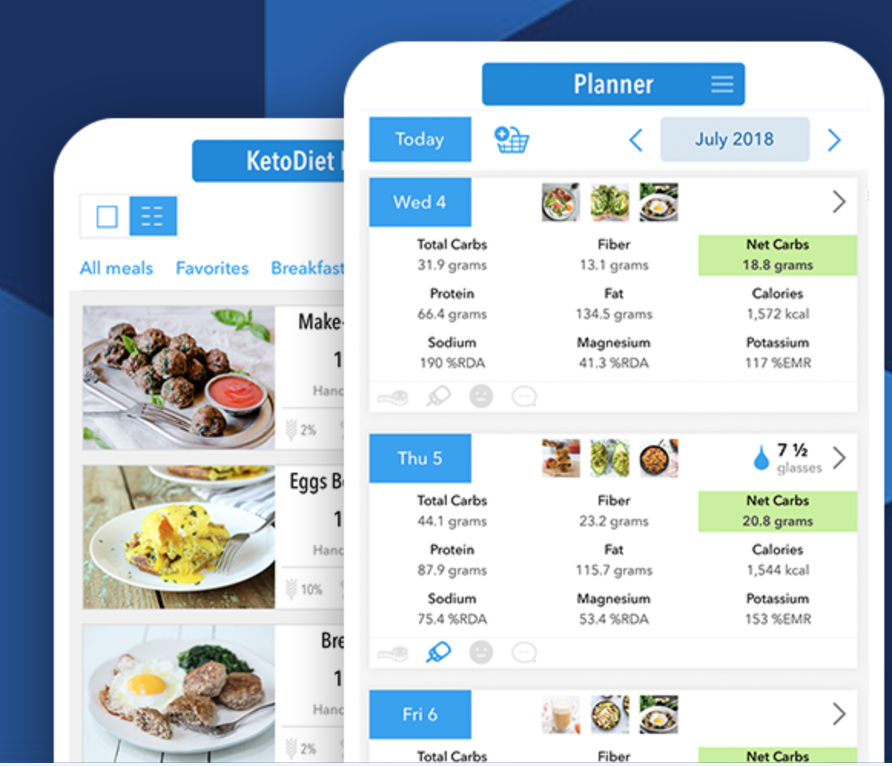
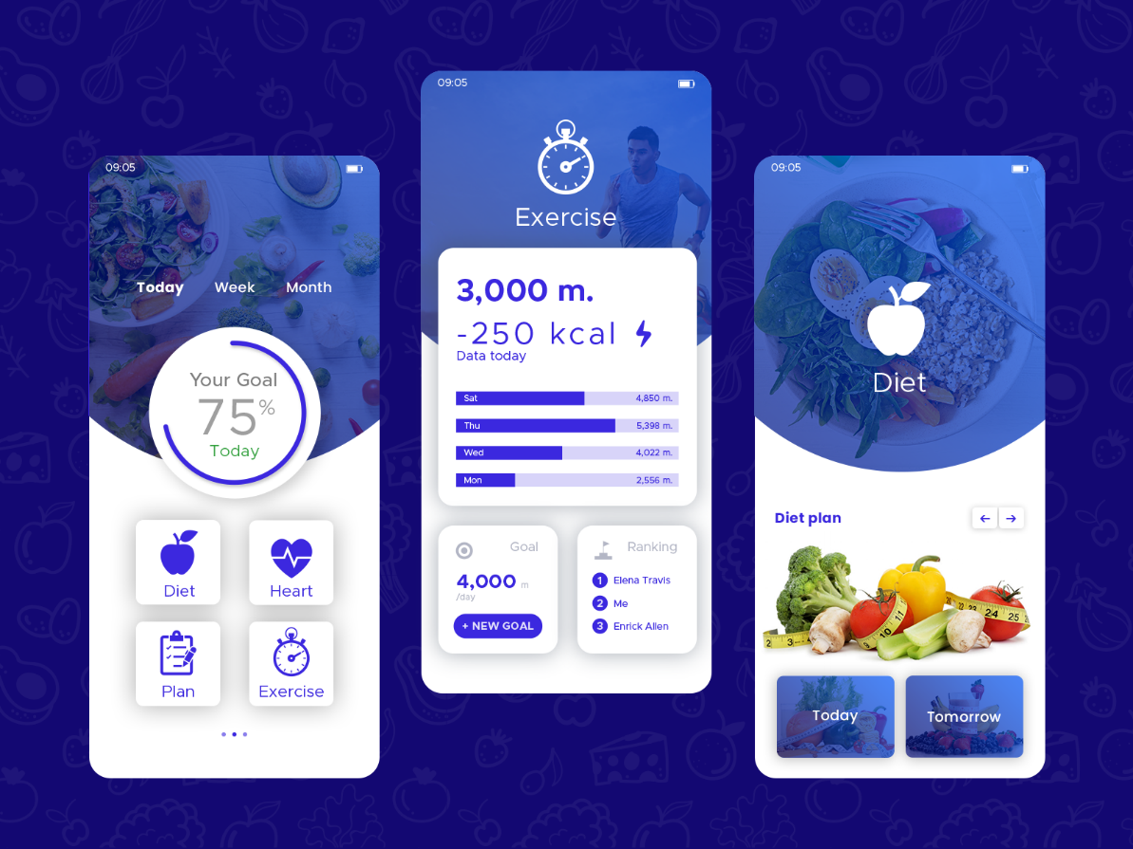
The mHealth app shall be developed in such manner that it syncs with the different existing smart wearables such as Apple Watch or Fitbit. Most importantly, the app will have a 24x7 AI-based chat support that would provide the users with instant emotional support, advice and motivation. The user would be required to input their basic information like dietary preference, age, weight and so on and the AI interface would develop customised exercise and diet plan based on these data. It would also integrate the information gathered from the wearable devices and generate a dynamic plan as per the real-time data collected. The users would receive meal suggestions, coaching notifications as well as motivational notifications. The app would have behavioural tracking adjustments that would recommend and prevent relapse of the user into unhealthy habits.
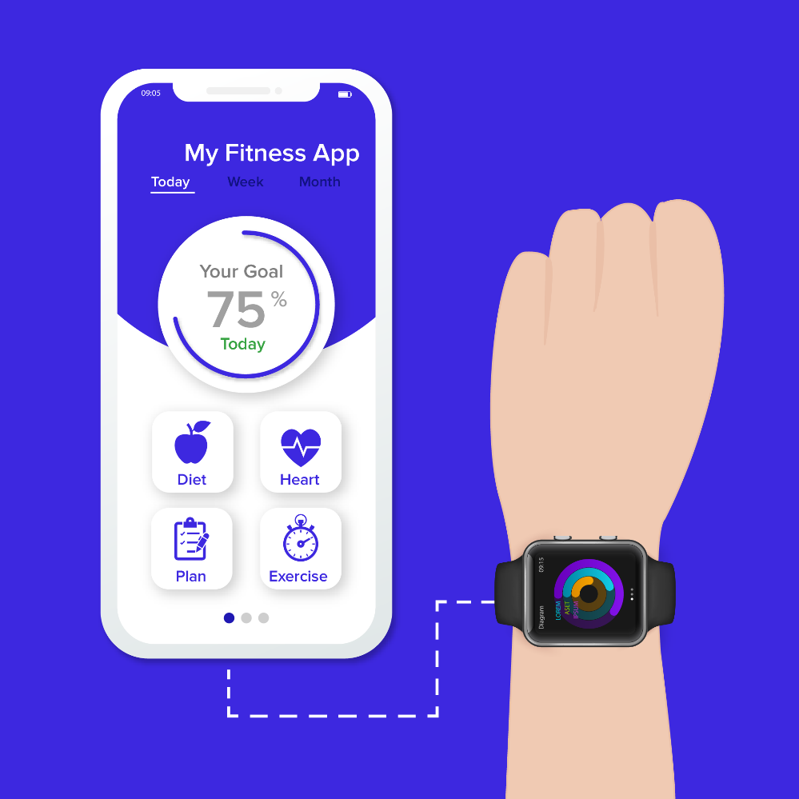

NutriCoach AI - For Health Promotion
NutriCoach AI would tackle the root causes of obesity with the help of features like real-time decision support, personalised feedback loops, AI coaching and emotional support and the gamification and reward system for long-term engagements. The AI would detect overeating triggers in the user and provide with instant healthy choices. Additionally, the users would earn points for maintaining their healthy habits, which they could redeem for other benefits such as insurance, meal plans and so on. It has been determined that AI-driven behavioural coaching tend to enhance the weight loss outcomes as compared to the conventional self-monitoring applications (Forman et al., 2023). It is expected that NutriCoach AI would offer the same to the users.
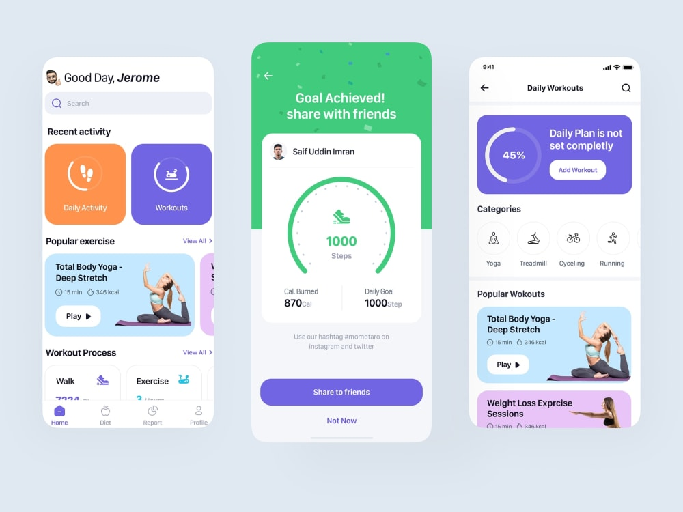

Impact of NutriCoach AI in Health Promotion
Studies have presented that the weight management app user tends to have higher adherence rate to the dietary and workout goals as compared to a non-user (Chew et al., 2022). NutriCoach AI would offer the users with personalised AI coaching which would keep the users engaged as well as motivated. Tsolakidis et al. (2024) have highlighted that data-driven innovations and personalised nutrition plans that fulfil the health requisites of individuals based on their habits and metabolism, facilitate better maintenance of their health. NutriCoach AI would provide the users with adaptive AI-based interventions on the basis of their individual habits and metabolism. However, the main challenge associated with the technological intervention is the AI bias and accuracy which might not take into consideration the cultural dietary preferences.

Shortfall Addressal
The main shortfall identified is the AI bias related to the AI-generated diet plans which might not be in line with the cultural dietary preferences. However, the same can be overcome by expanding the food database of the app by incorporation of region-specific dietary data.
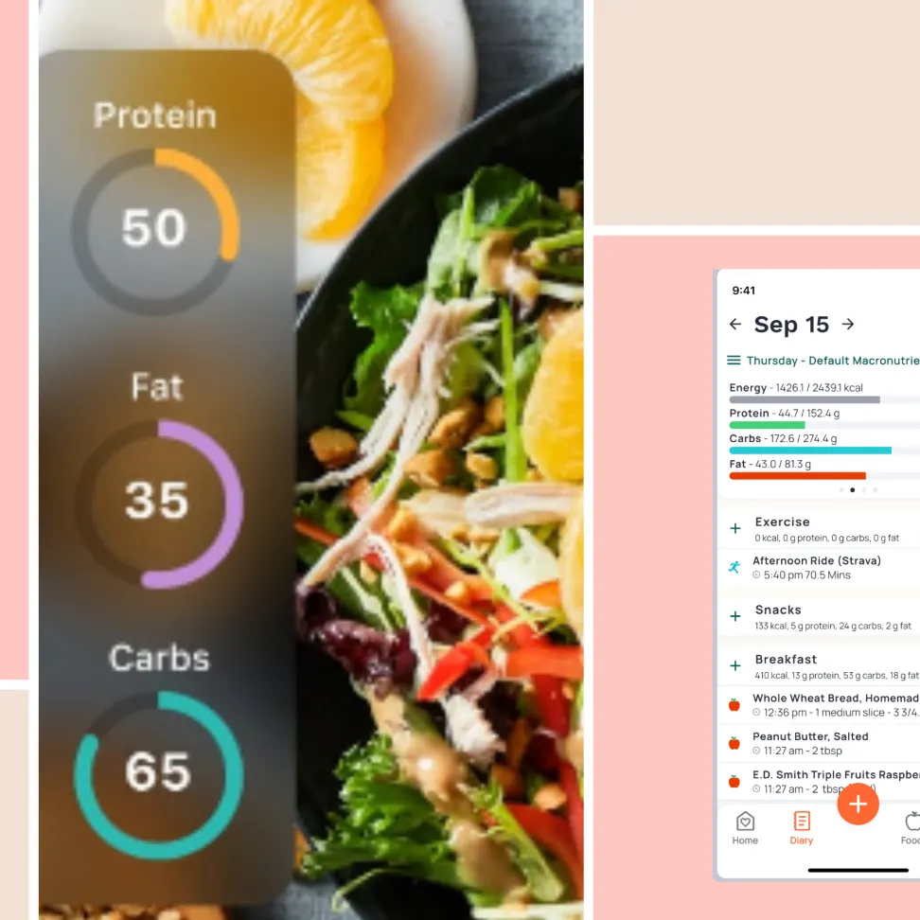

References
Berman, J., 2014. Report: Obesity Costs Global Economy $2 Trillion. [online] Available at: <https://www.voanews.com/a/global-obesity-hits-2-trillion/2528448.html> [Accessed 30 March 2025].
Chew, H.S.J., Koh, W.L., Ng, J.S.H.Y. and Tan, K.K., 2022. Sustainability of weight loss through smartphone apps: systematic review and meta-analysis on anthropometric, metabolic, and dietary outcomes. Journal of Medical Internet Research, 24(9), p.e40141. https://www.jmir.org/2022/9/e40141/
Forman, E.M., Berry, M.P., Butryn, M.L., Hagerman, C.J., Huang, Z., Juarascio, A.S., LaFata, E.M., Ontañón, S., Tilford, J.M. and Zhang, F., 2023. Using artificial intelligence to optimize delivery of weight loss treatment: Protocol for an efficacy and cost-effectiveness trial. Contemporary clinical trials, 124, p.107029. https://pmc.ncbi.nlm.nih.gov/articles/PMC9839592/pdf/nihms-1853769.pdf
Mustafa, A.S., Ali, N.A., Dhillon, J.S., Alkawsi, G. and Baashar, Y., 2022, January. User engagement and abandonment of mHealth: a cross-sectional survey. In Healthcare (Vol. 10, No. 2, p. 221). MDPI. https://www.mdpi.com/2227-9032/10/2/221/pdf
Tsolakidis, D., Gymnopoulos, L.P. and Dimitropoulos, K., 2024, August. Artificial Intelligence and Machine Learning Technologies for Personalized Nutrition: A Review. In Informatics (Vol. 11, No. 3, p. 62). MDPI. https://www.mdpi.com/2227-9709/11/3/62
WHO, 2024. One in eight people are now living with obesity. [online] Available at: <https://www.who.int/news/item/01-03-2024-one-in-eight-people-are-now-living-with-obesity#:~:text=New%20study%20released%20by%20the,to%2019%20years%20of%20age).> [Accessed 30 March 2025].
World Obesity Federation, 2022. The Economic Impact of Overweight & Obesity in 2020 and 2060 | 2nd Edition with Estimates for 161 Countries. [online] Available at: <https://data.worldobesity.org/publications/WOF-Economic-Impacts-2-V2.pdf> [Accessed 30 March 2025].

Task 2: Poster: The Power of Digital Health: Can Mobile Apps Tackle the Global Obesity Crisis?
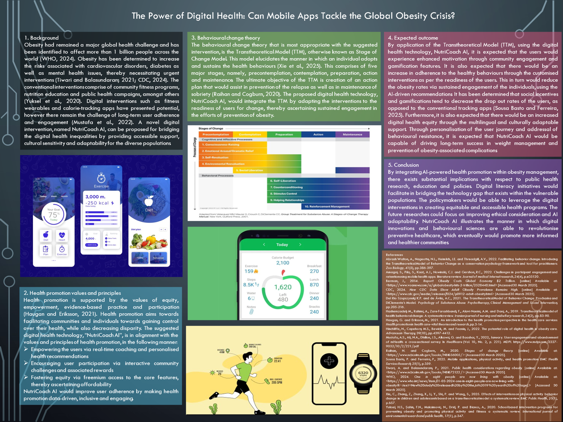
1. Background
Obesity had remained a major global health challenge and has been identified to affect more than 1 billion people across the world (WHO, 2024). Obesity has been determined to increase the risks associated with cardiovascular disorders, diabetes as well as mental health issues, thereby necessitating urgent interventions (Tiwari and Balasundaram, 2021; CDC, 2024). The conventional interventions comprise of community fitness programs, nutrition education and public health campaigns, amongst others (Yuksel et al., 2020). Digital interventions such as fitness wearables and calorie-tracking apps have presented potential, however there remain the challenge of long-term user adherence and engagement (Mustafa et al., 2022). A novel digital intervention, named NutriCoach AI, can be proposed for bridging the digital health inequalities by providing accessible support, cultural sensitivity and adaptability for the diverse populations.
2. Health promotion values and principles
Health promotion is supported by the values of equity, empowerment, evidence-based practice and participation (Haugan and Eriksson, 2021). Health promotion aims towards facilitating communities and individuals towards gaining control over their health, while also decreasing disparity. The suggested digital health technology, “NutriCoach AI”, is in alignment with the values and principles of health promotion, in the following manner:
- Empowering the users via real-time coaching and personalised health recommendations
- Encouraging user participation via interactive community challenges and associated rewards
- Fostering equity via freemium access to the core features, thereby ascertaining affordability
NutriCoach AI would improve user adherence by making health promotion data-driven, inclusive and engaging.
3. Behavioural change theory
The behavioural change theory that is most appropriate with the suggested intervention, is the Transtheoretical Model (TTM), otherwise known as Stage of Change Model. This model elucidates the manner in which an individual adopts and sustains the health behaviours (Xie et al., 2025). This comprises of five major stages, namely, precontemplation, contemplation, preparation, action and maintenance. The ultimate objective of the TTM is creation of an action plan that would assist in prevention of the relapse as well as in maintenance of sobriety (Raihan and Cogburn, 2020). The proposed digital health technology, NutriCoach AI, would integrate the TTM by adapting the interventions to the readiness of users for change, thereby ascertaining sustained engagement in the efforts of prevention of obesity.
4. Expected outcome
By application of the Transtheoretical Model (TTM), using the digital health technology, NutriCoach AI, it is expected that the users would experience enhanced motivation through community engagement and gamification features. It is also expected that there would be an increase in adherence to the healthy behaviours through the customised interventions as per the readiness of the users. This in turn would reduce the obesity rates via sustained engagement of the individuals, using the AI-driven recommendations. It has been determined that social incentives and gamifications tend to decrease the dropout rates of the users, as opposed to the conventional tracking apps (Sousa Basto and Ferreira, 2025). Furthermore, it is also expected that there would be an increased digital health equity through the multilingual and culturally adaptable support. Through personalisation of the user journey and addressal of behavioural resistance, it is expected that NutriCoach AI would be capable of driving long-term success in weight management and prevention of obesity-associated complications.
5. Conclusion
By integrating AI-powered health promotion within obesity management, there exists substantial implications with respect to public health research, education and policies. Digital literacy initiatives would facilitate in bridging the technology gap that exists within the vulnerable populations. The policymakers would be able to leverage the digital interventions in creating equitable and accessible health programs. The future researches could focus on improving ethical consideration and AI adaptability. NutriCoach AI illustrates the manner in which digital innovations and behavioural sciences are able to revolutionise preventive healthcare, which eventually would promote more informed and healthier communities.

References
Abrash Walton, A., Nageotte, N.L., Heimlich, J.E. and Threadgill, A.V., 2022. Facilitating behavior change: Introducing the Transtheoretical Model of Behavior Change as a conservation psychology framework and tool for practitioners. Zoo Biology, 41(5), pp.386-397. https://onlinelibrary.wiley.com/doi/pdfdirect/10.1002/zoo.21704
Amagai, S., Pila, S., Kaat, A.J., Nowinski, C.J. and Gershon, R.C., 2022. Challenges in participant engagement and retention using mobile health apps: literature review. Journal of medical Internet research, 24(4), p.e35120. https://www.jmir.org/2022/4/e35120/
Berman, J., 2014. Report: Obesity Costs Global Economy $2 Trillion. [online] Available at: <https://www.voanews.com/a/global-obesity-hits-2-trillion/2528448.html> [Accessed 30 March 2025].
CDC, 2024. New CDC Data Show Adult Obesity Prevalence Remains High. [online] Available at: <https://www.cdc.gov/media/releases/2024/p0912-adult-obesity.html> [Accessed 30 March 2025].
Del Rio Szupszynski, K.P. and de Ávila, A.C., 2021. The Transtheoretical Model of Behavior Change: Prochaska and DiClemente’s Model. Psychology of Substance Abuse: Psychotherapy, Clinical Management and Social Intervention, pp.205-216. https://www.researchgate.net/profile/Ahmed-Romain/publication/323335614_Is_there_something_beyond_stages_of_change_in_the_transtheoretical_model_The_state_of_art_for_physical_activity/links/5ad51749458515c60f546872/Is-there-something-beyond-stages-of-change-in-the-transtheoretical-model-The-state-of-art-for-physical-activity.pdf
Hashemzadeh, M., Rahimi, A., Zare-Farashbandi, F., Alavi-Naeini, A.M. and Daei, A., 2019. Transtheoretical model of health behavioral change: A systematic review. Iranian journal of nursing and midwifery research, 24(2), pp.83-90. https://journals.lww.com/jnmr/_layouts/15/oaks.journals/downloadpdf.aspx?an=01477816-201924020-00001
Haugan, G. and Eriksson, M., 2021. An introduction to the health promotion perspective in the health care services. Health promotion in health care–vital theories and research, pp.3-14. https://www.ncbi.nlm.nih.gov/books/NBK585681/
Hinchliffe, N., Capehorn, M.S., Bewick, M. and Feenie, J., 2022. The potential role of digital health in obesity care. Advances in Therapy, 39(10), pp.4397-4412. https://link.springer.com/content/pdf/10.1007/s12325-022-02265-4.pdf
Mustafa, A.S., Ali, N.A., Dhillon, J.S., Alkawsi, G. and Baashar, Y., 2022, January. User engagement and abandonment of mHealth: a cross-sectional survey. In Healthcare (Vol. 10, No. 2, p. 221). MDPI. https://www.mdpi.com/2227-9032/10/2/221/pdf
Raihan, N. and Cogburn, M., 2020. Stages of change theory. [online] Available at: <https://www.ncbi.nlm.nih.gov/books/NBK556005/> [Accessed 30 March 2025].
Sousa Basto, P. and Ferreira, P., 2025. Mobile applications, physical activity, and health promotion. BMC Health Services Research, 25(1), p.359. https://link.springer.com/content/pdf/10.1186/s12913-025-12489-z.pdf
Tiwari, A. and Balasundaram, P., 2021. Public health considerations regarding obesity. [online] Available at: <https://www.ncbi.nlm.nih.gov/books/NBK572122/> [Accessed 30 March 2025].
WHO, 2024. One in eight people are now living with obesity. [online] Available at: <https://www.who.int/news/item/01-03-2024-one-in-eight-people-are-now-living-with-obesity#:~:text=New%20study%20released%20by%20the,to%2019%20years%20of%20age).> [Accessed 30 March 2025].
Xie, C., Zhang, Z., Zhang, X., Li, Y., Shi, P. and Wang, S., 2025. Effects of interventions on physical activity behavior change in children and adolescents based on a trans-theoretical model: a systematic review. BMC Public Health, 25(1), p.657. https://link.springer.com/content/pdf/10.1186/s12889-025-21336-z.pdf
Yuksel, H.S., Şahin, F.N., Maksimovic, N., Drid, P. and Bianco, A., 2020. School-based intervention programs for preventing obesity and promoting physical activity and fitness: a systematic review. International journal of environmental research and public health, 17(1), p.347. https://www.mdpi.com/1660-4601/17/1/347/pdf

