Sam Melmoth
1809093@student.uwtsd.ac.uk
Manufacturing Process and Material Selection
Bike frame and part manufacturing development

Abstract
Additive manufacturing is defined by the Oxford dictionary as a replacement for the term 3D printing. Subsequently 3D printings definition is “The action or process of making a physical object from a three-dimensional digital model, typically by laying down many thin layers of a material in succession.” These materials are wide ranging from plastics such as ABS to metals like titanium.
Bike manufacturers are constantly looking for innovative ways to improve their products, by making them lighter, faster, stronger and more efficient for the rider. Whilst also looking for ways to be more profitable as a business. The rapid advancements in additive manufacturing technology has opened new avenues for the cycling industry to exploit and develop. This was echoed by the Additive Manufacturing journal in this statement in the inaugural issue, “Additive manufacturing technologies stand to transform the manner in which products are fabricated directly from digital data, and in doing so, these technologies are poised to have a profound impact on local economies around the world.”
Contents
Abstract 1
Introduction 1
Main body 2
Current saddle design 2
New manufacturing method selection 3
New manufacturing material selection 4
Conclusion 4
References 5

Introduction
A Bike saddle is one of the most important parts of a bike to aid the comfort of a rider. Long distance cyclists must sit in the saddle for hours on end and day after day in some competitions such as the Tour de France. For teams such as Ineos Pro cycling team they are constantly looking for the 1% gains in performance for their riders. The team broke down everything they could think of that goes into competing on a bike, and then improved each element by 1%, they would achieve a significant
aggregated increase in performance. Every rider on the Ineos team rides on Fizik saddles, the company offers 3 models of saddles to their riders. Each model is aimed at riders with differing amounts of flexibility and hip width. It is problematic for riders as humans to conform perfectly to only 3 shapes of saddles, this is why so much padding is needed on the saddle and inbuilt to the shorts of the rider. Average seat pressure increases as the workload increased (Carpes, et al., 2009). The aim of this essay is to make mass production of unique saddles personalised to riders a possibility for manufacturers and customers, to combat the saddle pressure that is believed to cause urological disorders (Carpes, et al., 2009).
There are plenty of papers that explain the problem of saddle pressure on riders and the problems that they can cause, and how different saddle shapes can alleviate this pressure. But the biggest hurdle for companies is to find a way of manufacturing different shaped saddles for each rider without investing in expensive jigs and moulds each time. This would drive the price of each saddle up drastically and make it inaccessible for most riders.
The research in this paper is to investigate if additive manufacturing could make it cost affective for manufacturers to make unique personalised saddles, whilst making them accessible for the wider market and improving comfort for all levels of riders not just the professionals.
The goal of this paper is to find a manufacturing technique that will allow manufacturers to produce fitted saddles for each individual rider. To do this I believe that additive manufacturing is the key to allowing companies to make the different complex shapes needed to fit each person’s individual anthropomorphic shape. Therefore, I will be using papers to discover the current requirements of the saddle and its current manufacturing techniques and materials. I will then also research the possible additive manufacturing methods and materials that are available to produce the new products moving forward and the benefits this will have.

Main body

Current saddle design
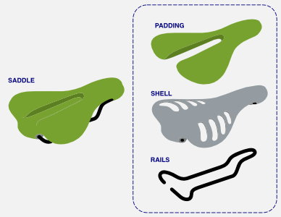
I will be focusing on the saddles produced by Fizik as they make up the biggest percentage of saddles used by professional riders in the Tour de France of the past few years (Bridgewood, 2019). They make 3 main shapes of saddles for road riding. The Arione, Aliante and the Antares. There are many different factors that that lead to choosing your perfect saddle shape, some of these include flexibility, riding activities but most importantly sit bone width (fi'zi:k, 2020). This measurement is the distance between the two contact points of your pelvis. The measurement dictates the width of saddle needed to support these two point properly. If a saddle is to narrow then the full weight of the rider won’t rest on the pelvis but on the soft tissues in-between this can cause discomfort and has been proven to increase the likelihood of certain anatomical and neurovascular pathologies (Barbagallo, 2015). The saddles other characteristics are the size of the cut out in the middle and the curvature of the saddle front to back. The reason for the cut-out is to limit the pressure on the soft tissues and nerves that are located in-between the two pelvis contact points, and to allow a non-restricted blood flow. The differences in curvature are for varying levels of flexibility. Where the saddles with minimal curve like the Arione are for more flexible riders typically professionals. And the curved saddles are for riders that struggle to get the right amount of pelvic tilt required to get into a racing position on a road bike.
Figure 1 (Saddle parts)
Saddle material can vary widely, there are three main parts to a saddle. The rails, these are what connects the saddle to the seat post and offer adjustment backwards and forwards to accommodate different proportioned riders, it is normally made from materials such as steel and aluminium for lower end products and titanium or carbon fibre for more expensive ones. The shell is the part of the saddle that offers rigidity to the padding that lies on top, this is commonly made from moulded plastic such as nylon and carbon fibber can also be used to add stiffness. The top layer of padding is then made from a combination of foam or gel which is sealed with leatherette, vinyl or spandex.

New manufacturing method selection
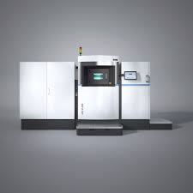
For manufacturing complex and unique shapes quickly, there is no better option than 3D printing, especially now that Direct Metal Laser Sintering (DMLS) allows metal powders to be used. By utilising this budding new technology, it would be possible for manufacturing companies to make personalised saddles uniquely, that were fitted to your physique. By using a test saddle for a rider to sit on and use in order for sensors in the saddle to pick up the pressure points and create a 3D projection of the outline of your behind. As the saddle would perfectly match the rider it would disperse the load more evenly therefore reducing hot patches and blisters. Intern this would negate the need to use padding on the saddle as the padding in the chamois would be enough due to the reduced pressure points, this will lead to greater weight saving on the bike which is crucial for certain events such as timed hill climbing.
Figure 2 (DMLS Machine)

In order to manufacture unique saddles using traditional techniques, processes such as casting, or carbon fibber moulding would have to be used. Both these processes require a mould to be made which is time consuming and expensive. 3D printing would get rid of this step, the only pre-production steps would be to have the fitting, which can be done anywhere, and for a CAD engineer to take the outline and add the framework and rails to support and connect the saddle to the seat post. All of this design work can be done on a computer which gets rid of the need for expensive tooling and equipment. The advantage of using laser additive manufacturing is that titanium or any other types of metal powder could be used to create these complex shapes to reduce weight of the parts and make the saddles more durable as there would only be the metal frame and no need for the gel and leather top layers that can easily be ripped and worn down over time.

New manufacturing material selection
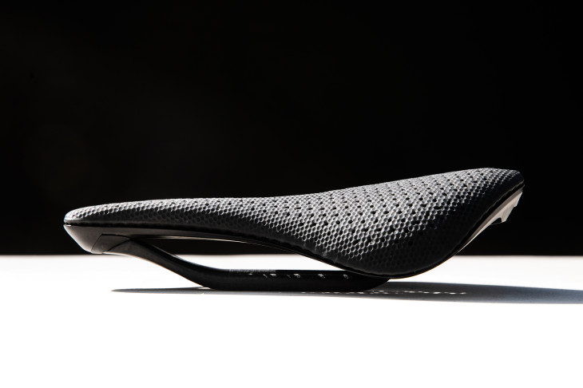
The requirements for this saddle are to be strong enough to support the weight of the rider and the force that they exert when peddling, but also light enough to not hinder the performance of the cyclist. Stiffness is another characteristic to consider because if the saddle flexes to much under load then then it will reduce the efficiency of the rider. It must also be able to be used by a 3D printer which eliminates options such as carbon fibber which is commonly used in the cycling industry. There are still plenty of options though and this can be chosen by the customer on ordering. The different materials would affect the price of the saddle. Titanium being the most expensive but the best suited for the application as it has the best strength to weight ratio compared to aluminium and stainless steel.
Figure 3 (3D printed prototype)

Conclusion
In conclusion additive manufacturing could revolutionise saddle design moving forward. The benefits are:
- Weight saving due to the lack of padding needed and the ability to create complex shapes and hollow parts using DMLS and CAD software.
- Better fitting saddles that will reduce friction and pressure spots to combat the formation of saddle sores.
- Faster manufacturing of one-off saddles that will allow large scale production and allow the product to be available to the wider market than just the professionals.
- Reduced labour needed to manufacture the products.
- Product is future proofed as changes in the design are easily changed by the CAD technology and no new tooling needed.
Some of the disadvantages are to the customer as bike manufactures:
- The product will always have a lead time greater than a standard off the shelf saddle.
- Fittings will have to be done so local hubs would have to be made to take customers measurements, unless a portable measurement tool could be created.
- Bike manufacturers wouldn’t be able to supple saddles with the bike.
- Bikes wouldn’t be able to be shared between people.
The target market for this product would be higher end riders, due to the bikes not being able to cater to more than one rider. Another reason that this is a higher end product is because only riders that spend long times in the saddle will feel the benefits of the product.
Additive manufacturing is crucial for the manufacturing of this new product, as it would not be possible to manufacture the complex shapes using a casting technique as the moulds would be redundant after one use which isn’t financially viable. Therefor the ability to manufacture multiple unique saddles on one deck is a massive advantage.

References
Barbagallo, G. S. a. F. M. O., 2015. Interactive re-design of a novel variable geometry bicycle saddle to prevent neurological pathologies. International Journal on Interactive Design and Manufacturing (IJIDeM), 10(2), pp. 165-172.
Bridgewood, O., 2019. New Pinarello Dogma F12 | Team Ineos' 2019 Race Bike: First Look. [Sound Recording] (Global cycling network ).
Carpes, F. P., Dagnese, F., Kleinpaul, J. F. & Martins, E. d. A., 2009. Effects of Workload on Seat Pressure While Cycling with Two Different Saddles. Journal of sexual medicine , 6(10), pp. 2728-2735.
fi'zi:k, 2020. fi'zi:k. [Online]
Available at: https://www.fizik.com/eu_en/saddle-finder.html
[Accessed January 2020].

