HOW HAVE THEORETICAL APPROACHES INFLUENCED OUR CLASSROOMS?

PRINCIPLES OF LEARNING AND TEACHING – SJIE4006 – CREATED BY ANDREW PALMER
  - My Educational scrapbook

HOW HAVE THEORETICAL APPROACHES INFLUENCED OUR CLASSROOMS?
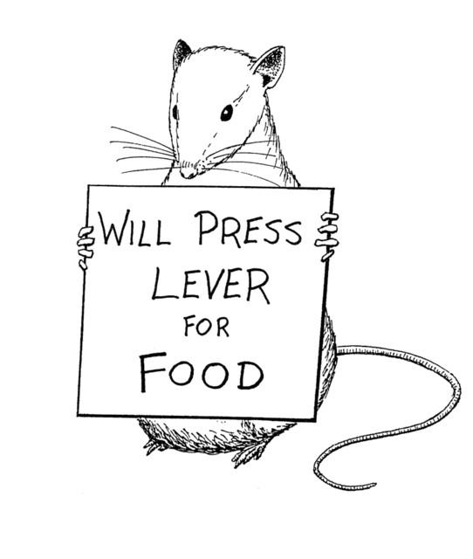
Behaviourism: Skinner and his operant conditioning theory.
- Developed from his work with rats in his ‘skinner box’.
- The box contained a lever and when the rat was placed into the box it would eventually move the lever and release food which the rat would eat.
- After a short period of time the rats would move the lever as soon as they were placed into the box to access the food, this meant that conditioning had taken place and the rats had learnt how to access the food.
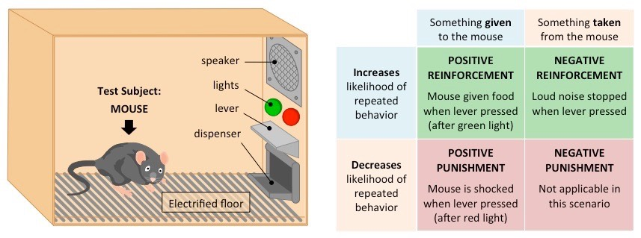
- Skinner described this as positive reinforcement; the desired behaviour has been rewarded with food.
NEGATIVE REINFORCEMENT
- Skinner arrived at this theory by placing an electrical current on the floor of his box, the rat would be in discomfort, however this time when the rat knocked the lever, instead of food as the reward it would turn off the current.
- In this case the desired behaviour had been achieved by removing an unwanted stimuli. Skinner reffered to this as Negative reinforcement.
How is this theory used today?
- An example of negative reinforcement would be using sun cream on a hot day. The negative stimulus is getting sunburned, so by using sun cream you are removing the sunburn you are gaining the desired outcome (Cosgrave, 2018).
Figure 1 - (BioNinja, no date)
Positive reinforcement
How is this theory used today?
- Positive reinforcement is a key strategy used by parents and teachers.
- Within education ‘rewards’ are used to reinforce a positive behaviour, for example, a teacher could give praise, or make a positive comment in a student’s school diary for engaging well in a lesson.
- Praise is given as a positive reinforcement to encourage the student to repeat the behaviour. Skinner also went on to develop ideas on token economy and behaviour shaping from his work on operant conditioning (McLeod, 2018).

Figure2 - (Funderstanding, 2011).

Social Constructivism: Lev Vygotsky’s Zone of Proximal Development, How big an influence has this theory had?

How constructivist theories are used in my setting.
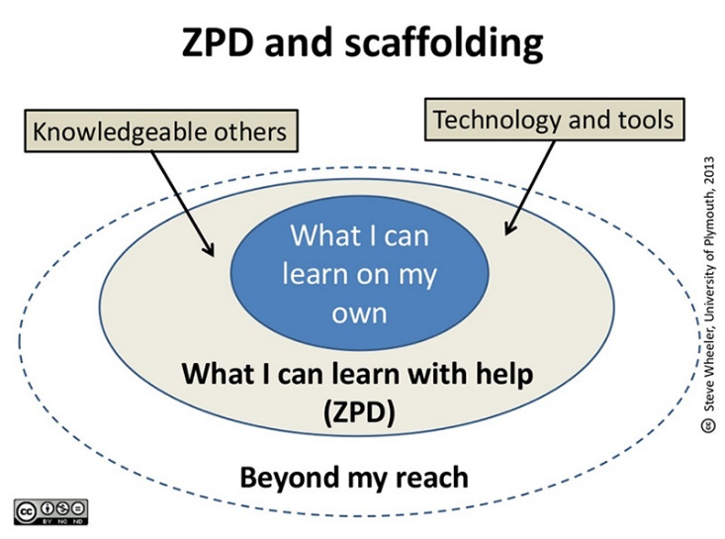
Figure 3 - (McLeod, 2018).
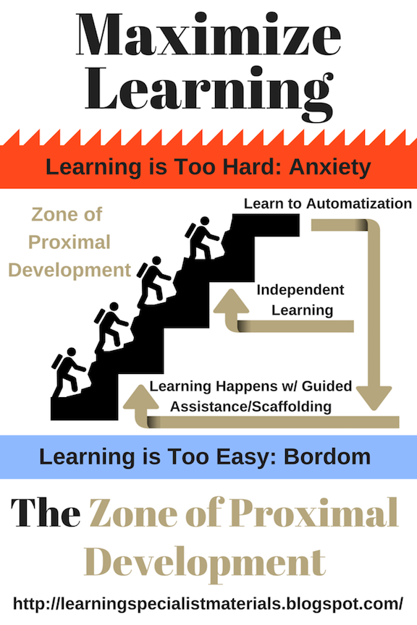
When starting a new unit of work or task, I always try to find the level of understanding that the students have. As I work in a setting with low pupil numbers this is often easily achieved by asking the students individual questions. Often their knowledge about a new subject is low so I can start the task/unit and discuss it in its most basic form. I get to spend time reinforcing their understanding in lessons but I can also record myself using screen casts, which they can access online at any time if they need additional support. I test the students when I feel they are ready to develop their understanding further, if the results are good, we move forward with the task, if not I continue that level of support. This process is repeated until I feel that the students are ready to undertake the task independently, hoping that the support that I have provided has given them the skills and knowledge to be successful. I Use this strategy in my classroom in the hope that I prepare my students to be successful in their GCSE exams and feel that it is a good example of a constructivist approach, using both the ZPD and scaffolding theories.
Figure 4 - (TES, 2020).
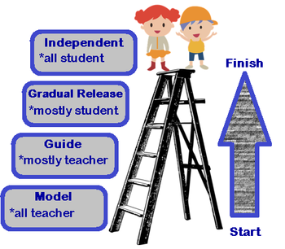
Bruner: Scaffolding
- Scaffolding requires the support from a practitioner (teacher, parent) to help ‘facilitate learning’ Bates (2019, p.56) the theory is based on understanding what the individual already knows, scaffolding them to develop knowledge and understanding, the more this devlops the scaffolding is gradually reduced and the learner continues to develop whilst learning key skills such as problem solving and using their initiative to gain more understanding (McLeod, 2019).

Figure 5 - (Study.com, 2020).
- This theory was created by Jerome Bruner, they are closely linked with Vygotsky’s ZPD theory.
- Brunner believed that for individuals to learn effectively they needed to have an active role and discover the important aspects of their knowledge (Bates, 2019).
- Brunner also felt that the social environment was key factor in learning and developed his ‘scaffolding’ theory.
I use screen casts to provide support to students when I am not available in person, this has been especially helpful during the difficulties we all faced during the Covid-19 lockdown.

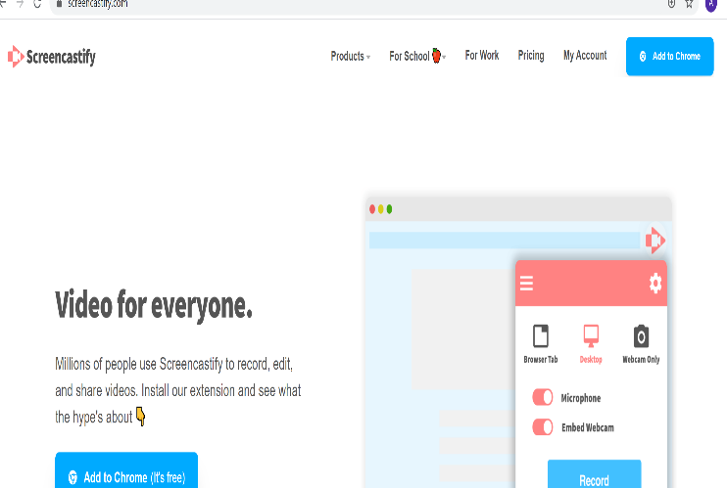
Figure 6 -(Screencastify, 2020).
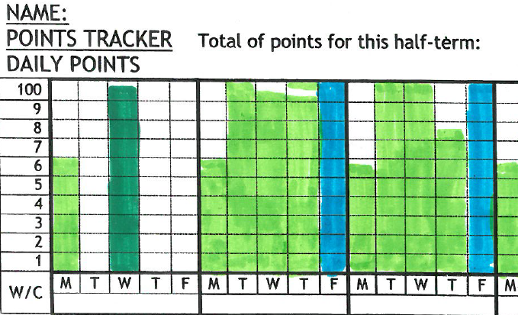
How these theories have influenced my classroom
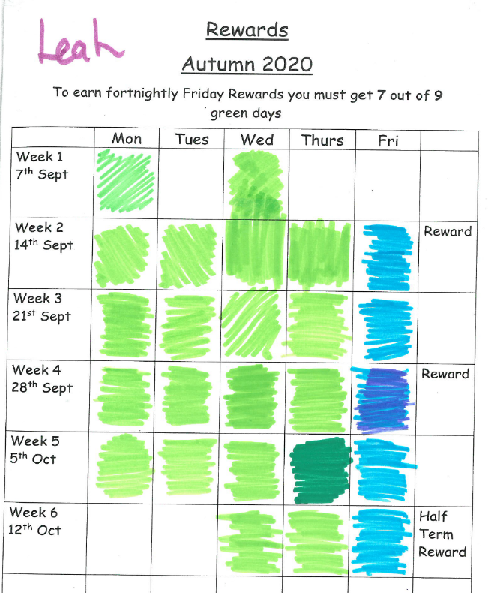
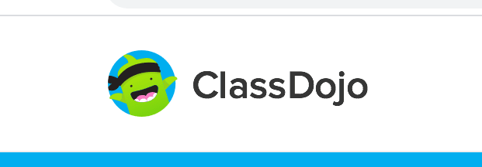
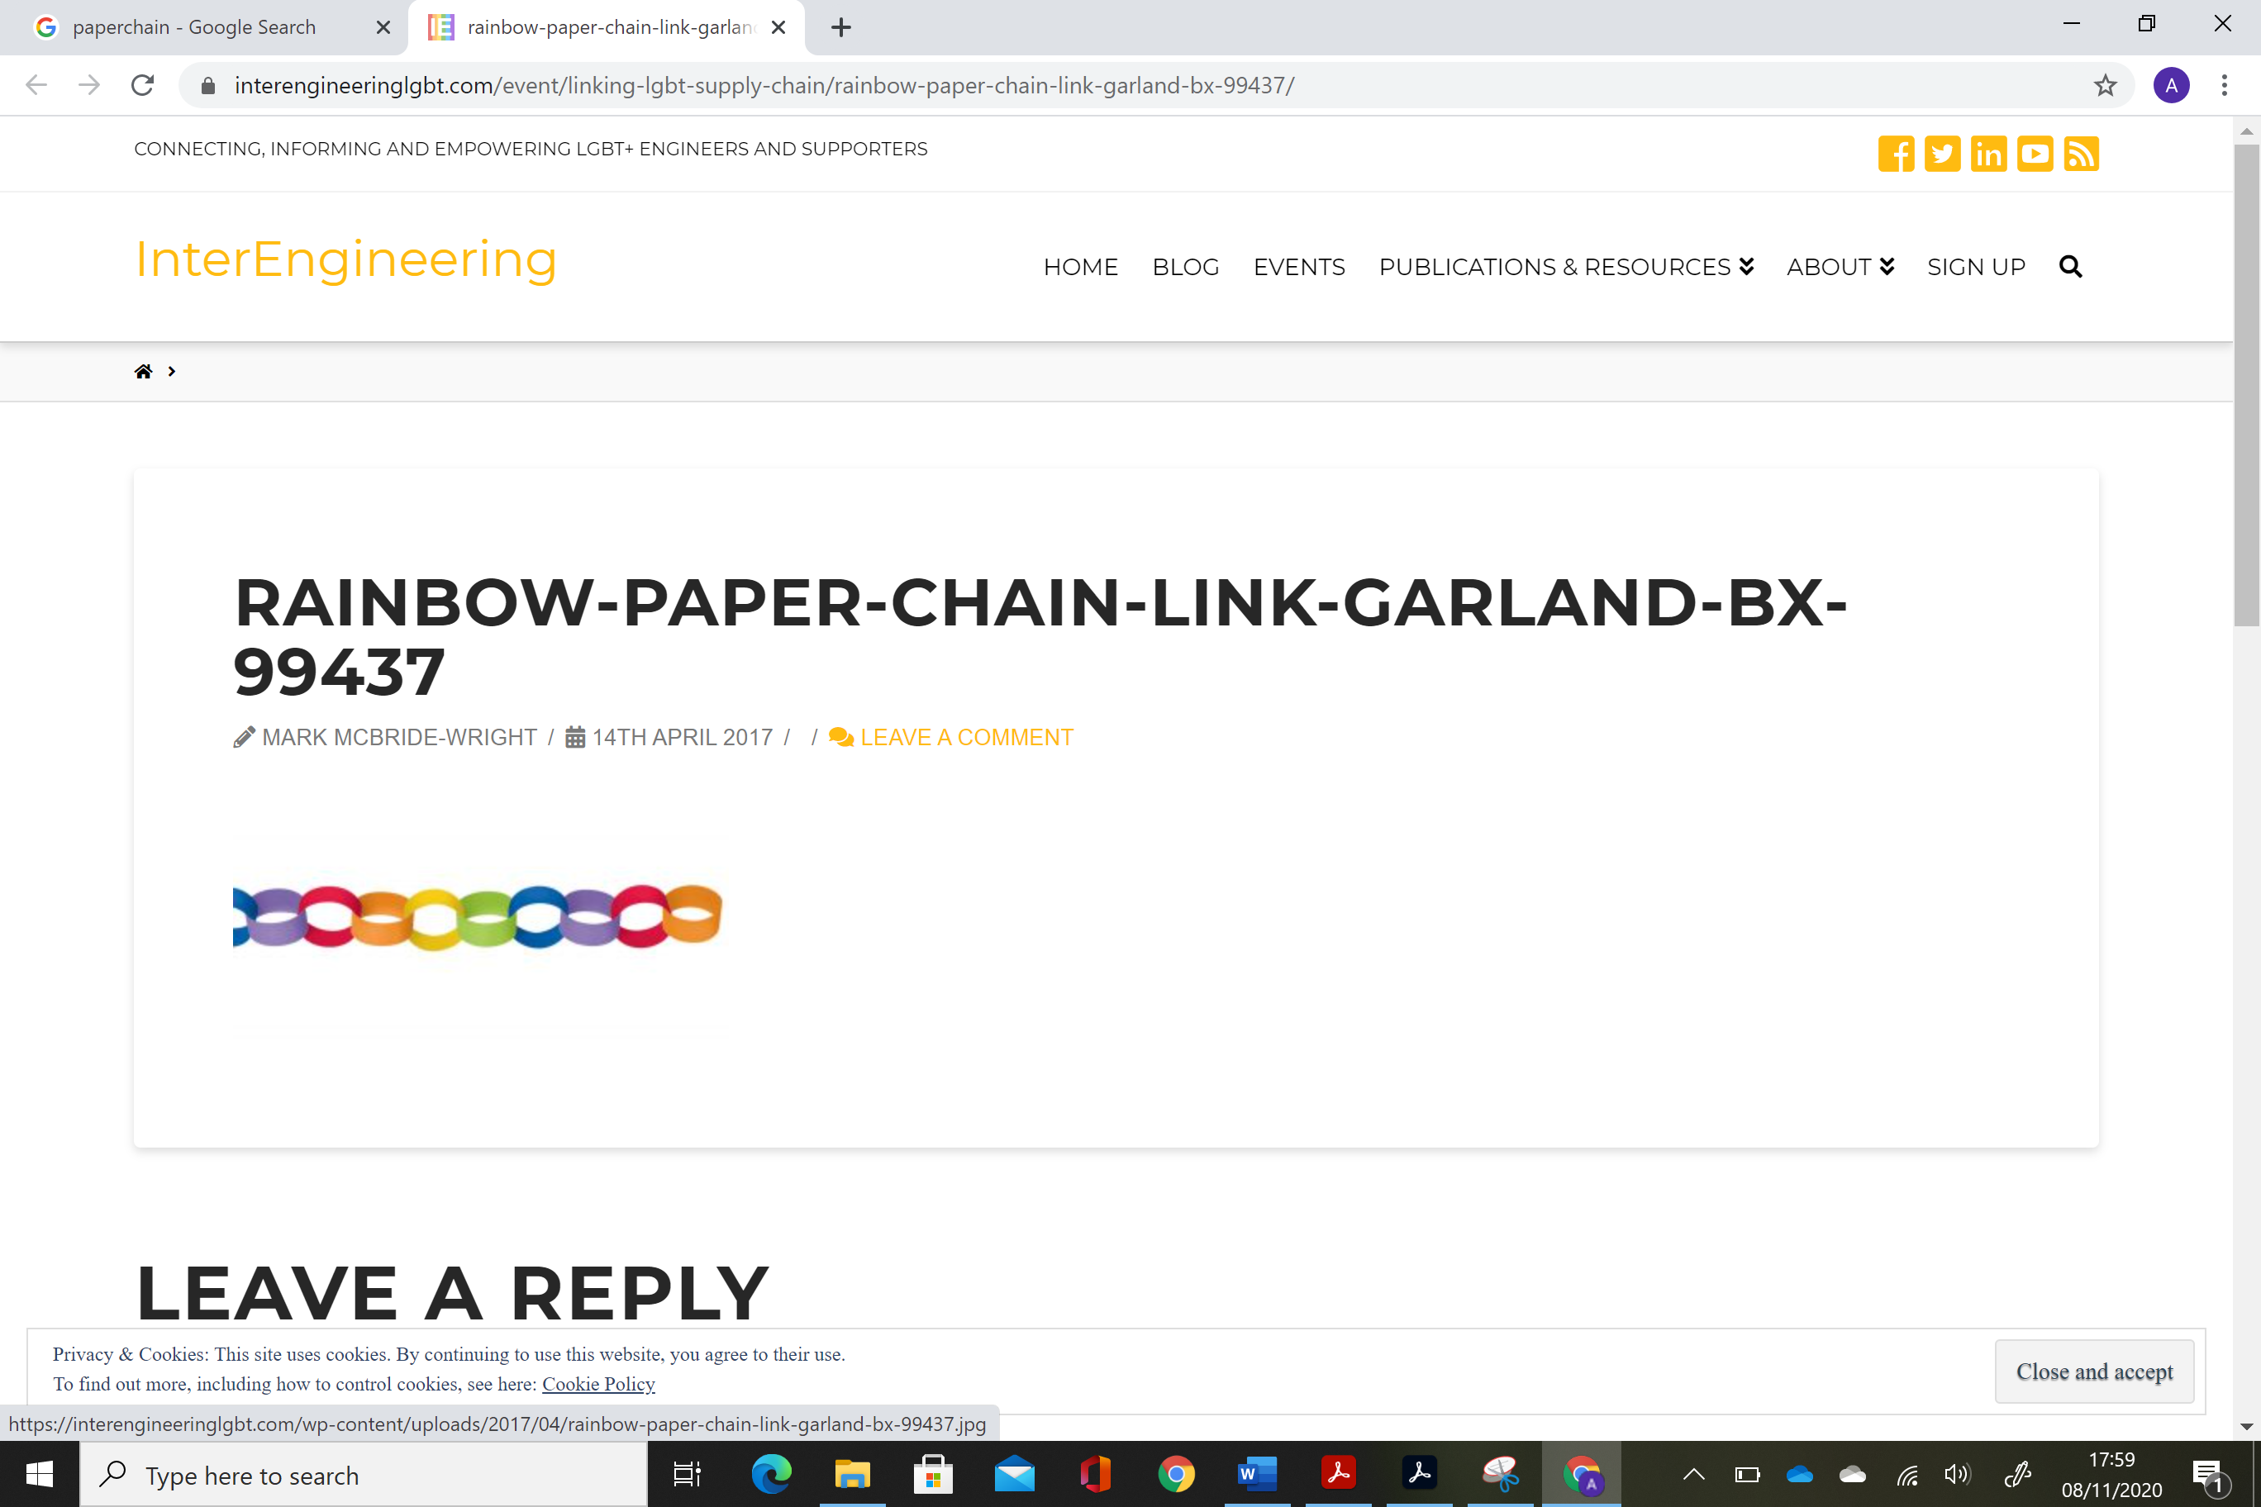

‘ClassCharts’ is an online tool that we use to record positive behaviour, this is done on the white board at the end of the lesson so the student can see the positive comments, this is reinforced with a text message via ClassDojo to the students parent at the end of the day. This is to encourage positive reinforcement at home and in school.
We have also used a paperchain reward system, if a student has exceeded expectations in a lesson or has displayed role model behaviour, they can be awarded a link. This is a group reward and encourages team work, the links start near the ceiling and when it reaches the floor the whole class earn a reward trip. E.g. Cinema, Zoo, BBQ at the beach.
Figure 7 - (Interengineering, 2017).
We use a points system in the student’s diary. The students can earn 100 points a day. If they earn 75+ points we call it a green day and it links with the reward system. We also use the points to praise students in assemblies and they are also linked with privileges at the centre such as accessing the pool table and tuck shop at social times. These are examples of behaviourism theory.

References

Bates, B. (2019) Learning theories simplified. 2nd Ed. London. Sage.
BioNinja. (No date) Conditioning. Available at: https://ib.bioninja.com.au/options/option-a-neurobiology-and/a4-innate-and-learned-behav/conditioning.html (Accessed: 03.11.2020).
Cosgrave, G. (2018) Examples of Negative Reinforcement. Available at: http://www.educateautism.com/behavioural-principles/examples-of-negative-reinforcement.html (Accessed on 03.11.2020).
Interengineering. (2017) Rainbow – paper-chain-link-garland-bx-99437. Available at: https://interengineeringlgbt.com/event/linking-lgbt-supply-chain/rainbow-paper-chain-link-garland-bx-99437/ (Accessed: 07.11.2020).
McLeod, S, A. (2019) Bruner – Learning theory in education. Available at: https://www.simplypsychology.org/bruner.html (Accessed: 05.11.2020).
McLeod, S.A. (2018) Lev Vygotsky’s Sociocultural Theory. Available at: https://www.simplypsychology.org/vygotsky.html (Accessed: 24.10.2020).
Study.com. (2020) Scaffolding student knowledge in mathematics. Available at: https://study.com/academy/lesson/scaffolding-student-knowledge-in-mathematics.html (Accessed: 03.11.2020).
TES. (2020) Principles of Choosing Teaching Writing Materials. Available at: https://www.tes.com/lessons/nQSTl-lzW9msXg/principles-of-choosing-teaching-writing-materials (Accessed: 04.11.2020).

