

MODULE CODE: ECDE7015

ASSESSMENT COMPONENT: Assessment 2 - Journal Article

STUDENT NAME: Katie Gardner

STUDENT NUMBER: 1809089

Doctorate in Education (EdD)

AI Acknowledgement

I acknowledge the use of Copilot [Chat | M365 Copilot] on 18 January 2026 to create a pie chart of statistics. I used the prompt(s):
1. Can you put the following numbers into a pie chart: Anxiety (61%) Depression (54%) Suicidal thoughts (39%) Eating disorders (28%) Obsessive compulsive disorder (10%) Bipolar disorder (3%)
I confirm that I have not presented any AI generated text as my own work.
I confirm that I have copies of my drafts, notes, and other resources I used before and after the use of AI tools which I may be asked to provide in evidence.

Mental health support in UK universities: As important as ever.

Abstract
Through an exploration of literature, research, policy and practice the importance and impact of student wellbeing will be discussed within this paper. A definition of mental health is offered with a discussion critiquing the language that is used when outlining the mental health of students studying within university setting. A consideration will be given to the risk factors specifically pertinent to university students along with a discussion on how to support those students. Finally, a view of the support on offer to students currently will be made, considering the financial and social barriers associated with gaining some support. Some suggestions for improvement and development in the future are offered.

Introduction
This paper will aim to discuss the importance of support for students within higher education in the United Kingdom (UK). Firstly, by defining mental health and the conditions that may be considered within the umbrella term (Wahlbeck, 2025) it will then outline the prevalence of mental health issues within the UK higher education sector and, the needs associated for students under this umbrella term. The paper will then consider the policies in place for these students from the UK and then specifically within Wales. A consideration will be made to the language used within the mental health context and any impact this might also have. Finally, this paper will outline the finances and barriers in place when students seek support around their mental health. It is pertinent that these issues are considered with the rise in mental health needs and issues amongst students there is a rising concern within the sector that students are supported in an appropriate and timely way (Gunnell at al., 2018).
Definitions
As a definition of a student, for the context of this paper, I will be considering those who attend a higher education institution. This means, in relation to age, I will be censuring the mental health of those from the ages of eighteen and up. According to the Higher Education Statistics Agency (HESA, 2025), in the most up to date statistics available there were 2,904,425 students across the UK in the academic year 2023/24 taught at all levels of university education. Within these statistics it is recognised that the number of students considered widening access students has increased. Widening access students are considered those students who are not traditional university students. As outlined by Universities and Colleges Admissions Service (UCAS, 2026a) a widening access (Reaching Wider in Wales) student is one who would not typically have considered accessing university education previously such as
Students who are the first in their family to go to university; are currently or have been in care; from particular ethnic groups, such as black, Asian, and minority ethnic; from low socio-economic groups (i.e. families with low income); in a school or live in an area where low numbers of students go to university or college [and] mature students who fall into one of the above categories (UCAS, 2026a, par. 1).
Universities within the UK are trying to encourage students from widening access to their degree programmes in recognition of the underrepresentation of those groups previously. Reaching Wider (2026) outlines a programme, in place since 2002, that to encourages students from the groups mentioned above to enrol in university education. According to Walters (2020) students from a widening access background however are more likely to need mental health support, this will be demonstrated further later in this paper.
According to the National Institute for Health and Care Excellence (NICE, 2025a) the prevalence of mental ill heath on the rise in the UK but, specifically within UK universities. Mental health can be defined in a number of ways, the World Health Organisation (WHO, 2026 par.1) defines mental health as “a state of well-being that enables people to cope with the stress of life, realize their abilities, learn well and work week, and contribute to their community.” Welsh Government (2025) expand this definition to outline the impact of different conditions that can influence an individual’s emotions, behaviour, or ability to think and process and that influence having a negative impact on lives. Areas that will inevitably impact students’ ability to concentrate, engage with studies and, for some, continue in higher education.
When considering the specific mental health conditions mentioned by WHO and Welsh Government the leading mental health charity in the UK (Mind 2025) state that mental health conditions include depression; anxiety; bipolar disorder; borderline personality disorder; eating disorders; schizophrenia; post-traumatic stress; psychosis; self-harm and many, many more. Each of these conditions can have a significant impact on a student’s ability to manage their studies, all of which students may experience whilst at university.
Language and stigma.
The language around mental health is evolving. Whilst generally in conversations, the general public and media describe and talk about mental health, what they really mean is individuals who are experiencing a mental health illness, concerns or episode (Rethink Mental Illness, 2026, APA, 2023) however, when considering the definitions above this is not an accurate definition. Instead, mental health is an umbrella term which describes both positive mental health and those with mental health conditions (Mind, 2025).
This is further supported by the American Psychiatric Association (APA, 2023), who assert that although there are general terms used to describe mental health conditions and the needs associated with them, there is a stigma attached to either disclosing or discussing mental health needs. They outline that there is a disconnect between those within the medical field; those impacted by mental health illness and those who are trained and knowledgeable within the area and the general public who the APA call ‘laypeople’ (APA 2023).
Alongside this lack of understanding of the language used within mental health there is a significant stigma attached to disclosing mental health needs. Cage et al. (2020) found that, amongst university students with mental health diagnosis, there was a perception that revealing a mental health condition was a sign of weakness. This viewpoint is supported by Katrina et al. (2020) who claims that students feel the need to hide their mental heal difficulties fearing judgement, exclusion, and further distress. Further support of this fear is offered by Cogan et al. (2025) who outlines a number of social and cultural barriers to students disclosing mental heal support needs.
On the other hand, according to Universities UK (2018a), the number of students who are disclosing their mental health needs to the university they attend is increasing, contrasting previous research. This demonstrated a possible disconnect between the views of institutions and students taking part in research.
Risk factors
Students at university are more likely to experience a mental illness than those who do not attend (McCloud et al. 2023). This shows that there are higher risk factors amongst university students. McCloud et al. (2023) also found that generally, for adults who had attended university, their mental health levels returned to the same as those the same age who had not attended university by the age of twenty-five. This further supports that views that students in university develop more risk factors for mental health conditions than those who enter the workforce directly from school. There is however a recognition that mental health for those aged 18-25 has declined since 2017 whether a university student or not (NHS England 2023) which adds pressure to mental health services within the university setting or not.
There is well documented recognition nonetheless that there are additional risk factors for those attending university to experience mental health issues. These additional risk factors include those moving away from home for the first time; the resilience in being able to live alone or in a new setting; students access to healthy and well prepared meals; pressures from the academic workload (both level of work that is required and the amount of work required); those developing a new sense of themselves as individuals and the financial pressures associated with university study (NICE 2025b). According to NICE (2025b) there are further risks associated with students who are over 25 years old, students from a widening access background and those who already have a diagnosed mental health condition. Added to these risk factors are students who are members of one or more of the protected characteristics for the Equalities Act 2010.
As a result of this it is a duty of university institutions to support students throughout their studies whether mentally healthy or mentally unwell as the discussion so far has evidenced that there is a direct link between university study and the rise in mental health issues.
Conversely there are those who attribute the high number of mental health illnesses and conditions within university settings to the improved and superior services that are provided in universities in comparison to the long waiting lists encountered by people who are not in university settings and waiting on the NHS (Bennett et al. 2024). According to Bennett et al. (2024) young people are specifically choosing to attend university to get the mental health support they need quicker. This is further supported by Remskar, et al. (2022) who states that prospective students research the mental health support offered by universities and most importantly the ‘ease of access’ (Remskar et al. 2022 p.781) to that support before making any decisions on which institutions to apply to. This demonstrates that the link between university students and mental ill health is more nuanced than simply the additional risk factors associated with attending university. Nevertheless, it is important to still consider the prevalence of mental ill health within university settings to discuss the services and provisions available to students.
Prevalence
According to Akram et al. (2023) the prevalence of mental health within the student population of the UK remains high with an increases year on year. A longitudinal study conducted by Sanders (2023) for KINGS College London and Transforming Access and Student Outcomes in Higher Education (TASO) found that there was a 10% rise in the number of students recoding and reporting mental health issues (academic years between 2016/17 and 2022/23). Caution needs to be given to such a rise in the number of students reporting mental health needs, however, with the impact of Covid-19 and the cost of living crisis the report acknowledges that these are significant global events that impact their findings considerably (Saunders 2023).
Cibyl (2024) builds on the research of Saunders (2023), when, in partnership with Universities UK, they conducted research that demonstrates the prevalence of mental health difficulties has not reduced significantly or even mildly improved in the last four years as indicated in the table below.

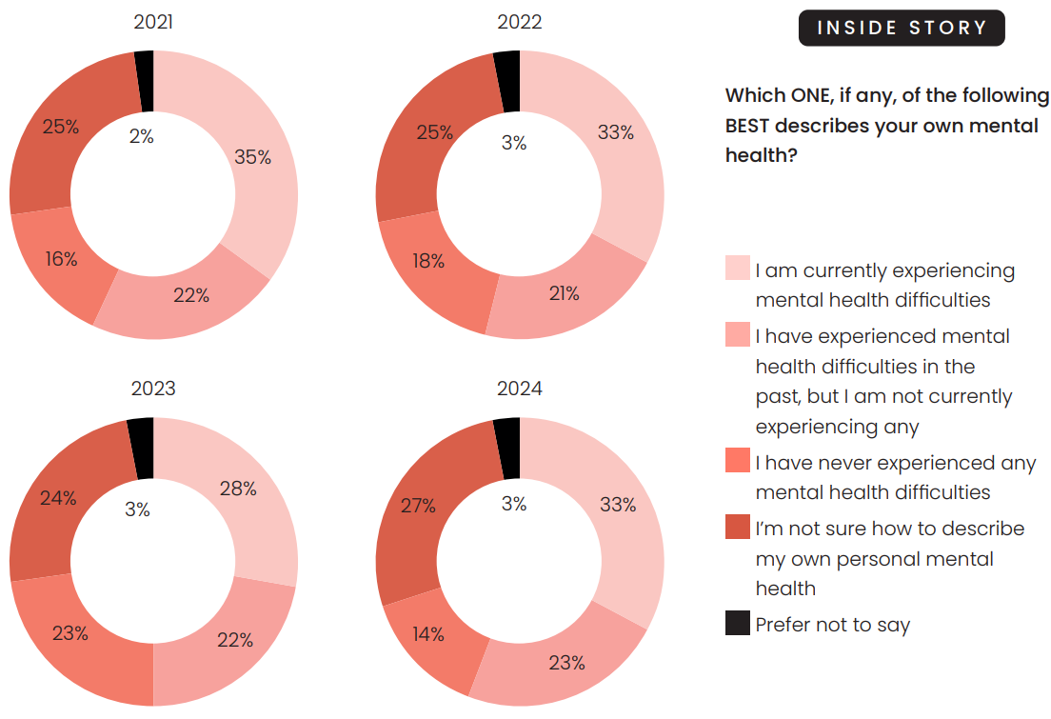
Figure 1 - Student Mental Health Research (Cibyl 2024)

As indicated in the table above, with over a third of all students disclosing a mental health need, and numbers of students suggesting they are struggling with their mental health (Saunders 2023, Akram et al. 2023, Cibyl 2025) there is a need to ensure support and security is in place for those students.
Mental health diagnosis.
In relation to the types of mental health diagnosis and needs NICE (2023) surveyed four thousand students asking them to outline the most common mental health difficulties they had, below is a pie chart showing the outcome.
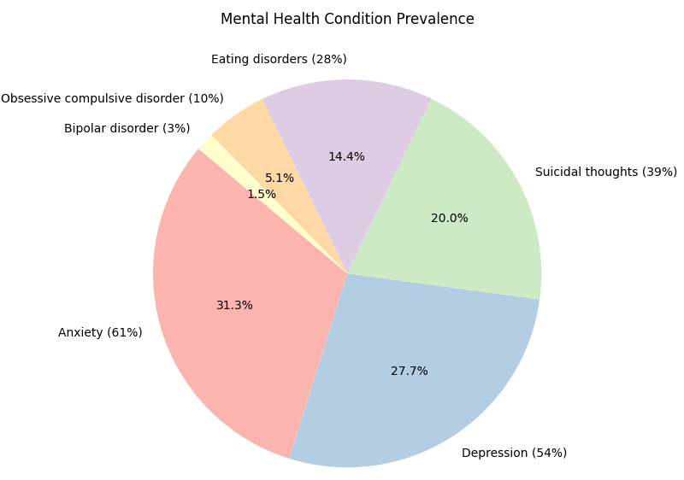
Figure 2- Copilot used to create pie chart with data from NICE (2024)

This research from NICE (2024) demonstrates that the most common mental health concern for students is anxiety, depression, and suicidal thoughts. As a result of this, when it comes to student provision and support services should endeavour to support those students with their anxiety and depression in the hope that this will prevent more serious mental health occurring.
Policy
In order to support students with mental health diagnosis over recent years a number of policies and procedures have been developed. The UK government has set clear targets and timeframes for universities to offer support to their students in a holistic way. Through the University Mental Health Charter Framework (UMHCF) (Hughes, 2024) they offer a new and improved set of standards for universities to meet and evidence. This framework is built on the first edition that was originally produced in 2019. There was a need to re-visit and re-assess the needs of students in light of the Covid-19 pandemic and the additional complexities related to mental health needs as a result of the pandemic (UMHCF, 2024).
A holistic approach to supporting students with mental health is advised by the UMHCF, the evidence for this within the UMHCF derives from the understanding that mental health is affected by societal and environmental factors, for students this is more than their accommodation, social status and social life. It recognises that, and puts an emphasis on, the academic elements of university life. The UMHCF (2024) does recognise that funding is needed within the sector to be able to adequately offer supporting provision for students but does not offer any funding. Linked to the UNHCF is a charter programme which offers universities who are supporting students to an excellent standard an of care an award they can achieve. According to Student Mind Hub (2024 par.2) ‘‘113 institutions [have signed up to the charter to evidence]… continuous improvement of mental health and wellbeing within their university community’’. This shows a strong commitment to improving student mental health and wellbeing within universities. This policy and charter however is only available to universities in England.
In 2023 the Children, Young People and Education Committee of the Senedd, a year before the UK government, recognised that support for students experiencing mental health issues was needed and that there were a variety of different services on offer to those students depending on what institution they were studying at in Wales. Identifying also that there were a number of gaps in provision for students in Wales they attempted, through the Mental Health support in Higher Education (Senedd 2023) report, to offer advice and guidance to reduce this unequal access across institutions. Some of the gaps identified by this report include those who are care experienced; international students; post-graduate students; those from the lesbian, gay, bisexual, transgender, queer, intersex, and asexual (LGBTQIA) community; disabled students and more (Senedd 2023).
This report outlined the extent of the issues connected to students with mental health issues within the student population, what caused them, how universities can support those within their institutions and how the statutory services can support those institutions (Senedd 2023). There is a limitation to this report however as the data sets considered for students with mental health issues were UK wide rather than Wales specifically. In order for this report to hold more weight amongst Welsh universities there is a need to engage with the student population attending Welsh universities.
There are more than 30 recommendations within the report that pertain to the improved service and support offered to students in Welsh universities, the report claims that it makes ‘’recommendations that we believe could make a big difference in improving the quality and consistency of support across higher education provision in Wales’’ (Senedd 2023, p.8). This demonstrates that the Senedd takes seriously the mental health of students and expects universities in Wales to do the same. There is no reference however to a charter by the Senedd as outlined in the UMHCF - there is a possibility that central government learnt from this in the construction of their framework.
Although not specifically aligned to students the Welsh Government’s Mental Health and Wellbeing Strategy 20025-2035 outlines its commitment to supporting those living in Wales with mental health conditions and illnesses into recovery (Welsh Government, 2025). This strategy aims to unite services, provide a person-centred approach to mental health support and focus on sustained recovery. The strategy has been designed to support those living in Wales from birth to death, which will therefore provide a seamless transition from support services throughout life’s transitions (Welsh Government 2025). This should therefore include Welsh students who study in Welsh universities and then, include students from outside of Wales when they move to their chosen institute.
This report aims to ensure “there are seamless mental health services – person -centred, needs led and guided to the right support, first time’’ (Welsh Government 2025 p.47) echoing the aims of the Senedd’s report specifically relating to students.
This need for mental health services to support students specifically is supported in literature and research. The approach of Welsh Government (2025) to integrate services and provide seamless person-centred approaches is reinforced by John et al. (2024, p.389) where they comment that “students require person-centred stepped care, integrated with local third-sector and healthcare services to address specific conditions”.
What does support look like?
According to Universities UK (2020b) good mental health supports the aims and objectives of universities generally, from student attainment to staff enhanced performance. Without good mental health services, appropriate to the needs of students there is a failure of the institution.
Support offered by universities to their students is generally based on needs of individual students and can include universal support through apps and online platforms to more specialist support through counselling and psychotherapy. Wellbeing services offer preventative support around assignments, workload, and financial issues whereas counselling services provide specialised support by trained professionals (UCAS 2026b).
For students to access the mental health and wellbeing support they would need to either access it independently or, be referred and supported to engage with support available through lecturing staff. This requires both students and staff to know how to access the provision.
Who’s responsibility?
It could be said however that this support and the mechanisms in place have come in too late for some students or is not going far enough. With access to mental health services within a university setting still hard to engage with and sometimes taking too long to access the support for some students is not there when they need it. Smith (2024) asserts that although in recent years a number of policies, strategies and frameworks have been published (such as those discussed earlier) there is a gap between these idealistic strategic directions and the practices and provisions within individual institutions.
Another area in which the support could be criticised is in the promotion and knowledge of the support services on offer to students from within their institutions. Olsson et al. (2024) found that students did not know how to get support when facing mental health issues. If students do not readily and easily know how to access services available to them there is no real value in the support services being offered at all.
This discussion can be further developed when considering the knowledge and ability of university lecturers in supporting students with mental health conditions. Baik (2019) suggests that without an excellent working knowledge of the mental health support within the institutions they work, lecturers are not in a position to support and guide their students. This then also links to the attitudes and behaviours of lecturers when teaching and supporting students with mental health issues, many students commented that they needed their lecturers to be “more approachable and understanding of diverse student circumstances” (Baik 2019 p.680) thus supporting the need for everyone within university institutions to have mental health training, an awareness of the support needed by students as well as the offer from the university to support students. For those students who support is offered by lecturers and the university community there was a significant difference in the outcome for those students both within their degree programme and their ability to manage their mental health condition (Baik 2019).
Conversely, although there is a large amount of data and research to support the need for universities to support students with mental health needs, there is an argument to be had around it weather it is the sole responsibility of the university institutions to support their students mental health or if in fact universities are sustaining the medical systems and statutory services by offering the range of support it does or. There are arguments that the mental health systems outside of the university institutions should be improved and therefore support those it needs to.
Adding to this is the questions Spear et al. (2020) asks regarding the training level of non-specialised university staff to support their students in an appropriate way asserting that medical practitioners are best placed to support students with mental health disorders, not university lecturers.
University lecturers, library staff and other general practitioners within a university do not always have the training and knowledge to offer the support needed by students and therefore are more likely to not be able to offer this support students need through fear of inappropriately supporting a student and making students situations worse or making them unsafe. Spear et al. (2020) also found a lacking in the training offered to university staff with “56% [of staff] had not received training in working with students with mental health problems” (p.1124). It is unreasonable to expect university staff who are not trained to support students in a confident and appropriate way. Helen (2022) also links university staff supporting the mental health of students to mental health concerns and illnesses of staff themselves and outline that without the proper mental health support for university staff they are not able to support students.
However, students say that they would prefer their lecturers to be more empathetic and have more knowledge in mental health issues there is an onus on lecturers to
upskill and attend training (Senedd 2025).
Financial implications.
Another consideration to the support of students are the financial implications of any support needed. Dougall et al. (2023) found that if there was more funding available for students and university institutions then the mental health and wellbeing of students would be improved.
In order to alleviate the financial barriers to mental health support in higher education in Wales Medr have allocated over two million pounds to ‘implement well-being and health strategies’ (Medr 2025 par.1). According to Medr, this money will bridge the gap between the services on offer to students in Welsh universities and the needs that are presenting in different institutions. Medr (2025) plan to distribute the finding based on student populations at each university, however, with nine universities in Wales (Universities Wales 2026) there is some speciesism as to how far this money will go, especially as the money is designed to support the offer of training for staff, providing bilingual resources, provide training for students, extend period dignity programmes and more (Medr, 2025).
Offering mental health support to students in a timely and appropriate way is not just a moral responsibility or be costly, it can also bring financial benefit. As outlined above, students are considering the mental health support offered by individual universities before applying (Bennett et al. 2024), therefore, for the purposes of recruitment and retention of students, and for universities to remain successful, they need to be demonstrating the excellent mental health support they offer. This is due to the financial restraints put upon universities for a number of reasons including the cost-of-living crisis, inflation and the legacy left by covid-19.
There is an increased need for universities to concentrate on being a business as well as being educational institutions (Bell et al. 2022) which can be further evidenced by the Times Higher Education assessing and ranking universities based on their mental and emotional health support of students (Times Higher Education 2026).
Conclusion
Support for students is generally good, as discussed above students are signposted by educational staff, and others, to the student support services who then assess the needs of the students. However, this support of students can be seen as passing the issue on rather than considering and reflecting upon the practice individual lecturers have. If in lectures students are having to confront and come against their triggers this will have a further impact on their mental health without sufficient support.
This paper has demonstrated the rigorously evidenced need for universities within Wales and the UK to offer more comprehensive and person-centred support to students. There is clear evidence that the support of students in universities is getting better, however, with newer policies and reports still concentrating on mental health of students and the need for support to be further developed it is clear there is still some way for the higher education sector to go in their support of students.
There is a need for research to conducted specifically in Wales so that those students studying in Wales receive the support they need, rather than assuming that all students at any university within the UK are facing the same issues – there is a need to understand the nuance of Welsh students and those studying in Wales in order to support them appropriately.

References
Akram, U., Irvine, K., Gardani, M., Allen, S., Akram, A., and Stevenson, J.C. (2023). ‘Prevalence of anxiety, depression, mania, insomnia, stress, suicidal ideation, psychotic experiences, & loneliness in UK university students,’ Scientific Data, 10(1), pp. 621-63. Available at: DOI10.1038/s41597-023-02520-5 (Accessed 12 December 25).
American Psychiatric Association (2023) Do the words matter?: The language we use for mental health. Available at: Psychiatry.org - Do the Words Matter?: The Language We Use for Mental Health (Accessed 04 January 2026).
Adrian R. Bell, A., Brooks, C., and Urquhart, A. (2022) Why have UK universities become more indebted over time? International Review of Economics & Finance, 82 pp. 771-783. doi.org/10.1016/j.iref.2022.08.008 (Accessed: 20 January 2026).
Baik, C., Larcombe, W. and Brooker, A (2019) “How universities can enhance student wellbeing: the student perspective” Taylor and Francis 38(4) pp. 674-687. Available at: doi.org/10.1080/07294360.2019.1576596 (Accessed 25 January 2026)
Bennett J., Haworth CMA., Kidger J., Heron J., Linton M-J., and Gunnell D. (2024) ‘Investigating changes in student mental health and help-seeking behaviour after the introduction of new well-being support services at a UK university’. BJPsych Open. 10(3) doi:10.1192/bjo.2024.711 (Accessed 23 January 2026).
Cage, E., Stock, M., Sharpington, A., Pitman, E., and Batchelor, R. (2020) ‘Barriers to accessing support for mental health issues at university’, Studies in Higher Education, 45(8), pp. 1637–1649. doi:10.1080/03075079.2018.1544237 (Accessed 23 January 2026).
Cogan, N., Murray, A., Gardani, M., O’Toole, M., Leung, M., Kyratzi, s., Milicev, J., Dytburgh, K., Bolota, C. and Ho, L. (2025) ‘Student Mental Health in UK Higher Education Institutions: Protocol for a Scoping Review of Trends, Gaps, and Research Directions’, JMIR Research Protocols, 14, pp. 11-21. Available at: doi.org/10.2196/65594 (Accessed 4 December 2025).
Cybil (2024) Student Mental Health Survey 2024, Available at: Student_Mental_Health_Research_2024.pdf (Accessed 17 January 2026).
Dougall, I., Vasiljevic, M., Kutlaca, M. and Weick, M (2023) “Socioeconomic inequalities in mental health and wellbeing among UK students during the Covid-19 pandemic: clarifying underlying mechanisms” PLoS ONE 18(11) Available at: doi.org/10.1371/journal.pone.0292842 (Accessed 12 January 2026).
Equalities Act 2010, c.15. Available at: https://www.legislation.gov.uk/ukpga/2010/15/contents (Accessed 20 January 2026).
Gunnell, D. Kidger, J. and Elvidge, H. (2018) ‘Adolescent mental health in crisis’, BMJ: British Medical Journal, 361. Available at: DOI:10.1136/bmj.k2608 (Accessed 20 January 2026).
Higher Education Statistics Agency (HESA) Higher Education; Student Statistics: UK, 2023/24 – Student Numbers and Characteristics. Available at: Higher Education Student Statistics: UK, 2023/24 - Student numbers and characteristics | HESA (Accessed 18 January 2026).
Hughes, G and Spanner, L. (2024) The University Mental Health Charter, 2nd edn. Available at: UMHC-Framework-Updated_2024.pdf (Accessed 10 January 2026).
John, A., Rouquette, O., Lee, S., Smith, J. and Pozo Banos, M. (2024) ‘Trends in incidence of self-harm, neurodevelopmental and mental health conditions among university students compared with the general population: nationwide electronic data linkage study in Wales’, The British Journal of Psychiatry, 225(3), pp. 389–400. doi:10.1192/bjp.2024.90 (Accessed 20 January 2026).
Medr (2025) ‘Further education wellbeing and mental health funding 2025/26’. Available at: Medr/2025/23: Further education wellbeing and mental health funding 2025/26 – Medr (Accessed 5 December 2025).
McCloud, T., Kamenov, S., Callendar, C., Lewis, G. and Lewis, G (2023) ‘The association between higher education attendance and common mental health problems among young people in England: evidence from two population-based cohorts,’ The Lancet. Public health, 8(10), pp. 811–819. Available at: https://doi.org/10.1016/S2468-2667(23)00188-3 (Accessed 20 January 2026).
Mind (2025) Types of Mental Health Problems. Available at: Mental health problems | What types are there? - Mind (Accessed 14 December 25).
National Institute for Health and Care Excellence (2025a) Mental health in students: How common is it? Available at: Prevalence | Background information | Mental health n students | CKS | NICE (Accessed 12 December 25).
National Institute for Health and Care Excellence (2025b) What are the Risk Factors? Available at: https://cks.nice.org.uk/topics/mental-health-in-students/background-information/risk-factors/ (Accessed 12 December 2025).
NHS England (2023) Mental Health of Children and Young People in England, 2023 – wave 4 follow up to the 2017 survey, Available at: Mental Health of Children and Young People in England, 2023 - wave 4 follow up to the 2017 survey - NHS England Digital (Accessed 20 January 2026).
Olsson, T., Briberg, M., Frisk, S., Wackenhut, A., Kjellin, D., Gullstrand, S., Rost, S. And Skoog, T (2024) “Health‐Promoting Learning Environments in Higher Education: A Scoping Review of Structural Interventions to Protect Student Mental Health,” European journal of education, 59(4). Available at: https://doi.org/10.1111/ejed.12772 (Accessed 22 January 2026).
Payne, H (2022) “Teaching staff and student perceptions of staff support for student mental health: A university case study” Education Sciences 12(4). Available at: DOI:10.3390/educsci12040237 (Accessed 22 January 2022).
Remskar, M., Atkinson, M., Marks, E., and Ainsworth, B. (2022) “Understanding university student priorities for mental health and well‐being support: A mixed‐methods exploration using the person‐based approach,” Stress and health, 38(4), pp. 776–789. Available at: https://doi.org/10.1002/smi.3133 (Accessed 22 January 2025).
Saunders, M. (2023) Student mental health in 2023: Who is struggling and how the situation is changing. Available at: 2023-09-18_Student-mental-health-in-2023_TASO.pdf (Accessed 10 January 2026).
Senedd (2023) Mental Health Support in Higher Education. Available at: https://senedd.wales/media/mdzljae3/cr-ld15768-e.pdf (Accessed: 23 November 2025).
Smith, J. (2024) “Addressing student mental health and suicide concerns: are we there yet?” Irish Journal of Psychological Medicine, 41(2) pp.171-174 Available at: DOI:10.1017/ipm.2024.18 (Accessed 25 January 2026).
Spear, S., Morey, Y. and S, T (2020) “Academics’ perceptions and experiences of working with students with mental health problems: insights from across the UK higher education sector” Taylor & Francis 42(5) pp.1117-1130. Available at doi.org/10.1080/07294360.2020.1798887 (Accessed 25 January 2026).
Student Mind Hub (2024) 113 universities join the 24-25 University Mental Health Charter Programme. Available at: 113 universities join the 24/25 University Mental Health Charter (Accessed 10 January 2026).
Times Higher Education (2026) Impact rankings. Available at: University Impact Rankings for UN SDG 3: good health and well-being | Times Higher Education (THE) (Accessed 25 January 2026)
Universities and Colleges Admissions Service (2026a) Scholarships, grants, and bursaries: Widening participation. Available at: Scholarships, grants, and bursaries: Widening participation | UCAS (Accessed 05 January 2026).
Universities and Colleges Admissions Service (2026b) Mental health and wellbeing: University support. Available at: Mental health and wellbeing: University support | UCAS (Accessed 15 January 2026).
Universities UK (2018a) Minding our Future, Available at: minding-our-future-starting-conversation-student-mental-health.pdf (Accessed 23 January 2026).
Universities UK (2020b) Why mental health should be a priority for universities. Available at: https://www.universitiesuk.ac.uk/what-we-do/policy-and-research/publications/features/stepchange-mentally-healthy-universities/why-mental-health-should-be-priority (Accessed 15 December 2026).
Universities Wales (2026) Universities Available at: Universities | Universities Wales (Accessed 15 December 2025).
Welsh Government (2025) The Mental Health and Wellbeing Strategy 2025-2026, Available at: Mental health and wellbeing strategy 2025 to 2035 (Accessed: 14 December 2025).
Wahlbeck, K. (2025) ‘Mental health promotion is at the core of public health’ Psychiatria fennica, 56(1), pp. 10–15. Available at: MENTAL HEALTH PROMOTION IS AT THE CORE OF PUBLIC HEALTH – DOAJ (Accessed: 18 January 2026).
Walters, J. (2020) Widening participation students, Available at: Widening participation students - Health Action Research Group (Accessed on 17 January 2026).
Wider Reaching (2026) Explore your future with Wider Reaching, Available at: Home - Reaching Wider (Accessed 17 January 2026).
World Health Organisation (2025) Mental Health, Available at: Mental health (Accessed: 14 December 2025).

