12/15/2025
University of Wales trinity saint David
London campous
Module Name: Software solution for business
Module Code: ACCA4026
Student Name: Francisca Lerka Fernandes
Student id: 2510888
Group: 2
Lecturer Name: Amitava Banik

Component 1- Coursework: Portfolio
Software solution for business Assignment 1

Table of Contents
Introduction 1
Task 1. e-Commerce Website builders or software solutions 1
1.1 Shopify 1
1.2 Wix eCommerce 1
Task 2. Mind-map of contemporary software applications 1
a. Explained and Advantages of Mind Mapping in Business Operation 1
b. Mind Map of Contempoary software applications 1
Task 3. Office Applications 1
a. Four office software solutions Ins. Analysis 1
MS Word 1
MS PowerPoint 1
MS Excel 1
MS Access 2
b. Practical demonstration of Two Office Features 2
Mail Merge 2
If Statement 2
Task 4. Communication and Collaboration applications 2
a. One contemporary Communication and one Online Collaboration applications/tools 2
MS Outlook 2
MS Teams 2
b. One feature of a freely available Communication (1) and one feature of a Collaboration (1) application 2
MS Outlook 2
Ms Teams 2
Conclusion 2
References 3

Component 1—Coursework: Portfolio

TASK 1: E-COMMERCE WEBSITE BUILDERS AND SOFTWARE SOLUTIONS
The fast growth of online trade has led to the creation of different e-commerce web solutions, which enable companies to create and operate e-stores effectively. Some of the most notable current solutions include Shopify and Wix eCommerce, which allow non-tech-savvy users and businesses to create, open, and run successful online stores. These tools combine various features like web page creation, cataloguing of the products, a secure payment system, and analytics, which altogether simplify business online operations.

Shopify
Shopify is acknowledged as one of the top cloud-based e-commerce systems that are used to support establishing and operating online stores of different sizes of business activities. It was introduced in 2006, and it supports a model of subscription that enables the hosting, integrated payment gateways, inventory management, and marketing tools in the same environment [1]. The platform has a huge collection of themes and templates, so the user can create visually appealing and responsive storefronts without having to know how to develop an advanced web-based application.
An important aspect of Shopify is its App Store that is full of thousands of extensions that can be used to expand functionality, such as social media integration, customer relationship management (CRM), and automated marketing [2]. Shopify Payments is also built-in to the system and is a native gateway that accepts multiple payment methods across the globe and is also compliant with the requirements of PCI DSS security. Besides that, the analytics dashboard of Shopify provides managers with real-time information on sales, customer behaviours, and inventory turnover to guide their decision-making based on evidence.
Scalability is also a major strength in Shopify since the platform supports both start-ups and enterprise-level retailers via the Shopify Plus service. Nonetheless, the platform has some limitations, in spite of these advantages. The price of a monthly subscription can rise significantly when some premium themes, add-ons, and transaction fees are added [3]. In addition, customization of designs is also a limitation to a degree compared to open-source options, with the Liquid template language needing expertise to make wide-scale changes. Shopify, however, remains the market leader in the e-commerce sector because of its stability, security, and the large number of integrations.

Wix eCommerce
The other modern web-building platform that facilitates online shopping is Wix eCommerce. Wix was originally created as a general web-building platform, but it developed into a full-fledged e-commerce site with the help of its Wix Stores feature. It offers a drag-and-drop experience that eases store building and displaying merchandise, including the small and medium-sized companies that find easy digital-commerce solutions [4]. The site offers a set of pre-configured templates tailored to different retailing industries, as well as messages that are responsive to the mobile phone.
Wix consolidates various in-built sales and marketing applications, including the email-marketing automation, the search-engine optimization tools, and the social-media connectivity to allow businesses to improve their visibility and interaction. It also has a Wix Payments system that can provide direct online payments in various currencies and regions and is also integrated with external gateways, including PayPal and Stripe. It also can support abandoned-cart recovery, coupon management, and real-time inventory monitoring aspects, which are more common with more advanced enterprise systems.
The strength of Wix eCommerce that can be mentioned is its structural flexibility. The users can use the Wix Editor X or Artificial Design Intelligence (ADI) to create automatic site layouts according to the preferred business requirements. Such flexibility gives a chance to develop unique and aesthetically appealing storefronts, which are also compliant with corporate branding strategies. Also, Wix gives a built-in analytics tool that allows tracking performance and customer segmentation to make informed business choices based on the available data [5].
Wix has limitations even though it has its strengths. In comparison to Shopify, the app ecosystem is smaller on Wix, which means that it does not support any advanced customization or connectivity with complex third-party logistics and enterprise resource-planning systems. Moreover, transaction and storage restrictions of the low-level plans may limit scalability of fast-growing businesses. However, the low cost of Wix, user-friendly interface, and powerful design capacity make the business the best solution to any emerging retailer with limited technical resources who wants to build an online presence.
Comparative Evaluation
Both Shopify and Wix eCommerce represent the current trend in Favor of Software-as-a-Service (SaaS)-based e-commerce solutions that minimize reliance on bespoke development solutions and local hosting facilities. Shopify is likely to cater to small to medium or fast-expanding businesses seeking advanced integrations and automated marketing and omnichannel retailing service. Wix eCommerce, in its turn, is focused on the needs of smaller organizations, which are more conscious of design flexibility, convenience, and affordability. The choice of these solutions usually relies on the size of the organization, the growth that is expected, and the availability of resources.
Overall, these platforms testify to the fact that modern e-commerce software makes digitalization of business simpler because the web design, marketing automation, payment security, and analytics are united into a single ecosystem. In this way, Shopify and Wix eCommerce work to increase productivity, simplify the workflow, and make decisions based on data in the work of contemporary business organizations.

TASK 2: MIND MAP OF CONTEMPORARY SOFTWARE APPLICATIONS
a. Explained the advantages of mind mapping in business operations.
Mind mapping is a visual tool that is aimed at organizing and structuring information and presenting it in the form of interconnected nodes or branches that have a common idea. The method, first developed by Tony Buzan in the 1970s, is a tool that encourages nonlinear thinking where the user can visualize connections between ideas and concepts [7]. A branch of a mind map usually symbolizes a subtopic or category, which is hierarchically connected to a central theme, which helps increase the cognitive interest and understanding. Some of the tools that have contributed greatly to this development are digital mind mapping tools, including mind Meister, Mind, and Miro, which allow collaborative editing, multimedia integration, and accessibility over the cloud.
Mind mapping has been used in business activities to simplify complicated information or data, thus making it easier to plan, analyze, and convey strategic goals. This method promotes inventive thinking and problem-solving as it enables the respondents to pursue several points of view without strict structural boundaries [8]. Incorporated into the corporate setting, mind mapping can help plan a project, brainstorm, manage knowledge, and optimize the workflow. Depending on the visual mapping of dependencies, the stakeholders can easily determine which resources need to be utilized, the priorities of the tasks, and possible difficulties.
Moreover, mind mapping will increase productivity and decision-making because it allows effective visual representation of interrelationships between business functions, including marketing, operations, finance, and customer service. Research has shown that mind mapping can be used to generate and recall ideas up to 30 percent more often than linear note-taking techniques [6]. The ability to update in real time and track versions, as well as cross-departmental integration, also helps teams using collaborative mind maps via cloud-based platforms. This will keep the distributed teams in sync with goals and work, particularly in digitally driven organizations.
Mind mapping can also enhance organized communication on a managerial level since visual charts provide brief summaries of strategies and performance measurements in an organized manner. This kind of representation helps in making it simple to make decisions in a meeting or an evaluation of the projects. Further, knowledge management systems that incorporate mind maps enable businesses to record processes and workflows in nonlinear and easy-to-understand formats and enhance organizational learning and operational transparency.
Mind mapping is therefore not only a creative process but also an effective mental and strategic process that increases the performance of businesses in terms of visual clarity, group interaction, and analytic effectiveness. It creates a seamless ecosystem when combined with digital productivity software, which enables innovation and constant improvement in the organizational setting.
b. Mind Map of Contemporary Software Applications
The following conceptual mind map illustrates categories of contemporary software applications that support day-to-day organizational operations. The central theme is “Business Software Applications,” from which six major branches extend, each representing a core operational domain.
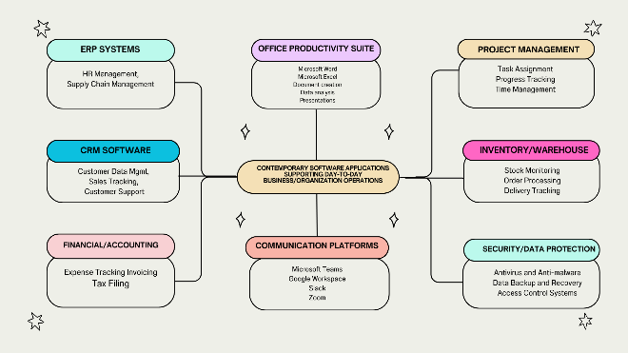
Explanation of Mind Map:
The mind map shows different types of modern software that businesses use every day. Each section explains what the software helps with. ERP systems help manage HR and supply chains. CRM software is used to store customer information, track sales, and support customers. Financial and accounting apps help with expenses, invoices, and taxes. Office productivity tools like MS Word, MS Excel, and presentation apps help staff create documents and work efficiently. Communication platforms such as Teams, Zoom, and Slack allow people to manage calls and work together. Project management software helps teams organize tasks and track progress. Inventory and warehouse systems manage stock, orders, and deliveries. Finally, security software protects company data with antivirus tools, backups, and access control.
Overall, the mind map shows how different software types support the daily operations of a business and help work run smoothly.

Figure 1: Mind Map
This visual framework demonstrates how modern organizations rely on an interconnected suite of software applications to manage communication, collaboration, data analytics, and operational functions. The interrelationship among these tools promotes efficiency, enhances data sharing, and enables remote work models essential in contemporary business environments.

III. TASK 3: OFFICE APPLICATIONS FOR CREATING, STORING, PRESENTING, AND ANALYSING INFORMATION/DATA
a. Four Office Software Solutions Inc. Analysis.
The contemporary business world heavily relies on office software suites to support documentation, communication, data analysis, and presentation processes. Microsoft Office, being a major productivity application, is a suite of applications that enables an environment where various tasks of the organization can be undertaken successfully. The foundation applications are Microsoft Word, Microsoft PowerPoint, Microsoft Excel, and Microsoft Access, which aid in the creation, storage, presentation, and analysis of information. All these applications have their unique features that facilitate productivity and efficiency in workflow and allow making informed decisions in the workplace.
I) Microsoft Word
Microsoft Word is part of the popular word-processing programs that are used in the business world globally. It allows editing, creating, and formatting of documents that are written in text, e.g. report, proposals, letters, and contracts. It has a wide range of file formats that include .docx, .pdf, and.rtf making it cross-platform compatible and sharing of documents [9].
Key Features
Microsoft Word includes support of advanced formatting, templates, and style management, enabling the user to create high-quality documents (professional or not) with a consistent design. The integration of the Track Changes and the Comments features facilitate collaborative editing so that two or more stakeholders could be able to review and annotate documents at the same time. Word is also compatible with the SmartArt graphics, tables, and charts where the data can be presented graphically in the form of the text files. Integration with Microsoft 365 Cloud Services is a guarantee that files can be stored and accessed through OneDrive to be used to support remote work and to manage versions.
Benefits
The main advantage of Microsoft Word is that it is easily available and flexible. It enables the rapid creation of documents with the consistency of the formatting across the devices. Grammar and spell-check features enhance the accuracy of the documents, whereas the ability to be used with screen readers and accessibility options is inclusive in the workplace. There is also the integration of mail merge that allows bulk personalized communications, including client letters and invoices, to be generated automatically.
Limitations
Nevertheless, Word may have a performance constraint about large or media-intensive files, which may be corrupted or have slow loading times [10]. In addition, though wealthy, it is highly customizable, which is too complex when not using it by experience. More complex automation or scripting is usually based on the knowledge of Visual Basic for Applications (VBA) and may be a learning curve.
ii) Microsoft PowerPoint
Microsoft PowerPoint is a hegemonic tool for making visual presentations in academic, corporate, and professional settings. It enables one to arrange content in a form of slides that mix text, images, charts, and multimedia to improve effective communication.

Key Features
The PowerPoint has various design templates, slide designs, and transitions of animation that lead to visual interaction. The Slide Master option will provide uniform formatting to all of the slides, and the Presenter View will provide the speakers with notes and the next slides on different screens. PowerPoint is also able to accommodate 3D, embedded videos, and integration of charts, which can be found in Excel, and it provides flexibility in content delivery. It can be integrated with Microsoft Teams and SharePoint to provide collaborative editing and sharing of presentations through the cloud [11].
Benefits
The application improves the clarity of the communication process by converting the complex data into easily comprehensible pictures. The use of PowerPoint presentations in the corporate briefings, marketing pitches, and training sessions is very common because of the dynamic presentation style. The AI-based Designer feature of the platform suggests layouts and visuals and enhances the aesthetics of the presentation with the least effort. With the possibility to be compatible with online delivery tools, remote presentation and collaborative work in real-time are available, which is a crucial quality in a hybrid workplace.
Limitations
Although PowerPoint allows visualization of the highest quality, the use of too many animations or too much text may decrease the involvement. Moreover, enormous multimedia files may create storage requirements as well as decrease efficiency in performance during play. Critics have further stated that badly designed slides have been a contributing factor to death by PowerPoint, whereby too many slides make the audience to not understand the message [12]. However, PowerPoint can still be used in effective ways; therefore, it is not going to be obsolete in professional communication.
iii) Microsoft Excel
Microsoft Excel is a spreadsheet application that is aimed at numerical computation, analysis of data, and records maintenance. It helps in complex formulae, data visualization, and functions of analysis that are vital in informed business decisions.
Key Features
The use of Excel is not limited to simple arithmetic operations but extends to higher statistical and financial analysis. Pivot tables, VLOOKUP, IF functions, and Goal Seek are some of the features that are used in dynamic data manipulation and forecasting. Data Analysis Toolpak offers the possibility of statistical calculation, whereas Conditional Formatting enables the visual analysis of patterns and anomalies. It can be integrated with Power Query and Power Pivot to be able to work with large datasets and model relationships. The Chart Tools feature offers several types of graphs to represent the visual data.
Benefits
Excel is a very important tool of business analytics, as it is used in analysing trends, budgets, and performance evaluation. Its formula-based system allows repetitive calculations to be automated and be more productive. Moreover, Excel is connected to Power BI and other Microsoft 365 apps, which encourages the end-to-end data analytics processes. The collaboration capabilities of the web-based version are enabling to work with multiple users at once and store data in the cloud, increasing the effectiveness and transparency of a team.
Limitations
Even though it has vast capabilities, Excel also has some limitations regarding the data integrity and the scalability. Performance can be a strain with large or complicated datasets, and a human input may introduce the possibility of human error. Also, although the system used in Excel is flexible in terms of its formulas, its misuse or configuration can lead to inaccurate calculations [13]. The issue of data security is also experienced in cases where spreadsheets are transferred to others without encryption or access control privileges.
iv) Microsoft Access
Microsoft Access is a relational database management system (RDBMS) that is used to store, manipulate, and access structured data. Access is suitable in small- to medium-scale database solutions, whereas Excel is only used in tabular data manipulation of data.
Key Features
Access allows one to create tables, queries, forms, and reports and have full control of data. Primary and foreign key use creates relational integrity, which guarantees consistency of records. The Query Design View is the one that allows querying based on SQL, and the Form Wizard and Report Wizard have an easy-to-use interface that enables data entry and presentation. Workflows can be automated with macros and VBA scripting, and manual intervention can be minimized. External databases like SQL Server, Excel, and SharePoint can also be connected to the Access databases, and this allows interoperability.
Benefits
The combination of simplicity and power is effective in Access because it provides organizations the ability to have customized databases without the complexity of the enterprise-level database management systems. It offers an economical online system of handling customer records, sales records, inventory, and employee databases. The graphical user interface enables the user who lacks technical knowledge to build and edit data solutions effectively. Additionally, Access facilitates uniformity and data validation by input masks and lookup fields as well as referential constraints [14].
Limitations
Scalability is one of the primary weaknesses of Access. Although efficient for small databases, the performance decreases when the size of the records grows to above a few gigabytes or when the database is accessed by more than a few users at the same time. Access is also mostly restricted to Windows environments and therefore not cross-platform. It has poor concurrency controls and does not have much security capability, like secure user role management, compared to SQL Server or Oracle [15]. Access is still the best option in data management of the department or the small business, though there are some limitations.
Application | Primary Function | Key Features | Benefits | Limitations
MS Word | Document creation and editing | Templates, Track Changes, Mail Merge | Professional documentation, collaboration | Complex for large documents
MS PowerPoint | Visual presentation creation | Slide Master, Animations, Designer AI | Enhanced communication, engagement | Overuse may reduce clarity
MS Excel | Data analysis and computation | Pivot Tables, Charts, Formulas | Accurate analysis, automation | Prone to human error
MS Access | Database management | Queries, Forms, Reports, Macros | Efficient structured data storage | Limited scalability

This analogy is important to note that although each application of the Microsoft Office suite is designed to meet organizational requirements, when combined to form the Microsoft 365 ecosystem, the different applications form a unified space that optimizes productivity, data integrity, and business process coordination.
All these tools together make significant contributions to information creation, storage, presentation, and analysis, the building blocks of productivity in the digital workplace. Word and PowerPoint facilitate external communication and documentation; Excel and Access provide data analysis and management; and OneDrive and SharePoint provide cloud integration and ensure secure and synchronized access by the devices.

b. Practical Testing
Feature 1: IF Function
Objective:
To demonstrate conditional analysis using the IF function to categorize sales performance as “High” or “Low.”
Formula Used:
=IF(B2>=5000, "High", "Low")
Explanation:
This formula checks whether the sales value in cell B2 meets the defined target of 5000. If true, the output displays “High”; otherwise, it returns “Low.” This function enables decision-making based on thresholds such as performance targets or budget goals.
Feature 2: Pivot Table
Objective:
To summarize and analyze sales data by region and product category.
Procedure:
- Select dataset range (A1:D50).
- Insert → Pivot Table → New Worksheet.
- Drag “Region” to Rows, “Product” to Columns, and “Sales” to Values.
- Display total sales per region and category.
Explanation:
The Pivot Table consolidates large datasets and enables interactive filtering and summarization. Business analysts use this feature to identify patterns, track sales performance, and generate dynamic summaries for managerial reporting.

IV. TASK 4. COMMUNICATION AND COLLABORATION APPLICATIONS
4a. Contemporary Communication and Collaboration Applications Analysis.
Application: Microsoft teams
Microsoft Teams is an integrated communication tool that Microsoft created by providing messaging, audio and video conferencing, file sharing, and application integration within a single workspace. It is a centralized communication hub for in-office and remote teams, with real-time messaging, group chat rooms, and high-definition video conferencing. Microsoft (2024) states that Teams is a component of the Microsoft 365 platform, enabling integration with other applications such as Word, Excel, and PowerPoint.
The persistent chat feature of Microsoft Teams is one of the main things because it supports threaded conversations and makes them available to all invited users. This aspect increases the openness of information and memory within organizations, saving reliance on repetitive email messages. The calendar integration of Outlook is also available in Teams, where users can schedule meetings inside the application. The feature of Meet Now enables impromptu video communication, and it facilitates both inter- and external cooperation.
Teams can be used to aid collaboration, which involves sharing files using the SharePoint and OneDrive tools and having several users co-authoring a document at the same time. The functionality can be expanded with the integration of third-party tools like Trello, Zoom, and Adobe Creative Cloud, which makes the tool flexible to suit different organizational workflows. Meetings and end-to-end encryption are part of the security architecture of Teams in addition to the fact that it meets the industry requirements like the ISO 27001 and GDPR, which guarantee weighted protection of data by the business operating in a foreign country.
Although Teams has a wide range of features, it also has several limitations. Users can have poor performance in case they have to work with big files or because the network is congested. Also, the abundance of features of the platform can present a steep learning curve to a novice user. However, Microsoft Teams is a valuable communication tool to the thriving business due to the advantages of centralized communication, safe data management, and thorough integration with Microsoft 365.
Key Features Summary:
- Continuous conversation and threaded messages.
- Video and audio conferencing.
- SharePoint file sharing and co-authoring.
- Connectivity with Microsoft 365 and third-party applications.
- Security compliance (ISO, GDPR)
Examples of such factors include the brand, the logo, the message, and the design. The examples of such factors are the brand, the logo, the message, and the design.
Collaboration Tool: Google Workspace (Google Docs, Google Sheets, and Google Drive).
Google Workspace (previously G Suite) is a productivity and collaboration product suite that was created by Google through cloud computing. It comprises Gmail, Google Drive, Google Docs, Sheets, Slides, and Meet, which are aimed at helping distributed teams work together. The suite is also popular in the sphere of education and business because of its features of access and real-time collaboration.
One of the outstanding features of Google Workspace is the ability to edit simultaneously. A document, spreadsheet, or presentation can be edited by multiple users at the same time with real-time updates being shown to all collaborators. This minimizes the problem of version control and enhances effective teamwork. Every modification is also automatically stored in Google Drive, which guarantees the continuous data protection and excludes the possibility of losing files.
The introduction of sophisticated commenting and suggestion systems is also part of Google Workspace, which can help in improving peer review capabilities. The users are able to label team members, add comments, and clear comments to the document. In addition, the platform can also be used to do offline editing and, therefore, can be productive even in areas where there is poor internet connectivity. To store and share files, Google Drive is used, as it offers cloud access and finer permission control to ensure safe handling of documents.
Type Hybrid Integration with Google Meet enables teams to integrate communication and collaboration by holding virtual meetings right away in their workspace within the same ecosystem. The fact the platform does not require an installer to use any extra software on the device implies that the user can access his or her files and applications via the web-based system. The system, however, demands a stable internet connection to work best, and low offline abilities could be seen to influence performance in areas of low connectivity.
Key Features Summary:
- Co-editing and commenting in real-time.
- Google Drive cloud storage.
- The Meet, Gmail, and Calendar integration.
- Automatic version history and saving.
- Multi-device accessibility
4b. Practical Testing of Communication and Collaboration Features
Communication Tool Test: Microsoft Teams, Chat and Meeting Scheduling
Feature Tested: Chat and meeting scheduling via integrated Outlook calendar.
Procedure and Observations:
- The Microsoft Teams desktop application was launched using a Microsoft 365 account.
- A new chat channel was created for a project group named “Business Operations Team.”
- Text messages, file attachments, and emojis were shared to demonstrate persistent messaging functionality.
- The “Calendar” tab was accessed to schedule a virtual meeting. A new event was created and linked to Outlook Calendar automatically.
- Meeting participants were invited using their email addresses, and Teams generated a unique meeting link for participants to join.
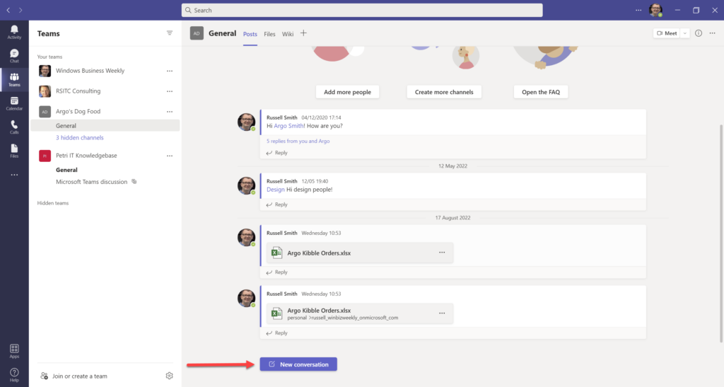

Figure 2: Creation of the chat channel
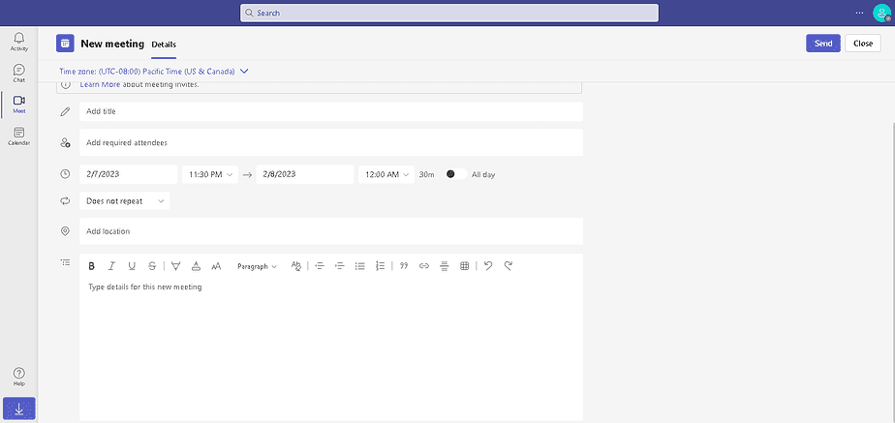

Figure 3: Scheduling window displaying meeting title
Outcome:
The feature successfully demonstrated the integration of real-time communication and scheduling. Participants were able to join seamlessly through the meeting link, and shared files were accessible during the session. This test confirmed the reliability and efficiency of Teams for organizational communication and planning.

V. REFERENCES
[1] Dushnitsky, Gary, and Bryan K. Stroube. "Low-code entrepreneurship: Shopify and the alternative path to growth." Journal of Business Venturing Insights 16 (2021): e00251.
[2] Bang, Seunghun. "Top E-Commerce CMS platforms (Shopify/WordPress/BigCommerce)." (2023).
[3] MacDonald, Larry. The Shopify Story: How a Startup Rocketed to E-commerce Giant by Empowering Millions of Entrepreneurs. ECW Press, 2024.
[4] Rumetna, Matheus Supriyanto, et al. "Optimalisasi Penjualan Buah-Buahan dalam E-Commerce Memanfaatkan Wix Builder: Solusi dan Implementasi." Jurnal Ilmiah Informatika Dan Komputer 1.1 (2024): 10-17.
[5] Lina, Tirsa Ninia, et al. "Peningkatan Daya Saing Toko Safar Melalui E-Commerce dan Pemasaran Digital Berbasis Wix." ABDIKAN: Jurnal Pengabdian Masyarakat Bidang Sains dan Teknologi 3.4 (2024): 239-248.
[6] Buzan, Tony. Mind map mastery: The complete guide to learning and using the most powerful thinking tool in the universe. Jaico Publishing House, 2024.
[7] Jadhav, Gauri Girish, Shubhangi Vitthal Gaikwad, and Dhananjay Bapat. "A systematic literature review: digital marketing and its impact on SMEs." Journal of Indian Business Research 15.1 (2023): 76-91.
[8] Jatmiko, Bambang, et al. "Strategies for MSMEs to achieve sustainable competitive advantage: The SWOT analysis method." The Journal of Asian Finance, Economics and Business 8.3 (2021): 505-515.
[9] Yulanda, Eny Pricilia. "A Literature Review: Microsoft Word in Improving Writing Skill during Hybrid Learning." Jurnal Penelitian Mahasiswa Indonesia 3.2 (2023): 350-356.
[10] Jalil, Abdul, et al. "Literature Review: Exploration of Features Microsoft Word." International Applied Science 3.1 (2024): 28-32.
[11] Baidoo-Anu, David, and Leticia Owusu Ansah. "Education in the era of generative artificial intelligence (AI): Understanding the potential benefits of ChatGPT in promoting teaching and learning." Journal of AI 7.1 (2023): 52-62.
[12] Younis, Hussain A., et al. "A systematic review and meta-analysis of artificial intelligence tools in medicine and healthcare: applications, considerations, limitations, motivation and challenges." Diagnostics 14.1 (2024): 109.
[13] Alcaraz-Martinez, Rubén, et al. "Can we create accessible charts with Microsoft Excel?: a review of possibilities and limits, with a special focus to users with low vision." Proceedings of the XXIV International Conference on Human Computer Interaction. 2024.
[14] Omar, Marwan. "New insights into database security: An effective and integrated approach for applying access control mechanisms and cryptographic concepts in Microsoft Access environments." (2021).
[15] Omar, Marwan. "New insights into database security: An effective and integrated approach for applying access control mechanisms and cryptographic concepts in Microsoft Access environments." (2021).

