UNIVERSITY OF WALES TRINITY SAINT DAVID
BSc Applied Computing

Assignment 2: Project Management & Innovation

Project Management, Enterprise & Innovation, and Reflection
A project report on investigating and addressing QR code phishing ("quishing") awareness among university students

Student name: | Yevhen Lytko
Student number: | 2424747
Programme: | BSc Applied Computing
Module: | Changemakers: Creativity and Value Creation (ACCA5033)
Assignment: | Assignment 2: Project Management & Innovation
E-portfolio: | https://sites.google.com/view/yevhen-lytko-portfolio/

Research area / project idea: QR code phishing ("quishing") — student awareness and a practical scan-safety intervention

Table of Contents

Introduction 3
Task 1: Project Management & Planning 4
Project scope and proposed solution 4
Technologies and resources 4
Timeline, schedule and constraints 4
Development method 5
Project design 5
Task 2: Enterprise & Innovation 7
Q1: PEST and SWOT analysis 7
Legal and ethical considerations 7
Q2: Developing, deploying and maintaining the project within a large organisation 8
Task 3: Project Reflection 9
Developing new skills 9
Positive impact on society 9
Risks and challenges 9
Conclusion 11
References 11
Appendix A: Pilot Data Collection Instrument 13

Introduction
The document offers information about project management and business and innovation through analysis of one project concept, which is studying how aware students of higher education institutions are of QR code phishing (quishing) and taking steps affordable to promote proper understanding of safe use of scanning. Quishing has emerged as a fast-growing social-engineering threat since QR codes became routine for payments, menus and parcel deliveries, and it is harder to detect than conventional phishing because the destination of a code is hidden until it is scanned [1], [2], [3]. For Task 1 of the project, the scope, the resources needed, the schedule, and the method of development will be examined, together with a Gantt chart and two design artifacts. In Task 2, the researcher will carry out a PEST analysis and a SWOT analysis of a well-established security-training company in order to analyse the global innovation and business environment, as well as discuss possible ways in which the project intervention can be introduced and used in large organisations. Finally, in Task 3 the researcher will have to consider the competencies that this project will help to develop, its potential positive impact on society, and the risks it might encounter. The report closes with a conclusion and an IEEE-formatted reference list, with supplementary material provided in the appendix.

Task 1: Project Management & Planning

Project scope and proposed solution
This project addresses a clear, precise issue which is QR code phishing (or "quishing") which means that QR code misleads the user by sending the captured information to a fake website, a phishing page or a page with malware. A QR code is different from an ordinary phishing link because it doesn’t show its destination until it is scanned, making it difficult for the users to see the warning sign (like a suspicious domain of a website and that has been sent in an email). The aim of the project is not to make quishing a national or global problem, but to find out how students learn about it and what causes them to scan a suspicious QR code without any backup. The project does not include creation of any scanning application or tool as it is not possible within the timeframe available and developing software would turn the project from behavioral awareness into a software engineering project.
This project calls for essential resources, that include an online survey tool such as Microsoft or Google Forms for the quantitative awareness questionnaire; basic vocabulary and design tools (Canva, PowerPoint) for designing orientation cards; access to academic databases (IEEE Xplore, Google Scholar) for finding the literature; and a small team of colleagues willing to take part in the pilot study. No hardware, licensed software, or laboratory is needed, which keeps the project simple and appropriate for a student’s work schedule.
Timings, plans, and limitations. The 12-week plan that is demonstrated by a Gantt chart in figure 1 shows that the initial five weeks were used for proper research and instrument design.
It was planned to devote week 5 solely to pilot testing and weeks 6–8 should be treated as buffer periods for making possible corrections to the survey card and instructions before it was to be distributed to the respondents. Feedback from the pilot test (which is attached in the appendix) indicated that even a pilot test with a small sample led to language problems that could disturb an entire dataset, thus establishing the necessity of building the buffer periods into the project instead of proceeding with administering the main survey immediately after the pilot test. Time was the main limitation of the study which could only be conducted as part of coursework without putting too much emphasis on the participant group and making study representative.
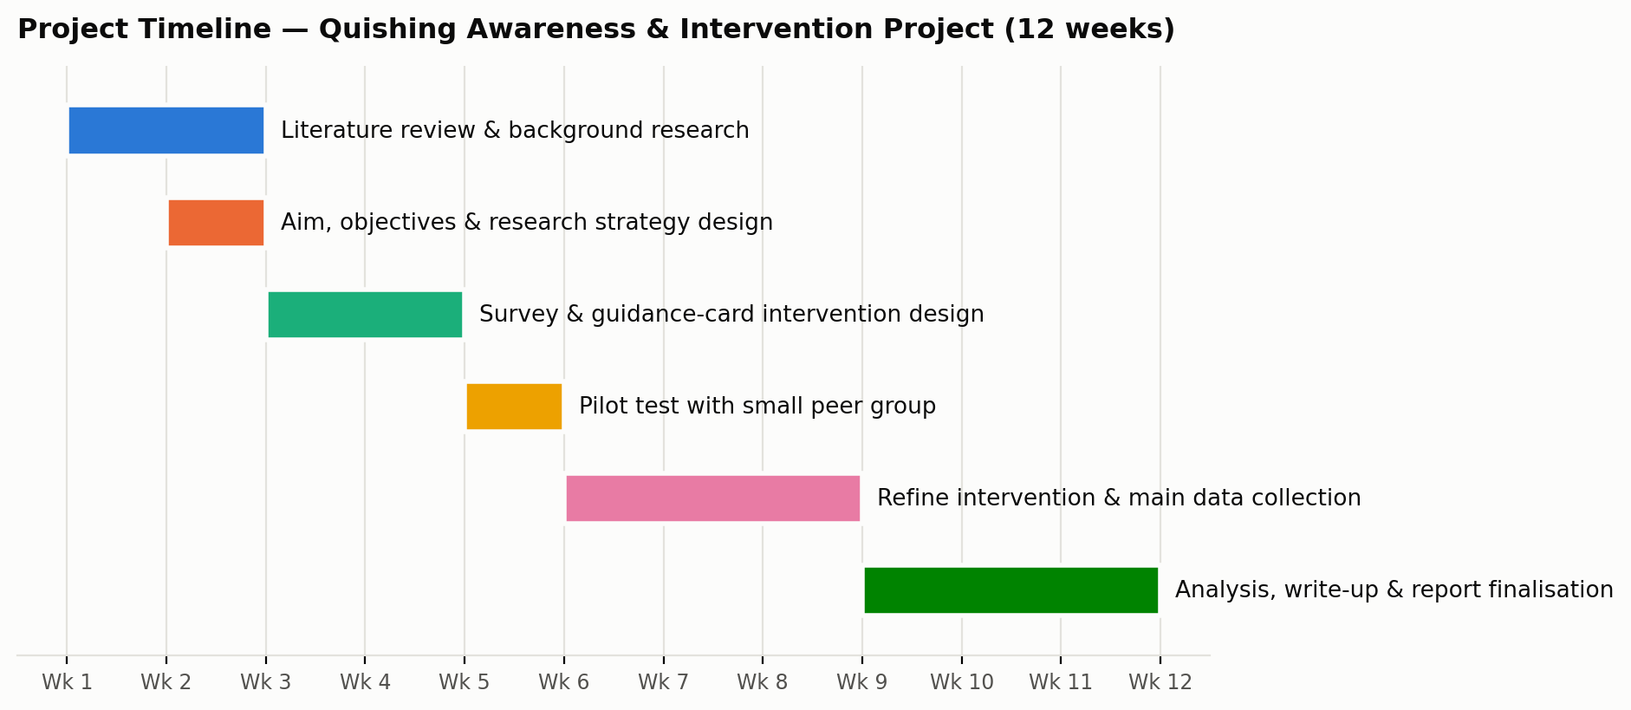
Figure 1. Proposed 12-week project timeline (Gantt chart).

Development method

In this project, an iterative approach influenced by agile approach was preferred to a lengthy plan-driven process like the waterfall, as one of the crucial products of the project, the guidance intervention cannot be achieved successfully on the first trial [4]. Agile methods and scrum methods were first implemented in small teams that needed to adapt to feedback rather than delivering a fixed specification. The same idea is valid here as the framework from figure 2 is a kind of shorter scrum sprint with the ‘increment’ produced in every iteration being a revised version of the survey of the card tested against the feedback obtained from real users. This method is quite consistent with the project requirements and there is even one small iteration in which three colleagues tested the card, which helped detect a vague question rather than using a plan with an upfront approach.

Project design
A variety of design documents lend credibility to the declared strategy. Flowchart 2 exhibits the multiple iterative steps in the sequence of phases of research, intervention action, starting from reviewing literature to piloting and analyzing feedback while ensuring that this feedback loop goes back to the initiation of intervention. Flowchart 3 again presents a sample of wireframe in the form of “Scan Safety” guidance card, which is one of the practical outputs of the project, and is used to illustrate the structure of checklist with an attention-grabbing title and instructions for a case when a code is not clear if safe.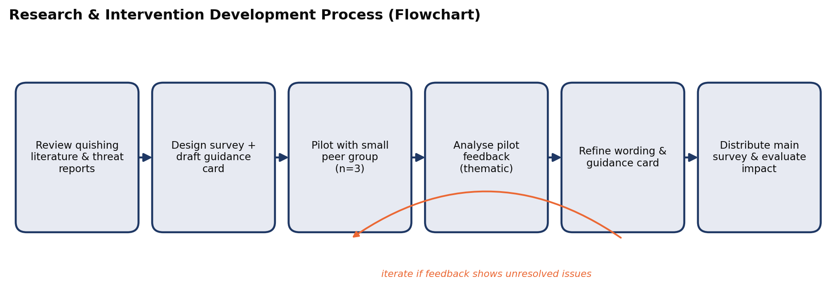
Figure 2. Research and intervention development process (flowchart).
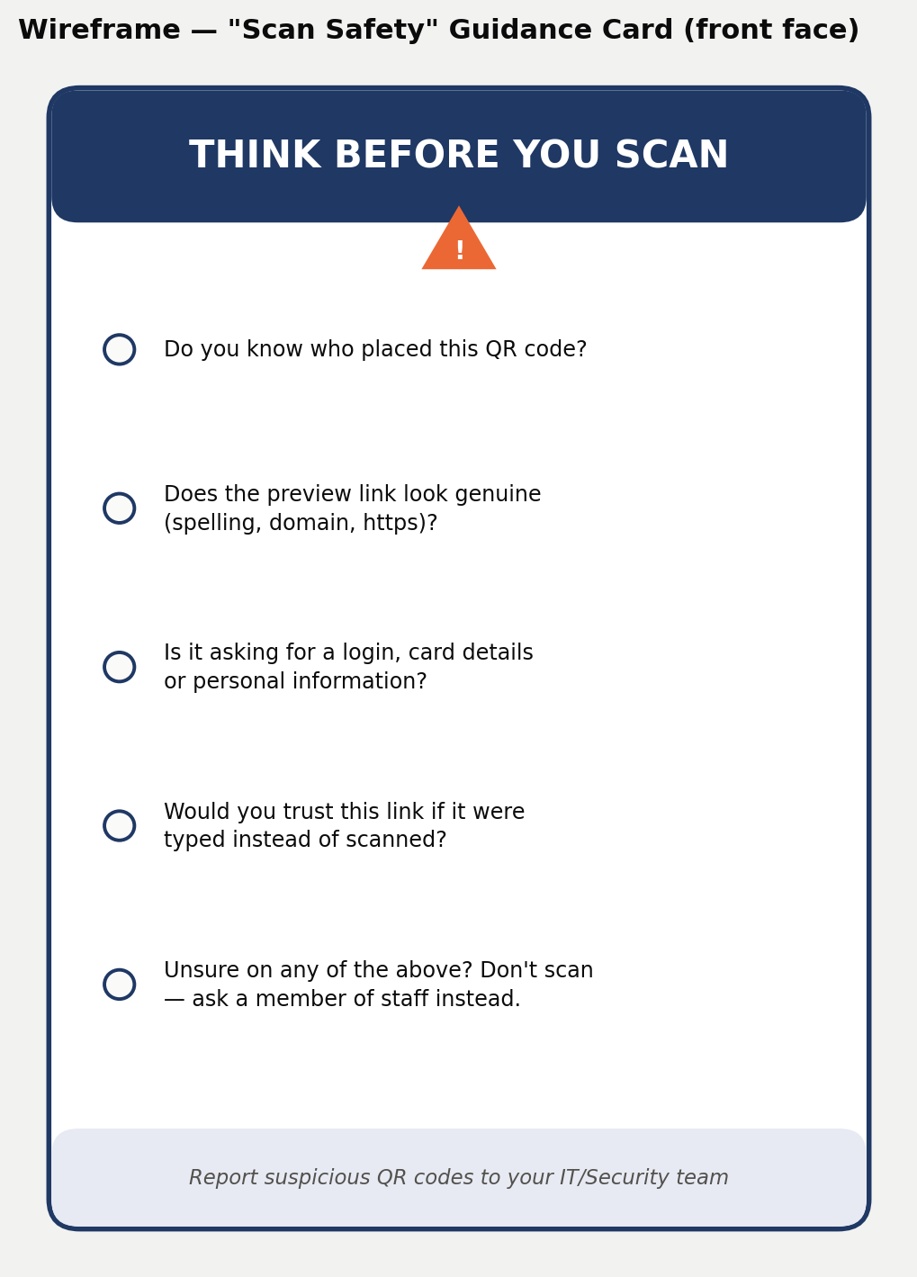
Figure 3. Wireframe of the ‘Scan Safety’ guidance card (design piece 2).

Task 2: Enterprise & Innovation

Q1: PEST and SWOT analysis
To anchor this analysis in reality we look at KnowBe4, a company engaged in security-awareness training and simulated phishing [8]. The PEST and SWOT analysis are shown in Tables 1 and 2 according to the PESTLE framework according to the CIPD [7].
Table 1. PEST analysis — KnowBe4 (security awareness training)
Political | Increase in the number of regulations (UK GDPR, breaches, NCSC guidelines) causes a push towards security-awareness training among organizations, which benefits companies such as KnowBe4 [1], [7].
Economic | Rising costs associated with data breaches and cyber-insurance premiums make preventive training an easier sell in terms of the budget, even in the conditions of limited discretionary IT budgets but an economic crisis may still result in training budget cuts [7].
Social | General awareness of the public for scams, that is evidenced by media reports about QR code fraud, is changing the public’s expectation of the training that should take place [1], [3].
Technological | The speed with which the attackers’ tactics are evolving, e.g. AI-phishing, deep fakes, quishing, makes it necessary to keep changing the content and creates an interdependence between the vendor and the threat environment [3], [9].

Legal and ethical considerations
Any organisation running phishing-simulation training, including a quishing-style test, must handle the resulting personal performance data (who clicked, who reported it) in line with UK GDPR: data should be used to improve training, not to unfairly discipline individuals, and staff should be informed that simulated phishing forms part of ongoing security-awareness activity [7]. Ethically, simulations should avoid content that could cause distress (for example, a fake redundancy notice) and should be designed so that a failed test is treated as a learning moment rather than a source of shame, since workforce research suggests a punitive culture actively discourages staff from reporting real incidents once they occur [9].
Table 2. SWOT analysis — KnowBe4
Strengths  Market-leading content library, large existing customer base, and a gamified training format that improves engagement over static slide decks [8]. | Weaknesses  Subscription pricing can be prohibitive for small organisations; completion metrics do not always translate into genuine behaviour change [9].
Opportunities  Expansion into attack-specific modules — a dedicated quishing-awareness module is a direct parallel to this project’s own intervention — and partnerships with universities to reach students before they enter the workforce. | Threats  Fast-moving attacker techniques risk outpacing training content; free or open-source awareness resources compete on cost; a security incident at the vendor itself would be especially damaging given its position as a security authority [9].

Q2: Developing, deploying and maintaining the project within a large organization
The guidance-card intervention proposed in Task 1 would use a structured security-awareness lifecycle that would be in in accordance with NIST SP 800-50 if adopted by a large-scale organization rather than being tested informally among students. The security-awareness or governance, risk and compliance (GRC) team would assume the development of the intervention employing the feedback-driven, iterative process introduced in Task 1 instead of a fully-fledged rollout as the wording and overall design of the card will continue to be altered taking into consideration the feedback received from employees. The guidance card would be deployed through the available LMS and intranet as well as digital signage in an organization thus significantly reducing new infrastructure procurement and costs. The maintenance of the existing system requires regular scheduled reviews since quishing attacks evolve so there should be a mechanism for employees to report on dubious QR codes, thus adjusting the future revisions of the card on the basis of the information received from the real incidents. Finally, the efficacy of the intervention could be assessed through such KPIs as the phishing-simulation click-through rates and self-reported confidence which is a common approach to measuring the effectiveness of awareness training.

Task 3: Project Reflection

Developing new skills
This initiative is expected to improve my talents in the areas of research, analysis, and communicative approach. In relation to research, one can develop skills in designing and piloting survey instruments and modifying the wording of the questions based on pilot results. Starting from this particular case and generalizing conclusions with Gibbs’ model can be regarded as a significant lesson learned about the importance of testing the survey instruments before launching them [10]. Regarding the analytical aspect, the combination of quantitative analysis (the percentages) and qualitative thematic analysis (putting comments into themes) improves the skills necessary in the field of cyber security where quantitative information about incidents is important, however, getting the root causes of incidents is usually not the issue of numbers but of qualitative analysis. In terms of communication, the ability to summarize an incident and a solution to a problem in one card that is informative and at the same time understandable to people who do not have any background in security is a very specific skill.

Positive impact on society

Quishing utilizes precisely this kind of straightforward, low-effort trust that QR codes were supposed to engender, and the fallout from such an attack goes beyond just one victim: there is the possibility of monetary loss, identity theft, and — on a larger scale — the decline of trust in QR codes in general — a technology that serves real and legitimate functions in payments, ticketing, and accessibility [1], [2]. A tested and inexpensive awareness intervention helps to close some of the well-known knowledge and awareness gap in cybersecurity information known from studies of the industry workforce [9], which does not require using enormous resources for setting a large-scale technical control. As the intervention is purposely inexpensive and simple (checklist and simplified advice card instead of creating software), it is also practically feasible for organizations that cannot afford a commercial platform such as KnowBe4, for example, small businesses, community organizations, or the university’s student services department, which allows it to have a greater positive impact on society than what could be achieved in large organizations only.

Risks and challenges
There are multiple hazards that can impact the implementation of this project. The most critical hazard relates to the sample size and generalizability; as three peers in the pilot or even a larger survey cannot be assumed to represent the entire student body or even the public in general, thus the results of this project will be considered as indicative rather than conclusive and therefore avoiding the overstating of the results derived from a small research study [5]. Another risk relates to the ethical implications of how research materials are handled; it is crucial that the QR codes used must be safe and labeled properly as part of the research process in order to eliminate any ethical concerns over the use of something closely resembling a malicious code even if used for demonstration purposes [2]. Another risk involves the possibility of response and social desirability bias as participants may provide the answer that they already carefully check the links because that is the expected “correct” answer which prompted pairing self-reports with behavioral questions in order to ensure consistency of results. Finally, there is a common risk of timelines associated with short projects.

Conclusion
This report outlines a comprehensive project plan based around one single topic; that of trying to understand why students in higher education tend to access QR codes which are not familiar with them and creating a simple solution to lead to safer practices. Task one has shown that this project can be accomplished within a reasonable time frame and minimal set of resources thanks to its iterative development approach, which is appropriate for the project, since its main deliverable consists of the feedback from the users. Task two presented the concept in terms of the broader context of innovation and entrepreneurship, i.e. how the existing company is considered from PEST and SWOT points of view and how the project idea can be assimilated and put into practice by a corporation. Task three gave a candid overview of what doing this project can add into the individual’s profile in terms of research, analytical and communication skills as well as project’s contribution to the sphere of cybersecurity. All in all, this project is not very massive in terms of its size but, at the same time, it is still highly organized.

References

[1] National Cyber Security Centre, "QR codes – what’s the real risk?," NCSC Blog, 2024. [Online]. Available: https://www.ncsc.gov.uk/blog-post/qr-codes-whats-real-risk. [Accessed: 22-Aug-2026].
[2] Cybersecurity and Infrastructure Security Agency, "Recognize and report phishing," CISA, 2024. [Online]. Available: https://www.cisa.gov/secure-our-world/recognize-and-report-phishing. [Accessed: 22-Aug-2026].
[3] Proofpoint, "What is quishing (QR phishing)?," Proofpoint Threat Reference, 2024. [Online]. Available: https://www.proofpoint.com/us/threat-reference/quishing. [Accessed: 22-Aug-2026].
[4] L. Rising and N. S. Janoff, "The Scrum software development process for small teams," IEEE Software, vol. 17, no. 4, pp. 26–32, Jul. 2000.
[5] Project Management Institute, "Risk analysis and management," PMI, 2024. [Online]. Available: https://www.pmi.org/learning/library/risk-analysis-project-management-7070. [Accessed: 22-Aug-2026].
[6] National Institute of Standards and Technology, Building a Cybersecurity and Privacy Awareness and Training Program, NIST Special Publication 800-50 Rev. 1, 2024. [Online]. Available: https://csrc.nist.gov/pubs/sp/800/50/r1/iprd. [Accessed: 22-Aug-2026].
[7] Chartered Institute of Personnel and Development, "PESTLE analysis factsheet," CIPD, 2024. [Online]. Available: https://www.cipd.org/en/knowledge/factsheets/pestle-analysis-factsheet/. [Accessed: 22-Aug-2026].
[8] KnowBe4, "AI-native security awareness training," KnowBe4, 2024. [Online]. Available: https://www.knowbe4.com/products/security-awareness-training. [Accessed: 22-Aug-2026].
[9] ISC2, "2025 ISC2 cybersecurity workforce study," ISC2, 2025. [Online]. Available: https://www.isc2.org/Insights/2025/12/2025-ISC2-Cybersecurity-Workforce-Study. [Accessed: 22-Aug-2026].
[10] G. Gibbs, Learning by Doing: A Guide to Teaching and Learning Methods. Oxford: Further Education Unit, Oxford Polytechnic, 1988.

Appendix A: Pilot Data Collection Instrument

This appendix reproduces the draft pilot questionnaire and pilot feedback developed during the initial scoping of this project, and is included here as supporting evidence for the design and reflection decisions made in Tasks 1 and 3 (e.g. the iterative development method, and the risk of ambiguous survey wording).
Draft pilot questionnaire (distributed to a small peer group before the main survey):
1. How often do you scan QR codes in a typical week?
2. Before today, had you heard the term "quishing" or "QR code phishing"?
3. In general, how confident are you that you could tell a safe QR code from a risky one? (scale 1–5)
4. Do you check where a QR code leads before entering any personal details? (yes / sometimes / no)
5. Have you ever scanned a QR code in a public place (poster, sticker, menu) without checking who placed it?
6. What would make you more cautious about scanning an unfamiliar QR code?
7. After reading the draft guidance card, was anything unclear or missing?
8. Any other comments on the length, wording or usefulness of this questionnaire?

Pilot feedback summary
The questionnaire was piloted with three participants. Responses showed relatively low prior awareness of quishing, with none of the three having heard the term before taking part, despite two of the three reporting they check where a QR code leads before entering personal details, and two reporting they scan QR codes only from sources they consider official or trusted (e.g. hotels, institutions). A consistent issue emerged with the original wording of Question 3: all three participants found it ambiguous, unsure whether it was asking about their general confidence in judging QR code safety, or their confidence in that specific moment. Two participants also raised a related point not directly asked about — that trusting an "official" source does not guarantee their data is handled safely afterwards, suggesting the original question oversimplified how users actually judge risk. As a result, Question 3 was reworded for clarity (the version shown above is the revised wording). No questions were removed, and feedback on length and overall clarity was positive across all three participants. This feedback was used to refine the wording of the main survey instrument before wider distribution.

Individual pilot responses
Person 1
1) Twice a week
2) No
3) 2
4) Yes
5) No
6) I never scan unknown QR codes, I decide to scan them only if I know where it goes to.
7) No, everything was covered.
8) I found Question 3 a bit confusing — I wasn't sure if 'confident in judging whether a QR code is safe' meant confident in general, or confident right now in this specific test.

Person 2
1) Almost never
2) No
3) 2-3
4) Yes
5) Yes
6) I only scan QR's from official institutions or their representatives, however, I am not sure about where my personal data goes then anyway.
7) No, everything is clear.
8) I was not sure what was exactly meant in question 3, as I never scan suspicious QR's, but I can't be sure that even official organisations don't sell or use my data in a way I would not appreciate that, so it is quite difficult to identify my judging skills.

Person 3
1) Twice a week
2) No
3) 3-4
4) Yes
5) Yes
6) I only scan QR code from Hotel, and from official institutions.
7) No.
8) I wasn't sure what question 3 meant, as I never scan suspicious QR codes. However, I can't be sure that even official organizations don't share or use my data in ways I wouldn't find offensive, so it's quite difficult to assess my detection skills.

