Marketing essential
Module BMI4005
Moryom Begom Qureshi (2238616)

In this assignment I will be demonstrating my marketing plan to attract new and existing customers by using one of the communication strategies. I will be using different platforms of the social media channels to promote my marketing plan I will demonstrate this by using Frameworks. My assignment will be based on the Hotel Holiday inn this is a franchise chain of hotels, this hotel is not a luxury hotel but more of a city centre hotel usually located in the heart of the city near commercial areas. This hotel already offers free Wi-Fi, late check out, earns points for reward nights.

There are six types of communication strategy, there’s Direct marketing this marketing targets existing customers by either email, text messages, phone call or magazines. Advertising is a way of marketing your business to increase the sales by attracting customer with leaflets distribution, billboard, or newspapers. Social media are interactive technology that are used on virtual communities and network. Content marketing is a marketing strategy to engage and capture and audience by making and sharing relevant videos, articles, podcast, and other media. This is to promote brand awareness. Email marketing is the act of dispatching commercial messages normally to a group by using emails this can include sales or advertisement. Online marketing this is strategy that uses the internet to promote products and services. For my marketing plan for Holiday Inn, I will be using the social media strategy to attract customers. Holiday inn has a very low audience online Appendix 2.
Holiday inn is a modern hotel that attracts mainly business and leisure travellers. Over 100 million people stay in Holiday inn. Holiday inn has huge number of competitors so this can limit the sales. Customers are always looking for seasonal offers. Holiday has competitors globally from renowned and local hotels.
Holiday inn marketing target is Businesspeople aged 35-54 travellers and last-minute bookings. Plan is to widen the customers base, reaching out to younger audience nationally and internationally. appendix 4
Holiday inn competitors are Hyatt hotels, Travelodge hotels, jury’s inn, Kew green hotels and premier inn. On the Bowmans strategy clock, they all fall on the number 2 low price. Appendix3
Political factors that can affect holiday inn is the war against Russia and Ukraine that can affect your sales. Economy of the people rate is less so there is a low disposable income due to recession. Social factor for holiday inn has been affected by covid, people are more reliant on digital technology.

My objectives are to develop the existing product by using social media platforms to promote customer relation and sales. The goal for Holiday Inn is to increase sales by doubling the sales every month by measuring the number of followers and interaction by customers, holiday inn is already an established hotel, so it is already a profitable company, so it is relevant to keep up to par in communication with the customers and sales, seek feedbacks, be part of the conversation, get customers involved. To implement this plan will have a team to work on this project will need a photographer, videographer, influencer a team that will be on the social media app promoting the adds to bring in more customers. The target timescale will be six months to see results but will be setting weekly goals this will strengthen progress and stimulate the team to stick to the plan.

There is a lot of benefits in marketing on social media, it is very cost effective, you get a lot of exposure, it helps with brand awareness. Instagram is a great platform it is more visually gripping posts and can create short videos. YouTube is better for more longer informative videos. Facebook allows brands to interact via live video, messaging and one to one interaction. All these social media will help holiday inn stand out.

Research has showed people are on their phone first thing in the morning so sending a post last thing at night or first thing in the morning will reach more customers which will make them more engaged appendix 4. Instagram has a business account that targets specific audience or market and demographic areas, and it is also a free platform which is good for businesses that don’t have a lot of disposable income, this means that they can utilise this disposable income on reinvesting on the business instead of using the funds on advertising which is more cost effective. Facebook will attract certain clients that are at different age as Facebook users are older, video streaming will be very beneficial as it showcases your business that will involve customers more. YouTube adds that are normally added in during a video break, you add will reach different area nationally or internationally. On the short video show case, holiday inn as a great hotel that gives 100% customer service and show the rooms and what holiday has to offer as in bed and breakfast. Once this plan is implemented all the record will stored in the Gannt chart, which will record all the amount of work done in certain period of time in relation to the amount planned for those periods. This will help organise the project, improve overall projects visibility and keep everything 0n track.

Appendix: 1
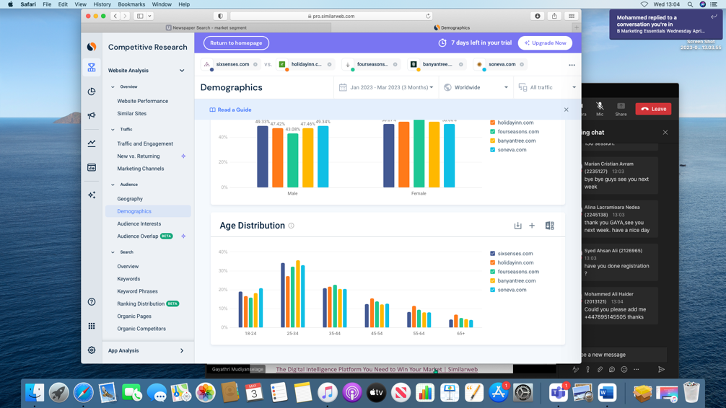

Appendix:2
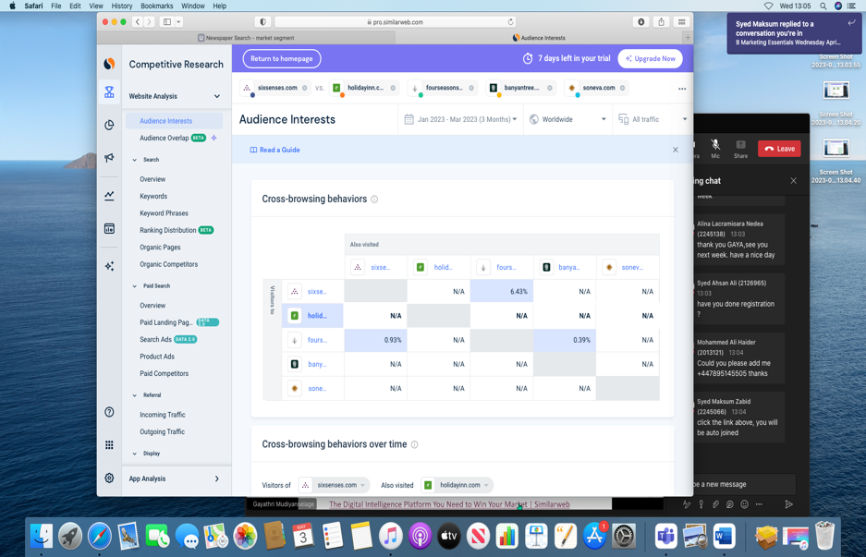

Appendix:3

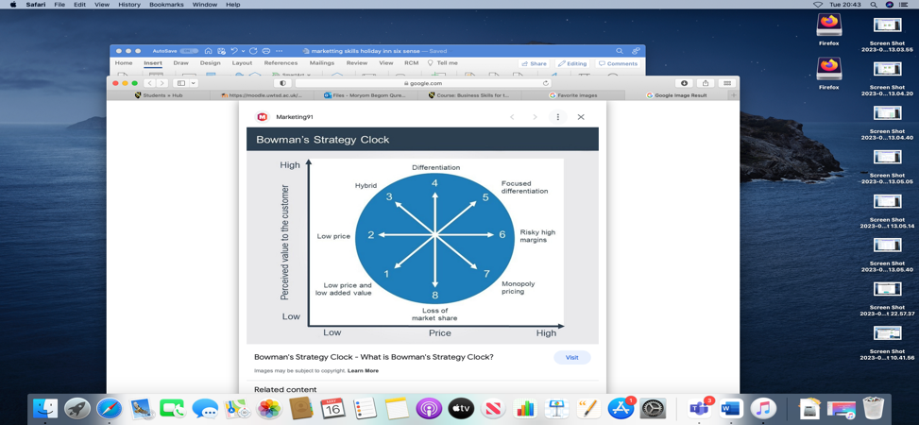

Appendix

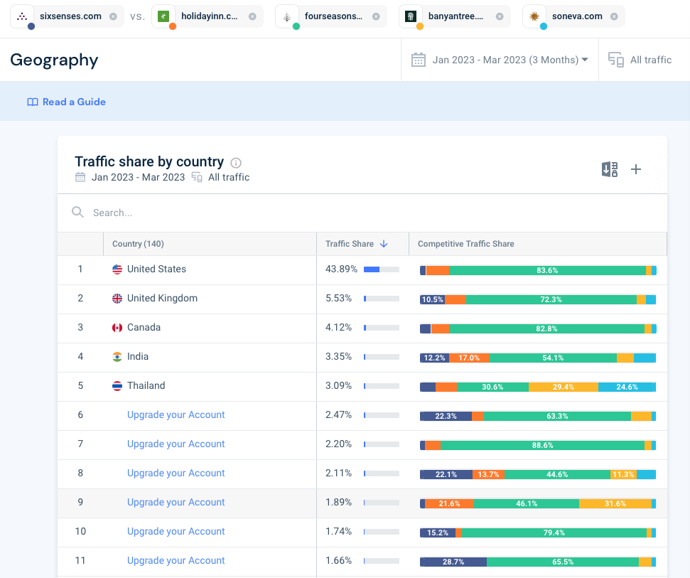

Appendix:4
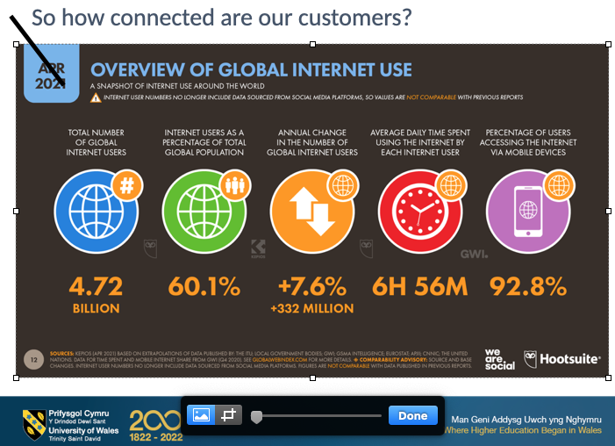

Appendix5

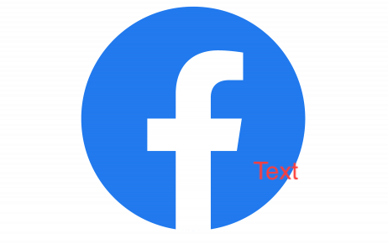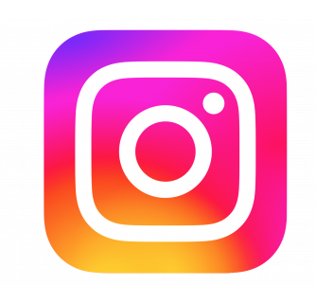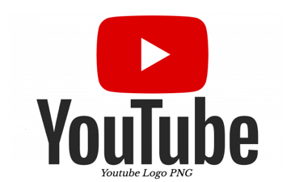

Appendix 6

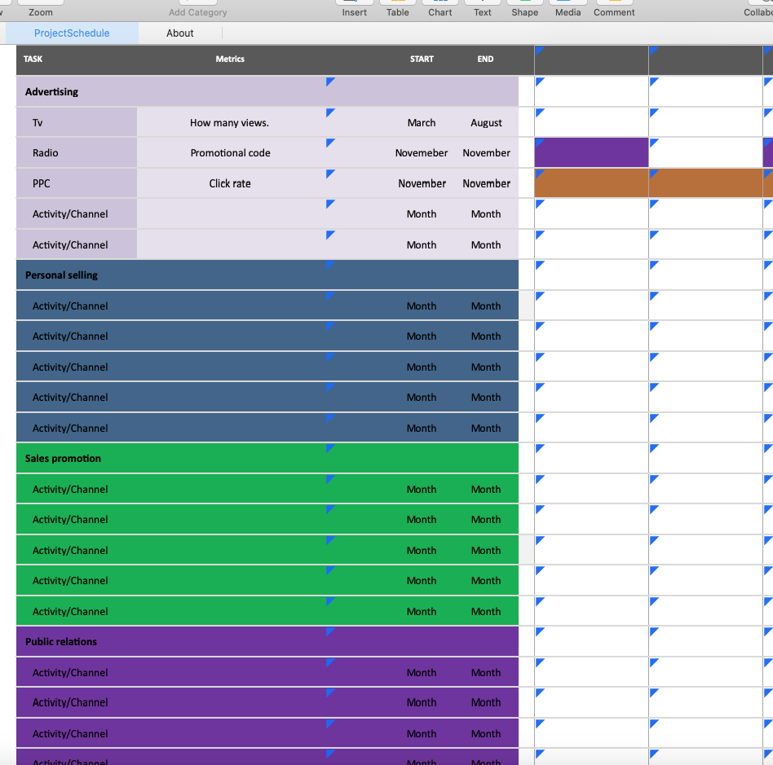

Appendix:7 presentation slides

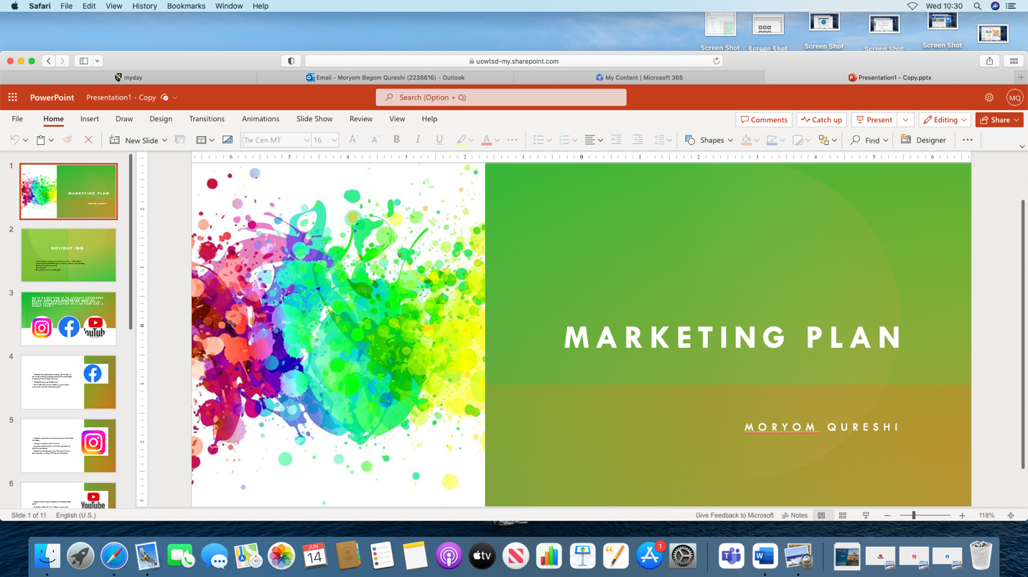

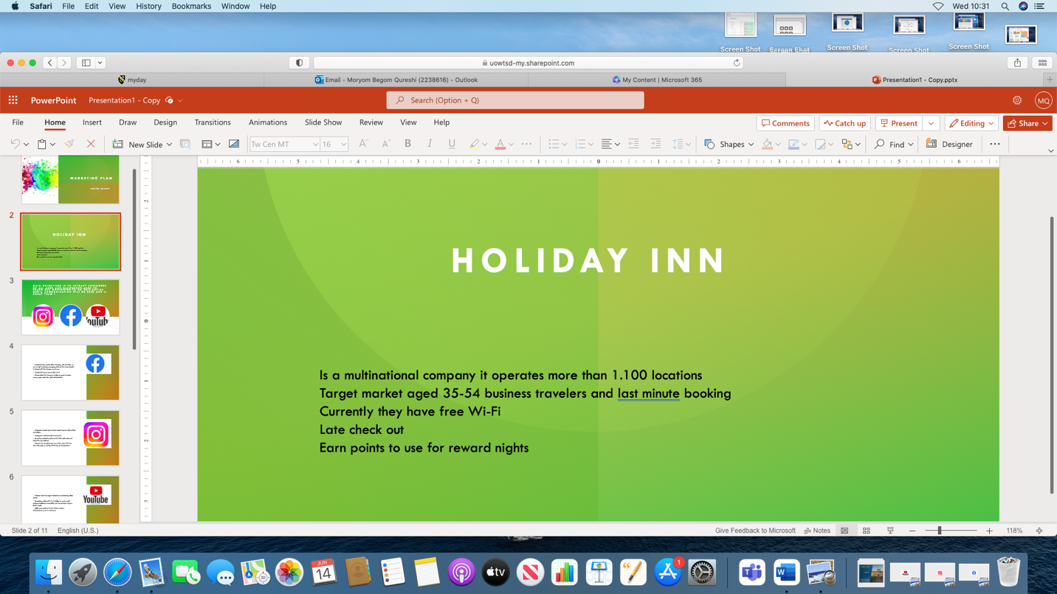

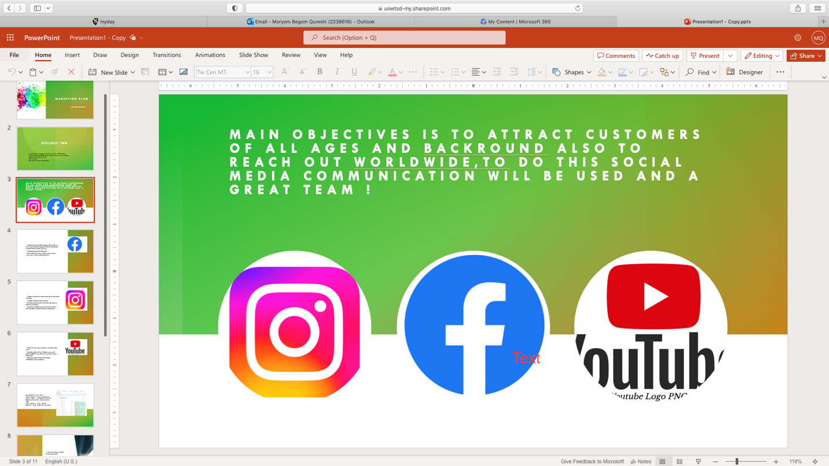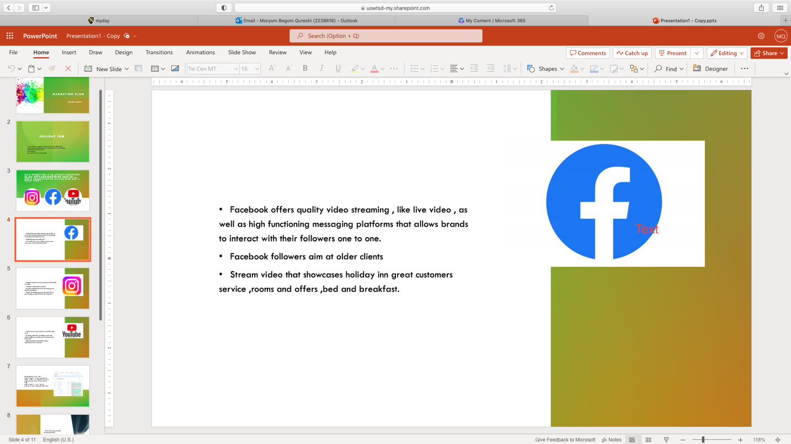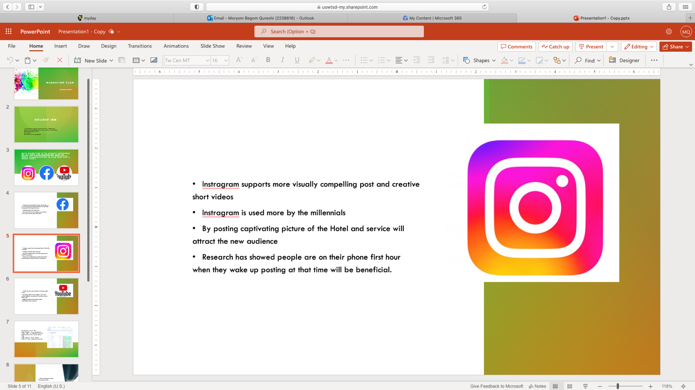
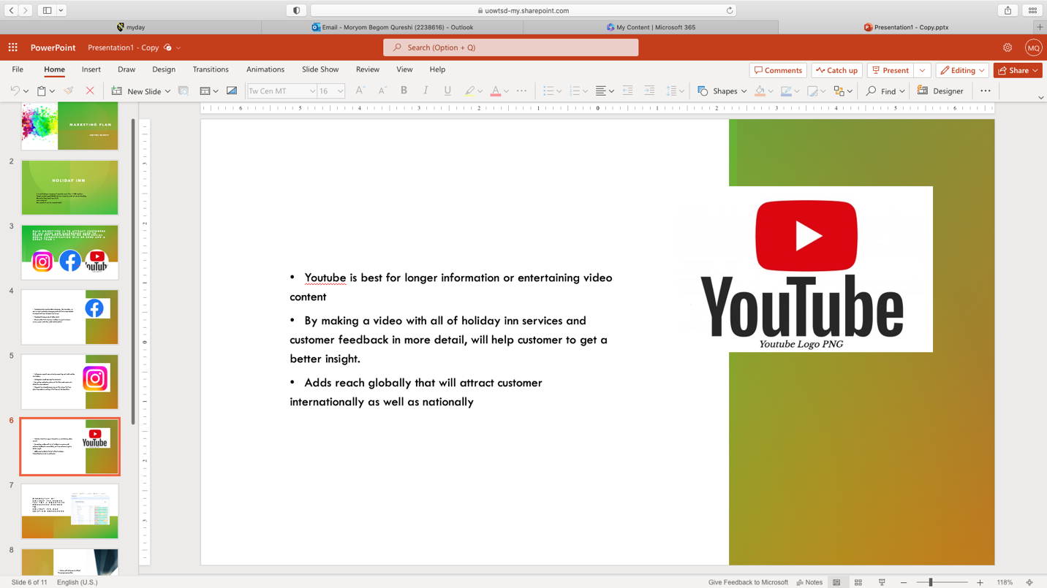

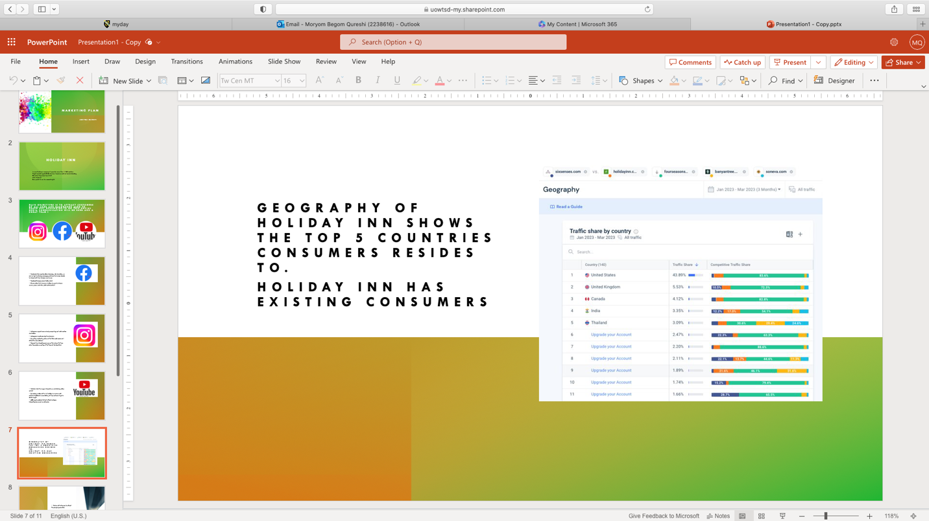

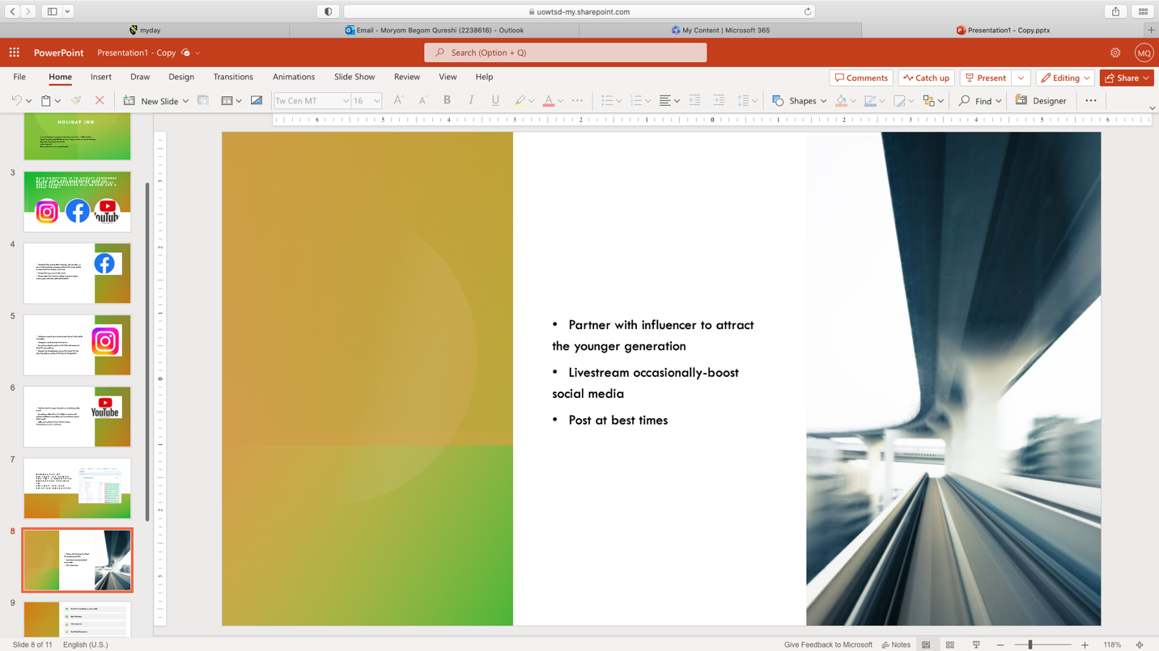
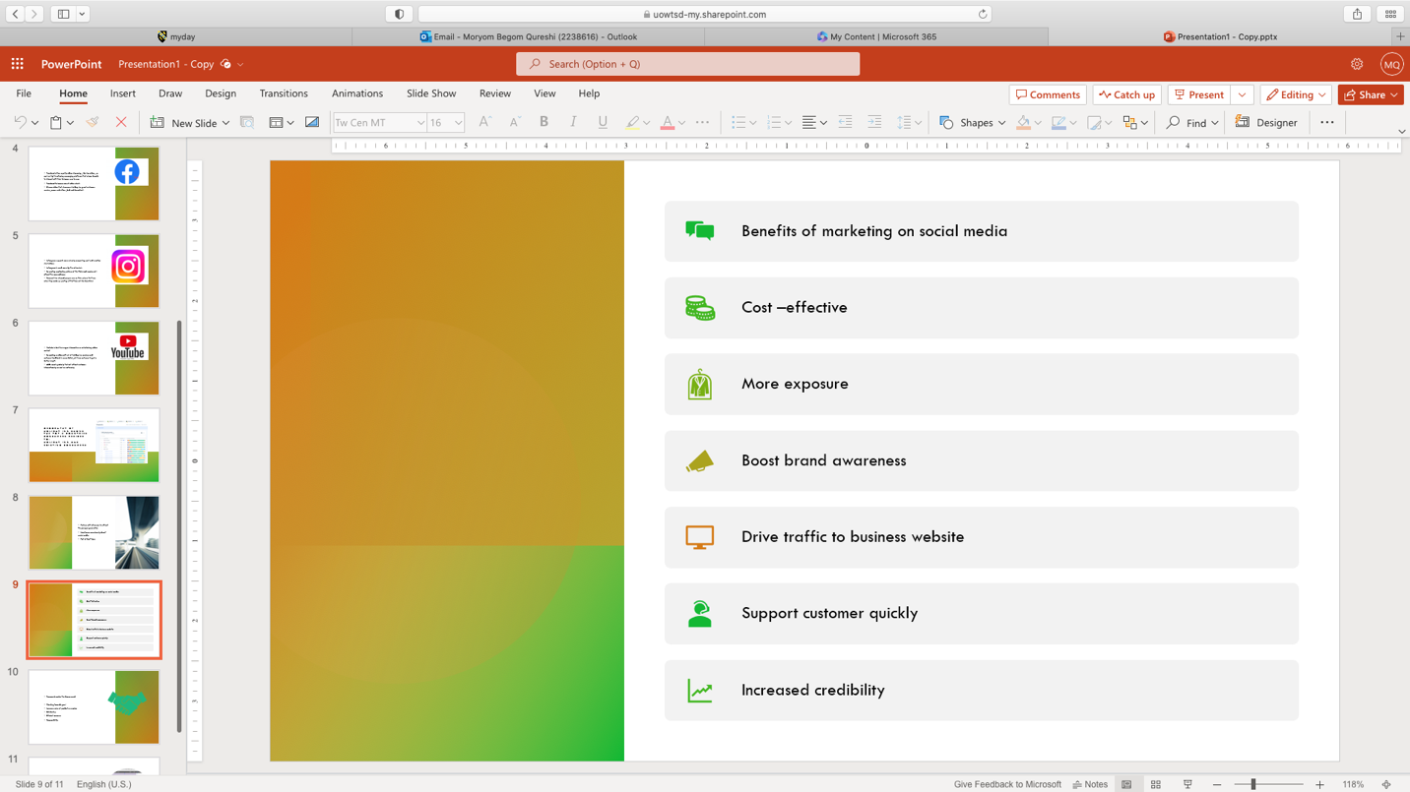

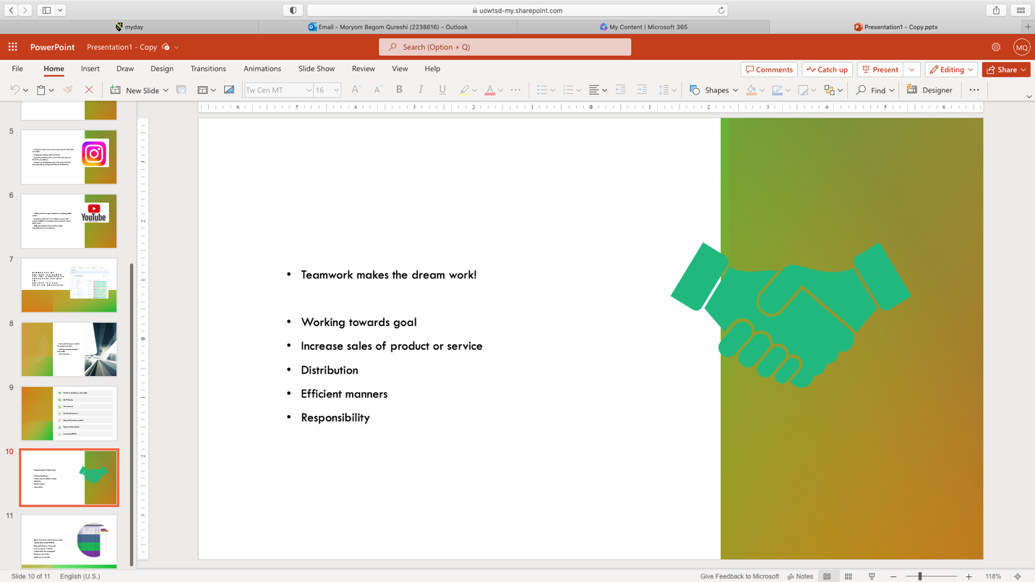

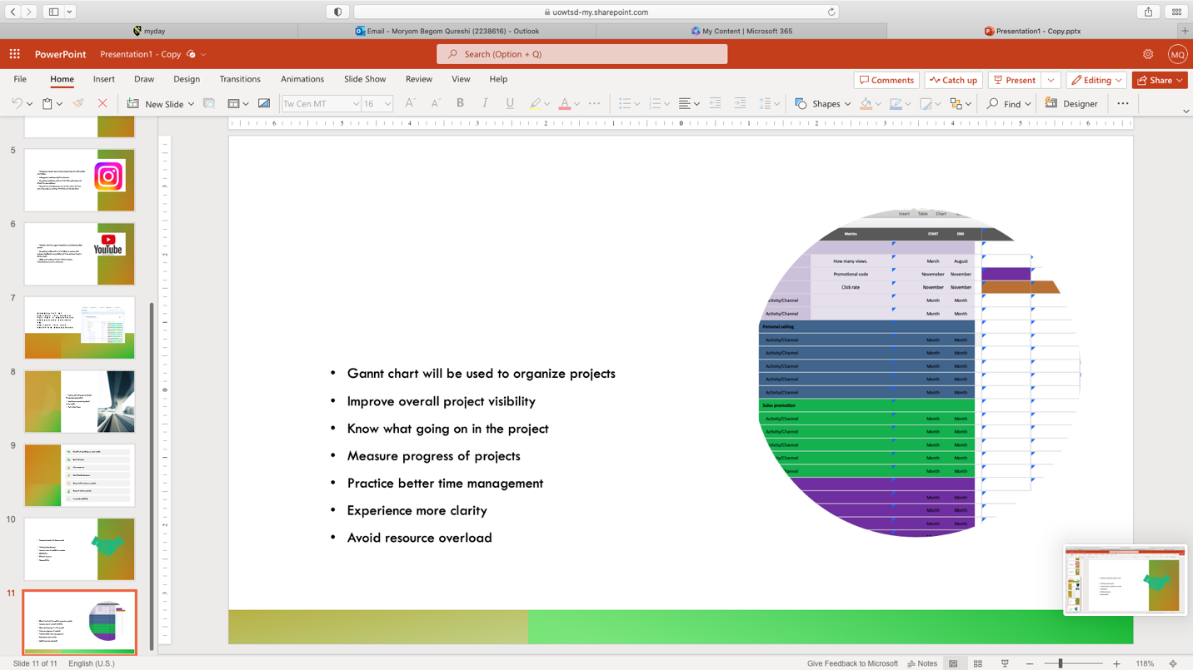

References: Ozuem, & Bowen, G. (2016). The Roles of Social Media Marketing and Brand Management in Global Marketing. In Competitive Social Media Marketing Strategies (pp. 173–200). IGI Global. https://doi.org/10.4018/978-1-4666-9776-8.ch009
Wilson Ozuem, Bibi Nafiisah Mulloo
This new phenomenon has impacted on the purchasing behaviour of consumers in the clothing sector as well, who are increasingly adopting this new shopping medium. This emerging trend has resulted in all major clothing retailers working to gain online presence with a view to achieving a stronger customer relationship and sustaining a strong presence in the clothing industry which is becoming highly competitive (Keynote, 2009).

Fotis John, Dimitrios Buhalis, Nicos RossidesDuring the last years social media have been enjoying a phenomenal success: Facebook, a social networking website, claims that its active users reached more than 500 million worldwide, 50% of which log in every day (Facebook, 2010); Twitter, a micro-blogging website hosts 175 million users who post 95 million tweets per day (Twitter, 2010); YouTube exceeds 200 million views on a daily basis from mobile devices only (YouTube, 2011); and at the same time it is estimated that there are over 150 million blogs worldwide (BlogPulse, http://www.blogpulse.com). With a participation of such a volume, social media constitute significant networks of consumer knowledge that influence consumer behaviour (De Valck, Van Bruggen, & Wierenga, 2009), and “further complicate the time-honoured textbook buying behaviour process described in the Inputs-Processing-Response model” (Constantinides & Fountain, 2008, p. 239). Moreover, social media start replacing commercial sources of information and evidence limited replacement of reference groups (Jepsen, 2006).

Fotis John, Dimitrios Buhalis, Nicos Rossides
To describe exposure to and role of social media during the holiday planning process, respondents were requested to think back (a) before their departure to their last holiday, (b) during their last holiday, and (c) after their last holiday. For each of these three holiday planning stages, respondents were asked (with multiple response questions) in which instances they visited or used any social media websites.

Harris Wilson Lipschult Media Influence: Breakthroughs in Research and Practice
For journalists, broadcasters, public relations practitioners, advertisers and marketers social networks offer new tools for reaching audience members. At the same time, social networks have activated some audience members to interact with each other, traditional media and organizational representatives. This chapter will explain the growing interest in social network visualization and the movement toward real-time data analysis to inform social media engagement, influence and trust.

