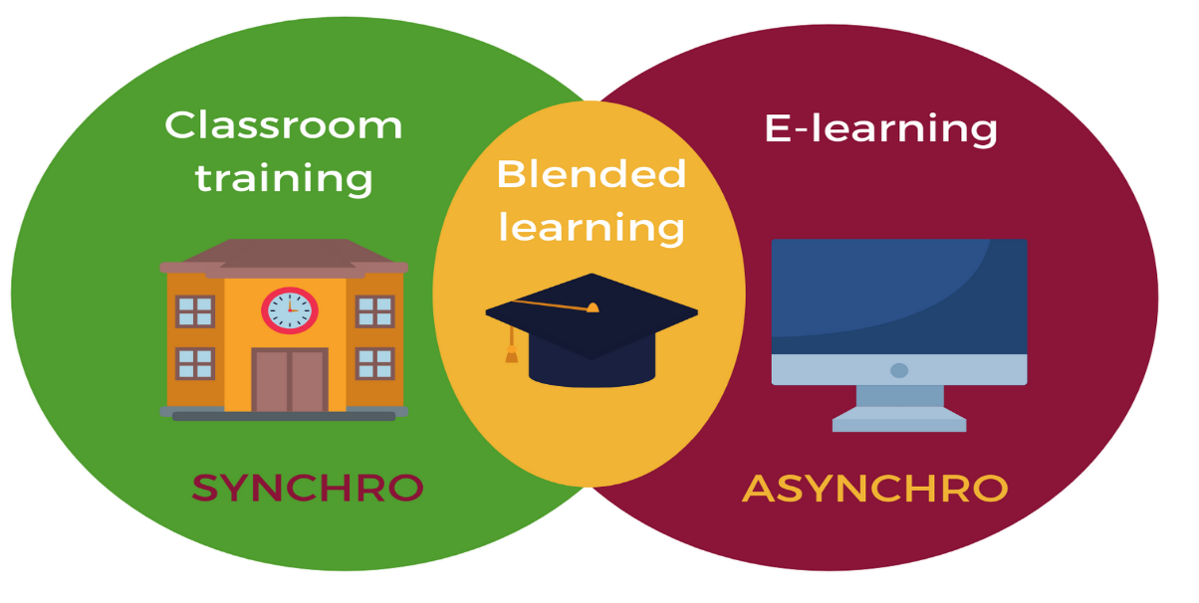
Evaluation of blended learning and class room learning on student attainment
Module | ACADEMIC & EMPLOYABILITY SKILLS
Module code | BMSK4001_BIRM
Student Name | ERHAN VITALIE
Student ID | 2111917
Lecturer

TABLE OF CONTENT:
INTRODUCTION:____________________________________________________2
1.What is Blended Learning____________________________________________4
2.Benfits of Blended Learning___________________________________________4
3.Advantege of blended learning_________________________________________4
4.Disadvantage of blended learning_______________________________________6
5.Types of blended learning_____________________________________________6
6.Blended learning examples____________________________________________7
7.Advantage of traditional learning________________________________________9
7.1..Disadvantage of traditional learning___________________________________9
8. Evaluation of both forms of teaching and learning in the past and present.
Support your arguments using evidence and examples.________________________10
9.Conclusion__________________________________________________________11
10.References_________________________________________________________12

INTRODUCTION
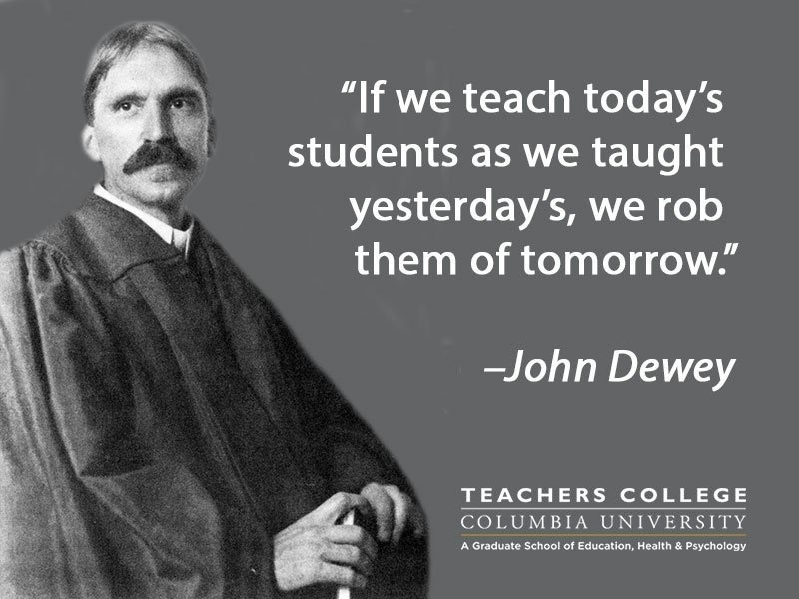
Modeling the educational process based on blended learning technology allows for a better and more systematic performance of the tasks set by the Federal State Educational Standard, namely, to enable students to independently assimilate new knowledge, including the organization of development, that is, to form educational skills. The introduction of a new generation federal state educational standard has brought the use of information and communication technologies by educational process articles to the level of metasubject of metasubject evaluations that permeate teaching aids not only to update the education system in accordance with modern trends in the development of the information society, but also to increase the efficiency of solving various pedagogical problems. Any technology without understanding “what we are using it for” runs the risk of being useless, not meeting the expectations of both the teacher and the student.
We live in a time of a rapidly changing world, the era of information technology, where the teacher is not so much a source of knowledge as a guide to it. Therefore, the teacher of the XXI century should not only have knowledge in the field of ICT, but also be a specialist in their effective application in their professional activities. Modern children can find information in a matter of minutes, and if the teacher continues to teach in the same way as he did yesterday, he becomes uninteresting to them. The challenges of time require the teacher to use new tools and methods for constructing new teaching models.

1.What is Blended Learning
Blended teaching is a complex format that consolidates different types of learning: for example, face-to-face training in classrooms, laboratories and online learning, or self-study and online learning. The curriculum, thanks to the presence of online components, is free from many unnecessary routine actions (for example, giving homework to students - everything is automated as much as possible). And in this regard, it is easy to compare it with a hybrid car, which has two engines: one is a classic internal combustion engine and the other is electric.

2.Benfits of Blended Learning
Blended learning provides real benefits to HEIs when implemented as part of a complete digital strategy that includes the development of 'modern electronic literacies,' such as highly qualified faculty, the development of critical 21st-century skills for students, and improved job prospects for graduates. This flexibility is likely to improve with the introduction of smartphones devices and a fuller understanding of'm-learning' methodologies.
There are various pedagogical and economic benefits to 'unbundling' education into informal and digital contexts. Students can interact with their peers, teachers, and academic subjects in new ways thanks to the innovative use of technology.
3.The advantage of blended learning
Students can select the type of content with which they want to interact, how they practise what they learn, and how they interact with instructors and other students at any time and on any device.
The success of blended learning is due to five major advantages:

Blended learning accommodates all types of learners, whether they prefer a familiar traditional classroom setting, prefer to study online, or want to try a combination of the two. Feedback and Learning Trends

Blended learning employs both online and offline technologies to enable educators to quickly incorporate the most recent trends and teaching methods into the curriculum.
4.Disadvantages of Blended Learning
Despite the fact that the internet is becoming more widely available, thousands of more disadvantaged students face serious barriers to accessing it – some even in educational settings.
From the perspective of an educator, it has become clear that providing clear and concise feedback when electronic media is used, as opposed to the traditional approach of written work, can be more time consuming. Another dilemma of blended learning is group work, which is characterised by the difficulties of managing such tasks in an online environment.
The first critical issue with blended learning is IT Literacy, which is especially important for students who are attempting to access course materials with a poor internet connection or an outdated device.
5.Types of Blended Learning
1) Station Rotation Blended Learning
Educators can work with small student groups
2) Lab Rotation Blended Learning
Flexible scheduling arrangements for teachers and students
3) Flipped Classroom Blended Learning
No need to adjust the classroom to suit the learning model
4) Mastery-based Blended Learning
Being able to show development and demonstration at an individual pace
5) Supplemental Blended Learning
Enriches interaction: permits online collaboration to deepen class-time activity
6) Outside-in Blended Learning
Allows traditional teaching methods to be consumed in external places
7) Self-Directed Blended Learning
Students get to choose how and what they learn
8) Individual Rotation Blended Learning
Student learning schedules can be customised

6.Blended learning examples
Speaking of the way the college makes use of the web surroundings to create a non-stop gaining knowledge of enjoy and produce the campus, simulation environments and expert exercise places together, he comments:
“In our healthcare technology course, gaining knowledge of takes region via a completely unique aggregate of observe weeks, administrative center training, and in particular tailor-made and interactive on line gaining knowledge of sources and stay far off lectures. ”
Example 2: Blended Learning at Leeds City College
Steven Hope is era-more desirable gaining knowledge of supervisor at Leeds City College.
“Students decorate their paintings-primarily based totally competencies for the duration of on-the-process training, that's primarily based totally on the ideal expert competencies.
Example 3: Blended Learning on the University of the West of England (UWE)
Manuel Frutos-Perez is head of virtual gaining knowledge of at UWE, and has been concerned in rolling out mixed gaining knowledge of throughout various courses. Discussing his reports of the use of era to gain the gaining knowledge of consequences of students, he comments:
“I modelled the mixed method to trainees with the aid of using tasking them to paintings in pairs on an `applied` activity, wherein they analysed various technologies ”
Example 4: Blended Learning at University Of Derby
Dan Williams is lecturer and appearing programme chief for the post-14 PGCE on the University of Derby, and makes use of mixed mastering as a part of his course. The solution changed into a mixed-mastering technique wherein our graduates could do 30% idea withinside the school room and the use of virtual technology, with the relaxation of the time spent on making use of the expertise they have been gaining direct directly to sensible situations. These are very useful as they permit the time in conventional lecture rooms to consciousness on extending the rookies` expertise and to assist them in accomplishing the better tiers of mastering consisting of analysing and evaluating. He comments:
Example 5: Blended Learning at Coventry University
“The mixed technique offers university team of workers the capacity so one can create flipped sports which rookies can whole pre- and post-lesson to advantage expertise of topics.
Carl Perrin is director of superior production and engineering (AME), an corporation that changed into installation as a collaboration among Coventry University and Unipart Manufacturing to encourage the subsequent technology of engineers. They were the use of Google as a part of their mixed mastering delivery, and he believes this has helped to growth college students` expertise of the challenge they're reading. The work-primarily based totally education is augmented with mixed mastering to make sure expertise and to allow college students to use this expertise in practice. This worried the of of entirety of a Google document, wherein every learner may want to critique peer examples and propose methods wherein the idea is probably higher implemented to assist rookies.
“We accept as true with that after AME college students go away us they're three hundred and sixty five days beforehand in their peers, regardless of reading for the identical period of time. Here, he describes how the scholars have benefited from the use of mixed mastering:
“Graduate engineers have been simply now no longer industry-geared up and that changed into inflicting a large trouble for employers.

7.Advantage of traditional learning
Regular attendance in classes, interaction between learners and lecturers inside their own group discussion, maintaining discipline by adhering to a schedule on campus, and improving the student's fitness and mental alertness are all advantages of a regular education procedure.
Lecturers can use the method to get to know their students on a more personal level, allowing them to assess their students' strengths and weaknesses and guide them toward better opportunities. Lecturers interact in traditional classroom training by raising their hands, asking questions, discussing a specific topic, giving a presentation, and so on. Participants can also directly speak to the professor and have their questions answered at the appropriate time. Students must plan their regular classes according to the schedule and follow the attendance policy.Traditional learning has the following advantages:
Experiment with various campus activities:
Teaching method provides a variety of experiences, as well as clubs, sports activities, communal activities, live seminars, live presentations, and eating in canteens, and many others.
7.1.Cons of Traditional Learning:
Expensive: Get facilities for different activities: Scheduled Favoritism Extracurricular Activities distort students
Negative Groups

8. Evaluation of blending learning and traditional teaching in the past and present

Blended learning is frequently linked to learners' instructional needs, allowing them to access the most current sources of information and best practises in education and pedagogy at their own pace and convenience ( HP Development Company, 2016Blended Learning Difficulties and Limitations Because it combines traditional classroom and online training, blended learning introduces a level of complexity in terms of learning contexts, learning design(s), and student [learning styles] (Garrison & Kanuka, 2004). According to the report, 66 percent of hybrid [blended] learners completed at least one level in 2009-2010, compared to 53 percent for distance and traditional classroom learners combined; in 2010-2011, 76 percent of hybrid learners completed at least one level, compared to 60 percent for distance and traditional classroom learners combined. In 2011-2012, hybrid participants "continued to have the highest completion rate (73 percent), but for the first time, distance students outperformed traditional classroom students."

9.Conclusion.
Blended learning, according to both groups of respondents, explains their learning activities, allows students to apply their learning skills and knowledge, makes it easier for them to handle and utilise learning resources, and helps them to review their learning results.
The major challenge of blended learning in this study confirmed to be a lack of formal university support, a lack of advanced technology and university policy guidelines, the integrity of learning tools and knowledge, and time management. They discovered that [blended learning] enhances collaborative learning chances in terms of pairing sharing, group learning, learning from others, and assisting others in the learning process. According to Singh and Reed (2001), today's technology improve students' academic performance, and the goal of blended learning, also known as technology-led learning, is to maximise students' learning success. Academics and students at the university confirmed that they use blended learning.

10. References

Andreeva N.V., Rozhdestvenskaya L.V., Yarmakhov B.B. The school's step into blended learning. - M .: Buki Vedi, 2016.

Carman, J. M. (2005). Blended Learning Design : Five Key Ingredients. Blended Learning Design: 5 Key Ingredients, (August), 1–10. https://doi.org/10.1109/CSSE.2008.198.
https://edtechnology.co.uk/latest-news/ultimate-guide-to-blended-learning/
https://pinlearn.com/traditional-learning-vs-online-learning/
https://www.ispring.ru/elearning-insights/chto-takoe-smeshannoe-obuchenie
John Dewey, Democracy and Education, New York: Macmillan Company, 1944, p. 167.
Larry Bielawski David Metcalf Blended eLearning: Integrating Knowledge, Performance, Support, and Online Learning, 2003 by HRD Press
Singh, H., & Reed, C. (2001). A white paper: Achieving success with blended learning. Centra Software, (March), 1–11. https://doi.org/10.1.1.114.821.
Stacey, E., & Gerbic, P. (2009). Effective Blended Learning Practices: Evidence-Based Perspectives. ICT-Facilitated Education, Information Science Reference, (November), 2–4.

