Report

Ideation:
Ideation:
Our new product ideas are classic gaming platforms capable of running arcade games. These platforms in question are classic arcade cabinets and plug and play consoles.

Illustration:
Below is the labelled illustration of the arcade cabinet along plug and play console.
The consoles use a raspberry pis, which would be pre-programmed with classic arcade games, although, in the case of the cabinets, this could be exchanged for a custom pc if the user wished to play games which would require some extra processing power. The consoles could be visually customized as per the customers wishes, this could include classic arcade prints or perhaps even LEDs.

Cabinet:
The cabinet itself is made of plywood. It is equipped with a monitor to display the games and a controls panel (equipped with a joystick and some buttons). Some machines may also have a coin slot which, when used, would grant the user access to play the games. We believe that these coin slots would make the consoles a lot more desirable for arcade owners who may wish to furnish an arcade with our products.
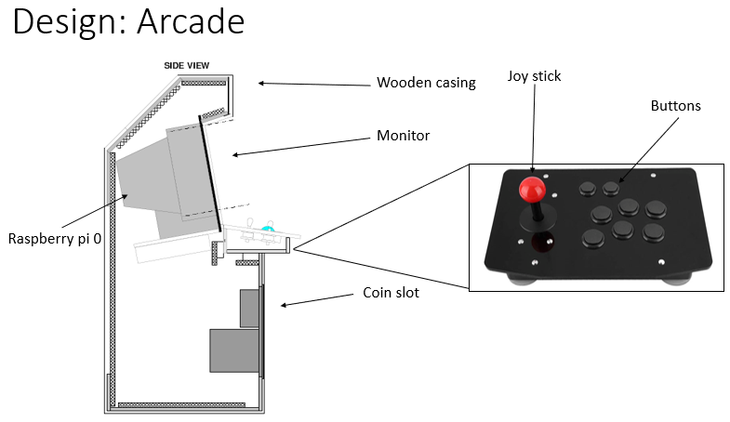

Plug n play:
The plug n play console has a much simpler design. Its casing is a simple plastic box which has a joystick and some buttons on its top along with some ports on its side (USB for the raspberry pi and HDMI for connecting the console to a tv).
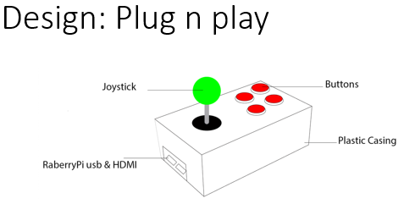

Design:
Requirements:
When first designing 1 UP GAMES’ arcade machines, we had a pretty good idea of what they required:
- A monitor capable of displaying these games with relatively high quality
- A computer capable of running these games relatively smoothly
- Access to emulators capable of run classic arcade games
- A joystick
- Some button
- HDMI ports and cables
- A cabinet with room for all other components
And for the plug and play console:
- A computer capable of running these games relatively smoothly
- Access to emulators capable of run classic arcade games
- A joystick
- Some button
- USB ports and cables
- HDMI ports and cables
- A small plastic box with room for all other components

MVP (Minimal Viable Products):
The MVP of these products would be versions yielding only a hand full of games and lacking non-essentials, such as artwork on cases.
The MVP will offer to a small number of potential customers pre-release in order to gather information on user behaviour such as: the amount of time spent using the device, time spent playing certain games and the frequency using the device over the time period.
This will help greatly as it will help find out whether or not customer would like to buy the product or whether certain changes should be made or indeed, whether the entire thing should just be scrapped.
This method of data gathering is far more useful than simply using questionnaires or market research to develop an understanding on whether a product is marketable or not.

Design documentation:
Arcade cabinets components:
- Rassberry pi 3b+
- Arcade buttons and joystick
- Cabinet made of plywood (1828mm x 750mm x 800mm)
- Monitor 18”
- HDMI ports and cables

Plug and play components:
- A plastic container 158 x 90 x 60 mm
- Rassberry pi 3b+
- Arcade buttons and joystick
- USB ports and cables
- HDMI ports and cables

Differentiation:
The main differences between 1 UP GAMES’ products and those of our competitors are that our products are estimated to much more cost effective, with our cabinets estimated to cost around £200 and the cheapest competitors product retailing at £699 and our plug and play consoles estimated to cost around £70 and the cheapest competitors product retailing at £95.

Moreover, after some research, it seems our plug and play consoles are the only ones on the market which run classic arcade games. Would really help our product stand out from any of our competitors.

Development:
Prototype (plug and play):
As a team, we decided to create a prototype of a plug and play console in order to showcase the company’s products. The prototype consists of a raspberry pi connected to a joystick and some buttons (for the purpose of the prototype, the box of the product will not be implemented as only functional pieces of the design will be utilized).
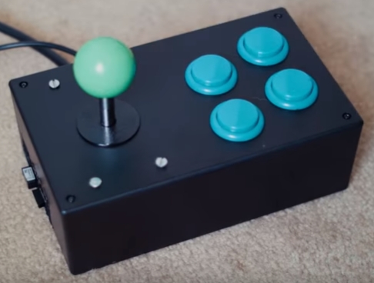

Key features:
The key features of this console are that:
- It is small and light (meaning it can be transported easily).
- Easy to operate (must simply be plug into a TV).
- Can be preprogramed with multiple games.

Management & operations:
Team working methods:
Discord:
As a class, we often discussed our objectives in lectures and helped each other with our individual segments. This proved such a help that we decided to create a discord chat in order to carry on helping each other outside of lecture.
This proved to be highly effective, especially as there was a lot of time in the week that we did not spend in class together.
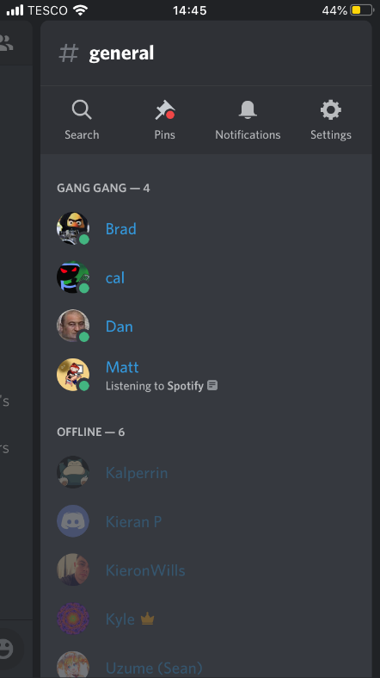
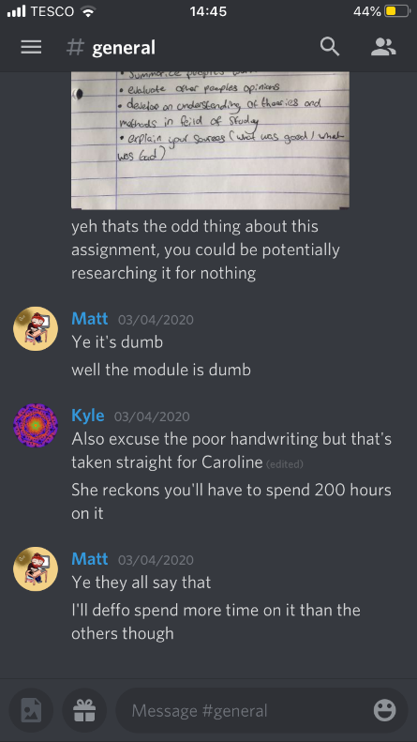
Gantt chart:
From the beginning of this project we knew that we would have to break our objective down into smaller, more manageable segments. As a team we then assigned ourselves with the completion of certain tasks and used a Gantt chart to plan who would do what, when the tasks should be completed and to update our progress on each task going forward.
This was a very productive aid to our progress and ensured that our aims were completed on time.

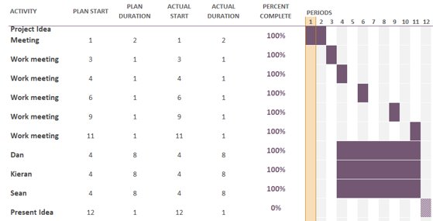

Necessary skills:
In order to complete this task in a compresences manner certain were required, they are as follows:
Team working:
As with any group project, the ability to work well with others is of paramount importance as one may find themselves arguing with other team members in which case, they would all have to exercise compromise.

Skills gaps:
Skill gaps can seriously hinder the progress of a project. Here are some that we ran into:
Time management:
In that case of long-term problems, such as what we faced, time management is key. Sadly, as a group we found that we had great difficulty with this skill and found ourselves making next to no progress.

How to solve:
We later decided to create a Gantt chart (as mentioned above) to aid planning. This was an enormous help to our team’s productivity and moral.

Are business premises required?
No. Given today’s technologies, it is possible to conduct any and all team meetings via group chats of video call software.

How will the team collaborate moving forward?
If, as a team, we decide to proceed with this project going forward then we would likely not change much. I believe that each member of the team carried out their given tasks with great efficiency and that the quality of the end product exhibited their diligent work.

Are any IT/production facilities needed?
Yes. As 1 UP GAMES produces physical products, we will require premises for the construction of said consoles.

Code of conduct?
Yes, 1 UP GAMES would have a code of conduct, not only to make sure that the business runs smoothly but to ensure that any and all employees of the business are treated fairly and ethically.

Appendix:

Reflection:
Technical and Employability skill:
Team working:
The main skill that I developed by completing this task was team working. The ability to compromise aided us greatly when discussing amongst ourselves about who should do which task and I am sure that it will proceed to do so in the future.

Networking:
Neither I nor any of my teammates attended any relevant industry networking events.

Team-working:
The following image depicts the gantt chart, which was used, by the team, to track our progress over the course of the project:

