
Analyis of power generation cycles & application of compression – vapour cycle

July 31, 2022
University of Wales Trinity Saint David

Contents
Part B Gas Turbines and Steam Turbines 2
Part C Vapour-compression cycle 4
Bibliography 7

7) Explanation: -
An ideal heat engine is an engine that can convert its entire heat energy into work done without any losses. This means by conservation of energy no heat is given to the sink. The efficiency of said engine is defined by the ratio between how much work done is achieved by the amount of heat the engine took as input. The second law of thermodynamics dictates the amount of work that the changing temperatures in a heat engine can produce.

Part B Gas Turbines and Steam Turbines
Steam, gas, and combined cycle turbine plants currently generate a major segment of energy consumed within the modern world. Due to the popularity of the plants, the efficiency of these plants is key to generating the maximum amount of energy possible. This is not an easy task for anyone as there are so many factors to consider. Steam turbines use high thermodynamical efficiency to reach the maximum temperate of steam, but these values are relatively low values of this maximum temperature. Gas turbines are similar, but these plants use high values of the maximum temperature of working substance, but the exhaust gas exerted is a much higher temperature which would mean that the temperature meets a high average of heat removal within the cycle. These cycles concerning both plants of gas to steam cause massive losses of efficiency due to the irreversibility of heat transfer processes. A A Vasserman and M A Shutenko (2017)
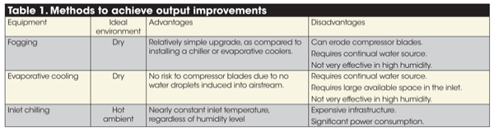
There are several ways in creating a more efficient system when talking about steam and gas systems. One of which would be inlet conditioning. This is the method of reducing the inlet air temperature. There are three main methods of achieving this which would consist of either fogging, evaporative cooling, and chilling. The Pros and cons of these three methods can be seen in the below table. International (2013)
Figure 1 Inlet Cooling Table
As seen in table 1 on the previous page these pieces of equipment can the chosen depending on what the plant is trying to achieve.
Fogging involves injecting atomized water into the air steam of the inlet system, downstream of the inlet filters. This system also controls the amount of water injected into the system to make sure that no large droplets are ingested into the downstream compressor. This can be seen in the diagram in figure 2. It can be seen in figure 3 the location of the water pump that is installed on the system after the steam condenser
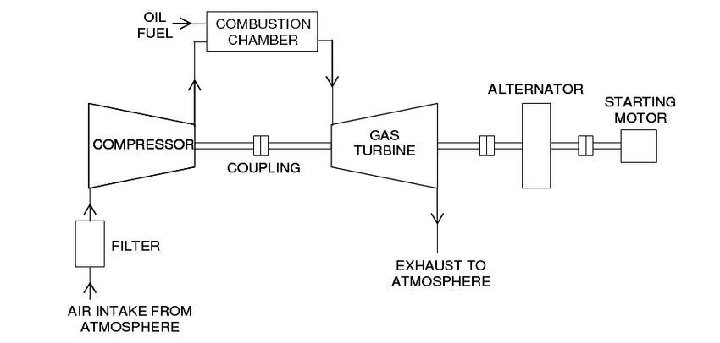

Figure 2 Gas Turbine Power Plat Diagram
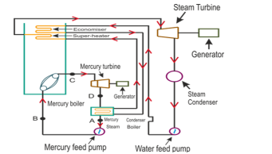
Evaporative cooling equipment would need to be installed in the inlet ducting after the filtration system. This equipment would consist of a media bank in the air stream which will consistently deposit water by one or more water pumps. This functions by air passing through the media bank and cooling the air as it passes through by absorbing the moisture in the air and creating denser and cooler air. When this denser air enters the turbine, it results in improved efficiency.
Figure 3 Water feed Pump Diagram
The last option would be to chill the inlet air stream which proves to be a very effective way of increasing the air density. The chiller would need to be a sizeable mechanical refrigeration unit that will be adjusted to inject cold air at a controlled temperature into the compressor. This option is preferred in high-humidity countries so they can dictate the air temperature.
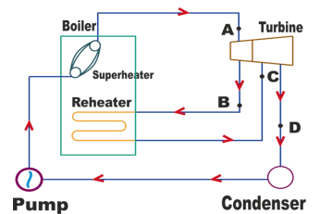
Another way of improving efficiency of a steam turbine plant is by recycling superheated air that is passed through the turbine. This can be done by adding a reheater stream after the turbine. Without the reheater the air would be in a wet condition due to a large temperature drop which is not good for the turbine, this reduces erosion and internal loss of the turbine. This problem would be solved by using the extra heater to reheat the exerted air and heating it back up to the correct temperature to be taken back through the turbine. This can be seen in figure 3. As can be seen by doing this it will increase the work done by the singular turbine and also reduce the erosion and the internal loss of the turbine due to the increase in the dryness of the steam within the exhaust.
Figure 4 Reheating Cycle

Part C Vapour-compression cycle

The vapour compression cycle is used predominately within air conditioning units all round the world. The cycle incorporates fluids that are used as a medium in the vapour compression refrigeration cycle, the fluid is commonly used in a vapour state. This cycle is designed to lower the temperature within a closed system lower than the normal temperature. The system rejects an excess amount of heat within the closed system and then deposits the excess heat out into the exterior environment. The vapour compression cycle is made up of a selection of components which can be seen below: Process Solutions (2020)
- Refrigerant Compressor
- Liquid Compressor
- Liquid Receiver
- Evaporator Valve
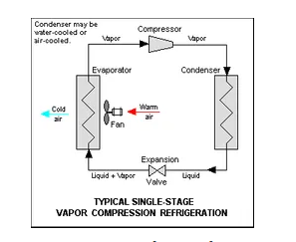
The cycle works by using four main steps to function, these include compression, condensation throttling, and evaporation. Compression of the refrigerant vapour is compressed isentropically using the compressor in the system. The pressure then rises from P1 to P2 and temperatures rise from T1 to T2. The total work done per KG during this process can then be worked out using a simple formula shown below.
Figure 5 Vapour Cycle
W= H2 – H1
H1= The amount of enthalpy of the vapour compression cycle in temperature T1 at the step of the compressor's suction.
H2= The amount of enthalpy of vapor compression cycle in temperature T2, at the step of the discharge of the compressor.
Banerjee (2014)
The refrigerant within the system contained in the vapour compression cycle is then passed through the compressor through the condenser at high temperatures and pressures. This is called condensation, after the condenser the vapour is then completely condensed which then changes the state of the refrigerant from a vapour to a liquid.
After this process, a process called throttling is carried out. This is when the high temperature and high-pressure refrigerant is expanded. At this time the expansion valve stays at a low temperature and low pressure. A small amount of the refrigerant is then evaporated by the expansion valve and then a large amount of the liquid is then vaporised by the evaporator with the system. This is a reversible adiabatic expansion process.
Evaporation of the mixture of vapour and liquid then takes place which turns it into vapour refrigerant. When the evaporation process takes place, the refrigerant absorbs the latent head left which leaves it in a cool state. This is called the refrigerating effect. The full cycle can be seen in figure 5 above.
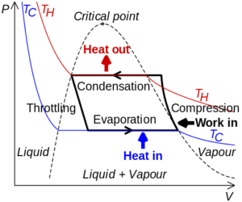
The refrigeration cycle works closely with heat pumps within the system also. The pumps do not contribute anything to the cycle in terms of changing the state of the liquid or gas within the system, but it does distribute the mass. The heat pumps operate by moving heat from lower-temperature areas to areas higher temperature areas. These pumps take advantage of electrically driven compressors and closed vapour compression cycles. As can be seen in figure 6 the heat pump would be able to use most of the refrigeration equipment and therefore can be classified as a heat pump, but the term is typically reserved for equipment that provides useful heat.
Figure 6 Vapour Cycle Diagram
Butbul (2022)
Finally, the heat pump performance can be measured, this is called the coefficient of performance (COP) for a heat pump. The COP is a ratio of the heating capacity of the total power unit. For example, If you take a heat pump with a 2.5 COP it would mean that you would generate 2.5 KW of heating capacity by using 1KW of electrical power. You can work this out using the formula below:
COP = Q / W
Q meaning heat that has been taken away from a cold reservoir and W meaning work done.
Using the second law of thermodynamics you can see the COP values for an ideal heat pump. Meyer (2011)
COP_{heat pump} = T_{hot}/(T_{hot}-T_{cold})
T_{hot} is hot temperatures we want to have during cold winters
T_{cold} is the cold temperature at which the heat pump starts to operate
Using this formula above the COP for any heat pump can be worked out. Users can then determine how much energy is required to run the heat pump to achieve a specific temperature.
For refrigeration, it is slightly different but the same theory. Using the first law of thermodynamics we can conclude the Carnot COP for cooling devices
COP_{cooling}= T_{cold}/(T_{hot}-T_{cold})
T_{cold} is the chill temperature you would like your room to be at. T_{hot} is the outside room temperature. Using this COP value you can then deduce which unit is the most efficient for the application required. Learnmetrics (2020)

Bibliography

A A Vasserman and M A Shutenko 2017 J. Phys.: Conf. Ser. 891 012248
International, Power Engineering. “Gas Turbines: How to Improve Operability, Output and Efficiency.” Power Engineering International, 1 Mar. 2010, www.powerengineeringint.com/coal-fired/equipment-coal-fired/gas-turbines-how-to-improve-operability-output-and-efficiency/#:~:text=IMPROVING%20OUTPUT&text=Inlet%20conditioning%20%E2%80%9D%20reducing%20the%20inlet. Accessed 7 Jan. 2023.
Banerjee, Indrani. “Vapor Compression Refrigeration Cycle: What, Diagram, Efficiency, Working, Steps.” Lambda Geeks, 2014, lambdageeks.com/vapor-compression-refrigeration-cycle/#compressor. Accessed 8 Jan. 2023.
Butbul, Yoni. “Heat Pump Cycle Fundamentals | Engineered Systems Magazine.” Www.esmagazine.com, 22 July 2022, www.esmagazine.com/articles/102492-heat-pump-cycle-fundamentals. Accessed 8 Jan. 2023.
learnmetrics. “Coefficient of Performance (COP) of Heat Pumps (Heating/Cooling).” LearnMetrics, 5 Apr. 2020, learnmetrics.com/coefficient-of-performance/.
Meyer, Josua Petrus. HEAT PUMPS. Www.thermopedia.com, Begel House Inc., 14 Feb. 2011, www.thermopedia.com/content/837/.
Process Solutions. “How Does a Compression Refrigeration System Work?” Process Solutions, Inc., 1 July 2020, processsolutions.com/how-does-a-compression-refrigeration-system-work/.

