
professional career development
March 29, 2018
University of Wales Trinity Saint David



Fulmodina Hannan - 1709529
Executive Summary

The reason of writing this essay is to reflect back on the learning journey to show the understanding of relevant skills and knowledge leant throughout the module. The researcher needed to demonstrate knowledge and understanding of the whole process. This easy has helped develop to reflect on what been learnt in the class and gave an opportunity to research further on preferred learning styles. Furthermore, it is very important to know the recruitment process to recruit a suitable employee for the organisation. This procedure allowed demonstrating and understanding the key points in the recruitment process.

Table of Contents

Executive Summary 1
Introduction………………………………………………………………………………………………………………………………………3
Findings……………………………………………………………………………………………………………………………………………..4
Conclusions and Recommendations…………………………………………………………………………………………………14
Appendices………………………………………………………………………………………………………………………………………15
References/Bibliography………………………………………………………………………………………………………………….23

Introduction

According to Holmes (2011) Professional Career Development is very important for career success. It is the starting process of career planning and development. It undertakes career exploration, considerate self-assessment, and planning an initial employment plan of action. It is an ongoing procedure towards a fulfilling and rewarding career. This module is very interesting, challenging and enjoyable. It will support to achieve a professional career and direct into a long-term career goals. Professional Career Development can supply a numerous of opportunities to attract own interests, values and skills. This will help to develop skills and qualities to allow being highly successful in the workplace. It will initiate a variation of career choices with a large numbers of opportunities to learn and practice in an appropriate and proficient way. It is a lifelong career planning academic activity, which engages in a thoughtful and professional learning process. In order to be successful , it is advised by Kihn (2018) to take charge of own career, and act to shape it up so that it is reaching the right direction that has been set out for. To be able to achieve this, it is encourage to plan in advance to see the results. The capability to satisfy aims and the need to self assess.
According to Wilson (2005) the realisation of a person’s ability is through conscious or unconscious learning which allow to broadened skills and knowledge whilst also enabling movement to next stage of a career. There are many skills needed which contribute to working effectively and being employment ready such as, communication skills, time management skills, problem solving skills, team working skills, interviewing skills, I.T. skills, interpersonal skills, decision making skills, organising and planning skills. According to Morgan (2017) these are the essential skills for being able for employment readiness. Being self-confident and feeling a sense of independence is when an employee can tell they are ready for employment.
Shindler (2011) highlights that the researcher has developed on these skills and knowledge by attending the lecture and through researching whilst also preparing for a presentation. This enhanced the researcher’s skills and knowledge on team working skills, as working with others has increased confidence as well as a gain in experience. It has helped to advance communication skills by encouraged talking in front of a large audience and leading to feel comfortable when presenting. By doing so, presentation has helped to grow organising and planning skills effectively. It has also provided the ability to make decisions and solve problems. Furthermore, conducting presentations have allowed improving and developing management skills. From this overall activity indicates the development of effective working as a potential learner.
According to Institute of Leadership and management (2007) there are numerous stages in a recruitment process. The recruiter firstly decides on what the actual job is thus attracting appropriate candidates for the required role. Next, they will analyse the candidate CV and cover letter before conducting personal interview to identify the correct candidate for the role. Finally, a letter is delivered to the chosen candidate for the role.

Findings
Honey and Mumford (1992)
According to Maund et at (2017) Peter Honey and Alan Mumford developed honey and Mumford (1992) learning styles and they identified that different people have innate learning preferences and their model of leaning styles link closely to each of the four stages, which are Activists, Reflectors, Theorists and Pragmatists.
On my learning journey for this module, I have done a Learning Style Questionnaire of Honey and Mumford. The purpose of this questionnaire is to find out the preferred learning styles. Fee (2011) state it has four learning styles, which are Reflector, Theorist, Pragmatist and Activist. The learning styles most suited to my styles is Reflector, Theorist and Pragmatist.
According to Wilson (2005) after completing Honey and Mumford (1992) questionnaire, my highest core was reflectors, second highest was theorist and third highest was pragmatist. This indicates my strengths and learning preferences situated on reflectors, theorist and pragmatist and weakest in activist.
Reflector: Strengths
According to Morgan (2017) as a reflector, I like to stand back and collect all the information together before coming to a conclusion or making any judgements. In a group discussion, I prefer to listen to others contribution before making my own views. I am cautious and thoughtful and I do not like jumping to conclusion. I am good at listening and assimilating information.
Theorist: Strengths
According to Shindler (2011) as a reflector, I would like fully understand the theory behind a subject before I feel comfortable with it. My strengths are I am logical, vertical, objective and systematic at what I do.
Pragmatist: Strengths
According to Morgan (2017) as a pragmatist, I want to see the practical use of what I am learning and want practical techniques. My strengths are I am practical, realistic and like to experiment new things out in practice. In addition, I am down to earth and like to get straight to the point.
Activist: Weaknesses
Activist is my weakest learning style. Maund et al (2017) puts forward to improve this learning style I will tackle problem by brainstorming, get into group discussion more often and seek to centre all the activities suited to me. However, I will be open to trying new things, as this will help me to adapt with most learning style.
VARK (1992)
Another model of learning style is VARK, which was, develop in the early 1990s by Fleming and Mills [1992]. Morgan [2017] highlights there are four types of learners, which are:
Visual: Visual learners, preference for seeing graphic display such as diagram, pictures, handouts, charts, illustrations and videos. These are the important learning tools for visual learners.
Auditory: Auditory learners learn best by hearing such as hearing a lecture, discussions, dialogue and music.
Reading/Writing: Reading and writing learners preference for reading books, writing notes, booklets, leaflets and very comfortable with displayed information in a text layout.
Kinaesthetic: Kinaesthetic learners preference for feeling, touching and doing such as practising skills, role play, experiments and anything hands-on.
Upon completing the VARK questionnaire, my preferred learning style revealed as Reading/Writing. Following from this my aims was to focus on reading/writing as a main source of learning in order to maximise my educational experience. Maund et al (2017) suggests to avoid from carried away with this model, it is hard not to identify that all these four learning styles are vital for effective learning as striving towards knowledge and experience.
Personal SWOT analysis
According to Holmes (2011) in order to plan career, Personal SWOT analysis is a great tool to assess an individual as well as apply it to find career growth opportunities. It can help to reduce weaknesses and manage to eliminate threats. It will also give ability to move forward in career and help to achieve personal goal. SWOT analysis stands for Strengths, Weaknesses, Opportunities and Threats.
Strengths
One of my strengths is group working. Pandya (2017) suggests I can work confidently within a group and I contribute my own ideas efficiently. I take my share of the responsibility as well as being assertive and can take constructive criticism. When others ask for feedback, I give positive and constructive feedback. Another strength is that I have is time management skills. The first thing I do before I start on a task is make a list. I set reminders on my phone, prioritise each task and plan accordingly. When it is time to set a deadline, I set my deadlines a few days before the task has to be completed. This allows if other things get in the way, but also still allow me to get the task done.
In addition to this, I also have another strength, which is reading skills. Holmes (2011) state I take time to immerse in reading, which allows me to learn new information and I can read for hours if the contents is interesting. When reading something that I do not understand, I will read it over and look up for certain words for my understanding. Furthermore, I like reflecting back on what I have read and take notes of new words. I enjoy any form of reading and find it relaxing.
My final strength is self-awareness. According to Shindler (2011) I have a sharp realisation of my personality such as strengths, weaknesses, thoughts, beliefs, emotion and motivation. Being self-aware helps me to spot my goals and emotions, which makes me recognise where my emotions and thoughts are leading me. Moreover, being self-awareness gives me a clear understanding of myself. I feel my thoughts and emotions guide me to take control of my actions. In the night, I take some time to write about my thoughts, feelings, successes and failures of the day. I often find a quiet place to reflect on myself as a person and practice on breathing meditation. This helps me to question myself as what I am working towards, what are my goals and how am I going to achieve it.
Almost all jobs in these days require some basic knowledge of I.T skills. Most employers expect the employees to have good an understanding of this skill. Knowing even the basic knowledge of I.T skill can put an employee in a better position in the workplace.
Weakness
My weakness is I.T skills. To do assignments and get a better job in the near future I will need to develop on this skill. Shindler (2011) suggests being able to improve on this skill, I will use online tools to learn and develop further while also getting support from the university. Furthermore, to be able to progress further on learning I.T skills I will have to find a relevant online course to help me strengthen my I.T skills.
Go M.A.D (2001)
Go M.A.D is a Thinking model, which is developed by Andy Gilbert and Ian Chakrovorty (2001).This model is use for panning possibilities, priorities, challenge and takes responsibility for the action.
- Reason why: I want to do this course for myself which will allow me to gain relevant skills and knowledge also it is an good opportunity to prove to myself that I can do this and become a role model for my children’s.
- Define goal: my dream is to open my own business on women’s party and casual wear boutique. I have a passion for designing my daughter’s clothes and mine in my spare time. In addition, I have desire to work in business industries. I enjoy working and liaising with people and the atmosphere of an office attract me the most.
- Plan and priorities: to be able to do this course I will need to priorities and plan ahead to do well. It is very important that I attend every lecture and take note to reflect back on learning log. In order complete the assignments correctly and effectively I will need to do lots of research and needs to work very hard and do extra work to get a good grade.
- Self-belief: I can do this course because I believe in hard working and very passionate to achieve the desired goal. I am hard working reliable and trustworthy. I also have a very friendly personality and I can work under pressure in any circumstances. My target is to complete this course with a good grade and hoping to get a better job in the future.
- Involve others: to be able to successfully complete this course I will involve my family to help with the moral support and encourage me all the way through. I will definitely need to involve my lecturers to assist and provide help to achieve my target goal. I will also need organisations to help gain work experience and finally I will need my peers support to build self- esteem and confidence.
- Personal responsibility: it is a big challenge for myself, after many years later going back to study, there for I will need to stay focus to be able to concentrate and do well. I Need to be motivated, flexible and be organised. Always have to think positive as this will help to minimise stress. As well as this, I will do lots of reading to help gain knowledge and work effectively with others.
- Take action and measure results: to be able to complete this course and gets graduated I will have to set targets and work very hard to achieve this. Furthermore, needs to complete the assignments before deadlines and get the assignments checked by the teachers before handing in and I need to take the action now.

Take the action and measure results
7
Work very hard and hand in assignment on time.
Get the assignments checked by lectures before handing in.
Need to take action now.

6
Personal 5
Responsibility involve others
Family.
Lecturers.
Organisation.
Peers.

Need to stay focused and be motivated. Do lots of reading. Think positive, and be flexible. Work with others. Gain experience. Challenge myself. Be organised.

3
Plan priorities
Attend to lectures.
Take notes.
Do research.
Complete assignments.
Need to do extra work and plan things ahead.

4
Self Believe
I can do this because I am very passionate to work with all different people. I have a very friendly personality and I can work under pressure. By doing the course, I can get a better job in the future.

1 2
Reason why Define Goal
I would like to setup my own business on women’s party and casual dress boutique. Alternatively, would like to get a job in business industries as a computer administrative.
I want to do this for myself, so I can prove to me that I can do it.

Personal Development Plan

Development Objective | Specific actions | Barriers and how they will be removed | Support required | How I will know when I have achieved the objective
- To understand I.T. Skills. | Need further developing. | Lack of knowledge regarding I.T. skills. Do lots of browsing in the computer, use online tools to learn I.T skills. | Get support from university. | Once I am able to apply the I.T. skills necessary to do my academic learning.
- To know Presentation Skills. | Practice and rehearse multiple times in front of a mirror, with a recorder or in front of a friend or peers. Watch videos of other people presentations and get some context. | Nerves and forgetfulness. To overcome this I will Build on self-confidence and follow the presentation structure.  Make plans and organise beforehand. | Using online resources and library and talk to the lecturers to get a better idea of the subject. Also research the topic thoroughly. | I will know when I have achieved this by lectures comment and how confident and relax I feel on delivering every presentation.
- To learn essay Writing. | To make a list of resources such as library books. Make a little timeline and plan the essay structure. | Find writing essay stressful due to lack of confidence in own ability. To improve this I will need to relax, have a positive and a constructive mind set. | Be patience, concentrate on reading lots of books and gather all the information together. Get support from lectures. | Once I start to feel positive, relax and feel confidence while writing the essay. Also get good feedback on work submission.

Recruitment Process

According to ILM (2007) the best way to recruit and hire successfully, the organisation will need to follow a required method for the recruitment process. It is a major part of an organisation to employ the suitable person for the business. Recruitment process should be productive as well as less waste of time and effort. It is important to make sure that the organisation is making the right choice over the recruiting candidate, as this can be costly and time consuming. In addition, it is a good idea to list all the skills, duties and responsibilities that is relevant to the job. The purpose of recruitment process is to identify candidates with relevant skills, experience, qualification and talent.

Job Title: Team Leader
Job Description:
- Lead and manage a team
- Awareness of Safety and deadlines
- Updated on team performance
- Engage the team to achieve goals
- Ensure smooth team work
- Effective collaboration
Job Responsibilities
- Manage and keep record of goods sales, instruct management on order when necessary.
- Encourage team members, communicating team goals and identifying areas of new training or skills.
- Serve management with hiring processes and new team member training.
- Answer team member questions and solve problems.
- Set deadline and sales goals to team members.
- Develop and promote team members adherence to company regulations and performance goals.
- Conduct team meeting to update members to practices and continue expectations.
- Produce and share comprehensive reports on team performance.
- Ensure company brand materials and physical working spaces meet and exceed company presentation standards.
- Supply quality customer service, interacting with customers, answering customer enquiries and handling customer complaints effectively.
Skills, Qualifications and Requirements
- Excellent leadership experience
- Excellent product knowledge
- Required industry experience
- Effective oral/written communication skills
- Self motivated
- Results oriented professional
- Advertising experience
- Excellent interviewing skills
- High level customer service skills
- Excellence I.T skills
- Excellence time management skills
- Excellence decision making and problem solving skills
- Masters degree Leadership and management
- Effective team working skills
- Motivation and dedication
Salary: £38,944 per annum
Permanent – full-time
Apply with CV along with Cover letter.
Application deadlines: 29th March 2018
Recruitment Advertisement
According to ILM (2007) The organisation needs to follow an advertising procedure to recruit applicants. There are many methods of job advertisement to recruit new people. Internet website is one of the popular meeting sources between employers and employees, such as, http//www. Indeed.co.uk, http//www.reed.co.uk, http//www.monster.co.uk and http//www.gumtree.com etcetera. Also social media is another popular platforms such as, twitter, facebook and linkedIn etcetera. As well as commercial recruitment agencies, executive search organisations, local or national newspapers, specialist publications, for example trade or professional journals, local schools, colleges, career service and job Centre Plus.
According to Wilson (2005) as well as decided where to advertise, the organisation now need to think about the advert itself. The advert needs to have the essential part of the job description, personal specification, salary, permanent, full-time, a brief description of the organisation, details about how to apply and by when. The advert can be short, as long as it is clear and easy to understand. However gender or culturally specific language in to be avoided and it should be non-discriminatory. To attract more applicants, maybe consider to include an equality clause and flexible working hours.
CV
According to Maund et al (2017) CV is a key document for job applications. It should immediately attract a good impression to the person who is reading it. The applicant should convert the information into the CV to the main points in the job advertisement. In addition to this applicant need to show how they are most suitable for this specific role and link it to the requirements role. The CV should contain a personal profile, summary of education, career history, competences and skills summary, additional training and skills, hobbies/interest and reference.
Personal profile
According to Bright et al (2015) personal profile is an introductory paragraph, which contains a short summary of background and career plans. This should link to the key skills, qualities, and job requirements for the job applying for and needs to fit into the role and highlight the specific experience, ensuring it matches exactly to the job specification.
Education/Qualifications
This section need to be accurate, expressive and appropriate to the job. Morgan (2017) state In general, always needs to list the most recent education and qualification first and emphasise the most relevant qualifications. In addition, include any other qualification and experience gain through past job. Highlight any skills, knowledge, and achievements that link to the job. Although can expand on any education which is relevant to the job application. The qualification, which is not relevant to the job, should avoid listing it. Always need to be honest about qualifications and experience.
Career history
This section is the most important part of the CV, as the employers look to see what sort of experience the applicant can bring to the organisation. Rogers (2017) highlights this part begins with the most recent roles first in reverse chronological order, showing the employer, the date of the employment, job tile, job duties and the key achievement in the job. List the jobs, which are relevant to the job applying for. The employers want to see the abilities and achievement.
Competences and skills
According to Maund et al (2017) In this section applicant need to research, the job specification or job description thoroughly to match the competences and skills required for the role that they are applying for. They must also emphasise and demonstrate all the skills and attributes to the relevant role.
Activities and interest
According to Rogers (2017) this section is the chance to convey to an employer that the applicant is a versatile individual which can be seen through the many hobbies and interest they portray. As well as this, it is important that they hobbies and interest relate to the post they are applying for. Furthermore, this section needs to be short as it is an additional part, which has been added to give the employer a more complete picture of the applicant.
References
According to Hichens (2013) at this stage of the application, employers are not concerned about references, but more so whether the applicant is suitable for the role. However, should the employer be interested they would ask for references upon request.
Cover letter
Cover letter is so important in a successful job search. However, it is important that the cover letter and CV both complement each other in which the cover letter will elaborate more areas of the CV. Innes (2016) state that employers have hundreds of CVs to plough through; the cover letter sets the character of the application and should impress the employer to turn over and read the CV enthusiastically. Therefore, it is a good idea to express clearly and re-emphasise the skills and experience that been highlighted in the CV. This will distract the employer to find any weaker points and rather focus attention on the applicant strengths.
According to Yate (2012) should be brief while also captivating the reader and emphasising why the applicant is suitable for the role. The cover letter divided into sections with the first paragraph stating the position they are applying for and how they have heard about the post. The next paragraph is where the applicant will then explain why they are suitable for the role and what has encourage them to apply for the role and the third paragraph can used to highlight any relevant work experience that they have and how their skills are suitable for the role. Finally, the last paragraph should bring together all the key points that been mentioned as well as thanking the recruiter for their time.
Interviewing Process
ILM (2007) suggests that in order select the best candidate the employer must go through a selection criteria, checking the relevant skills and experience that the candidate required and it link up with the job description and person specification.
Rogers (2017) highlights at this stage recruiters select what type of interview will take place, whether it will be a individual interviews, panel interviews or selection board interview and they also decides on structured of the interview such as, whether it will be a structured, semi structured or competency based. Furthermore, recruiters now need to go through the applications by using checklist to make a short list of candidates to interview who meet the entire requirement for the job role. In addition to this a inviting letter is send out to the selected candidate.
Furthermore, Rogers (2017) puts forward that some organisation carry out several tests such as, psychological test, psychometric test and personality test to identify the correct candidate for the post. These tests are normally conducted before or during the interview. It is important to make sure no discrimination made between the candidates and every candidate is given the equal opportunities to express themselves and give chance to them to ask questions.
It is advice by maund et al (2017) all the interviewers should be well prepared making sure they have read all the materials provided by the applicants. Furthermore, interviewers need to have questions prior to the interview. Following on this the interviewer should aim to make the candidates feel relax.
According to Martin (2012) typical questions asked during structured interviews are:
- Say little bit about you
- why have you applied for the job
- Why do you want to work with our organisation and what attracts you to this role
- Give a specific example of a time when you last used the initiative
- Describe a time when you had to make an difficult decision
- Say a time when you had to overcome obstacles to get the job done
- When did you last co-ordinated a project or event
- What are your strengths and how do you overcome your weaknesses
- Why should we hire you
- Are there any questions that you may have
According to Morgan (2017) at the end of each interviewing process, the recruiters should inform the candidate that what happed next and when they will next hear from them. The final stage of the process is to select the best candidate by measuring each candidate’s performance at the interview and match up with the job description and personal specification requirements.

Conclusion and Recommendations
Based on the findings of this essay the researcher reflected on the learning journey of what has been learnt in the class. According to Fee (2011) reflecting back on learning journey helps to learn from the mistake and it encourage to elaborate on demonstrating the progress results achieved which enable to express the thoughts and feeling. In addition, the recruitment process requires a lot of strategy and planning. A full assessment of skills and experience needed to ensure that the correct candidate chosen for the required role.
One of the weaknesses of the researcher is I.T skills. To overcome this needs to develop further by doing an online course and ask family members help.

Appendices

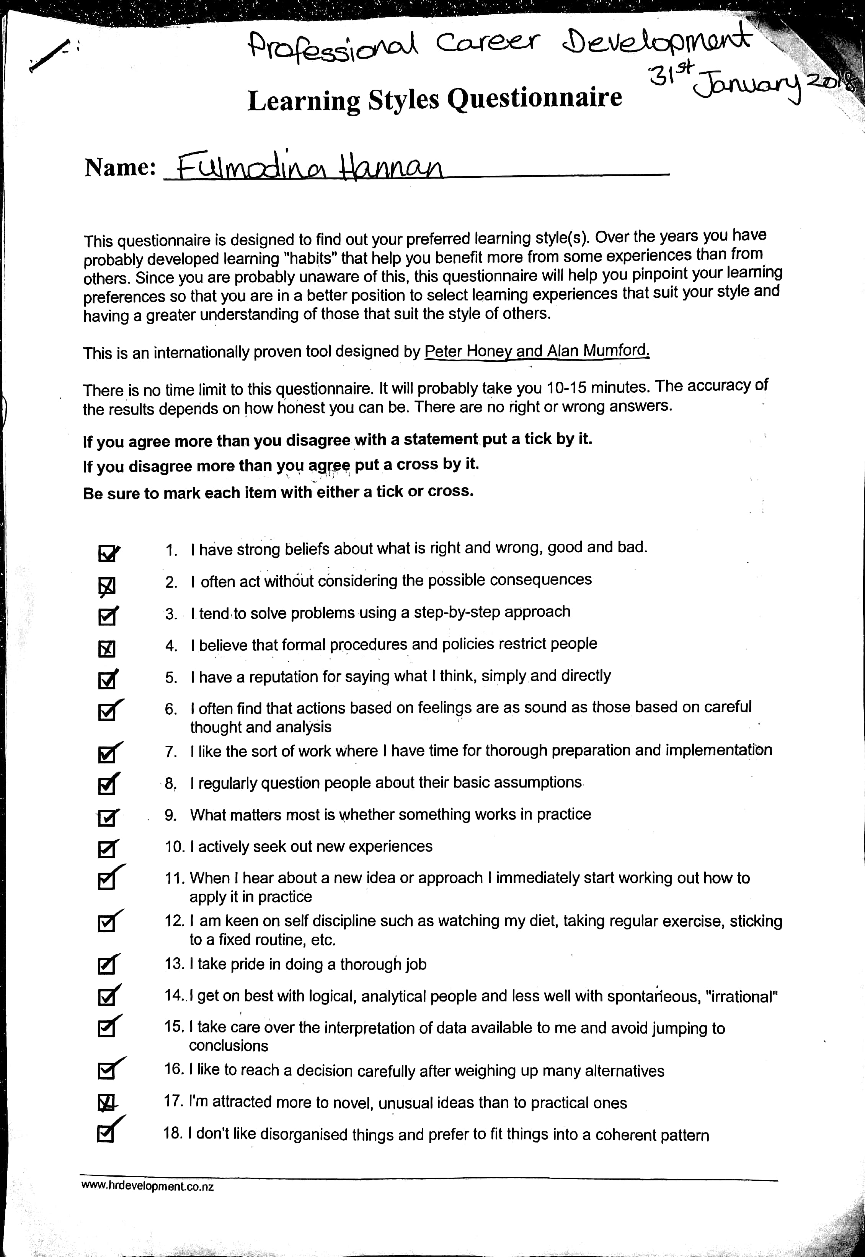

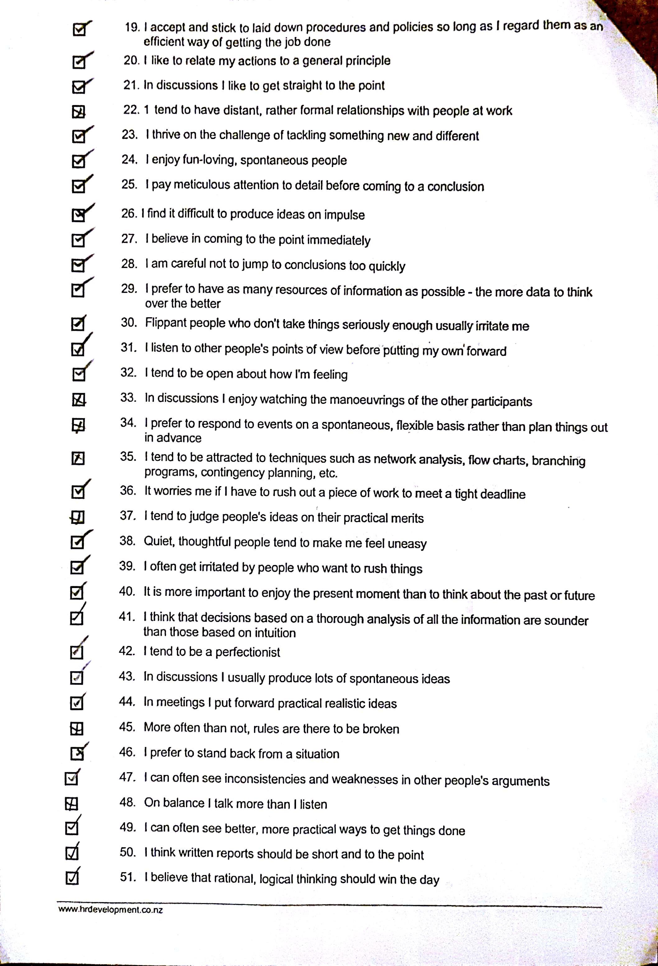

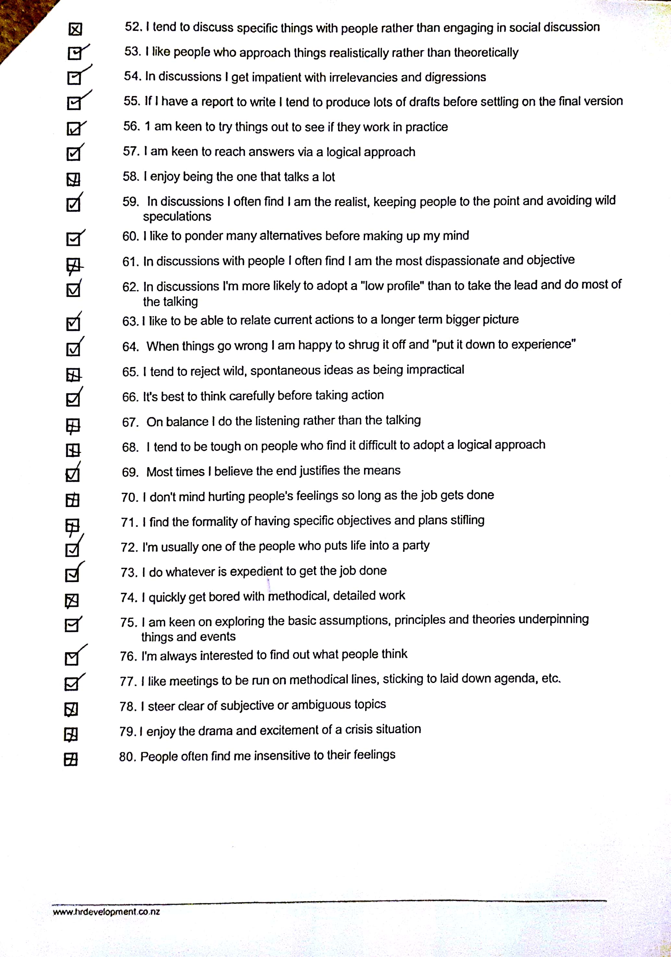

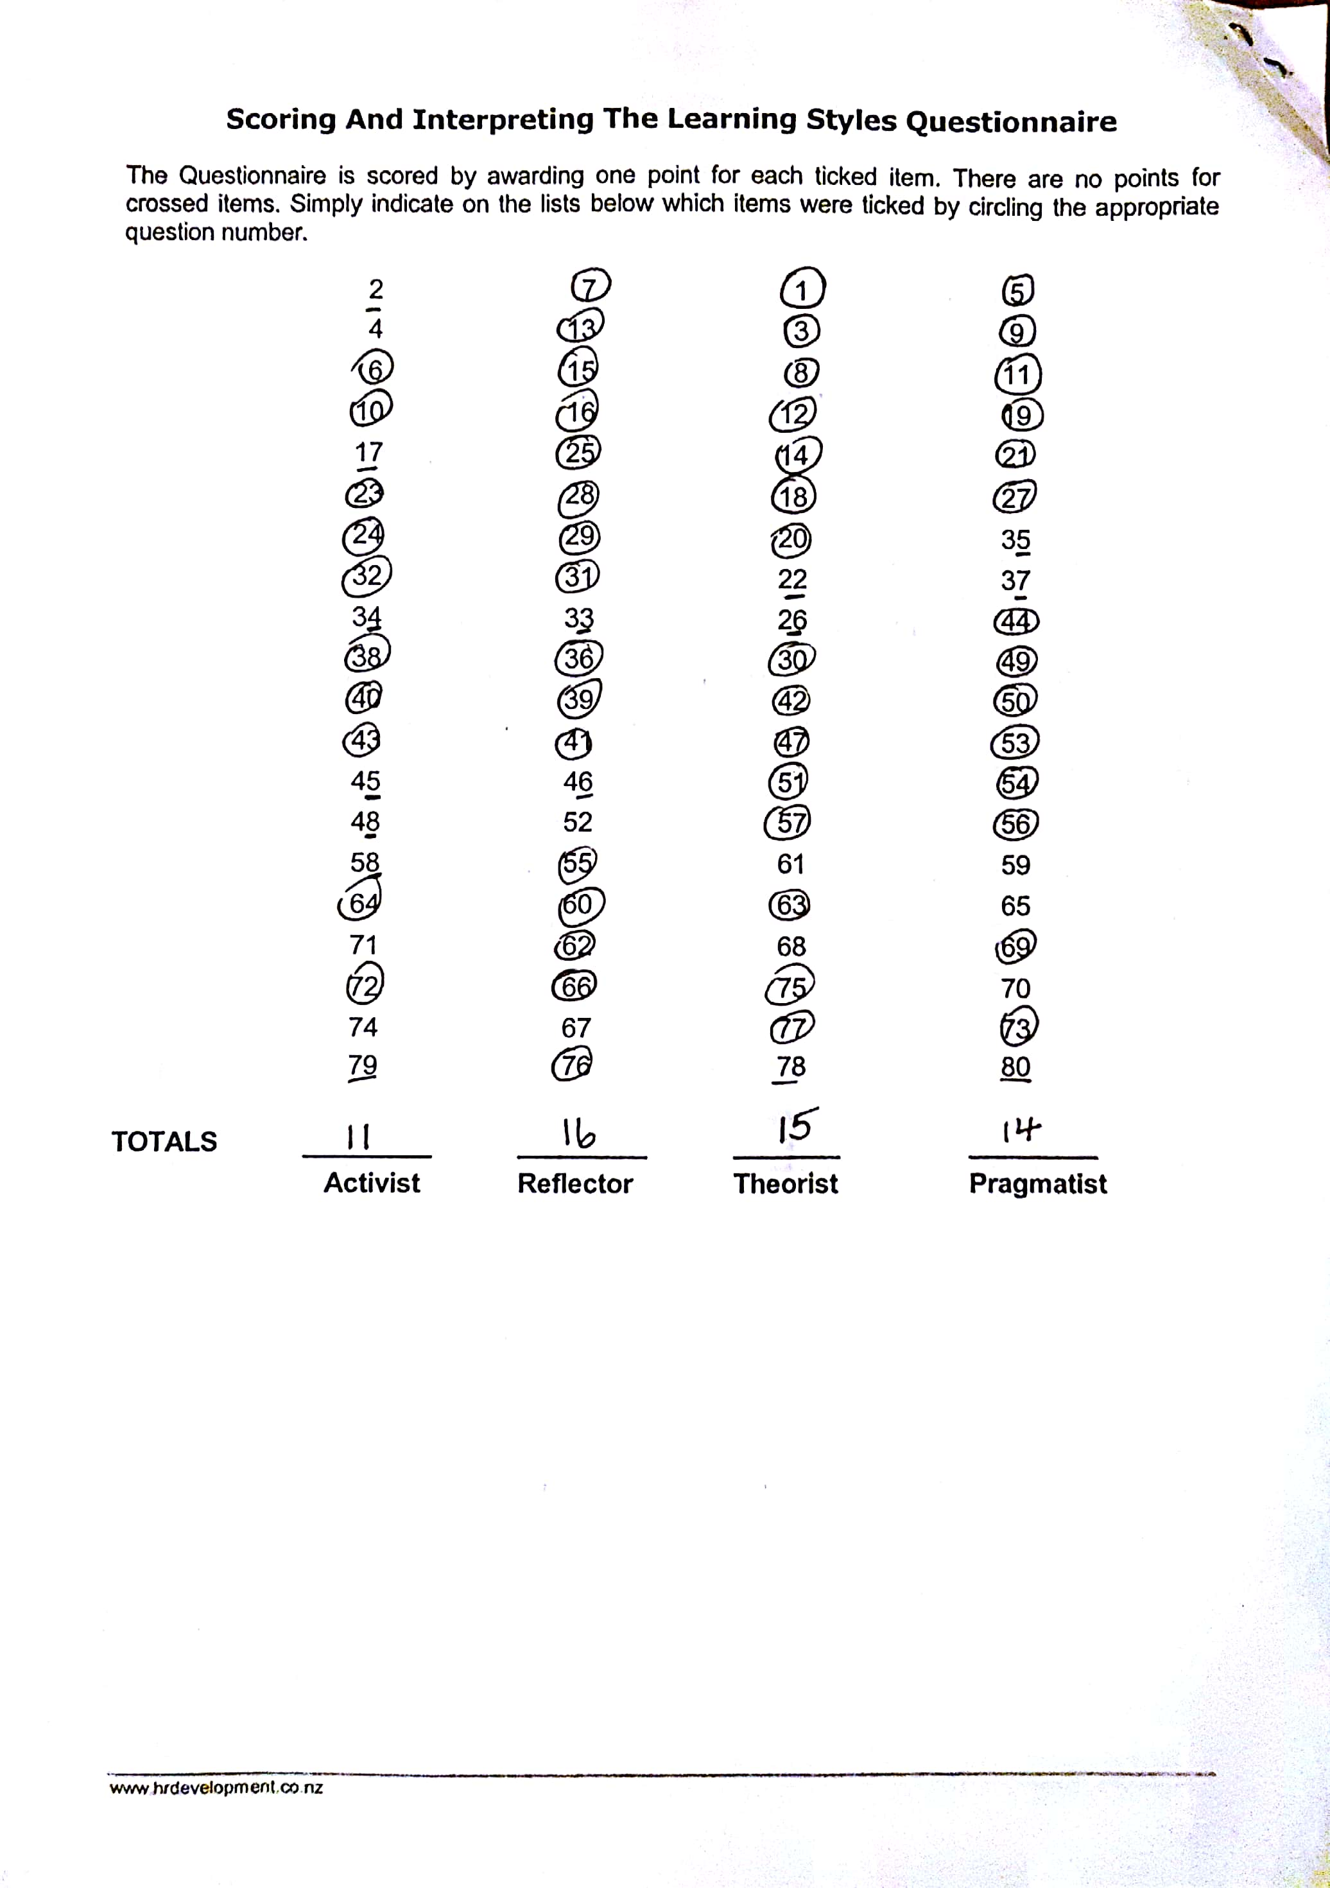

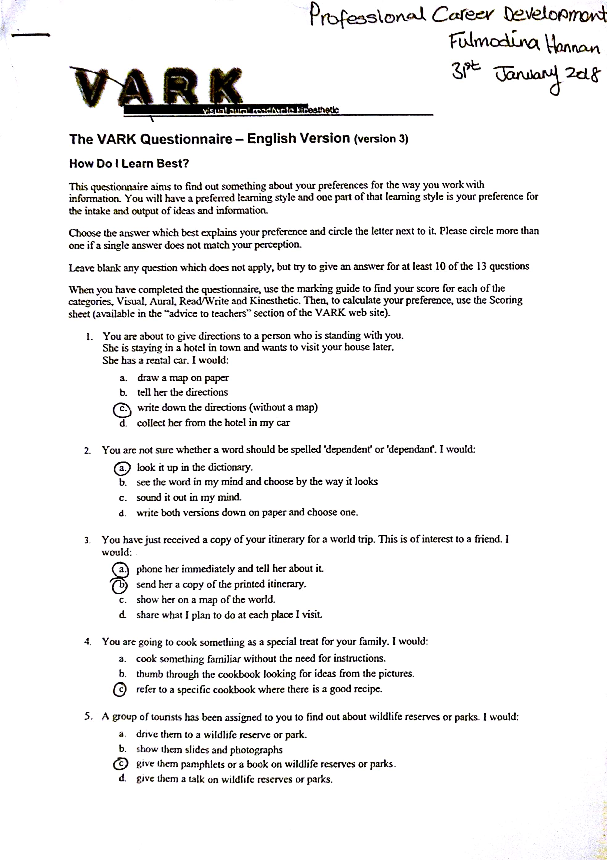
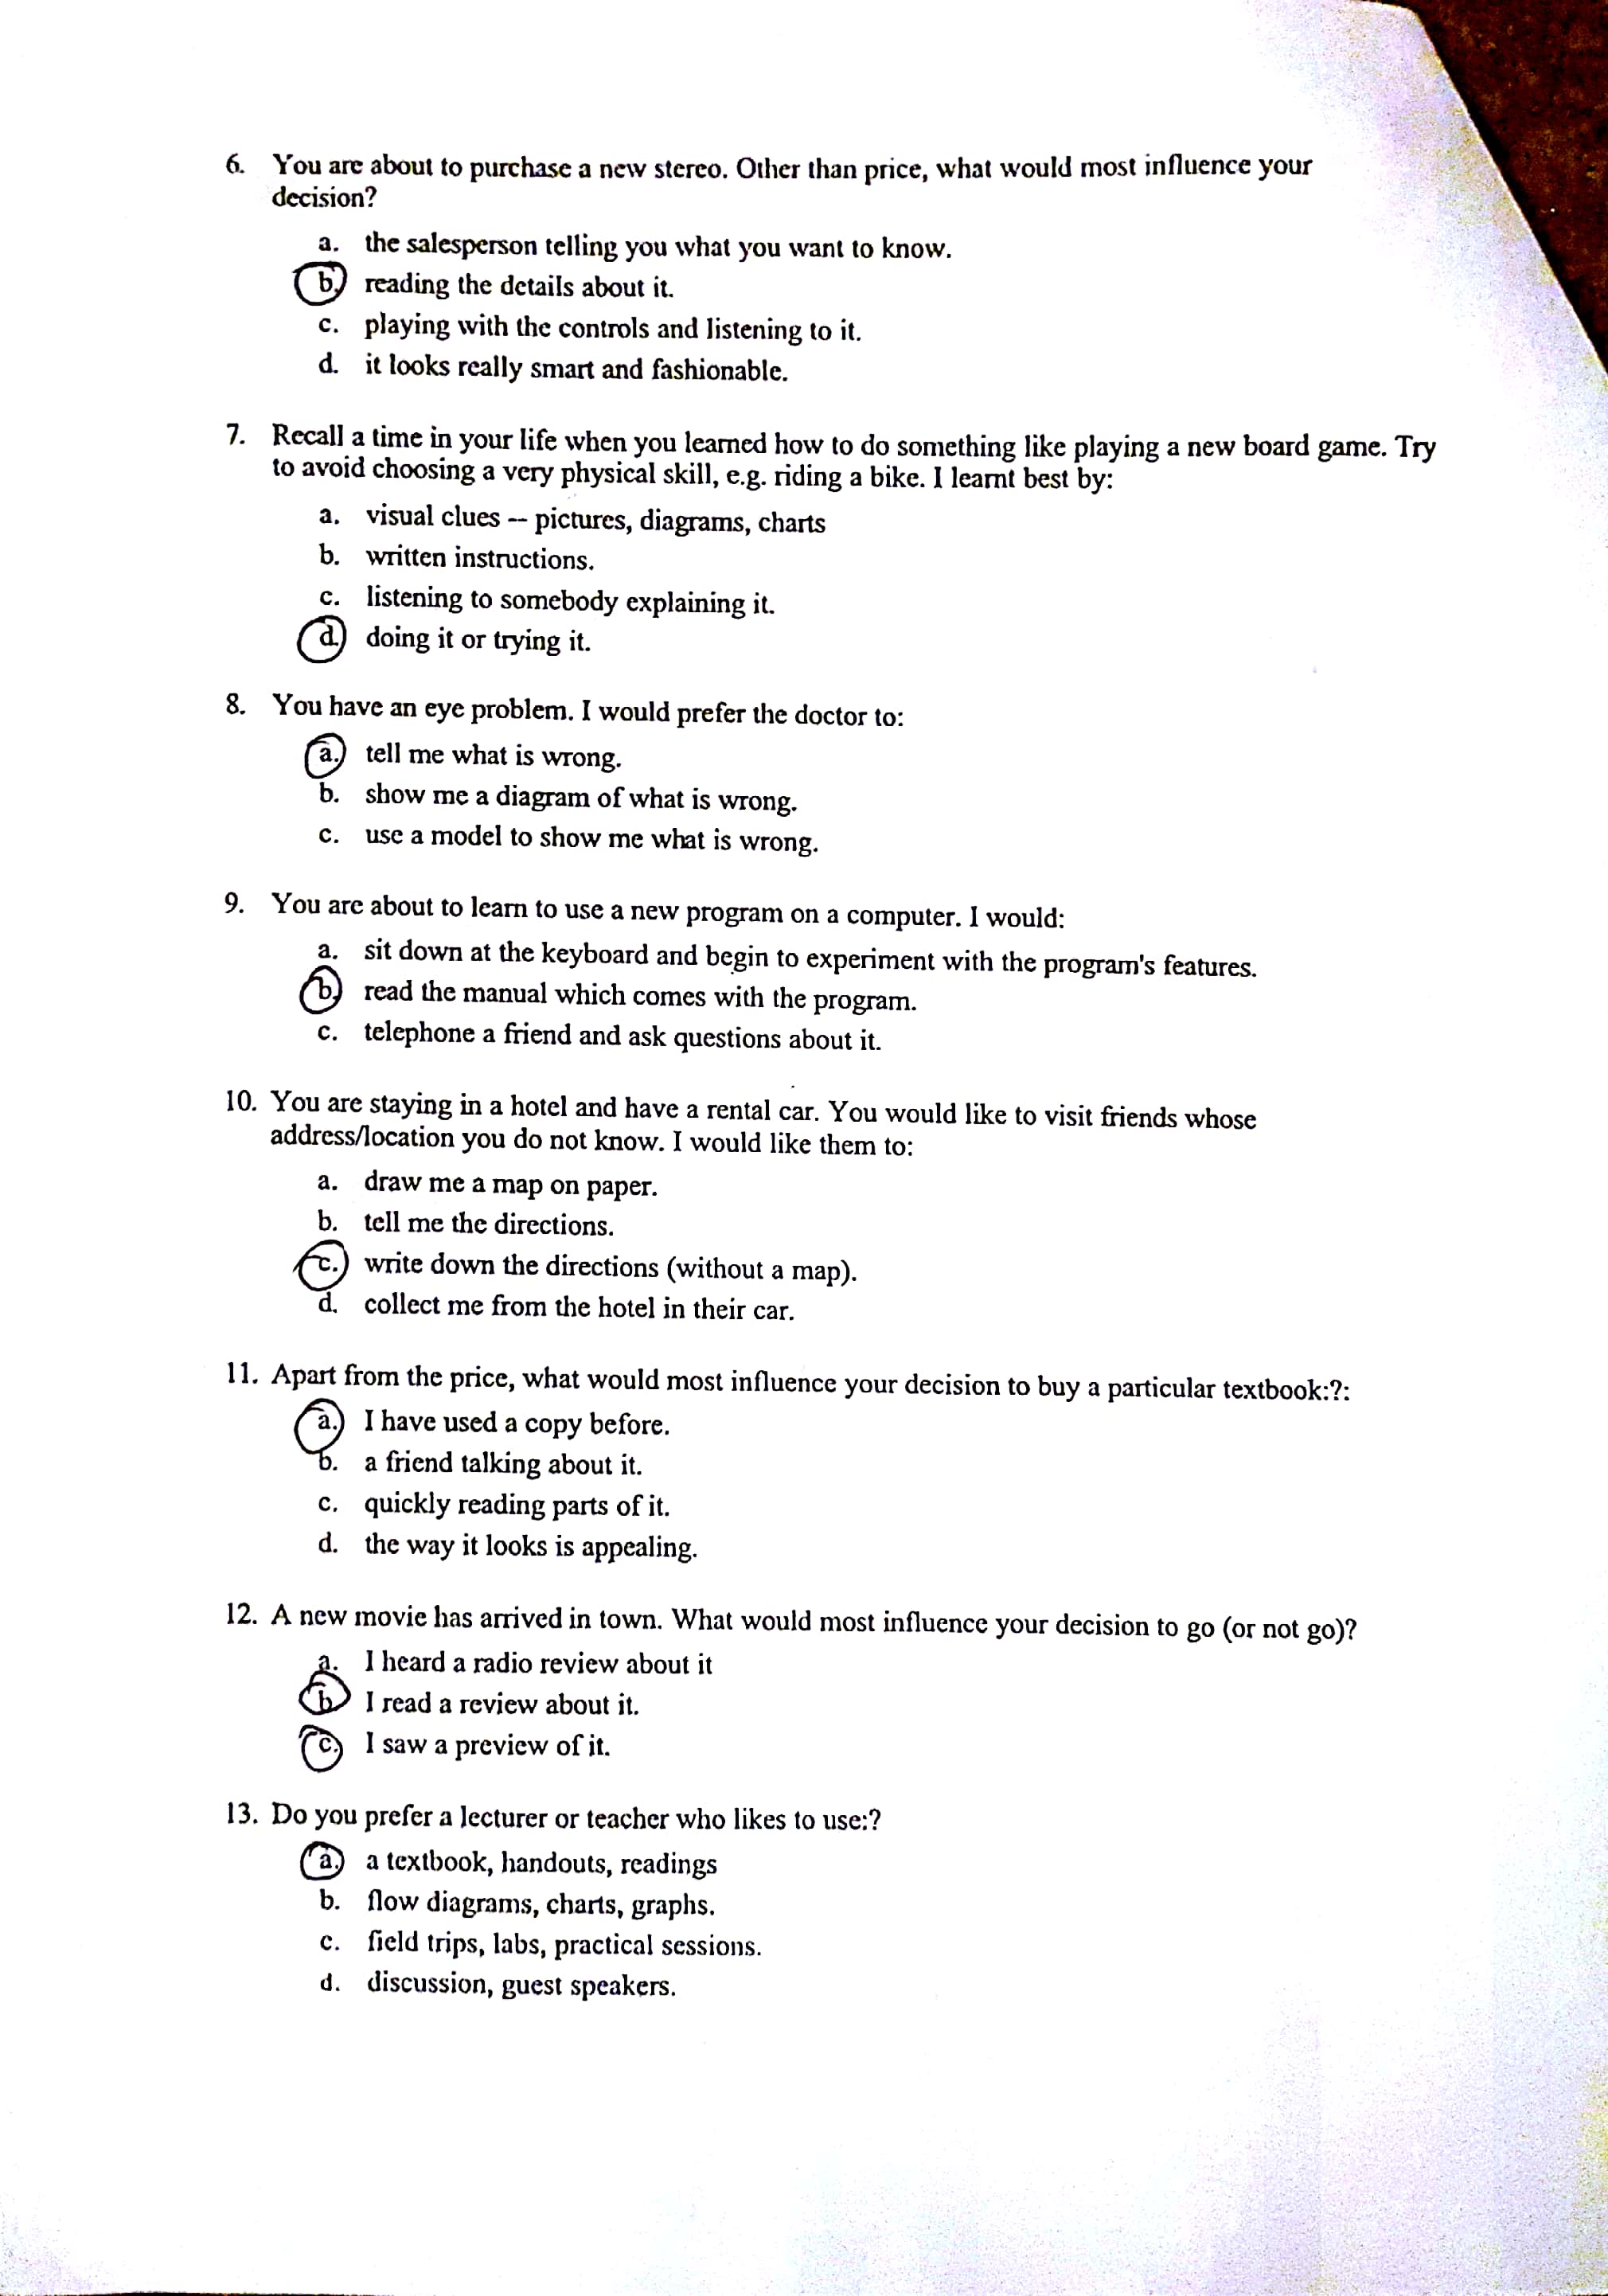

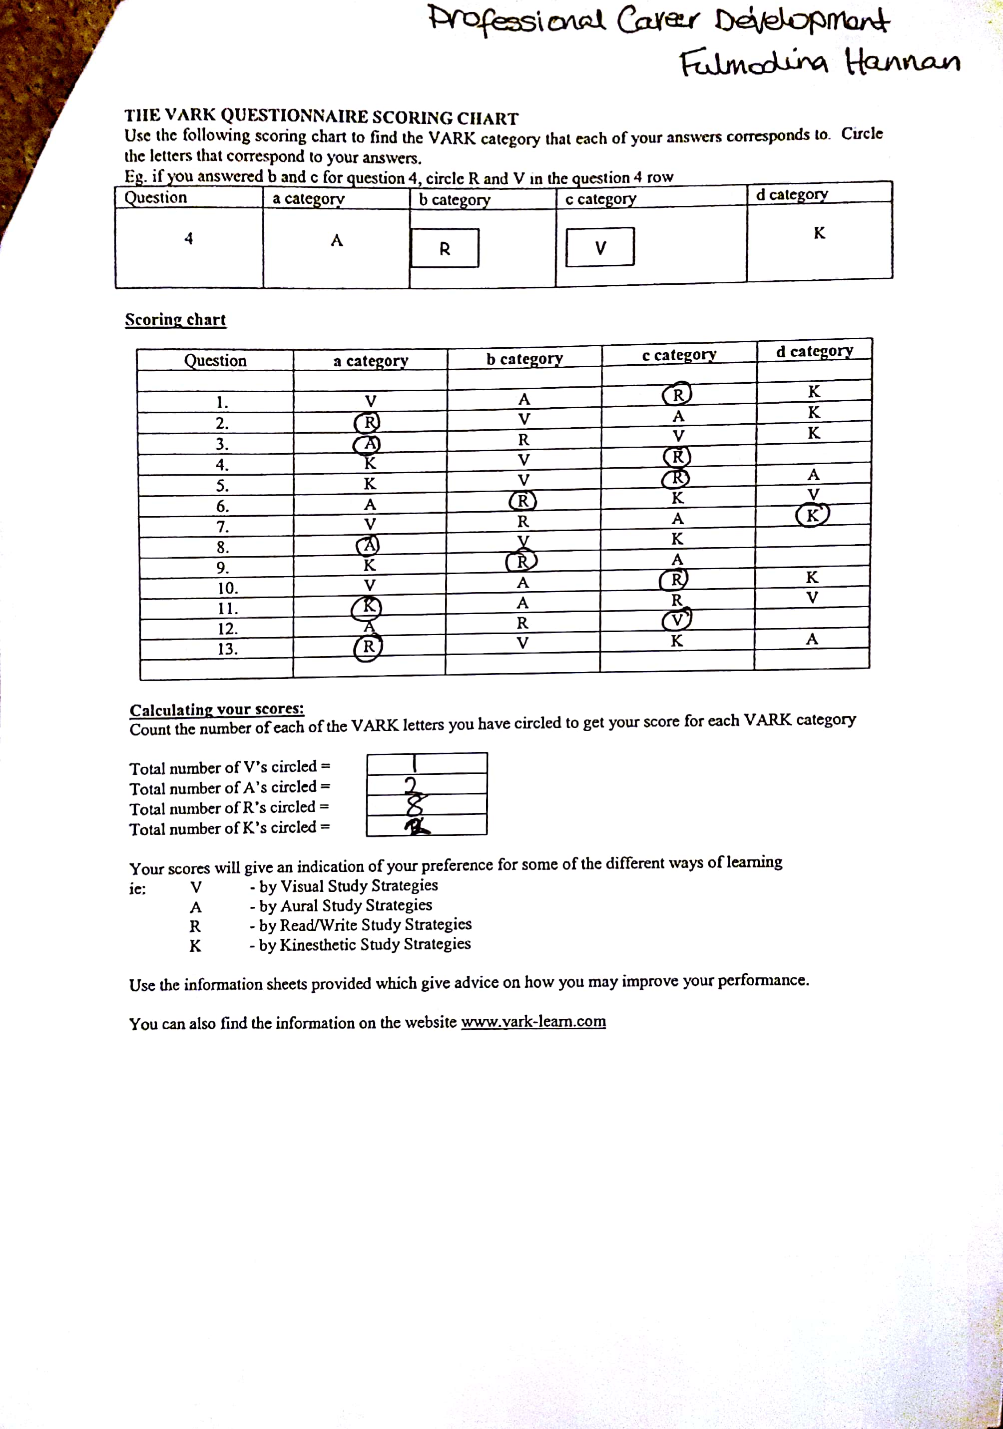

References/Bibliography

Bright, J., Earl, J. And Winter, D. (2015), How to Write a Brilliant CV, Harlow: Pearson.
Fee, K. (2011), 101 Learning and Development Tools, London: Kogan Page Limited.
Hichens, P. (2013), The One Page CV, Harlow: Pearson.
Holmes, K. (2011), What Employers Want The work skills handbook, Surrey: Imprint of Crimson.
Innes, J. (2016), The Cover Letter Book, (Third Edition), Harlow: Pearson.
Institute of Leadership and Management. (2007), Recruiting, Selecting and Inducting New Staff in the Workplace, (Fifth Edition), Burlington: Elservier.
Kihn, S. [2018], The Importance of Planning in your Career, [online] https://careerminer.infomine.com, Accessed date 10th March 2018.
Martin, C. (2012), Boost Your Interview IQ,(Second Edition), United States: The Mcgraw Hill.
Maund, A. Schriek, M. And Tinkler, P.K. (2017), Certificate in Higher Education: Skills for the Workplace Student Yearbook, London: SAGE.
Morgan, P. (2017, The Business Guide to Study Employability, London: SAGE.
Pandya, S. (2017).‘Improving the learning and developmental potential of SWOT analysis: introducing the LISA framework’, Proquest, 33, (3), pp.12-14.
Paschalidou, A., Tsatiris, M. And Kitikidou, K. (2016).‘Energy crops for biofuel production or for food? – SWOT analysis (case study: Greece)’, Science Direct, 93, pp 636-647.
Rogers, H. (2017), A Guide to Writing a CV, Great Britain: Straightforward Publishing.
Shindler, D. (2011), Learning to Leap a guide to being more employable, Evesham: HotHive Book.
Wilson, P. J. (2005), Human Resource Development, (Second Edition), London: Kogan Page Limited.
Yate, M. J. (2012), Ultimate Cover Letters, (Third Edition), London: Kogan Page Limited

