Assignment 2 Planning and analysing community sport development
BMSM5008

Task A, Prestation given on Thursday 3rd March.,

Task B,

SWOT analysis is a strategic planning and management technique, which is used to help organisations and identify organisations strengths, weaknesses, opportunities, and threats. These are related to the businesses market and competition. SWOT analysis is also useful for future planning, adapting, and evolving the business. SWOT analysis is useful as its as its realistic, fact based, and data driven. This means that data is reliable and relatable to the business or organisation. The organisation, I will analyse is, the Physical Activity and Sport Service in NPT (Neath Port Talbot). There vision and aims are to promote a better life through active living. The sub heading below will look at the aims for the future of this organisation and how they are developing sports and activity.

Strengths
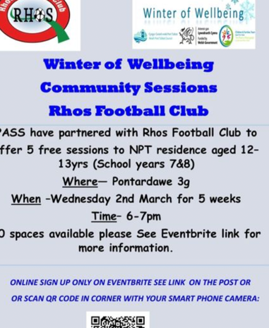
Strengths describe what an organization excels at, and what sets it apart from others, in the same market. This is though strong brands, a development customer base and so on. These all act as a pull for customers. Ways of increasing sales and participation levels in sport include market research and promotion. The NPT sports service understands the importance of increasing participation in sports and therefore aim to increase sports involvement. There the organisation provides grants to help support and set up community games and sport sessions. Although lots of community sports developers provide grants, NPT sports service is pushing it more than others. This suggests that research has been carried out to identify a need for this. The average salary for NTP is £27.6k per annum (LTD, 2022). Unemployment rates are also high at 4.8% (wales, 2020). This shows that grants are needed, in some cases, to provide equal opportunities to the community, which suggests that the organisation listens and understands what the community needs to be more active and will allow the organisation to develop sports. The image about was posted on the NPT P.A.S.S Facebook page (PASS, 2021). Here participation is trying to be increased by the free sessions within a club. This is a clear strength that clubs are on board with the sessions. They are also using new and user-friendly technology like Eventbrite, which is a strength as they are moving and developing within the market. P.A.S.S was set up to “Promoting Better Health through Active Living” (Council, 2022). Strengths of this organisation are also management and organisation to provide support and sessions that fit their clients.

Weakness
Weaknesses stop organizations from performing at their optimum level. Having too many weaknesses with result in more competitors and aims and targets won’t be met. This will result is less funding and support from government or communities. Ultimately weaknesses open gaps in the market for competitors, like the private sector. Reasons for these in business can be high employee turnover, lack of funding and weak brand image. NPT sports service is council run. Therefore, there funding is though the local government, council tax, business rates and rents. Although this is a set amount for each year and the money is a guarantee, employees and management may feel less motivated as there is no danger of not gaining funding in the future. This can result in aims not being met and poor running and use of the funds. The NPT sports service is also only based in the Neath local area. This means that there is only a selective pool of participants for the service to reach out to.

Opportunities
Opportunities refer to favourable external factors that could give an organization a competitive advantage. This helps to set businesses apart from one another. This can include accessing new markets and providing a new product. For NPT promoting their product could provide them with new opportunities and will gain them more clients. This would therefore work with their strengths, of increasing participation in sports and physical activity. Using a Facebook accounts to promote sessions is a good way gain participants or free sessions at local clubs to gain interest in sessions and therefore increase interest and participation in sports. Another opportunity is setting up competitions. For example, a ladder format between clubs. This could help to develop sports and the level of players. Another area which could have future development is working with disabled groups. This is a growing market, and this is a definite area for development. Another area for sports development is working with schools. This is an area of opportunity as it’s a good way to get more younger, grass root participants engaged in sports and physical activity.

Threats
Threats refer to factors that have the potential to harm an organization. For example, loss in sales or higher production costs. Identifying threats can help expose barriers to success and position companies to develop strategies to overcome them. One of the biggest threats the NPT sports service is the private sector. NPT is counsel run and therefore the way they run and operate is different to private sector run business. As a rule, private sector businesses are profit lead. This means that their morals and aims are different. Although the NPT sports service is often free or low cost, the private sector can pump more money into their product and service to gain the most clients and make the most money. This also means that they often have more developed facilities and coaches due to being able to pay more and have access to more funds. Therefore, this is competition. Another threat for this organisation is employment and free time. Being able to perform sports and develop skills takes time. Most of the Neath area have long working job, like working in the Steel works. This is an area where physical activity and sports needs development and support. However, time is of the essence. A way of improving this could be to work with local businesses like TATA steel to be able to provide more time for there employees to be more active. Sport and activity are proven to increase moral and teamwork. Therefore, working with local business could benefit the community and the businesses simultaneously.

Bibliography
Council, N. P. T., 2022. About P.A.S.S.. [Online]
Available at: https://www.npt.gov.uk/17518
[Accessed 4TH MARCH 2022].
LTD, 2. A., 2022. Neath Port Talbot salary stats. [Online]
Available at: https://www.adzuna.co.uk/jobs/salaries/neath-port-talbot
[Accessed 7th March march ].
PASS, N., 2021. P.A.S.S. [Online]
Available at: https://www.facebook.com/nptpass
[Accessed March 2022].
Plumpot, 2018. West Glamorgan average salary comparison. [Online]
Available at: https://www.plumplot.co.uk/West-Glamorgan-salary-and-unemployment.html
[Accessed 5th March 2022].
wales, G., 2020. Annual Population Survey: April 2019 to March 2020. [Online]
Available at: https://gov.wales/annual-population-survey-april-2019-march-2020
[Accessed 4th march https://gov.wales/annual-population-survey-april-2019-march-2020].

