
Master of Business Administration

DISSERTATION PROPOSAL

TOPIC:
THE INFLUENCE OF GENERATIVE AI ON MARKETING PRODUCTIVITY IN FASHION RETAIL ORGANISATIONS

Student Name: MD Alamin
Student ID: 2434280

Supervisor: Dr. Jio Miao

Word Count: 2640

Date: 31st July 2026

Table of Contents
1: Introduction 3
1.1 Research background 3
1.2 Research aim 4
1.3 Research objectives 4
1.4 Research questions 4
1.5 Research significance 4
1.6 Dissertation proposal structure 5
2. Literature Review 5
2.1 Influence of Generative AI on marketing functions and content productivity management in the retail organisations 5
2.2 Impact of Generative AI capabilities on diversified marketing activities, including customer personalisation, content creation, and marketing decision-making for retail companies 6
2.3 Organisational barriers affecting current retail companies in implementing Generative AI to improve their marketing structures and productivity 6
2.4 Theoretical framework 7
2.5 Literature gap 8
3. Research Methodology 8
3.1 Research philosophy 8
3.2 Research design 8
3.3 Research approach 9
3.4 Data collection and analysis techniques 9
3.5 Sampling technique 9
3.6 Ethical consideration 10
4. Research limitation 10
5. Research timeline 10
References 11

1: Introduction

1.1 Research background
In the current era of Industry 4.0, Generative AI tools boost retail companies' productivity through marketing by automatically forming content with advanced graphic designs, streamlining the formal ways of market research in their competitive environment (Devadiga and Aithal, 2026). Enabling the hyper-personalisation messaging structure, GPT, DALL-E-based social media posts, outlined product descriptions as well as quick research trends designing are actively intending the core capacity of the fashion retail companies to emphasise their automated marketing functions and stability process assessments effectively. Therefore, the essentiality of using Generative AI tools in the current marketing productivity approaches of the fashion retail firms and exceeding their marketing workflow by around 15% better have also been estimated as per the competitive structure development by companies (Chowdhury et al. 2025).
In terms of the digital technologies adaptation, then fashion retail industry has been always in a top list and earliest industry to adopt it in order to make significant customer experience improvement and to beat competitiveness. Fashion retail organisations in the UK market are also increasingly utilising Generative AI for the development of personalised marketing campaigns and description of automate products and analysing consumer behaviour (Grewal et al. 2025). It also helps to develop in generation of social media content and supporting marketing decisions based on data driven.
Generative AI possesses the potentiality to overcome the challenges like promotional materials with conducting market research, as well as evaluating campaign effectiveness by doing automating marketing activities (Kumar et al. 2024). These used to be done while activating marketing professionals doing focus on the strategic planning with customer engagement. Despite of the increasing adoption of Generative AI in the fashion retail industry, it also presents some possible challenges. There are some issues such as data privacy, intellectual property and ethical concerns with bias of algorithm, and also AI generated content accuracy to make influence on organisational decisions for AI adoption (Bahangulu et al. 2025).
Hence, this research has the aim for examining the Generative AI influence on fashion retail organisations marketing productivity with the explorations of its contribution to make marketing efficiency and customer personation and decision-making process. This research also aims in the identification of organisational challenges that affects on successful implementation of AI in marketing strategy.

1.2 Research aim
The main aim of the research is to illustrate the influence of Generative AI on marketing productivity and optimised operational smoothness process in fashion retail organisations of the UK.

1.3 Research objectives
- To evaluate the influence of Generative AI on marketing functions and content productivity management in the fashion retail organisations.
- To demonstrate the impact of Generative AI capabilities on diversified marketing activities, including customer personalisation, content creation, and marketing decision-making for fashion retail companies.
- To examine the organisational barriers affecting current fashion retail companies in implementing Generative AI to improve their marketing structures and productivity.

1.4 Research questions
- How does generative AI has influence on marketing functions and productivity of content in fashion retail organisation?
- What are the impacts of Generative AI on the personalisation and creation of content and its decision making of marketing in fashion retail organisations?
- What are the possible organisational barriers have effects on the effective implementations of Generative AI to make improvement on marketing productivity in fashion retail organisations of UK?

1.5 Research significance
This research has the significance of its contribution in the increasing academic as well as practical understanding on Generative AI in the fashion retail marketing industry. As these technologies rapidly evolving, hence, organisations need evidence-based strategies to influence in the marketing productivity and organisational performance. Highlighting these key concepts, the research aims to achieve the accurate working proficiency, effectiveness and customer engagement structures of Generative AI, which may integrate the sustainable business expansion scalability of the fashion retail companies by almost 25% within the next 3 years. Additionally, underpinning the organisational and technological factors which have been re-shaped through the AI-based tools' adaptation to strengthen automation in their regular marketing approaches would also be contemplated as the key area to be achieved by the research.
Apart from that, leveraging of Generative AI in extended marketing forms as per the transformed workforce structure within companies through the perspectives of the employees and the senior leaders will also be estimated as achieved by the research (Chowdhury et al. 2024). Though these key concepts will strengthen the essentiality and role of Generative AI in the current fashion retail company-based operations and its positive influence on the future productivity measuring process for fashion retail companies. Even so, the contribution of Generative AI on active and advanced marketing performance goals for fashion retail companies will also be aimed at achieving by determining the comparison factors with the empirical literature's critical demonstration.

1.6 Dissertation proposal structure
There are interconnected chapters in the dissertation in which introduction is the first chapter which provides the base and significance of the research area. Following this, literature review is the second chapter that critically analyse the existing research studies of Generative AI, fashion retail marketing and others factors regarding this. Then methodology is the next chapter that analyse the research philosophy, design and its approach along with data collection and sampling strategy and adoption of ethical considerations for the research. Following these chapters, the research will conduct expected findings, limitations and conclusions.

2. Literature Review

2.1 Influence of Generative AI on marketing functions and content productivity management in the fashion retail organisations
Implications of Generative AI in the current marketing functions of the fashion retail companies are estimated to reshape the overall drastic marketing plans and creative phenomena development as per the competitive productivity. Gastmann and Bastos (2025) have opined that Generative AI is intended to help social media marketing scalability of the companies, which helps to explain companies' further operating strategies, improve their capacity to design in-house AI tools, design concepts and acquire a stable operating process acquisition effectively. For that, lowering the operational costs of the companies and reducing content production timing by around 30% to 50% have also highlighted the significant part of company systems management effectively. On the other hand, Wahid et al. (2025) have argued that Generative AI enables the technological system functions within fashion retail firms, AI-powered virtual assistance, where 'pre-sale and post-sale chatbots, 24/7 localised customer support' are ensuring the credibility of customer engagement of the companies in their regular entities. Alongside, hyper-personalisation process for streamlined communication techniques, management and integrations by the fashion retail firms to develop marketing-related content functions are also estimated as developed within the companies.

2.2 Impact of Generative AI capabilities on diversified marketing activities, including customer personalisation, content creation, and marketing decision-making for fashion retail companies
Patil (2024) has stated that Generative AI diversified the structures of marketing activities, which mostly moved from niche tools to manage primary drivers of efficiency alignment and growth. Enabling the system of data-driven marketing intelligence management to serve a personalised structure to the customers and scaling up the content production efficacy of the companies by adding the value of their stable growing operational changes. On the contrary, Lanfranchi et al. (2026) have demonstrated that in dynamic competitiveness, adding to the business goals of the companies, Generative AI boosted 'return on ad spend (ROAS) by 10% to 25% and overall marketing productivity by 5% to 15%'. For that, acquisition of the dynamic shopping assistance for customers in terms of content creation and marketing decision making, as well as integration of the sustainable retailing functions, are also estimated as influencing the long-term business growth by the fashion retail firms in their competitive environment.

2.3 Organisational barriers affecting current fashion retail companies in implementing Generative AI to improve their marketing structures and productivity
Intending the key structures of using Generative AI in marketing productivity, different challenges related to the infrastructure-based operational process affect the profit margin and generational capacity of the companies. According to Al-Kfairy (2025), in a GenAI-based marketing structure, a major digitalised skills gap and risk-averse approach for the leadership process acquisition within the company segmentations are critically affecting the operational growth of companies in their recent competitive segments. Additionally, frequent transition of customers' demand and their engaging behaviours, accurate infrastructure gap with the poor leadership efficacy to involve their coordinators with the operational procedures have also been estimated as impacted. On the other hand, Soni (2023) has contradicted that disconnected process of data silos and cultural resistance, citing 'difficulty of measuring exact returns' from the competitive market of the fashion retail companies. For that, challenges with the loyalty programs management and collaboration to transform their operational credibility management goals of the companies have also been estimated as affected by the advanced marketing functions differently.

2.4 Theoretical framework
Technology Acceptance Model (TAM)
The theoretical concept posits with a prediction of how an organisation is able to adapt a new technological structure to balance their competitive practices as well as their utilising capacity to maintain the procedures effectively (Schorr, 2023). Underpinning 'Perceived Usefulness and Perceived Ease of Use' as the key components, beliefs of the specific system-oriented performance functions of a company to strategically emphasise their new technological function elaboration are also estimated as influencing their competitive practices accurately.
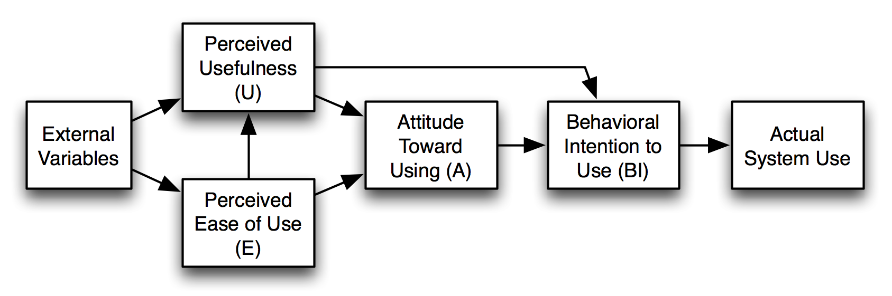
Figure 1: Technology Acceptance Model (TAM)
(Source: Schorr, 2023)
The new technological structure adapted by the fashion retail companies can be reshaped with the key operational structure of TAM, efficient marketing content generation, better customer engagement and personalised process practices are also followed by the firms. Perceived Usefulness would help to measure job performance betterment for the fashion retail firms by improving their professional scalability and integrating GenAI-based training processes of those companies. Additionally, Perceived Ease of Use would help to extend easy options of learning and usage, which will lead to more productivity and stability for the companies in their current competitive segment.

2.5 Literature gap
In the existing literature review segment, a gap in outlining the practices and projections of Generative AI by outlining its benefits and roles for the current fashion retail firms has been identified. Limitations of understanding the real-time benefits, which specify the changed and modern operating credibilities of the companies to balance their competitive operational verifications for their sustainable operating changes, have also been measured as a major gap in analysing the literature.

3. Research Methodology
Research onion
Research onion is defined as the simplified framework of defining each breaked structure and phases of the research methodology for dividing the process of data collection and demonstration equally (Assadpour et al. 2023). The core six layers of the research methodology including ‘research philosophy, approach to theory development, methodological choice, research strategy, time horizon, and data collection techniques’ are divided under the divisional explanation of research onion by optimising the changes as per the phenomena. Based on that the gap between knowledge and reality has also been estimated as evolved by using the key functions of the research onion.
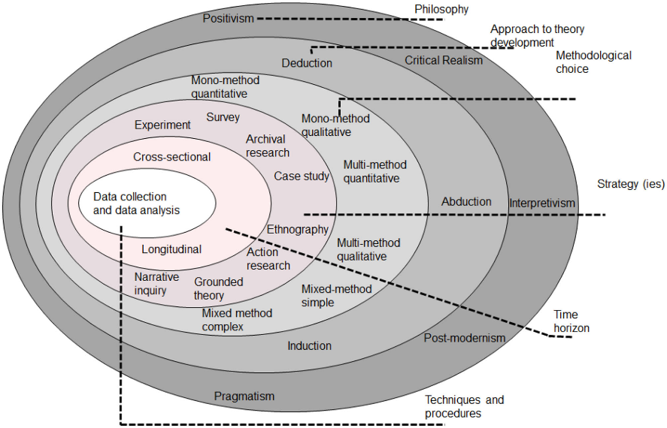
Figure 1: Research Onion
(Source: Assadpour et al. 2023)
In the current research phenomena, key divisions of the research onion will be applied to outline the effectiveness of AI to translate the process of retail marketers capacity to align their operational process of changes in terms of competitive validity management. As well as focusing on the real time estimation of the company goals to meet their differential company functions will also be outlined by using the onion.

3.1 Research philosophy
Research philosophy is contemplating the set of assumptions in research according to the outcomes and further specification of the research process acquisition effectively (Bergmann, 2023). Following the key efficacy of the research philosophy, the interpretivism research philosophy will be used in the research to develop subjective analysis-based formats of data collection and proceeding. Alongside, the research philosophy will help to focus on observational complex information analysis for the researcher, by which specification of how fashion retail companies' associations are required to be transformed in their competitive market can be measured. Although the transformational structure of the fashion retail companies, including their advanced marketing functions, can be measured by the researcher for using the positivism research philosophy in the research.

3.2 Research design
Research design is defined as the blueprint of a research phenomenon that helps to specify the key tools and techniques determining the capacity for research to meet the core objectives (Ansari et al. 2022). Among different designs, the explanatory research design will be used by the researcher to develop an in-depth form of data collection and elaboration in an effective way. Using the research design, manipulation of the key variables of the research phenomena can be estimated (Furidha, 2023). Additionally, the influence of Generative AI on changing marketing operations, automating the customer engagement formats of the fashion retail companies to meet their competitive market demand-oriented understanding, would also be effectively estimated by the researcher.

3.3 Research approach
Critically organising, collecting and analysing the key operating factors as per the research-related process acquisition demonstrates the effectiveness of the research approach (Mantula et al. 2024). In between the three main research approaches, the inductive research approach will be selected by the researcher to optimise the particular and direct sources based on information obtaining and validated forms changing credibility as per the scenario. As well as the benefits of GenAI tools to integrate customer personalisation, more attractive visualised forms of marketing content to evolve competitive segmentation of the fashion retail companies, which can also be identified by the researcher through using the research approach.

3.4 Data collection and analysis techniques
Considering the key derivatives of the research phenomena, the secondary qualitative data collection method, by conducting the thematic analysis technique, will be selected to be used in the research by the researcher. Analysing through the thematic analysis method, the researcher will be able to measure the positive influence, growing benefits and role of Generative AI for emphasising marketing productivity in the current fashion retail companies (Cernasev and Axon, 2023). Apart from that, the methods will ensure the ways of collecting information from different fashion retail companies, such as Zara UK, Next, Primark, Marks & Spencer's and justify the engagement and ethical ways of the research phenomena, following and developing structures of the key objectives in an effective way.
Moreover, the data collection method will centralise with the recently published books, journals and articles to align the key research phenomena with the selective topic. Alongside, current industry reports, companies’ annual reports, news articles including Mintel, BBC, Forbes, CNBC, Bloomberg will also be used as the key sources of the research to align the topic with real time scenarios.

3.5 Ethical consideration
Meeting the key ethical process of the research phenomenon, the Code of Conduct of the University of Wales Trinity saint David will be underpinned by the researcher. Moreover, maintaining academic integrity, acknowledging authors contribution on the research as well as avoiding the chance of academic misconduct will also be considered as the key ethical structure for the research. Additionally, using the university protected folder to keep all the reports and articles and develop specific password to protect does information from breach, will also be selected as another way of managing ethical consideration process.

4. Research limitation
In the current research, the researcher has only mentioned using the secondary qualitative method to align the data collection process with the real-time scenarios and explore the current company centric understanding and customers feedback as per the determination from staff's perceptions. However, the lack of existing information structure, limitation on analysing the current company-based employees’ engagement, their opinion, sustainability factors and the advanced operating strategies suggested by employees in fashion retail companies to add Generative AI tools in their competitive functions. For that, a major limitation is that a clarification about the current fashion retail companies’-oriented concepts and aspirations to coordinate with their customers through marketing functions, as well as their staff's training applications, will be found.

5. Research timeline
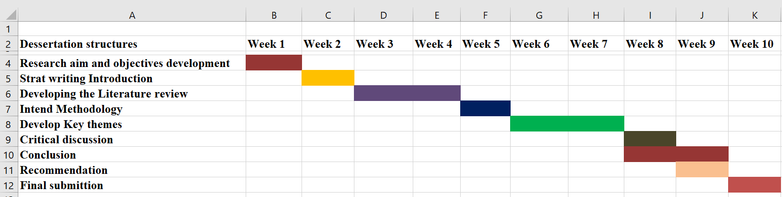
Figure 2: Research timeline
(Source: Self-developed)

References
Al-Kfairy, M., 2025. Strategic integration of generative AI in organizational settings: Applications, challenges, and adoption requirements. IEEE Engineering Management Review, 53(6), pp.80-97.
Ansari, M.R., Rahim, K., Bhoje, R. and Bhosale, S., 2022. A study on research design and its types. International Research Journal of Engineering and Technology (IRJET), 9(7), pp.1132-1135.
Assadpour, H., Ghalehnoee, M. and Bahramian, A., 2023. Developing the model of research method in urban landscape studies emphasizing the Saunders’ research onion. Motaleate Shahri, 12(45), pp.3-18.
Bahangulu, J.K. and Owusu-Berko, L., 2025. Algorithmic bias, data ethics, and governance: Ensuring fairness, transparency and compliance in AI-powered business analytics applications. World Journal of Advanced Research and Reviews, 25(2), pp.1746-1763.
Bergmann, J., 2023. Research philosophy, methodological implications, and research design. In At Risk of Deprivation: The Multidimensional Well-Being Impacts of Climate Migration and Immobility in Peru (pp. 57-89). Wiesbaden: Springer Fachmedien Wiesbaden.
Cernasev, A. and Axon, D.R., 2023. Research and scholarly methods: Thematic analysis. Journal of the American College of Clinical Pharmacy, 6(7), pp.751-755.
Chowdhury, A.G., Bandapati, G. and Chilakapati, P., 2025. Revolutionizing Retail Operations through Generative AI: A Systematic Review. International Journal of Computer Applications, 975, p.8887.
Chowdhury, S., Budhwar, P. and Wood, G., 2024. Generative artificial intelligence in business: towards a strategic human resource management framework. British Journal of Management, 35(4), pp.1680-1691.
Devadiga, D. and Aithal, P.S., 2026. Generative AI in the Marketing Industry: An Industry Analysis of Content Transformation, Consumer Engagement, and Firm Performance. Poornaprajna International Journal of Management, Education & Social Science (PIJMESS), 3(1), pp.220-248.
Furidha, B.W., 2023. Comprehension of the descriptive qualitative research method: A critical assessment of the literature. Acitya Wisesa: Journal Of Multidisciplinary Research, pp.1-8.
Gastmann, J. and Bastos, M., 2025. Strategising with generative AI: Productivity gains in social media marketing. Journal of Marketing Communications, pp.1-20.
Grewal, D., Satornino, C.B., Davenport, T. and Guha, A., 2025. How generative AI is shaping the future of marketing. Journal of the Academy of Marketing Science, 53(3), pp.702-722.
Kumar, P., Satanasavapak, P., Chantokul, D. and Wang, Y., 2024. Generative Artificial Intelligence For Digital Marketing: Insights and Antecedents-A Systematic Literature Review. Journal of Roi Kaensarn Academi, 9(12), pp.2047-2062.
Lanfranchi, G., Cioli, A., Amanti, A. and Marinelli, L., 2026. Reconfiguring competitive advantage: a resource dynamic framework for generative AI adoption in digital content marketing. European Journal of Innovation Management, 29(3), pp.770-798.
Mantula, F., Mpofu, A.C., Mpofu, F.Y. and Shava, G.N., 2024. Qualitative research approach in higher education: Application, challenges and opportunities. East African Journal of Education and Social Sciences, 5(1), pp.1-10.
Patil, D., 2024. Generative artificial intelligence in marketing and advertising: Advancing personalization and optimizing consumer engagement strategies. Available at SSRN 5057404.
Schorr, A., 2023, February. The technology acceptance model (TAM) and its importance for digitalization research: A review. In International Symposium on Technikpsychologie (TecPsy) (pp. 55-65).
Soni, V., 2023. Adopting generative ai in digital marketing campaigns: An empirical study of drivers and barriers. Sage Science Review of Applied Machine Learning, 6(8), pp.1-15.
Wahid, R., Mero, J. and Ritala, P., 2025. Technology-enabled democratization: Impact of generative AI on content marketing agencies. Industrial Marketing Management, 131, pp.1-16.

